A Standalone Solar Photovoltaic and Battery-Based Power Supply for Center-Pivot Irrigation Systems
S.M. Bakirov¹, Lyazat Sadykova ^{2,a)}, S.V. Bakhteev¹, S.S. Eliseev¹, I.Yu. Kuryatnikov¹, Anvar Saidkhodjaev ³
¹ Vavilov University (Federal State Budgetary Educational Institution of Higher Education), Russia
² West Kazakhstan Innovative and Technological University, Uralsk, Kazakhstan
³ Tashkent state technical university named after Islam Karimov, Tashkent, Uzbekistan
^{a)} Corresponding author: muhammadxon.toirov@gmail.com
Abstract. The reliable operation of center-pivot irrigation machines in regions with limited access to centralized power grids requires the development of energy-autonomous and cost-effective power supply solutions. This paper proposes and substantiates an autonomous power supply system for a center-pivot irrigation machine based on solar photovoltaic modules and battery energy storage, integrated with a switched reluctance electric drive. The study combines an analysis of solar energy potential during the irrigation season with a section-by-section assessment of the energy consumption characteristics of a six-section irrigation machine operating in an intermittent and continuous duty cycle. A full-scale experimental section equipped with photovoltaic modules, traction batteries, and a switched reluctance motor was developed to validate the theoretical assumptions. The results demonstrate that the proposed system ensures stable operation under variable load conditions, reduces transmission losses due to localized energy generation, and improves overall drive efficiency compared with conventional asynchronous motor–diesel generator configurations. A techno-economic analysis confirms the feasibility of the proposed solution, revealing a significant reduction in annual operating costs, an annual economic benefit of 44.1 thousand RUB, and a payback period of approximately four years. The findings indicate that solar–battery-based autonomous power supply system’s represent a viable and sustainable alternative for electrically driven center-pivot irrigation machines in regions with high solar energy exposure.
INTRODUCTION
Irrigation of agricultural crops in regions characterized by high climatic and agronomic risk enables a two- to six-fold increase in crop yields and creates favorable conditions for cultivating plant species with elevated agronomic requirements. A wide range of irrigation technologies is employed for this purpose; however, in the Lower Volga region, sprinkler irrigation machines remain the most prevalent solution. Among these systems, center-pivot sprinkler machines account for 62.9%, of which 52% are electrically driven [1,2].
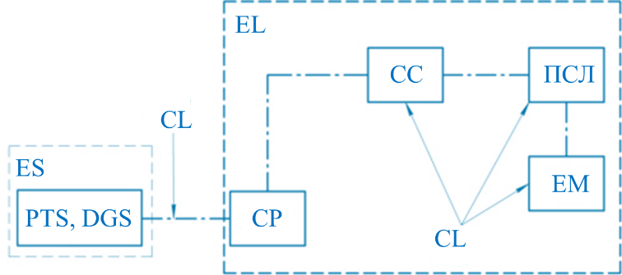
FIGURE 1. Structural layout of the power supply system for an electrically driven center-pivot irrigation machine: ES – energy source; CTS – packaged transformer substation, DG – diesel generator set; CL – cable link, LP – electrical load of the irrigation machine; CP – control panel, CC – current collector; LSD – line-synchronization device ensuring coordinated movement, EM – electric motor.
Despite the widespread adoption of the considered power supply configuration, it exhibits a number of operational shortcomings. The principal limitations are summarized in Table 1.
TABLE 1. Operational Characteristics and Limitations of Power Supply Components in Electrically Driven Center-Pivot Irrigation Machines (EDCPIM)
Component | Operational characteristic | Periodicity
Electricity sources
Diesel generator set | Equipment adjustment and calibration | Before commissioning at the start of the irrigation season
Diesel generator set | Routine technical maintenance | After 50–100 operating hours
Diesel generator set | Fuel level monitoring | Throughout the irrigation season
Diesel generator set | Electrical energy losses | During irrigation operation
Diesel generator set | Changes in fuel tariffs | During the irrigation season
Packaged transformer substation | Relatively high material and labor intensity during installation of the substation and cable laying | Before commissioning
Packaged transformer substation | Inability to relocate the EDCPIM from the installation site | After installation
Packaged transformer substation | Changes in electricity tariffs | During operation
Electricity consumers
Electric motor | Overloading of contact connections in power supply and control circuits | During start-up
Line synchronization device | Contact sticking of limit switches and burnout of magnetic starter contacts | After machine operation up to 100 h
Line synchronization device | Increase in contact resistance due to carbon deposition and oxidation | During irrigation
Cable line | Short circuiting to the irrigation machine frame | During irrigation
Control panel | Burnout of magnetic starter contacts | During irrigation

The operational specifics of power supply components prior to commissioning also include the relative complexity of commissioning and adjustment procedures [3–6]. Currently, a large share of agricultural producers employ UMC PowerSaver 3.5 electric motors in center-pivot irrigation machines manufactured by Bauer (Austria), KASKAD (Russia), Zimmatic (USA), and RKD (Spain) [7]. In parallel, modern electromechanical systems are increasingly adopting switched reluctance motors (SRMs), which operate on the principle of a quasi-moving electromagnetic field. These motors demonstrate an efficiency 1.5–2.5% higher than that of conventional asynchronous motors and are particularly well suited for operation from direct current sources, enabling direct integration with solar photovoltaic and battery energy storage systems [8].
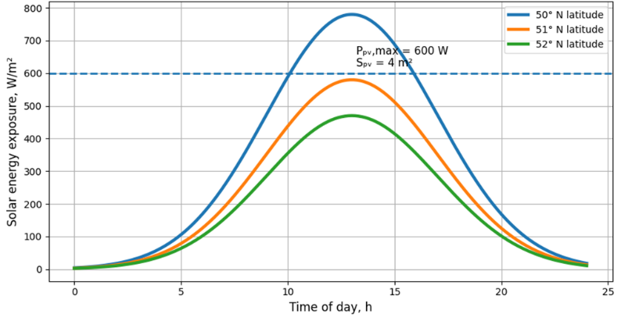
FIGURE 2. Average solar energy exposure during the March–September period
Given that sprinkler irrigation machines are predominantly operated during the spring–summer period, when solar energy availability is at its peak, the application of autonomous power supply systems based on solar and battery storage becomes technically feasible. Advances in solar energy technologies justify considering such systems as a primary power source for center-pivot irrigation machines equipped with SRMs. In this context, it is necessary to assess the electrical energy output of photovoltaic modules within the latitude range of 49°52′–52°42′ N during the irrigation season from March to September, with average values of specific solar energy exposure presented in Figure 2. According to Figure 2, at a latitude of 51° N (corresponding to the cities of Saratov, Voronezh, and Kursk), the solar energy exposure reaches 582 W/m². Under these conditions, a photovoltaic module with an area of 1 m² and an efficiency of 20% delivers a peak electrical power of approximately 150 W.

RESULT AND DISSCUSSION
Consequently, a photovoltaic array with a total area of 4 m² and a rated peak power of 600 W can be considered sufficient to sustain the operational duty cycle of the electric drive of a sprinkler machine section equipped with a switched reluctance motor. Considering the structural and functional uniformity of the sprinkler machine sections, an autonomous power supply configuration for a single section is presented in Figure 3.

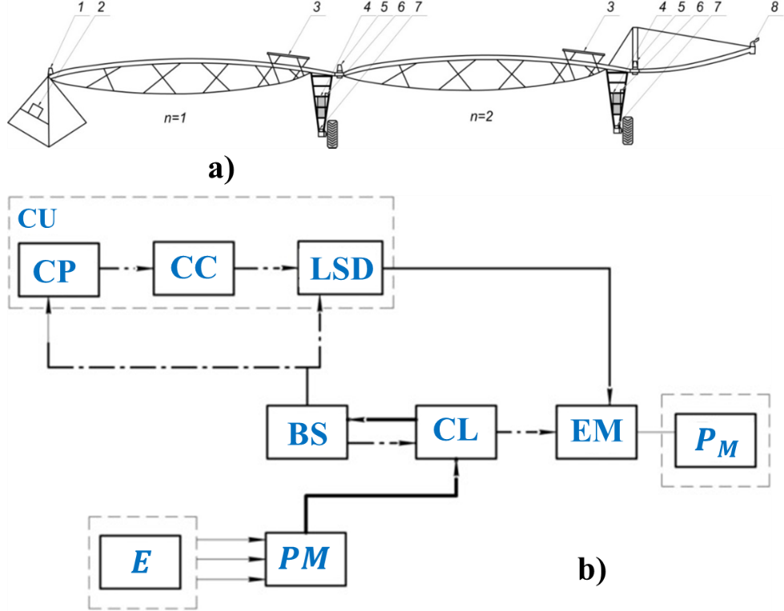
Figure 3. Power supply configuration of an electrically driven center-pivot irrigation machine with solar and battery storage systems (patent No. 189495 [61]) (a), and the corresponding block diagram of the power supply system (b): n – number of sections (n = 2–10); 1 – stationary support; 2 – control panel; 3 – photovoltaic modules; 4 – battery storage; 5 – line synchronization device; 6 – controller; 7 – electric motor;
8 – long-range water jet sprinkler; CU – control unit.
A distinctive feature of the proposed power supply architecture is that the photovoltaic modules and battery storage units are installed in close proximity to the electric drive on the support trolley, which virtually eliminates transmission losses and results in a near-zero marginal cost of electrical energy [8]. Another defining characteristic of the system is the use of switched reluctance motors (SRMs) in the drive units of the sprinkler machine trolleys. Owing to their control-oriented structure, SRMs operate in conjunction with a dedicated controller and demonstrate stable performance when supplied by unstable direct-current sources, such as solar–battery systems. In addition, SRMs exhibit an efficiency approximately 2% higher than that of conventional asynchronous motors employed in traditional irrigation power systems, while also providing soft starting capability and adaptive power regulation under variable load conditions.
When assessing the feasibility of deploying a solar–battery-based power supply system combined with switched reluctance drives for a center-pivot irrigation machine, it is essential to analyze both the energy consumption characteristics and the structural features of the irrigation system. A center-pivot irrigation machine consists of multiple identical sections that move sequentially in a repetitive short-time (“start–stop”) operating mode. Each section travels a different path length; for example, the section adjacent to the stationary support covers approximately half the distance of the subsequent section, while all sections operate at the same translational speed. As a result, the total rotation time differs for each section. The motion of the sections is driven by an electric motor, which constitutes the primary electrical load of each section. The kinematics of the section movement are illustrated in Figure 4.
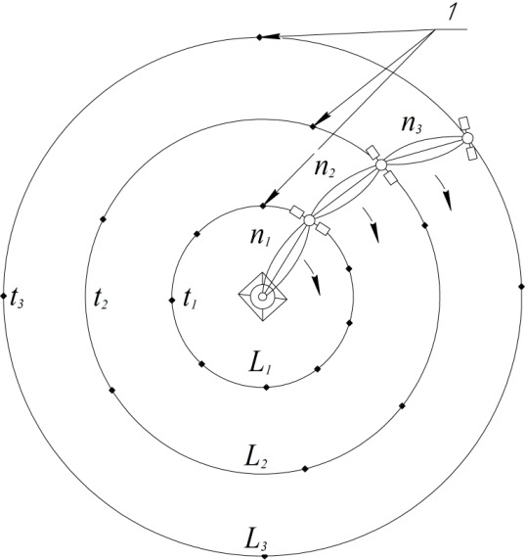
Figure 4. Motion of the sections of a center-pivot irrigation machine: 1 – stopping points of section movement; n₁–n₃ – sections with ordinal numbers 1, 2, and 3; L₁–L₃ – distances traveled by the corresponding sections; t₁–t₃ – operating durations of the n-th sections.
The first section (n₁) of a center-pivot irrigation machine covers a distance L₁ over a time interval t₁. Since all sections are identical in length, the second section (n₂) travels a distance that is twice as long, while each subsequent section covers an increasingly greater path length. As a result, the operating duration of each section increases progressively. The energy consumption of an individual section can therefore be expressed as the product of the electric motor power and the operating time of the corresponding section. Considering that the first five sections, starting from the stationary support, operate in a repetitive short-time duty cycle, whereas the sixth section, which governs the overall movement of the machine, operates in a continuous mode, the total energy consumption of the center-pivot irrigation machine is determined as the sum of the energy consumed by all sections, each characterized by different travel distances and operating durations.
To verify the theoretical assumptions, an experimental prototype of a sprinkler machine section equipped with a solar–battery power supply system and a switched reluctance motor (SRM) was developed. The integration of photovoltaic modules was carried out with consideration of the structural features of the irrigation machine and the irrigation process, ensuring maximum solar irradiance, mechanical stability, resistance to wind-induced vibrations, and safe maintenance access. Placement of the photovoltaic modules on the upper surface of the water-conveying pipeline provides uniform exposure to solar radiation, while increased aerodynamic loads are mitigated through optimized module distribution and reduced panel width. Battery energy storage units were mounted on the support trolley frame, ensuring operational safety and compact integration. The developed section employs a BLDC-type SRM, Delta Gel traction batteries, and SilaSolar photovoltaic modules, with the motor power matched to that of the asynchronous motor used in conventional systems. The battery capacity was selected to provide up to 10 hours of continuous motor operation, ensuring reliable autonomous performance of the irrigation machine section.

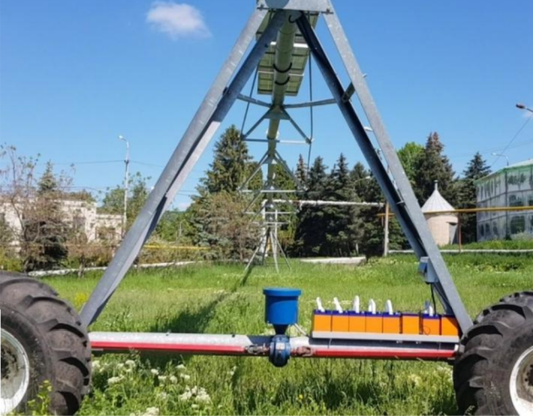
Figure 5. General view of the tested full-scale section of the irrigation machine equipped with photovoltaic modules and battery storage: 1 – SilaSolar photovoltaic modules with a total rated power of 600 W; 2 – Delta GEL battery units (12-55) with a total nominal capacity of 110 Ah; 3 – switched reluctance electric motor (gear motor) with a rated power of 500 W.

METHODOLOGY
This study adopts a system-oriented and pedagogically driven methodology for the development of a 5D educational simulation framework aimed at teaching Power Supply Fundamentals in higher education institutions. The methodology integrates engineering system modeling, scenario-based instructional design, learner–system interaction analysis, and outcome-oriented assessment into a unified virtual reality (VR) environment [6,9]. The proposed framework is structured around five interdependent dimensions:
$F_{5D}=\left\{D_{s},D_{t},D_{i},D_{c},D_{o}\right\}$ (1)
where $D_{s}$denotes spatial visualization of power supply components, $D_{t}$represents time-dependent process dynamics,
$D_{i}$corresponds to interactive control actions, $D_{c}$ reflects cognitive engagement mechanisms, and
$D_{o}$denotes outcome-based assessment and feedback.
Each simulation scene $S_{k}$is modeled as a composite function:
$S_{k}=f\left(D_{s},D_{t},D_{i},D_{c},D_{o}\right)$ (2)
ensuring that technical behavior, learner interaction, and pedagogical objectives are simultaneously satisfied.
Scenario logic is defined as a directed state-transition system:
$G=(V,E,Π)$ (3)
where $V=\{v_{1},v_{2},…,v_{n}\}$represents operational states of the power system (normal, overload, fault, recovery), $E⊂V×V$denotes permissible transitions, and $Π$is a rule set governing transitions based on learner actions [9,10]. The transition probability between states is modeled as:
$P\left(v_{i+1} ∣ v_{i},a_{i}\right)=σ\left(α⋅Q\left(a_{i}\right)-β⋅R\left(v_{i}\right)\right)$ (4)
where $a_{i}$is the learner’s action at state $v_{i}$, $Q(a_{i})$is an action-quality function, $R(v_{i})$is system risk severity, $α,β$are weighting coefficients, and $σ(⋅)$is the sigmoid activation function.
This formulation ensures that correct operational decisions increase system stability, while incorrect actions escalate scenario complexity. Dynamic behavior of the simulated power supply system is governed by state-space equations:
$\dot{x}(t)=Ax(t)+Bu(t)+Ew(t)$ (5)
where $x(t)$is the system state vector (voltage, current, power flow), $u(t)$is the learner-controlled input vector, and
$w(t)$represents disturbances and fault events. System stability during learning tasks is evaluated using a Lyapunov function:
$V\left(x\right)=x^{T}Px,P>0$ (6)
with stability ensured if:
$\dot{V}(x)=x^{T}(A^{T}P+PA)x<0$ (7)
This enables real-time visualization of transient phenomena and reinforces cause–effect relationships in power system operation. Learner cognitive progression is quantified using a weighted achievement index aligned with Bloom’s taxonomy:
$C_{\text{score}}=\sum_{k=1}^{m}{w_{k}}⋅b_{k}$ (8)
where $b_{k}∈\{1,2,3,4,5,6\}$denotes Bloom’s cognitive level, and $w_{k}$is the task-specific weight.
Final learning outcomes are evaluated through a composite performance metric:
$L_{\text{out}}=γ_{1}C_{\text{score}}+γ_{2}OAI+γ_{3}LEI$ (9)
where $OAI$is the operational accuracy index, $LEI$is the learning efficiency index, and
$γ_{i}$are normalization coefficients. This methodology ensures a closed-loop educational system in which learner actions dynamically influence system behavior, cognitive engagement, and assessment outcomes. By tightly coupling engineering dynamics with pedagogical logic, the proposed 5D framework provides a scalable and scientifically grounded foundation for advanced power supply education in VR environments.
The energy consumption of each section of a six-section center-pivot irrigation machine is summarized in Table 2.
Table 2. Section-by-section energy consumption of a six-section center-pivot irrigation machine
(Rated motor power $P_{rated}=550$W)
Section No. | Operating mode | Section length $l_{sec}$, m | Section speed $v_{sec}$, m/h | Distance per revolution $S$, m | Rotation time $t_{rot}$, h | Energy per revolution $W_{rot}$, kWh
 |  |  |  |  |  | P – 550 Вт
1 | Intermittent | 65,25 | 226 | 410 | 1,81 | 0,99
2 | Intermittent | 65,25 | 226 | 820 | 3,62 | 1,9
3 | Intermittent | 65,25 | 226 | 1230 | 5,44 | 2,9
4 | Intermittent | 65,25 | 226 | 1640 | 7,25 | 3,9
5 | Intermittent | 65,25 | 226 | 2050 | 9,07 | 4,9
6 | Continuous | 65,25 | 226 | 2460 | 10,8 | 10,8

Note. The translational speed of each section is determined by the rotational speed of the electric motor $n_{m}=1750\text{–}2000\text{ rpm}$and the gear ratio $i=2000$. Here, $l_{sec}$denotes the section length; $v_{sec}$is the section travel speed; $S$is the distance covered per full rotation; $t_{rot}$is the rotation duration; $W_{rot}$is the energy consumed per rotation. Intermittent mode corresponds to repetitive short-time motor operation, while continuous mode refers to long-duration operation.
Based on the data in Table 2, the lowest energy consumption corresponds to Section 1, whose energy demand per full rotation is 0.99 kWh with a rotation time of approximately 1 h 50 min. In contrast, the outermost section, located farthest from the stationary support, operates in a continuous duty mode and exhibits the highest energy demand, reaching 10.8 kWh per full rotation.
A comparative assessment of the economic efficiency of the proposed solar–battery power supply system and a conventional diesel generator-based power source was performed. The total cost $Z_{SB}$of implementing an autonomous solar–battery power system was calculated as.
$\begin{matrix} & Z_{SB}=C_{ED}+C_{B}+C_{PV}+C_{CC}+Z_{add}+Z_{inst}, & & \end{matrix}$ (10)
where $C_{ED}$is the average market cost of the switched electric drive; $C_{B}$and $C_{PV}$are the costs of the battery storage system and photovoltaic modules, respectively; $C_{CC}$is the cost of the charge controller; $Z_{add}$represents additional expenses for mounting structures, electrical connections, protective devices, and spare parts; and $Z_{inst}$denotes installation labor costs. Labor expenses associated with installation account for approximately 15% of the total equipment cost. The implementation of a solar–battery power source requires a transition of the irrigation machine power system from alternating current to direct current. Structurally, this involves replacing the AC motor–gear unit with a DC switched electric drive and reducing the overall length of the cable line. The economic effect $E$resulting from the adoption of the solar–battery power supply system is determined by
$\begin{matrix} & E=ΔZ_{op}-Z_{SB}, & & \end{matrix}$ (11)
where $ΔZ_{op}$denotes the reduction in annual operating costs.

Table 3. Economic indicators of the upgraded irrigation machine with solar–battery power supply and the baseline diesel-powered variant
Indicator | Baseline variant (diesel generator) | Upgraded variant (solar–battery system)
Capital investment, thousand RUB | 441.8 | 609
Annual operating costs, thousand RUB | 45.3 | 1.3
including maintenance and repair | 5.8 | 1.2
including spare parts | 3.0 | 0.1
Cost of generated electricity, RUB/kWh | 15.5 | 0.5
Annual economic effect, thousand RUB | – | 44.1
Payback period, years | – | 3.9
Net present value, thousand RUB | – | 219.8
Profitability index, RUB/RUB | – | 1.25
Thus, the annual economic benefit achieved by implementing a solar–battery power supply system for the irrigation machine amounts to 44.1 thousand RUB, with a payback period of approximately four years.
CONCLUSIONS
An autonomous power supply system for a center-pivot irrigation machine based on solar photovoltaic modules and battery storage has been proposed, considering the solar energy potential of the Saratov region during the irrigation season and the current technological maturity of photovoltaic systems. It has been demonstrated that the use of switched reluctance motors (SRMs) for the support trolleys of irrigation machines is preferable to conventional asynchronous motors, as SRMs offer a 2% higher efficiency, soft-start capability, and adaptive power control under variable load conditions, while maintaining stable operation when powered by unstable DC sources such as solar–battery systems. A detailed section-by-section energy consumption analysis of a six-section irrigation machine was performed, confirming that the proposed power supply architecture yields a significant economic advantage, with an annual economic effect of 44.1 thousand RUB and a payback period of four years.
REFERENCES
- B. M. Lebedev, Sprinkler Irrigation Machines: Theory and Design (Mashinostroenie, Moscow, 1965), 255 pp.
- E. I. Mazhugin and A. L. Kazakov, Reclamation Machines: Study Guide, Part 2 (a (Belarusian State Agricultural Academy, Gorki, 2018), 172 pp.
- GOST 17513–72, Traction Electric Drives for Wheeled Machines. Terms and Definitions (Interstate Standard, Moscow, 1972), 2 pp.
- G. P. Eroshenko, S. M. Bakirov, and I. Yu. Loshkarev, “The role of diagnostics in the operation of electrical equipment in agriculture,” in Proceedings of the IV International Scientific and Practical Conference “Current Problems of Energy in the Agro-Industrial Complex” (KUBiK, Saratov, 2012), pp. 84–85.
- D. A. Solovyov, S. M. Bakirov, and G. N. Kamyshova, “Development of a logical control circuit for the movement of sprinkler machine sections preventing simultaneous motor start-up,” Bulletin of the Bashkir State Agrarian University 3(55), 119–126 (2020). https://doi.org/10.31563/1684-7628-2020-55-3-119-126
- S. M. Bakirov, “Development of a device for determining the rotation angle of a sprinkler machine section,” Agroengineering 4(98), 55–60 (2020). https://doi.org/10.26897/2687-1149-2020-4-55-60
- G. P. Eroshenko and S. M. Bakirov, Adaptation of Electrical Equipment Operation to the Specific Features of Agricultural Production (Nauka Publishing Center, Saratov, 2011), 132 pp.
- M. G. Bychkov, “Elements of the theory of switched reluctance electric drives,” Elektrichestvo 8, 35–44 (1997).

