Analysis of the Statistical Characteristics of Electric Energy Consumption Modes in Mining Enterprises
Asqar Karshibayev¹, Zavqiyor Jumayev^{1,a)}, Khasan Murodov¹, Rivojiddin Teshaboyev
¹Navoi State University of Mining and Technologies, Navoiy, Uzbekistan
² Andijan State Technical Institute, Andijan, Uzbekistan
^{a)} Corresponding author: zavqiyorjumayev@gmail.com
Abstract. This study presents a comprehensive statistical analysis of the active power consumption of major technological electricity consumers at the 7th Hydrometallurgical Plant of Navoiy Mining and Metallurgical Combinat. The research covers key energy-intensive units involved in ore transportation, grinding, and hydrotransport, including conveyors, mills, and pumps. Real industrial measurements collected across all seasonal operating conditions were analyzed using mathematical statistics and probability theory methods. The Kolmogorov-Smirnov goodness-of-fit test was applied to identify the most appropriate theoretical distribution for each consumer’s electrical load. The results show that the active power consumption of conveyors and several pumping units follows a Normal distribution, mills exhibit an Exponential distribution, while high-capacity pumps demonstrate behavior consistent with the Weibull distribution. The obtained statistical parameters—including mean, standard deviation, skewness, kurtosis, and load factor—indicate that most technological equipment operates under low load levels, resulting in incomplete utilization of installed capacity and reduced energy efficiency. The findings provide a reliable scientific basis for improving the accuracy of electrical load forecasting, optimizing operational modes, and developing energy-efficient control strategies for mining enterprises.
INTRODUCTION
Efficient management of electrical energy consumption is a critical factor in ensuring the operational reliability and economic performance of mining enterprises. Ore extraction, crushing, grinding, and hydrotechnical processes require continuous operation of high-power technological equipment, leading to significant electrical load fluctuations. Understanding the statistical nature of these fluctuations is essential for optimizing energy use, improving equipment performance, and reducing operational costs [1-3].
The 7th Hydrometallurgical Plant of Navoiy Mining and Metallurgical Combinat represents a complex technological system in which conveyors, mills, and pumping units constitute the core electricity consumers. These units operate under varying technological conditions, including seasonal temperature changes, ore hardness variations, and fluctuating material flow rates. As a result, their power consumption exhibits stochastic behavior that must be analyzed using advanced statistical tools [4-9].
This study addresses the need for a deeper understanding of the probabilistic characteristics of electricity consumption in mining operations. By applying mathematical statistics, probability theory, and hypothesis testing, the research identifies the most representative distribution laws for the active power consumption of major technological consumers. The results contribute to the development of scientifically grounded methods for optimizing energy consumption and enhancing the overall energy efficiency of mining production systems [10-14].

EXPERIMENTAL RESEARCH
Mining enterprises are high electricity-consuming users, and their level of electric energy consumption is continuously increasing. This trend is associated with changes in the conditions of mineral extraction and processing, the decline in the content of valuable components in the ore, the use of mechanisms with high electricity demand, as well as the implementation of environmental protection measures.
In mining enterprises, the main electricity consumers are involved in the ore grinding process.
Electric energy consumption is characterized by the following aspects:
1. Electricity consumption covers all seasons — winter, summer, and transitional periods between winter–summer and summer–winter.
2. Electricity consumption encompasses both the main type of operation (ore processing) and its technological stages (ore transportation, crushing, hydrotransport).
3. The main technological electricity consumers of mining enterprises are included, such as conveyors, mills, pumps, and others.
4. As a result of electricity consumption, the following parameters were measured:
- Average voltage in phases and in the three-phase system;
- Average current in phases and in the three-phase system;
- Active power in phases and in the three-phase system;
- Reactive power in phases and in the three-phase system;
- Active energy in single-phase and three-phase configurations;
- Reactive energy in single-phase and three-phase configurations;
- Power factor by phases;
- Harmonic components from the 3 rd to the 52 nd order;
- Frequency.
The electricity consumption modes cover all major electricity consumers involved in the ore grinding process of the mining enterprise and can serve as a basis for establishing reliable statistical calculations [15-19].
The experimental data obtained on electricity consumption modes include almost all major electricity consumers used in the ore grinding process of the plant. These data can serve as a scientific foundation for developing reliable statistical evaluation criteria and forming strategies for the efficient use of electrical energy.
The analysis of electricity consumption modes for ore processing and beneficiation in the production of finished products was carried out using probability theory and mathematical statistics methods. As a result of the analysis, the statistical characteristics of electricity consumption modes as stochastic processes were determined, including: mean value, median, mode, skewness, kurtosis, and standard deviation. The statistical characteristics of the electricity consumption of mining enterprise consumers are presented in Table 1 [20].

TABLE 1. Statistical Characteristics of the Active Power (kW) Distribution of Electric Energy Consumers in Mining Enterprises.
Electric Consumers  (P, kW) | Mean | Median | Mode | Skewness | Kurtosis | Standard Deviation
Conveyor 1 (500) | 228.78 | 234.0 | 245.0 | -0.22 | -0.17 | 26.87
Conveyor 2 (75) | 40.27 | 39.4 | 39.4 | 0.53 | 0.34 | 4.70
Conveyor 3 (200) | 100.54 | 100.85 | 80.50 | -0.71 | 0.78 | 18.52
Weighing Conveyor (55) | 27.44 | 27.30 | 26.10 | 0.48 | -0.53 | 2.76
Ball mill 1 (4000) | 2613.19 | 2541.50 | 2458.40 | 0.56 | -0.33 | 254.09
Ball mill 2 (4000) | 2703.24 | 2587.30 | 2501.70 | 0.59 | -0.45 | 262.12
Ball mill 3 (2500) | 797.83 | 797.50 | 897.20 | -0.46 | -0.53 | 80.46
Ball mill 4 (2500) | 783.14 | 784.60 | 881.70 | -0.44 | -0.50 | 78.14
Zump Pump 1 (400) | 285.54 | 284.60 | 310.40 | 0.25 | -0.55 | 18.20
Zump Pump 2 (250) | 189.47 | 188.94 | 205.70 | 0.19 | -0.43 | 15.30
Pump 1 (630) | 518.05 | 520.00 | 523.30 | 0.28 | 0.05 | 20.67
Pump 2 (1000) | 618.42 | 616.30 | 613.70 | 0.92 | 0.62 | 24.35

Analysis of the statistical characteristics shows that the average load factors for the technological electricity consumers in terms of active power are as follows:
- Conveyor 1: 0.40 – 0.65
- Conveyor 2: 0.42 – 0.69
- Conveyor 3: 0.38 – 0.62
- Weighing conveyor: 0.41 – 0.64
- Ball mill 1: 0.49 – 0.81
- Ball mill 2: 0.50 – 0.80
- Ball mill 3: 0.28 – 0.41
- Ball mill 4: 0.29 – 0.43
- Zump Pump 1: 0.60 – 0.75
- Zump Pump 2: 0.60 – 0.75
- Pump 1: 0.60 – 0.79
- Pump 2: 0.58 – 0.81

Most of the technological electricity consumers exhibit statistically diverse load characteristics, indicating a polymodal distribution. This reflects the statistically varied operating modes of these technological devices.
The variation of active loads around their mean values is relatively low, which is confirmed by the values of the standard deviations. The obtained data indicate that, in practice, some electricity consumers operate with significantly lower loads. In general, at 7th Hydrometallurgical Plant, the electricity consumption modes of technological consumers in the ore grinding process can be characterized by underutilization of the installed capacity, meaning that the machines and equipment do not fully exploit their technological power capabilities. This, in turn, is one of the conditions leading to high power consumption [21].
The above data show that the main technological electricity consumers are not fully loaded, which leads to a deterioration in energy indicators and, consequently, a decrease in the efficiency of electricity usage. As a random variable, the variability of consumed active power is relatively low. Some electricity consumers exhibit statistically diverse characteristics of electricity consumption, reflecting instability in the operation of technological devices, which reduces the efficiency of electricity usage [22].
Using the Kolmogorov–Smirnov criterion (with a confidence probability of 0.95), the experimental distributions of electricity consumers’ loads were tested for conformity with theoretical distributions: normal, beta, gamma, exponential, Weibull, and log-normal. Testing the statistical hypotheses showed that the experimental distributions best fit the normal distribution law, i.e., they can be generally represented as:

$f\left(P\right)=\frac{1}{\sqrt{2π}*σ}e^{-\frac{{(P\overset{⃛}{-} \overline{P})}^{2}}{{2*σ}^{2}}}$, (1)

where, $P$ – mean load; σ – standard deviation.
In this case (for the ball mill), the experimental distribution fits the exponential law better:

$f\left(P\right)=λe^{λ*P},$ (2)
where, λ – distribution parameter describing the intensity of the process occurrence.
In some cases (for pumps), the experimental distribution fits the Weibull law better:

$f\left(P\right)=\frac{β}{η}{\left(\frac{P}{η}\right)}^{β-1}e^{-{(P/η)}^{β}} (P≥0)$ (3)

where: P is the average load; β is the shape parameter, which characterizes the operational properties of the pump, i.e., the distribution of its operating life. If β>1, it indicates that the probability of failure increases over time; if β=1, the distribution resembles an exponential distribution (i.e., failures occur randomly at a constant rate); if β<1, the pump fails more rapidly in the initial stages. η is the scale parameter, which defines the actual operating time or the average period until a failure occurs [23,24].
RESEARCH RESULTS
The parameters of the distribution laws for the active power of the main types of technological electricity consumers at the 7th Hydrometallurgical Plant of of Navoiy Mining and Metallurgical Combinat are presented in Table 2.
In this table, the distribution laws, as well as the corresponding mean and standard deviation, of various electricity consumers (conveyors, mills, and pumps) are presented. This data allows for the analysis of each consumer’s electricity consumption. The analysis is carried out from the perspective of different distributions (Normal, Exponential, Weibull).
1. Normal Distribution (for conveyors and pumps 1-4) is often characterized by the mean and standard deviation. The data in the table with a normal distribution is described using these two parameters.
Mean represents the central tendency of the dataset, i.e., the average level of consumption.
Standard deviation indicates the variability (dispersion) of the dataset. A small standard deviation implies that the data points are close to the mean, whereas a large standard deviation indicates greater spread.

TABLE 2. Distribution laws of active power consumption for the main technological electricity consumers at the 7th Hydrometallurgical Plant.
Electricity Consumers | Distribution Law | Mean | Standard Deviation | λ | β
Conveyor 1 | Normal distribution | 228,78 | 26,87 | - | -
Conveyor 2 | Normal distribution | 40,27 | 4,70 | - | -
Conveyor 3 | Normal distribution | 100,54 | 17,52 | - | -
Weighing Conveyor | Normal distribution | 27,44 | 2,76 | - | -
Ball mill 1 | Exponential distribution | 2613,19 | 254,09 | 0,01 | -
Ball mill 2 | Exponential distribution | 2703,24 | 262,12 | 0,01 | -
Ball mill 3 | Exponential distribution | 797,83 | 80,46 | 0,01 | -
Ball mill 4 | Exponential distribution | 783,14 | 78,14 | 0,01 | -
Slurry pump 1 | Normal distribution | 285,54 | 18,2 | - | -
Slurry pump 2 | Normal distribution | 190,37 | 15,4 | - | -
Pump 1 | Normal distribution | 518,05 | 20,67 | - | -
Pump 2 | Weibull distribution | 618,42 | 24,35 | - | 0,67

For example:
- Conveyor 1: mean = 228.78, standard deviation = 26.87. This indicates that the conveyor’s electricity consumption averages 228.78 units, with a variation of 26.87 units.
- Pump 1: mean = 644.52, standard deviation = 36.61. This shows that the pump’s electricity consumption averages 644.52 units, with a variability of 36.61 units.
Normal distribution is suitable for systems where electricity consumption is relatively stable and exhibits low variability (conveyors and pumps 1-4). These systems tend to remain close to the mean value, with only rare deviations.
2. Exponential Distribution (for ball mills) is used to model variables primarily influenced by external events or occurrences. The exponential distribution is characterized by the mean and the rate parameter λ.
For example:
- Ball mill 1: mean = 2613.19, standard deviation = 254.09, λ=0.01;
- Bal mill 2: mean = 2703.24, standard deviation = 262.12, λ=0.01;
These parameters describe the gradual increase or decrease of electricity consumption for the mills, though their standard deviations indicate significant variability [25-54]. Exponential distribution models consumption over a specific interval, similar to a Poisson process, and is suitable for systems like mills where electricity consumption may change over time. This distribution emphasizes probability and time dependency.
3. Weibull Distribution (for pumps 2) is mainly used to assess the time to failure or lifetime. It is characterized by the standard deviation and the shape parameter β, which reflects variability and short- or long-term events.
For example:
- Pump 2: mean = 618.42, standard deviation = 24.35, β=0.67;
The Weibull distribution is suitable for systems like pumps 2 because they have a defined operating lifetime and tend to remain stable over short periods. The β value of 0.67 indicates that the pump’s electricity consumption changes little over short time intervals. The histogram descriptions of the power consumption distributions for electricity consumers are shown in figure 1.

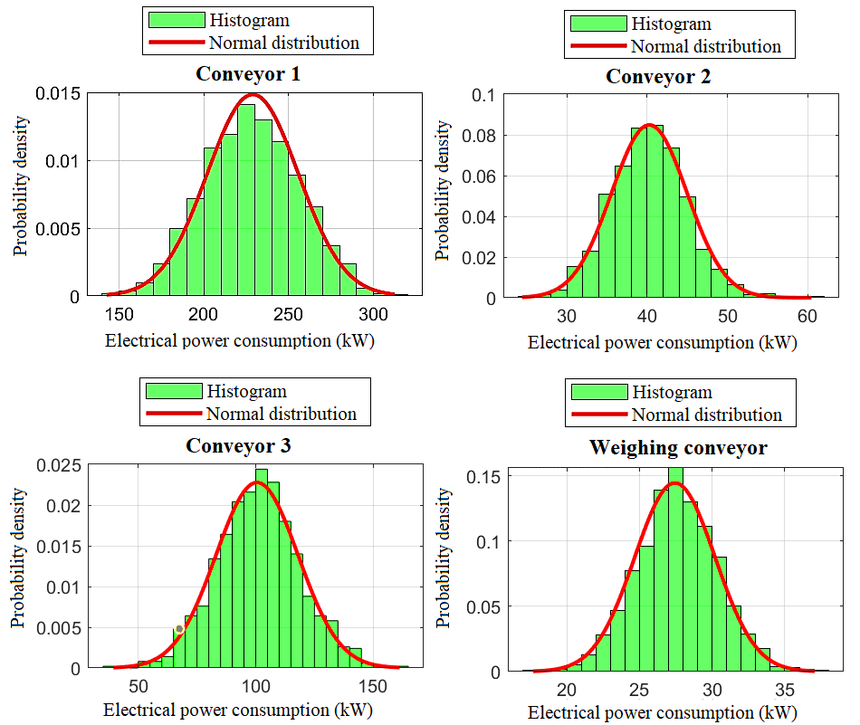
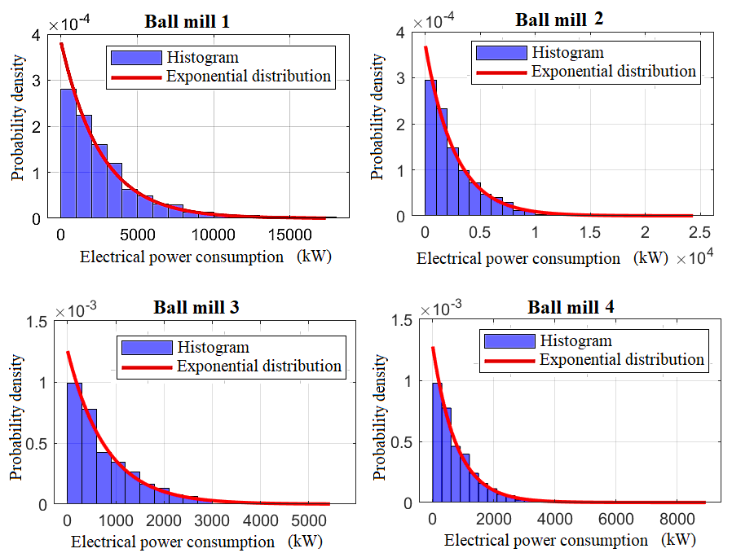

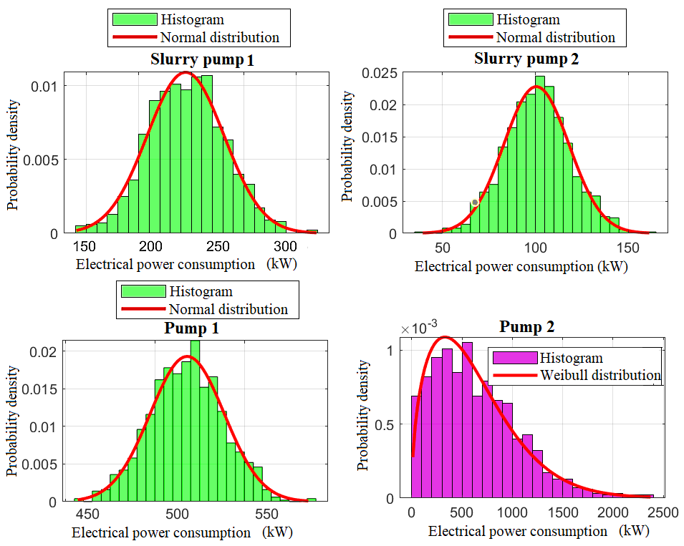
FIGURE 1. Histogram characteristics of the power consumption distribution of electricity consumers.
for conveyors; for ball mills; for pumps.
CONCLUSIONS
The graphs clearly show that the electricity consumption of conveyors and pumps 1–4 follows a normal distribution, indicating that the data is concentrated around the mean value. In the histograms, the bars are shown in green, while the distribution function is depicted in red. This demonstrates that these units operate with small fluctuations and maintain a stable operating mode.
The ball mills exhibit an exponential distribution, where the data tends to vary significantly and may display large deviations. Mills often show considerable changes during long-term operation, meaning that in some cases the power consumption may increase sharply; however, their probability density decreases rapidly.
The Weibull distribution is effective for pumps because it represents uncertainties related to operating time or system lifetime. Pumps typically operate steadily, and their probability density is high at the beginning and then gradually decreases.
The obtained distribution laws reliably describe the electrical load patterns of the active power consumption modes of the main technological equipment, machinery, and devices of the plant during ore processing.

REFERENCES
- Mukhtorkhon Ibadullayev; Shavkat Begmatov; Akram Tovbaev. Subharmonic resonance in three-phase ferroresonant circuits with common magnetic cores. AIP Conf. Proc. 3152, 050019 (2024) https://doi.org/10.1063/5.0218907
- Qarshibaev, A. I., Narzullaev, B. S., & Murodov, H. S. (2020, November). Models and methods of optimization of electricity consumption control in industrial enterprises. In Journal of Physics: Conference Series (Vol. 1679, No. 2, p. 022074). IOP Publishing. DOI 10.1088/1742-6596/1679/2/022074
- Eshmurodov, Z., & Abdullaev, S. (2024). Investigation of the methods of starting and braking in the “Frequency converter asynchronous motor” system. In E3S Web of Conferences (Vol. 548, p. 06013). EDP Sciences. https://doi.org/10.1051/e3sconf/202454806013
- Eshpulatov, N., Khalmuradov, T., Rakhimov, F., Abdurayimov, S., Khurramov, A., Ruziyeva, U., ... & Maftuna, I. (2023, March). Influence of the parameters of the impact of electrical impulses on the yield of juice from the pulp. In IOP Conference Series: Earth and Environmental Science (Vol. 1142, No. 1, p. 012006). IOP Publishing. DOI 10.1088/1755-1315/1142/1/012006
- Eshpulatov, N., Khalmuradov, T., Rakhimov, F., Abdurayimov, S., Khurramov, A., Mullajonov, I., & Vorisova, R. (2023, March). The influence of the impact of electrical impulses on the juice outputting of the pulp. In IOP Conference Series: Earth and Environmental Science (Vol. 1142, No. 1, p. 012017). IOP Publishing. DOI 10.1088/1755-1315/1142/1/012017
- Boboqulov J., Narzullayev B. Development of a model for diagnosing rotor conditions in the parallel connection of synchronous generators with the network // E3S Web of Conferences. – EDP Sciences, 2024. – Т. 525. – С. 06001. https://doi.org/10.1051/e3sconf/202452506001
- Khasan Murodov, Askarbek Karshibayev, and Shukhrat Abdullayev, Analysis of the process of balanced charging of the battery group with high capacity, E3S Web of Conferences 548, 03012 (2024) https://doi.org/10.1051/e3sconf/202454803012
- Muzaffar Xolmurodov., Shaxzod Hakimov., Umida Oripova, Improving energy efficiency in public buildings: Modern technologies and methods, AIP Conf. Proc. 3331, 040060 (2025) https://doi.org/10.1063/5.0306935
- Akram Tovbaev, Muxtarxan Ibadullayev and Mohinur Davronova. Study of subharmonic oscillation processes in ferroresonance circuits. E3S Web of Conf. Volume 525, 2024. IV International Conference on Geotechnology, Mining and Rational Use of Natural Resources (GEOTECH-2024). https://doi.org/10.1051/e3sconf/202452503008
- Asliddin Norqulov, Feruz Raximov, Methods for evaluating financial and economic effectiveness of investment projects in the energy sector with time factor considerations, AIP Conf. Proc. 3331, 030070-1–030070-6. https://doi.org/10.1063/5.0306104
- Shukhrat Abdullaev., Ziyodullo Eshmurodov., Islom Togaev, A systematic analysis of the gradual increase in quality indicators of electricity using reactive power sources involves several steps, AIP Conf. Proc. 3331, 040051 (2025). https://doi.org/10.1063/5.0306786
- Olimov, J. S., Fayziyev, S. S., Raximov, F. M., Majidov, A. U., & Muxammadov, B. Q. (2023). Controlling power of short circuited induction motor via modern sensors without speed change. In E3S Web of Conferences (Vol. 417, p. 03007). EDP Sciences. https://doi.org/10.1051/e3sconf/202341703007
- Tovboyev, A. N., Mardonov, D. S., Mamatazimov, A. X., & Samatova, S. S. (2021, November). Analysis of subharmonic oscillations in multi-phase ferroresonance circuits using a mathematical model. In Journal of Physics: Conference Series (Vol. 2094, No. 5, p. 052048). IOP Publishing. DOI 10.1088/1742-6596/2094/5/052048
- Nazirova, H., Nazirova, O., Toshxoʻjayeva, M., Badalova, D., & Ramazonov, B. (2025, November). Optimization of electricity loss forecasting using ANN. In AIP Conference Proceedings (Vol. 3331, No. 1, p. 060027). AIP Publishing LLC. https://doi.org/10.1063/5.0305944
- Shaymamov, B., Rahmatov, D., Kholnurodov, M., Mukhtorov, A., & Rakhmamova, M. (2020, December). Probe of process of multiple-loop chains of parallel and consecutive joints. In E3S Web of Conferences (Vol. 216, p. 01142). https://doi.org/10.1051/e3sconf/202021601142
- I.Togayev, A.Tovbaev, G. Nodirov, Assessment of the quality of electricity by applying reactive power sources, E3S Web of Conferences, 525, 03004 (2024) https://doi.org/10.1051/e3sconf/202452503004
- G.Boynazarov, A. Tovbaev, U. Usarov, Methology of experimental research of voltage quality in electrical circuit, E3S Web of Conferences 548, 03009 (2024) https://doi.org/10.1051/e3sconf/202454803009
- N.Ataullayev, A.Norqulov, B.Muxammadov, A.Majidov, I.Tog’ayev. Principles of protection against single phase earth faults in networks with capacitive current compensation. E3S Web of Conferences, 548, 06008 (2024). https://doi.org/10.1051/e3sconf/202454806008
- Jumayev, Z.I., Karshibayev, A.I., Sayidov, M.K., & Shirinov, S.G. Analysis of climate-meteorological and technological factors affecting electricity consumption of mining enterprises. Vibroengineering Procedia, Vol. 54, pp. 293-299 (Apr. 4 2024). https://doi.org/10.21595/vp.2024.24047
- Murodov K., Karshibayev A. Development of the management system of technical indications of high-power charger-discharger rectifier device //E3S Web of Conferences. – EDP Sciences, 2023. – Т. 417. – С. 03012. https://doi.org/10.1051/e3sconf/202341703012
- Ataullaev N. O., Dziaruhina A. A., Murodov K. S. Static Characteristics of Magnetic Modulation DC Converters with Analog Filter // Science and technology. – 2023. – Т. 22. – №. 5. – С. 428-432. https://doi.org/10.21122/2227-1031-2023-22-5-428-432
- Ikromjon Rakhmonov; Zamira Shayumova; Kamal Reymov; Laziz Nematov Energy efficiency indicators // AIP Conf. Proc. 3152, 020002 (2024) https://doi.org/10.1063/5.0218763
- Dinora Jalilova; Gulnora Kasimova; Zamira Shayumova; Gulmira Abidova Current status of ensuring power quality in spinning mills // AIP Conf. Proc. 3331, 070021 (2025) https://doi.org/10.1063/5.0306211
- O.O. Zaripov, S.J. Nimatov, Y.M. Yeralieva, S.O. Zaripova, M.A. Zakirov, D.M. Nomozova, J.T. Akhmedov, Akram Tovbaev. Calculation of the nominal power and еlectrical еnergy of the hydro power plant on an еlectronic calculator. E3S Web Conf. Volume 486, 2024. IX International Conference on Advanced Agritechnologies, Environmental Engineering and Sustainable Development (AGRITECH-IX 2023). https://doi.org/10.1051/e3sconf/202448601027
- Urishev, B., and Fakhriddin Nosirov. 2025. “Hydraulic Energy Storage of Wind Power Plants.” Proceedings of the International Conference on Applied Innovation in IT.
- Mukhammadiev, M., K. Dzhuraev, and Fakhriddin Nosirov. 2025. “Prospects for the Development of the Use of Pumped Storage Power Plants in the Energy System of the Republic of Uzbekistan.” Proceedings of the International Conference on Applied Innovation in IT.
- Urishev, B., Fakhriddin Nosirov, and N. Ruzikulova. 2023. “Hydraulic Energy Storage of Wind Power Plants.” E3S Web of Conferences, 383. https://doi.org/10.1051/e3sconf/202338304052
- Urishev, B., S. Eshev, Fakhriddin Nosirov, and U. Kuvatov. 2024. “A Device for Reducing the Siltation of the Front Chamber of the Pumping Station in Irrigation Systems.” E3S Web of Conferences, 274. https://doi.org/10.1051/e3sconf/202127403001
- Turabdjanov, S., Sh. Dungboyev, Fakhriddin Nosirov, A. Juraev, and I. Karabaev. 2021. “Application of a Two-Axle Synchronous Generator Excitations in Small Hydropower Engineering and Wind Power Plants.” AIP Conference Proceedings. https://doi.org/10.1063/5.0130649
- Urishev, B., Fakhriddin Nosirov, Obid Nurmatov, S. Amirov, and D. Urishova. 2021. “Local Energy System Based on Thermal, Photovoltaic, Hydroelectric Stations and Energy Storage System.” AIP Conference Proceedings. https://doi.org/10.1063/5.0306446
- Nurmatov, Obid, Fakhriddin Nosirov, Khusniddin Shamsutdinov, and Dildora Obidjonova. 2025. “Research on Control Systems for Automatic Excitation Regulation Utilizing Fuzzy Logic Methodology.” AIP Conference Proceedings. https://doi.org/10.1063/5.0306119
- Nurmatov O. Large pumping stations as regulators of power systems modes. Rudenko International Conference “Methodological problems in reliability study of large energy systems” (RSES 2020), E3S Web of Conferences 216, 01098(2020) https://doi.org/10.1051/e3sconf/202021601098
- Nurmatov O., Makhmudov T.: Pulatov N. Сontrol of the excitation system of synchronous motors pumping stations //AIP Conference Proceedings, 3152, 040008 (2024) https://doi.org/10.1063/5.0218781
- Nurmatov O., Nosirov F., Shamsutdinov K., Obidjonova D.Research on control systems for automatic excitation regulation utilizing fuzzy logic methodology. AIP Conference Proceedings AIP Conf. Proc. 3331, 040081 (2025) https://doi.org/10.1063/5.0306119
- Makhmudov T.: Nurmatov O., Ramatov A.N., Site Selection for Solar Photovoltaic Power Plants Using GIS and Remote Sensing Techniques//AIP Conference Proceedings, 3152, 060002 (2024) https://doi.org/10.1063/5.0218779
- Urishev B., Nosirov F., Nurmatov O., Amirov Sh.,Urishova D. Local energy system based on thermal, photovoltaic, hydroelectric stations and energy storage system AIP Conf. Proc. 3331, 070015 (2025) https://doi.org/10.1063/5.0306446
- Rismukhamedov D., Shamsutdinov K., Magdiev K., Peysenov M., Nurmatov O. Construction of pole-switchable windings for two-speed motors of mechanisms with a stress operating modeAIP Conference Proceedings AIP Conf. Proc. 3331, 040059 (2025) https://doi.org/10.1063/5.0305963
- Rabatuly M., Myrzathan S.A., Toshov J.B., Nasimov J., Khamzaev A. Views on drilling effectiveness and sampling estimation for solid ore minerals. Комплексное Использование Минерального Сырья. №1(336), 2026. https://doi.org/10.31643/2026/6445.01
- Toshov J.B., Rabatuly M., Khaydarov Sh., Kenetayeva A.A., Khamzayev A., Usmonov M., Zheldikbayeva A.T. Methods for Analysis and Improvement of Dynamic Loads on the Steel Wire Rope Holding the Boom of Steel Wire Rope Excavators. Kompleksnoe Ispolzovanie Mineralnogo Syra = Complex Use of Mineral Resources 2026; 339(4):87-96 https://doi.org/10.31643/2026/6445.43
- Zokhidov O.U., Khoshimov O.O., Khalilov Sh.Sh. Experimental analysis of microges installation for existing water flows in industrial plants. III International Conference on Improving Energy Efficiency, Environmental Safety and Sustainable Development in Agriculture (EESTE2023), E3S Web of Conferences. Том 463. Страницы 02023. 2023. https://doi.org/10.1051/e3sconf/202346302023
- Zokhidov O.U., Khoshimov O.O., Sunnatov S.Z. Selection of the type and design of special water turbines based on the nominal parameters of Navoi mine metallurgical combine engineering structures. AIP Conf. Proc. 3331, 050022 (2025). https://doi.org/10.1063/5.0306554
- Khamzaev A.A., Mambetsheripova A., Arislanbek N. Thyristor-based control for high-power and high-voltage synchronous electric drives in ball mill operations/ E3S Web Conf. Volume 498, 2024/ III International Conference on Actual Problems of the Energy Complex: Mining, Production, Transmission, Processing and Environmental Protection (ICAPE2024) DOI: https://doi.org/10.1051/e3sconf/202449801011
- Toshov B.R., Khamzaev A.A. Development of Technical Solutions for the Improvement of the Smooth Starting Method of High Voltage and Powerful Asynchronous Motors/AIP Conference Proceedings 2552, 040018 (2023); https://doi.org/10.1063/5.0116131 Volume 2552, Issue 1; 5 January 2023
- Toshov B.R., Khamzaev A.A., Sadovnikov M.E., Rakhmatov B., Abdurakhmanov U./ Automation measures for mine fan installations/ SPIE 12986, Third International Scientific and Practical Symposium on Materials Science and Technology (MST-III 2023), 129860R (19 January 2024); doi: 10.1117/12.3017728. Third International Scientific and Practical Symposium on Materials Science and Technology (MST-III 2023), 2023, Dushanbe, Tajikistan.
- Toshov B.R., Khamzaev A.A., Namozova Sh.R.Development of a circuit for automatic control of an electric ball mill drive. AIP Conference Proceedings 2552, 040017 (2023) Volume 2552, Issue 1; 5 January 2023.
- Toirov, O., Pirmatov, N., Khalbutaeva, A., Jumaeva, D., Khamzaev, A. Method of calculation of the magnetic induction of the stator winding of a spiritual synchronous motor. E3S Web of ConferencesЭта ссылка отключена., 2023, 401, 04033
- O. Toirov, A. Khalbutaeva, Z. Toirov. Calculation of the magnetic flux with considering nonlinearities of saturation of the magnetic circuit of synchronous motors, // 3rd International Scientific and Technical Conference on Actual Issues of Power Supply Systems, ICAIPSS 040022, (2023). https://doi.org/10.1063/5.0218821
- O. Toirov, S. Khalikov. Research and Evaluation of the Reliability Indicators of Pumping Units for Mechanical Irrigation of the Pumping Station “Kyzyl-Tepa”, // Power Technology and Engineering, 57 (5), (2024). https://doi.org/10.1007/s10749-024-01720-2
- O. Toirov, M. Taniev, B. Safarov, Z. Toirov. Simulation model of an asynchronous generator integrated with a power supply system at different wind speeds, // AIP Conference Proceedings, 3331 (1), 060025, (2025). https://doi.org/10.1063/5.0305672
- O. Toirov, Sh. Azimov, Z. Toirov. Improving the cooling system of reactive power compensation devices used in railway power supply // AIP Conference Proceedings, 3331, 1, 050030, (2025). https://doi.org/10.1063/5.0305670
- O. Toirov, W. Yu. Non-Intrusive Load Monitoring Based on Image Load Signatures and Continual Learning
// Proceedings of 2025 2nd International Conference on Digital Society and Artificial Intelligence, (2025) https://doi.org/10.10.1145/3748825.3748963
- O. Toirov, Sh. Azimov, Z. Najmitdinov, M. Sharipov, Z. Toirov. Improvement of the cooling system of reactive power compensating devices used in railway power supply // E3S Web of Conferences, 497, 01015, (2024). https://doi.org/10.1051/e3sconf/202449701015
- Melikuziev M.V. Determination of the service area and location of transformer substations in the city power supply system. E3S Web of Conferences 384, 01033 (2023) RSES 2022. https://doi.org/10.1051/e3sconf/202338401033
- Melikuziev M.V., Usmonaliev S., Khudoyberdiev N., Sodikov J., Imomaliev Z. Issues of the design procedure for the power supply system. AIP Conference Proceedings 3152, 040031 (2024). https://doi.org/10.1063/5.0218873

