Analysis of methods for increasing the reliability of power supply systems for lighting and automation devices in mines
Murodov Khasan^{1,a)}, Mingboyev Uchqun², Asliddin Norqulov¹, Botir Muradov³
¹ Navoi State Mining and Technologies University, Navoi, Uzbekistan
² UZERAEALTERNATOR Limited Liability Company, Navoi, Uzbekistan
³ Tashkent state technical university named after Islam Karimov, Tashkent, Uzbekistan
^{a)} Corresponding author: murodov.xasan@inbox.ru
Abstract. This article analyzes modern approaches aimed at increasing the reliability of power supply systems for lighting and automation devices in mines. In mine conditions, it is important to ensure the uninterrupted operation of lighting and automatic control systems and the stable operation of the production process. The study shows that the overall stability of the system increases significantly when using backup energy sources and automatic reconnection systems. Also, the stability indicators of the power supply system are analyzed in depth using the Mikhailov and Nyquist criteria. The results show that the integration of power supply with digital monitoring methods expands the possibility of early detection of accidents, and the introduction of backup and automated control measures can increase the reliability of the system. This approach is considered a promising and effective solution for high-risk technological processes in mines.
INTRODUCTION
Over the past decade, increasing the reliability of power supply systems for lighting and automation devices in mines has become of great importance and plays a significant role in ensuring the continuity of energy supply in many mines; at the same time, the efficiency and stability of the system are significantly increased by using installed power and backup sources. [1-6].

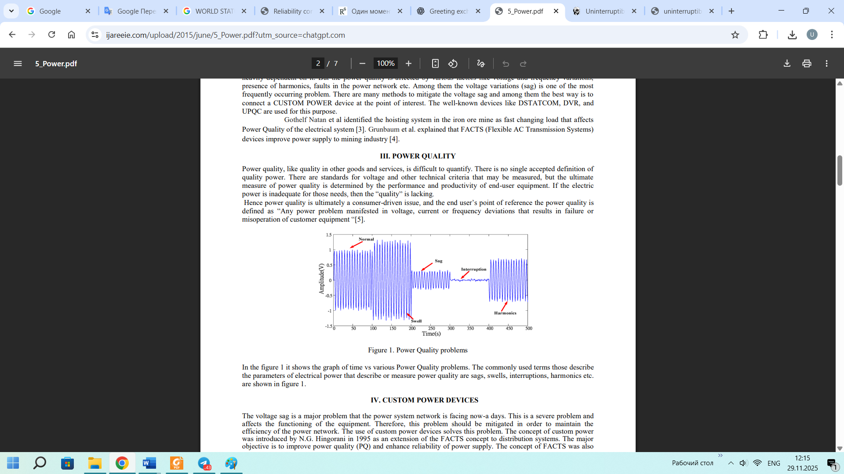FIGURE 1. Power Quality problems In the figure 1 it shows the graph of time vs various Power Quality problems. The commonly used terms those describe the parameters of electrical power that describe or measure power quality are sags, swells, interruptions, harmonics etc. are shown in figure 1.
Development of power supply for lighting and automation devices in mines. In 2025–2035, special attention will be paid to ensuring uninterrupted and reliable power supply for lighting and automation devices in mines. [7-10]. These projects will be implemented mainly at the expense of mining enterprises and investors. In order to increase the reliability of the power supply system in mines, it is planned to introduce backup sources, UPS systems and automated control tools. Through annual modernization and upgrades, stable operation of lighting and automation systems in mines will be guaranteed. [11-14].
EXPERIMENTAL RESEARCH
The uninterrupted operation of lighting systems and automation devices used in the mining industry is one of the main factors of production safety and labor productivity. These devices cannot operate without a reliable power supply, since in mining conditions, power outages or changes in parameters can lead to accidents, shutdowns of technological processes, and a threat to the lives of workers. Therefore, increasing the reliability of power supply systems in mines is one of the important scientific and practical directions of modern energy. The quality indicators of electricity - voltage stability, frequency and phase stability - ensure the normal operation of lighting and automation devices operating in mining conditions. GOST and other current standards impose strict requirements on the quality indicators of electricity. In mines, voltage drops or fluctuations can be observed due to frequent changes in loads, the length of cable routes, sudden changes in humidity and temperature. Compensation for these factors and the organization of stable supply are considered one of the main directions of increasing reliability. The uninterrupted operation of lighting systems and automation devices in mining conditions directly depends on the stability of the power supply system. Voltage fluctuations, frequency fluctuations or short-term interruptions lead to the cessation of technological processes and a decrease in safety. Therefore, stabilizing the quality indicators of electricity within the framework of regulatory requirements is one of the main tasks of the mining power system. Power supply systems used in mines are usually characterized by complex load dynamics, long cable routes, high humidity and environmental variability. These factors can cause voltage drops, fluctuations and accidents. Several technical solutions for power supply systems are used to eliminate these problems. [15-18].
The main areas of increasing the reliability of power supply are: Creating a stable power supply. Modernization of transformer stations, proper load distribution and optimization of protective devices increase the overall stability of the system. Voltage stabilization. Automatic voltage stabilizers, inverters and compensators quickly eliminate voltage fluctuations, ensuring uninterrupted operation of lighting and automation devices. Backup power sources. The main safety requirement of lighting and control systems is continuity. Therefore, batteries, diesel generators and UPS systems provide uninterrupted power to the main consumers in case of an emergency. Automatic reconnection and control systems. Intelligent systems that monitor electrical parameters (voltage, current, frequency) in real time detect faults, isolate and restore supply. A specific feature of the mine power supply is the need to compensate for instability caused by rain, gas, dust, vibration and high loads. Therefore, it is especially important to control voltage, frequency and phase changes for the stable operation of automation devices. By applying the above methods, it is possible to significantly increase the reliability of power supply for lighting and automation systems in mines. This ensures safety, uninterrupted continuation of technological processes and reduces the risk of accidents. [19-23].
RESEARCH RESULTS
Studies on ensuring reliable power supply of lighting and automation devices in mines show that existing power supply systems often operate unstable due to voltage drops, uneven load distribution, and severe conditions. To eliminate these problems, solutions were proposed aimed at real-time control of electricity quality indicators. [24-25,26,27]. During the study, a hybrid lighting and automation power supply model adapted to mine conditions was created. This model is based on an optimized combination of standard transformer points, backup power sources (UPS, battery packs), voltage stabilizers, and automatic disconnection devices. The advantage of the proposed hybrid system is that its technical indicators are more stable compared to existing alternative schemes, and changes in electrical parameters (voltage, frequency, phase asymmetry) are minimized. In addition, the voltage recovery time in lighting circuits is significantly reduced. Analyses have shown that the hybrid power supply system increases the uninterrupted operation of lighting and automation devices, reduces accidents, and ensures a high level of mine safety. [28-29,30].
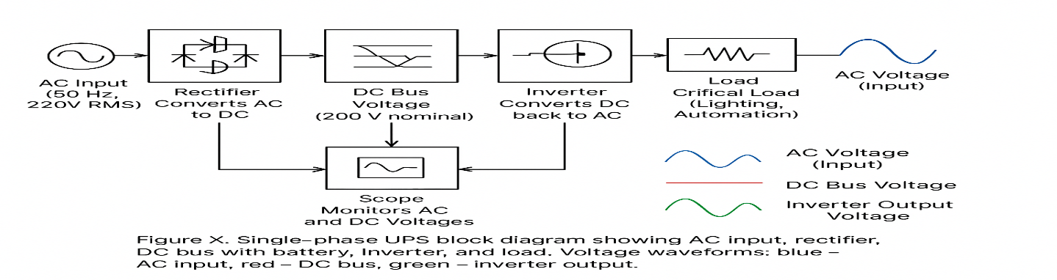
FIGURE 2. Single-phase UPS block diagram illustrating the AC input, rectifier, DC bus with battery, inverter, and load. Voltage waveforms: blue – AC input, red – DC bus, green – inverter output.

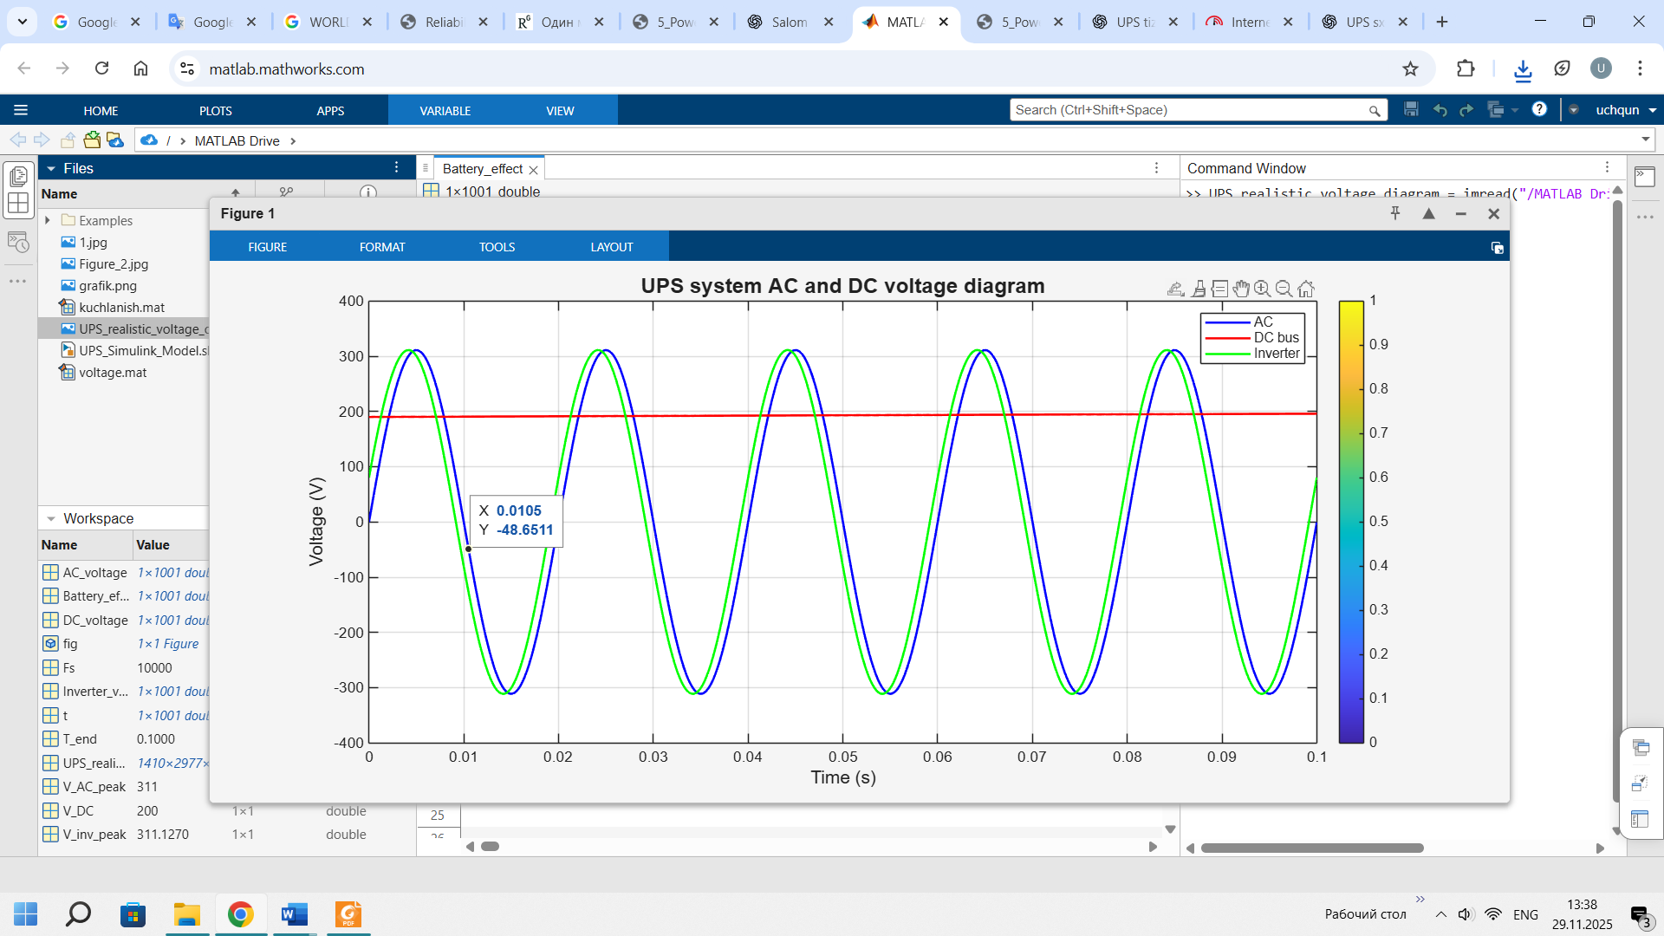
FIGURE 3. AC and DC Voltage Diagram of UPS System

The diagram provides a visual representation of how a UPS system works: AC input → Rectifier → DC bus + Battery → Inverter → Load. It clearly shows how the AC input, DC bus, and inverter output voltages change over time. This graph is used to analyze the performance and voltage stability of a UPS system. [31-34].Electrical data has been collected from GDK-10A underground mine and based on the data collected, power system model has been developed in MATLAB / SIMULINK. The simulations are performed for the cases: (i) without compensation and (ii) with compensation. The system performance is analyzed. These cases are summarized below: [35-36].
Case (1): Without compensation Model has been simulated for one second and load 1 (375 KW) is switched on between 0.3 to 0.5 sec and load 2 (250KW) is switched on between 0 to 1 sec. After switching ON the load, the voltage was falling down and decreased to a certain level. Simulation results are shown in Figure 4. The Total Harmonic Distortion (THD) without compensation observed is 28 % at 50 Hz fundamental frequency which is high.

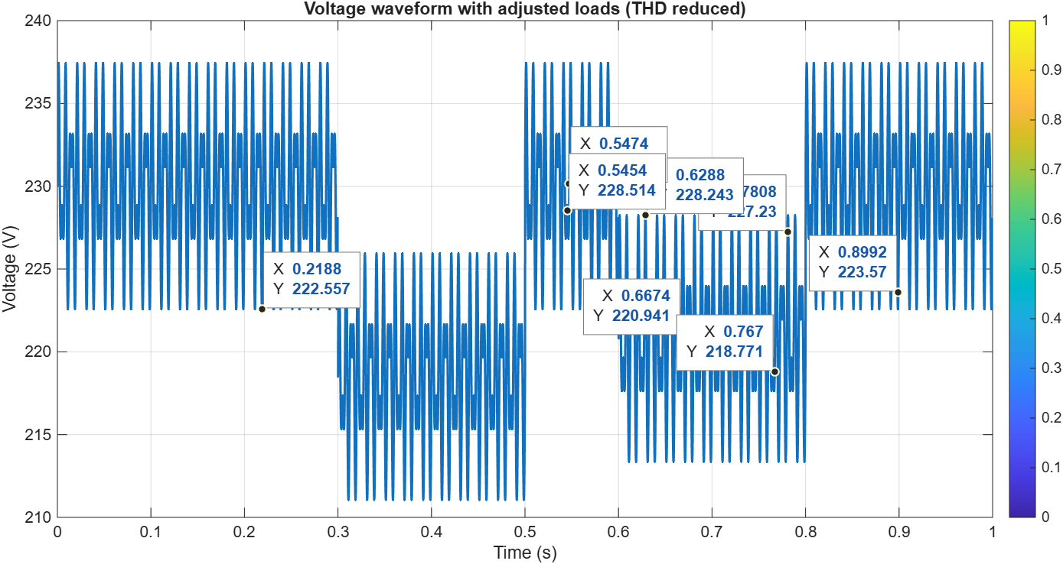
FIGURE 4. Load voltage Magnitude
CONCLUSIONS

As can be seen from the above analysis, the stable operation of lighting and automation devices in mines is directly dependent on the reliability of the power supply system. The changing requirements of various loads and electrical devices can lead to voltage drops in the system, the appearance of harmonics, and additional losses [37-66].
The results of the analysis show that the following methods are effective for increasing the reliability of power supply systems:
1. Reducing voltage drops in the system through time monitoring of loads and dynamic control.
2. Improving the quality of operation of lighting and automation devices by reducing harmonics and using filters, reducing torque pulses.
3. Ensuring uninterrupted operation of the system during any malfunction by introducing backup (reserve) power sources.
4. Optimizing transformer and cable networks, as well as reducing losses by using high-quality windings and cables. 5. Predicting and optimizing system operation under different load conditions through energy monitoring and simulation systems.
Methods used in this way make it possible to increase the stability of lighting and automation systems in mines, improve energy quality, and increase their resilience to emergency situations.
REFERENCES

- Boboqulov J., Narzullayev B. Development of a model for diagnosing rotor conditions in the parallel connection of synchronous generators with the network // E3S Web of Conferences. – EDP Sciences, 2024. – Т. 525. – С. 06001. https://doi.org/10.1051/e3sconf/202452506001
- Tursunova A. et al. Researching localization of vertical axis wind generators //E3S Web of Conferences. – EDP Sciences, 2023. – Т. 417. – С. 03005. https://doi.org/10.1051/e3sconf/202341703005
- Bakhodir Ramazonov, Shakhzodbek Sayfiev, Khasan Muradov, Mathematical modeling and research of high capacity lead-acid stabilized accumulator battery, AIP Conf. Proc. 3268, 020043 (2025) https://doi.org/10.1063/5.0257860
- Khasan Murodov, Askarbek Karshibayev, and Shukhrat Abdullayev, Analysis of the process of balanced charging of the battery group with high capacity, E3S Web of Conferences 548, 03012 (2024) https://doi.org/10.1051/e3sconf/202454803012
- Muzaffar Xolmurodov., Shaxzod Hakimov., Umida Oripova, Improving energy efficiency in public buildings: Modern technologies and methods, AIP Conf. Proc. 3331, 040060 (2025) https://doi.org/10.1063/5.0306935
- Shirinov S.G., J.S. Olimov, I.Z. Jumayev, M.K. Sayidov Analysis of patterns of electricity consumption in mining and processing enterprises. Vibroeng. Procedia 2024, 54, 308–313. https://doi.org/10.21595/vp.2024.24073
- Jumayev, Z.I., Karshibayev, A.I., Sayidov, M.K., & Shirinov, S.G. Analysis of climate-meteorological and technological factors affecting electricity consumption of mining enterprises. Vibroengineering Procedia, Vol. 54, pp. 293-299 (Apr. 4 2024). https://doi.org/10.21595/vp.2024.24047
- O.O. Zaripov, S.J. Nimatov, Y.M. Yeralieva, S.O. Zaripova, M.A. Zakirov, D.M. Nomozova, J.T. Akhmedov, Akram Tovbaev. Calculation of the nominal power and еlectrical еnergy of the hydro power plant on an еlectronic calculator. E3S Web Conf. Volume 486, 2024. IX International Conference on Advanced Agritechnologies, Environmental Engineering and Sustainable Development (AGRITECH-IX 2023). https://doi.org/10.1051/e3sconf/202448601027
- Akram Tovbaev, Muxtarxan Ibadullayev and Mohinur Davronova. Study of subharmonic oscillation processes in ferroresonance circuits. E3S Web of Conf. Volume 525, 2024. IV International Conference on Geotechnology, Mining and Rational Use of Natural Resources (GEOTECH-2024). https://doi.org/10.1051/e3sconf/202452503008
- Narzullayev B. S., Eshmirzaev M. A, Causes of the appearance of current waves in high voltage electric arc furnaces, and methods of their reduction, E3S Web of Conferences. – EDP Sciences, 2023. – Т. 417. – С. 03003. https://doi.org/10.1051/e3sconf/202341703003
- Akram Tovbaev., Islom Togaev., Uktam Usarov.,Gulom Nodirov, Reactive power compensation helps maintain a stable voltage profile across the network, AIP Conf. Proc. 3331, 060014 (2025). https://doi.org/10.1063/5.0307209
- Asliddin Norqulov, Feruz Raximov, Methods for evaluating financial and economic effectiveness of investment projects in the energy sector with time factor considerations, AIP Conf. Proc. 3331, 030070-1–030070-6. https://doi.org/10.1063/5.0306104
- Turdibekov K. et al. Experimental and statistical methods for studying the modes of electric power systems under conditions of uncertainty //E3S Web of Conferences. – EDP Sciences, 2023. – Т. 452. – С. 04002. https://doi.org/10.1051/e3sconf/202345204002
- Bobur Narzullayev; Javokhir Boboqulov, Improving reliability based on diagnostics of the technical condition of electric motor stator gutters, AIP Conf. Proc. 3331, 030032 (2025). https://doi.org/10.1063/5.0305735
- Abdurakhim Taslimov., Feruz Raximov., Farrukh Rakhimov., Iles Bakhadirov, Optimal parameters and selection criteria for neutral grounding resistors in 20 kv electrical networks, AIP Conf. Proc. 3331, 030048 (2025) https://doi.org/10.1063/5.0306108
- Sulton Amirov, Aminjon Ataullayev, Sine-cosine rotating transformers in zenith angle converters, E3S Web of Conferences 525, 03010 (2024) GEOTECH-2024, https://doi.org/10.1051/e3sconf/202452503010
- Sultan F. Amirov, Nodir O. Ataullayev, Amin O. Ataullayev, Bobur Q. Muxammadov, and Ahror U. Majidov, Methods for reducing the temperature components of magnetomodulation DC convertors errors, E3S Web of Conferences 417, 03011 (2023) GEOTECH-2023 https://doi.org/10.1051/e3sconf/202341703011
- Raximov, F., Taslimov, A., Majidov, A., & Norqulov, A. (2024). Optimization of losses by switching to higher voltage in distribution networks. In E3S Web of Conferences (Vol. 525, p. 03009). EDP Sciences. https://doi.org/10.1051/e3sconf/202452503009
- A.Tovboyev, I.Togayev, I.Uzoqov, G. Nodirov, Use of reactive power sources in improving the quality of electricity, E3S Web of Conferences 417, 03001 (2023) https://doi.org/10.1051/e3sconf/202341703001
- I.Togayev, A.Tovbaev, G. Nodirov, Assessment of the quality of electricity by applying reactive power sources, E3S Web of Conferences, 525, 03004 (2024) https://doi.org/10.1051/e3sconf/202452503004
- G.Boynazarov, A. Tovbaev, U. Usarov, Methology of experimental research of voltage quality in electrical circuit, E3S Web of Conferences 548, 03009 (2024) https://doi.org/10.1051/e3sconf/202454803009
- O.Jumaev, M. Ismoilov, D. Rahmatov, A. Qalandarov, Enhancing abrasion resistance testing for linoleum and rubber products: A proposal for improved device operation, E3S Web of Conferences 525, 05012 (2024) https://doi.org/10.1051/e3sconf/202452505012
- Ataullayev N.O., Muxammadov B.Q., Idieva A.A., Research of dynamic characteristics of magnetic modulation current converter with negative feedback // International Journal of Advanced Research in Science, Engineering and Technology, India, 2020, November, Vol. 7, Issue 11. – P. 15749-15752. http://www.ijarset.com/volume-7-issue-11.html?utm_source=chatgpt.com
- N.Ataullayev, A.Norqulov, B.Muxammadov, A.Majidov, I.Tog’ayev. Principles of protection against single phase earth faults in networks with capacitive current compensation. E3S Web of Conferences, 548, 06008 (2024). https://doi.org/10.1051/e3sconf/202454806008
- Shirinov S.G., J.S. Olimov, I.Z. Jumayev, M.K. Sayidov Analysis of patterns of electricity consumption in mining and processing enterprises. Vibroeng. Procedia 2024, 54, 308–313. https://doi.org/10.21595/vp.2024.24073
- Jumayev, Z.I., Karshibayev, A.I., Sayidov, M.K., & Shirinov, S.G. Analysis of climate-meteorological and technological factors affecting electricity consumption of mining enterprises. Vibroengineering Procedia, Vol. 54, pp. 293-299 (Apr. 4 2024). https://doi.org/10.21595/vp.2024.24047
- Amirov S.F., Ataullayev N.O., Ataullayev A.O., Muxammadov A.O., Majidov B.Q., A.U. Methods for reducing the temperature components of magnetomodulation DC converter errors. E3S Web of Conferences, 417, 03011 (2023). https://doi.org/10.1051/e3sconf/202341703011
- Amirov S.F., Ataullayev A.O., Sayidov M.K., Togayev I.B. Methods of reduction of interference signals in electromagnetic conductors that measure fluid flow Journal of Physics: Conference Series, 2094(5), 052053 (2021) 10.1088/1742-6596/2094/5/052053
- Olimov J., Ramazonov B., Sayfiyev S. Increasing efficiency of induction motor by predictive control system //E3S Web of Conferences. – EDP Sciences, 2024. – Т. 525. – С. 03006. https://doi.org/10.1051/e3sconf/202452503006
- Murodov K., Karshibayev A. Development of the management system of technical indications of high-power charger-discharger rectifier device //E3S Web of Conferences. – EDP Sciences, 2023. – Т. 417. – С. 03012. https://doi.org/10.1051/e3sconf/202341703012
- Tatkeyeva G. et al. Experimental research of the developed method to determine the network insulation for ungrounded AC systems in laboratory conditions //2022 International Conference on Electrical, Computer and Energy Technologies (ICECET). – IEEE, 2022. – С. 1-4. 10.1109/ICECET55527.2022.9873012
- Ataullaev N. O., Dziaruhina A. A., Murodov K. S. Static Characteristics of Magnetic Modulation DC Converters with Analog Filter // Science and technology. – 2023. – Т. 22. – №. 5. – С. 428-432. https://doi.org/10.21122/2227-1031-2023-22-5-428-432
- Murodov K., Karshibayev A., Abdullayev S. Analysis of the process of balanced charging of the battery group with high capacity //E3S Web of Conferences. – EDP Sciences, 2024. – Т. 548. – С. 03012. https://doi.org/10.1051/e3sconf/202454803012
- Ikromjon Rakhmonov; Zamira Shayumova; Kamal Reymov; Laziz Nematov Energy efficiency indicators // AIP Conf. Proc. 3152, 020002 (2024) https://doi.org/10.1063/5.0218763
- Ikromjon Rakhmonov; Dinora Jalilova; Zamira Shayumova; Nargiza Karimova; Gulmira Abidova; Khurshida Khalikova Voltage regulation issues in spinning enterprises // AIP Conf. Proc. 3331, 080009 (2025) https://doi.org/10.1063/5.0306210
- Dinora Jalilova; Gulnora Kasimova; Zamira Shayumova; Gulmira Abidova Current status of ensuring power quality in spinning mills // AIP Conf. Proc. 3331, 070021 (2025) https://doi.org/10.1063/5.0306211
- Urishev, B., and Fakhriddin Nosirov. 2025. “Hydraulic Energy Storage of Wind Power Plants.” Proceedings of the International Conference on Applied Innovation in IT.
- Mukhammadiev, M., K. Dzhuraev, and Fakhriddin Nosirov. 2025. “Prospects for the Development of the Use of Pumped Storage Power Plants in the Energy System of the Republic of Uzbekistan.” Proceedings of the International Conference on Applied Innovation in IT.
- Urishev, B., Fakhriddin Nosirov, and N. Ruzikulova. 2023. “Hydraulic Energy Storage of Wind Power Plants.” E3S Web of Conferences, 383. https://doi.org/10.1051/e3sconf/202338304052
- Urishev, B., S. Eshev, Fakhriddin Nosirov, and U. Kuvatov. 2024. “A Device for Reducing the Siltation of the Front Chamber of the Pumping Station in Irrigation Systems.” E3S Web of Conferences, 274. https://doi.org/10.1051/e3sconf/202127403001
- Turabdjanov, S., Sh. Dungboyev, Fakhriddin Nosirov, A. Juraev, and I. Karabaev. 2021. “Application of a Two-Axle Synchronous Generator Excitations in Small Hydropower Engineering and Wind Power Plants.” AIP Conference Proceedings. https://doi.org/10.1063/5.0130649
- Urishev, B., Fakhriddin Nosirov, Obid Nurmatov, S. Amirov, and D. Urishova. 2021. “Local Energy System Based on Thermal, Photovoltaic, Hydroelectric Stations and Energy Storage System.” AIP Conference Proceedings. https://doi.org/10.1063/5.0306446
- Nurmatov, Obid, Fakhriddin Nosirov, Khusniddin Shamsutdinov, and Dildora Obidjonova. 2025. “Research on Control Systems for Automatic Excitation Regulation Utilizing Fuzzy Logic Methodology.” AIP Conference Proceedings. https://doi.org/10.1063/5.0306119
- Nurmatov O. Large pumping stations as regulators of power systems modes. Rudenko International Conference “Methodological problems in reliability study of large energy systems” (RSES 2020), E3S Web of Conferences 216, 01098(2020) https://doi.org/10.1051/e3sconf/202021601098
- Nurmatov O., Makhmudov T.: Pulatov N. Сontrol of the excitation system of synchronous motors pumping stations //AIP Conference Proceedings, 3152, 040008 (2024) https://doi.org/10.1063/5.0218781
- Nurmatov O., Nosirov F., Shamsutdinov K., Obidjonova D.Research on control systems for automatic excitation regulation utilizing fuzzy logic methodology. AIP Conference Proceedings AIP Conf. Proc. 3331, 040081 (2025) https://doi.org/10.1063/5.0306119
- Makhmudov T.: Nurmatov O., Ramatov A.N., Site Selection for Solar Photovoltaic Power Plants Using GIS and Remote Sensing Techniques//AIP Conference Proceedings, 3152, 060002 (2024) https://doi.org/10.1063/5.0218779
- Urishev B., Nosirov F., Nurmatov O., Amirov Sh.,Urishova D. Local energy system based on thermal, photovoltaic, hydroelectric stations and energy storage system AIP Conf. Proc. 3331, 070015 (2025) https://doi.org/10.1063/5.0306446
- Rismukhamedov D., Shamsutdinov K., Magdiev K., Peysenov M., Nurmatov O. Construction of pole-switchable windings for two-speed motors of mechanisms with a stress operating modeAIP Conference Proceedings AIP Conf. Proc. 3331, 040059 (2025) https://doi.org/10.1063/5.0305963
- Rabatuly M., Myrzathan S.A., Toshov J.B., Nasimov J., Khamzaev A. Views on drilling effectiveness and sampling estimation for solid ore minerals. Комплексное Использование Минерального Сырья. №1(336), 2026. https://doi.org/10.31643/2026/6445.01
- Toshov J.B., Rabatuly M., Khaydarov Sh., Kenetayeva A.A., Khamzayev A., Usmonov M., Zheldikbayeva A.T. Methods for Analysis and Improvement of Dynamic Loads on the Steel Wire Rope Holding the Boom of Steel Wire Rope Excavators. Kompleksnoe Ispolzovanie Mineralnogo Syra = Complex Use of Mineral Resources 2026; 339(4):87-96 https://doi.org/10.31643/2026/6445.43
- Zokhidov O.U., Khoshimov O.O., Khalilov Sh.Sh. Experimental analysis of microges installation for existing water flows in industrial plants. III International Conference on Improving Energy Efficiency, Environmental Safety and Sustainable Development in Agriculture (EESTE2023), E3S Web of Conferences. Том 463. Страницы 02023. 2023. https://doi.org/10.1051/e3sconf/202346302023
- Zokhidov O.U., Khoshimov O.O., Sunnatov S.Z. Selection of the type and design of special water turbines based on the nominal parameters of Navoi mine metallurgical combine engineering structures. AIP Conf. Proc. 3331, 050022 (2025). https://doi.org/10.1063/5.0306554
- Khamzaev A.A., Mambetsheripova A., Arislanbek N. Thyristor-based control for high-power and high-voltage synchronous electric drives in ball mill operations/ E3S Web Conf. Volume 498, 2024/ III International Conference on Actual Problems of the Energy Complex: Mining, Production, Transmission, Processing and Environmental Protection (ICAPE2024) DOI: https://doi.org/10.1051/e3sconf/202449801011
- Toshov B.R., Khamzaev A.A. Development of Technical Solutions for the Improvement of the Smooth Starting Method of High Voltage and Powerful Asynchronous Motors/AIP Conference Proceedings 2552, 040018 (2023); https://doi.org/10.1063/5.0116131 Volume 2552, Issue 1; 5 January 2023
- Toshov B.R., Khamzaev A.A., Sadovnikov M.E., Rakhmatov B., Abdurakhmanov U./ Automation measures for mine fan installations/ SPIE 12986, Third International Scientific and Practical Symposium on Materials Science and Technology (MST-III 2023), 129860R (19 January 2024); doi: 10.1117/12.3017728. Third International Scientific and Practical Symposium on Materials Science and Technology (MST-III 2023), 2023, Dushanbe, Tajikistan.
- Toshov B.R., Khamzaev A.A., Namozova Sh.R.Development of a circuit for automatic control of an electric ball mill drive. AIP Conference Proceedings 2552, 040017 (2023) Volume 2552, Issue 1; 5 January 2023.
- Toirov, O., Pirmatov, N., Khalbutaeva, A., Jumaeva, D., Khamzaev, A. Method of calculation of the magnetic induction of the stator winding of a spiritual synchronous motor. E3S Web of ConferencesЭта ссылка отключена., 2023, 401, 04033
- O. Toirov, A. Khalbutaeva, Z. Toirov. Calculation of the magnetic flux with considering nonlinearities of saturation of the magnetic circuit of synchronous motors, // 3rd International Scientific and Technical Conference on Actual Issues of Power Supply Systems, ICAIPSS 040022, (2023). https://doi.org/10.1063/5.0218821
- O. Toirov, S. Khalikov. Research and Evaluation of the Reliability Indicators of Pumping Units for Mechanical Irrigation of the Pumping Station “Kyzyl-Tepa”, // Power Technology and Engineering, 57 (5), (2024). https://doi.org/10.1007/s10749-024-01720-2
- O. Toirov, M. Taniev, B. Safarov, Z. Toirov. Simulation model of an asynchronous generator integrated with a power supply system at different wind speeds, // AIP Conference Proceedings, 3331 (1), 060025, (2025). https://doi.org/10.1063/5.0305672
- O. Toirov, Sh. Azimov, Z. Toirov. Improving the cooling system of reactive power compensation devices used in railway power supply // AIP Conference Proceedings, 3331, 1, 050030, (2025). https://doi.org/10.1063/5.0305670
- O. Toirov, W. Yu. Non-Intrusive Load Monitoring Based on Image Load Signatures and Continual Learning
// Proceedings of 2025 2nd International Conference on Digital Society and Artificial Intelligence, (2025) https://doi.org/10.10.1145/3748825.3748963
- O. Toirov, Sh. Azimov, Z. Najmitdinov, M. Sharipov, Z. Toirov. Improvement of the cooling system of reactive power compensating devices used in railway power supply // E3S Web of Conferences, 497, 01015, (2024). https://doi.org/10.1051/e3sconf/202449701015
- Melikuziev M.V. Determination of the service area and location of transformer substations in the city power supply system. E3S Web of Conferences 384, 01033 (2023) RSES 2022. https://doi.org/10.1051/e3sconf/202338401033
- Melikuziev M.V., Usmonaliev S., Khudoyberdiev N., Sodikov J., Imomaliev Z. Issues of the design procedure for the power supply system. AIP Conference Proceedings 3152, 040031 (2024). https://doi.org/10.1063/5.0218873

