Analysis of thyristors in the excitation system of synchronous generators
Bobur Narzullayev¹, Javokhir Boboqulov^{1,a)}, Bakhodir Ramazonov¹, Botir Muradov ²
¹Navoi State University of Mining and Technologies, Navoi, Uzbekistan
² Tashkent state technical university named after Islam Karimov, Tashkent, Uzbekistan
^{a)} Corresponding author: javohirsaydullayevich96@mail.ru
Abstract. This article presents a scientific analysis of the electrical charactyristics of thyristors applied to the excitation system of synchronous generators located in thermal power plants. Scientific insights have been studied through key parameters of thyristors such as current and voltage charactistics, the state of pulses Fed to the control electrode, and their rate of change, additive processes, and temperature control of thyristors. It has also been experimentally studied the transient processes of thyristors, the state of blocking, the angle of opening, and their effect on the operating modes of the excitation system. As a result, it is possible to prevent the efficiency of the semiconductor thyristor excitation system, the stability of the dynamic stationary, the tolerance of voltage fluctuations, as well as their state in accident modes.as also been experimentally studied the transient processes of thyristors, the state of blocking, the angle of opening, and their effect on the operating modes oors.
INTRODUCTION
Currently, the stable and uninterrupted operation of synchronous generators used in large-capacity thermal power plants and hydroelectric power plants in our country plays an important role in ensuring the reliability, efficiency of the entire power supply system. The excitation system from the main constructive elements of the synchronous generator is important in ensuring the automatic adjustment of the voltage of the generator, the control of reactive power and the stability of the electromagnetic field in the stator windings [1-6]. Therefore, in large power generators, the speed of the excitation system, the accuracy of operation, as well as the control system directly affect the control of the operating modes of the entire energobloc [7,8].
Today, thyristors made up of semiconductor elements are widely used in excitation systems, with conventional contact ring electric machine excitation devices fully replacing. The speed of thyristors at high switching, resistance to large currents and voltages, ease of control from the control electrode consists in applying them to modern fast automatic voltage adjuster systems. One of the widely used models of semiconductor thyristor excitation systems is the high-power thyristor brand T383-2500/32, which is characterized by conducting rectified currents up to 2500 A, withstands a blocking voltage of up to 3200 V, and high thermal stability.ne of the widely used models of semiconductor thyristor excitation systems is the high-power thirst [9-15].

EXPERIMENTAL RESEARCH
An urgent task is the deep study of the dynamic reaction of thyristors in conditions of transient processes occurring in synchronous generators, increased load, fluctuations in the symmetrical and symmetrical consumption of voltage, as well as in-depth study of the dynamic reaction of thyristors in the conditions of accident modes. The opening angle of thyristors is α, the delay in addition to subtraction, The Shape of the control pulses, the change in voltage and currents have a direct effect on the electromagnetic stability of the excitation system. Therefore, the study of the electrical, dynamic and thermal characteristics of large-power thyristors of brand T383-2500/32 is important not only theoretically, but also practically [16-18].
Figure 1 of the T383-2500/32 branded thyristors located in the thyristor excitation system of the synchronous generator provides a principled outline, showing the functional nodes of the common block, connection schemes and stamps of measuring devices [19-21].
FIGURE 1. Single-line principal diagram of thyristor excitation system T383-2500/32

Figure 1, shows the determination of the main parameters of thyristors, the analysis of their modes of operation. The circuit used a T383-2500/32 branded thyristor, with this thyristor being a low-frequency, tablet-view large-power semiconductor radio element shows the determination of the main parameters of thyristors, the analysis of their modes of operation [22,23]. The circuit used a T383-2500/32 branded thyristor, w.
Average nominal rectifier current of the thyristor:
$I_{n}=2500 \text{[}\text{A}$];
This value reliably controls the excitation current of the synchronous generator.
The voltage drop is calculated by the following expression:
$U_{n}=U_{p-n}+r_{T}I_{T} \left[V\right]$;
where: U_{p-n} - is the static representation of the p-n transition, r_{T} - is the internal resistance;
Waste of thyristors power;
$P_{t}=U_{t}I_{t}=U_{p-n}I_{T}+r_{T}I_{T}^{2} [Vt]$;
Here, the power loss expression allows for the calculation of the thermal regime and the selection of a cooling system (Table 1).
TABLE 1. Electrical parameters of the T383-2500/32 thyristor.
Average direct current |  |  | I_{TAV} | 2500 A
Repetitive pulse voltage in the closed state |  |  | U_{DRM} | 2200-3200 V
Repetitive pulsed reverse voltage |  |  | U_{RRM}
Shutdown time |  |  | T_{q} | 320, 400, 500 mks
U_{DRM}, U_{RRM}, V | 2200 | 2400 | 2600 | 2800 | 3000 | 3200
Voltage class | 22 | 24 | 26 | 28 | 30 | 32
T_{j}, ⁰C | -60÷125

In Table 1 of the above, thyristor quenching time by dynamic parameters is in the $T_{j}=320\text{-}500$ mks range, where an industrial frequency of 50-60 Hz can be achieved with sufficient acceleration in Phase control processes in three - phase rectifiers [24-28].
RESEARCH RESULTS
At a relatively small value compared to the delay in the switching process, the thyristor's automatic voltage allows accurate and smooth adjustment of the angle α controlled by the tuning device. This increases the stability of the synchronous generator voltage and reduces the increase in reactive power during transient processes.
T383-2500/32 branded thyristor:
- designed for high current and voltages;
- the width of the possibility of maintaining dynamic stagnation;
- thermal stability as well as the size of the working temperature range;
- stronger mechanical as well as more reliable for electrical effects.
This thyristor plays an important role in ensuring the dynamic stability of the generator, the sensitivity of the voltage adjuster, as well as the continuous operation of the entire excitation system (Figure 2).
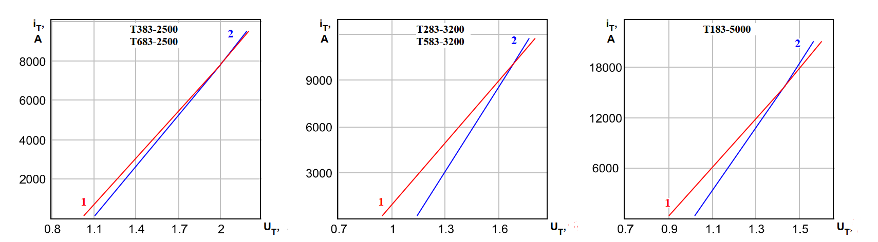
a) b) c)
FIGURE 2. Graph of the dependence of the volt-ampere characteristics of a thyristor on the temperature;
a) T383-2500 for thyristor; b) T283-3200 for thyristor; c) T183-5000 for thyristor.

Maximum permissible transition temperature, T_{jm} (1), current-voltage at temperature, Т_{j}=25 °C (2), I_{T}=3,14 I_{T}, boundary characteristic.

FIGURE 3. Time-dependent graph of the thyristor control pulse

In the figure above, when the excitation system is started, the current initially reaches a large value at a certain time interval, starting with a small value. At this stage, the current growth rate will be determined by di/dt and will depend on the reactive values of the excitation system elements, the control system and the capabilities of thyristor amplifiers [32-61]. The current reaches the maximum value of the I_{max} value, maintaining that value for a short period of time. This process allows the generator to form the magnetic flux generated in the initial magnetic field and ensure synchronization with the load [25-34].
There is an opportunity to model the thyristor excitation system of a synchronous generator in a MATLAB/Simulink environment, the electrical circuit of which is shown in Figure 4. The transient processes of the thyristor based on the imitation model to be created, the effect of the synchronous generator on reactive power compensation, dynamic stability as well as the ability to adjust voltage.
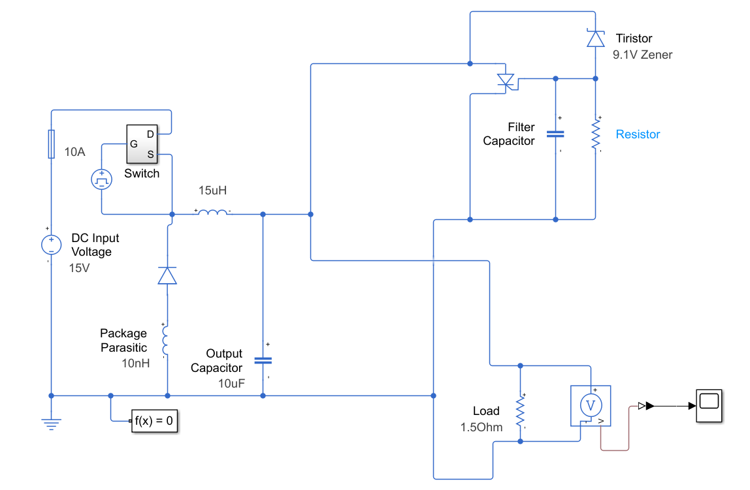
FIGURE 4. MATLAB/Simulink model of a thyristor excitation system of a synchronous generator
Figure 4 above shows the imitation scheme of the operation of the thyristor in the castrated virtual circuit. It has the ability to spy on processes such as the transfer of energy through switching, accumulation in a magnetic field, straightening through a thyristor, filtering through capacitors, and avoiding over-voltages using protective elements.
FIGURE 5. Graph of the time dependence of the excitation current generated in thyristors

The figure above shows the dynamics of the change in Current by time when the excitation system is running. The characteristic of the current in such a way was assessed the control of the automatic control system of the synchronous generator, which occurs in transient processes, as well as the state of electromagnetic processes affected by loading. We can see from the graph the excitation current of the synchronous generator that a rapid rise in the value of the current is observed. In this process, the excitation works in connection with the formation of a magnetic field in the Marsh, as well as the supply of the initial excitation energy by the control system. Current fluctuations in the early period are explained by electromagnetic inertia, the effect of inductance, as well as delays in the feedback loop of the automatic adjuster.
CONCLUSIONS
In conclusion, it can be argued that the analysis of the electrical, dynamic and thermal properties of thyristor devices used in the excitation system of synchronous generators is indicated. The scientific article theoretically analyzed the static characteristics of thyristors, the voltage drops in conduction, the blocking voltage, the average current capacity, the pulse parameters required for the control electrode, as well as the switching and shutdown times through the dynamic parameters. In the MATLAB/Simulink environment, a mathematical model of a thyristor excitation system was developed, simulating transient processes in different operating modes. The results of the simulation were compared with the parameters of the real device, and the correlation between them was determined to be no more than 5-7%, determining the sufficient accuracy of the model the MATLAB/Simulink environment, a mathematical model of a thyristor excitation system was developed, simulating transient processes in different operating modes. The results of the simulation were co.
REFERENCES
- N. Niyozov, A. Akhmedov, S. Djurayev, B. Tukhtamishev, and A. Norqulov, “Development of a method for forecasting the specific consumption indicator of electric energy,” AIP Conference Proceedings 3331, 080008 (2025). https://doi.org/10.1063/5.0305729
- J. Boboqulov and B. Narzullayev, “Development of a model for diagnosing rotor conditions in the parallel connection of synchronous generators with the network,” E3S Web of Conferences 525, 06001 (2024). https://doi.org/10.1051/e3sconf/202452506001
- A. Tursunova et al., “Researching localization of vertical axis wind generators,” E3S Web of Conferences 417, 03005 (2023). https://doi.org/10.1051/e3sconf/202341703005
- B. Ramazonov, S. Sayfiev, and K. Muradov, “Mathematical modeling and research of high capacity lead-acid stabilized accumulator battery,” AIP Conference Proceedings 3268, 020043 (2025). https://doi.org/10.1063/5.0257860
- K. Murodov, A. Karshibayev, and S. Abdullayev, “Analysis of the process of balanced charging of the battery group with high capacity,” E3S Web of Conferences 548, 03012 (2024). https://doi.org/10.1051/e3sconf/202454803012
- M. Xolmurodov, S. Hakimov, and U. Oripova, “Improving energy efficiency in public buildings: Modern technologies and methods,” AIP Conference Proceedings 3331, 040060 (2025). https://doi.org/10.1063/5.0306935
- Z. I. Jumayev, A. I. Karshibayev, M. K. Sayidov, and S. G. Shirinov, “Analysis of climate-meteorological and technological factors affecting electricity consumption of mining enterprises,” Vibroengineering Procedia 54, 293–299 (2024). https://doi.org/10.21595/vp.2024.24047
- O. O. Zaripov et al., “Calculation of the nominal power and electrical energy of the hydro power plant on an electronic calculator,” E3S Web of Conferences 486, 01027 (2024). https://doi.org/10.1051/e3sconf/202448601027
- M. Ibadullayev, S. Begmatov, and A. Tovbaev, “Subharmonic resonance in three-phase ferroresonant circuits with common magnetic cores,” AIP Conference Proceedings 3152, 050019 (2024). https://doi.org/10.1063/5.0218907
- K. Turdibekov et al., “Experimental and statistical methods for studying the modes of electric power systems under conditions of uncertainty,” E3S Web of Conferences 452, 04002 (2023). https://doi.org/10.1051/e3sconf/202345204002
- B. Narzullayev and J. Boboqulov, “Improving reliability based on diagnostics of the technical condition of electric motor stator gutters,” AIP Conference Proceedings 3331, 030032 (2025). https://doi.org/10.1063/5.0305735
- A. Taslimov, F. Raximov, F. Rakhimov, and I. Bakhadirov, “Optimal parameters and selection criteria for neutral grounding resistors in 20 kV electrical networks,” AIP Conference Proceedings 3331, 030048 (2025). https://doi.org/10.1063/5.0306108
- I. Togaev, A. Tovbaev, and G. Nodirov, “Systematic analysis of reactive power compensation in electric networks,” AIP Conference Proceedings 3331, 030099 (2025). https://doi.org/10.1063/5.0305740
- A. Taslimov, F. Rakhimov, F. Raximov, and V. Mo’minov, “Analysis of the results of sampling the surfaces of sections of rural electric networks,” AIP Conference Proceedings 3331, 030041 (2025). https://doi.org/10.1063/5.0305783
- S. Amirov and A. Ataullayev, “Sine-cosine rotating transformers in zenith angle converters,” E3S Web of Conferences 525, 03010 (2024). https://doi.org/10.1051/e3sconf/202452503010
- S. F. Amirov et al., “Methods for reducing the temperature components of magnetomodulation DC convertors errors,” E3S Web of Conferences 417, 03011 (2023). https://doi.org/10.1051/e3sconf/202341703011
- A. Tovboyev et al., “Use of reactive power sources in improving the quality of electricity,” E3S Web of Conferences 417, 03001 (2023). https://doi.org/10.1051/e3sconf/202341703001
- I. Togayev, A. Tovbaev, and G. Nodirov, “Assessment of the quality of electricity by applying reactive power sources,” E3S Web of Conferences 525, 03004 (2024). https://doi.org/10.1051/e3sconf/202452503004
- G. Boynazarov, A. Tovbaev, and U. Usarov, “Methodology of experimental research of voltage quality in electrical circuit,” E3S Web of Conferences 548, 03009 (2024). https://doi.org/10.1051/e3sconf/202454803009
- N. Ataullayev et al., “Principles of protection against single-phase earth faults in networks with capacitive current compensation,” E3S Web of Conferences 548, 06008 (2024). https://doi.org/10.1051/e3sconf/202454806008
- A. Tovbaev, M. Ibadullayev, and M. Davronova, “Study of subharmonic oscillation processes in ferroresonance circuits,” E3S Web of Conferences 525, 03008 (2024). https://doi.org/10.1051/e3sconf/202452503008
- B. S. Narzullayev and M. A. Eshmirzaev, “Causes of the appearance of current waves in high-voltage electric arc furnaces and methods of their reduction,” E3S Web of Conferences 417, 03003 (2023). https://doi.org/10.1051/e3sconf/202341703003
- A. Tovbaev et al., “Reactive power compensation helps maintain a stable voltage profile across the network,” AIP Conference Proceedings 3331, 060014 (2025). https://doi.org/10.1063/5.0307209
- A. Norqulov and F. Raximov, “Methods for evaluating financial and economic effectiveness of investment projects in the energy sector with time factor considerations,” AIP Conference Proceedings 3331, 030070 (2025). https://doi.org/10.1063/5.0306104
- S. Abdullaev, Z. Eshmurodov, and I. Togaev, “A systematic analysis of the gradual increase in quality indicators of electricity using reactive power sources,” AIP Conference Proceedings 3331, 040051 (2025). https://doi.org/10.1063/5.0306786
- S. F. Amirov et al., “Methods of reduction of interference signals in electromagnetic conductors that measure fluid flow,” Journal of Physics: Conference Series 2094, 052053 (2021). https://doi.org/10.1088/1742-6596/2094/5/052053
- J. Olimov, B. Ramazonov, and S. Sayfiyev, “Increasing efficiency of induction motor by predictive control system,” E3S Web of Conferences 525, 03006 (2024). https://doi.org/10.1051/e3sconf/202452503006
- G. Tatkeyeva et al., “Experimental research of the developed method to determine the network insulation for ungrounded AC systems,” in Proceedings of ICECET, IEEE (2022). https://doi.org/10.1109/ICECET55527.2022.9873012
- M. Rabatuly et al., “Views on drilling effectiveness and sampling estimation for solid ore minerals,” Complex Use of Mineral Resources 1, 336 (2026). https://doi.org/10.31643/2026/6445.01
- J. B. Toshov et al., “Methods for analysis and improvement of dynamic loads on steel wire rope excavators,” Complex Use of Mineral Resources 339(4), 87–96 (2026). https://doi.org/10.31643/2026/6445.43
- O. U. Zokhidov et al., “Experimental analysis of micro-HPP installation for existing water flows in industrial plants,” E3S Web of Conferences 463, 02023 (2023). https://doi.org/10.1051/e3sconf/202346302023
- Melikuziev M.V., Fayzrakhmanova Z., Akhmedov A., Kasimova G. Development of an Educational Simulator's Working Logic for the Course 'Fundamentals of Power Supply'. AIP Conference Proceedings 3152, 050025 (2024). https://doi.org/10.1063/5.0218875
- Melikuziev M.V., Nematov L.A., Novikov A.N., Baymuratov K.K. Technical and economic analysis of parameters of city distribution electric network up to 1000 V. E3S Web of Conferences 289, 07016 (2021) Energy Systems Research. https://doi.org/10.1051/e3sconf/202128907016
- L.Jing, J.Guo, T.Feng, L.Han, Z.Zhou and M.Melikuziev, "Research on Energy Optimization Scheduling Methods for Systems with Multiple Microgrids in Urban Areas," 2024 IEEE 4th International Conference on Digital Twins and Parallel Intelligence (DTPI), Wuhan, China, 2024, pp. 706-711, https://ieeexplore.ieee.org/abstract/document/10778839
- Shukhrat Umarov, Murot Tulyaganov. Peculiarities of simulation of steady modes of valve converters with periodic power circuit structure. III International Scientific and Technical Conference “Actual Issues of Power Supply Systems” (ICAIPSS2023). AIP Conf. Proc. 3152, 050004-1–050004-7; https://doi.org/10.1063/5.0218869
- Murot Tulyaganov, Shukhrat Umarov. Improving the energy and operational efficiency of an asynchronous electric drive. III International Scientific and Technical Conference “Actual Issues of Power Supply Systems” (ICAIPSS2023); https://doi.org/10.1063/5.0218876
- Shukhrat Umarov, Khushnud Sapaev, Islambek Abdullabekov. The Implicit Formulas of Numerical Integration Digital Models of Nonlinear Transformers. AIP Conf. Proc. 3331, 030105 (2025); https://doi.org/10.1063/5.0305793
- Shukhrat Umarov, Murat Tulyaganov, Saidamir Oripov, Ubaydulla Boqijonov. Using a modified laplace transform to simulate valve converters with periodic topology. AIP Conf. Proc. 3331, 030104 (2025); https://doi.org/10.1063/5.0305792
- Murat Tulyaganov, Shukhrat Umarov, Islambek Abdullabekov, Shakhnoza Sobirova. Optimization of modes of an asynchronous electric drive. AIP Conf. Proc. 3331, 030084 (2025); https://doi.org/10.1063/5.0305786
- Islombek Abdullabekov, Murakam Mirsaidov, Shukhrat Umarov, Murot Tulyaganov, Saidamirkhon Oripov. Optimizing energy efficiency in water pumping stations: A case study of the Chilonzor water distribution facility; AIP Conf. Proc. 3331, 030107 (2025); https://doi.org/10.1063/5.0305780
- Kobilov, N., Khamidov, B., Rakhmatov, K., Abdukarimov, M., Daminov, O., Shukurov, A., Kodirov, S., Omonov, S. Investigation and study of oil sludge of oil refinery company in Uzbekistan. AIP Conference Proceedings, 3304, 040076, (2025), https://doi.org/10.1063/5.0269039
- Kobilov, N., Khamidov, B., Rakhmatov, K., Daminov, O., Ganieva, S., Shukurov, A., Kodirov, S., Omonov, S. Development of effective chemicals for drilling fluid based on local and raw materials of Uzbekistan. AIP Conference Proceedings, 3304, 040077, (2025), https://doi.org/10.1063/5.0269403
- Umerov, F., Daminov, O., Khakimov, J., Yangibaev, A., Asanov, S. Validation of performance indicators and theoretical aspects of the use of compressed natural gas (CNG) equipment as a main energy supply source on turbocharged internal combustion engines vehicles. AIP Conference Proceedings, 3152, 030017, (2024), https://doi.org/10.1063/5.0219381
- Matmurodov, F.M., Daminov, O.O., Sobirov, B.Sh., Abdurakxmanova, M.M., Atakhanov, F.U.M. Dynamic simulation of force loading of drives of mobile power facilities with variable external resistance. E3s Web of Conferences, 486, 03001, (2024), https://doi.org/10.1051/e3sconf/202448603001
- Musabekov, Z., Daminov, O., Ismatov, A. Structural solutions of the supercharged engine in the output and input system. E3s Web of Conferences, 419, 01015, (2023), https://doi.org/10.1051/e3sconf/202341901015
- Musabekov, Z., Ergashev, B., Daminov, O., Khushnaev O., Kurbanov, A., Kukharonok, G. Efficiency and environmental indicators of diesel engine operation when using water injection. IOP Conference Series Earth and Environmental Science, 1142, 012024, (2023), https://doi.org/10.1088/1755-1315/1142/1/012024
- Tulaev, B.R., Musabekov, Z.E., Daminov, O.O., Khakimov, J.O. Application of Supercharged to Internal Combustion Engines and Increase Efficiency in Achieving High Environmental Standards. AIP Conference Proceedings, 2432, 030012, (2022), https://doi.org/ 10.1063/5.0090304
- Matmurodov, F., Yunusov, B., Khakimov, J., Daminov, O., Gapurov, B. Mathematical Modeling and Numerical Determination of Kinetic and Power Parameters of Loaded Power Mechanisms of a Combined Machine. AIP Conference Proceedings, 2432, 040013, (2022), https://doi.org/ 10.1063/5.0090304
- Ma’ruf, K., Tursoat, A., Dilnavoz, K., Bekmurodjon, R., Ra'no, A., Saida, T., ... & Toshbekov, B. (2025). ZnO Nanoparticles Incorporated on Multi-Walled Carbon Nanotubes as A Robust Heterogeneous Nano-catalyst for Biodiesel Production from Oil. Journal of Nanostructures, 15(3), 1050-1060.
- Safarov J., Khujakulov A., Sultanova Sh., Khujakulov U., Sunil Verma. Research on energy efficient kinetics of drying raw material. // E3S Web of Conferences: Rudenko International Conference “Methodological problems in reliability study of large energy systems” (RSES 2020). Vol. 216, 2020. P.1-5. doi.org/10.1051/e3sconf/202021601093
- Safarov J., Sultanova Sh., Dadayev G.T., Zulponov Sh.U. Influence of the structure of coolant flows on the temperature profile by phases in a water heating dryer. // IOP Conf. Series: Materials Science and Engineering. Dynamics of Technical Systems (DTS 2020). Vol.1029, 2021. №012019. P.1-11. doi:10.1088/1757-899X/1029/1/012019
- Sultanova Sh.A., Artikov A.A., Masharipova Z.A., Abhijit Tarawade, Safarov J.E. Results of experiments conducted in a helio water heating convective drying plant. // International conference AEGIS-2021 «Agricultural Engineering and Green Infrastructure Solutions». IOP Conf. Series: Earth and Environmental Science 868 (2021) 012045. P.1-6. doi:10.1088/1755-1315/868/1/012045
- Sultanova Sh., Safarov J., Usenov A., Samandarov D., Azimov T. Ultrasonic extraction and determination of flavonoids. XVII International scientific-technical conference “Dynamics of technical systems” (DTS-2021). AIP Conference Proceedings 2507, 050005. 2023. P.1-5. doi.org/10.1063/5.0110524
- Saparov Dj.E., Sultonova S.A., Guven E.С., Samandarov D.I., Rakhimov A.M. Theoretical study of characteristics and mathematical model of convective drying of foods. // RSES 2023. E3S Web of Conferences 461, 01057 (2023). P.1-5. https://doi.org/10.1051/e3sconf/202346101057
- Safarov J.E., Sultanova Sh.A., Dadayev G.T., Samandarov D.I. Method for drying fruits of rose hips. // International Journal of Innovative Technology and Exploring Engineering (Scopus). Volume-9, Issue-1, November, 2019. Р.3765-3768. doi: 10.35940/ijitee.A4716.119119
- Safarov J.E., Sultanova Sh.A., Dadayev G.T., Samandarov D.I. Method for the primary processing of silkworm cocoons (Bombyx mori). // International Journal of Innovative Technology and Exploring Engineering (Scopus). Volume-9, Issue-1, November, 2019. Р.4562-4565. DOI: 10.35940/ijitee.A5089.119119
- Sultanova Sh., Safarov J., Usenov A., Raxmanova T. Definitions of useful energy and temperature at the outlet of solar collectors. // E3S Web of Conferences: Rudenko International Conference “Methodological problems in reliability study of large energy systems” (RSES 2020). Vol. 216, 2020. P.1-5. doi.org/10.1051/e3sconf/202021601094
- Usenov A.B., Sultanova Sh.A., Safarov J.E., Azimov A.T. Experimental-statistic modelling of temperature dependence of solubility in the extraction of ocimum basilicum plants. // International conference AEGIS-2021 «Agricultural Engineering and Green Infrastructure Solutions». IOP Conf. Series: Earth and Environmental Science 868 (2021) 012047. P.1-5. doi:10.1088/1755-1315/868/1/012047
- 1Sultanova Sh.A., Safarov J.E., Usenov A.B., Muminova D. Analysis of the design of ultrasonic electronic generators. // Journal of Physics: Conference Series. International Conference "High-tech and Innovations in Research and Manufacturing" (HIRM 2021). 2176 (2022) 012007. doi:10.1088/1742-6596/2176/1/012007
- Zulpanov Sh.U., Samandarov D.I., Dadayev G.T., Sultonova S.A., Safarov J.E. Research of the influence of mulberry silkworm cocoon structure on drying kinetics. // IOP Conf. Series: Earth and Environmental Science (AEGIS-2022). 1076 (2022) 012059. Р.1-6. doi:10.1088/1755-1315/1076/1/012059
- Tarawade A., Samandarov D.I., Azimov T.Dj., Sultanova Sh.A., Safarov J.E. Theoretical and experimental study of the drying process of mulberry fruits by infrared radiation. // IOP Conf. Series: Earth and Environmental Science (ETESD). 1112 (2022) 012098. P.1-9. doi:10.1088/1755-1315/1112/1/012098

