Detection and Classification of Partial Discharges in Insulators Based on Acoustic Signals
Khasan Murodov¹, Mukhriddin Tuyqulov^{1,a)}, Muzaffar Sayidov¹, Shakhnazakhon Tashmatova ²
¹Navoi State University of Mining and Technologies, Navoiy, Uzbekistan
²Tashkent state technical university named after Islam Karimov, Tashkent, Uzbekistan
^{a)} Corresponding author: toyqulovmuhriddin@gmail.com
Abstract. Acoustic inspection is an effective method that enables the detection of early-stage defects in equipment, thereby facilitating predictive maintenance. In recent years, the practice of identifying partial discharges through ultrasonic sensors has expanded significantly. However, interpreting acoustic signals remains challenging and requires extensive experience and knowledge related to equipment configuration. To address this issue, an approach based on evaluating the fundamental frequency has been proposed to standardize insulator diagnostics. In the experiment, a database of more than ten acoustic signals with frequencies ranging from 0 to 120 kHz was created, and various contamination levels and defects were introduced into the insulator string. Using the proposed method, it is possible to detect the occurrence of partial discharges and classify their types, such as corona or surface discharge. This advanced diagnostic approach simplifies the process and provides valuable insights into the severity of phenomena observed under operating conditions.
INTRODUCTION
Partial discharges (PDs) are spatially localized and incomplete dielectric breakdown events in which the voltage gradient is sufficiently high only around the initiation point to generate and sustain electric charge [1-5]. PDs occur in localized regions of the insulation system and, over time, may lead to material degradation. In general, four main types of PDs are distinguished: corona discharge, internal discharge, surface discharge, and treeing discharge. Each type is formed depending on local electric-field intensification, insulation geometry, or the physicochemical properties of the surrounding medium, and they possess distinct physical mechanisms, spectral characteristics, and diagnostic signatures. As illustrated in Fig. 1a, corona discharge occurs when the electric field in the surrounding medium is sufficiently non-uniform. This type of partial discharge typically appears near sharp geometrical points or around curved conductors in transmission lines. Corona discharges may manifest as bluish luminescence accompanied by ultrasonic and audible acoustic emissions. Furthermore, their temporary or persistent development can lead to gradual degradation of the insulation material. Internal discharge, shown in Fig. 1b, arises within voids located in layers of the insulator where the dielectric strength is reduced. The sustained presence of such discharges within a solid dielectric medium may cause the formation of severe defects in the material structure, particularly the development of conductive paths (tracks). The progression of this process may eventually lead to treeing discharge, illustrated in Fig. 1c. Surface discharges, depicted in Fig. 1d, occur when the tangential component of the electric field along the dielectric surface becomes significantly high [6-9].
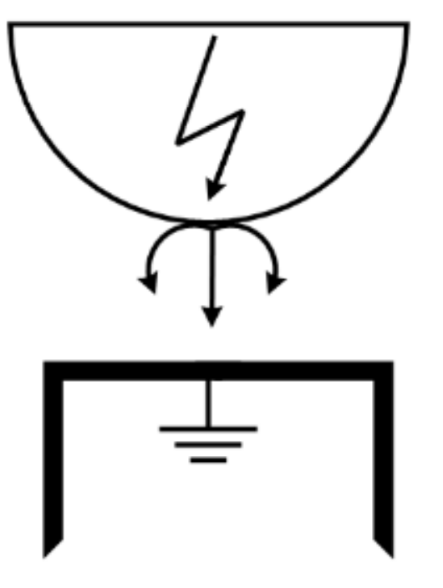a) 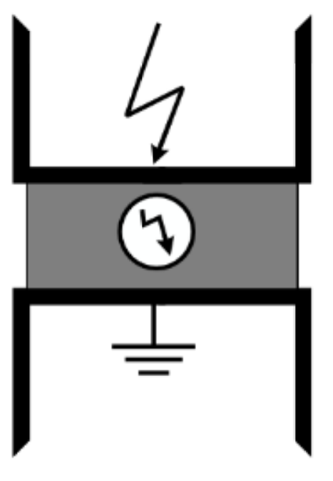 b) 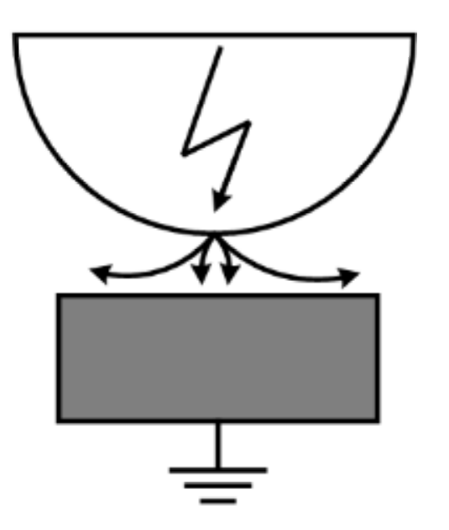c) 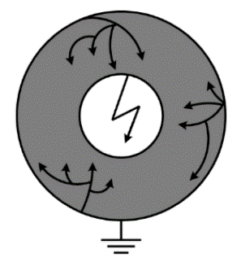d)
FIGURE 1. Types of electrical discharges: a) corona discharge, b) internal discharge, c) surface discharge, and d) treeing (root-like) electrical discharge

EXPERIMENTAL RESEARCH
In this article, a method for determining the fundamental frequency in the evaluation of partial discharges (PDs) is used, which is based on the power spectral density (PSD) approach to frequency estimation. The process of determining the frequency is carried out through the power spectrum of the signal. The power spectral density technique represents how the signal power is distributed over frequency. The power spectrum is obtained by applying the Fourier transform to the autocorrelation function of the acoustic signal.
The autocorrelation function is an effective mathematical tool for identifying repeating patterns in unknown periodic signals masked by noise. It also makes it possible to determine the fundamental frequency of the signal and its harmonics by analyzing the linear relationship between delayed values in time-series data [10-15].
For random signals, the periodogram is used as a method for estimating the power spectral density (S_{x}), and it is expressed by equation (1).
$S_{x}\left(e^{jw}\right)=\lim_{N→∞}{E\left\{\frac{1}{2N+1}{\left|\sum_{n=-N}^{N}{x(n)e^{-jwn}}\right|}^{2}\right\}}$ (1)
here, E denotes estimation, i.e., mathematical expectation.
Considering a finite amount of data with lengths equal to N − 1, equation (1) can be transformed into equation (2).
$S_{x}\left(e^{jw}\right)=\frac{1}{N}{\left|\sum_{n=0}^{N-1}{x(n)e^{-jwn}}\right|}^{2}=\frac{1}{N}{\left|X(e^{jw})\right|}^{2}$ (2)
here, X(e^{jω}) is the discrete-time Fourier transform (DTFT) of the signal, which in turn is given by (3). The rectangular input signal has the same length and the frequency sampling is equal to 250 kHz.
$ω=\frac{2πk}{N}, k=0,1,2,…N-1$ (3)
Using the expressions above, it is possible to calculate the fundamental frequency and harmonic characteristics of partial discharge (PD). The methodology of the laboratory experiments is shown in Figure 2. The equipment shown in Figure 2 consists of the following components:
1. Resonant controller;
2. Power transformer;
3. Resonant source;
4. Device under test — insulator string (IS);
5. Capacitive divider;
6. Digital ultrasonic testing device located 12.5 m away from the device under test;
7. Oscilloscope;
8. Receiving system of the capacitive divider;
9. Computer.
In the tests, a string of three-element high-voltage glass insulators was used, to which various types of artificial pollution were applied. The technical datasheet of the insulator is provided in [16-21].

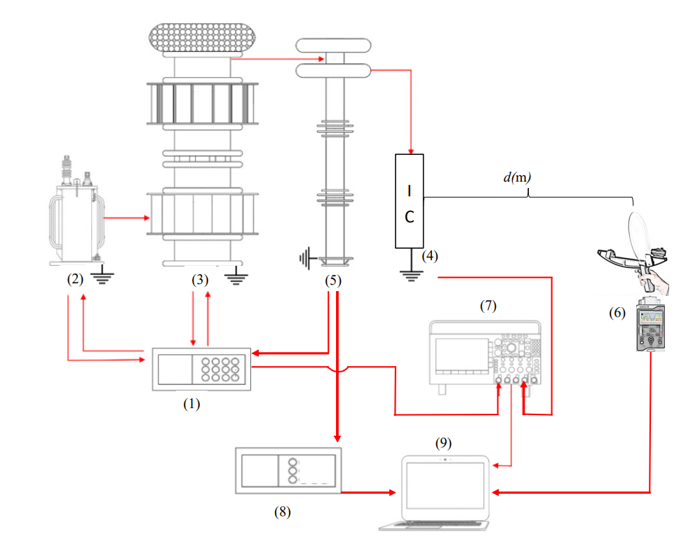
FIGURE 2. Organization of the experimental method
RESEARCH RESULTS
The tests were carried out in a way aimed at recreating the real operational conditions that insulators could encounter. This took into account the formation of permeable microfilming, which occurs under the influence of rain, wind or other environmental factors, the presence of a layer of clay that can arise as a result of dust and bird droppings, as well as cases of partial damage and degradation he tests were carried out in a way aimed at recreating the real operational conditions that insulators could encounter [33-62]. This took into account the formation of permeable microfilming, which occurs under the influence of rain, wind or other environmental factors, the presence of a layer of clay that can arise as a result of dust and bird droppings, as well as cases of partial damage and degradation. The insulator is characterized by a conductive microfilm produced by contamination that is partially or completely scattered along its surfaces. Also applied was clay contamination consisting of a mixture of soil and water. After that, partial mechanical damage was created on the surface of the insulator. Small cracks are observed on the surface of the insulator. Figure 3 presents the general condition of the insulators and the range of voltages applied in laboratory experiments. The insulator chain was tested at voltages ranging from 10 kV to maximum values provided by a laboratory resonance source, until the over-current protection system came into operation [22-25].
Below, the maximum voltage levels depend on the condition of the insulator (pollution level) and environmental conditions, as humidity and temperature affect the occurrence of PDs due to favorable or unfavorable ionization conditions in the air. Therefore, laboratory tests carried out on days with different environmental conditions with the same insulator chain can partially lead to different maximum voltage levels required for dielectric breakdown [26-32].
FIGURE 3. The condition of the insulators and the voltage range used in laboratory experiments.

Ultrasonic measurements were carried out at a distance of 12.5 m for 10 seconds with a sampling rate of 250 kHz. The measurements consisted of a raw audio signal measured in microvolts and in the frequency spectrum, both of which vary over time. Figures 4 show the amplitude and frequency spectrograms at different voltage intensities for each test condition.

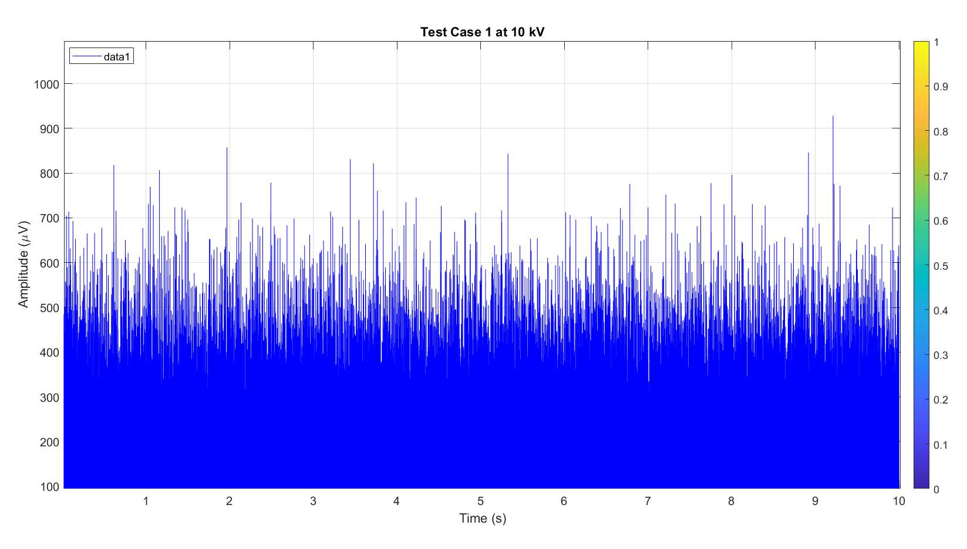
FIGURE 4. Amplitude and frequency spectrogram of the ultrasound signal for the test state at a voltage of 10 kV.

An experimental test showed that the measurement time of 10 seconds was sufficient to determine the occurrence of PDs. This duration allows the operator to control the digital ultrasound Tester without noticing fatigue or vibration along the insulator chain, thus facilitating experimental measurements.
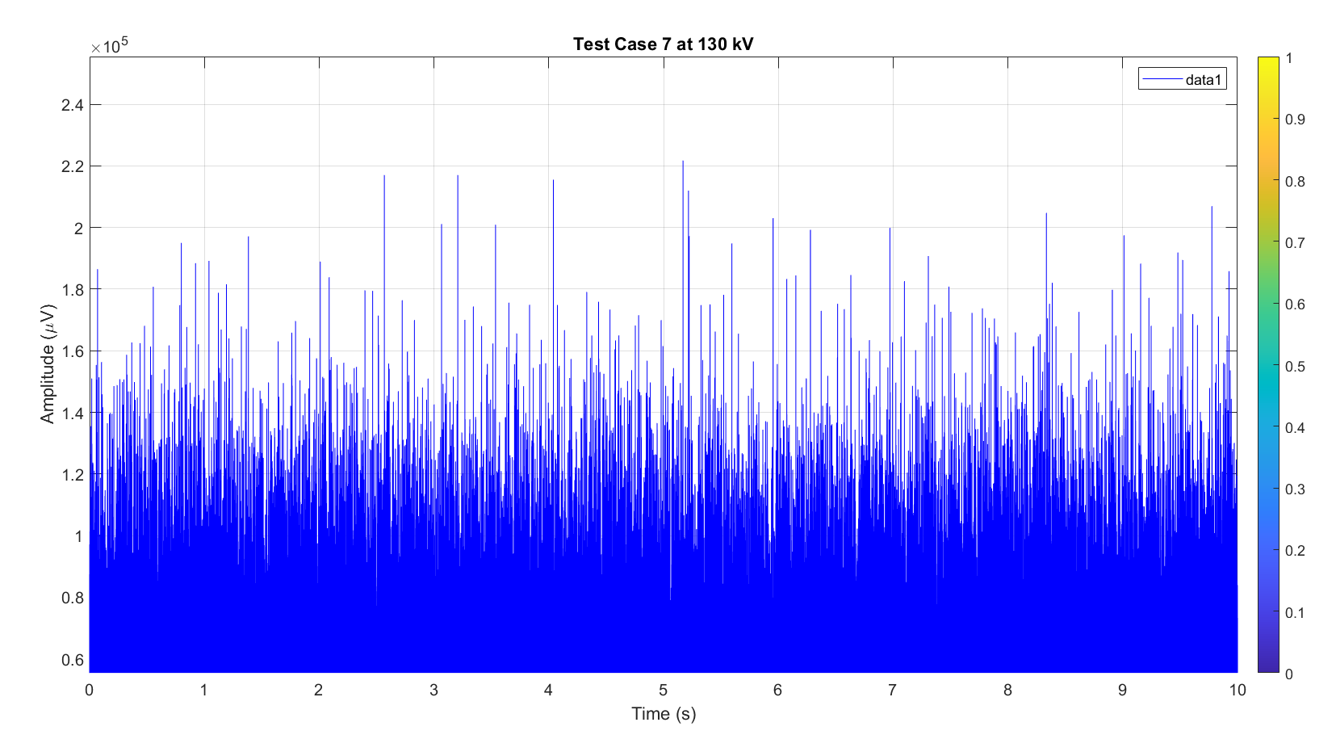
FIGURE 5. Amplitude and frequency spectrogram of the ultrasound signal for the test state at a voltage of 130 kV.

The measurement time of 10 seconds was shown to be sufficient to determine the occurrence of PDs. This duration allows the operator to control the digital ultrasound tester without noticing wear or vibration along the insulator chain, and thus facilitates experimentalof the dimensions.
CONCLUSIONS
Identification and classification of PDs by acoustic inspection can be a powerful predictive maintenance tool. Acoustic signals, without pre-processing and covering a wide frequency range (0 to 120 kHz), contain large amounts of data both in the audible spectrum (<20 kHz) and in the ultrasound spectrum (>20 kHz). When appropriate techniques are used, they allow a more accurate diagnosis of PDs. A test case of artificial contamination was performed on high-voltage glass insulators, resulting in various physical conditions and different levels of tension, such as mud accumulation, conductive microfilm formation, and damage. Thus, some conditions have been partially illuminated by the results of the following test to determine the formation of PDs and predict the working condition of the insulators through modern structures.
REFERENCES
- A. S. Zhuraev, S. A. Turdiyev, S. T. Jurayev, and S.S. Q. Salimova, "Characteristics of packing gland seals in hydraulic systems of quarry excavators and results of comparative analysis of experimental tests," Vibroengineering Procedia, Vol. 54, pp. 252–257, Apr. 2024, https://doi.org/10.21595/vp.2024.24051
- Akbar Zhuraev, Sardorjon Turdiyev; Analyses and studies of working fluid flow in the hydraulic system of hydraulic excavators at the Auminzo-Amantaytau open pit mine. AIP Conf. Proc. 4 November 2025; 3331 (1): 030067. https://doi.org/10.1063/5.0305703
- Mislibaev I.T., Makhmudov A.M., Makhmudov Sh.A. Theoretical generalisation of functioning modes and modelling of operational indicators of excavators. // Mining information-analytical bulletin. - 2021. №1. p. 102-110. DOI: 10.25018/0236-1493-2021-1-0-102-110
- Makhmudov Sh, Makhmudov A, Khudojberdiev L, Izzat Rakhmonov, “Criteria for assessing the performance of mining and transport equipment of mining enterprises,” Proc. SPIE 12986, Third International Scientific and Practical Symposium on Materials Science and Technology (MST-III 2023), 129860P (19 January 2024); doi: 10.1117/12.3017722
- Ataqulov L.N., Haydarov Sh.B., Polvonov N.O. Impact forces on side and middle rollers. SPIE 12986, Third International Scientific and Practical Symposium on Materials Science and Technology (MST-III 2023), 129860Q (19 January 2024); doi: 10.1117/12.3017724
- Atakulov L.N., Kakharov S.K., Khaidarov S.B. Selection of optimal jointing method for rubber conveyor belts. Gornyl Zhurnal, 2018. (9), 97-100. DOI:10.17580/gzh.2018.09.16
- O.Jumaev, M. Ismoilov, D. Rahmatov, A. Qalandarov, Enhancing abrasion resistance testing for linoleum and rubber products: A proposal for improved device operation, E3S Web of Conferences 525, 05012 (2024) https://doi.org/10.1051/e3sconf/202452505012
- Ataullayev N.O., Muxammadov B.Q., Idieva A.A., Research of dynamic characteristics of magnetic modulation current converter with negative feedback // International Journal of Advanced Research in Science, Engineering and Technology, India, 2020, November, Vol. 7, Issue 11. – P. 15749-15752. http://www.ijarset.com/volume-7-issue-11.html?utm_source=chatgpt.com
- N.Ataullayev, A.Norqulov, B.Muxammadov, A.Majidov, I.Tog’ayev. Principles of protection against single phase earth faults in networks with capacitive current compensation. E3S Web of Conferences, 548, 06008 (2024). https://doi.org/10.1051/e3sconf/202454806008
- Shirinov S.G., J.S. Olimov, I.Z. Jumayev M.K. Sayidov Analysis of patterns of electricity consumption in mining and processing enterprises. Vibroeng. Procedia 2024, 54, 308–313. https://doi.org/10.21595/vp.2024.24073
- Jumayev, Z.I., Karshibayev, A.I., Sayidov, M.K., & Shirinov, S.G. Analysis of climate-meteorological and technological factors affecting electricity consumption of mining enterprises. Vibroengineering Procedia, Vol. 54, pp. 293-299 (Apr. 4 2024). https://doi.org/10.21595/vp.2024.24047
- Amirov S.F., Ataullayev N.O., Ataullayev A.O., Muxammadov A.O., Majidov B.Q., A.U. Methods for reducing the temperature components of magnetomodulation DC converter errors. E3S Web of Conferences, 417, 03011 (2023). https://doi.org/10.1051/e3sconf/202341703011
- Amirov S.F., Ataullayev A.O., Sayidov M.K., Togayev I.B. Methods of reduction of interference signals in electromagnetic conductors that measure fluid flow Journal of Physics: Conference Series, 2094(5), 052053 (2021) 10.1088/1742-6596/2094/5/052053
- Olimov J., Ramazonov B., Sayfiyev S. Increasing efficiency of induction motor by predictive control system //E3S Web of Conferences. – EDP Sciences, 2024. – Т. 525. – С. 03006. https://doi.org/10.1051/e3sconf/202452503006
- Sulton Amirov, Aminjon Ataullayev, Sine-cosine rotating transformers in zenith angle converters, E3S Web of Conferences 525, 03010 (2024) GEOTECH-2024, https://doi.org/10.1051/e3sconf/202452503010
- Sultan F. Amirov, Nodir O. Ataullayev, Amin O. Ataullayev, Bobur Q. Muxammadov, and Ahror U. Majidov, Methods for reducing the temperature components of magnetomodulation DC convertors errors, E3S Web of Conferences 417, 03011 (2023) GEOTECH-2023 https://doi.org/10.1051/e3sconf/202341703011
- Raximov, F., Taslimov, A., Majidov, A., & Norqulov, A. (2024). Optimization of losses by switching to higher voltage in distribution networks. In E3S Web of Conferences (Vol. 525, p. 03009). EDP Sciences. https://doi.org/10.1051/e3sconf/202452503009
- Boboqulov J., Narzullayev B, Development of a model for diagnosing rotor conditions in the parallel connection of synchronous generators with the network, E3S Web of Conferences. – EDP Sciences, 2024. – Т. 525. – С. 06001. https://doi.org/10.1051/e3sconf/202452506001
- Narzullayev B. S., Eshmirzaev M. A, Causes of the appearance of current waves in high voltage electric arc furnaces, and methods of their reduction, E3S Web of Conferences. – EDP Sciences, 2023. – Т. 417. – С. 03003. https://doi.org/10.1051/e3sconf/202341703003
- Akram Tovbaev., Islom Togaev., Uktam Usarov, Gulom Nodirov, Reactive power compensation helps maintain a stable voltage profile across the network, AIP Conf. Proc. 3331, 060014 (2025). https://doi.org/10.1063/5.0307209
- Asliddin Norqulov, Feruz Raximov, Methods for evaluating financial and economic effectiveness of investment projects in the energy sector with time factor considerations, AIP Conf. Proc. 3331, 030070-1–030070-6. https://doi.org/10.1063/5.0306104
- Shukhrat Abdullaev., Ziyodullo Eshmurodov., Islom Togaev. A systematic analysis of the gradual increase in quality indicators of electricity using reactive power sources involves several steps, AIP Conf. Proc. 3331, 040051 (2025). https://doi.org/10.1063/5.0306786
- Bobur Narzullayev; Javokhir Boboqulov, Improving reliability based on diagnostics of the technical condition of electric motor stator gutters, AIP Conf. Proc. 3331, 030032 (2025). https://doi.org/10.1063/5.0305735
- Abdurakhim Taslimov., Feruz Raximov., Farrukh Rakhimov., Iles Bakhadirov, Optimal parameters and selection criteria for neutral grounding resistors in 20 kv electrical networks, AIP Conf. Proc. 3331, 030048 (2025) https://doi.org/10.1063/5.0306108
- Islom Togaev., Akram Tovbaev., Gulom Nodirov, Systematic analysis of reactive power compensation in electric networks is essential for improving electricity quality enhancing system stability, and reducing operational costs, AIP Conf. Proc. 3331, 030099 (2025) https://doi.org/10.1063/5.0305740
- Abdurakhim Taslimov., Farrukh Rakhimov., Feruz Rakhimov., Vaxobiddin Mo’minov, Analysis of the results of sampling the surfaces of sections of rural electric networks, AIP Conf. Proc. 3331, 030041 (2025) https://doi.org/10.1063/5.0305783
- Numon Niyozov, Anvar Akhmedov, Shukhrat Djurayev, Botir Tukhtamishev, Asliddin Norqulov, Development of a method for forecasting the specific consumption indicator of electric energy, AIP Conf. Proc. 3331, 080008 (2025) https://doi.org/10.1063/5.0305729
- Bakhodir Ramazonov,Shakhzodbek Sayfiev, Khasan Muradov, Mathematical modeling and research of high capacity lead-acid stabilized accumulator battery, AIP Conf. Proc. 3268, 020043 (2025) https://doi.org/10.1063/5.0257860
- Khasan Murodov, Askarbek Karshibayev, and Shukhrat Abdullayev, Analysis of the process of balanced charging of the battery group with high capacity, E3S Web of Conferences 548, 03012 (2024) https://doi.org/10.1051/e3sconf/202454803012
- Muzaffar Xolmurodov., Shaxzod Hakimov., Umida Oripova, Improving energy efficiency in public buildings: Modern technologies and methods, AIP Conf. Proc. 3331, 040060 (2025) https://doi.org/10.1063/5.0306935
- Toshov B.R., Khamzaev A.A., Namozova Sh.R.Development of a circuit for automatic control of an electric ball mill drive. AIP Conference Proceedings 2552, 040017 (2023) Volume 2552, Issue 1; 5 January 2023.
- Toirov, O., Pirmatov, N., Khalbutaeva, A., Jumaeva, D., Khamzaev, A. Method of calculation of the magnetic induction of the stator winding of a spiritual synchronous motor. E3S Web of Conferences, 2023, 401, 04033
- Mahmutkhonov S., Baizhonova L., Mustayev R., Tashmatova S. Dynamic analysis of voltage-ampere characteristics and harmonic distortions in electric arc furnaces. // AIP Conference Proceedings. 3331(1), 2025. pp. 070023, 1–5. https://doi.org/10.1063/5.0305745.
- Bobojanov M., Mahmutkhonov S. Influence of the consumer to power quality at the point of connection // E3S Web of Conferences 384. 2023. РР, 01041, 1-5. https://doi.org/10.1051/e3sconf/202338401041.
- Bobojanov M.K., Karimov R.Ch., Popkova O.S., Tuychiev F.N., Makhmutkhanov S.K. Analysis of the results of experimental studies of the arc furnace DSP-30. // Power Engineering Research & Technology. 27(2), 2025. pp. 126–137. https://doi.org/10.30724/1998-9903-2025-27-2-126-137
- Reymov K.M., Makhmuthonov S.K., Turmanova G., Uzaqbaev Q. Optimization of electric networks modes under conditions of partial uncertainty of initial information // E3S Web of Conferences 289, 07023 (2021). -2021, pp: 1-4, https://doi.org/10.1051/e3sconf/202128907023.
- R. K. Kurbaniyazov, A. M. Reimov, A.T. Dadakhodzhaev, Sh. S. Namazov, B. M. Beglov. Nitrogen-phosphoric fertilizers produced by introduction of Central Kyzylkum phosphate raw material into ammonium nitrate melt. Russian Journal of Applied Chemistry. Russ J Appl Chem (2007) 80(11): 1984-88. https://doi.org/10.1134/S1070427207110456
- Namazov, Sh.S., Kurbaniyazov, R.K., Reimov, A.M., Beglov, B.M. Hardness of the granules of ammonium nitrate doped with the Central Kyzylkum Phosphorite. Russian Journal of Applied Chemistry. Russ J Appl Chem (2007) 81(6): 1103–1106. http://dx.doi.org/10.1134/s1070427208060402.
- Kurbaniiazov, R.K., Reimov, A.M., Namazov, Sh.S., Beglov, B.M. Nitrogen-phosphoric fertilizers obtained by interaction of the concentrated solutions of ammonium nitrate with the mineralized mass of the phosphorites of Central Kyzylkum. Russian Journal of Applied Chemistry. Russ J Appl Chem (2009) 82: 1123. https://link.springer.com/journal/11167
- Alimov, U.K., Reimov, A.M., Namazov, Sh.S., Beglov, B.M. The insoluble part of phosphorus fertilizers, obtained by processing of phosphorites of central kyzylkum with partially ammoniated extraction phosphoric acid. Russian Journal of Applied Chemistry. Russ J Appl Chem (2010) 83(3): 545–552. https://doi.org/10.1134/S107042721030328
- Reymov, A.M., Namazov, S.S., Beglov, B.M. Effect of phosphate additives on physical-chemical properties of ammonium nitrate. Journal of Chemical Technology and Metallurgy 2013 48(4), 391-395. http://dl.uctm.edu/journal/
- Reymov Akhmed, Namazov Shafoat. Nitrogen-phosphorous fertilizers on the base of concentrated ammonium nitrate solution and Central Kyzylkum phosphate raw material. Polish Journal of Chemical Technology 16(3), Sep 2014, 30-35. https://doi.org/10.2478/pjct-2014-0046
- Alisher Eshimbetov, Shahobiddin Adizov, Inderpreet Kaur, Akhmed Reymov. Is it possible to differentiate between 2-phenylaminodihydro-1,3-thiazine from 2-phenyliminotetrahydro-1,3-thiazine by spectral methods? New glance to the old problem. European Journal of Chemistry 12 (1) (2021). https://doi.org/10.5155/eurjchem.12.1.77-80.2068
- A.Ahmadjonov, U.Alimov, P.Tuychi, A.Seitnazarov, A.Reimov, Sh.Namazov, S.Sadullayev. Effect of temperature on the kinetics of the process of nitric acid decomposition of Arvaten serpentinite. IOP Conf. Series: Earth and Environmental Science 1142 (2023) 012034. https://www.scopus.com/pages/publications/85151285667
- Xudoyberdiev J., Reymov A., Kurbaniyazov R., Namazov S., Badalova O., Seytnazarov A. Mineral Composition of Nodular Phosphorite of Karakalpakstan and its Processing into Simple Superphosphate. (2023) E3S Web of Conferences, 449, art. no. 06005. https://www.scopus.com/inward/record.uri?eid=2-s2.0-85178595919&doi=10.1051%2fe3sconf%2f202344906005&partnerID=40
- Kosnazarov K., Ametov Y., Khabibullaev A., Reymov A., Turdimambetov I., Shaniyazov S., Berdimuratova A. Characteristics of dust-salt transfer from the dried bottom of the Aral Sea and the Aral region, as well as their lossout. E3S Web of Conferences. https://www.scopus.com/pages/publications/85212840616
- Seyilkhanova A., Reymov Q., Eshmuratov A., Gulimbetov B., Medetov M., Reymov A., Berdimuratova A., Shaniyazov Sh. E3S Web of Conferences ISSN: 25550403Volume: 575. https://www.scopus.com/pages/publications/85212825022
- Turdimambetov I., Murgaš F., Victor F., Oteuliev M., Madreimov A., Shamuratova G., Atabayev S., Reymov A. Geojournal of Tourism and Geosites. ISSN: 20650817, Volume: 57 Pages: 1941 – 1951. https://www.scopus.com/pages/publications/85213872579
- Temirov G., Alimov U., Seytnazarov A., Reymov A., Namazov S., Beglov B. Rheological Properties and Composition of Products of Phosphogypsum Conversion with Sodium Carbonate. Russian Journal of General Chemistry. ISSN: 10703632 Volume: 94 Issue: 7 Pages: 1837 – 1847. https://www.scopus.com/pages/publications/85202786813
- Reymov A., Turdimambetov I., Pirnazarov N., Shaniyazov Sh., Absametova D., Baymurzaev A., Orazbaev A., Usnatdinov A.,Tajetdinov S. Exploring novel techniques for measuring and identifying minuscule dust particles in the atmosphere. E3S Web of Conferences ISSN: 25550403 Volume: 575. https://www.scopus.com/pages/publications/85212822728
- Chavliyeva F., Turakulov B., Kucharov B., Erkayev A., Reymov A., Karshiboev M., Mamajonov M. Study of obtaining potassium hydroxide by electrochemical method on the bases of flotation and hallurgic potassium chloride. New Materials, Compounds and Applications ISSN: 25217194 Volume: 8 Issue: 2 Pages: 244 – 253. https://www.scopus.com/pages/publications/85204364412
- Kuldasheva S., Aziza A., Kulmatov R., Karimova G., Dauletbayeva R., Nortojiyeva G., Reymov A. Study and assessment of mineralogical, chemical and granulometric composition of volatile soil-sand aerosols from the dried-out part of the Aral Sea. E3S Web of Conferences ISSN: 25550403 Volume: 575. https://www.scopus.com/pages/publications/85212848932
- M. Medetov, D. Musaev, U. Shakarbaev, A. Yusupova, J. Tajibaeva, A. Reymov, A. Yusupova, D. Bazarbaeva, B. Gulimbetov. Insect fauna of the Republic of Uzbekistan: Rare true bugs (Hemiptera, Heteroptera). Regulatory Mechanisms in Biosystems ISSN: 25198521 Volume: 15 Issue: 4 Pages: 882 – 888. https://www.scopus.com/pages/publications/85218798691
- Kurbaniyazov R.K., Khudoyberdiev J.H., Reymov A.M., Namazov Sh.S., Radjapov R., Seytnazarov A.R. Characteristics of nodular phosphorites of karakalpakstan and their processing into granular simple superphosphate. ChemChemTech ISSN: 05792991 Volume: 68 Issue: 1 Pages: 109 – 119. https://www.scopus.com/pages/publications/85211354040?origin=resultslist
- M.ZH.Medetov, J.K.Abdullaeva, A.M. Reymov, A.M.Miratdinova, A.K.Seytmuratov, J.D.Tajibaeva, R.S.Kadirov, N.A.Utemuratov, S.K.Kimyonazarov, J. Kudratov, R.S.Urazova, X.X.Keldiyova, U.B.Uralov. Diversity of true bugs (Hemiptera: Heteroptera) of the Southern Aral Sea Region, Uzbekistan. Biodiversitas ISSN: 1412033X Volume: 26 Issue: 7 Pages: 3125 – 3135. https://www.scopus.com/pages/publications/105014219940?origin=resultslist
- Ulugbek Urinov, Nilufar Hamidova and Ilhom Mirzakulov . Chemical technology of oligomers production from homopolymer based on epichlorohydrin and morpholine. E3S Web of Conferences 497, 03030 (2024) ICECAE 2024. https://doi.org/10.1051/e3sconf/202449703030
- Bakhtiyor, K., Gafurov, B., Mamatkulov, A., Shayimov, F., Tukhtaev, B. AIP Conference Proceedings, 3331(1), 080001. https://doi.org/10.1063/5.0306044
- Khusanov, B., Keunimjaeva, A., Jalelova, M., Rustamov, S. AIP Conference ProceedingsOpen source preview, 2024, 3152(1), 030024. https://doi.org/10.1063/5.0218924
- Khusanov, B., Arzuova, S., Radjapov, Z., Babaev, O. AIP Conference ProceedingsOpen source preview, 2024, 3152(1), 030028. https://doi.org/10.1063/5.0219241
- Urishev, B., F. Artikbekova, D. Kuvvatov, F. Nosirov, and U. Kuvatov. 2022. “Trajectory of Sediment Deposition at the Bottom of Water Intake Structures of Pumping Stations.” IOP Conference Series: Materials Science and Engineering, 1030(1). https://doi.org/10.1088/1757-899X/1030/1/012137
- Nosirov, Fakhriddin, Abdurasul Juraev, Ibragim Khamdamov, and Nurmukhammed Kuvatov. 2023. “Economic Calculation of a Photoelectric Station for Degradation Processes.” AIP Conference Proceedings. https://doi.org/10.1063/5.0130642
- Nosirov, Fakhriddin, Oleg Glovatsky, Bekzod Khamdamov, and Armen Gazaryan. 2023. “Increasing the Stability of the Supply Hydraulic Structures.” AIP Conference Proceedings. https://doi.org/10.1063/5.0218867

