Research on New Designs of Adjustable-Range
Ferromagnetic Current Regulators in the Field
of Electrical Engineering
Sulton Amirov¹, Yulchi Shoyimov^{2,a)}, Raxmatillo Karimov^{2,3},
Mamura Normirzayeva², Shaxzod Jorayev² and Komila Kudratova²
¹Tashkent State Transport University, Tashkent, Uzbekistan
²Almalyk State Technical Institute, Almalyk, Uzbekistan
³Tashkent state technical university named after Islam Karimov, Tashkent, Uzbekistan
^{a)} Corresponding author: raxmatillo82@mail.ru
Abstract. This article investigates updated designs of variable-range ferromagnetic current transformers used in the field of electrical engineering. In conventional transformer-type current converters, changing the measurement range is achieved either by altering the number of turns of the windings or by creating opposing magnetic driving forces in the primary circuit; this process usually requires disconnecting the source or using contact-based switching, which can cause inconveniences in production. Based on these, the article proposes new design solutions that address these problems.
INTRODUCTION
It is known that in ferromagnetic current transformers, adjusting the measurement limits is primarily carried out by increasing the number of turns of the windings or by creating opposing magnetic driving forces in the primary winding circuit and adjusting their magnitudes. In both methods, the primary circuit is disconnected from the source or through contact switching (commutation). This, of course, leads to certain inconveniences in the production environment [1-3].
NEW DESIGNS OF FERROMAGNETIC VARIABLE CURRENT TRANSFORMERS
Figure 1 shows the design scheme of a new transformer ferromagnetic current converter, which allows the primary chain range to be adjusted without interrupting the electric power supply and without contact [4-5].
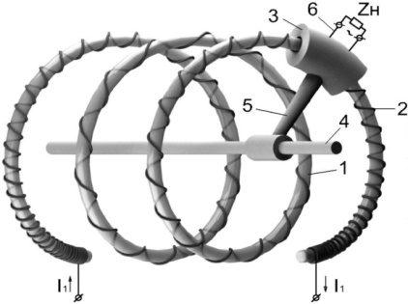 | 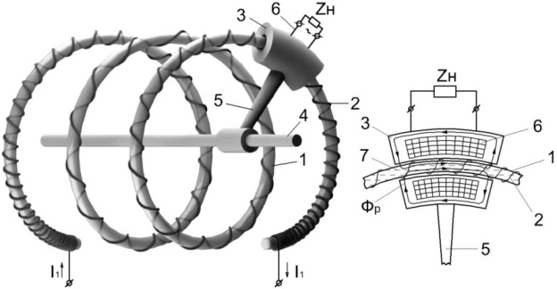
a) | b)
FIGURE 1. Structural diagram of a contactless adjustable-range transformer ferromagnetic current converter:
a – general view; b – structure of the measuring coil movable magnetic conductor
The ferromagnetic current transformer consists of a stationary, non-magnetic, and insulating core (1), a primary winding (2) wound around it with a number of turns varying according to a specific functional law, and a movable ferromagnetic magnetic conductor (3). The magnetic conductor (3) is able to move along the core (1) while rotating around the common axis (4) with the help of a rod (5). Moreover, the variable (6) includes elements such as a measuring coil and a tube (1), as well as a ferromagnetic liquid (7) that is held in place by a magnetic field at the location of the movable (3) magnetic conductor of the core. The primary coil (2) is multi-turn and wound around the core (1) in such a way that the net number of turns gradually increases from one end of the core to the other. This ferromagnetic current transformer belongs to the category of laboratory current transformers, which are low-power and have an air gap [6-10].
The created ferromagnetic current transformer operates as follows. (2) When an alternating current that needs to be modified flows through the primary coil, the alternating magnetic flux generated around it (6) induces an alternating electromotive force in the secondary coil. Since the secondary winding is connected to a load, the resulting secondary current is proportional to the primary current, just like in current transformers.
This new ferromagnetic current transformer is designed for converting relatively small alternating currents and has the capability to extend the lower limit of its measurement range without contact, that is, without interrupting the primary circuit. For this purpose, the movable magnetic conductor is moved along the multi-turn core and positioned at the part of the primary winding turns that has a greater comparative value [11-13].
The newly developed ferromagnetic current transformer (Fig.2) consists of a high-current-carrying busbar (1), multi-turn magnetic conductors made in the form of ferromagnetic rods (2) arranged in a series and surrounding it, and П-shaped (3) ferromagnetic elements. At one end of the transformer, there is a longitudinally positioned ferromagnetic rod-connector (4) and a movable small ferromagnetic rod (5). (6) The Hall element is placed in the intended δ air gap in the first winding of the multi-turn magnetic conductor [14-16].
FIGURE 2. Variable-range ferromagnetic current transformer circuit
When a measured direct or alternating current (1) passes through a busbar, it induces a magnetomotive force in each turn of a multi-turn magnetic conductor, and the total magnetomotive force in the multi-turn magnetic circuit is equal to the sum of the magnetomotive forces in the individual turns. Under the influence of this general magnetic driving force, a working magnetic flux is generated in the magnetic circuit, and as it intersects the Hall element, a Hall electromotive force proportional to the current passing through the output circuit (1) is produced [17-23].
When measuring large currents, the ferromagnetic small core (5) is installed such that (as shown in Fig.2, with the ferromagnetic small core (5) indicated by continuous lines), the working magnetic flux combines along only one flux of the multi-turn magnetic conductor. In this case, the working magnetic flux is determined by the following expression (the magnetic reluctance of the steel parts in the magnetic circuit is not taken into account, i.e., μ→∞):
$Q_{μ1}=μ_{0}\frac{S_{μ}}{2δ}I_{e1}$, (1)
Here, μ and μ₀ are, respectively, the relative magnetic permeability of the steel material and the magnetic constant, H/m; $S_{μ}$ – is the cross-sectional area along the working magnetic flux path of the magnetic circuit, m²; $I_{e1}$ – is the measured current, A.
When measuring relatively small currents, the (5) ferromagnetic small core is installed in such a way that (as shown in Fig.2, the (5) ferromagnetic small core is indicated with dashed lines), resulting in the working magnetic flux combining through several turns of the multi-turn magnetic conductor [24-28].
For this case, the working magnetic flux will be equal to the following:
$Q_{μ2}=w_{м}μ_{0}\frac{S_{μ}}{2δ}I_{e1}$, (2)
Here, $w_{м}$ – is the number of turns in the portion of a multi-turn magnetic conductor where the working magnetic flux is combined.
As can be seen from expressions (1) and (2), at the same measured current, using a multi-turn magnetic conductor results in a working magnetic flux that is $w_{м}$ times greater than that in a single-turn magnetic conductor. That is, by changing the position of the small ferromagnetic rod in (5), it becomes possible to adjust the measurement range of the ferromagnetic current transformer by extending its lower limit [29-32].
The third newly developed ferromagnetic current transformer (Figure 3) was created as a result of improving the existing current measuring device of this type using the energy-information method. The existing device consists of two unclosed ferromagnetic ring-shaped conductors arranged in parallel, two long parallel ferromagnetic rods connecting them, and Hall elements connected in series and placed between them. The bus carrying the current to be measured passes through or is wound around the ferromagnetic ring-shaped conductors [33-37].
a) | b)
c)
FIGURE 3. Schematics of the new ferromagnetic current transformer: a and b – constructive schematics of ferromagnetic current transformers with an unclosed ferromagnetic ring-shaped magnetic core, having two and three magnetic conductors, respectively; c – interconnection scheme of the Hall elements
The drawbacks of this existing current measuring device are as follows: first, due to the presence of two parallel ferromagnetic rods arranged along the busbar, its overall dimensions along the busbar are very large; second, in the two open ferromagnetic ring-shaped magnetic conductors, the measured currents create two oppositely directed magnetic driving force sources, which reduces the magnetic field induction in the working air gap and, consequently, decreases the sensitivity; third, the value of induction in the working air gap between the two parallel ferromagnetic rods is not uniform, which naturally lowers the measurement accuracy [36-38].
Therefore, the invention is aimed at reducing the dimensions of the existing ferromagnetic current transformer, increasing its sensitivity, and improving measurement accuracy.
To implement the above task, the existing ferromagnetic current transformer contains two open-ended ferromagnetic ring-shaped magnetic conductors, whose differently named terminals are interconnected by ferromagnetic cores. Hall elements connected in series with each other are placed in the ring-shaped air gap between the two open-ended ferromagnetic ring-shaped magnetic conductors, and the measured current-carrying windings enclose both of these open-ended ferromagnetic ring-shaped magnetic conductors together [37-39].
In the new ferromagnetic current transformer, the winding whose current needs to be measured (1) and two non-closed ferromagnetic ring-shaped cores (2) and (3), arranged parallel to each other, are jointly surrounded, while the differently named terminals of the rings (2) and (3) are connected to each other through a ferromagnetic rod-type connector (4). Five Hall elements (2) and (3), connected in series, are placed in a ring-shaped δ₁ air gap between the rings. When measuring large currents, a busbar-like conductor passing through a non-saturated ferromagnetic toroidal core can be used [39].
To extend the lower limit of the measurement range, additional ring-shaped ferromagnetic conductors (7) without clamps and the ferromagnetic rods (8) connecting them can be used, and between the ring-shaped magnetic conductors, additional serially connected Hall elements (9) can be placed (see Figures 3b and 3c).
When a current flows through the (1) coil (or (6) busbar), an equal magnetomotive force $U_{μx}$ is generated in the (2) and (3) ferromagnetic ring-shaped magnetic conductors, which are not short-circuited. Since the unclosed ferromagnetic ring conductors (2) and (3) are connected to each other by a ferromagnetic core (4) through their identically named terminals (marked as A and B in the schematic of Fig.3a), the magnetic driving forces generated by the unclosed ferromagnetic ring conductors (2) and (3) add to each other. The working magnetic flux $Q_{μ}$ is generated through the conductor rings (2) and (3) under the influence of the resultant magnetic driving force, the ferromagnetic core (4), and the ring-shaped air gap connecting them. When Hall elements, placed in the working air gap with magnetic flux lines and supplied with uniform working currents, are intersected, Hall voltages arise at their Hall outputs [40-43].
The resulting electric driving force in the overall output of Hall elements connected in series is generated, the magnitude of which is determined using the following expression:
$E_{exit.}={nK}_{h}I_{h}B$, (3)
Here, $K_{h}$ - is the Hall element's sensitivity coefficient, [V/(A⋅T)]; $I_{h}$ - is the stable operating current supplied to the current sections, [A]; $B$ - is the magnetic flux density in the working $δ_{1}$ air gap between non-saturated ferromagnetic ring-shaped magnetic conductors, [T]; $n$ - is the number of Hall elements placed in the working $δ_{1}$ air gap of the ring.
In this ferromagnetic current transformer, the longitudinal overall dimension is determined by the length of the ferromagnetic core-connector (4), which is connected to ring-shaped ferromagnetic conductors with an air gap δ₁ that is not fixed and is much shorter than the length of the parallel ferromagnetic core-connectors determining the longitudinal overall dimension in the prototype [41-43].
In a new ferromagnetic current transformer, the magnetomotive forces produced by the measured current in the non-closed ferromagnetic ring-shaped magnetic conductors are additive, which contributes to an increase in the magnetic induction in the working air gap and, consequently, enhances the sensitivity of the ferromagnetic current transformer. In the working δ₁ air gap between the non-saturated ferromagnetic ring-shaped conductors, the magnetic induction is evenly distributed along the angular coordinate where the Hall elements are placed, because the like-named poles of the two non-saturated ferromagnetic (2) and (3) ring-shaped conductors are connected to each other via a ferromagnetic rod (4), making the magnetic reluctances along the path of the resulting working magnetic flux equal. For this reason, the new ferromagnetic current transformer measures current with smaller errors. In this case, it is assumed that the magnetic flux does not pass through the non-working δ₂ air gaps (since δ₂≫δ₁) [43].
The sensitivity threshold of the transformer ferromagnetic current transducer mentioned above has a relatively high value. This, in turn, narrows its scope of application. Therefore, this paper aims to reduce the threshold sensitivity of the ferromagnetic current transformer in order to expand its field of application.
To accomplish the given task, a ring-shaped element was constructed in the form of two electrically insulated rings arranged opposite each other, with air gaps provided at their opposing ends. The formation of the ring-shaped element in this way allows the sensitivity threshold of this ferromagnetic current transducer to be reduced to the sensitivity threshold of a conventional current transformer [43].
Figures 4–6 show the new constructive schemes of the transformer ferromagnetic current converter. Specifically, Figure 4 presents its axonometric view, Figures 5a and 5b show the front and top views of the ferromagnetic current converter, respectively, and Figure 6 illustrates the connection of the current-receiving outputs to the diametral connectors.
The ferromagnetic current-transforming device is composed of two mutually opposed ring-shaped elements (1) and (2) made of electrically conductive material, as well as diametrically connected conductors (3) and (4), which are insulated from each other by a dielectric layer (5). A solid ferromagnetic core (6) surrounds the diametrically connected conductors. The secondary winding (7) is evenly wound on the ferromagnetic core (6). The current-carrying outputs (8) are connected either to the diametrically connected conductors (3) and (4) or to the ring-shaped elements (1) and (2) [40-43].
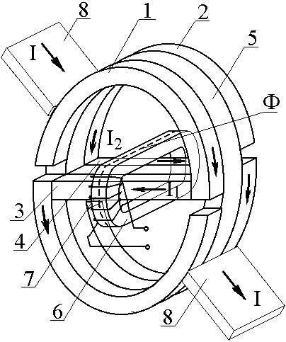
FIGURE 4. Axonometric view of the new transformer ferromagnetic current converter: 1, 2 – ring-shaped elements; 3, 4 – diametral connectors; 5 – dielectric layer; 6 – closed ferromagnetic core;
7 – secondary winding; 8 – current-receiving outputs
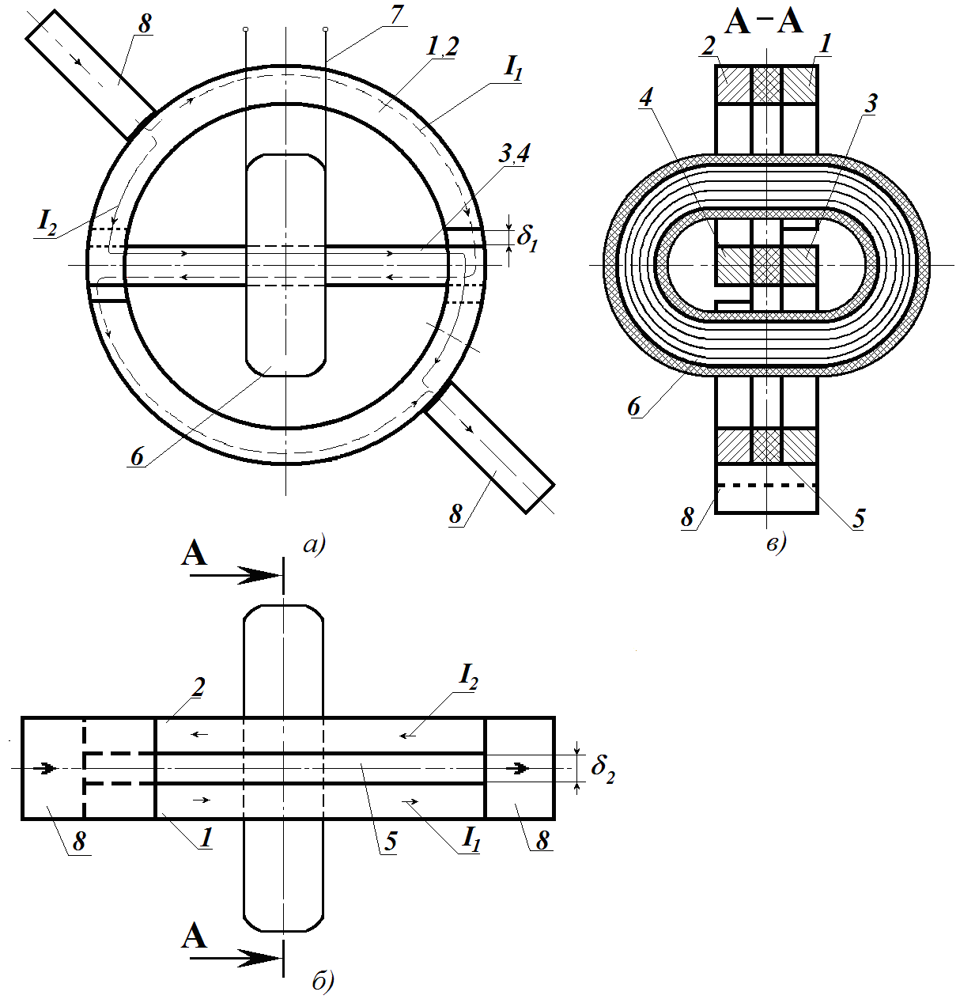
a) | b) | c)
FIGURE 5. Structural diagrams of a ferromagnetic current transformer:
a – view from the front, b – view from above
The secondary measuring coil is connected to the load. In this ferromagnetic current regulator, the measurement range is adjusted by generating opposing magnetic driving forces in the magnetic circuit and altering their values through the adjustment of the primary electrical circuit's resistance.
The new ferromagnetic current transformer operates as follows. When it is required to extend the upper limit of the measurement range (8), the current-carrying outputs (1) and (2) are connected diametrically to the ring-shaped elements (Fig.5,a). In this case, the values of the currents in the diametrically connected conductors are not equal to each other, and their directions are opposite, creating opposing magnetomotive forces in the closed ferromagnetic core. Therefore, in this case, the value of the resultant magnetic flux generated in the closed ferromagnetic core decreases sharply, resulting in the saturation process occurring at relatively higher currents [41-43].
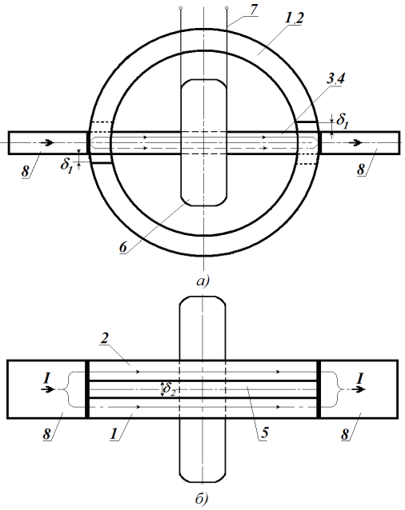
a) | b)
FIGURE 6. Constructive diagrams of a new ferromagnetic current converter when used like a simple current transformer: a – front view, b – top view
When the proposed new ferromagnetic current transformer is required to operate within the range of a standard current transformer, the current-measuring outputs are fixed to the diametrically connected terminals with bolts, through which the alternating current to be measured is passed (Fig.6). In this case, currents flow in the same direction through the diametral connectors.
The analysis of the design structure and operating modes of this new ferromagnetic current converter shows that its measurement range has a lower limit comparable to that of a conventional current transformer, while its upper limit is virtually unrestricted, and a ferromagnetic core can be used in the form of a toroidal core made from commercially produced ferromagnetic tape. Moreover, since the magnetic flux in the ferromagnetic core is generated due to the difference between the two currents passing in opposite directions through the diametral conductors, the effect of the aperiodic component that appears in the primary current during transient modes in the power system on measurement results is significantly reduced [41-43].
The above information indicates that the functional capabilities of this ferromagnetic current converter have been significantly expanded in relation to the series-produced current transformers.
Thus, the study of the functional capabilities of the four new ferromagnetic current transformers briefly analyzed in this article showed that the first design-whose range can be adjusted without contact (without disconnecting the chain from the source), as shown in Figure 1-is convenient for measuring variable currents that change over a wide range in low-power circuits. However, its use is not advisable for measuring currents in electrical supply systems with devices operating at 27.5 kV and above. In the second design shown in Figure 2, it is possible to calibrate the measurement range contactlessly, and it can be used to measure currents in electrical power supply systems at voltages of 27.5 kV and above, as well as for measuring both direct and alternating currents. Moreover, this ferromagnetic current transformer can also be used in transformer mode by winding a measuring coil around its multi-turn ferromagnetic core. To calibrate the measurement ranges of the third and fourth new ferromagnetic current transformers shown in Figures 3-6, it is necessary to remove and reinstall them from the power supply circuit [1-3, 23, 43].
Based on the above, it can be concluded that among the four newly developed ferromagnetic current transformers, the design shown in Figure 5 best meets the requirements of control and management systems for traction power supply equipment.
CONCLUSION
The article presents conclusions on the study of new designs of ferromagnetic current transformers with an extended range in the field of electrical engineering:
- using the energy-information method of technical creativity, 57 generalized methods for improving the operational characteristics of ferromagnetic current converters were identified, and as a result of applying them, four new designs of ferromagnetic current converters were developed;
- it was determined that if the turns of the primary winding, where current is measured, are distributed along the length (or angle) according to a specific law, and the secondary winding is made to enclose a portion of the primary winding with the possibility of displacement, this allows for adjusting the measuring range by changing the lower limit of the current;
- it has been established that constructing a multi-turn ferromagnetic core around the conductor (busbar) with an increasing number of magnetic conductor windings enhances the sensitivity of the ferromagnetic current transformer and allows the possibility of extending its measurement range by adjusting its lower limit.
REFERENCES
1. M.Sadullaev, E.Usmanov, R.Karimov, D.Xushvaktov, D.Xalmanov, Y.Shoyimov, D.Khimmataliev. Mathematical Models and Calculation of Elements of Developed Schemes of Contactless Devices. AIP Conference Proceedings, 3331(1), 040043, (2025), https://doi.org/10.1063/5.0305748
2. E.Yuldashev, M.Yuldasheva, A.Togayev, J.Abdullayev, R.Karimov. Energy efficiency research of conveyor transport. AIP Conference Proceedings, 3331(1), 040030, (2025), https://doi.org/10.1063/5.0305742
3. E.Abduraimov. Automatic control of reactive power compensation using a solid state voltage relays. Journal of Physics Conference Series, 2373(7), 072009, (2022). DOI 10.1088/1742-6596/2373/7/072009
4. E.Abduraimov, D.Khalmanov. Invention of a contactless voltage relay with an adjustable reset ratio. Journal of Physics Conference Series, 2373(7), 072010, (2022). DOI 10.1088/1742-6596/2373/7/072010
5. M.Sadullaev, E.Usmanov, R.Karimov, D.Xushvaktov, N.Tairova, A.Yusubaliev. Review of Literature Sources and Internet Materials on Contactless Devices for Reactive Power Compensation. AIP Conference Proceedings, 3331(1), 040041, (2025), https://doi.org/10.1063/5.0305878
6. M.Sadullaev, M.Bobojanov, R.Karimov, D.Xushvaktov, Y.Shoyimov, H.Achilov. Experimental Studies of Contactless Devices for Controlling the Power of Capacitor Batteries. AIP Conference Proceedings, 3331(1), 040044, (2025), https://doi.org/10.1063/5.0307195
7. E.Usmanov, M.Bobojanov, R.Karimov, D.Xalmanov, N.Tairova, S.Torayev. Contactless Switching Devices Using Nonlinear Circuits. AIP Conference Proceedings, 3331(1), 040031, (2025), https://doi.org/10.1063/5.0305744
8. K.Abidov, A.Alimov, M.Gafurova. Transients in Devices of Control Systems With Excitation Winding. AIP Conference Proceedings, 3331(1), 040033, (2025), https://doi.org/10.1063/5.0305756
9. K.Abidov, E.Abduraimov, M.Gafurova. Possibility of Applying Methods of Analysis and Synthesis of Linear Electrical Circuits to Some Nonlinear Circuits. AIP Conference Proceedings, 3331(1), 040034, (2025), https://doi.org/10.1063/5.0305757
10. O.Ishnazarov, N.Khamudkhanova, K.Kholbutayeva, K.Abidov. Energy Efficiency Optimization in Irrigation Pump Installations. AIP Conference Proceedings, 3331(1), 040036, (2025), https://doi.org/10.1063/5.0305844
11. K.Abidov, A.Alimov, N.Khamudkhanova, M.Gafurova. Determination of the Permissible Number of Pumping Units Supplied From the Transformer of the Amu-Zang-I Substation, Selection of the Power of Static Capacitors. AIP Conference Proceedings, 3331(1), 040029, (2025), https://doi.org/10.1063/5.0305754
12. F.Akbarov, R.Kabulov, A.Alimov, E.Abduraimov, D.Nasirova. Dependence of Output Parameters of Photovoltaic Module Based on CIGS Solar Cells on External Temperatures. AIP Conference Parameters, 3331(1), 040046, (2025), https://doi.org/10.1063/5.0305885
13. A.Alimov, K.Abidov, E.Abduraimov, F.Akbarov, H.Muminov. Generalized Model of Nonlinear Inductance and its. AIP Conference Parameters, 3331(1), 040035, (2025), https://doi.org/10.1063/5.0305883
14. E.Abduraimov, M.Peysenov, N.Tairova. Development of Contactless Device for Maintaining the Rated Voltage of Power Supply Systems. AIP Conference Proceedings, 2552, 040012, (2022). https://doi.org/10.1063/5.0116235
15. A.Nuraliyev, I.Jalolov, M.Peysenov, A.Adxamov, S.Rismukhamedov, R.Karimov. Improving and Increasing the Efficiency of the Industrial Gas Waste Cleaning Electrical Filter Device. AIP Conference Proceedings, 3331(1), 040040, (2025), https://doi.org/10.1063/5.0305751
16. M.Sadullaev, E.Usmanov, R.Karimov, D.Xushvaktov, N.Tairova, A.Yusubaliev. Development of Contactless Device Schemes for Automatic Control of the Power of a Capacitor Battery. AIP Conference Proceedings, 3331(1), 040042, (2025), https://doi.org/10.1063/5.0305879
17. E.Abduraimov, D.Khalmanov, B.Nurmatov, M.Peysenov, N.Toirova. Analysis of dynamic circuits of contactless switching devices. Journal of Physics Conference Series, 2094(2), 022072, (2021). DOI 10.1088/1742-6596/2094/2/022072
18. Y.Adilov, A.Nuraliyev, M.Abdullayev, S.Matkarimov. Dynamic Performance Model of a Hybrid Power System. AIP Conference Proceedings, 3331(1), 040038, (2025). https://doi.org/10.1063/5.0305909
19. Y.Adilov, M.Khabibullaev. Application of fiber-optic measuring current transformer in control and relay protection systems of belt conveyor drives. IOP Conference Series Earth and Environmental Science, 614(1), 012022, (2020), doi:10.1088/1755-1315/614/1/012022
20. R.Yusupaliyev, N.Musashayxova, A.Kuchkarov. Methods of Purification of Polluted Water from Ammonia Compounds at Nitrogen Fertilizer Plants. E3S Web of Conferences, 563, 03085, (2024). https://doi.org/10.1051/e3sconf/202456303085
21. R.Yusupaliev, N.Kurbanova, M.Azimova, N.Musashaikhova, A.Kuchkarov. Establishing a Water-chemical Regime and Increasing the Efficiency of Combustion of a Mixture of Fuel Oil and Gas in a DE 25-14 GM Boiler: A Case Study of the Kokand Distillery. AIP Conference Proceedings, 2552, 030026, (2022), https://doi.org/10.1063/5.0130471
22. R.Yusupaliev, B.Yunusov, M.Azimova. The composition of natural waters of some source rivers of the republic of Uzbekistan, used in the thermal power engineering and the results of the experimental researches at preliminary and ion exchange treatment of water. E3S Web of Conferences, 139, 01083, (2019), https://doi.org/10.1051/e3sconf/201913901083
23. S.Kasimov, A.Sulliev, A.Eshkabilov. Optimising Pulse Combustion Systems for Enhanced Efficiency and Sustainability in Thermal Power Engineering. E3S Web of Conferences, 449, 06006, (2023), https://doi.org/10.1051/e3sconf/202344906006
24. M.Azimova, N.Kurbanova, D.Rakhmatov. Large-scale environmental benefits of biogas technology. AIP Conference Proceedings, 3152(1), 060007, (2024), https://doi.org/10.1063/5.0218937
25. M.Jalilov, M.Azimova, A.Jalilova. On a new technology of preparation of hot drinking water. Energetika Proceedings of Cis Higher Education Institutions and Power Engineering Associations, 60(5), (2017), pp.484-492. https://doi.org/10.21122/1029-7448-2017-60-5-484-492
26. S.Amirov, A.Sulliev, U.Mukhtorov. Resonance sensors of motion parameters. AIP Conference Proceedings, 3256(1), 050028, (2025). https://doi.org/10.1063/5.0267548
27. K.Turdibekov, A.Sulliev, O.Iskandarova, J.Boboqulov. Experimental and statistical methods for studying the modes of electric power systems under conditions of uncertainty. E3S Web of Conferences, 452, 04002, (2023), https://doi.org/10.1051/e3sconf/202345204002
28. S.M.Turabdzhanov, J.M.Tangirov, P.M.Matyakubova, N.S.Amirkhulov, S.S.Khabibullaev. Methods of providing metrological supply when pumping water into wells in oil fields. AIP Conference Proceedings, 3045(1), 030073, (2024), https://doi.org/10.1063/5.0197355
29. S.Amirov, A.Sulliev, S.Sharapov. Study on differential transformer displacement sensors. E3S Web of Conferences, 434, 02011, (2023), https://doi.org/10.1051/e3sconf/202343402011
30. S.Amirov, A.Sulliev, K.Turdibekov. Investigation of biparametric resonance sensors with distributed parameters. E3S Web of Conferences, 377, 01002, (2023), https://doi.org/10.1051/e3sconf/202337701002
31. M.Yakubov, A.Sulliev, A.Sanbetova. Modern methods of evaluation of metrological indicators of channels for measurement and processing of diagnostic values of traction power supply. IOP Conference Series Earth and Environmental Science, 1142(1), 012010, (2023), doi:10.1088/1755-1315/1142/1/012010
32. K.Turdibekov, A.Sulliev, I.Qurbanov, S.Samatov, A.Sanbetova. Voltage Symmetration in High Speed Transport Power Supply Systems. AIP Conference Proceedings, 2432, 030084, (2022), https://doi.org/10.1063/5.0089958
33. K.Turdibekov, M.Yakubov, A.Sulliev, A.Sanbetova. Mathematical Models of Asymmetric Modes in High-Speed Traffic. Lecture Notes in Networks and Systems, 247, (2022), pp.1051-1058. DOI:10.1007/978-3-030-80946-1_95
34. S.K.Shah, L.Safarov, A.Sanbetova, and etc. Investigation on composite phase change materials for energy-saving buildings. E3S Web of Conferences, 563, 01003, (2024), https://doi.org/10.1051/e3sconf/202456301003
35. A.Sanbetova, A.Mukhammadiev, A.Rakhmatov, Z.Beknazarova. Study on cultivation of environmentally friendly seed potatoes based on electrical technology. E3S Web of Conferences, 377, 03001, (2023), https://doi.org/10.1051/e3sconf/202337703001
36. J.Safarov, A.Khujakulov, Sh.Sultanova, U.Khujakulov. S.Verma. Research on energy efficient kinetics of drying raw material. E3S Web of Conferences, 216, 01093, (2020). https://doi.org/10.1051/e3sconf/202021601093
37. Y.Y.Shoyimov, K.N.Kudratova, O.A.Shodiyev. Speed adjustment relay in conveyor device. Journal of New Century Innovations, 41(2), (2023). pp.45-51.
38. Sh.Umarov, Kh.Sapaev, I.Abdullabekov. The Implicit Formulas of Numerical Integration Digital Models of Nonlinear Transformers. AIP Conference Proceedings, 3331, 030105, (2025), https://doi.org/10.1063/5.0305793
39. I.Abdullabekov, M.Mirsaidov, F.Tuychiev, R.Dusmatov. Frequency converter – asynchronous motor – pump pressure piping system mechanical specifications. AIP Conference Proceedings, 3152, 040007 (2024). https://doi.org/10.1063/5.0218880
40. I.Abdullabekov, M.Mirsaidov, Sh.Umarov, M.Tulyaganov, S.Oripov. Optimizing energy efficiency in water pumping stations: A case study of the Chilonzor water distribution facility. AIP Conference Proceedings, 3331, 030107, (2025). https://doi.org/10.1063/5.0305780
41. M.Bobojanov, F.Tuychiev, N.Rashidov, A.Haqberdiyev, I.Abdullabekov. Dynamic simulation of a three-phase induction motor using Matlab Simulink. AIP Conference Proceedings, 3331, 040012, (2025). https://doi.org/10.1063/5.0305750
42. M.Tulyaganov, Sh.Umarov, I.Abdullabekov, Sh.Adilova. Optimization of modes of an asynchronous electric drive taken into account thermal transient processes. AIP Conference Proceedings, 3331, 030084, (2025). https://doi.org/10.1063/5.0305786
43. M.Mirsadov, B.Fayzullayev, I.Abdullabekov, A.Kupriyanova, D.Kurbanbayeva, U.Boqijonov. The mutual influence of electromagnetic and mechanical processes in dynamic modes of inertial vibrating electric drives. IOP Conference Series Materials Science and Engineering, 862(6), 062081, (2020). doi:10.1088/1757-899X/862/6/062081

