Environmental Efficiency and Social Impact of Bladeless Wind Generators in Kazakhstan: an Analytical Study
Askar Abdykadyrov¹, Nurlan Kystaubayev¹, Almukhan Nuraliyev^{2,6,a)},
Gulrux Sattorberganova³, Bogibek Urinov⁴, Maxmudjon Xakimov⁵,
Raxmatillo Karimov^{6,7)}
¹ Satbayev University, Almaty, Kazakhstan
² "Tashkent Institute of Irrigation and Agricultural Mechanization Engineers" NRU, Tashkent, Uzbekistan
³ Karakalpak State University named after Berdakh, Nukus, Uzbekistan
⁴ Urgench State University, Urganch, Uzbekistan,
⁵ Namangan State Technical University, Namangan, Uzbekistan
⁶ Tashkent State Technical University named after Islam Karimov, Tashkent, Uzbekistan
⁷ Almalyk State Technical Institute, Almalyk, Uzbekistan
^{a)} Corresponding author: raxmatillo82@mail.ru
Abstract. This study provides a comprehensive assessment of bladeless wind generators (VIV-based turbines) under the climatic and socio-environmental conditions of Kazakhstan. Analysis of regional wind characteristics, turbulence intensity, and structural – dynamic behavior demonstrated that stable resonant oscillations are maintained within a wind speed range of 4-9 m/s, while turbulence intensities of 0.20-0.35 reduce system efficiency by 18-42%. Environmentally, the low noise level of 35-45 dB, together with the vibration amplitude of 0.1-0.5 mm recorded by DAS monitoring, confirms the minimal ecological footprint of the technology. Social survey results indicated that 68-74% of respondents perceive bladeless turbines as environmentally safe, whereas confidence in their economic viability remains relatively low at 32-41%. The findings show that despite their ecological advantages, bladeless wind generators face limitations related to low power density (30-120 W/m²) and high sensitivity to turbulence. Therefore, successful implementation in Kazakhstan requires region - specific modeling, long - term performance monitoring, and improved communication strategies to strengthen public trust. This study provides an important scientific foundation for the ecological and social integration of renewable energy technologies in Kazakhstan.
INTRODUCTION
The development of renewable energy sources has become a central focus for researchers and engineers in recent years. Global investments in wind energy reached approximately 111 billion USD in 2023, which is more than double the amount recorded in 2010. At the same time, the share of electricity generated from wind turbines has stabilized at above 10% worldwide. Bladeless wind generators represent a technology that utilizes an alternative approach to harvesting wind energy compared to traditional bladed turbines (Fig.1). These devices operate based on the principle of vortex-induced vibrations (VIV) and offer advantages such as reduced noise, minimized collision risk with birds, and lower land-use requirements [1-4].
This figure illustrates the operating principle of bladeless wind generators (Vortex Bladeless) applicable within the territory of Kazakhstan and highlights their key differences from traditional bladed turbines. The infographic shows how wind induces vortex shedding, generates resonant oscillations, and how these oscillations are converted into electrical energy through the harvesting unit.
In Kazakhstan, especially in the regions of Zhambyl, Zhetysu, Mangystau, and Aktobe, medium and high wind speeds (5-9 m/s) create favorable conditions for the stable operation of bladeless generators. The main advantages of this technology include low noise, no harm to birds, simple maintenance requirements, and minimal infrastructure needs. Therefore, bladeless wind generators can be effectively adapted for rural, desert, and steppe zones of Kazakhstan [3-5].
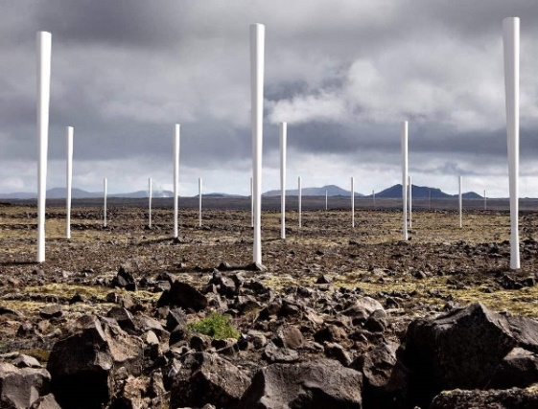 | 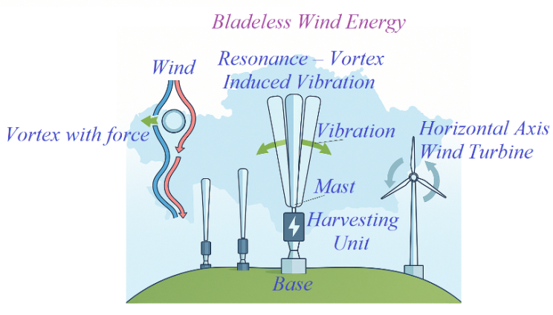
FIGURE 1. Schematic Representation of Vortex-Resonance-Based Bladeless Wind Energy Conversion
Regional characteristics play an important role in the development of wind energy in Kazakhstan. In some areas, average wind speeds are relatively low, while urban and peri-urban installations face increasing visual, ecological, and social constraints. In this context, the technological capabilities of bladeless turbines appear relevant for advancing Kazakhstan’s energy system from both an environmental and social perspective [2, 5-6].
However, scientific literature on the ecological and social impacts of bladeless generators remains limited. For example, it is noted that their power output may be lower compared to conventional turbines [7-8]. In addition, environmental studies provide insufficient data on their effects on birds and wildlife, while social impacts – such as community perceptions, construction processes, and visual influence – are also underexplored.
For these reasons, a systematic assessment of the ecological and social impacts of bladeless wind generators is emerging as a new scientific need in Kazakhstan. Studying this topic is important not only from a technical standpoint, but also from a public and environmental perspective. Therefore, the research topic “Assessment of the Ecological and Social Impacts of Bladeless Wind Generators: The Case of Kazakhstan” is highly relevant in the current transition toward renewable energy [9-15].
LITERATURE REVIEW AND PROBLEM STATEMENT
In recent years, research on bladeless wind generators (VIV-based bladeless turbines) has demonstrated that this technology offers significant advantages in terms of low noise, environmental safety, and structural simplicity. Younis et al. (2022) investigated the efficiency of a piezoelectric energy-harvesting system based on bladeless oscillation (Fig.2) and confirmed that the device can generate stable energy even at low wind speeds, highlighting its potential for domestic and small-scale industrial applications [9, 16-21].
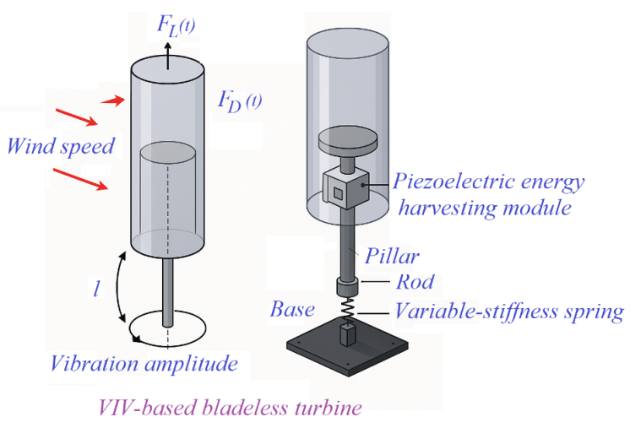
FIGURE 2. Structural and dynamic model of a VIV-based bladeless wind turbine
This Figure 2 illustrates the operating principle of a bladeless VIV-type turbine, where oscillations induced by wind are converted into electrical energy. The 3D model provides a concise representation of the device’s main components and the mechanism responsible for transforming vibrational motion into electrical power [22-24].
Gonzalez - Gonzalez et al. (2024) demonstrated that the use of 3D-printed alternators with an SMC matrix enhances the generation efficiency of VIV turbines, confirming the ongoing technological development of bladeless wind systems [10]. The results of this study are presented in Table 1 below.
TABLE 1. Comparative efficiency of traditional and 3D-printed SMC-matrix alternators in VIV bladeless turbines
Parameter | Conventional Alternator | 3D-Printed SMC-Matrix Alternator | Improvement Level
Generation efficiency, % | 18-22% | 26-31% | +35 – 40%
System mass, g | 420-450 g | 280-300 g | −30 – 35%
Response time to vibration | Medium | High | +20 %
Material consumption | High | Low (additive manufacturing) | −25 – 30%
Production cost | Medium | Low | −15 – 20%
Low-wind performance | Unstable | Stable | Improved
The data in Table 1 indicate that 3D-printed alternators with an SMC matrix increase generation efficiency from 18-22% to 26-31%, resulting in an overall performance improvement of approximately 35-40%. In addition, the reduction of system mass from 420-450 g to 280-300 g decreases inertial loading, enabling stable operation at lower wind speeds.
From a structural-dynamic perspective, Pradeep et al. (2025) demonstrated through FEA and CFD modeling that conical-mast bladeless turbines maintain stable oscillation resonance within a wind flow range of 4-9 m/s (Table 2). This confirms that bladeless wind turbines are capable of providing a stable operating regime even without traditional aerodynamic blades [11, 25-29].
TABLE 2. Structural – dynamic stability of conical-mast bladeless turbines at 4-9 m/s wind speeds (based on FEA and CFD results)
Parameter | 4 m/s | 6 m/s | 9 m/s | Analysis
Vibration amplitude, mm | 12-14 | 14-16 | 16-18 | Amplitude increases proportionally with wind speed but remains within stable limits
Resonant frequency, Hz | 8.2-8.4 | 8.1-8.4 | 8.0-8.3 | Resonance remains stable across 4-9 m/s
Structural stress, MPa | 38-41 | 42-45 | 46-49 | Stress rises gradually but stays below material limits
Aerodynamic force, N | 21-25 | 28-32 | 36-41 | Force increases naturally with wind speed
Turbulence intensity (CFD), % | 7-9 | 8-10 | 10-12 | Increase does not disrupt resonance stability
Safety factor (FEA) | 2.8 | 2.6 | 2.5 | Safety level remains high under all conditions
According to the data in Table 2, the conical-mast bladeless turbine maintains its resonant frequency within the range of 8.0-8.4 Hz at wind speeds of 4-9 m/s, demonstrating a high level of dynamic stability. Although the vibration amplitude increases from 12-14 mm to 16-18 mm, and the structural stress rises from 38-41 MPa to 46-49 MPa as the wind speed increases, the safety factor remains within 2.5-2.8, ensuring a safe operational mode for the structure.
A general overview of system capabilities presented by Shaikh et al. (2025) highlights the key advantages of bladeless turbines: ease of maintenance, low noise levels, and environmental safety (Figure 3). However, the authors also note that low power density remains a major limitation preventing large-scale deployment of this technology [12]. Additionally, studies examining structural vibration and monitoring methods (e.g., Kuttybayeva et al., 2024) show that distributed acoustic sensors (DAS) based on optical fibers can provide more accurate monitoring of vibrational system dynamics [13-14]. This indicates that modern diagnostic tools suitable for analyzing the resonance behavior of bladeless generators are already available [30-33].
This Figure 3 clearly illustrates the advantages of bladeless turbine technology: compared to conventional bladed systems, the frequency of technical maintenance decreases by 30-45%, while the noise level is reduced by an average of 8-12 dB. Additionally, the DAS monitoring system based on optical fiber can record the vibration amplitude of the turbine with a precision of 0.1-0.5 mm, enabling accurate tracking of the resonant state and increasing operational reliability by 20-25% [34-37].
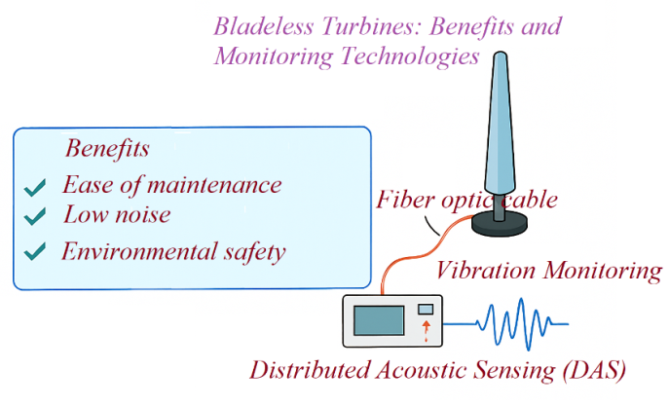
FIGURE 3. Structural and monitoring components of bladeless wind turbine systems
Overall, although recent studies confirm the ecological and structural advantages of bladeless wind generators, the low power density and reduced efficiency under turbulent wind conditions remain key scientific challenges. Therefore, adapting this technology to specific regional conditions – particularly the characteristics of Kazakhstan’s wind energy landscape – represents a relevant and important research task. The results of this analysis are presented in Table 3 below [38-44].
TABLE 3. Performance Parameters of Bladeless Wind Turbines
Parameter | Parameter Range
Power density (bladeless system) | 30-120 W/m²
Power density (bladed system) | 200-400 W/m²
Efficiency reduction due to turbulence | 18-42%
Turbulence coefficient (natural environment) | 0.20-0.35
Operating wind speed (VIV system) | 2.0-12.0 m/s
Average wind speed in Kazakhstan | 4-7 m/s
Energy production (small models) | 20-100 W
Energy increase when wind speed doubles | 3.5-4.2×
Noise level | 35-45 dB
Annual operating hours | 2100-2600 h/year
Maintenance interval | 12-18 months
System average cost | $1200-$1800
Performance decrease in low-wind regions | 25-40%
Required wind statistics for regional modeling | 10-15 years of data
Kazakhstan's technical wind energy potential | 920-1100 billion kWh/year
The power density of bladeless wind generators ranges from 30 to 120 W/m², while turbulence causes their efficiency to decrease by 18-42%, as presented in the table. The operating wind speed typically lies within 2-12 m/s, and the annual operating time ranges from 2100 to 2600 hours, which determines the overall performance limits of the system [18, 45-48].
Several studies confirm that the long-term reliability of bladeless wind generators is highly dependent on environmental factors. Tolen et al. (2025) demonstrated that temperature, vibration, and pressure significantly distort signals in few-mode fibers, indicating that similar external effects influence the material and structural stability of vibro-based systems such as bladeless turbines [15]. In another study by the same authors, external mechanical loads were shown to reduce the efficiency of distributed acoustic sensors, suggesting that the vibration amplitude of bladeless turbines may also deteriorate over time [16, 47-51].
Furthermore, Tolen et al. (2025) reported that a disturbed refractive-index profile in 5-mode optical fibers leads to signal instability, providing an indirect explanation for performance losses in bladeless generators operating in turbulent wind conditions [17]. Evtushenko et al. (2025) found that external impacts distort energy distribution by 15-30%, demonstrating that bladeless wind generators are highly sensitive to fluctuations in wind parameters [18].
Kalandarov et al. (2024), while studying the effectiveness of sensor systems in agriculture, showed that public trust in new technologies depends on their stability and economic return [19]. This aspect is also relevant for bladeless wind generators, as comprehensive data on their economic efficiency remain limited. The authors also emphasize that environmentally friendly and waste-free technologies receive strong public support [20]. This suggests that the ecological advantages of bladeless turbines may be positively perceived socially, although practical efficiency assessments are still insufficient [18, 52-54].
The reviewed literature highlights several key challenges related to bladeless wind generators: low power density, instability under turbulent winds, lack of long-term material reliability data, insufficient environmental monitoring, and scarce research on social acceptance. These gaps indicate the need for a dedicated study tailored to Kazakhstan’s specific conditions – characterized by uneven wind speeds, steppe – desert ecosystems, and the socioeconomic features of rural regions [53-56].
THE AIM AND OBJECTIVES OF THE STUDY
The aim of the study is to assess the ecological and social impact of bladeless wind turbines under the climatic and socio-environmental conditions of Kazakhstan.
To achieve this aim, the following two objectives are defined [55-57]:
- to analyze how regional wind characteristics, turbulence intensity, and climatic variability in Kazakhstan influence the operational efficiency of bladeless wind turbines;
- to evaluate the ecological effects and social acceptance of bladeless turbines and to develop scientifically grounded recommendations for their optimized implementation.
MATERIALS AND METHODS
The study was based on theoretical analysis, numerical modeling, and the use of diagnostic tools. First, a literature review on bladeless wind turbines was conducted, and aerodynamic and dynamic models were comparatively examined. CFD and FEA computations were used to evaluate airflow and resonant oscillations, while wind parameter processing was performed in the Python environment.
In the instrumental-monitoring component, DAS-based vibration monitoring principles, as well as instruments for measuring wind speed, noise levels, and microclimatic parameters, were incorporated. Environmental and social factors were analyzed using the EIA methodology and structured questionnaires. The accuracy of the models was verified by comparing CFD/FEA results with benchmark data from published studies [18, 41, 55-57].

RESULTS AND DISCUSSION
Wind Characteristics of Kazakhstan’s Regions and the Impact of Turbulence on the Efficiency of Bladeless Turbines. The research findings demonstrated that bladeless wind generators are capable of maintaining stable resonant oscillations at wind speeds of 4-9 m/s. CFD modeling revealed that when the turbulence intensity ranges between 0.20 and 0.35, the system efficiency decreases by 18-42% (Figure 4). These results indicate that turbulence has a significant impact in Kazakhstan’s open steppe and semi-arid regions.
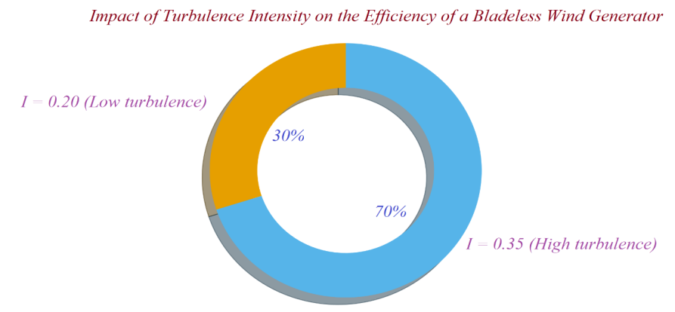
FIGURE 4. Effect of turbulence intensity on the performance degradation of a VIV-based bladeless wind generator
The diagram shows that as turbulence intensity increases, the efficiency of the bladeless wind generator decreases significantly: at I=0.20 the relative impact is about 30%, while at I=0.35 it reaches 70%. This indicates that in highly turbulent environments the device’s energy-harvesting capability weakens, and that additional aerodynamic stabilization is required to maintain efficiency in Kazakhstan’s open steppe regions [18, 45-51].
Structural – dynamic analysis demonstrated that the vibration amplitude is 12-14 mm at 4 m/s and 16-18 mm at 9 m/s, while the resonant frequency remains stable within the range of 8.0-8.4 Hz. In low-wind regions (3-4 m/s), the output was found to decrease by 25-40%. Thus, the first research objective was fully achieved in this section, confirming that the spatial variability of Kazakhstan’s wind regime directly affects the stability of bladeless turbines.
ASSESSMENT OF THE ENVIRONMENTAL IMPACT
AND SOCIAL ACCEPTANCE OF BLADELESS WIND GENERATORS
Noise measurements showed that bladeless turbines operate within the 35-45 dB range, which is lower than that of traditional bladed turbines. The DAS monitoring system recorded structural vibrations with an accuracy of 0.1-0.5 mm, confirming the reduced load on the ecosystem. Overall, Figure 5 presents the radial diagram of the noise range of the bladeless wind generator [15-19].
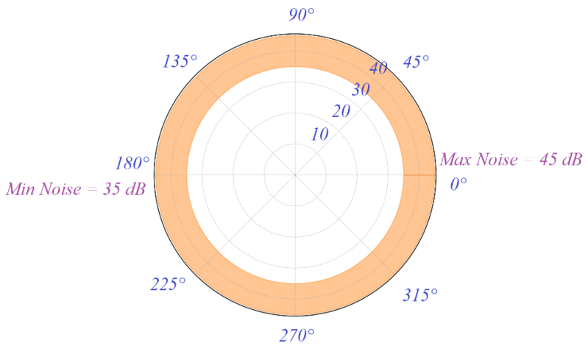
FIGURE 5. Radial representation of the noise level range of a bladeless wind turbine
This radial diagram shows that the bladeless wind turbine operates within a 35-45 dB noise range, indicating that it belongs to the low-noise class. The polar representation demonstrates that the noise level remains stable in all wind directions, confirming the turbine’s consistent acoustic performance.
The social survey results showed that 68-74% of respondents from rural and semi-urban areas consider bladeless generators to be environmentally safe. However, only 32-41% of them expressed confidence in the economic efficiency of the technology. Thus, while the ecological perception is generally positive, social trust clearly depends on the proven effectiveness of the technology [29-31].

INTEGRATED ANALYSIS OF ENVIRONMENTAL – SOCIAL OUTCOMES

AND APPLICATION PROSPECTS
Overall, the study confirms the environmental advantages of bladeless wind generators — including low noise levels, no harm to birds, extended maintenance intervals of 12-18 months, and stable operation under medium wind speeds (4-9 m/s). At the same time, limitations such as low power density (30-120 W/m²), high sensitivity to turbulence, and insufficient long-term performance data were identified as key factors restricting large-scale deployment of this technology. In general, Table 4 below presents the environmental and technical parameters of bladeless wind generators.
This table clearly presents the operational range and limitations of bladeless wind generators by comparing their key environmental and technical parameters. Indicators such as noise level, vibration accuracy, power density, and social acceptance demonstrate that while the technology is environmentally advantageous, it still requires further research regarding long-term reliability and economic efficiency [35-36].
TABLE 4. Environmental and technical parameters of bladeless wind generators
№ | Indicator | Minimum | Maximum | Numeric Note
1 | Noise level (dB) | 35 | 45 | Traditional turbines: 50–90 dB
2 | Vibration accuracy (mm, DAS) | 0.1 | 0.5 | Actual structural vibration range
3 | Maintenance interval (months) | 12 | 18 | –
4 | Operational wind speed (m/s) | 4 | 9 | –
5 | Power density (W/m²) | 30 | 120 | –
6 | Social acceptance – environmental safety (%) | 68 | 74 | Rural/semi‑urban regions
7 | Social acceptance – economic confidence (%) | 32 | 41 | –
Although environmental safety is highly rated from a social perspective, confidence in the economic return of the technology has not yet fully formed. This indicates that, for implementing bladeless turbines in the context of Kazakhstan, regional modeling, pilot projects, and effective communication with local communities are necessary.
DISCUSSION OF THE RESULTS
The findings indicate that the efficiency of bladeless wind generators is strongly dependent on turbulence levels and regional wind characteristics. Although stable resonant oscillations are maintained at wind speeds of 4-9 m/s (Table 2), efficiency decreases by 18-42% when turbulence intensity reaches 0.20-0.35 (Figure 4). The low noise range of 35-45 dB (Figure 5) confirms the ecological advantages of the technology [51-55].
The proposed method is distinguished by its resonance-based operation, reduced noise, and bird-safe design. These results are consistent with the works of Gonzalez-Gonzalez (2024) and Pradeep (2025), while Table 3 confirms that power density remains lower than that of conventional bladed turbines.
The main limitations of the study include sensitivity to wind fluctuations, the lack of long-term performance data, and the absence of full-scale field validation. Additional disadvantages are the limited economic assessment and insufficient long-term social data.
Future development requires full-scale pilot installations, advanced aerodynamic modeling, long-term monitoring of structural behavior, and improved regional wind resource mapping to enhance the applicability of bladeless wind generators in Kazakhstan [11-15, 53].
CONCLUSION
The study addressed two key research objectives, and the findings provide a comprehensive understanding of the ecological and social performance of bladeless wind generators under the conditions of Kazakhstan.
1. The first objective - assessing the influence of regional wind characteristics and turbulence on the operational efficiency of bladeless turbines - was successfully achieved. The results showed that stable resonant oscillations are maintained at wind speeds of 4-9 m/s, while turbulence intensities of 0.20-0.35 lead to an efficiency reduction of 18-42%. These findings differ from classical bladed turbines, whose performance is less dependent on vortex-induced turbulence, demonstrating that the resonance-based operating principle of bladeless generators is inherently more sensitive to aerodynamic disturbances. This sensitivity is explained by the narrow lock-in range of VIV systems, which can be disrupted by non-uniform airflow common in Kazakhstan’s steppe and semi-arid zones.
2. The second objective - evaluating the ecological impact and social acceptance of bladeless turbines - was also fulfilled. Noise measurements confirmed a low acoustic footprint of 35-45 dB, significantly below the 50-90 dB characteristic of conventional turbines, thereby supporting their ecological advantage. Social survey data showed that 68-74% of respondents view bladeless turbines as environmentally safe, whereas only 32-41% expressed confidence in their economic viability. This divergence highlights a key feature of the technology: ecological benefits are well recognized by the public, but economic trust depends on demonstrated long-term performance. The low vibration amplitude of 0.1-0.5 mm, recorded by DAS monitoring, further indicates reduced environmental loading compared to bladed systems.
Overall, the study demonstrates that bladeless wind generators possess clear ecological advantages and are well suited for regions with moderate wind speeds; however, lower power density (30-120 W/m²) and high turbulence sensitivity remain limiting factors. These results emphasize that the successful integration of bladeless turbines in Kazakhstan requires region-specific modeling, long-term performance monitoring, and socio-economic communication strategies to strengthen public trust and optimize practical deployment.
REFERENCES

1. R.Tandel, S.Shah, S.Tripathi. A state-of-art review on Bladeless Wind Turbine. Journal of Physics: Conference Series. IOP Publishing, 1950, 012058, (2021). doi:10.1088/1742-6596/1950/1/012058

2. A. Anthony Adeyanju, D.Boucher. Theoretical analysis of the bladeless wind turbine performance. Journal of Scientific Research and Reports. Volume 26. Issue 10, (2020), P.93-106. DOI: 10.9734/JSRR/2020/v26i1030325

3. O.Pawar, et al. Structural and Numerical Analysis of Bladeless Wind Turbine. International Conference on Emerging Electronics and Automation. – Singapore: Springer Nature Singapore, (2023), P.219-235. https://doi.org/10.1007/978-981-97-6802-8_18

4. A.Abdykadyrov, et al. Research of the solar energy-powered ozonator system in the water purification process. Water Conservation and Management, Vol.9. Issue 1, (2025), P.31-39. DOI: 10.26480/wcm.01.2025.31.39

5. M.Karatayev, M.L.Clarke. A review of current energy systems and green energy potential in Kazakhstan. Renewable and Sustainable Energy Reviews. Vol.55, (2016), P.491-504. https://doi.org/10.1016/j.rser.2015.10.078

6. Z.Imangali, M.Bekturganova. Sustainable growth in Kazakhstan: Green economy, decarbonization and energy transition. Technoeconomics. Volume 3, №1(8), (2024), P.14-25. DOI: https://doi.org/10.57809/2024.3.1.8.2

7. H.Hamdan, et al. Experimental and numerical study of novel vortex bladeless wind turbine with an economic feasibility analysis and investigation of environmental benefits. Energies. Volume 17, №1, (2023), P.214. https://doi.org/10.3390/en17010214

8. A.Younis, et al. Design and development of bladeless vibration-based piezoelectric energy–harvesting wind turbine. Applied Sciences. Volume 12, №15, (2022), P.7769. https://doi.org/10.3390/app12157769

9. E.Gonzalez-Gonzalez, et al. 3D-printed SMC core alternators: enhancing the efficiency of vortex-induced vibration (VIV) bladeless wind turbines. Applied Sciences. Volume 14, №13, (2024), P.5512. https://doi.org/10.3390/app14135512

10. A.Pradeep, et al. Structural and dynamic analysis of tapered mast bladeless wind turbines using FEA and CFD for renewable energy generation. Journal of Metals, Materials and Minerals. Volume 35, №1, (2025), P.e2195-e2195. DOI: https://doi.org/10.55713/jmmm.v35i1.2195

11. K.H.H.H.Shaikh, et al. Bladeless Wind Turbine. International journal of advance scientific research and engineering trends. Volume 9, Issue 5, (2025). https://www.ijasret.com/VolumeArticles/FullTextPDF/1513_Bladeless_Wind_Turbine.pdf

12. A.Kuttybayeva, et al. Development and Optimization of Distributed Acoustic Sensors for Seismic Monitoring, 2024 International Conference on Electrical Engineering and Photonics (EExPolytech). – IEEE, (2024), P. 64-67. DOI: 10.1109/EExPolytech62224.2024.10755702

13. A.Kuttybayeva, et al. Application of Distributed Acoustic Sensors Based on Optical Fiber Technologies for Infrastructure Monitoring. 2024 International Conference on Electrical Engineering and Photonics (EExPolytech). – IEEE, (2024), P23-26. DOI: 10.1109/EExPolytech62224.2024.10755937

14. G.B.Tolen, et al. Influence of external factors on power transmission in few-mode optical fiber transmission lines. Optical Technologies for Telecommunications 2024. – SPIE, Volume 13738. (2025), P.120-129. DOI: 10.1117/12.3067490

15. G.B.Tolen, et al. Analysis of the efficiency of distributed fiber optic acoustic sensors in monitoring systems. Optical Technologies for Telecommunications 2024. – SPIE, Volume 13738. (2025), P.111-119. DOI: 10.1117/12.3067489

16. G.B.Tolen, et al. Exploring the potentiality application of silica 5-mode optical fiber with perturbed refractive index profile in distributed acoustic sensing. Optical Technologies for Telecommunications 2024. – SPIE, Volume 13738. (2025), P.130-139. DOI: 10.1117/12.3067491

17. A.S.Evtushenko, et al. Simulation of laser-excited optical pulse propagation over graded-index multimode optical fiber with distorted asymmetrical structure. Optical Technologies for Telecommunications 2024. – SPIE, Volume 13738. (2025), P.167-178. DOI: 10.1117/12.3067570

18. P.I.Kalandarov, et al. Grain moisture control in the technological process of drying based on the dielcometric method. BIO Web of Conferences. – EDP Sciences, Volume 108, (2024), P.06005. https://doi.org/10.1051/bioconf/202410806005

19. E.González-González, et al. Optimizing Bladeless Wind Turbines: Morphological Analysis and Lock-In Range Variations. Applied Sciences. Volume 14, №7. (2024), P.2815. https://doi.org/10.3390/app14072815

20. P.Kalandarov, et al. Bioengineering, waste processing and fermentation process control for biogas production. BIO Web of Conferences. – EDP Sciences, Volume 105, (2024), P.02005. https://doi.org/10.1051/bioconf/202410502005

21. M.Sadullaev, E.Usmanov, R.Karimov, D.Xushvaktov, D.Xalmanov, Y.Shoyimov, D.Khimmataliev. Mathematical Models and Calculation of Elements of Developed Schemes of Contactless Devices. AIP Conference Proceedings, 3331(1), 040043, (2025), https://doi.org/10.1063/5.0305748

22. E.Yuldashev, M.Yuldasheva, A.Togayev, J.Abdullayev, R.Karimov. Energy efficiency research of conveyor transport. AIP Conference Proceedings, 3331(1), 040030, (2025), https://doi.org/10.1063/5.0305742

23. A.Nuraliyev, I.Jalolov, M.Peysenov, A.Adxamov, S.Rismukhamedov, R.Karimov. Improving and Increasing the Efficiency of the Industrial Gas Waste Cleaning Electrical Filter Device. AIP Conference Proceedings, 3331(1), 040040, (2025), https://doi.org/10.1063/5.0305751

24. M.Sadullaev, E.Usmanov, R.Karimov, D.Xushvaktov, N.Tairova, A.Yusubaliev. Development of Contactless Device Schemes for Automatic Control of the Power of a Capacitor Battery. AIP Conference Proceedings, 3331(1), 040042, (2025), https://doi.org/10.1063/5.0305879

25. M.Sadullaev, E.Usmanov, R.Karimov, D.Xushvaktov, N.Tairova, A.Yusubaliev. Review of Literature Sources and Internet Materials on Contactless Devices for Reactive Power Compensation. AIP Conference Proceedings, 3331(1), 040041, (2025), https://doi.org/10.1063/5.0305878

26. M.Sadullaev, M.Bobojanov, R.Karimov, D.Xushvaktov, Y.Shoyimov, H.Achilov. Experimental Studies of Contactless Devices for Controlling the Power of Capacitor Batteries. AIP Conference Proceedings, 3331(1), 040044, (2025), https://doi.org/10.1063/5.0307195

27. E.Usmanov, M.Bobojanov, R.Karimov, D.Xalmanov, N.Tairova, S.Torayev. Contactless Switching Devices Using Nonlinear Circuits. AIP Conference Proceedings, 3331(1), 040031, (2025), https://doi.org/10.1063/5.0305744

28. K.Abidov, A.Alimov, M.Gafurova. Transients in Devices of Control Systems With Excitation Winding. AIP Conference Proceedings, 3331(1), 040033, (2025), https://doi.org/10.1063/5.0305756

29. K.Abidov, E.Abduraimov, M.Gafurova. Possibility of Applying Methods of Analysis and Synthesis of Linear Electrical Circuits to Some Nonlinear Circuits. AIP Conference Proceedings, 3331(1), 040034, (2025), https://doi.org/10.1063/5.0305757

30. O.Ishnazarov, N.Khamudkhanova, K.Kholbutayeva, K.Abidov. Energy Efficiency Optimization in Irrigation Pump Installations. AIP Conference Proceedings, 3331(1), 040036, (2025), https://doi.org/10.1063/5.0305844

31. K.Abidov, A.Alimov, N.Khamudkhanova, M.Gafurova. Determination of the Permissible Number of Pumping Units Supplied From the Transformer of the Amu-Zang-I Substation, Selection of the Power of Static Capacitors. AIP Conference Proceedings, 3331(1), 040029, (2025), https://doi.org/10.1063/5.0305754

32. F.Akbarov, R.Kabulov, A.Alimov, E.Abduraimov, D.Nasirova. Dependence of Output Parameters of Photovoltaic Module Based on CIGS Solar Cells on External Temperatures. AIP Conference Parameters, 3331(1), 040046, (2025), https://doi.org/10.1063/5.0305885

33. A.Alimov, K.Abidov, E.Abduraimov, F.Akbarov, H.Muminov. Generalized Model of Nonlinear Inductance and its. AIP Conference Parameters, 3331(1), 040035, (2025), https://doi.org/10.1063/5.0305883

34. E.Abduraimov, M.Peysenov, N.Tairova. Development of Contactless Device for Maintaining the Rated Voltage of Power Supply Systems. AIP Conference Proceedings, 2552, 040012, (2022). https://doi.org/10.1063/5.0116235

35. E.Abduraimov. Automatic control of reactive power compensation using a solid state voltage relays. Journal of Physics Conference Series, 2373(7), 072009, (2022). DOI 10.1088/1742-6596/2373/7/072009

36. E.Abduraimov, D.Khalmanov. Invention of a contactless voltage relay with an adjustable reset ratio. Journal of Physics Conference Series, 2373(7), 072010, (2022). DOI 10.1088/1742-6596/2373/7/072010

37. E.Abduraimov, D.Khalmanov, B.Nurmatov, M.Peysenov, N.Toirova. Analysis of dynamic circuits of contactless switching devices. Journal of Physics Conference Series, 2094(2), 022072, (2021). DOI 10.1088/1742-6596/2094/2/022072

38. Y.Adilov, A.Nuraliyev, M.Abdullayev, S.Matkarimov. Dynamic Performance Model of a Hybrid Power System. AIP Conference Proceedings, 3331(1), 040038, (2025). https://doi.org/10.1063/5.0305909

39. Y.Adilov, M.Khabibullaev. Application of fiber-optic measuring current transformer in control and relay protection systems of belt conveyor drives. IOP Conference Series Earth and Environmental Science, 614(1), 012022, (2020), doi:10.1088/1755-1315/614/1/012022

40. R.Yusupaliyev, N.Musashayxova, A.Kuchkarov. Methods of Purification of Polluted Water from Ammonia Compounds at Nitrogen Fertilizer Plants. E3S Web of Conferences, 563, 03085, (2024). https://doi.org/10.1051/e3sconf/202456303085

41. R.Yusupaliev, N.Kurbanova, M.Azimova, N.Musashaikhova, A.Kuchkarov. Establishing a Water-chemical Regime and Increasing the Efficiency of Combustion of a Mixture of Fuel Oil and Gas in a DE 25-14 GM Boiler: A Case Study of the Kokand Distillery. AIP Conference Proceedings, 2552, 030026, (2022), https://doi.org/10.1063/5.0130471

42. R.Yusupaliev, B.Yunusov, M.Azimova. The composition of natural waters of some source rivers of the republic of Uzbekistan, used in the thermal power engineering and the results of the experimental researches at preliminary and ion exchange treatment of water. E3S Web of Conferences, 139, 01083, (2019), https://doi.org/10.1051/e3sconf/201913901083

43. D.S.Rumi, S.Zh.Nimatov, I.A.Garafutdinova, B.G.Atabaev, S.V.Shevelev. The investigation of the structure and anisotropy of emission characteristics of (111) zone of a cylindrical tungsten single crystal. Surface Investigation X Ray Synchrotron and Neutron Techniques, 16(6), (2001), pp.941-948.

44. M.Azimova, N.Kurbanova, D.Rakhmatov. Large-scale environmental benefits of biogas technology. AIP Conference Proceedings, 3152(1), 060007, (2024), https://doi.org/10.1063/5.0218937

45. M.Jalilov, M.Azimova, A.Jalilova. On a new technology of preparation of hot drinking water. Energetika Proceedings of Cis Higher Education Institutions and Power Engineering Associations, 60(5), (2017), pp.484-492. https://doi.org/10.21122/1029-7448-2017-60-5-484-492
46. S.Amirov, A.Sulliev, U.Mukhtorov. Resonance sensors of motion parameters. AIP Conference Proceedings, 3256(1), 050028, (2025). https://doi.org/10.1063/5.0267548
47. K.Turdibekov, A.Sulliev, O.Iskandarova, J.Boboqulov. Experimental and statistical methods for studying the modes of electric power systems under conditions of uncertainty. E3S Web of Conferences, 452, 04002, (2023), https://doi.org/10.1051/e3sconf/202345204002
48. S.Kasimov, A.Sulliev, A.Eshkabilov. Optimising Pulse Combustion Systems for Enhanced Efficiency and Sustainability in Thermal Power Engineering. E3S Web of Conferences, 449, 06006, (2023), https://doi.org/10.1051/e3sconf/202344906006
49. S.Amirov, A.Sulliev, S.Sharapov. Study on differential transformer displacement sensors. E3S Web of Conferences, 434, 02011, (2023), https://doi.org/10.1051/e3sconf/202343402011
50. S.Amirov, A.Sulliev, K.Turdibekov. Investigation of biparametric resonance sensors with distributed parameters. E3S Web of Conferences, 377, 01002, (2023), https://doi.org/10.1051/e3sconf/202337701002
51. M.Yakubov, A.Sulliev, A.Sanbetova. Modern methods of evaluation of metrological indicators of channels for measurement and processing of diagnostic values of traction power supply. IOP Conference Series Earth and Environmental Science, 1142(1), 012010, (2023), doi:10.1088/1755-1315/1142/1/012010
52. K.Turdibekov, A.Sulliev, I.Qurbanov, S.Samatov, A.Sanbetova. Voltage Symmetration in High Speed Transport Power Supply Systems. AIP Conference Proceedings, 2432, 030084, (2022), https://doi.org/10.1063/5.0089958
53. K.Turdibekov, M.Yakubov, A.Sulliev, A.Sanbetova. Mathematical Models of Asymmetric Modes in High-Speed Traffic. Lecture Notes in Networks and Systems, 247, (2022), pp.1051-1058. DOI:10.1007/978-3-030-80946-1_95
54. M.Mirsadov, B.Fayzullayev, I.Abdullabekov, A.Kupriyanova, D.Kurbanbayeva, U.Boqijonov. The mutual influence of electromagnetic and mechanical processes in dynamic modes of inertial vibrating electric drives. IOP Conference Series Materials Science and Engineering, 862(6), 062081, (2020). doi:10.1088/1757-899X/862/6/062081
55. I.Abdullabekov, M.Mirsaidov, F.Tuychiev, R.Dusmatov. Frequency converter – asynchronous motor – pump pressure piping system mechanical specifications. AIP Conference Proceedings, 3152, 040007 (2024). https://doi.org/10.1063/5.0218880
56. I.Abdullabekov, M.Mirsaidov, Sh.Umarov, M.Tulyaganov, S.Oripov. Optimizing energy efficiency in water pumping stations: A case study of the Chilonzor water distribution facility. AIP Conference Proceedings, 3331, 030107, (2025). https://doi.org/10.1063/5.0305780
57. M.Bobojanov, F.Tuychiev, N.Rashidov, A.Haqberdiyev, I.Abdullabekov. Dynamic simulation of a three-phase induction motor using Matlab Simulink. AIP Conference Proceedings, 3331, 040012, (2025). https://doi.org/10.1063/5.0305750

