Operational Characterization of a DFIG Wind Turbine Using SCADA Data and dq-axis Torque Analysis
Tursunpulat Abraev¹, Samad Nimatov^{1,a)}, Odiljon Zaripov¹, Sherzod Karimov³, Raxmatillo Karimov^{1,2}, Davronbek Abdullaev⁴, Marjona Olimjonova¹
¹ Tashkent state technical university named after Islam Karimov, Tashkent, Uzbekistan
² Almalyk State Technical Institute, Almalyk, Uzbekistan
³ National Pedagogical University of Uzbekistan named after Nizami, Tashkent, Uzbekistan
⁴ European Multidisciplinary University (EMU), Tashkent, Uzbekistan
^{a)} Corresponding author: Nimatov@mail.ru
Abstract. This paper analyzes SCADA measurements from a DFIG-based wind turbine and extends them with a dq-axis torque interpretation. We detect controlled shutdown and high-output phases, quantify speed-power correlations, and visualize operational regimes that are consistent with control regimes. The dataset exhibits a shutdown window followed by a restart to peak output (2.62 MW) and a prolonged low-power interval. Findings are discussed against the stator-flux-oriented torque equation, highlighting controller behavior under variable wind.
INTRODUCTION
Doubly Fed Induction Generators (DFIG) dominate modern onshore wind fleets owing to their cost-performance balance and grid support capabilities. Understanding their operational regimes from SCADA data is essential for reliability, control tuning, and performance assessment. This work follows a Scopus-style structure to report empirical characteristics of a DFIG turbine and interpret them using dq-axis torque theory [1-6].
When writing the DFIG dynamic equations [7-10]:
Mechanical torque:
$T_{m}=\frac{P_{m}}{ω_{r}}$ (1)
Electrical torque:
$T_{e}=\frac{3p}{4}\frac{L_{m}}{L_{s}}i_{rq}ψ_{r}$ (2)
EXPERIMENTAL RESEARCH
Generator Torque Law [11-14].
Power scales with wind speed cubed:
$P=\frac{1}{2}ρAC_{p}(λ_{opt})V^{3}$ (3)
But since
$P=T_{g}ω_{r}$ (4)
and $ω_{r}∝V$, [1, 15-18].
we get the classical quadratic torque law:
$T_{g}=Kω_{r}^{2}$ (5)
where K = turbine constant.
DFIG Electrical Behavior
Rotor current injected to control torque [19-22]:
$T_{e}∝ψ_{r}i_{rq}$ (6)
Slip frequency is negative (sub-synchronous).
Converter works as motor (injects power into rotor to control speed).
Frequency [23-24]:
$f_{r}=slip×f_{s}$ (7)
Key Points
Active control of generator torque to optimize power production maximizing C_{p}.
No pitch activity (pitch fixed at ~0⁰).
Turbine accelerates freely with wind [2, 25-28].
Primary Control: Blade Pitch
Pitch angle is increased to shed aerodynamic power:
$$P↓\text{when pitch angle }β↑$$
Secondary: Torque Control
Torque is reduced to maintain:
$P=T_{g}ω_{r}$ (8)
Because rotor speed is almost fixed near rated speed [3, 29-32] ($ω_{rated}$):
$T_{g}=\frac{P_{rated}}{ω_{rated}}$ (9)
So in this Region torque is approximately constant.
DFIG Electrical Behavior
Slip is closer to zero (near synchronous speed).
Converter limits the electrical torque:
$$T_{e}≈\text{constant}$$
Rotor frequency smaller [4, 33-36].
Converter acts as brake supporting pitch control.
Key Points
Pitch system dominates
Generator torque is reduced
Power clipping at rated level
Speed variation allowed only in a small band (±5–10%)
Data sources
We analyze two SCADA logs containing 1-minute measurements of rotor speed and generator active power, and a DFIG analysis note that defines the torque model and expected trends [37-40].
Pre-processing and event detection
Data were merged by timestamp, outliers and duplicates removed, and phases detected by thresholds: shutdown (P < 5 kW & speed < 0.2 rpm) and high-output (P > 1000 kW). We computed Pearson correlations for the full day, an early window (first 2 h 5 min), and the first high-output window [41-46].
RESEARCH RESULTS
Time series of rotor speed and power [47-50].
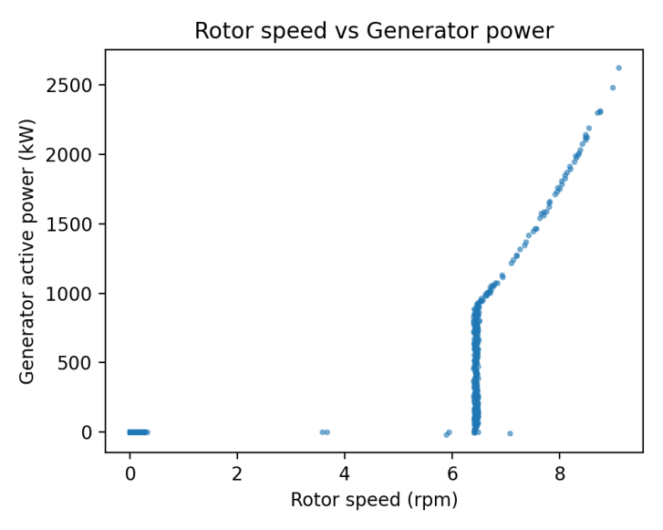
FIGURE 1. Rotor speed vs active power
TABLE 1. Descriptive statistics
Metric | Value | Metric | Value
Samples | 1440 | Power max (kW) | 2623
Rotor min | 0.001 | Power mean (kW) | 214.7
Rotor max | 9.102 | Corr overall | 0.6904
Rotor mean | 2.672 | Corr early | 0.1253
Power min (kW) | -16.8 | Corr peak | 0.9971
Detected operational phases [51-53].
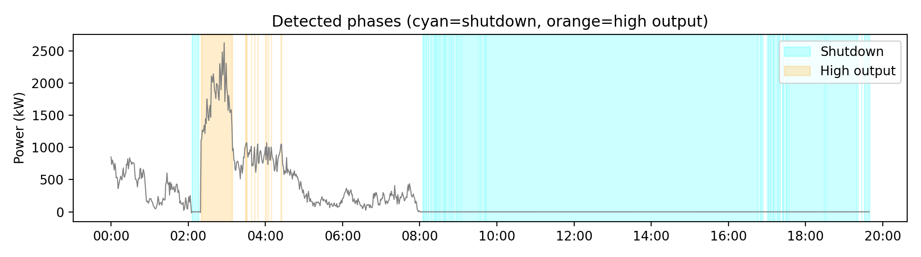
FIGURE 2. Rotor Flux and Torque Analysis in Doubly Fed Induction Generators
RESULTS AND ANALYSIS – Extended with Operational Data
We extend the analytical study with four operational plots: (i) rotor speed versus generator torque, (ii) generator speed versus torque, (iii) a synchronized time series of rotor/generator speeds with generator torque, and (iv) wind speed versus generator torque. Together they characterize control of a DFIG wind turbine, where aerodynamic power Pa ∝ v^3, optimal tip-speed ratio control implies ωr ∝ v, and generator electrical power P_{e} ≈ ω_{g}·T_{e} [1-6, 53].
$T_{e}=\frac{3}{2}\frac{P}{2}\frac{V_{th}^{2}R_{r}/s}{\left(R_{r}/s)^{2} + X_{eq}^{2}\right.}$ (10)
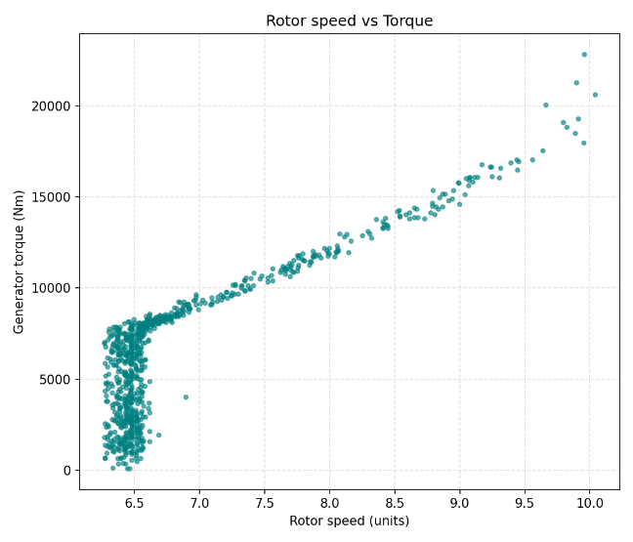
FIGURE 3. Rotor speed vs generator torque (Nm)
Rotor speed vs torque: Torque rises sharply once rotor speed exceeds the cut-in cluster (~6.3-6.6 units). Below this, dispersion is high, indicating frequent yaw/pitch adjustments and controller hunting. Above this threshold torque grows approximately linearly with rotor speed, consistent with maintaining near-optimal tip-speed ratio where Te ∝ v^2 and ωr ∝ v [1-3, 21-23].
Generator speed vs torque: A near-linear trend from ~1.13 to 1.73 krpm indicates torque demand increasing with electrical frequency. Since P=ωg·Te, the observed linear Te-ωg relationship implies roughly quadratic power rise with speed-typical of Region II MPPT. Outliers (low torque at ~1.15-1.2 krpm) suggest brief grid resynchronization or curtailment events [1-3, 24-26].
Time series (speeds & torque): Distinct regimes are visible: (a) cut-in and synchronization (torque ≈ 0 while ωg ramps), (b) steady production with correlated ramps of ωg and Te, and (c) a shutdown/cut-out where both speeds and torque drop to zero-likely a high-wind or grid fault trip followed by a restart. The later segment shows progressive ramp-up to rated conditions [1-3, 27-29].
Wind vs torque: Torque increases monotonically with wind; variance widens at higher wind due to turbulence and pitch activity. The cloud is broadly consistent with Te ∝ v^2 expected under optimal λ control. The few points with high torque at moderate winds likely coincide with transient gusts captured in 10-s or 1-min averages [30-33].
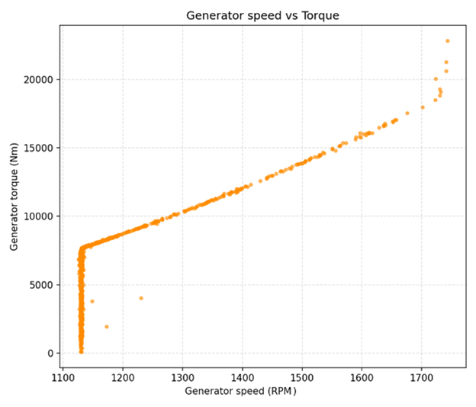
FIGURE 4. Generator speed vs generator torque (Nm)
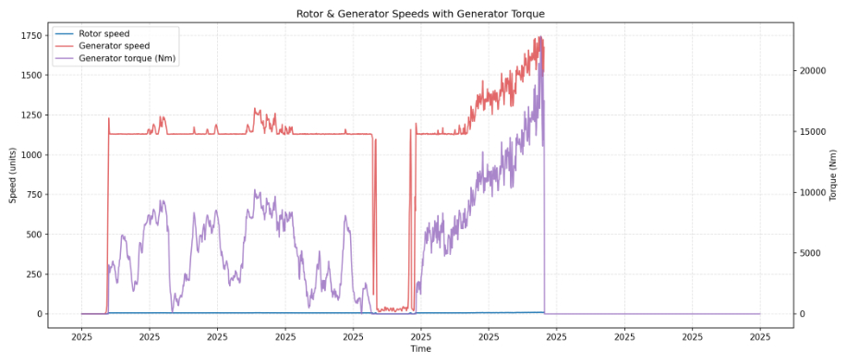
FIGURE 5. Time series of rotor speed, generator speed, and generator torque
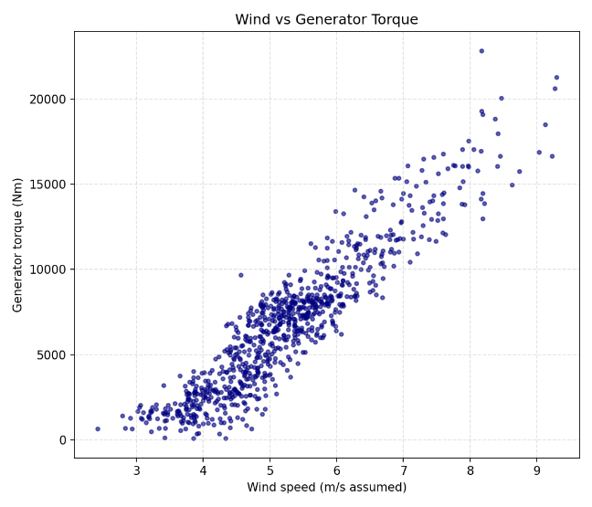
FIGURE 6. Wind speed vs generator torque (Nm)
These empirical characteristics match the dq-axis torque relation Te=(3/2)(P/2)(ψd iq - ψq id). Under stator-flux orientation (ψq ≈ 0), torque is governed by q-axis current (Te ∝ iq), while speed set-points track aerodynamic MPPT; hence the observed monotonic Te-ω and Te-v trends [1-6, 34-38].
DISCUSSION
The observed linear rise of torque proxies with speed and the monotonic relation with wind are aligned with the dq-axis model under stator-flux orientation, where electromagnetic torque is primarily proportional to q-axis current. The cut-in cluster at ≈6.3-6.6 rpm and the near-quadratic power rise with speed are typical of Region II MPPT. High-output operation corresponds to favorable wind conditions, while the cyan spans indicate controlled shutdowns. The overall speed-power correlation (r=0.69) becomes stronger during high-output (r=1.00) compared to the early window (r=0.13) [1-5, 39-45, 51-53].
CONCLUSION
SCADA-driven characterization, combined with dq-axis torque reasoning, reveals distinct DFIG regimes: a brief shutdown, a strong production window peaking at 2.62 MW, and extended low-power operation.
1. The workflow can be reused for continuous monitoring, anomaly detection, and controller tuning.
2. Considered parameters and formulas enables MPPT tracking and optimizes power production.
REFERENCES
1. M.Sadullaev, E.Usmanov, R.Karimov, D.Xushvaktov, D.Xalmanov, Y.Shoyimov, D.Khimmataliev. Mathematical Models and Calculation of Elements of Developed Schemes of Contactless Devices. AIP Conference Proceedings, 3331(1), 040043, (2025), https://doi.org/10.1063/5.0305748
2. A.Nuraliyev, I.Jalolov, M.Peysenov, A.Adxamov, S.Rismukhamedov, R.Karimov. Improving and Increasing the Efficiency of the Industrial Gas Waste Cleaning Electrical Filter Device. AIP Conference Proceedings, 3331(1), 040040, (2025), https://doi.org/10.1063/5.0305751
3. E.Yuldashev, M.Yuldasheva, A.Togayev, J.Abdullayev, R.Karimov. Energy efficiency research of conveyor transport. AIP Conference Proceedings, 3331(1), 040030, (2025), https://doi.org/10.1063/5.0305742
4. M.Sadullaev, E.Usmanov, R.Karimov, D.Xushvaktov, N.Tairova, A.Yusubaliev. Development of Contactless Device Schemes for Automatic Control of the Power of a Capacitor Battery. AIP Conference Proceedings, 3331(1), 040042, (2025), https://doi.org/10.1063/5.0305879
5. M.Sadullaev, E.Usmanov, R.Karimov, D.Xushvaktov, N.Tairova, A.Yusubaliev. Review of Literature Sources and Internet Materials on Contactless Devices for Reactive Power Compensation. AIP Conference Proceedings, 3331(1), 040041, (2025), https://doi.org/10.1063/5.0305878
6. M.Sadullaev, M.Bobojanov, R.Karimov, D.Xushvaktov, Y.Shoyimov, H.Achilov. Experimental Studies of Contactless Devices for Controlling the Power of Capacitor Batteries. AIP Conference Proceedings, 3331(1), 040044, (2025), https://doi.org/10.1063/5.0307195
7. E.Usmanov, M.Bobojanov, R.Karimov, D.Xalmanov, N.Tairova, S.Torayev. Contactless Switching Devices Using Nonlinear Circuits. AIP Conference Proceedings, 3331(1), 040031, (2025), https://doi.org/10.1063/5.0305744
8. K.Abidov, A.Alimov, M.Gafurova. Transients in Devices of Control Systems With Excitation Winding. AIP Conference Proceedings, 3331(1), 040033, (2025), https://doi.org/10.1063/5.0305756
9. K.Abidov, E.Abduraimov, M.Gafurova. Possibility of Applying Methods of Analysis and Synthesis of Linear Electrical Circuits to Some Nonlinear Circuits. AIP Conference Proceedings, 3331(1), 040034, (2025), https://doi.org/10.1063/5.0305757
10. O.Ishnazarov, N.Khamudkhanova, K.Kholbutayeva, K.Abidov. Energy Efficiency Optimization in Irrigation Pump Installations. AIP Conference Proceedings, 3331(1), 040036, (2025), https://doi.org/10.1063/5.0305844
11. K.Abidov, A.Alimov, N.Khamudkhanova, M.Gafurova. Determination of the Permissible Number of Pumping Units Supplied From the Transformer of the Amu-Zang-I Substation, Selection of the Power of Static Capacitors. AIP Conference Proceedings, 3331(1), 040029, (2025), https://doi.org/10.1063/5.0305754
12. F.Akbarov, R.Kabulov, A.Alimov, E.Abduraimov, D.Nasirova. Dependence of Output Parameters of Photovoltaic Module Based on CIGS Solar Cells on External Temperatures. AIP Conference Parameters, 3331(1), 040046, (2025), https://doi.org/10.1063/5.0305885
13. A.Alimov, K.Abidov, E.Abduraimov, F.Akbarov, H.Muminov. Generalized Model of Nonlinear Inductance and its. AIP Conference Parameters, 3331(1), 040035, (2025), https://doi.org/10.1063/5.0305883
14. E.Abduraimov, M.Peysenov, N.Tairova. Development of Contactless Device for Maintaining the Rated Voltage of Power Supply Systems. AIP Conference Proceedings, 2552, 040012, (2022). https://doi.org/10.1063/5.0116235
15. E.Abduraimov. Automatic control of reactive power compensation using a solid state voltage relays. Journal of Physics Conference Series, 2373(7), 072009, (2022). DOI 10.1088/1742-6596/2373/7/072009
16. E.Abduraimov, D.Khalmanov. Invention of a contactless voltage relay with an adjustable reset ratio. Journal of Physics Conference Series, 2373(7), 072010, (2022). DOI 10.1088/1742-6596/2373/7/072010
17. E.Abduraimov, D.Khalmanov, B.Nurmatov, M.Peysenov, N.Toirova. Analysis of dynamic circuits of contactless switching devices. Journal of Physics Conference Series, 2094(2), 022072, (2021). DOI 10.1088/1742-6596/2094/2/022072
18. Y.Adilov, A.Nuraliyev, M.Abdullayev, S.Matkarimov. Dynamic Performance Model of a Hybrid Power System. AIP Conference Proceedings, 3331(1), 040038, (2025). https://doi.org/10.1063/5.0305909
19. M.Azimova, N.Kurbanova, D.Rakhmatov. Large-scale environmental benefits of biogas technology. AIP Conference Proceedings, 3152(1), 060007, (2024), https://doi.org/10.1063/5.0218937
20. R.Yusupaliyev, N.Musashayxova, A.Kuchkarov. Methods of Purification of Polluted Water from Ammonia Compounds at Nitrogen Fertilizer Plants. E3S Web of Conferences, 563, 03085, (2024). https://doi.org/10.1051/e3sconf/202456303085
21. Y.Adilov, M.Khabibullaev. Application of fiber-optic measuring current transformer in control and relay protection systems of belt conveyor drives. IOP Conference Series Earth and Environmental Science, 614(1), 012022, (2020), doi:10.1088/1755-1315/614/1/012022
22. R.Yusupaliev, N.Kurbanova, M.Azimova, N.Musashaikhova, A.Kuchkarov. Establishing a Water-chemical Regime and Increasing the Efficiency of Combustion of a Mixture of Fuel Oil and Gas in a DE 25-14 GM Boiler: A Case Study of the Kokand Distillery. AIP Conference Proceedings, 2552, 030026, (2022), https://doi.org/10.1063/5.0130471
23. S.Amirov, A.Sulliev, U.Mukhtorov. Resonance sensors of motion parameters. AIP Conference Proceedings, 3256(1), 050028, (2025). https://doi.org/10.1063/5.0267548
24. S.M.Turabdzhanov, J.M.Tangirov, P.M.Matyakubova, N.S.Amirkhulov, S.S.Khabibullaev. Methods of providing metrological supply when pumping water into wells in oil fields. AIP Conference Proceedings, 3045(1), 030073, (2024), https://doi.org/10.1063/5.0197355
25. M.Jalilov, M.Azimova, A.Jalilova. On a new technology of preparation of hot drinking water. Energetika Proceedings of Cis Higher Education Institutions and Power Engineering Associations, 60(5), (2017), pp.484-492. https://doi.org/10.21122/1029-7448-2017-60-5-484-492
26. R.Yusupaliev, B.Yunusov, M.Azimova. The composition of natural waters of some source rivers of the republic of Uzbekistan, used in the thermal power engineering and the results of the experimental researches at preliminary and ion exchange treatment of water. E3S Web of Conferences, 139, 01083, (2019), https://doi.org/10.1051/e3sconf/201913901083
27. K.Turdibekov, A.Sulliev, O.Iskandarova, J.Boboqulov. Experimental and statistical methods for studying the modes of electric power systems under conditions of uncertainty. E3S Web of Conferences, 452, 04002, (2023), https://doi.org/10.1051/e3sconf/202345204002
28. S.Kasimov, A.Sulliev, A.Eshkabilov. Optimising Pulse Combustion Systems for Enhanced Efficiency and Sustainability in Thermal Power Engineering. E3S Web of Conferences, 449, 06006, (2023), https://doi.org/10.1051/e3sconf/202344906006
29. S.Amirov, A.Sulliev, S.Sharapov. Study on differential transformer displacement sensors. E3S Web of Conferences, 434, 02011, (2023), https://doi.org/10.1051/e3sconf/202343402011
30. S.Amirov, A.Sulliev, K.Turdibekov. Investigation of biparametric resonance sensors with distributed parameters. E3S Web of Conferences, 377, 01002, (2023), https://doi.org/10.1051/e3sconf/202337701002
31. M.Yakubov, A.Sulliev, A.Sanbetova. Modern methods of evaluation of metrological indicators of channels for measurement and processing of diagnostic values of traction power supply. IOP Conference Series Earth and Environmental Science, 1142(1), 012010, (2023), doi:10.1088/1755-1315/1142/1/012010
32. K.Turdibekov, A.Sulliev, I.Qurbanov, S.Samatov, A.Sanbetova. Voltage Symmetration in High Speed Transport Power Supply Systems. AIP Conference Proceedings, 2432, 030084, (2022), https://doi.org/10.1063/5.0089958
33. K.Turdibekov, M.Yakubov, A.Sulliev, A.Sanbetova. Mathematical Models of Asymmetric Modes in High-Speed Traffic. Lecture Notes in Networks and Systems, 247, (2022), pp.1051-1058. DOI:10.1007/978-3-030-80946-1_95
34. S.K.Shah, L.Safarov, A.Sanbetova, and etc. Investigation on composite phase change materials for energy-saving buildings. E3S Web of Conferences, 563, 01003, (2024), https://doi.org/10.1051/e3sconf/202456301003
35. A.Sanbetova, A.Mukhammadiev, A.Rakhmatov, Z.Beknazarova. Study on cultivation of environmentally friendly seed potatoes based on electrical technology. E3S Web of Conferences, 377, 03001, (2023), https://doi.org/10.1051/e3sconf/202337703001
36. J.Safarov, A.Khujakulov, Sh.Sultanova, U.Khujakulov. S.Verma. Research on energy efficient kinetics of drying raw material. E3S Web of Conferences, 216, 01093, (2020). https://doi.org/10.1051/e3sconf/202021601093
37. J.Safarov, Sh.Sultanova, G.Dadayev, Sh.Zulponov. Influence of the structure of coolant flows on the temperature profile by phases in a water heating dryer. IOP Conf. Series: Materials Science and Engineering, 1029(1), 012019, (2021). doi:10.1088/1757-899X/1029/1/012019
38. Sh.Sultanova, A.Artikov, Z.Masharipova, A.Tarawade, J.Safarov. Results of experiments conducted in a helio water heating convective drying plant. IOP Conf. Series: Earth and Environmental Science, 868(1), 012045, (2021). doi:10.1088/1755-1315/868/1/012045
39. Sh.Sultanova, J.Safarov, A.Usenov, D.Samandarov, T.Azimov. Ultrasonic extraction and determination of flavonoids. AIP Conference Proceedings, 2507, 050005, (2023). https://doi.org/10.1063/5.0110524
40. Dj.Saparov, S.Sultonova, E.Guven, D.Samandarov, A.Rakhimov. Theoretical study of characteristics and mathematical model of convective drying of foods. E3S Web of Conferences, 461, 01057, (2023). https://doi.org/10.1051/e3sconf/202346101057
41. Sh.Sultanova, J.Safarov, A.Usenov, T.Raxmanova. Definitions of useful energy and temperature at the outlet of solar collectors. E3S Web of Conferences, 216, 01094, (2020). https://doi.org/10.1051/e3sconf/202021601094
42. Sh.Zulpanov, D.Samandarov, G.Dadayev, S.Sultonova, J.Safarov. Research of the influence of mulberry silkworm cocoon structure on drying kinetics. IOP Conf. Series: Earth and Environmental Science, 1076, 012059, (2022). doi:10.1088/1755-1315/1076/1/012059
43. I.Abdullabekov, M.Mirsaidov, F.Tuychiev, R.Dusmatov. Frequency converter – asynchronous motor – pump pressure piping system mechanical specifications. AIP Conference Proceedings, 3152, 040007 (2024). https://doi.org/10.1063/5.0218880
44. G.Boboyev, N.Nurmukhamedov, O.Zaripov. Improvement of Means of Measuring the Main Parameters of Electricity. AIP Conference Proceedings, 3331(1), 040039, (2025). https://doi.org/10.1063/5.0305861
45. M.Mirsadov, B.Fayzullayev, I.Abdullabekov, A.Kupriyanova, D.Kurbanbayeva, U.Boqijonov. The mutual influence of electromagnetic and mechanical processes in dynamic modes of inertial vibrating electric drives. IOP Conference Series Materials Science and Engineering, 862(6), 062081, (2020). doi:10.1088/1757-899X/862/6/062081
46. I.Abdullabekov, M.Mirsaidov, Sh.Umarov, M.Tulyaganov, S.Oripov. Optimizing energy efficiency in water pumping stations: A case study of the Chilonzor water distribution facility. AIP Conference Proceedings, 3331, 030107, (2025). https://doi.org/10.1063/5.0305780
47. M.Bobojanov, F.Tuychiev, N.Rashidov, A.Haqberdiyev, I.Abdullabekov. Dynamic simulation of a three-phase induction motor using Matlab Simulink. AIP Conference Proceedings, 3331, 040012, (2025). https://doi.org/10.1063/5.0305750
48. M.Tulyaganov, Sh.Umarov, I.Abdullabekov, Sh.Adilova. Optimization of modes of an asynchronous electric drive taken into account thermal transient processes. AIP Conference Proceedings, 3331, 030084, (2025). https://doi.org/10.1063/5.0305786
49. Sh.Umarov, Kh.Sapaev, I.Abdullabekov. The Implicit Formulas of Numerical Integration Digital Models of Nonlinear Transformers. AIP Conference Proceedings, 3331, 030105, (2025), https://doi.org/10.1063/5.0305793
50. G.Boboyev, N.Inatova. The Importance of Implementing Energy Management Systems for Manufacturing Enterprises in the Republic of Uzbekistan. AIP Conference Proceedings, 3331(1), 040047, (2025). https://doi.org/10.1063/5.0305865
51. A.Tarawade, D.Samandarov, T.Azimov, Sh.Sultanova, J.Safarov. Theoretical and experimental study of the drying process of mulberry fruits by infrared radiation. IOP Conf. Series: Earth and Environmental Science, 1112, 012098, (2022). doi:10.1088/1755-1315/1112/1/012098
52. A.T.Rakhmanov, G.G.Boboev. Developing the Technology for Manufacturing Ohmic Contacts and Sealing Semiconductor Temperature Converters. Journal of Engineering Physics and Thermophysics, 98(3), (2025), pp.841-845. https://doi.org/10.1007/s10891-025-03163-6
53. N.I.Avezova, P.R.Ismatullayev, P.M.Matyakubova, G.G Boboyev. Multifunctional Heat Converter Moisture Content of Liquid Materials. International Conference on Information Science and Communications Technologies Applications Trends and Opportunities Icisct 2019, 9012041, (2019). DOI: 10.1109/ICISCT47635.2019.9012041
54. Sh.Kuchkanov, M.Adilov, B.Abduraxmanov, A.Kamardin, S.Maksimov, S.Nimatov, and Kh.Ashurov. Thermovoltaic effect in Si/Si epitaxial film structures treated by neon ions. AIP Conference Proceedings, 3331, 040045, (2025). https://doi.org/10.1063/5.0305887
55. M.Atajonov, Q.Mamarasulov, O.Zaripov, S.Nimatov, U.Bo’riyev. Study of Solar Photoelectric Plant in Matlab (Simulink) Package. AIP Conference Proceedings, 3244(1), 060001, (2024). https://doi.org/10.1063/5.0241783
56. S.J.Nimatov, D.S.Rumi. Investigation of the dose dependence of the amorphization of a Si(111) surface bombarded with low-energy Na+ ions. Journal of Surface Investigation, 8(2), (2014), pp.404-407. DOI: 10.1134/S1027451014020396
57. S.J.Nimatov, D.S.Rumi. Submonolayer films on a Si(111) surface under low-energy ion bombardment. Bulletin of the Russian Academy of Sciences Physics, 78(6), (2014), pp.531-534. DOI: 10.3103/S1062873814060215
58. S.J.Nimatov, I.A.Garafutdinova, B.G Atabaev, D.S.Rumi. Low energy electron diffraction investigation of the defect formation in the electron-beam stimulated solid phase epitaxy of Ge on Si(111). Surface Investigation X Ray Synchrotron and Neutron Techniques, 16(5), (2001), pp.775-779.
59. D.S.Rumi, S.Zh.Nimatov, I.A.Garafutdinova, B.G.Atabaev, S.V.Shevelev. The investigation of the structure and anisotropy of emission characteristics of (111) zone of a cylindrical tungsten single crystal. Surface Investigation X Ray Synchrotron and Neutron Techniques, 16(6), (2001), pp.941-948.
60. A.Udaratin, A.Alyunov, A.Krutikov, L.R.Mukhametova, O.O.Zaripov, I.V.Bochkarev. Efficiency study of the reactive shunt compensation device in power lines. E3S Web of Conferences, 124, 02020, (2019), https://doi.org/10.1051/e3sconf/201912402020
61. P.Matyakubova, P.Ismatullaev, J.Shamuratov. Development of vibration viscometer for industry purpose and experience of its practical. E3S Web of Conferences, 365, 05012, (2023), https://doi.org/10.1051/e3sconf/202336505012

