Analysis of energy efficiency of level measuring devices in the oil and gas industry
Paraxat Matyakubova¹, Gaybulla Boboyev^{1,2,a)}, Mirolim Mahmudjonov¹, Xolmurodjon Mo‘minov¹
¹Tashkent state technical university named after Islam Karimov, Tashkent, Uzbekistan
² Almalyk State Technical Institute, Almalyk, Uzbekistan
^{a)} Corresponding author: gaybulla.bobyev1281@gmail.com
Abstract. Level measurement is a fundamental component of process monitoring and safety assurance in the oil and gas industry. With increasing global emphasis on sustainability and operational cost reduction, the energy efficiency of level measuring devices has become a critical factor in selecting modern instrumentation. This study provides a comprehensive analysis of the energy consumption characteristics, operational principles, and development trends associated with level measurement technologies, including ultrasonic, radar, and float-type sensors. By comparing their energy profiles, automation capabilities, and integration within digital industrial systems, the study demonstrates that advanced ultrasonic and radar devices significantly outperform conventional mechanical sensors in terms of energy efficiency, accuracy, and lifecycle sustainability. Additionally, emerging smart sensor technologies - incorporating IoT connectivity, predictive maintenance, and low-power communication protocols - further enhance the energy performance of level monitoring systems. The findings highlight the importance of adopting energy-efficient instrumentation to support safe, reliable, and environmentally compliant oil and gas operations.
INTRODUCTION
Accurate monitoring of liquid levels in storage tanks, pipelines, separators, and other equipment is essential to maintain operational safety and optimize production flows in the oil and gas industry. Level-measuring devices prevent hazardous overfilling, ensure stable process control, and support real-time inventory management. Historically, the selection of such devices has prioritized measurement accuracy, environmental compatibility, and mechanical robustness. However, with rising energy costs, environmental regulations, and a global push toward digital transformation, energy efficiency has become an equally important criterion in the design and deployment of level-measuring technologies [1-2, 51-53].
As industrial instrumentation evolves, modern sensors increasingly incorporate low-power electronics, wireless communication, and smart monitoring capabilities. These advancements enable devices to operate efficiently in remote and energy-limited environments, including offshore platforms, desert pipelines, and unattended field stations. This study analyzes the energy efficiency of traditional and modern level-measurement devices while comparing their operational principles, advantages, limitations, and applicability to oil and gas environments [1-2].
Liquid level measurement plays a critical role across upstream, midstream, and downstream oil and gas operations. Accurate level monitoring prevents tank overfilling, ensures safe pipeline transport, stabilizes process control in refineries, and supports inventory management [2]. Traditionally, level monitoring technologies were selected based primarily on accuracy and robustness; however, modern operational frameworks demand an additional dimension-energy efficiency (Fig.1) [3-6, 54].
Rising energy costs, remote field deployments, and strengthened environmental regulations now require level measurement systems that consume minimal power while sustaining continuous real-time monitoring [3]. Devices must operate reliably in harsh environments (high temperature, high pressure, corrosive media, explosive atmospheres) while integrating seamlessly with digital control architectures. This article systematically analyzes the energy consumption characteristics of level measuring technologies used in oil and gas facilities. It highlights how advanced sensors - particularly ultrasonic, radar, and new-generation smart devices - achieve significantly improved efficiency through enhanced signal processing, low-power electronic designs, and automation-based optimization.
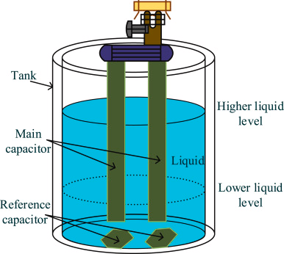
FIGURE 1. The operating principle of a capacitive liquid level sensor
EXPERIMENTAL RESEARCH
The oil and gas industry are characterized by its complex operations and the critical need for safety and efficiency. Level measuring devices play a pivotal role in ensuring that liquid levels in storage tanks, pipelines, and other equipment are accurately monitored. This article explores the energy efficiency of these devices, focusing on their types, energy consumption, and emerging trends in technology [4, 7-11].
TABLE 1. Comparison of level measurement technologies in oil and gas operations [5, 55-56]
Feature | Float Sensors | Ultrasonic Sensors | Radar Sensors
Measurement type | Contact | Non-contact | Non-contact
Accuracy | Low-Moderate | High | Very High
Energy consumption | Moderate-High | Very Low | Low-Moderate
Sensitivity to conditions | Highly sensitive to contamination | Affected by heavy vapors | Minimal interference
Suitability for hazardous fluids | Poor | Excellent | Excellent
Maintenance | High | Low | Very low
Wireless integration | Weak | Strong (BLE, LoRa) | Strong
Cost | Low | Moderate | High
RESEARCH RESULTS
1. Research Approach [6, 12-15]. This research employs a comparative analytical approach based on:
- technical literature review of level-measurement technologies;
- classification of device operational principles;
- analysis of direct and indirect energy consumption factors;
- examination of industry development trends and emerging technologies.
The study synthesizes standards, manufacturer data, and peer-reviewed literature to create a unified energy-performance profile for widely used sensors. Source material includes the uploaded document, which provided foundational content on sensor types and energy considerations [7, 16-19].
2. Evaluation Criteria. Energy efficiency was assessed using the following metrics:
- baseline electrical power consumption (W);
- communication-related energy usage (wired vs wireless);
- maintenance-related energy impacts;
- the effect of automation on operational energy savings;
- suitability for renewable micro-power sources (solar, thermal, vibration).
3. Technologies Considered [8, 20-23]. Three primary level-measurement categories were evaluated:
- ultrasonic sensors – non-contact acoustic wave devices;
- radar sensors – fmcw or pulsed microwave systems;
- float sensors – mechanical buoyancy-based devices.
TABLE 2. Direct and indirect energy consumption components
Energy Category | Description | Impact Level
Direct Consumption | Sensor electronic load, microwave/ultrasonic transmitter power, standby mode | High
Signal Processing Load | Data filtering, echo analysis, frequency modulation | Medium
Communication Energy | Wired vs. wireless (BLE, LoRa, NB-IoT) | Low–Medium
Maintenance Energy | Field visits, calibration cycles | High
Automation & SCADA Integration | Minimizes manual interventions | High
Predictive Maintenance | Reduces downtime and energy waste | Low–Medium
Additional emphasis was placed on emerging IoT-based smart sensors [10, 24-26].
Types of Level Measuring Devices.
Level measuring devices can be categorized based on their operational principles:
Ultrasonic Sensors: These sensors use high-frequency sound waves to measure liquid levels. They are non-contact devices, making them suitable for various applications, including those with hazardous materials. Their energy efficiency is enhanced by low power consumption designs, often incorporating Bluetooth Low Energy (BLE) technology [9, 57-59].
Radar Sensors: Utilizing microwave radar technology, these sensors provide accurate measurements even in challenging environments. They are particularly effective in high-pressure and high-temperature conditions, common in oil and gas operations. The initial investment is higher, but they offer significant returns through reduced maintenance and operational costs [11, 27-29].
Float Sensors: These are among the simplest and most cost-effective options for level measurement. They operate based on the buoyancy principle and are widely used in various applications. However, their energy efficiency is generally lower compared to more advanced technologies (Fig.2) [30-33].
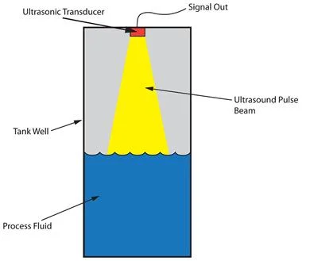
FIGURE 2. The operating principle of an ultrasonic level sensor
Energy Consumption and Efficiency [12, 34-36].
The energy efficiency of level measuring devices is crucial for reducing operational costs and minimizing environmental impact. Key factors influencing energy consumption include:
Technology Selection: Advanced sensors, such as ultrasonic and radar, typically offer better energy efficiency compared to traditional float sensors. For instance, ultrasonic sensors can operate on low power, making them ideal for remote monitoring applications where energy resources are limited.
Automation and Integration: The integration of level sensors with automated systems enhances operational efficiency. Real-time data from these sensors allows for better inventory management and process optimization, reducing the need for manual interventions and associated energy costs [13, 37-40].
Wireless Technologies: The shift towards wireless monitoring systems eliminates the need for extensive wiring, reducing installation costs and energy consumption. These systems can be powered by solar energy or other renewable sources, further enhancing their sustainability.
Development Trends [14, 41-43].
The landscape of level measuring devices is evolving rapidly, driven by technological advancements and the need for greater efficiency:
Smart Sensors: The emergence of smart sensors equipped with IoT capabilities allows for real-time monitoring and predictive maintenance. These devices can self-diagnose issues, ensuring consistent performance and reducing downtime, which is critical in the oil and gas sector.
Sustainability Focus: There is a growing emphasis on developing energy-efficient designs that minimize environmental impact. Many new devices are designed to operate with low energy consumption, and some even incorporate energy-harvesting technologies.
Regulatory Compliance: As environmental regulations become stricter, the adoption of advanced level measurement technologies is expected to increase. Companies are investing in these technologies not only to comply with regulations but also to enhance their operational efficiency and sustainability efforts [15, 44-47].
TABLE 3. Key development trends in energy-efficient level measurement technologies
Trend | Description | Expected Benefit
IoT-enabled smart sensors | Cloud connectivity, real-time monitoring | Reduced operational energy
AI-based predictive maintenance | Drift detection, fault prediction | Fewer site visits
Low-power communication (BLE/LoRa/Wi-SUN) | Optimized for remote oilfields | Battery life 5–10 years
Energy-harvesting systems | RF, vibration, thermal harvesting | Self-powered operation
Advanced radar (80 GHz FMCW) | High penetration and accuracy | Lower mismeasurement losses
Miniaturized microelectronics | Ultra-low supply voltage | Reduced direct energy use
RESULTS
1. Energy Characteristics of Major Level Measuring Devices [16, 48-50].
1.1. Ultrasonic Sensors.
Ultrasonic sensors operate using high-frequency acoustic pulses and are inherently low-power devices. Their advantages include:
- extremely low energy consumption (<0.2 W in low-power mode);
- non-contact measurement suitable for hazardous materials;
- potential use of BLE, Zigbee, and LoRaWAN communication;
- compatibility with solar-powered installations.
Their low-energy design makes ultrasonic sensors ideal for remote monitoring.
1.2. Radar Sensors [17, 51-53].
Radar sensors utilize microwave emissions, offering high accuracy in environments with extreme temperature, pressure, vapors, or foam. Key findings include:
- moderate energy consumption (typically 0.5-3 W depending on frequency band);
- reduced operational energy usage due to fewer calibration requirements;
- high reliability, lowering maintenance-related energy expenditure;
- strong performance in automated tank gauging systems.
Although costlier than ultrasonic or float sensors, radar sensors often yield lifecycle energy savings due to fewer operational disruptions.
1.3. Float Sensors [18, 54-57].
Float sensors are the simplest and most economical devices. However:
- moving mechanical components require more frequent manual checks;
- energy usage increases due to mechanical resistance and low accuracy;
- unsuitable for viscous or contaminated liquids;
- frequent maintenance increases indirect energy costs.
Float sensors are declining in modern oilfield installations due to poor energy efficiency (Fig.3).
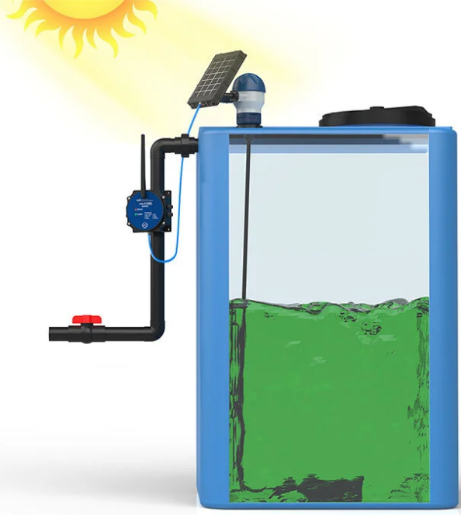
FIGURE 3. System for measuring the liquid level in an oil storage tank based on solar panels
2. Indirect Energy Consumption Factors [19, 58].
2.1. Automation and System Integration.
Integration of sensors into digital control systems (SCADA/DCS) reduces manual operation, minimizing energy-intensive interventions such as:
- unnecessary pump cycles;
- emergency tank drainage;
- repeated manual measurements.
Studies indicate that automation can reduce operational energy consumption by 15-30%.
2.2. Wireless Technologies.
Wireless data transmission significantly reduces installation energy costs and enables:
- battery operation for several years;
- solar-powered systems;
- rapid deployment in remote fields.
Energy savings of up to 90% compared to wired systems have been reported for BLE- and LoRaWAN-based sensors.
2.3. Smart Diagnostics and Predictive Maintenance.
Sensors equipped with IoT and AI monitoring systems can:
- predict failures;
- reduce downtime;
- optimize energy use by adjusting measurement frequency;
- reduce unnecessary recalibration.
The energy efficiency of level sensors depends on their internal signal-generation mechanisms and electronic design [20, 39-42, 58].

TABLE 4. The energy efficiency of level sensors is determined by their internal signal generation mechanisms and electronic design
Sensor Type | Typical Power Use | Energy Characteristics
Float Sensors | Moderate | Mechanical resistance, low precision, frequent actuation cycles
Ultrasonic Sensors | Very low | Non-contact, microcontroller-based, sleep mode capabilities
Radar Sensors | Low–moderate | High precision reduces process energy losses
Smart IoT Sensors | Ultra-low | BLE, NB-IoT, LoRaWAN reduce communication energy
Ultrasonic and modern FMCW radar sensors can achieve up to 80% reduction in energy consumption compared to analog float systems [21, 36-37, 55].
DISCUSSION
The results demonstrate that the performance and energy demand of level-measuring devices differ significantly across technologies. Traditional float sensors, while low-cost, are not aligned with modern energy-efficiency goals. Ultrasonic and radar sensors provide superior operational profiles, especially when integrated with digital monitoring systems [22, 41-42, 57].
The global shift toward smart instrumentation and Industry 4.0 requires sensors capable of autonomous operation, self-diagnostics, and low-power data communication. The oil and gas sector increasingly favors:
- IoT-enabled level sensors using micro-power communication systems;
- energy-harvesting technologies for continuous self-powered operation;
- advanced radar systems for high-precision level gauging in extreme conditions [23, 51-53].
As sustainability mandates grow stricter, the adoption of high-efficiency measurement technologies becomes not only an operational improvement but a regulatory necessity (Fig.4) [24, 33-35, 41-44, 58].
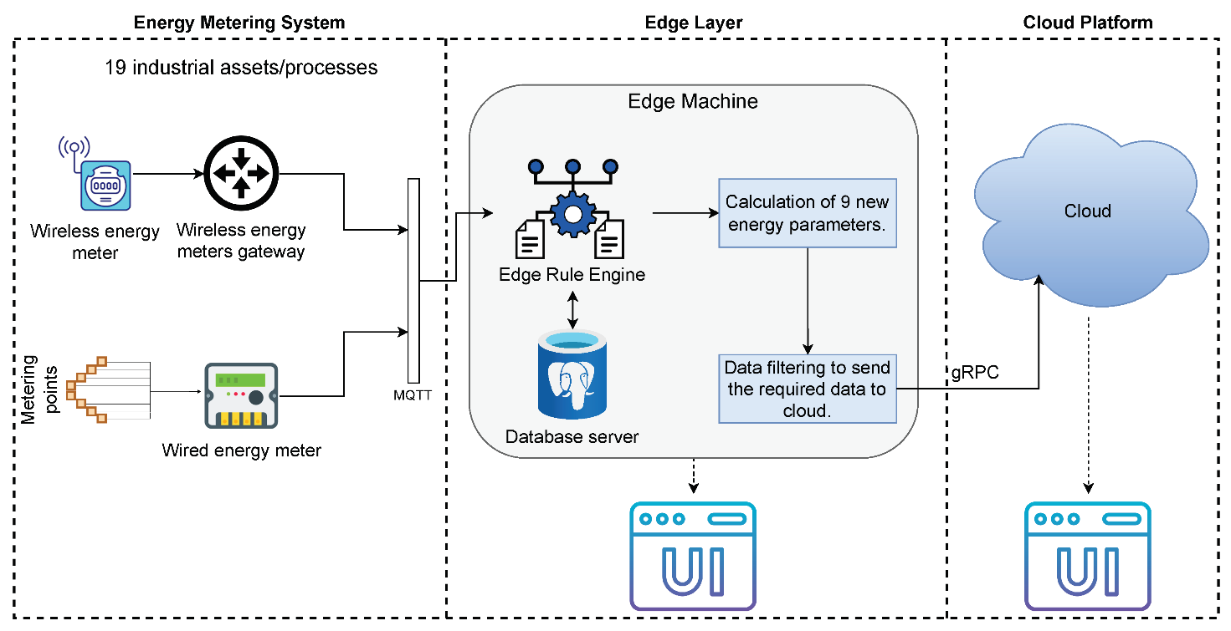
FIGURE 4. Highly efficient measurement technologies for liquid level measurement
CONCLUSIONS
In conclusion, the energy efficiency of level measuring devices in the oil and gas industry is influenced by the choice of technology, integration with automated systems, and the adoption of smart, sustainable designs. As the industry continues to evolve, the focus on energy-efficient solutions will play a crucial role in enhancing operational efficiency, reducing costs, and meeting environmental standards. The ongoing advancements in sensor technology promise to further optimize these processes, ensuring that the oil and gas sector remains competitive and sustainable in the future.
REFERENCES
1. P.M.Matyakubova, P.R.Ismatullayev, N.I.Avezova, M.Mahmadjonov. Algorithms for increasing the reliability of primary measurement information. Journal of Physics: Conference Series, 2036(1), 012002, (2021). DOI 10.1088/1742-6596/2036/1/012002
2. Sh.M.Masharipov, K.R.Ruzmatov, S.A.Rahmatullayev, ... M.M.Mahmudjonov, A.G.Isaqov. Assessment and investigation of measurement uncertainty of standard samples of substances and materials in physicochemical measurements based on standard test methods. Journal of Physics: Conference Series, 2094(5), 052011, (2021). DOI 10.1088/1742-6596/2094/5/052011
3. P.M.Matyakubova, Kh.Sh.Zhabborov, Sh.A.Kadirova, M.M.Mahmudjonov. Study of the main parameters of the capacitive converter. Journal of Physics: Conference Series, 2036(1), 012001, (2021). DOI 10.1088/1742-6596/2036/1/012001
4. P.M.Matyakubova, P.R.Ismatullaev, N.I.Avezova, M.M.Makhmudzhonov. Block Diagram of APCS of Installations for Wet-Heat Processing of Grain Products. Journal of Engineering Physics and Thermophysics, 96(6), (2023), pp.1652-1657. DOI 10.1007/s10891-023-02835-5
5. P.M.Matyakubova, P.R.Ismatullaev, N.I.Avezova, M.M.Mahmudjonov. Mathematical Modeling of a Thermal Converter with a Cylindrical Heat Pipeline and a Lumped Heat Source. Journal of Engineering Physics and Thermophysics, 96(1), (2023), pp.178-187. DOI 10.1007/s10891-023-02674-4
6. P.M.Matyakubova, P.R.Ismatullaev, Z.U.Shamuratov. Oscillatory Viscometer for Measuring the Viscosity of Liquids. Journal of Engineering Physics and Thermophysics, 97(1), 2024, pp.134-141. DOI 10.1007/s10891-024-02876-4
7. G.Boboyev, М.Mirshomilova. Analysis of metrological supply problems in electricity generation. E3S Web of Conferences, 461, 01088, (2023). https://doi.org/10.1051/e3sconf/202346101088
8. G.G.Boboev, M.M.Mahmudjonov, and ofters. AIP Conference Proceedings, 2432, 030042, (2022), https://doi.org/10.1063/5.0089626
9. B.Ametova, G.Boboyev, N.Djumaniyazova. Implementation of an integrated management system in calcium soda production. E3S Web of Conferences, 434, 02029, (2023). https://doi.org/10.1051/e3sconf/202343402029
10. G.Boboyev, G.Mirpayzieva. Modern technologies of calibration with measuring devices of electrical quantities. E3S Web of Conferences, 461, 01087, (2023). https://doi.org/10.1051/e3sconf/202346101087
11. P.M.Matyakubova, G.G.Babaev. Moisture Meter for Loose Materials. J Eng Phys Thermophy, 97, (2024), pp.504-505. https://doi.org/10.1007/s10891-024-02917-y
12. A.T.Rakhmanov, G.G.Boboev. Developing the Technology for Manufacturing Ohmic Contacts and Sealing Semiconductor Temperature Converters. Journal of Engineering Physics and Thermophysics, 98(3), (2025), pp.841-845. https://doi.org/10.1007/s10891-025-03163-6
13. G.Boboyev, N.Nurmukhamedov, O.Zaripov. Improvement of means of measuring the main parameters of electricity. AIP Conference Proceedings, 3331, 040039, (2025). https://doi.org/10.1063/5.0305861
14. G.Boboyev, N.Inatova. The importance of implementing energy management systems for manufacturing enterprises in the Republic of Uzbekistan. AIP Conference Proceedings, 3331, 040047, (2025). https://doi.org/10.1063/5.0305865
15. N.I.Avezova, P.R.Ismatullayev, P.M.Matyakubova, G.G Boboyev. Multifunctional Heat Converter Moisture Content of Liquid Materials. International Conference on Information Science and Communications Technologies Applications Trends and Opportunities Icisct 2019, 9012041, (2019). DOI: 10.1109/ICISCT47635.2019.9012041
16. N.Ibodullaevna, M.P.Mayliyevna and B.G.Gafurovich. Ways To Develop Innovative Processes In Grain Production. 2019 International Conference on Information Science and Communications Technologies (ICISCT), (2019), pp.1-4. doi: 10.1109/ICISCT47635.2019.9012034
17. M.Sadullaev, E.Usmanov, R.Karimov, D.Xushvaktov, D.Xalmanov, Y.Shoyimov, D.Khimmataliev. Mathematical Models and Calculation of Elements of Developed Schemes of Contactless Devices. AIP Conference Proceedings, 3331(1), 040043, (2025), https://doi.org/10.1063/5.0305748
18. A.Nuraliyev, I.Jalolov, M.Peysenov, A.Adxamov, S.Rismukhamedov, R.Karimov. Improving and Increasing the Efficiency of the Industrial Gas Waste Cleaning Electrical Filter Device. AIP Conference Proceedings, 3331(1), 040040, (2025), https://doi.org/10.1063/5.0305751
19. M.Sadullaev, E.Usmanov, R.Karimov, D.Xushvaktov, N.Tairova, A.Yusubaliev. Development of Contactless Device Schemes for Automatic Control of the Power of a Capacitor Battery. AIP Conference Proceedings, 3331(1), 040042, (2025), https://doi.org/10.1063/5.0305879
20. E.Yuldashev, M.Yuldasheva, A.Togayev, J.Abdullayev, R.Karimov. Energy efficiency research of conveyor transport. AIP Conference Proceedings, 3331(1), 040030, (2025), https://doi.org/10.1063/5.0305742
21. M.Sadullaev, E.Usmanov, R.Karimov, D.Xushvaktov, N.Tairova, A.Yusubaliev. Review of Literature Sources and Internet Materials on Contactless Devices for Reactive Power Compensation. AIP Conference Proceedings, 3331(1), 040041, (2025), https://doi.org/10.1063/5.0305878
22. M.Sadullaev, M.Bobojanov, R.Karimov, D.Xushvaktov, Y.Shoyimov, H.Achilov. Experimental Studies of Contactless Devices for Controlling the Power of Capacitor Batteries. AIP Conference Proceedings, 3331(1), 040044, (2025), https://doi.org/10.1063/5.0307195
23. E.Usmanov, M.Bobojanov, R.Karimov, D.Xalmanov, N.Tairova, S.Torayev. Contactless Switching Devices Using Nonlinear Circuits. AIP Conference Proceedings, 3331(1), 040031, (2025), https://doi.org/10.1063/5.0305744
24. K.Abidov, A.Alimov, M.Gafurova. Transients in Devices of Control Systems With Excitation Winding. AIP Conference Proceedings, 3331(1), 040033, (2025), https://doi.org/10.1063/5.0305756
25. K.Abidov, E.Abduraimov, M.Gafurova. Possibility of Applying Methods of Analysis and Synthesis of Linear Electrical Circuits to Some Nonlinear Circuits. AIP Conference Proceedings, 3331(1), 040034, (2025), https://doi.org/10.1063/5.0305757
26. O.Ishnazarov, N.Khamudkhanova, K.Kholbutayeva, K.Abidov. Energy Efficiency Optimization in Irrigation Pump Installations. AIP Conference Proceedings, 3331(1), 040036, (2025), https://doi.org/10.1063/5.0305844
27. K.Abidov, A.Alimov, N.Khamudkhanova, M.Gafurova. Determination of the Permissible Number of Pumping Units Supplied From the Transformer of the Amu-Zang-I Substation, Selection of the Power of Static Capacitors. AIP Conference Proceedings, 3331(1), 040029, (2025), https://doi.org/10.1063/5.0305754
28. F.Akbarov, R.Kabulov, A.Alimov, E.Abduraimov, D.Nasirova. Dependence of Output Parameters of Photovoltaic Module Based on CIGS Solar Cells on External Temperatures. AIP Conference Parameters, 3331(1), 040046, (2025), https://doi.org/10.1063/5.0305885
29. A.Alimov, K.Abidov, E.Abduraimov, F.Akbarov, H.Muminov. Generalized Model of Nonlinear Inductance and its. AIP Conference Parameters, 3331(1), 040035, (2025), https://doi.org/10.1063/5.0305883
30. E.Abduraimov, M.Peysenov, N.Tairova. Development of Contactless Device for Maintaining the Rated Voltage of Power Supply Systems. AIP Conference Proceedings, 2552, 040012, (2022). https://doi.org/10.1063/5.0116235
31. E.Abduraimov, D.Khalmanov, B.Nurmatov, M.Peysenov, N.Toirova. Analysis of dynamic circuits of contactless switching devices. Journal of Physics Conference Series, 2094(2), 022072, (2021). DOI 10.1088/1742-6596/2094/2/022072
32. E.Abduraimov. Automatic control of reactive power compensation using a solid state voltage relays. Journal of Physics Conference Series, 2373(7), 072009, (2022). DOI 10.1088/1742-6596/2373/7/072009
33. E.Abduraimov, D.Khalmanov. Invention of a contactless voltage relay with an adjustable reset ratio. Journal of Physics Conference Series, 2373(7), 072010, (2022). DOI 10.1088/1742-6596/2373/7/072010
34. Y.Adilov, A.Nuraliyev, M.Abdullayev, S.Matkarimov. Dynamic Performance Model of a Hybrid Power System. AIP Conference Proceedings, 3331(1), 040038, (2025). https://doi.org/10.1063/5.0305909
35. Y.Adilov, M.Khabibullaev. Application of fiber-optic measuring current transformer in control and relay protection systems of belt conveyor drives. IOP Conference Series Earth and Environmental Science, 614(1), 012022, (2020), doi:10.1088/1755-1315/614/1/012022
36. R.Yusupaliyev, N.Musashayxova, A.Kuchkarov. Methods of Purification of Polluted Water from Ammonia Compounds at Nitrogen Fertilizer Plants. E3S Web of Conferences, 563, 03085, (2024). https://doi.org/10.1051/e3sconf/202456303085
37. R.Yusupaliev, N.Kurbanova, M.Azimova, N.Musashaikhova, A.Kuchkarov. Establishing a Water-chemical Regime and Increasing the Efficiency of Combustion of a Mixture of Fuel Oil and Gas in a DE 25-14 GM Boiler: A Case Study of the Kokand Distillery. AIP Conference Proceedings, 2552, 030026, (2022), https://doi.org/10.1063/5.0130471
38. R.Yusupaliev, B.Yunusov, M.Azimova. The composition of natural waters of some source rivers of the republic of Uzbekistan, used in the thermal power engineering and the results of the experimental researches at preliminary and ion exchange treatment of water. E3S Web of Conferences, 139, 01083, (2019), https://doi.org/10.1051/e3sconf/201913901083
39. M.Jalilov, M.Azimova, A.Jalilova. On a new technology of preparation of hot drinking water. Energetika Proceedings of Cis Higher Education Institutions and Power Engineering Associations, 60(5), (2017), pp.484-492. https://doi.org/10.21122/1029-7448-2017-60-5-484-492
40. S.M.Turabdzhanov, J.M.Tangirov, P.M.Matyakubova, N.S.Amirkhulov, S.S.Khabibullaev. Methods of providing metrological supply when pumping water into wells in oil fields. AIP Conference Proceedings, 3045(1), 030073, (2024), https://doi.org/10.1063/5.0197355
41. M.Azimova, N.Kurbanova, D.Rakhmatov. Large-scale environmental benefits of biogas technology. AIP Conference Proceedings, 3152(1), 060007, (2024), https://doi.org/10.1063/5.0218937
42. S.Amirov, A.Sulliev, U.Mukhtorov. Resonance sensors of motion parameters. AIP Conference Proceedings, 3256(1), 050028, (2025). https://doi.org/10.1063/5.0267548
43. K.Turdibekov, A.Sulliev, O.Iskandarova, J.Boboqulov. Experimental and statistical methods for studying the modes of electric power systems under conditions of uncertainty. E3S Web of Conferences, 452, 04002, (2023), https://doi.org/10.1051/e3sconf/202345204002
44. S.Kasimov, A.Sulliev, A.Eshkabilov. Optimising Pulse Combustion Systems for Enhanced Efficiency and Sustainability in Thermal Power Engineering. E3S Web of Conferences, 449, 06006, (2023), https://doi.org/10.1051/e3sconf/202344906006
45. S.Amirov, A.Sulliev, S.Sharapov. Study on differential transformer displacement sensors. E3S Web of Conferences, 434, 02011, (2023), https://doi.org/10.1051/e3sconf/202343402011
46. S.Amirov, A.Sulliev, K.Turdibekov. Investigation of biparametric resonance sensors with distributed parameters. E3S Web of Conferences, 377, 01002, (2023), https://doi.org/10.1051/e3sconf/202337701002
47. M.Yakubov, A.Sulliev, A.Sanbetova. Modern methods of evaluation of metrological indicators of channels for measurement and processing of diagnostic values of traction power supply. IOP Conference Series Earth and Environmental Science, 1142(1), 012010, (2023), doi:10.1088/1755-1315/1142/1/012010
48. K.Turdibekov, A.Sulliev, I.Qurbanov, S.Samatov, A.Sanbetova. Voltage Symmetration in High Speed Transport Power Supply Systems. AIP Conference Proceedings, 2432, 030084, (2022), https://doi.org/10.1063/5.0089958
49. P.Matyakubova, P.Ismatullaev, J.Shamuratov. Development of vibration viscometer for industry purpose and experience of its practical. E3S Web of Conferences, 365, 05012, (2023), https://doi.org/10.1051/e3sconf/202336505012
50. S.K.Shah, L.Safarov, A.Sanbetova, and etc. Investigation on composite phase change materials for energy-saving buildings. E3S Web of Conferences, 563, 01003, (2024), https://doi.org/10.1051/e3sconf/202456301003
51. A.Sanbetova, A.Mukhammadiev, A.Rakhmatov, Z.Beknazarova. Study on cultivation of environmentally friendly seed potatoes based on electrical technology. E3S Web of Conferences, 377, 03001, (2023), https://doi.org/10.1051/e3sconf/202337703001
52. M.Mirsadov, B.Fayzullayev, I.Abdullabekov, A.Kupriyanova, D.Kurbanbayeva, U.Boqijonov. The mutual influence of electromagnetic and mechanical processes in dynamic modes of inertial vibrating electric drives. IOP Conference Series Materials Science and Engineering, 862(6), 062081, (2020). doi:10.1088/1757-899X/862/6/062081
53. I.Abdullabekov, M.Mirsaidov, F.Tuychiev, R.Dusmatov. Frequency converter – asynchronous motor – pump pressure piping system mechanical specifications. AIP Conference Proceedings, 3152, 040007 (2024). https://doi.org/10.1063/5.0218880
54. N.I.Avezova, P.R.Ismatullaev, P.M.Matyakubova, Sh.A.Kodirova. Mathematical model of a heat transducer with a cylindrical heat pipeline and with a focused heat source. Journal of Physics Conference Series, 1686(1), 012063, (2020), DOI: 10.1088/1742-6596/1686/1/012063
55. M.Bobojanov, F.Tuychiev, N.Rashidov, A.Haqberdiyev, I.Abdullabekov. Dynamic simulation of a three-phase induction motor using Matlab Simulink. AIP Conference Proceedings, 3331, 040012, (2025). https://doi.org/10.1063/5.0305750
56. O.Khakimov, P.M.Matyakubova, G.A.Gaziev, R.R.Jabbarov. Evaluation of ultrasound reflection coefficient measurement result and its uncertainty by the method of linearization. Proceedings of the International Conference on Advanced Optoelectronics and Lasers Caol, 9019476, (2019), pp.721-723, DOI: 10.1109/CAOL46282.2019.9019476
57. Sh.Umarov, Kh.Sapaev, I.Abdullabekov. The Implicit Formulas of Numerical Integration Digital Models of Nonlinear Transformers. AIP Conference Proceedings, 3331, 030105, (2025), https://doi.org/10.1063/5.0305793
58. N.I.Avezova, P.M.Matyakubova, P.R.Ismatullaev, S.A.Kodirova. Design and Practical Application of Thermal Humidity Converters for Liquid Materials. Journal of Engineering Physics and Thermophysics, 96(1), (2023), pp.206-214. DOI: 10.1007/s10891-023-02677-1

