Formation of a Balanced Energy Balance with a Dominance of Carbon-Free Sources
Otabek Akhmedov ¹, Otabek Begmullaev ^{2, 3, a)}, Foziljon Saotov ², Abdurashid Samanov ², Ravshan Khikmatov ²
¹ Russian State University of Oil and Gas named after I.M.Gubkin in Tashkent city, Tashkent, Uzbekistan
²Tashkent state technical university named after Islam Karimov, Tashkent, Uzbekistan
³University of Tashkent for Applied Sciences, Tashkent, Uzbekistan
^{a)} Corresponding author: o.begmullaev@gmail.com
Abstract. The article analyzes current problems and ways to ensure the balanced development of the energy sector of the Republic of Uzbekistan. The high energy intensity of the economy, infrastructure wear and tear, and dependence on gas are considered as key challenges. As a strategic solution, the necessity to diversify the energy balance through the accelerated introduction of renewable energy sources (RES), the development of nuclear energy, and the implementation of energy efficiency programs is justified. Current data on the RES potential and the target indicators of the state energy strategy up to 2030 are provided.
INTRODUCTION
Relevance of the Energy Balance Problem. The energy sector is the foundation of Uzbekistan's economy, ensuring its stability and growth. However, today it faces a complex of systemic challenges: growing domestic demand for electricity, high dependence on natural gas (about 84,7% in the generation structure), significant wear and tear of fixed assets (average wear exceeds 50%), and extremely high GDP energy intensity.

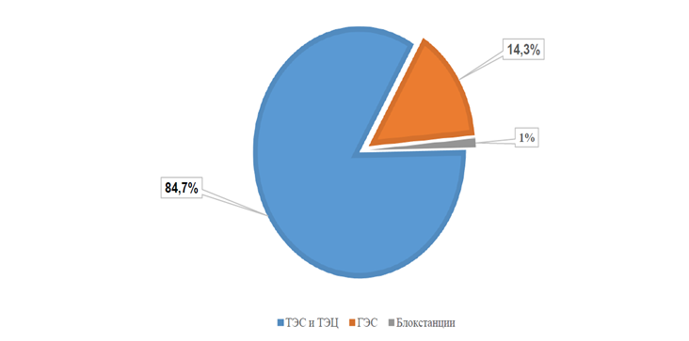
FIGURE 1. Structure of electricity generation in the power system of Uzbekistan.

According to recent estimates, the energy intensity of Uzbekistan's economy is 3-5 times higher than that of developed countries. This is a consequence of using outdated technologies, low tariff policies in the past, and insufficient implementation of energy-saving solutions. Overcoming these challenges requires a comprehensive modernization of the fuel and energy complex (FEC) and the formation of a diversified, sustainable energy balance.
Key Challenges of the Energy Sector:
- Structural dependence on gas. The dominance of natural gas in generation creates risks for energy security, reduces export volumes, and contradicts global environmental trends.
- Technological lag and wear. Low efficiency of thermal power plants (TPP) and a high percentage of equipment wear lead to significant losses and low efficiency.
- High energy intensity. This indicator is the main indicator of inefficient energy use in the national economy, reducing its competitiveness.
- Regional specifics. The historically established Unified Power System of Central Asia currently functions with interruptions due to disagreements between countries on tariffs and operating modes, which requires Uzbekistan to strengthen energy self-sufficiency.
The response to these challenges was the development of the National Energy Strategy until 2030, which sets ambitious goals for diversifying energy sources and improving efficiency.
Strategic Directions for Diversifying the Energy Balance
The diversification strategy is based on three pillars: development of RES, launch of nuclear energy, and a large-scale energy saving program.
1. Large-Scale Introduction of Renewable Energy Sources (RES)
Uzbekistan possesses colossal, yet underutilized RES potential.

Table 1. Potential of renewable energy sources in Uzbekistan (in million tons of oil equivalent)
Potential | Total | Hydroenergy | Solar Energy | Wind Energy
Gross | 50984.6 | 9.2 | 50973.0 | 2.2
Technical | 179.0 | 3.2 | 175.4 | 0.4
Utilized | ~1.0 | ~0.9 | ~0.1 | negligible

Source: based on data from the State Committee on Ecology and the Ministry of Energy of Uzbekistan.
According to the concept for the development of the energy sector [2], the republic's total electricity demand by 2030 will increase to 120.8 billion kWh, or 1.86 times (+55.8 billion kWh) compared to 2019 (65.0 billion kWh), i.e., an average of 5.8% per year.
Figure 2 shows the forecast for the growth of installed capacity in Uzbekistan's power system.[3]

GW
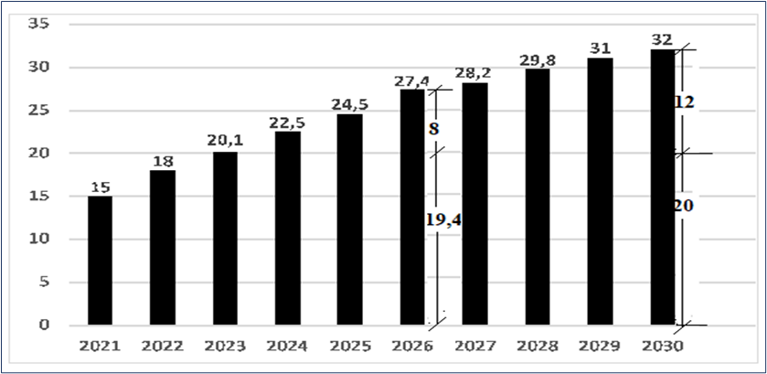FIGURE 2. Forecast of growth in installed capacity of electricity sources in the power system of Uzbekistan (according to calculations by Academician of the Academy of Sciences of the Republic of Uzbekistan K.R. Allaev).

In Figure 2, the values of RES installed capacity in Uzbekistan's power system in 2026 and 2030 are highlighted respectively: 8 GW (29.2% of installed) and 12 GW (37.5%), with the remaining part consisting of the total capacities of TPPs and HPPs.
In the field of wind energy, the priority is the formation of large wind farms with a unit capacity of 100-500 MW, most of which are planned to be located in the Northwestern region. In other regions of the republic, the construction of solar photovoltaic stations (PVS) with a capacity of 50-200 MW is envisaged. At the same time, large solar PVS (with a total capacity of over 300 MW) will be gradually equipped with industrial energy storage systems designed to smooth generation fluctuations and regulate peak loads. Alongside this, the development of isolated, low-power solar PVS not connected to the unified power system, focused on powering remote settlements, is planned. Additionally, an expansion in the construction of medium-power solar stations (1-20 MW), intended to meet the own energy needs of industrial enterprises and industrial parks, is expected.
This set of measures aims to meet the annually growing demand for electricity and support the intensive development of industry and the national economy.
However, increasing installed generation alone does not ensure the reliability of power supply and energy security in the medium and long term. The stability of the power system is possible only with constant adherence to the balance between electricity production and consumption. Otherwise, the power system loses stability, forcing the purchase of balancing services from neighboring power systems and/or imposing consumption restrictions.
To ensure this balance and reduce the volume of purchased regulating capacity from adjacent power systems, it is necessary that the share of maneuverable generating capacities in Uzbekistan's power system be at least 30%. Currently, this indicator reaches only 5-7%, which is significantly below the required level.
According to data from the National Dispatch Center of Uzbekistan, the difference between night minimum loads and evening maximum loads ranges from 2000-2500 MW depending on the season, which is approximately 35% of the maximum consumption capacity. The contribution of hydroelectric power plants to covering this unevenness in winter is about 7-8%, while in summer it practically drops to zero, as HPPs operate in base mode to meet irrigation needs.
According to operational information from the National Dispatch Center, to maintain the balanced operation of the power system and reduce the volume of purchased regulating capacity, over a thousand dispatch starts of thermal power plant units are carried out annually, along with regular reduction of generator loads to the technological minimum. Such operating modes reduce the reliability of TPP equipment, accelerate its wear, and increase specific fuel consumption.
For example, according to calculations by specialists of JSC "Thermal Power Plants," the fuel consumption at the units of the Tashkent TPP at a nominal load of 150 MW is 420 g/kWh, while when reducing the load to the technological minimum (80 MW), it increases to 435-440 g/kWh. At the modernized units of the Syrdarya TPP, fuel consumption at base load is 330 g/kWh, and when reducing the load to 205 MW, it increases to 345-350 g/kWh.
According to information from JSC "NES of Uzbekistan" in recent years, expenses for payment for regulating capacity services in the power system amounted to an average of 2.3 million USD, and this value could increase significantly due to the variability and difficult predictability of solar and wind power plant output.
DEVELOPMENT OF NUCLEAR ENERGY
The construction of a nuclear power plant in the Jizzakh region, comprising two power units with a total capacity of about 2.1 GW at the first stage of implementation, is considered a key element of the country's long-term energy strategy. The project is aimed at forming sustainable base generation that is not subject to seasonal factors and weather variability.
According to concluded agreements with Rosatom, the selected site is expected to host both large VVER-1000 type power reactors and low-capacity modular RITM-200N units, each with a capacity of about 55 MW. This combination of technologies will ensure generation flexibility and expand the station's functional capabilities.
According to estimates by relevant authorities, after the facility is commissioned, the total annual output will exceed 15 billion kWh. This will make a significant contribution to the formation of stable base generation and increase the level of energy reliability.
The project is expected to have a comprehensive impact on the country's economy and energy system, in particular:
- will ensure the release of significant volumes of natural gas used in thermal generation, allowing this resource to be redirected to industrial production and other important sectors of the economy;
- will reduce the dependence of the national power system on seasonal fluctuations in wind and solar power plant output;
- will create prerequisites for the industrial development of the region, including attracting investments, expanding production capacities, and creating new jobs in construction, operation, and maintenance of nuclear infrastructure;
- will contribute to the diversification of the energy balance and improvement of energy security through the integration of nuclear generation into the structure of the national power system.
Additionally, it is reported that the project envisages an operational lifespan of about 60 years and includes the construction of all necessary accompanying infrastructure for the long-term and safe operation of the facility. This confirms the strategic nature of the project and its significance for the sustainable development of the republic's energy sector.
Thus, the creation of the NPP in the Jizzakh region represents not just a separate infrastructure project, but a systemic step towards modernizing the energy complex, forming reliable base generation, and supporting the country's socio-economic growth.
ENERGY EFFICIENCY PROGRAMS AND FEC MODERNIZATION
Parallel to the development of new capacities, programs to reduce energy intensity are being implemented:
- TPP Modernization: Introduction of combined cycle technologies, allowing efficiency to be increased from the current 32-35% to 50-60%.
- Implementation of Smart Grid: Development of "smart" grids to reduce commercial and technical losses.
- Stimulation of Energy Saving: Programs for replacing inefficient equipment in the public sector, industry, and housing and communal services.
CONCLUSION
Forming a balanced and sustainable energy balance for Uzbekistan is a complex but achievable strategic goal. The coming decade will be a period of radical transformation of the energy sector.
- In accordance with the Concept for the Development of the Energy Sector of Uzbekistan, the initial plan was to introduce up to 5 GW of solar and 3 GW of wind power plants by 2030. However, the current pace of project implementation allows us to expect these indicators to be achieved by 2026, while by 2030 it is planned to increase the total installed capacity of generation based on renewable energy sources to 12 GW.
- By 2030, an almost twofold increase in electricity demand is projected, which should reach approximately 120.8 billion kWh per year. Maximum power consumption, according to forecast estimates, will exceed 20 GW.
- Considering the progressive increase in electricity consumption and the limited availability of fuel and energy resources, the necessity for accelerated development of alternative generation directions focused on ensuring the energy security and stability of the national power system becomes obvious.
The success of this transformation depends on the consistent implementation of the state strategy, attraction of large-scale foreign investments and technologies, as well as on strengthening regional cooperation. Diversification of energy sources, where RES, nuclear generation, and the modernized FEC do not oppose but mutually complement each other, is the only correct path to ensuring the long-term energy security and competitiveness of Uzbekistan's economy.
REFERENCES
- Decree of the President of the Republic of Uzbekistan "On the Development Strategy of Uzbekistan for 2022-2026". - Tashkent, 2022.
- Concept for Ensuring Uzbekistan with Electricity for 2020-2030. - Ministry of Energy of the Republic of Uzbekistan, 2020.
- Allaev K.R. On the Issue of Integrating Renewable Energy Sources into the Power System of Uzbekistan. - Tashkent, Problems of Energy and Resource Saving. No. 1, 2022.
- International Energy Agency (IEA). Energy Policy Review of Uzbekistan. - 2021.
- Official data of JSC "Uzbekenergo" and the Ministry of Energy of the Republic of Uzbekistan. -- 2021-2023.
- Analytical reports of the World Bank and the Asian Development Bank on projects in the energy sector of Uzbekistan. - 2020-2023.
- Otabek, A., Otabek, B. Alternative energy and its place in ensuring the energy balance of the Republic of Uzbekistan. In AIP Conference Proceedings, 2023, 2552, 050030 https://doi.org/10.1063/5.0117633
- Akhmedov, O., Begmullaev, O. The ways ensuring energy balance in Uzbekistan. In E3S Web of Conferences 216, 01137 (2020), https://doi.org/10.1051/e3sconf/202021601137
- Otabek Begmullaev, Saidaxon Nabieva, Shakhnoza Mirsaidova, Classification of energy efficiency policies and their implementation Available to Purchase. In AIP Conference Proceedings. 3331, 030053 (2025) https://doi.org/10.1063/5.0305929
- Ravshan Xusainov, Otabek Begmullaev, Problems of ensuring the electricity supply system in Uzbekistan. In AIP Conference Proceedings. 3331, 030002 (2025) https://doi.org/10.1063/5.0305927
- Gulchekhra Allaeva, Gulchekhra Yusupkhodjaeva, Kamola Mukhitdinova, Methodology for calculating sustainable development of fec enterprises based on consolidated integral indices. AIP Conf. Proc. 3331, 030006 (2025) https://doi.org/10.1063/5.0308133
- Gulchekhra Yusupkhodjaeva, Gulchekhra Allaeva, Kamola Mukhitdinova, Sustainable development of transport enterprises in the context of the formation of the digital economy. AIP Conf. Proc. 3331, 030087 (2025) https://doi.org/10.1063/5.0306872
- Kamala Mukhitdinova, Gulchekhra Yusupkhodjaeva, Gulchekhra Allaeva, Econometric modeling of investment potential of industrial enterprisess. AIP Conf. Proc. 3331, 050026 (2025) https://doi.org/10.1063/5.0308123
- Gulchekhra Allaeva, Main directions of sustainable development of fuel and energy enterprises. AIP Conf. Proc. 3152, 050012 (2024) https://doi.org/10.1063/5.0220851
- Gulchekhra Allaeva, The role of energy security in forming the foundations for sustainable development of fuel and energy complex enterprises. In E3S Web of Conferences 461, 01061 (2023), https://doi.org/10.1051/e3sconf/202346101061
- Gulchekhra Allaeva, Sustainable development methodology of fuel-energy complex of the republic of Uzbekistan. In E3S Web of Conferences 289, 07033 (2021) https://doi.org/10.1051/e3sconf/202128907033
- Gulchekhra Allaeva, Fiscal instruments of taxation improvement as a factor of sustainable development of enterprises of the fuel and energy sector. In E3S Web of Conferences 216, 01173 (2020) https://doi.org/10.1051/e3sconf/202021601173
- Gulchekhra Allaeva, Priority directions of development “Uzbekneftegas” jsc in the conditions of globalization of the world economy. In E3S Web of Conferences 139, 01008 (2019) https://doi.org/10.1051/e3sconf/201913901008
- Saodat Ibragimova, Khilola Bakhodirova, Formation of investment activities of energy enterprises. E3S Web of Conferences 461, 01074 (2023) https://doi.org/10.1051/e3sconf/202346101074
- Ravshan Xusainov, Barno Tillayeva, Nigina Sayfutdinova, Development of ecology and energy in Uzbekistan. AIP Conf. Proc. 3331, 030010 (2025) https://doi.org/10.1063/5.0306384
- Gulchekhra Yusupkhodjaeva, Development of a unified digital transport and logistics intelligent platform based on the National Operator. E3S Web of Conferences 461, 01055 (2023) https://doi.org/10.1051/e3sconf/202346101055
- Kamola Mukhitdinova, Gulmira Tarakhtieva, Ensuring sustainable future: The interconnectedness of food safety and environmental health. E3S Web of Conferences 497, 03037 (2024) https://doi.org/10.1051/e3sconf/202449703037
- Hashimova, S., Yakubova, D., Tursunova, N. (2024). Possibilities of Expanding the Mineral Resource as a Base of Ferrous Metallurgy. In Lecture Notes in Networks and Systems, vol 733. Springer, Cham. https://doi.org/10.1007/978-3-031-37978-9_70
- Sarvinoz Salomova, Matlyuba Saidkarimova, Latofat Karieva, Kamola Ibragimova, Gulnora Saidova, Ravshan Khikmatov, Improving the efficiency of energy enterprises AIP Conf. Proc. 3331, 040076 (2025) https://doi.org/10.1063/5.0305987
- Saidakhon Nabieva, Shakhnoza Atakhanova, Modern methods of investment activity in the development of industrial enterprises. AIP Conf. Proc. 3331, 050010 (2025) https://doi.org/10.1063/5.0308119
- Sarvinoz Salomova, Increasing the efficiency of oil and gas industry enterprises in Uzbekistan. AIP Conf. Proc. 3331, 040075 (2025) https://doi.org/10.1063/5.0305986
- Mukhitdinova, K.A, Vildanova, L.A Transport improvement of the method of assessing the attractiveness of investment in automotive enterprises. Published 2020 Engineering, Business, Economics, 171 Corpus ID: 218792573, https://DOI:10.31838/jcr.07.05.
- Safarov J., Khujakulov A., Sultanova Sh., Khujakulov U., Sunil Verma. Research on energy efficient kinetics of drying raw material. // E3S Web of Conferences: Rudenko International Conference “Methodological problems in reliability study of large energy systems” (RSES 2020). Vol. 216, 2020. P.1-5. doi.org/10.1051/e3sconf/202021601093

