Performance Improvement in Sugarcane Disease Classification Using Deep Transfer Learning
Chandana Khatavkar ^{1,a}, Raghavendra R Sedamkar^{2 ,b}, Sujata Alegavi^{3,c}
¹Research Scholar, Thakur College of Engineering and Technology, Mumbai, India.
²Professor, Thakur College of Engineering and Technology, Mumbai, India.
³Associate Professor, Thakur College of Engineering and Technology, Mumbai, India.
^{a)} khatavkar.chandana@gmail.com
^{b)} rr.sedamkar@thakureducation.org
^{c)} sujata.dubal@thakureducation.org
Abstract. Sugarcane is an important cash crop, which largely contributes in the sugar production globally. However, due its long growth cycles its yield as well as quality are often affected by various fungal, bacterial and viral diseases. Traditional disease detection methods completely rely on the human manual inspection, which is prone to errors and time consuming. Recent advancements in deep learning have improved the capability of automated, image-based plant disease detection. A detailed review of deep learning and transfer learning techniques for sugarcane leaf disease detection and classification is provided in this paper. It presents the various methodologies used for sugarcane plant disease detection along with its performance. Leveraging insights from existing literature, a modified MobileNetV2 architecture is used which embeds a dilated depth wise separable convolution to elevates feature extraction strength. This method also replaces ReLU activation function of the traditional MobileNetV2 with swish which helps in better optimization. The model is assessed on a varied, balanced dataset of sugarcane plant leaf images. It achieves a classification accuracy of 95%, transcending several existing models. The results show that the enhanced MobileNetV2 is well-suited for effectively detecting and classifying sugarcane plant diseases. It further provides insight for future research into multimodal inputs and combining environmental parameters for the development of robust and scalable solutions for better precision agriculture.

Introduction
Sugarcane is a global cash crop, prized for its high sugar content and is used to produce ethanol, jaggery, bagasse, and molasses as by product. As the second-largest producer and consumer of sugar, India supports one of the world’s most extensive agriculture-based industries. The juice from sugarcane has health benefits due to its alkaline properties. However, industry faces significant challenges as sugarcane diseases frequently endanger the yield and quality of sugarcane, posing major difficulties for farmers and the stakeholders.
Despite the significant economic value, sugarcane is highly prone to diseases caused by bacteria, fungi, viruses, and other pathogens. Common diseases affecting sugarcane leaves and stems include mosaic disease, white leaf disease, red rot, smut, wilt, yellow leaf disease, grassy shoot, red stripe, and rust. Foliar diseases are especially harmful, resulting in considerable losses in productivity and product quality. Therefore, early detection and accurate identification are crucial for implementing effective management strategies and minimizing potential damage.
Traditional approach to diagnosing sugarcane leaf diseases usually depend on visual inspections carried out by agricultural experts. Although traditional manual methods can be somewhat effective, they are generally slow, labour-intensive, and prone to human errors and subjective judgements. Adopting automated techniques for detecting sugarcane leaf diseases provides a more efficient, accurate, and reliable solution, significantly improving the precision and speed of disease identification. Automation in this context offers several significant benefits.
Enhanced accuracy: Traditional disease detection relies on expert assessment, which can be error prone. Automated systems reduce human intervention, thereby increasing accuracy.
Cost efficiency: Manual crop inspection is resource-intensive, requiring high labour costs and specialized equipment. Automation provides efficient and cost-effective solutions to these challenges.
Improved monitoring: By leveraging advanced technology, automated sugarcane leaf disease detection enhances monitoring efficiency, boosts diagnostic accuracy, and optimizes crop management.

The lengthy growth cycle of sugarcane makes timely disease detection crucial. Image processing and deep learning can identify plant issues by analysing leaf colour, shape, and damage. As climate challenges intensify, deep learning combined with tools like sensors and drones, enhances crop monitoring, soil analysis, and farm management. Although still emerging, these technologies have great potential for early and accurate disease detection, thereby boosting productivity and food security.

REPORTED WORK
Deep Learning based approach

Deep learning methodologies have revolutionized sugarcane plant disease detection, which offer better accuracy, automated feature extraction, and scalability as compared to the traditional machine learning methods. Unlike machine learning models such as Random Forest, SVM, and KNN, which rely on manual feature engineering and handcrafted segmentation techniques, deep learning models like CNNs, Vision Transformers (ViTs), and hybrid architectures automatically learn spatial hierarchies and complex patterns from the raw images. By use of this, the dependency on predefined feature selection is eliminated, making deep learning more robust to variations in lighting, background, and disease symptoms.

Deep learning-based methodologies have significantly advanced sugarcane plant disease detection by leveraging powerful convolutional and transformer-based architectures. Various studies have explored deep learning models to optimize classification accuracy and efficiency. [1] compared multiple CNN architectures, including StridedNet, LeNet, and VGGNet, on a dataset of 14,725 sugarcane leaf images, with VGGNet achieving the highest accuracy of 95.40%, demonstrating its superior feature extraction capability. Similarly,[2] investigated EfficientNetV1 and EfficientNetV2 on the Sugarcane Leaf Dataset (6,748 images, 11 disease classes), revealing that EfficientNet-B6 (93.39%) and InceptionV4 (93.10%) performed best, emphasizing the need for architecture-specific optimizations. A comparative analysis by [3] assessed AlexNet, ResNet18, VGG19, and DenseNet201 for detecting Red Rot, Red Rust, Mosaic, and Yellow Leaf Disease on a dataset of 1,990 images, with VGG19 achieving 98.82% accuracy, making it the most effective model in multi-class classification. Furthermore, [4] developed a self-created dataset-based model that outperformed VGG19, ResNet50, XceptionNet, and EfficientNet_B7, achieving 86.53% accuracy and integrating the AMRCNN model into a mobile application, ensuring accessibility and real-time disease classification.

Enhancing efficiency,[5] introduced an optimized ShuffleNetV2-based model with ECA attention and Transformer modules, achieving lightweight mobile deployment with only 0.4MB of parameters and 1.57MB memory usage. Moreover, [6] presented an explainable AI model that integrates DenseNet with SVM and LIME, providing visual interpretability to aid farmers in disease classification and pesticide recommendation. Additionally, [7] evaluated ResNet-50, VGG-16, DenseNet-201, VGG-19, and Inception V3 on a dataset of 2,511 images, where ResNet-50 (95.69%) and VGG-16 (93.26%) outperformed other models, while Inception V3 (74.88%) exhibited lower accuracy. These studies collectively highlight advancements in deep learning-driven sugarcane disease detection, with improvements in accuracy, efficiency, mobile deployment, and interpretability. However, gaps remain in real-time scalability, dataset diversity, and edge-computing implementation for offline detection, necessitating further research into lightweight and high-accuracy models tailored for real-world agricultural applications.
Mobile integration has enhanced accessibility, enabling farmers to diagnose diseases using smartphone-based applications. The development of lightweight and efficient models, such as ShuffleNetV2 and AMRCNN, has optimized computational resources while maintaining high classification accuracy. Additionally, by combining explainable AI methods like DNet-SVM: XAI, the model's transparency has been greatly enhanced. This makes it easier to understand and interpret the decisions behind disease classifications. Furthermore, the implementation of state-of-the-art CNN architectures has considerably increased the accuracy and reliability of plant disease detection and classification, ensuring reliable and trustworthy detection in actual agricultural conditions.

Despite these advancements, several challenges persist, hindering the scalability and practical deployment of these models. A significant limitation is the need for larger and more diverse datasets. Many existing models are trained on region-specific or laboratory-controlled datasets, which restrict their generalizability across various climatic and environmental conditions. Also, real-time performance optimization is necessary to enable immediate disease identification and intervention, particularly for large-scale farming operations. Moreover, the absence of edge computing-based solutions limits the feasibility of offline disease detection in remote with limited internet connectivity. Overcoming these challenges through data augmentation, federated learning, and edge AI technologies will be essential for improving the effectiveness and accessibility of deep learning models in precision agriculture.
Transfer Learning based approach
Transfer learning is an effective approach for plant disease detection. It employs pre-trained deep learning models, where knowledge acquired from one task one task is applied to improve performance on a related task. It is widely used to improve classification accuracy for plant disease detection with limited data. It is particularly helpful when labeled images of sugarcane diseases are scarce. It allows models to learn from larger, related datasets, adapt knowledge and perform effectively on task with small dataset. This approach eliminates the need for training from scratch, significantly reducing time and computational costs. It is useful when existing models trained on general plant diseases can be fine-tuned for sugarcane-specific conditions.

TABLE 1. Overview of Deep Learning models utilized in sugarcane plant disease detection across various studies

Ref | Dataset | Image Count | Classe  Count | Name of diseases | Classifier / Model / Algorithm | Performance Parameters | Methodology
[1] | Self-collected | 14,725 | 7 | Grassy shoot, Red Rot, Smut, Rust, Yellow Disease, Healthy | LeNet  VGGNet  StridedNet | Accuracy - 95.40%  Accuracy - 93.65%  Accuracy - 90.10% | Employes three CNN architectures (VGGNet, LeNet, and StridedNet) with data augmentation and Adam Optimizer with categorical cross-entropy
[2] | Publicly available | 6748 | 11 | Banded Chlorosis, Brown Rust, Brown Spot, Grassy Shoot, Pokkah boeng, Sett Rot, Smut, Viral Disease, Yellow Leaf, Dried Leaves, Healthy Leaves | EfficientNet-B6 InceptionV4 | Accuracy - 93.39%  Accuracy - 93.10% | Employs DL and TL with EfficientNet, ResNetv2-50, and InceptionV4 models, leveraging data augmentation and pre-trained weights
[3] | Publicly available  Kaggle | 1990 | 4 | Red Rot,Red Rust, mosaic,  and yellow leaf disease | AlexNet,  VGG19  ResNet18  DenseNet201 | Accuracy - 97.06%, Precision - 94.06%  Accuracy - 98.82% , Precision - 96.77%  Accuracy - 97.21% , Precision - 90.64%  Accuracy - 97.94% , Precision - 94.16% | Employes CNN architectures with data augmentation and hyperparameter tuning for enhanced model performance
[4] | Public  Mendeley  [39] | 2569 | 5 | Healthy, Mosaic, Redrot, Rust and Yellow disease | Attention based multi-level residual convolutional neural network | Accuracy - 86.53% | An attention-based CNN architecture with channel and spatial attention mechanisms, leveraging residual connections for improved feature extraction.
[5] | Kaggle | 2569 | 5 | Healthy, Mosaic, Redrot, Rust and Yellow disease | ShuffleNetV2 | Accuracy - 93.88% | Uses ShuffleNetV2 by integrating multi-scale feature extraction, ECA attention, and Transformer-based learning, and training on an augmented dataset.
[6] | Plant Village and  Self | 14000 | 5 | bacterial blight/red stripe, wilt, red rot, red rust, and sett rot | DNet-SVM | Accuracy - 94 %  Sensitivity - 0.94  Specificity - 0.86  FNR - 0.05, FPR - 0.13 | Feature Extraction using DenseNet201, classifies images with SVM instead of Softmax, and utilizes LIME (Local Interpretable Model-Agnostic Explanation) to provide transparent justifications for disease predictions
[13] | Self-collected | 3000 | 3 | Rust, Smut, and Leaf Scald | EfficientNet | Accuracy - 94.6% | Fine-tuning a pre-trained EfficientNet model
[14] | Public  Mendeley | 2521 | 5 | Healthy, Mosaic, Redrot, Rust and Yellow disease | ResNet-50  VGG-16  DenseNet-201  VGG-19  Inception V3 | Accuracy - 95.69%  Accuracy - 93.26%  Accuracy - 89.62%  Accuracy - 79.62%  Accuracy - 74.88% | Preprocessing techniques like gamma correction and contrast stretching are applied followed by fine-tuning model parameters
[15] | Self-collected | 16,800 | 6 | Cercospora Leaf Spot, Helminthosporium Leaf, Rust, Red Dot, Yellow Leaf Disease, Healthy | VGG16  ResNetV2-152  AlexNet,  InceptionV3 | Accuracy - 98.88%  Accuracy - 99.23%  Accuracy - 99.24%  Accuracy - 99.53% | Use of SGD optimizer with varying hyperparameter settings, including epoch count, momentum, learning rate, and batch size, to optimize classification accuracy.
[16] | Self-collected | 1,828 |  | Sugarcane Smut, Sugarcane Mosaic Virus | Modified ResNet34 | Accuracy - ~94 – 95%  F1 Score - ~96% | Modified ResNet34 with Dual Self-Attention Block (DSAB) for spectral-spatial feature extraction on high-resolution hyperspectral image
[17] | Self-collected | 3,279 | 2 | Sugarcane smut | Enhanced YOLOv5s | Precision: 97.0%  Recall: 94.3%  mAP : 97.8% | lightweight YOLOv5s-based model (YOLOv5s-ECCW) designed using EfficientNetV2, CBAM, C3STR, and WIoU loss function
[18] | Self-collected | 200 |  | Sugarcane smut | ResNet-based CNN with Dual Self-Attention Block (DSAB) | Accuracy -90.86%  F1 Score – 88.51%  Specificity - 93.64%  Sensitivity - 86.79% | Employed hyperspectral imaging and a ResNet-based deep learning model with a Dual Self-Attention Block (DSAB)
[19] | Publicly avaible | 250 | 5 | Mosaic, Red Rot, Rust, Yellow Leaf, and Healthy | VGG16 | Accuracy- 90.11% | VGG16 model optimized with L2 regularization and the Adam optimizer.
Additionally, transfer learning excels in detecting multiple diseases with subtle visual differences, ensuring better pattern recognition and classification. By adapting pre-learned knowledge, it enables precise identification of diseased and healthy leaves, making it an efficient and scalable solution for agricultural disease detection.
Deep learning methodologies have demonstrated superior performance in sugarcane disease detection, particularly through transfer learning, optimization techniques, and advanced classification models. In [8] modifications to DenseNet121 and InceptionV3 with additional layers, batch normalization, dropout, and LASSO regularization significantly improved accuracy, with InceptionV3 achieving 97% and DenseNet121 reaching 96%, outperforming traditional architectures. Similarly, [9] validates the effectiveness of transfer learning for sugarcane disease detection on a limited dataset (1,470 images), where ResNet (91%) outperformed VGG-16 (83%), reinforcing the adaptability of deep learning in agricultural applications. Further optimization is explored in [10] where a Quantum Behaved Particle Swarm Optimization-based Deep Transfer Learning (QBPSO-DTL) model achieved 96.25% accuracy by integrating optimal region-growing segmentation, SqueezeNet for feature extraction, and a Deep Stacked Autoencoder (DSAE) for classification. The use of QBPSO for hyperparameter tuning further validated the efficiency of the model in fine-tuning deep learning architectures. Similarly, [11] investigates the impact of activation functions on AlexNet, showing that LeakyReLU improved accuracy to 90.67% compared to ReLU (87.90%), though at a higher computational cost, emphasizing the trade-off between accuracy and efficiency in deep learning.
In [12] ResNet-50 was utilized as the backbone model, incorporating transfer learning, fine-tuning in TensorFlow, and data augmentation techniques (Gaussian Blur, brightness adjustment) to enhance classification. Despite achieving an accuracy of 81.70%, this study highlights the challenges of background segmentation and dataset variability in deep learning-based disease detection.
Despite these advancements, several challenges remain that hinder the real-time applicability and scalability of these models. Computational efficiency remains a concern, particularly for resource-constrained environments, as deep learning models often require high processing power and extended training times. Additionally, dataset limitations, including insufficient labeled images and variations in environmental conditions, impact model generalization across diverse agricultural settings. Sensitivity to background noise and variability in leaf textures and lighting conditions further affect the reliability of disease detection models in real-world applications.

TABLE 2. Overview of Transfer Learning models utilized in sugarcane plant disease detection across various studies
Ref | Dataset | Image Count | Classe  Count | Name of diseases | Classifier / Model / Algorithm | Performance Parameters | Methodology
[8] | Public  Mendeley | 2569 | 5 | Healthy, Mosaic, Redrot, Rust and Yellow disease | Regularized InceptionV3  Dense-Net121 | Precision - 97%, Recall - 97%, F1 Score - 97%, Accuracy - 97%  Precision - 96%, Recall - 96%, F1 Score - 96%, Accuracy - 96% | Incorporated nine additional layers, LASSO regularization, dropout layers, normalization techniques, optimization strategies, and early stopping
[9] | Self -Collected | 1470 | 5 | Healthy, Mosaic, Redrot, Rust and Yellow disease | VGG-16  ResNet | Accuracy - 83%  Accuracy - 91% | learning rate of 0.005, Adam Optimization algorithm and a batch size  of 32 images.
[10] | Self collected | 80 | 2 | Diseased and Non diseased | Deep Stacked Autoencoder (DSAE) | Accuracy - 96.25%, | SqueezeNet model for efficient feature extraction and Deep Stacked Autoencoder (DSAE) for classification
[11] | Public  Mendeley | 2569 | 5 | Healthy, Mosaic, Redrot, Rust and Yellow disease | AlexNet (activation functions ReLU and LeakyReLU) | LeakyReLU -Accuracy - 90.67%  ReLU -Accuracy - 87.90% | Impact of activation functions on AlexNet's performance in sugarcane disease classification, comparing ReLU and LeakyReLU.
[12] | Public  Mendeley | 2569 | 5 | Healthy, Mosaic, Redrot, Rust and Yellow disease | Modified ResNet50 | Accuracy - 81.7% | Utilizes techniques such as gaussian blur, linear contrast, brightness adjustment, and additive gaussian noise for data augmentation.  feature histograms used for feature extraction

METHODOLOGY

Dataset
This experiment utilized the sugarcane leaf disease dataset [21] which comprises 2,569 RGB images across five categories: Healthy, Mosaic, Red Rot, Rust, and Yellow Leaf Disease. Captured in Maharashtra, India, the dataset maintains a balanced distribution among all classes and includes a wide range of visual variations.

TABLE 3. Dataset class labels and no of samples
Class | No of samples
Mosaic | 511
Red Rot | 519
Rust | 514
Yellow | 505
Healthy | 520

Dataset Preprocessing
The dataset was divided using an 80:10:10 ratio for training, validation, and testing to evaluate the model's performance effectively. All images were resized to 224x224 pixels, to ensure uniformity and consistency. Post resizing, normalization is applied, pixel values are normalized to scale to a specific range. Normalization helps to support efficient and stable model training. To boost the training set’s ability and robustness, several data augmentation techniques are applied. These includes color jittering where random color adjustments are done, images are flipped horizontally and vertically as it generates mirrored versions of images. Images are also rotated as it alters their orientation by applying random angles. To help the model generalize to different object distances, images are scaled as it adjusts image size, and lastly images are translated along the X or Y axis. By applying transformation like positional shifts and color jittering, realistic changes in lighting, brightness and color which simulates real-world conditions

Methodology
An adapted form of popular MobileNetV2 architecture is used for feature extraction, referred to as modified MobileNetV2. MobileNetV2 is a lightweight, resource-efficient deep learning architecture specifically designed for mobile and edge devices.[20] For image classification and object detection tasks, it is popularly used as it offers improved computational efficiency while maintaining high performance [22]. The fundamental building block of MobileNetV2 is the inverted residual block, which is made up of several important components as shown in Figure 1.

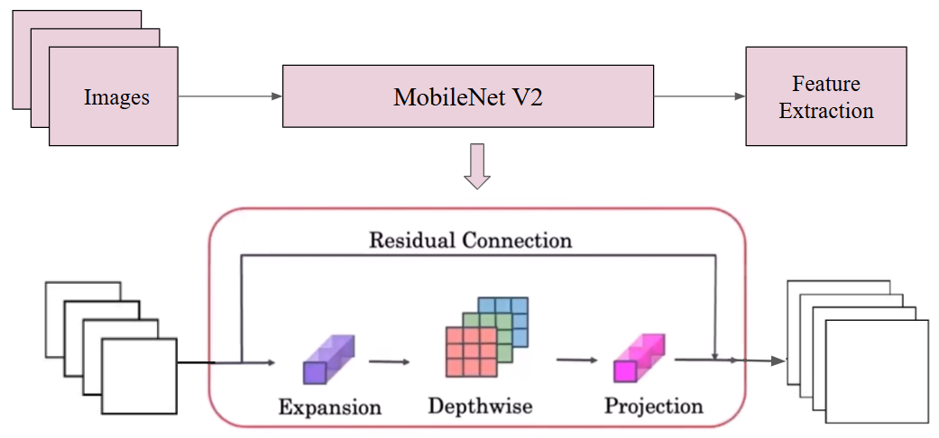

FIGURE 1. MobileNetV2

The core unit of MobileNetV2 is the inverted residual block which helps make the model both powerful and efficient. It consists of Expansion Layer which utilizes a 1×1 convolution to increase the input channel dimensions. This improves the model's ability to capture and represent complex features effectively.

The depth wise separable convolution reduces the computational complexity while maintaining the expressive power of the network. The Projection layer also known as the bottleneck layer compresses feature maps to lower dimensionality, improving efficiency. Similar to ResNet, skip connection helps the network by allowing information and gradients to flow more easily and allowing deeper networks to be trained effectively [23].

To further enhance feature extraction capabilities, the final inverted residual block of MobileNetV2 is substituted with a depth-wise dilated separable convolution layer. This modification was used to broaden the receptive field while preserving computational efficiency. Unlike the traditional 3×3 depth wise convolution, this approach uses a 3×3 depth wise dilated convolutions with a dilation rate of 2. By doing so, the network effectively captures multi-scale contextual information without significantly increasing the number of trainable parameters.

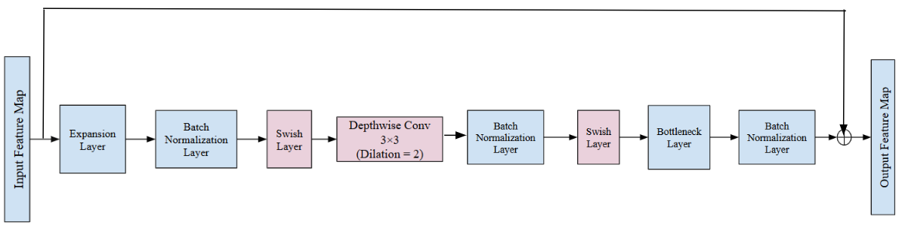
FIGURE 2. Modified MobileNetV2

A dilated convolution introduces spatial gaps (holes) between kernel values, effectively widening the receptive field of the convolutional operation. Instead of increasing kernel size or the number of parameters, dilated convolutions achieve broader coverage by inserting zeros between elements in the convolutional kernel. Mathematically, a dilated convolution with dilation rate 𝑑 is given by:
$y(i) = \sum_{k=0}^{K-1}{}x(i+ d⋅ k) ⋅w\left(k\right) (1)$
where: 𝑥(𝑖) - is the input feature map, 𝑤(𝑘) - is the kernel weight, 𝑑 - is the dilation rate, and 𝐾 - is the kernel size.

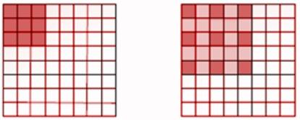
(a) (b)
FIGURE 2. Effect of Dilation Rate (a) Dilation Rate = 1 (b) Dilation Rate = 2

RESULTS AND DISCUSSIONS

Model Training Details

To enhance the feature extraction capabilities of the baseline MobileNetV2 architecture, a custom convolutional module is used. This module combines depth wise separable convolution with dilation, enabling the model to capture multi-scale contextual information while maintaining computational efficiency. It consists of the depth wise convolution with dilation which performs convolution independently over each input channel with a dilation rate of 2. This expands the receptive field without increasing the number of parameters or significantly impacting computational cost [24]. Pointwise Convolution applies a 1×1 convolution to project the depth wise output to the desired number of output channels, facilitating inter-channel mixing. For faster convergence and improved generalization batch normalization is used [25]. The swish activation introduces non-linearity after normalization, enabling the model to learn complex patterns. Unlike ReLU used in MobileNetV2, swish is differentiable as it allows negative values which improves the gradient flow. It provides more flexibility as the input is scaled by a sigmoid gate as shown in equation 2.
$swish(x)= x⋅σβx)$ (2)
where $x$ is the input, $σβx)$ is the sigmoid function, $β$ is a trainable or fixed parameter which is often set to 1.
If $β=1,$the equation simplifies to
$swish(x)= x⋅σx)$ (3)

The final layers include adaptive average pooling layer which reduces the spatial dimensions to 1×1 aggregating global features and fully connected layer which maps the 1280-dimensional feature vector to the number of disease classes using a linear classifier.

In the modified MobileNetV2 framework, the initial layers (0 to 16) were frozen to preserve the knowledge acquired during pre-training, while layers 17 and 18 were fine-tuned to adapt the model to the specific task of sugarcane disease classification. Training was carried out using the adam optimizer in conjunction with a multi-class cross-entropy loss function. To enhance the model's effectiveness, various hyperparameter settings were evaluated. A learning rate of 0.00001 was employed, and experiments were conducted with batch sizes of 32.

RESULTS
The classification report demonstrates that the modified model achieves strong and consistent performance across all five categories of sugarcane leaf conditions Mosaic, Red Rot, Rust, Yellow and Healthy. The model demonstrates high precision and recall values and attains an overall accuracy of 95%. This indicates that model’s robustness in making accurate and trustworthy predictions. Figure 4, showcases that model has a high performance in detecting rust and healthy leaves with f1-score of 0.97 for both classes. It demonstrates impressive recall of 0.99 for healthy leaves and 0.98 for rust class. This justifies that it rarely missed actual cases and made very few false negatives.

A balanced classification ability is seen as Mosaic, red rot, and yellow diseases also show strong f1scores of 0.95, 0.94, and 0.95, respectively. Across all classes, the macro and weighted averages for precision, recall, and F1-score are 0.95. The model’s effectiveness for both balanced and imbalanced class distributions can be seen. Overall, the model is reliable and can make a practical option for real-world use in precision agriculture especially when it comes to spotting sugarcane leaf diseases early and accurately.

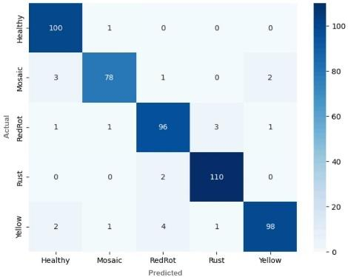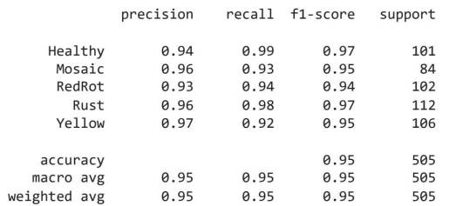
FIGURE 3. Confusion matrix for Modified MobileNetV2 FIGURE 4. Classification Report for Modified MobileNetV2

The training and testing performance of the Modified MobileNetV2 model over 20 epochs demonstrated in Figures 5 and 6. In Figure 5, the accuracy curve shows a gradual improvement in training accuracy, which reaches close to 99%, while testing accuracy plateaus at around 95% early in the training process and remains consistent. This indicates that the model has learnt well from the training data and model’s ability is not reduced to generalize the learnings on the unseen data.

Figure 6 presents the loss curves Figure 6 presents the loss curves, which shows a steep drop in training loss that converges to zero. Additionally at the same time the testing loss stays low and stable across the epochs. This shows that the model avoids overfitting ensuring stable performance on the unseen data. This collectively highlights the capability of the Modified MobileNetV2 architecture in both, learning from data and generalizing key features for sugarcane leaf disease classification.

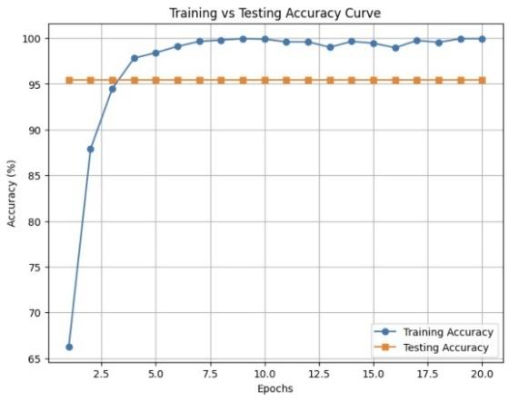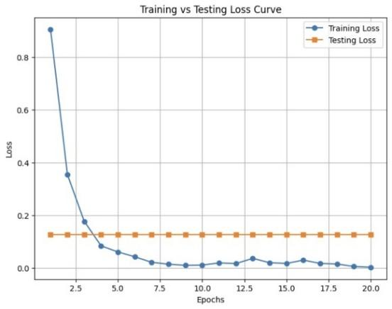
FIGURE 5. Accuracy Curve for Modified MobileNetV2 FIGURE 6. Loss trend for Modified MobileNetV2

Performance Evaluation against Baseline Models
A standard pretrained MobileNetV2 was also evaluated under identical experimental conditions achieving an accuracy of 85.3%. A number of pre-existing models that were documented in earlier research were taken into consideration for comparison study. Table 4 provides an overview of their classification accuracy for identifying sugarcane leaf disease. Notably, the suggested model outperformed the technique presented in [4], which achieved an accuracy of 86.35% using a stacking ensemble that combined a conventional CNN with a spatial attention-based CNN. It also performed well as compared to other popular models.

TABLE 4. Comparison of Model Performance
Reference | Class | Accuracy
[7] | EfficientNet_B7 | 72.72%
[7] | ResNet50 | 80.64%
[12] | Modified ResNet50 | 81.70%
[7] | MobileNetV2 | 83.24%
[4] | CNN Stack Ensemble Model | 86.53 %
- | Modified MobileNetV2 | 95.00%

In contrast, the modified MobileNetV2 achieved the accuracy of 95%, making it the most effective model among those compared. To provide consistent and fair evaluation, every model in the comparison worked on the same dataset [20].

CONCLUSION AND FUTURE DIRECTION

Several deep learning and transfer learning techniques for classification of sugarcane leaf diseases have been reviewed and a brief summary has been provided. A modified MobileNetV2 technique based on integration of MobileNetV2 architecture with dilated depth wise separable convolution for improved performance is presented. The model’s ability to learn essential spatial features is considerably strengthened by expanding the receptive field in the final residual block. Further the ReLu activation function of MobileNetV2 is replaced by swish, which allows small negative values to pass through, and helps in better optimization. Thorough experimentation on a diverse dataset demonstrated the enhanced performance of the model by achieving classification accuracy of 95%. This outperforms not only the baseline MobileNetV2 but also other architectures including EfficientNet_B7, ResNet50 and a stacking ensemble of sequential CNN and spatial attention-based CNN [4].

In the future, research work can focus on increasing the dataset size to include a greater variety of sugarcane plant leaf diseases with different classes. Alternative deep learning architectures leveraging ensemble strategies, attention-based transformer architectures can be explored. Additionally, integration of data from different modality, such as agro-climatic parameter of soil and weather conditions can build robust models to work in real time agricultural field. Employing progressive optimization techniques based on particle swarm optimization may further improve the accuracy and suitability of disease detection systems in actual agricultural environments.

References
- S. V. Militante and B. D. Gerardo, "Detecting Sugarcane Diseases through Adaptive Deep Learning Models of Convolutional Neural Network," 2019 IEEE 6th International Conference on Engineering Technologies and Applied Sciences (ICETAS), Kuala Lumpur, Malaysia, 2019, pp. 1-5.
- Kunduracıoğlu, İ., & Paçal, İ. Deep Learning-Based Disease Detection in Sugarcane Leaves: Evaluating EfficientNet Models. Journal of Operations Intelligence, (2022)2(1), 44–58.
- Reddy, A. V., Thiruvengatanadhan, R., Srinivas, M., & Dhanalakshmi, P. (2023). Artificial Intelligence Framework for Sugarcane Diseases Classification using Convolutional Neural Network. International Journal on Recent and Innovation Trends in Computing and Communication, 11(9), 3620–3628
- Daphal, S. D., & Koli, S. M. (2024). Enhanced deep learning technique for sugarcane leaf disease classification and mobile application integration. Heliyon, 10(8), e29438
- Xu, Y., Lu, Z., Zhai, Y., Jiao, Y., & Zhou, Y. (2023). A Method for Sugarcane Disease Identification Based on Improved ShuffleNetV2 Model. Research Square.
- Pudupet Ethiraj, R., & Paranjothi, K. (2024). A deep learning-based approach for early detection of disease in sugarcane plants: an explainable artificial intelligence model. International Journal of Artificial Intelligence (IJ-AI), 13(1), 974–983.
- Daphal SD, Koli SM. Enhancing sugarcane disease classification with ensemble deep learning: A comparative study with transfer learning techniques. Heliyon. 2023 Jul 18;9(8):e18261.
- Sidana, S. (2024). Improving Sugarcane Disease Identification with L1-Regularized Transfer Learning Approach. In Proceedings of the 2nd International Conference on Emerging Technologies and Sustainable Business Practices-2024 (ICETSBP 2024) (pp. 152–166). Atlantis Press.
- Daphal, S. D., & Koli, S. M. (2021). Transfer Learning Approach to Sugarcane Foliar Disease Classification with State-of-the-Art Sugarcane Database. In Proceedings of the 2021 International Conference on Computational Intelligence and Computing Applications (ICCICA) (pp. 1–4). IEEE.
- T, Tamilvizhi & .R, Surendran & Anbazhagan, K. & Kalimuthu, Rajkumar. (2022). Quantum Behaved Particle Swarm Optimization-Based Deep Transfer Learning Model for Sugarcane Leaf Disease Detection and Classification. Mathematical Problems in Engineering. 2022. 1-12. 10.1155/2022/3452413.
- Kursun, R., Yasin, E. T., & Koklu, M. (2024). Classification of Sugarcane Leaf Disease with AlexNet Model. Proceedings of International Conference on Intelligent Systems and New Applications, 2, 32–37.
- Lawanwong, N., & Pumrin, S. (2022). Development of an Algorithm for Classifying Common Sugarcane Diseases in Thailand. In Proceedings of the 14th Regional Conference on Electrical and Electronics Engineering (RC-EEE 2021) (pp. 152–155).
- G. Singh, K. Guleria and S. Sharma, "RedRot and Mosaic Sugarcane Leaf Disease Classification using an EfficientNet Deep Learning Model," 2024 IEEE 3rd World Conference on Applied Intelligence and Computing (AIC), Gwalior, India, 2024, pp. 1058-1063
- M. A. Rahaman Yead, L. Rukhsara, T. Rabeya and I. Jahan, "Deep Learning-Based Classification of Sugarcane Leaf Disease," 2024 6th International Conference on Electrical Engineering and Information & Communication Technology (ICEEICT), Dhaka, Bangladesh, 2024, pp. 818-823
- Hernandez, A. A., Bombasi, J. L., & Lagman, A. C. (2022). Classification of Sugarcane Leaf Disease using Deep Learning Algorithms. In Proceedings of the 2022 IEEE 13th Control and System Graduate Research Colloquium (ICSGRC) (pp. 47–50). IEEE.
- Bao, D., Zhou, J., Bhuiyan, S. A., Adhikari, P., Tuxworth, G., Ford, R., & Gao, Y. (2024). Early detection of sugarcane smut and mosaic diseases via hyperspectral imaging and spectral-spatial attention deep neural networks. Journal of Agriculture and Food Research, 18, 101369.
- Yu, M., Li, F., Song, X., Zhou, X., Zhang, X., Wang, Z., Lei, J., Huang, Q., Zhu, G., Huang, W., et al. (2024). YOLOv5s-ECCW: A Lightweight Detection Model for Sugarcane Smut in Natural Environments. Agronomy, 14(2327)
- D. Bao, J. Zhou, S. A. Bhuiyan, A. Zia, R. Ford and Y. Gao, "Early Detection of Sugarcane Smut Disease in Hyperspectral Images," 2021 36th International Conference on Image and Vision Computing New Zealand (IVCNZ), Tauranga, New Zealand, 2021
- Ubaidulla, S., & Mary Vennila, S. (2024). AI-Powered Insights for Early Detection of Sugarcane Leaf Diseases Using VGG16 Deep Learning Model. The Academic, 2(10), 749–761. ​
- Sandler, M., Howard, A., Zhu, M., et al. (2018) Mobilenetv2: Inverted Residuals and Linear Bottlenecks. Proceedings of the IEEE Conference on Computer Vision and Pattern Recognition, Salt Lake City, 18-23 June 2018, 4510-4520.
- Daphal, Swapnil; Koli, Sanjay (2022), “Sugarcane Leaf Disease Dataset”, Mendeley Data.
- Alegavi, S., & Sedamkar, R. (2025), “Optimizing Remote Sensing Image Retrieval Through a Hybrid Methodology”, Journal of Imaging, MDPI, 11(6), 179. https://doi.org/10.3390/jimaging11060179
- Yele, V.P., Badhe, N.B., Alegavi, S. et al. Multi Attention Convolutional Sparse Coding U-Net for Enhanced Land-Use and Land-Cover Segmentation Using Hyperspectral Images. Sensing and Imaging Journal, Springer Nature, Sens Imaging 26, 69 (2025). https://doi.org/10.1007/s11220-025-00594-6, Volume 26, article number 69, (2025), Published: 20 May 2025.
- Yele, V.P., Alegavi, S. & Sedamkar, R.R., “Effective segmentation of land-use and land-cover from hyperspectral remote sensing image”, International Journal of Information Technology, Int. j. inf. tecnol. (2024). https://doi.org/10.1007/s41870-023-01711-y (Springer Scopus Indexed Journal), 26 January 2024.
- Prachi Janrao; Sujata Alegavi; Vedant Pandya; Chetashri Bhadane; Rutvi Thakar; Hemant Kasturiwale, “Weather forecasting using IoT and neural network for sustainable agriculture” AIP Conf. Proc. 2842, 040003 (2023),doi.org/10.1063/5.0176348

