Labor Link : An Application For Blue Collar Workers
Deep Parekh^{1,a}, Shubh Harde^{2,b}, Drashti Shah^{3,c}, Sweedle Machado^{4,d}, and Deepali Patil ^{5,e}
¹Department of Information Technology, Dwarkadas J. Sanghvi College of Engineering, Mumbai, India
²Department of Artificial Intelligence and Data Science, Dwarkadas J. Sanghvi College of Engineering, Mumbai, India
Author Emails
^{a)}parekhdeep92@gmail.com,
^{b)}shubhharde158@gmail.com,
^{c)}drashtishah101003@gmail.com
^{d)}sweedle.machado@djsce.ac.in,
^{e)}deepali.patil@djsce.edu.in
Abstract. The populace has encountered difficulties in getting blue-collar laborers for daily household chores or any form of service. Blue- collar workers make up over 80% of India's non-agricultural workforce, which is roughly 300 million workers in total. Numerous applications and agencies provide such laborers on demand. Nonetheless, these platforms confront several challenges, including a lack of worker authentication in certain instances, and the absence of temporary scheduling options. The proposed system delineated in this paper seeks to mitigate these shortcomings by devising an application that integrates worker authentication through facial recognition. Furthermore, the application can be operated using voice commands, and it encompasses temporary scheduling. Moreover, the application incorporates a content-based recommendation system and sentiment analysis functionality. To bolster the development of this system, we have amassed a sample database from blue-collar workers in Mumbai.
Keywords—Blue-Collar workers; face recognition; Content based recommendations; Resnet50; blue collar application; gemini pro vision model

Introduction
In the current landscape of the Indian market, a noticeable void exists, and it is quite conspicuous a lack of a unified application that brings together an array of daily services under one comprehensive platform. There are many blue collar workers but their potential is not being tapped as they struggle to connect with customers. In this space Proposed system is a game changer, a unique platform that caters to the various needs of users who need daily services and a lifeline for blue collar workers to earn a living in a more dignified and efficient way.
A major challenge in the current situation is the lack of a streamlined solution for temporary scheduling. [3] Proposed system addresses this challenge by introducing a user-friendly system to simplify the scheduling process services on temporary basis. This approach not just advantages workers who need transient help yet additionally labourers by giving them greater adaptability in dealing with their schedules. By presenting a dynamic and adaptable booking framework, Proposed framework have an impact on how temporary services are planned and executed.
One of the main concerns with any platform that links users and service providers is worker authentication. [1] This issue is resolved by the suggested framework, which uses an Aadhar card to provide a strong authentication procedure.This procedure ensures that each employee on the platform undergoes a comprehensive competency and dependability verification process. The proposed system's strict worker verification not only increases customer trust but also provides blue collar workers with a platform to demonstrate their abilities and land positions that fit their qualifications.
This authentication ensures a trustworthy and transparent environment for service providers and users.
In summary, the proposed system is more than just a platform for everyday services; it is a game changer in the Indian market. It prioritizes worker authentication, resolves scheduling issues, and unifies several services.
By bridging the gap between users and blue collar workers, Proposed system empowers workers economically and gives them more opportunities. Simultaneously customers get a reliable and comprehensive service ecosystem to cater to their various needs.
Alan AI voice commands allow for greater accessibility for blue-collar workers, providing intuitive app interaction with the use of voice instructions. It overcomes the literacy and technological barriers that prevail in India's diverse workforce and ensures efficient hands-free usage, which improves user experience and makes the app more inclusive and user-friendly.
The platform’s focus on innovation goes hand in hand with its focus on community and shared responsibility. Besides connecting service providers with users, Proposed system is a hub for knowledge sharing, training programs and skill enhancement opportunities. This multifaceted strategy improves the abilities of blue collar workers as well as the service ecosystem as a whole. The system will act as a catalyst for socioeconomic change as it expands. The platform raises the bar for the gig economy with its emphasis on community development, flexibility, and authenticity. It serves as a model for other markets dealing with similar challenges, demonstrating how technology may be applied to satisfy the changing needs of users while providing workers with worthwhile and long-lasting possibilities.

LITERATURE SURVEY
A Cloud-based Mobile Application to Hire Unskilled Workers [1] The system aims to modernize hiring in construction but has major limitations. Worker verification is not done, no online payment and no location based job allocation. These are the obstacles that affects user trust, transactional efficiency and resource optimization. To overcome these is key to the app to really make an impact in workforce management and meet the needs of employers and workers.
Automated Platform for Onboarding Employee[3] This paper introduces an idea for worker verification using OCR models based on the Aadhar card. However, it faces limitations in the verification process.
A paper on Job Satisfaction: High and Low Job-Skill Level Blue Collar Workers [4] The study explores the job satisfaction levels of low-and high-skill blue-collar workers. Differences are identified in factors such as autonomy, security, and pay, contributing to varying satisfaction levels.
"Human face detection algorithm via Haar cascade classifier combined with three additional classifiers”, [8] This paper introduces a novel human face detection algorithm utilizing a combination of a primitive Haar cascade algorithm and three additional weak classifiers. Through the incorporation of skin hue histogram matching, eyes detection, and mouth detection, the algorithm effectively minimizes false positives while maintaining a low false negative rate. Still this approach had accuracy issues hence the proposed system has implemented the ResNet 50 model for the purpose of authentication.
Given its simplicity of implementation, we have thus integrated this approach into our proposed system.
Addressing Employment Challenges for Blue-collar Workers: A case study from Thailand. The study by Pyae et al. (2023) explores the design and development of a mobile-based job portal tailored to blue-collar and migrant workers in Thailand.
Although the study offers a solid framework for improving employment accessibility, its applicability is limited due to its concentration on Thailand.[9]

PROPOSED METHODOLOGY
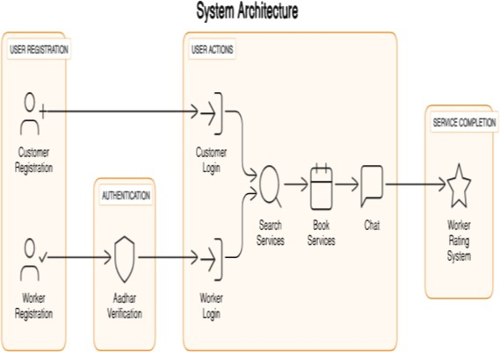
The system tries to address some of the current limitations, particularly worker verification and temporary scheduling. It also has an automated voice based application management which makes it more accessible and convenient for users especially for elderly and illiterate workers. This inclusion will make it easier and for all kinds of users to use the system.

- SYSTEM ARCHITECTURE
In figure 1 : The application's system architecture provides a visual representation of all of the components of the system and demonstrates how they will interact and communicate with one another. The system will have two types of users, Both employees who are offering the service and customers who need the service will be able to access the system; their registration information will be kept in a database. The service exploration and booking option is available to the user upon successful login. The worker receives feedback from the user after the service is completed.
In the course of the worker registration process for authentication and verification, the worker will submit a facial image, which will be validated by comparing it to a current live image captured at that moment, utilizing the ResNet 50 model for this comparison. Once the registration and login are successfully completed, workers will have the ability to view incoming service requests and can choose to accept or decline them according to their availability and preferences. Additionally, a content-based recommendation system will be implemented to improve user experience by providing personalized suggestions tailored to their preferences and content affinities.

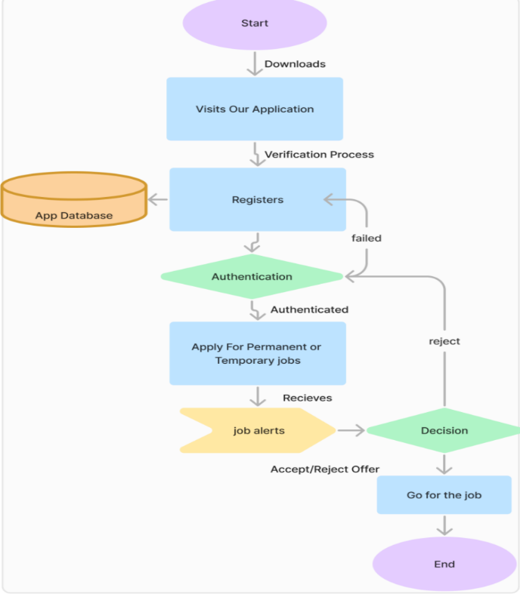
- WORKFLOW – WORKER

After they have established their job preferences, the platform will monitor the job postings continuously and provide timely messages through job alerts. This allows the workers to either accept an offer right away, or to dynamically bid on existing positions, resulting in competitive and equitable distribution of jobs. When an offer is made, the worker considers the opportunity and accepts, or declines, the offer. If the worker declines the job, they will remain on the short list for future work. If they accept the job, they will proceed with the assignment and begin their work according to the job description.
Figure 3 : This is the flowchart for user registration and installation of the system. Users can either upload an image of the service or request a worker. After the service is done users can give feedback by rating their experience. This user focused approach ensures a smooth and personalized experience.

Importance of Identity Verification in Blue Collar Workforce:
When registering blue collar workers, accuracy and authenticity of identity information is key to security and accountability. Face matching is a very essential part of this process to authenticate the workers during registration.[9]
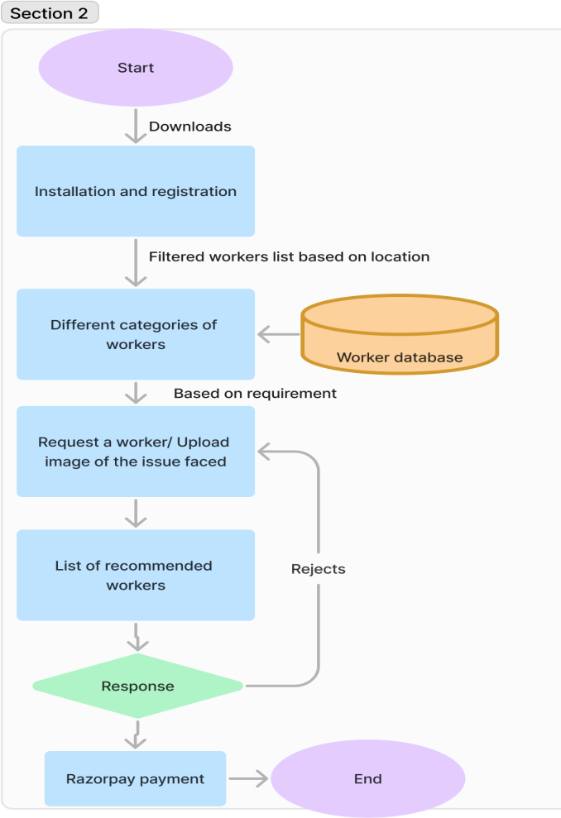
- WORKFLOW – CUSTOMER

Description of models used in the proposed application:
- ResNet50 model for face detection using VGGFace2:
VGGFace2 is a high-scale facial recognition dataset as well as a corresponding deep learning model for face recognition and verification tasks.[5] It is designed based on the success story of the VGGFace model, which was originally introduced by the Visual Geometry Group (VGG) at the University of Oxford earlier. The VGGFace2 dataset and the model are widely used in research and applications requiring robust facial recognition capabilities.
A ResNet50 model, built on deep learning principles and pre-trained using the VGGFace2 dataset, serves as an effective architecture for facial verification by accurately capturing and comparing facial features. The initial step involves preprocessing the input images, which includes resizing them to 224x224 pixels, normalizing the data, and detecting faces to isolate the area of interest. ResNet50 employs residual learning to address the vanishing gradient issue, enhancing its ability to learn hierarchical features efficiently. For each face, the model produces a 512-dimensional feature vector, or embedding, that represents distinct facial traits.
This computes similarity metrics for comparing the embeddings to measure the resemblance between two faces. Cosine similarity is used as a metric. A threshold
value is assigned to the pair so that it is classified as a match or mismatch. When the similarity score surpasses the threshold or the distance goes below it, the faces are considered a match.
As shown in the table below, ResNet50 (VGGFace2-trained) outperforms others with state-of-the-art accuracy on benchmarks, high flexibility for fine-tuning, and excellent real-world performance under variations like pose and lighting making it superior to alternatives like FaceNet and Dlib.
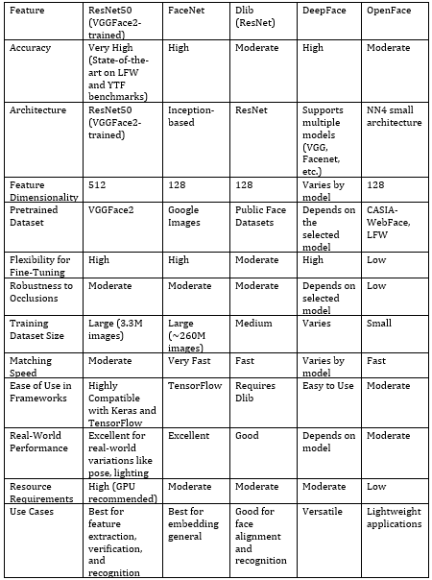
This comparative method utilizes metrics to process an image based on an Aadhar card alongside real-time selfies. It extracts embeddings and employs the aforementioned metrics to confirm individual identity. The entire process demonstrates resilience in addressing variations that may occur due to differences in quality or environmental conditions during the authentication of a biometric signature.
TABLE I. Model Comparision

2. Implementation of Content-Based Recommendation System:
For blue collar workers, a content based recommendation system is implemented using skills and numerical features. Here are the steps:
  - TF-IDF Vectorization for Skills:
The skills of workers are vectorized using the Term Frequency- Inverse Document Frequency (TF-IDF) technique.
The ’Skills’ column in the dataset is tokenized and the resulting matrix is obtained using the TfidfVectorizer.

Normalization of Numerical Features:
The numerical features ’Rating’, ’PositiveFeedback’ and ’NegativeFeedback’ are normalized so that they are on the same scale. The normalize function is applied to these features.
Formula:
$$x^{'}=\frac{x-min⁡(x)}{\max\left(x\right)- min⁡(x)}$$
Where x is original feature value.

Combination of Features:
TF-IDF and numerical features are combined to create a feature matrix. This matrix represents each worker by their skills and numerical attributes.

Cosine Similarity Calculation:
Cosine similarity is calculated between workers using the feature matrix. Cosine similarity function calculates pairwise cosine similarities
Formula:
$$Cosine Similarity \left(A,B\right)=\frac{A*B}{\left\|A\right\|×\left\|B\right\|}$$

Recommendation Function:
A function recommend workers is defined to recommend workers for a given worker type. It considers average similarity of workers with the specified expertise.
Formula:
$$Avg Similarity\left(W,E\right)= \frac{1}{n}\sum_{i=1}^{n}{Cosine similarity(W_{i,}E)}$$

System implementation

The application developed utilizes Flutter, an open-source UI software development kit created by Google. This framework enables the creation of natively compiled applications for mobile, web, and desktop platforms from a single codebase. Python is employed to implement three distinct models: ResNet 50 for facial recognition, a content-based recommendation system, and a computer vision model designed to identify issues from images and suggest appropriate workers.

To evaluate the proposed system, a dataset comprising blue-collar workers was assembled. The facial recognition algorithm was tested using sample data, where images from Aadhar cards were compared with images captured in real-time. The results of these tests are as follows:

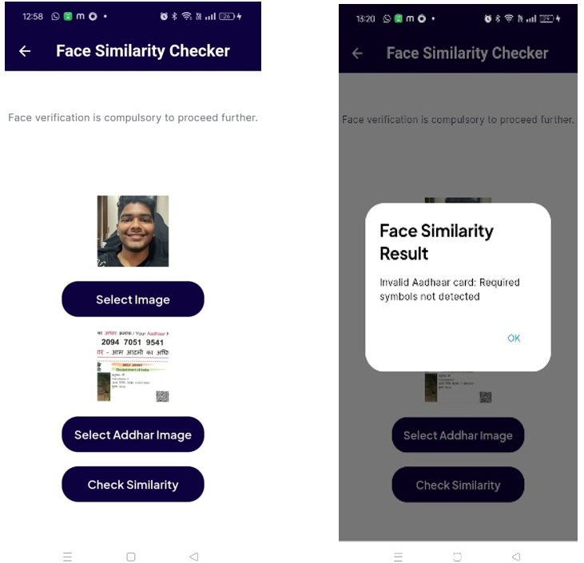
- Input real-time selfie image, incorrect aadhar and output of the model
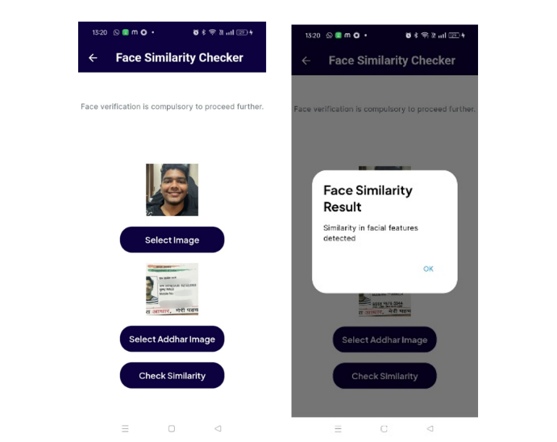
In Figure 4, the model is analyzing a selfie image in real-time alongside an Aadhar card image belonging to a different individual. The input images undergo preprocessing steps, which include resizing, normalization, and face detection to isolate the facial regions. These facial regions are then input into the ResNet50 model to generate 512-dimensional feature embeddings for each image. A similarity metric, such as cosine similarity or Euclidean distance, is employed to assess the embeddings. Since the Aadhar image is incorrect, the similarity score will be below a predetermined threshold, leading to a mismatch. Consequently, the model outputs a "Not Verified" or "Mismatch" result, thereby preventing the erroneous authentication of a person's identity.

- Input real-time selfie image, correct aadhar and output of model
In figure 5, the model takes in a real-time selfie image and an Aadhar card image of the same person. The same as in the previous case, the images are preprocessed and the feature embeddings are obtained using the ResNet50 model. Since the Aadhar image is the correct one, the similarity score crosses the threshold defined for matching. The model will output a "Verified" or "Match" result that confirms the identity of the individual with high accuracy. This robust process ensures secure and reliable biometric verification.
The facial verification system implemented uses the ResNet50 architecture pre-trained on the VGGFace2 dataset that matches faces from Aadhar card images with the real-time selfies. The pipeline starts by preprocessing both images, which includes resizing to 224x224 pixels, normalization, and lastly face detection to extract the face region. The ResNet50 model then extracts a 512-dimensional feature embedding for each face, which results in capturing unique and discriminative facial characteristics. With the use of a wide-ranging VGGFace2 dataset, the model achieved robustness to pose variations, lighting, and expression variations. The embeddings compared through cosine similarity, Euclidean distance, and with predefined thresholds deciding whether it matches; thus, this method achieves precise and reliable verification while real-world adaptability is guaranteed due to its ability to change with varied input conditions. The system is optimized for high accuracy and efficient real-time performance, so it is a robust solution for facial verification applications.
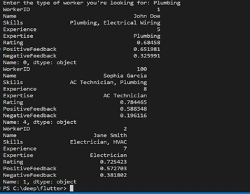
- CONTENT BASED RECOMMENDATION SYSTEM
The given Python code snippet handles a dataset containing workers' profiles. It starts by importing the data from a JSON file into a Pandas DataFrame. Following this, it calculates the TF-IDF representation of the workers' skills utilizing the TfidfVectorizer. Furthermore, it standardizes numerical attributes, including ratings and feedback. The concluding step merges the TF-IDF matrix with the normalized numerical features to form a cohesive feature representation. This processed data is suitable for various applications, such as similarity analysis, recommendation systems, clustering, or predictive modeling. In summary, the code exemplifies proficient feature engineering for machine learning purposes.
Implementation of Gemini Pro Vison Model for identifying the problem:
Gemini 1.0 Pro Vision is a sophisticated vision model capable of comprehending input from text, images, and videos to generate appropriate textual responses. It excels in various multimodal tasks including visual understanding, classification, summarization, and content creation from visual inputs like photographs, documents, infographics, and screenshots.
Model Functionality
The core functionality of the application revolves around the Gemini Pro Vision model:
- Image Input: The customer captures and uploads an image depicting the problem they're facing, for example, an open wire or a burst pipe.
- Image Preprocessing (Optional): Depending on the model's requirements, preprocessing steps like resizing, normalization, or color conversion might be applied to prepare the image for analysis.
- Feature Extraction: Gemini Pro Vision, a pre-trained deep learning model, analyzes the image. It extracts relevant features that describe the visual content, such as shapes, textures, and object locations.
- Classification: Based on the extracted features, the model classifies the image into a predefined category. In your case, categories might include "Open Wires," "Burst Pipe," "Leaking Faucet," etc.
- Service Recommendation: Upon successful classification, the application identifies the relevant service category (e.g. Electrician for open wires). It then leverages a database to recommend qualified blue-collar workers (electricians, plumbers) in the customer's location

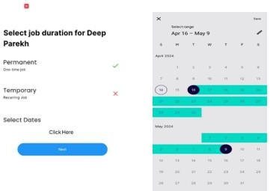
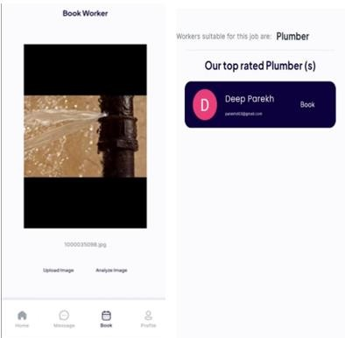
- INPUT TO THE CV MODEL AND OUTPUT OF RECOMMENDED WORKERS

- IMPLEMENTATION OF TEMPORARY SCHEDULE BOOKING
Temporary Scheduling in the proposed system fundamentally changes how short-term workforce requirements are fulfilled. This feature is especially important because it helps deal with a challenge: booking for fewer days, like days. So, no matter what their urgent task or need might be, such as helping to man an event or to finish up a short-term project, users can schedule easily.

CONCLUSION And future scope
The success of the app is based on 2 pillars: customer and worker satisfaction. Our top priority is to build a platform that exceeds both parties expectations. For customers this means delivering a seamless and high quality service that meets their needs and leaves a positive lasting impression.
For workers we will provide a platform that not only connects them to job opportunities but also ensures those opportunities match their skills and preferences. This will make the services more efficient.
The application will enhance communication by offering a platform for real-time updates, allowing customers to monitor service progress while keeping workers informed about job specifics. This level of transparency will foster trust and empower both parties to make well-informed decisions.
Recognizing that challenges may occasionally arise, the proposed system will emphasize a strong and responsive customer support framework. Promptly addressing concerns is essential, and we are committed to resolving any issues efficiently and effectively. This approach will not only boost user satisfaction but also enhance the system's reliability. The app aims to set new benchmarks for customer and worker satisfaction within the service industry by focusing on quality, transparency, and effective communication. In doing so, we will cultivate a mutually beneficial ecosystem for our customers and the workforce associated with our platform.
Looking ahead, a significant opportunity for an app designed for blue-collar workers lies in utilizing government support to broaden the scope of data verification and authentication. Currently, the app relies on the Aadhaar card as its primary authentication method, which is a sound strategy given its widespread use in India. However, integrating additional government-backed data could further enhance inclusivity and accuracy.
Firstly getting access to the government database to verify Aadhaar card numbers and other related parameters will increase the reliability and efficiency of the app. By cross verifying user data with government records the app can reduce fraud and ensure workers identity is properly authenticated. This will also increase trust and adoption among users as they can be sure their data is being verified through official channels.
Another area to explore is to integrate other government issued documents like ration cards. Many of the most economically disadvantaged have ration cards and integrating this as an authentication method for those who don’t have Aadhaar card will provide an alternative. Access to ration card database will increase the reach of the app to a larger population and support the underprivileged and marginalized sections.

Acknowledgments

We would like to thank the professors at Dwarkadas Jivanlal Sanghvi College of Engineering, namely, Prof. Deepali Patil and Prof. Sweedle Machado and also we would like to thank our Department heads namely, Dr. Vinaya Sawant of Information Technology and Dr. Pratik Kanani of Artificial Intelligence and Data Science, for giving us the opportunity to work on project and research topic and guiding us all the way through the time we have been working on the topic.

References
- G. Devisree, C. Rupa, U. Gayathri, and H. C. Kumar, A Cloud-Based Mobile Application to Hire Unskilled Workers, 2022 IEEE International Conference on Current Development in Engineering and Technology (CCET), Bhopal, India (IEEE, 2022), pp. 1–6. doi:10.1109/CCET56606.2022.10080710.
- S. Amirneni, Mukundaram P., J. Balaji, and Nivedha N., Demand-Based Blue-Collared Job Allocation Using Multiple Priorities and Heuristics, 2016 IEEE International Conference on Knowledge Engineering and Applications (ICKEA), Singapore (IEEE, 2016), pp. 226–230. doi:10.1109/ICKEA.2016.7803024.
- S. Sambare, A. Singh, C. Kriplani, S. Kale, and T. Balkhande, Automated Platform for Onboarding Employee, 2022 6th International Conference on Computing, Communication, Control and Automation (ICCUBEA), Pune, India (IEEE, 2022), pp. 1–5. doi:10.1109/ICCUBEA54992.2022.10010715.
- R. J. Tersine and C. A. Altimus, Job Satisfaction: High and Low Job-Skill Level Blue-Collar Workers, J. Bus. Res. 2, 17–26 (1974). doi:10.1016/S0148-2963(74)800032.
- Q. Cao, L. Shen, W. Xie, O. M. Parkhi, and A. Zisserman, VGGFace2: A Dataset for Recognising Faces Across Pose and Age, 2018 13th IEEE International Conference on Automatic Face & Gesture Recognition (FG 2018), Xi’an, China (IEEE, 2018), pp. 67–74. doi:10.1109/FG.2018.00020.
- L. Pawar, A. K. Saw, A. Tomar, and N. Kaur, Optimized Features-Based Machine Learning Model for Adult Salary Prediction, 2022 IEEE International Conference on Data Science and Information System (ICDSIS), Hassan, India (IEEE, 2022), pp. 1–5. doi:10.1109/ICDSIS55133.2022.9915981.
- S. K. A. S, S. S, A. S. M, and S. K. S, Machine Learning-Based Ideal Job Role Fit and Career Recommendation System, 2023 7th International Conference on Computing Methodologies and Communication (ICCMC), Erode, India (IEEE, 2023), pp. 64–67. doi:10.1109/ICCMC56507.2023.10084315.
- L. Cuimei, Q. Zhiliang, J. Nan, and W. Jianhua, Human Face Detection Algorithm via Haar Cascade Classifier Combined with Three Additional Classifiers, 2017 13th IEEE International Conference on Electronic Measurement & Instruments (ICEMI), Yangzhou, China (IEEE, 2017), pp. 483–487. doi:10.1109/ICEMI.2017.8265863.
- A. Pyae, S. Saetoen, S. Vanichayangkuranont, et al., Design and Development of an Interactive Mobile-Based Job Portal for Blue-Collar and Migrant Workers in Thailand: A Design Thinking Approach, Preprint (Research Square, 2023). doi:10.21203/rs.3.rs-3397465/v1.

