Light Inspection Vehicle with Obstacle Detection for analysis of Street lights

Kalpana Patil ^{1,a} Dr. Varsha Bendre ^{2,b} Vaishnavi Pujari ^{3,c} Sunnika Pandita ^{4,d}

Abhishek Patil ^{5,e} Swayam Patil ^{6,f}

¹ Dept. Electronics and Telecommunication PCET’s Pimpri Chinchwad College of Engineering Pune, India
² Dept. Electronics and Telecommunication PCET’s Pimpri Chinchwad College of Engineering Pune, India
³ Dept. Electronics and Telecommunication PCET’s Pimpri Chinchwad College of Engineering Pune, India
₄ Dept. Electronics and Telecommunication PCET’s Pimpri Chinchwad College of Engineering Pune, India
⁵ Dept. Electronics and Telecommunication PCET’s Pimpri Chinchwad College of Engineering Pune, India
⁶ Dept. Electronics and Telecommunication PCET’s Pimpri Chinchwad College of Engineering Pune, India
^{a)} kalpana.patil@pccoepune.org
^{b)} varsha.bendre@pccoepune.org
^{c)} pujarivaishnavi@gmail.com
^{d)} sunnika.pandita21@pccoepune.org
^{e)} abhishek.patil21@pccoepune.org
^{f)}swayam.patil21@pccoepune.org

Abstract.At present, millions of streetlights illuminate cities and towns around the globe, playing a vital role in maintaining nighttime activity and public safety. However, one of the common challenges associated with these lights is the issue of malfunction or failure. Our project aims to address this problem by identifying non-functional streetlights and providing real-time status updates through a mobile application. When a streetlight is found to be non-operational, its location is accurately tracked and displayed within the app, thereby assisting municipal authorities in timely maintenance and management.To facilitate efficient data collection, we propose the use of an autonomous vehicle equipped with an obstacle detection system. This vehicle will streamline the survey process by navigating streets and identifying faults without manual intervention. The obstacle detection system is also designed to assess the proximity of nearby objects or vehicles, enabling the autonomous unit to maintain safe distances and respond swiftly to avoid collisions. This ensures both effective data gathering and operational safety.
Keywords— Non-functional streetlights, Obstacle detection system, Data gathering

INTRODUCTION
There are many problems when it comes to street lights in India, and the primary problem being focused upon is malfunctioning street lights. To call it as an issue to manage a street light is logical as it will need a survey system on regular basis to ensure each and every lamp is working or not, which is manually not possible. Better street light management system requires an analysis of a number of contributing elements, including traffic (as higher traffic will demand higher luminosity), cost, and power consumption. It also depends on the location where the lamp is placed, urban areas, rural areas, near IT Hubs, etc scenarios, the reason being power waste is one of the major issues being faced due to unordered planning of townships and smart cities.
Thus, this is an attempt to make an autonomous (self- driven) smart inspection vehicle for analysis of street lights, hence reducing human effort. The main objective is to design self-responsive cars and handle street light management through automation, which could be a good part of smart transport technology. The main focus is on the vehicles on which the light detecting sensor is mounted, which is responsible for detecting the light. This vehicle is supposed to run in the night to make the detection of light very easier. With the sensor, this vehicle can send a signal to the controller how it works and whether the light is detected or not. Otherwise, this machine will forward the coordinates of the location of non-working lamp. The data of status of light will be sent through a mobile application to the user. This, therefore, makes it easy for the user to identify the exact location to visit and rectify that particular streetlight.
In our case, the user will the electricity board which is responsible for street light management. Basically, this device will act as a mediator or a communicator between the non-working lamps and the people responsible for its repair.
Another feature of our inspection vehicle is obstacle avoidance - an ultrasonic sensor is installed for the distance measurement of a near object. When the sensor senses any obstacle, it will change its path. So, this does not cause inconvenience to moving vehicles on the road. Conventional lighting systems frequently result in wasteful energy use, particularly when traffic is light. While preserving road safety, adaptive street lighting systems that change brightness in response to vehicle movement can drastically cut down on energy waste. When compared to traditional fixed-intensity lighting, these intelligent systems maximize power usage, reduce operating expenses, and increase efficiency. The goal of this research is to create smarter and more sustainable urban lighting solutions by increasing street lighting efficiency through creative control mechanisms. For autonomous driving to be safe and effective, accurate moving object detection is essential. In dynamic environments, traditional methods encounter difficulties that reduce the reliability of detection. By examining both temporal changes and object characteristics, the combination of motion and appearance-based techniques improves accuracy. In order to improve autonomous vehicles' safety and responsiveness in real-time traffic situations, this research focuses on developing detection techniques. For surveillance systems to be effective, multiple object detection must be done accurately. Tracking objects in dynamic environments is frequently a challenge for traditional methods. Advanced detection methods increase security and monitoring by increasing accuracy and efficiency. Enhancing object detection for more dependable surveillance applications is the main goal of this study.

LITERATURE REVIEW
These days, a significant portion of energy consumption is shared by roadways and lighting. Vehicles are constantly passing over, and certain locations will have lower population densities or even areas where there aren't any vehicles at all. However, in traditional street lighting systems, all of the lights will be on at night. Implementing appropriate energy-saving techniques and lighting management will help to resolve this problem [1]. An economical urban lighting alternative is smart street lighting, which combines low-cost LED lights, advanced wireless communication technology, and additional sensors to control light intensity [2].
They tried to show and evaluate how to perform real-time object detection with autonomous vehicles using the recent technology, with an object detection algorithm operating on an NVIDIA Jetson TX2, a GPU platform made for power-constrained mobile applications that uses neural networks under the hood [3].
The distance to the object and the locations of its side boundaries must be determined in order to prevent a collision with an object that obstructs a vehicle's path [4].
K. Santha Sheela and S. Padmadevi [5] propose a street lighting system that adapts to vehicle movements to optimize energy consumption. The system dynamically adjusts the intensity of streetlights based on the presence of vehicles, ensuring energy is utilized only when necessary. This approach not only reduces power usage but also contributes towards the sustainability of urban infrastructure by incorporating smart lighting technology in a vehicle.

Autonomous Driving Using Motion and Appearance-Based recognition: Mennat Allah Siam et al. [6] provide a powerful moving object recognition network that integrates motion and appearance characteristics. This network is made to manage complicated situations, such as changing occlusions and ambient circumstances. Combining these elements improves object detection's precision and dependability, making it a crucial development for effective and safe autonomous car navigation.
Chethan Kumar B et al. [7] focus on the development of a multiple object detection system made for surveillance applications. Their work is focused on real-time identification and tracking of objects to enhance security in monitored environments. By using advanced techniques and technology, the system aims to improve the effectiveness of surveillance by providing accurate and continuous monitoring capabilities.
Current research and experiences have brought into focus the increasing need for incorporating IoT and centralized systems in street light fault detection systems. Harini et al. [8] stressed the importance of fault detection in real-time using embedded controllers and GPS tracking, making authorities provide quick maintenance. The same is brought forward in [9], which highlights how IoT can make monitoring more efficient by minimizing manual intervention.
In addition, improvement in central monitoring systems has enabled smart urban infrastructure. M.S et al. [10] developed a centralized system that not only detects broken lights but also incorporate them into a smart city control framework for simplified access and control. Their emphasis on real-time analysis and dashboard-based monitoring lays the foundation for scalable smart lighting solutions.
Further developing this idea, Prathiba R et al. [11] showed the use of a centralized checking system where an integration of GPS modules and GSM communication is used to facilitate accurate fault localization. Their work targets power wastage reduction as well as improving transparency of operation in city-wide lighting systems.
Kiran et al. [12] brought forth UNIFY, a system that synergizes IoT with location-aware fault reporting to optimize the detection and correction of faults in streetlights. Their suggested model significantly minimizes human reliance with high efficiency in fault mapping.
Selvam et al. [13] discussed urban-focused applications, including the presentation of a smart street light control system that is adaptive and responsive to environmental lighting conditions and system health status. This adaptive system tackles both energy saving and fault detection through the real-time interpretation of data, representing an important part of smart city infrastructure.

PROPOSED METHODOLOGY
Indicate the goals, such as finding obstacles, detecting malfunctioning street lights, and guaranteeing effective lighting. Creating a plan for gathering data for obstacle detection and street light inspection and establishing the locations and frequency of data collection runs. Take the time of day and the weather into consideration when making the decisions. Considering variables like precision, velocity, and processing capacity, select or create an obstacle detection algorithm. Provide an intuitive user interface so that operators can monitor and manage the LIV system. Provide reporting features to generate inspection reports that include performance metrics, identified obstacles, and malfunctioning street lights.
The automatic vehicle works on the infrared detection concept. Using the Arduino Uno we will follow the targeted object. If the obstacle is detected the sensor will get activated then it will move in the appropriate direction whether the obstacle is not present. Hence the obstacle will be successfully avoided. If the obstacle is not present the further process will not take place.

Obstacle Detection and Avoidance
It checks whether there is any object between the path, if there is any object observed then it captures it through ultrasonic waves it emits and captures, otherwise if does not receive any response then the vehicle keeps travelling as per the designed path.
It thus sends the captured signal to Arduino-uno(controller). The controller, then performs a sequence of actions for the object detection. In case of the presence of an object the sensor first transmits the signal that stops the motors to avoid collision. It travels a bit in the opposite direction. It checks the right and left directions and moves in the direction where no interruption is detected.

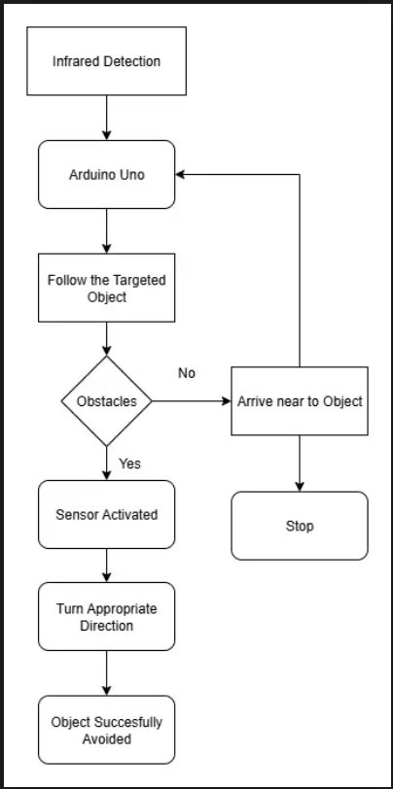
Figure 1: OBSTACLE DETECTION AND AVOIDANCE

Light Sensing and location provision
It will sense the presence of street light in a manner that when light is 'on' the vehicle continue its motion and move to its next survey point which has a specified distance and when light is 'off' it will upload the output to the controller and the controller sends the result data to the firebase which has been specifically created for the application.
The application will consist of a database of multiple surveys conducted in any desired location. It has been designed in such a way that when the lamp is off it will provide the information regarding the exact location (latitude, longitude) and status of the lamp.

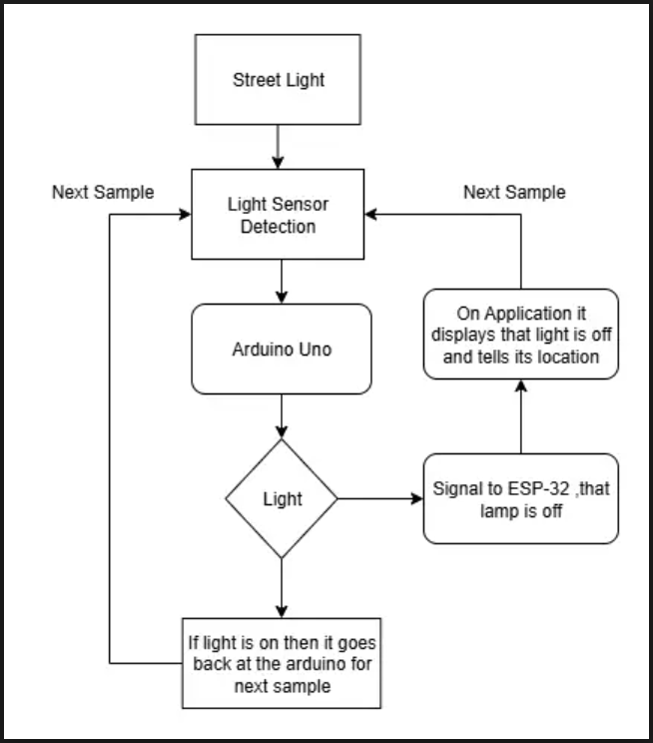
Figure 2: LIGHT SENSING MECHANISM

Results and Discussion
From the results obtained we can understand multiple factors, Firstly the obstacle detection range that means from how far our light inspection vehicle can detect the object and take an action upon it by either going to the left or the right depending upon the obstacle in the either direction. The feature of obstacle avoidance helps to design an autonomous vehicle which directly supports our main primary function which is the light inspection part. As we have to travel across long distances using the sensor as well as the rest of all hardware devices and working manually won't be productive for our aims in reducing time taken in observation or a survey done manually. Thus, finally our autonomous vehicle helps to completely automate the process of taking a survey and giving a survey report to the industry people.

Testing List | Obstacles | Distance
Test 1 | Water Bottle | 17cm
Test 2 | Mobile Phone | 30cm
Test 3 | Human | 57cm
table 1. OBSTACLE DETECTION RANGE
Survey Lists | Lamp Status | Distance after each survey (in cm) (in 5 sec)
Survey 1 | Off | 0cm
Survey 2 | On | 35cm
Survey 3 | Off | 70cm
Survey 4 | On | 105cm

table 2. LIGHT INSPECTION STATUS

Lamps Off | Lamps On | Total Lamps (Lamp On + Lamps Off)
5 | 5 | 10
table 3. FINAL SURVEY OF LIGHTS
In addition to the accuracy of obstacle detection and light inspection, additional tests were performed to evaluate the energy efficiency and response time of the system. The analysis of battery usage was used to ascertain the working range of the autonomous vehicle for real-time streetlight surveys. The accuracy of sensors in various light conditions was also evaluated to determine the reliability of the system under diverse environments like dawn, dusk, or glare areas.
The speed and timing performance of the vehicle were also tested to make route planning optimal and cover the greatest area in a short amount of time. These results further confirm the system's aptness for urban and semi-urban applications. With an increase in the number of street lights to be surveyed, such autonomous methods provide a scalable and effective solution to the limitations of manual surveys.

Condition | Lights Actually OFF | Lights Detected as OFF | Accuracy (%)
Low Ambient Light | 5 | 5 | 100
Mild Ambient Light | 5 | 4 | 80
Mild Ambient Light | 5 | 3 | 60

table 4: LIGHT DETECTION ACCURACY

Survey Run | Distance Covered (meters) | Time Taken (sec) | Average Speed (m/s)
Survey 1 | 7 | 70 | 0.1
Survey 2 | 10 | 90 | 0.11
Survey 3 | 15 | 130 | 0.12
table 5 : TIME TAKEN PER SURVEY CYCLE

Obtained Outcomes

- Hardware Implementation

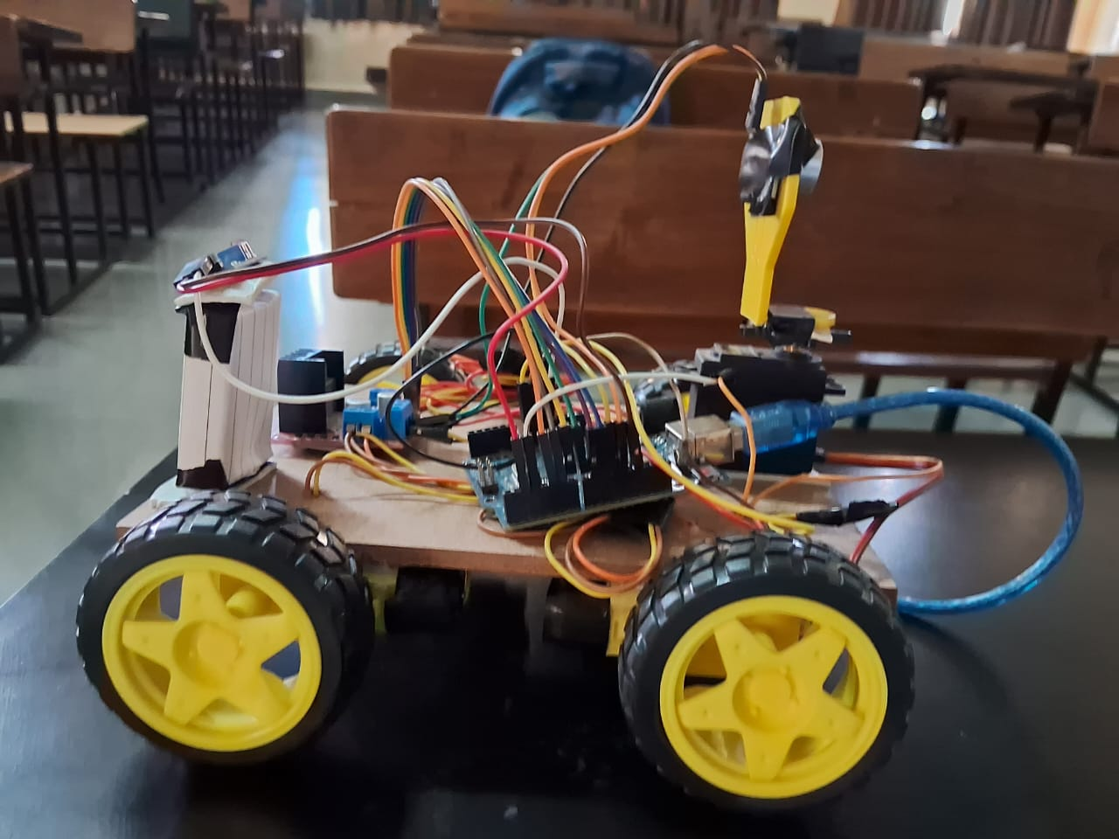
Figure 3- LIGHT INSPECTION VEHICLE (HARDWARE)
- Software Implementation
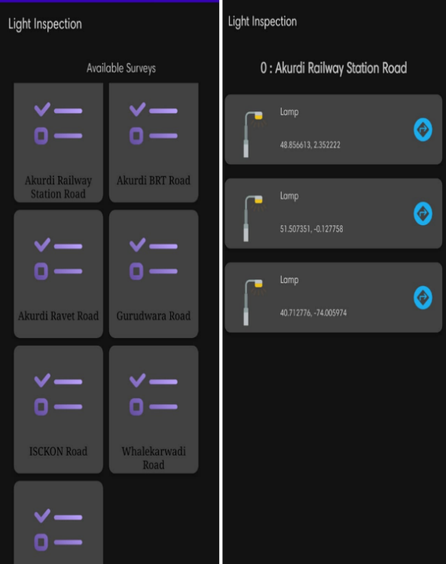
Figure 4 - LIGHT INSPECTION APP (SOFTWARE)
- Light Inspection Area
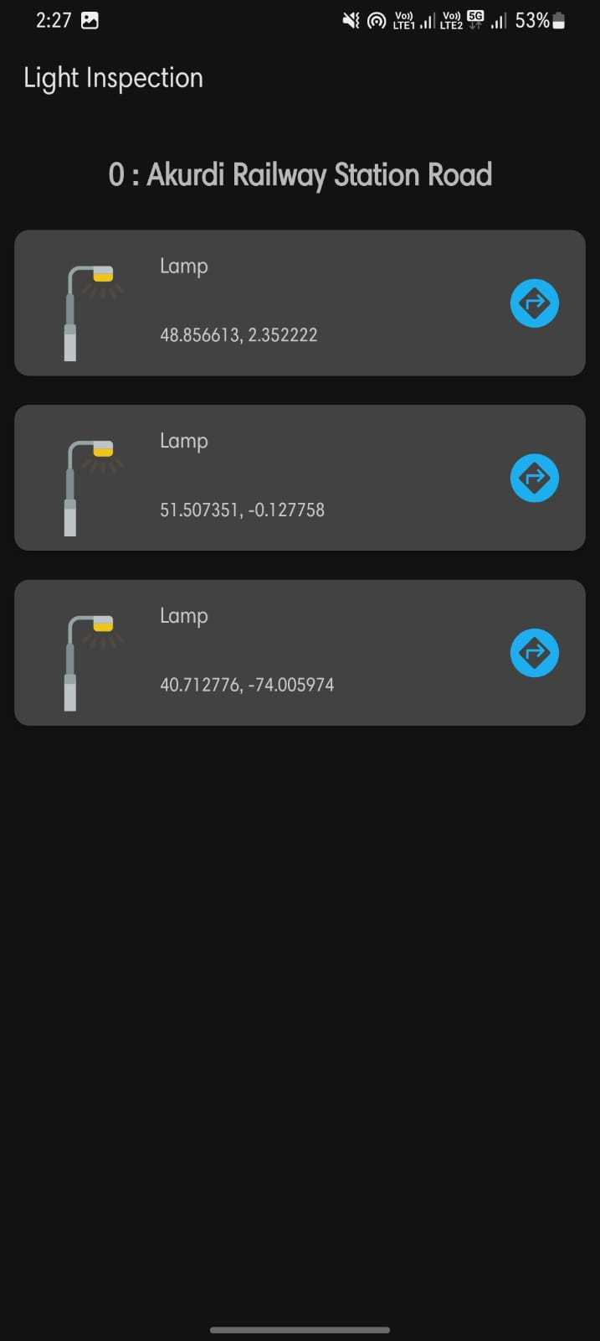
FIGURE 5- LOCATIONS INTERFACE

- App View
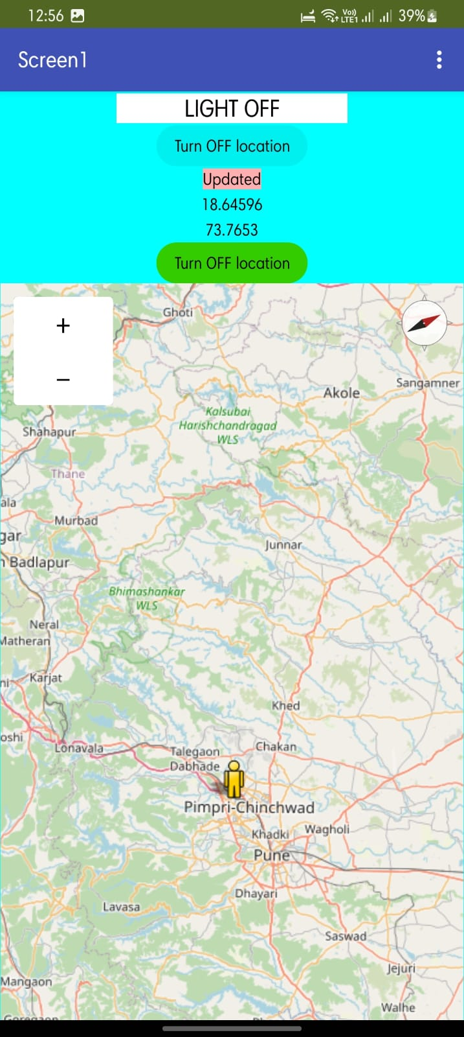
Figure 6- MOBILE VIEW (SOFTWARE)

CONCLUSION
This project is an example of how embedded systems may be improved and developed to automatically regulate street light intensity and vehicle speed. We also demonstrated a collision avoidance strategy that can function in dynamic and complex settings. Nearly every nation is currently dealing with an energy crisis. With smart street lights that know about vehicles and pedestrians, we can save a lot of electricity. Rural electrification could make advantage of this saved energy. In essence, it is objective motion-based energy-efficient street light automation.
. When deployed on highways with less traffic, self-responsive cars can improve road safety and assist drivers in learning and comprehending the advantages of automatic street light automation. As a result, fewer incidents involving uncontrolled automobiles will occur. In fact, strategies from e-navigation can use tools and methods gained from studying new materials. Therefore, self-driving and collision avoidance features can be included in the care sector.

REFERENCES
- Yashaswini and Raghu, "Automatic Street light control by detecting vehicle movement." January 2018.

- Prasad, R. "IoT-Based Energy-Efficient Smart Street Lighting System in Nagpur Smart City: A Case Study." 10.1109/FMEC49853.2020.9144848, 2020, pp. 100-103, Journal of the Fifth International Conference on Fog and Mobile Edge Computing (FMEC).

- Yu-Hau Huang, Yi-Xian Kuo, Yu-Chieh Chung, Chuan-Wei Huang, Chu-Ying Ho, and Yeong-Kang Lai. "Deep Learning-Based Intelligent Vehicle Collision-Avoidance System." K. Elissa, "Title of paper if known," unpublished.

- Takeo Kato, Yoshiki Ninomiya, and Ichiro Masaki. "An Obstacle Detection Method by Fusion of Motion Stereo and Radar." member of IEEE.

- "Survey on Street Lighting System Based on Vehicle Movements" was written by S. Padmadevi and K. Santa Sheela. February 2, 2014.

- Ahmad El-Sallab, Martin Jagersand, Senthil Yogamani, Mohamed Zahran, Heba Mahgoub, and Mennat Allah Siam. "Detection of Moving Objects based on Motion and Appearance"

- Autonomous Driving Network. Mohana Electronics & Telecommunication Engineering RV College of Engineering, Bangalore, Karnataka, India; Chethan Kumar B; Punitha R. "Detection of Multiple Objects for Surveillance Applications."

- August 2024, "Street Light Fault Detection and Location Tracking," in 2024 IJMRSET | Volume 7, Issue 8, Harini T, Leela Darshni M, Srilakshmi CH.

- Volume 12 Issue IV, April 2024, "IoT Based Street Light Fault Detection and Location Tracking" IJRASET |ISSN: 2321-9653; IC Value: 45.98; SJ Impact Factor: 7.538.
- The paper "Centralized Monitoring System Street Light Fault Detection and Location Tracking for Smart City," by M. S. et al., was presented at the 2024 International Conference on Electronics, Computing, Communication, and Control Technology (ICECCCC) in Bengaluru, India.

- "Centralized Monitoring System Street Light Fault Detection and Location Tracking," IRJMETS, Volume 06/Issue 05/May 2024 Prathiba R*1, Mohammed Mustafa A*3, Punith Gowda A*4, Suhas SM*5, and Chinmayi C*2.

- November 2023 | ISSN: 2320-2882 | 2023 IJCRT | Volume 11, Issue 11 Integrate location tracking content with street light fault detection on the Internet of Things. 1 G. Kiran, 2 N. Prachi, 3 C. Nikita, 4 J. Snehal, and 5 Z. Aishwarya.

- July 2024: International Journal of Engineering Research in Electronics and Communication Engineering (IJERECE) Vol. 11, Issue 7. Urban Glow Street Light Fault Detection and Control System [1] Rathi G., [2] Sudharsh Manivannan, [3] Tharun Saravanan, and [4] Shrinidhi Selvam.

