The Effects of Spatial Resolution and Noise on the Processing of Multi-Band Hyperspectral Images
Vaibhav J. Babrekar^{1,a} and Shirish M. Deshmukh^{2,b}
Author Affiliations
1Research Scholar, Department of Electronics & Telecommunication, Prof. Ram Meghe Institute of Technology & Research, Badnera-Amravati, MH- India
2Research Supervisor, Department of Electronics & Telecommunication, Prof. Ram Meghe Institute of Technology & Research, Badnera-Amravati, MH- India
Author Emails
a) vaibhav.babrekar@gmail.com
b) smdeshmukh001@yahoo.com
Abstract.Hyperspectral imaging has emerged as an essential instrument for analyzing a range of applications, particularly in environmental monitoring and agriculture. Nevertheless, the efficacy lies in processing images for hyperspectral multi band needs with the consideration of reducing the noise from the aspect of spatial resolution. These considerations may result in miss or inaccurate results especially in classification of image. This research paper via our developed machine learning classification algorithm is structured to study these inaccuracies and reduction of its effects on multi band hyperspectral images is structured. Specifically, the developed model utilizes a custom RESNET machine learning architecture that tailor the main task of improving classification by removing multiband propagating noise. It emphasizes influence of spatial resolution on ResNet's performance, demonstrating that lower spatial resolutions can cause important spectral and spatial details to be lost. This deficiency poses challenges in training data as features that are extracted so that they help in increasing the testing accuracy are poised hence testing becomes difficult. Research experiments carried out illustrate changes affect RESNET’S capability to accurately classify hyperspectral data by reducing spatial noise and resolution. Additionally, the study investigates resilience of RESNET model towards different types noise in varying categories; highlighting that the models efficiency declines with increase in noise which is directly proportional to spatial resolution. To mitigate these noise challenges, we demonstrate a solution via image preprocessing and noise reduction where end result is increase in the classification levels in regards to RESNET models accuracy for hyperspectral multi band images.
Keywords—Hyperspectral Imaging, Image Pre-Processing, RESNET.

INTRODUCTION
Today's advanced technological data processing for landscape satellite based hyper spectral image classification depends on the utilization of various data processing bands, which encompass multiple spectral wavelength bands. Traditional image processing has relied on visible electromagnetic spectrum for data extraction and classification which is obsolete due to its narrow range of data sources. Realm of artificial intelligence necessitates an expansion from single band processing to multi-band data processing, as machine learning offers solutions that surpass human imagination. Effective multi-band data processing solutions must encompass Hyperspectral multi band resolution, thereby addressing the demand for broader application coverage. Numerous methodologies can be employed to achieve a comprehensive understanding of objects within images, as the analysis of extensive data volumes necessitates fusion of clustered data.
Challenges encountered in processing multiple bands or frequencies are significantly greater than those associated with single band processing. Comprehensive data extraction is now imperative, as multi-band and multi-wavelength processing requires robust centralized algorithms that rely on artificial intelligence for rapid and efficient analysis. The accurate identification and classification of objects have become accessible as its remarkable power is seen in smartphones as example to perform extraordinary tasks. The compelling advertisement from Samsung, “Can you circle it?” exemplifies the artificial intelligence's potential in the context of search engines. This potential of multi-band processing necessitates significant breakthroughs in the field. The impact of noise and its types on multi band image processing is summarized in table 1. The research in the hyperspectral domain has drawn a lot of attention, particularly in agricultural sector via Hyper Spectral Image Classification (HSI). Our investigation focuses on the impact of noise and its associated parameters concerning datasets, which will be elaborated upon in the subsequent section.

TABLE 1: TYPES OF NOISE [1-14] 1
Types | Characteristics | Effects | Typical Causes | References
Gaussian | Mean, Standard Deviation | Blurring | Sensor imperfections, environmental factors | [1],[2]
Salt and Paper | Black and white pixels (Spots) | Contrast, visual quality | Transmission errors, sensor defects | [3],[4]
Poisson | Intensity to the order of square root | Brightness | Low light | [5],[6]
Speckle | Granular interference | Consistency | Wave interference, radar imaging | [7],[8]
Impulse | Sudden/sharp spikes or pulses | Abrupt Pixel placement in terms of intensity | Sudden surges or drops in signal intensity | [9],[10]
Colored | Frequency spectrum variation | Introduces complex patterns; affects different bands differently | Variations in signal processing or recording | [11],[12]
Thermal | Movement of electrons lead to noise generation | Introduces random noise | Electronic sensor heat generation | [13],[14]

HYPERSPECTRAL IMAGING DATASETS

The introduction of hyperspectral imaging (HSI) cameras in soil perception research and its practical applications offers significant advantages for the collection and categorization of extensive datasets related to soil and vegetation surface analysis through HSI data. These datasets which are globally available have notably broadened the prospective benefits of machine learning methods, such as deep learning (DL), which necessitate substantial amounts of data for both the training of datasets and their subsequent evaluation. The table below provides a concise summary of several available HSI datasets [47], highlighting the key features of each dataset. The table presented outlines essential characteristics of each dataset. To illustrate these concepts, we can examine the Indian Pines dataset (IP), which was captured in 1992 using NASA’s AVIRIS sensor. This dataset encompasses a range of measurements and diversity across 16 classes, categorized into 220 groups. A critical factor to consider is the spatial resolution, where an increase in sharpness leads to a reduction in classification classes. This represents a "point of range" for optimization; for ensuring that the number of classes aligns with the spatial resolution noise levels. When selecting a hyperspectral imaging dataset, it is crucial to consider dataset size, its diversity etc. towards application under test. These considerations aid in aligning the characteristics of each dataset with the conditions of the intended analysis.
The different ranges of such datasets discussed in this study are abecedarian to the development of deep literacy models. This information is vital for training models to extract fine details that help in decision- making capacities. The methods for testing and noise reduction will be addressed in the following section.

TABLE 2: HSI DATASETS COMPARISON 1
Dataset | Year | Source | Spectral Dimension (SD) | Spatial Bandwidth (SB) | Wavelength Range (WL) | Classes | Spectral Resolution (SR)
Indian  Pines | 1992 | Purdue University (AVIRIS) | 220 | 10 nm | 400 - 2500 | 16 | 1.0 m
Salinas | 1998 | AVIRIS (Salinas Valley, CA) | 224 | 10 nm | 400 - 2500 | 16 | 3.7 m
Pavia University | 2008 | University of Pavia, Italy (reflectance data) | 103 | 4 - 10 nm | 430 - 860 | 9 | 0.1 m
Botswana | 2017 | Various (field hyperspectral data) | 200+ | 1 - 5 nm | 400 - 2500 | 6 | 0.5 m

TRADITIONAL TECHNIQUES FOR REMOVAL OF NOISE:

The process and techniques used for noise removal is initially categorized based on filter design, followed by the development of a statistical algorithm, and ultimately the application of machine learning models and techniques. Filters play a crucial role in reducing noise to enhance image quality across various spectral bands. They preserve essential fine details of the object being analyzed which aid in eliminating artifacts and distortions, resulting in cleaner and more reliable data for analysis and interpretation. The subsequent critical phase in noise removal involves statistical analysis orinterpretation. These interpretation techniques look up to machine learning algorithms such as supervised learning and deep learning that facilitate in contributing towards greater classification accuracy. These statistical analyses have to cater to ways of noise reduction as vital information and its retention lies in relationships development within datasets as number of classification layers increase. A summary of the utilization of filters, algorithms, and models is presented in Table 3, 4, 5 below for improved insight and comprehension.

TABLE 3: TYPES OF FILTERS [1 – 20] 1
Method/Technique | Advantages | Applications | References
Gaussian Filter | Gaussian noise removal | Pre-processing | [1], [2]
Median Filter | Saltandpepper noise removal | Image denoising, edge preservation | [3], [4]
Bilateral Filter | Gaussian noise removal in regards to edges | Noise reduction in complex images | [15], [16]
Wavelet Thresholding | Reduces noise while preserving image details | Multi-band image denoising, compression | [17], [18]
Fourier-Based Filtering | Frequencybased noise | Image enhancement, frequency domain filtering | [19], [20]

TABLE 4: TYPES OF ALGORITHMS 1
Method/Technique | Advantages | Applications | References
PrincipalComponent Analysis (PCA) | Data simplification | Noise reduction | [21], [22]
Independent Component Analysis (ICA) | Noise Separation | Noise isolation | [23], [24]
Image Fusion | Feature extraction | Image Enhancement | [25], [26]

Advancements in image processing have provided great solutions with the utilization of Neural Networks.So, with realm of multiband image processing these neural models provide information extraction solutions ranging over spectral bands with the incorporation of below enlisted techniques:
a. Automated Feature Extraction
b. Improved Classification and Detection
c. Versatility

TABLE 5: TYPES OF MACHINE LEARNING 1
Method/Technique | Advantages | Applications | References
Convolutional Neural Networks (CNNs) | Noise Pattern | Advanced noise removal, feature learning | [27], [28]
Deep Learning Models  (e.g. Resnet) | Denoising tasks | Image segmentation, denoising | [29], [30]
Support Vector Machines  (SVM) | Noise and signal difference | Classification, noise reduction | [31], [32]
K-Means Clustering | Simple clustering approach; can enhance feature extraction | Band classification, noise separation | [33], [34]
Random Forests | Handles complex data relationships; robust to noise | Feature extraction, classification | [35], [36], [37]
Over the past few decades, neural networks have gained significant traction; however, traditional networks have demonstrated restricted use in multi band image processing. Our main aspect is to provide solution via preprocessing which is achieved with the use of residual networks discussed in the following section.

RESIDUAL NETWORKS (RESNET) IN HYPERSPECTRAL IMAGERY
This research describes a variant of deep learning models specifically designed to tackle the aforementioned challenges, as well as additional issues encountered in training deep neural networks for various applications. The advantages of employing RESNET are as follows:
4.a. Enhanced Depth: The architecture of RESNET supports the creation of deeper neural networks without compromising performance, thereby enabling more sophisticated and nuanced analyses.
4.b. Increased Precision: The inclusion RESNET leads to more precise representations. This significantly improves classification by reducing the overfitting and underfitting of data through multiple layers utilized.
4.c. Streamlined Training: The design of RESNET promotes quicker convergence and lowers computational demands hence gets rid of gradient.

Literature has reported that RESNET models are capable in processing and analyzing satellite images where in the data covers various spectral bands utilized to provide classification in applications of land cover types, environmental changes to identify natural disasters. Furthermore, these models are also utilized to provide disease identification in medial field and object tracking in defense sector. The application of RESNET in hyperspectral image classification, often referred to as "HIS," has demonstrated significant advancements due to its robust training capabilities in multi-band image processing. Taking all the advantages into account our research utilizes a tailored RESNET model with the context of noise removal in land covered image analysis.

RELATED WORK
HSI Denoising:

1. Characteristic Methods for HSI denoising:
The initial methods for removing or lowering the noise in hyperspectral images (HSI), like WNNM [48] and BM3D [49], drew inspiration from denoising of natural image and concentrated using a band-by-band approach for eliminating noise, overlooking the interdependencies between bands during the noise removal process. To address this concern, dictionary-based approaches were developed for HSI denoising, efficiently leveraging both correlations that are nonlocal and global across spectral bands to improve noise elimination. Typical approaches, including [50], [51], [52], addressed noise challenges by employing hand-designed priors within the methodologies which are dictionary-based. Additionally, a flexible dictionary-oriented method introduced in [53] specifically aimed at tackling noise inside the spatial and spectral aspects of HSI. The low-rank characteristic of hyperspectral images (HSI) is crucial and has been extensively examined denoising of HSI. Chang et al. [54] combined a hyper Laplacian regularized one-way method using a Low Rank tensor recovery technique, capitalizing on the structural relationships and natural tensor sparsity found in hyperspectral imaging. He et al. [55] concentrated on improving the global spectral low rank and the non-local spatial similarity characteristics in hyperspectral imaging. Using both original and global spatial/ spectral redundancies and correlations (RAC), a low- rank, meager HSI denoising constraint was presented in [56]. This fashion successfully lowers noise and fixes spectral deformations by using meager coding for spatial RAC and a low- rank constraint for global spectral RAC. A low- rank regularization tensor fashion is suggested in [57] to ameliorate the denoising performance in hyperspectral images (HSI) by utilizing the global correlation across the diapason (GCS) and the nonlocal tone- similarity (NSS) essential in HSI.

2. Methods based on Deep Learning (DL) Models:
Due to its strong capability for nonlinear mapping, deep literacy is extensively studied for the purpose of denoising hyperspectral images (HSI). It successfully mitigates noise in HSI by learning to transfigure a noisy image into a clearer representation. In a separate line of exploration, the authors in [58] enforced a deep residualnetwork was to address Gaussian noise in both spatial and spectral disciplines of hyperspectral imaging (HSI) using a sliding window approach. The study mentioned in [59] presented a completely convolutional encoding- decrypting algorithm aimed at minimizing noise in HSI, demonstrating enhanced performance in managing Gaussian noise while requiring less computational time compared to the BM3D technique referenced in [61]. Additionally, MemNet [60] incorporated a memory component that preserves long-term feature information essential for the denoising task, alongside residual networks [62] which establish highly interconnected core modules. Zhang et al. [63] proposed a residual-based nonlocal attention method to capture dependencies across long ranges and highlight essential information. Despite the prevalent use of these methods for HSI denoising, they encounter difficulties concerning receptive field sizes and inflexible patterns of the feature extraction. As a result, they do not maximize the valuable spectral data present in HSI. Transformers provide a more effective approach for examining the plentiful and repetitive features that are characteristic of HSI. In the researcher study conducted by Radhesyam Vaddi et al. [44], presents a optimized Convolutional Neural Networks (CNNs) which utilized Probabilistic Principal Component Analysis (PPCA) and Gabor filtering to achieve batch normalization. This tailored combination focusses on data normalization to reduce noise as well as computational iterations by orders of scalar factoring. Their research emphasizes on a approach where there convolutional and pooling layers each have significant role to play for normalization of data in context of batch size.
To further reduce computation time, decrease noise, and improve accuracy relative to the findings presented in the aforementioned paper [44], our research replaces CNN with REESNET and employs a neural framework consisting of 12 layers. This approach uses a layer normalization method as an alternative to batch normalization, striking a balanced relationship between the intricacy of the layers and the effectiveness of the algorithm.
HIS classification has normalization of data as its first step that is used for enhancing the spatial features at the first level itself. This pre normalization helps not only to reduce the complexity of 3D dimensionality of multi band image correlation; but also provides us means of using statistical analysis of mean and variance. This structure can be mathematically understood by below formulations:
Assume the input shape [m, H, W, C], for each channel c ϵ {1,2,…,C}
$μ_{i,C}=\frac{1}{HW}\sum_{j=1}^{H}{\sum_{k=1}^{w}{x_{i,j,k,c}}}$₍₁₎

$δ_{i,c}^{2}=\frac{1}{HW}\sum_{j=1}^{H}{\sum_{k=1}^{w}{{(x}_{i}}}$_{,j,k,c}- $μ_{i,C})2$₍₂₎

$${\hat{x}}_{i,j,kc}=\frac{x_{i,j,k,c}-μ_{i,c}}{\sqrt{σ_{ⅈ,c}^{2}+ϵ}} (3)$$

Specifically for each channel, we have learnable parameters γ_{c}and β_{c} such that
$$y_{i,j,k,c}=γ_{c}{\hat{x}}_{i,j,k,c}+β_{c}=LN_{γ}β_{c}{(x}_{i,j,k,c}) (4)$$
The working of the above mathematical equations can be best understood with the help of neurons that are a key step in training the database. These neurons are normalised across various layers of data translation which can be best visualised with the help of the below pooling diagram (figure 1). The convolution steps based on neuron filtering are determined by variable 2𝑁, where 𝑁represents the number of layers. Each layer takes care of a filter that is responsible for feature map generation whose dimensional complexity known as labelling is the key aspect of the developed model. Each step is then formulated post labelling by pooling hence twelve layers of labelling means twelve steps of normalised pooling. These pooling layers take care of the overfitting data batches through data averaging.

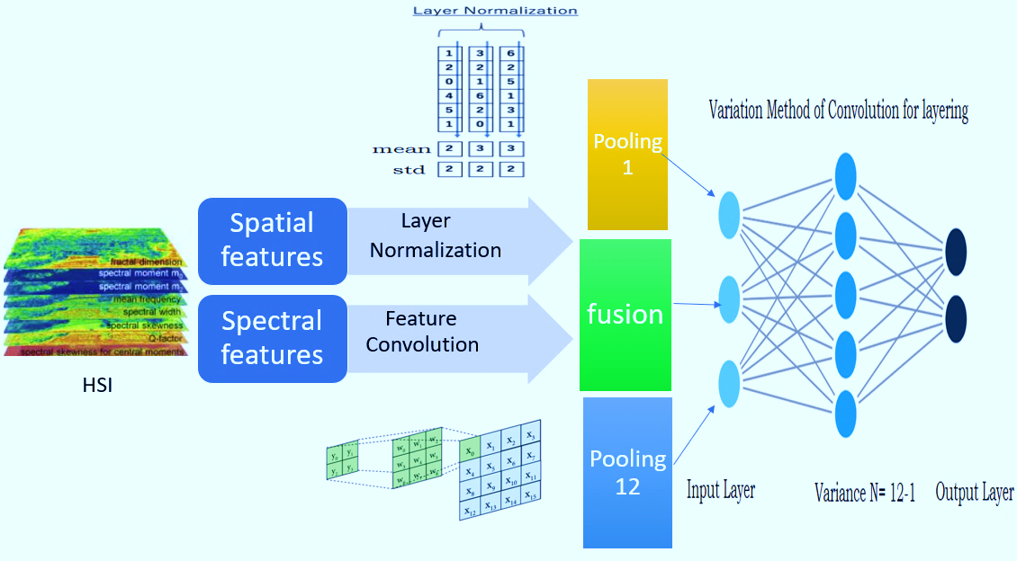
Figure 1: Work Flow Diagram of Neural Network [65]

Each convolution is followed by incorporating a bounded variation (BV) which helps is creation of layer-to-layer correlation according to the definitions of the axisrows and columns. This step requires that one axis is constant and the other defines the convoluting hyperplane.
$\int_{R^{d}}{f\left(x\right)ⅆ\left(μ*v\right)}\left(x\right)=\int_{R^{d}}{\int_{Rd}{f\left(x+y\right)ⅆu}\left(x\right)ⅆv}\left(y\right)$ (5)

In particular,
$\left(u×v\right)\left(A\right)=\int_{R^{d}×Rd}{1A\left(x+y\right)ⅆ\left(μ×v\right)}\left(x,y\right)$ (6)

IMPLEMENTATION
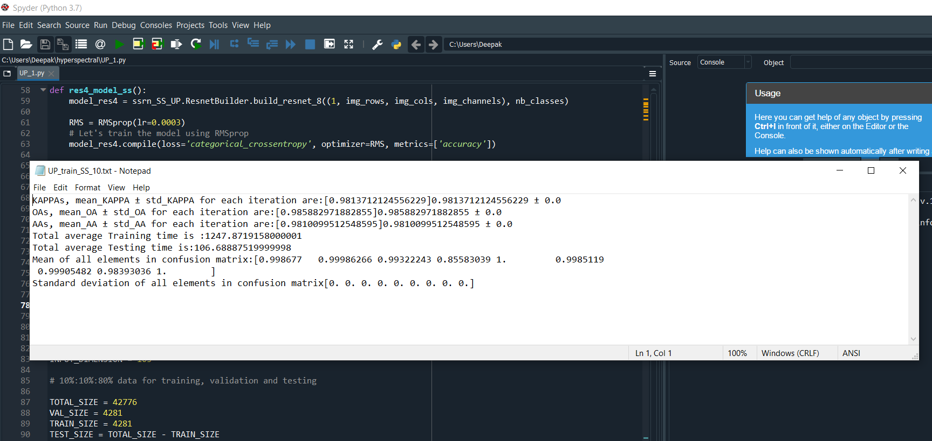
FIGURE 2: PYTHON ANALYSIS
TABLE 6: ACCURACY AND LOSS CALCULATIONS 1
 | Reference algorithm [44] |  | Proposed Framework
Name of the Dataset | Accuracy (%) | Loss (%) | Accuracy | Loss
Indian Pines | 99.02 | 3.55 | 99.86 | 3.3
Salinas | 99.94 | 0.33 | 99.69 | 0.76
Pavia University | 99.94 | 0.32 | 99.56 | 0.74
Pavia Centre | Not Analyzed | Not Analyzed | 99.47 | 0.85

Figure 1 depicts the structural architecture of our model which is utilised to assess the four standard hyperspectral datasetsoutlined in Table 2 [47]. The experiments are designed to examine the effects of different spatial resolution sizes and their impact on classification accuracy. The framework developed comprises of four steps distinctively. First step is data normalization which is done across each layer followed by the second step of pooling that does average calculation. The third step is the bounded variation convolution followed by the final step of feature labelling which on our case is for twelve layers of formulation compared to the three layers of reported literature [44].
Figure 2highlights the means of visualising and storing result in text file post completion of testing script and table 6 highlights the figures compared with the literature reported especially in means of accuracy and computation losses.The matplotlib library is utilised for visualisation and the results in terms of these plots is as shown in figure 3, 4 and 5 and summarised in table 7. The advantage of layer normalization in 12-layer classification pooling is that the computation time is reduced down to 106 seconds as illustrated from figure 2. In table 6 one can see that on comparison with reported literature accuracy is improved as well as loss kappa coefficient is reduced and a additional data set is classified which was not target by the cited literature work.

From Table 6 we summarize that the proposed framework demonstrates superior performance compared to the reference algorithm [44] across multiple benchmark hyper spectral datasets. Notably, it achieves a substantial improvement in classification accuracy on the Indian Pines dataset, increasing from 99.02% to 99.86%, along with a reduction in loss from 3.55% to 3.3%, indicating better learning and convergence. While the Salinas and Pavia University datasets show a marginal reduction in accuracy (from 99.94% to 99.69% and 99.56%, respectively), the proposed model maintains a consistently high performance with only a slight increase in loss, staying below 1%. Moreover, the proposed framework extends its evaluation to the Pavia Centre dataset, which was not analyzed by the reference method, achieving an accuracy of 99.47% and a loss of 0.85%, thereby demonstrating broader generalization capability. These results collectively suggest that the proposed method not only achieves competitive or superior accuracy but also offers improved model robustness and applicability across diverse hyper spectral data, making it a more effective and versatile solution.

TABLE 7: ACCURACY AND LOSS CALCULATIONS 1
Sr No | Class | Color Map | Precision | Recall | F1-score | Support
1 | Alfalfa |  | 0.56 | 0.35 | 0.43 | 51
2 | Corn-notill |  | 0.57 | 0.89 | 0.7 | 649
3 | Corn-mintill |  | 0.55 | 0.75 | 0.64 | 429
4 | Corn |  | 0.63 | 0.7 | 0.66 | 148
5 | Grass-pasture |  | 0.8 | 0.89 | 0.84 | 306
6 | Grass-trees |  | 0.99 | 0.9 | 0.94 | 563
7 | Grass-pasture-mowed |  | 0 | 0 | 0 | 0
8 | Hay-windrowed |  | 0.98 | 0.93 | 0.95 | 355
9 | Oats |  | 0 | 0 | 0 | 0
10 | Soybean-notill |  | 0.81 | 0.63 | 0.7 | 876
11 | Soybean-mintill |  | 0.77 | 0.72 | 0.74 | 1843
12 | Soybean-clean |  | 0.78 | 0.54 | 0.64 | 601
13 | Wheat |  | 0.92 | 0.96 | 0.94 | 136
14 | Woods |  | 0.93 | 0.91 | 0.92 | 913
15 | Buildings-Grass-Trees-Drives |  | 0.62 | 0.67 | 0.64 | 248
16 | Stone-Steel-Towers |  | 0.86 | 0.98 | 0.97 | 57

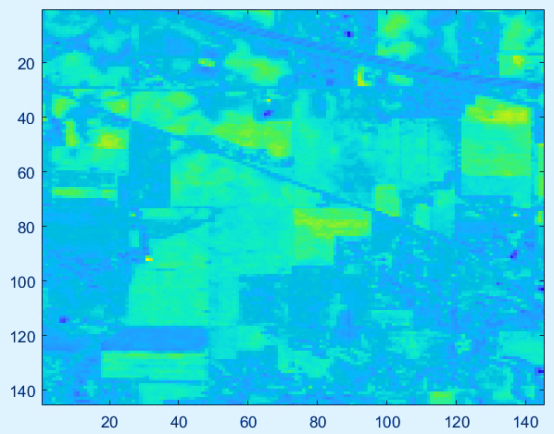

FIGURE 3: EMPIRICAL EVIDENCE COVERAGE

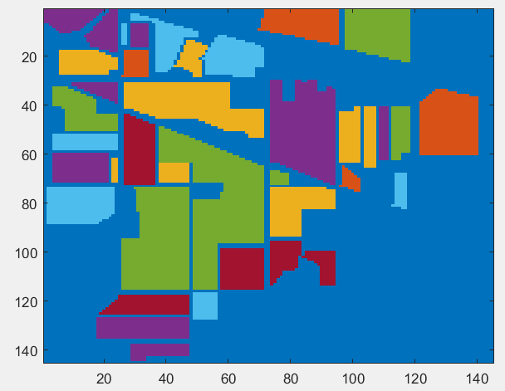

FIGURE 4: CLASSIFIED LABELING AREAS

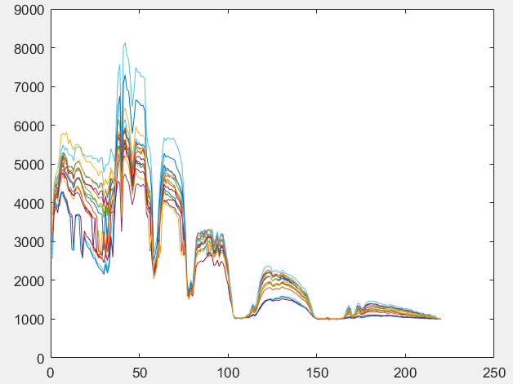

FIGURE 5: PERCENTAGE OF COVERAGE IN TERMS OF CLASSIFIED AREA

DISCUSSION
HSI in machine and deep learning significantly enhances research by addressing the challenges posed by human intervention and judgment. The applications of HSI in agriculture, along with their corresponding datasets, demonstrate the improvement in classification which is significantly possible because of neural network, compared to conventional algorithms of filtering or statistical analysis, importance of HSI is highlighted by noise loss encountered when attempting to utilize multiple wavelength spectrums. Therefore, it is essential to acknowledge the necessity, demand, and specifications of multi-band spectrum analysis in imaging. While substantial tested by developed algorithm still research requires more effective strategies for noise reduction. In the developed algorithm the complexity escalates with the addition of classification layers hence a mid-point of coverage of how many layers of pooling will be enough is still uncertain.

conclusion and future scope
The main benefit of our research lies in batch normalization and pooling transformation of multi band image featured data. As this significantly improves system reliability compared to cited results. This study utilizes multi band input which is possible because of BV clustering to mitigate the overfitting challenges encountered with deep layering during the training process. By employing a 12-layer architecture to manage three-dimensional input, the complexity of nonlinear functions is reduced. The process of hyperparameter tuning for specific class functions necessitates extensive experimentation, constrained by the limitations of available machines and servers. As a result, makingprecise comparisons with existing studies can prove difficult, potentially leading to uncertainties regarding the software and hardware used. Future research will concentrate on addressing these challenges and improving the tuning methodology.

REFERENCES
- Gonzalez, R. C., & Woods, R. E. (2008). Digital Image Processing (3rd ed.). Pearson.
- Jain, A. K. (1989). Fundamentals of Digital Image Processing. Prentice Hall.
- Castelletto, M., &Schalkoff, R. (2002). "Salt-and-Pepper Noise Removal in Digital Images," Proceedings of the SPIE, 4470, 206-217.
- G. S. L. L. Lu and J. M. G. T. Liu. (2004). "Noise Reduction in Image Processing," IEEE Transactions on Image Processing, 13(6), 890-898.
- Poisson, S. (1837). Recherches sur la Probabilité des Jugementsen Matière Criminelle et en Matière Civile. Bachelier.
- Kittler, J., & Illingworth, J. (1986). "Minimum Error Thresholding," Pattern Recognition, 19(1), 41-47.
- Lee, J. S. (1980). "Refined Filtering of Image Noise Using Local Statistics," IEEE Transactions on Pattern Analysis and Machine Intelligence, PAMI-2(3), 165-168.
- R. G. J. H. C. R. Kaiser. (1984). "Speckle Noise Reduction in Synthetic Aperture Radar Images," IEEE Transactions on Aerospace and Electronic Systems, AES-20(4), 489-497.
- Xu, L., & Prince, J. L. (1998). "Impulse Noise Removal with Adaptive Filtering," Journal of Mathematical Imaging and Vision, 9(3), 197-210.
- Jain, A. K. (1992). "Fundamentals of Digital Image Processing," Prentice Hall.
- Hurst, H. E. (1951). "Long-Term Storage Capacity of Reservoirs," Trans. Amer. Soc. Civil Eng., 116, 770-799.
- Clarke, T. A., & J. D. M. Barnett. (1996). "Colored Noise and Image Filtering," IEEE Transactions on Image Processing, 5(2), 320-327.
- Nyquist, H. (1928). "Thermal Agitation of Electric Charge in Conductors," Physical Review, 32(1), 110-113.
- Johnson, J. B. (1925). "Thermal Agitation of Electricity in Conductors," Physical Review, 32(1), 97-109.
- Lu, G. S., & Liu, J. M. (2004). "Noise Reduction in Image Processing," IEEE Transactions on Image Processing, 13(6), 890-898.
- Tomasi, C., &Manduchi, R. (1998). "Bilateral Filtering for Gray and Color Images," IEEE Transactions on Pattern Analysis and Machine Intelligence, 20(12), 1233-1242.
- Kaur, M., & Singh, N. (2011). "A Comparative Study of Bilateral Filter for Noise Removal in Images," International Journal of Computer Applications, 25(5), 12-18.
- Donoho, D. L. (1995). "De-Noising by Soft-Thresholding," IEEE Transactions on Information Theory, 41(3), 613-627.
- Mallat, S. (1999). A Wavelet Tour of Signal Processing. Academic Press.
- Gonzalez, R. C., & Woods, R. E. (2002). Digital Image Processing Using MATLAB. Gatesmark Publishing.
- Smith, S. W. (1997). The Scientist and Engineer's Guide to Digital Signal Processing. California Technical Publishing.
- Hotelling, H. (1933). "Analysis of a Complex of Statistical Variables into Principal Components," Journal of Educational Psychology, 24(6), 417-441.
- Jolliffe, I. T. (2002). Principal Component Analysis. Springer.
- Hyvärinen, A., & Oja, E. (2000). "Independent Component Analysis: Algorithms and Applications," Neural Networks, 13(4-5), 411-430.
- Comon, P. (1994). "Independent Component Analysis, A New Concept?" Signal Processing, 36(3), 287-314.
- Yang, X., & Zhang, L. (2009). "Multi-sensor Image Fusion and Applications," Wiley Encyclopedia of Electrical and Electronics Engineering.
- Li, S., & Kang, X. (2011). "Image Fusion Based on Multiscale Transform and PCA," IEEE Transactions on Geoscience and Remote Sensing, 49(9), 3277-3286.
- LeCun, Y., & Bengio, Y. (1995). "Convolutional Networks for Images, Speech, and Time-Series," The Handbook of Brain Theory and Neural Networks, 255-258.
- Zhang, K., & Zuo, W. (2017). "Beyond a Gaussian Denoiser: Residual Learning of Deep CNN for Image Denoising," IEEE Transactions on Image Processing, 26(7), 3142-3155.
- Ronneberger, O., Fischer, P., & Brox, T. (2015). "U-Net: Convolutional Networks for Biomedical Image Segmentation," MICCAI, 234-241.
- Çiçek, Ö., Abdulkadir, A., Lienkamp, S. S. (2016). "3D U-Net: Learning Dense Volumetric Segmentation from Sparse Annotation," MICCAI, 424-432.
- Cortes, C., &Vapnik, V. (1995). "Support-Vector Networks," Machine Learning, 20(3), 273-297.
- Cristianini, N., & Shawe-Taylor, J. (2000). An Introduction to Support Vector Machines and Other Kernel-Based Learning Methods. Cambridge University Press.
- MacQueen, J. (1967). "Some Methods for Classification and Analysis of Multivariate Observations," Proceedings of the Fifth Berkeley Symposium on Mathematical Statistics and Probability, 1, 281-297.
- Lloyd, S. P. (1982). "Least Squares Quantization in PCM," IEEE Transactions on Information Theory, 28(2), 129-137.
- Breiman, L. (2001). "Random Forests," Machine Learning, 45(1), 5-32.
- Liaw, A., & Wiener, M. (2002). "Classification and Regression by Random Forest," R News, 2(3), 18-22.
- Chen, J., Li, X., & Li, C. (2019). "Multi-band Image Fusion Using Residual Networks." IEEE Transactions on Geoscience and Remote Sensing, 57(8), 6351-6361.
- Krizhevsky, A., Sutskever, I., & Hinton, G. E. (2012). "ImageNet Classification with Deep Convolutional Neural Networks." Proceedings of the 25th International Conference on Neural Information Processing Systems (NIPS), 1097-1105.
- Goodfellow, I., Bengio, Y., & Courville, A. (2016). Deep Learning. MIT Press.
- He, K., Zhang, X., Ren, S., & Sun, J. (2016). "Deep Residual Learning for Image Recognition." Proceedings of the IEEE Conference on Computer Vision and Pattern Recognition (CVPR), 770-778.
- Zhang, L., Li, X., & Shen, Y. (2018). "Deep Residual Network for Remote Sensing Image Classification." International Journal of Remote Sensing, 39(17), 5743-5765.
- Zhang, Y., Yang, X., & Zhang, J. (2017). "Application of Residual Networks in Medical Image Analysis." Journal of Medical Imaging and Health Informatics, 7(5), 1044-1050.
- Radhesyam Vaddi, Prabukumar Manoharan, “Hyperspectral image classification using CNN with spectral and spatial features integration”, Infrared Physics & Technology, Volume 107, June 2020, 103296.
- Gabriel Zaid, Lilian Bossuet, Amaury Habrard, Alexandre venelli, “Methodology for efficient CNN architectures in profiling attacks”, Research gate, July 2019, DOI: 10.13154/tches.v2020.i1.1-36
- DANIEL GOELEVEN, “Variation method with application to convolution equations”, journal of integral equations and analysis, Volume 6, number 3, 1994.
- Hyperspectral Remote Sensing Scenes - http://www.ehu.eus/ccwintco/index.php?title=Hyperspectral_Remote_Sensing_Scenes
- S. Gu, L. Zhang, W. Zuo and X. Feng, "Weighted Nuclear Norm Minimization with Application to Image Denoising," 2014 IEEE Conference on Computer Vision and Pattern Recognition, Columbus, OH, USA, 2014, pp. 2862-2869, doi: 10.1109/CVPR.2014.366.
- K. Dabov, A. Foi, V. Katkovnik and K. Egiazarian, "Image Denoising by Sparse 3-D Transform-Domain Collaborative Filtering," in IEEE Transactions on Image Processing, vol. 16, no. 8, pp. 2080-2095, Aug. 2007, doi: 10.1109/TIP.2007.901238.
- G. Chen and S. -E. Qian, "Denoising of Hyperspectral Imagery Using Principal Component Analysis and Wavelet Shrinkage," in IEEE Transactions on Geoscience and Remote Sensing, vol. 49, no. 3, pp. 973-980, March 2011, doi: 10.1109/TGRS.2010.2075937
- Lu, Ting & Li, Shutao& Fang, Leyuan& Ma, Yi & Benediktsson, Jon. (2015). Spectral–Spatial Adaptive Sparse Representation for Hyperspectral Image Denoising. IEEE Transactions on Geoscience and Remote Sensing. 54. 1-13. 10.1109/TGRS.2015.2457614.
- X. Zheng, Y. Yuan and X. Lu, "Hyperspectral Image Denoising by Fusing the Selected Related Bands," in IEEE Transactions on Geoscience and Remote Sensing, vol. 57, no. 5, pp. 2596-2609, May 2019, doi: 10.1109/TGRS.2018.2875304.
- Y. Fu, A. Lam, I. Sato and Y. Sato, "Adaptive Spatial-Spectral Dictionary Learning for Hyperspectral Image Denoising," 2015 IEEE International Conference on Computer Vision (ICCV), Santiago, Chile, 2015, pp. 343-351, doi: 10.1109/ICCV.2015.47.
- Y. Chang, L. Yan and S. Zhong, "Hyper-Laplacian Regularized Unidirectional Low-Rank Tensor Recovery for Multispectral Image Denoising," 2017 IEEE Conference on Computer Vision and Pattern Recognition (CVPR), Honolulu, HI, USA, 2017, pp. 5901-5909, doi: 10.1109/CVPR.2017.625.
- W. He, Q. Yao, C. Li, N. Yokoya and Q. Zhao, "Non-Local Meets Global: An Integrated Paradigm for Hyperspectral Denoising," 2019 IEEE/CVF Conference on Computer Vision and Pattern Recognition (CVPR), Long Beach, CA, USA, 2019, pp. 6861-6870, doi: 10.1109/CVPR.2019.00703.
- Y. -Q. Zhao and J. Yang, "Hyperspectral Image Denoising via Sparse Representation and Low-Rank Constraint," in IEEE Transactions on Geoscience and Remote Sensing, vol. 53, no. 1, pp. 296-308, Jan. 2015, doi: 10.1109/TGRS.2014.2321557.
- J. Xue, Y. Zhao, W. Liao and J. C. -W. Chan, "Nonlocal Low-Rank Regularized Tensor Decomposition for Hyperspectral Image Denoising," in IEEE Transactions on Geoscience and Remote Sensing, vol. 57, no. 7, pp. 5174-5189, July 2019, doi: 10.1109/TGRS.2019.2897316.
- Q. Yuan, Q. Zhang, J. Li, H. Shen and L. Zhang, "Hyperspectral Image Denoising Employing a Spatial–Spectral Deep Residual Convolutional Neural Network," in IEEE Transactions on Geoscience and Remote Sensing, vol. 57, no. 2, pp. 1205-1218, Feb. 2019, doi: 10.1109/TGRS.2018.2865197.
- X. Cao, X. Fu, C. Xu and D. Meng, "Deep Spatial-Spectral Global Reasoning Network for Hyperspectral Image Denoising," in IEEE Transactions on Geoscience and Remote Sensing, vol. 60, pp. 1-14, 2022, Art no. 5504714, doi: 10.1109/TGRS.2021.3069241.
- Tai, Y., Yang, J., Liu, X., & Xu, C. (2017). MemNet: A Persistent Memory Network for Image Restoration (Version 1). arXiv. https://doi.org/10.48550/ARXIV.1708.02209.
- K. Dabov, A. Foi, V. Katkovnik and K. Egiazarian, "Image Denoising by Sparse 3-D Transform-Domain Collaborative Filtering," in IEEE Transactions on Image Processing, vol. 16, no. 8, pp. 2080-2095, Aug. 2007, doi: 10.1109/TIP.2007.901238.
- Zhang, Y., Tian, Y., Kong, Y., Zhong, B., & Fu, Y. (2018). Residual Dense Network for Image Super-Resolution (Version 2). arXiv. https://doi.org/10.48550/ARXIV.1802.08797
- Zhang, Y., Li, K., Li, K., Zhong, B., & Fu, Y. (2019). Residual Non-local Attention Networks for Image Restoration (Version 1). arXiv. https://doi.org/10.48550/ARXIV.1903.10082
- M. Ashraf, L. Chen, X. Zhou and M. A. Rakha, "A Joint Architecture of Mixed-Attention Transformer and Octave Module for Hyperspectral Image Denoising," in IEEE Journal of Selected Topics in Applied Earth Observations and Remote Sensing, vol. 17, pp. 4331-4349, 2024, doi: 10.1109/JSTARS.2024.3356523.
- Vaibhav J. Babrekar. (2024). Spatial Resolution and Noise impact on Multi Band Hyperspectral Image Processing. Panamerican Mathematical Journal, 35(2s), 296–307. https://doi.org/10.52783/pmj.v35.i2s.2571

