Comprehensive Weather Monitoring Station for Real-Time Data Acquisition and Analysis

Sanjay C Patil ^{1,a}, Jash Gogri ^{1,b}, Ram Gupta^{1,c,} Rajat Kumar Gupta^{1,d}

- Department of Electronics and Computer Science, Thakur College of Engineering and Technology, Mumbai,400101, India

a) sanjay.patil@tcetmumbai.in
b) jashgogri1023@gmail.com
c) ramgupta1106@gmail.com
d) rajatgupta14092001@gmail.com

Abstract: This extensive research work seeks to the design and development of an Internet of Things (IoT) paradigm-based real-time weather monitoring and alerting system for cranes deployed at construction sites. The ESP32 microcontroller is used to develop the system, which is the central unit for collecting key environmental parameters like wind speed, wind direction, temperature, humidity, and atmospheric pressure using integrated sensors. The main goal is to avoid possible accidents through constant observation of weather and sending timely alerts when unsafe limits are reached
The monitoring station features advanced wireless communication protocols that facilitate seamless remote monitoring functionality and extensive data logging capability, thus providing a highly flexible and scalable solution for detailed meteorological analysis at various spatial and temporal scales. The resilient physical construction of the system combined with its modular architectural design ensures high durability in harsh environmental conditions while also offering great flexibility for customization based on specific deployment needs. This flexibility renders the weather monitoring system especially useful across various application fields, such as precision agriculture and smart farming, disaster prevention and relief, environmental science and ecological studies, urban planning, and climate science education programs.
The incorporation of cloud-based data storage and analytics also maximizes the utility of the system by allowing long-term trend analysis and complementing evidence- based decision-making in different environmental situations.
It is consistent with international smart infrastructure and green building trends in that it presents a solution not only enhancing safety but also furthering eco-friendly innovation.

Key words —IoT, Weather Monitoring, Environmental Sensors, Real-time Data, Cloud Computing, Machine Learning, Sensor Networks, Environmental Analysis.

INTRODUCTION

Monitoring weather and environmental factors has become more essential as climate change intensifies, urbanization increases, and data-driven agriculture and environmental management become more in demand. The increased occurrence of extreme weather events, the spread of urban heat islands, and changes in local climate dynamics have emphasized the need for localized, real-time weather data that can support decision-making processes in various sectors. Although traditional weather stations offer high reliability and accuracy, they are highly limited—they tend to be costly, need advanced infrastructure support, are stationery, and therefore become infeasible for large-scale use, especially in far-flung, resource- poor, or developing areas where this data may be of greatest use.
The latest developments in Internet of Things (IoT) technology have transformed the use of environmental monitoring by making cost-efficient, highly scalable, and wireless- integrated weather monitoring stations possible. These cutting- edge systems use miniaturized microcontrollers, low-power sensor modules, and secure wireless communication protocols to gather and send out environmental information in real-time with limited human interaction. This paradigm changes from traditional human-managed fixed systems to smart, autonomous IoT-based solutions presents unprecedented possibilities for integrated weather monitoring over various geographic regions and socio-economic settings that were previously under-served by traditional meteorological infrastructure.
The IoT-based solution presents many benefits over traditional weather monitoring systems. On one hand, the intrinsic modularity and portability of the stations make their installation possible where there is scanty infrastructure, widening the ambit of weather observing facilities to where it was out of reach hitherto. On the other hand, remote accessibility of the data and live monitoring significantly curb on-site maintenance needs and tedious data collection methodologies, thus driving down operational expense and enhancing efficacy. Third, effortless integration with cloud computing systems facilitates better data visualization, safe long-term storage, and deep predictive analytics by advanced machine learning algorithms. Such a complete technology ecosystem not only makes access to essential environmental information democratic but also encourages collaborative involvement of various stakeholders, leading to more informed and effective environmental decision-making processes.
IoT-enabled weather stations are of great practical use in multiple industries and applications. In farming, these systems give farmers vital microclimate information to maximize irrigation scheduling, crop protection strategies, and general farm management practices, potentially boosting yields while saving resources. In urban development and planning, real- time environmental monitoring guides the design and construction of sustainable infrastructure projects, leading to more resilient and environmentally responsive cities. In disaster management applications, distributed sensor network-powered early warning systems can lower response times when there are extreme weather occurrences, potentially saving lives as well as reducing damage to property. In addition, in educational and research environments, inexpensive IoT weather stations are useful devices for scientists, students, and instructors to explore climate dynamics, local weather phenomena, and environmental interaction at never-before-seen levels of detail. In this research study, we introduce a complete IoT-based weather station designed specifically for the measurement and monitoring of important environmental parameters such as temperature, relative humidity, atmospheric pressure, rainfall intensity, and wind properties (speed and direction). Our system has been carefully crafted with three key performance factors in mind: energy efficiency for long term autonomous operation, data accuracy for giving reliable measurements comparable to professional equipment, and architectural simplicity for straightforward deployment and scalability. All the environmental data gathered by the distributed sensor nodes is transmitted wirelessly to a central cloud server infrastructure for processing, analysis, and presentation in an easy- to-use, user-friendly interface. This has made it possible for stakeholders to view essential environmental data remotely from any gadget such as smartphones, tablets, and computers. The whole system has been designed to be cost-effective and operationally reliable, hence very ideal for deployment in a variety of contexts from crowded urban areas to deep rural areas with poor infrastructures.
By overcoming the essential limitations of legacy weather monitoring techniques and leveraging the revolutionary power of advanced IoT technology, our intended solution seeks to democratize the availability of environmental data and enrich communities, scholars, policymakers, and other stakeholders with actionable real-time information.
This capability facilitates better decisionmaking on climate adaptation, resource management, disaster preparedness, and sustainable development in addition to enhancing our collective understanding of local environmental circumstances.
The data producedUtilizing our system could be crucial to creating ecosystems and communities that are more resilient in the face of escalating environmental problems and climatic variability.

LITERATURE REVIEW

The use of Internet of Things-based weather monitoring devices has increased significantly in recent years. impetus, fueled by developments in wireless communication, microcontroller technology, and sensor research.Numerous academics have made substantial contributions to this field by examining a range of topics, including realtime monitoring, system scalability, data accuracy, and cost effectiveness. Using Arduino microcontrollers and basic environmental sensors, Shinde et al. [1] built an inexpensive weather monitoring station that can detect temperature, humidity, and precipitation.
The experiment demonstrated that lowcost installations were possible, but it was hindered by the absence of cloud integration, which limited the availability of real-time data and remote monitoring. The data could only be applied in local settings due to its lack of integration with online platforms, which limited its potential influence. This concept was further refined by Kumar et al. [2].
Moreover, it did not have modular architecture, making it hard to enhance or interface with sophisticated predictive analytics software.
Sharma et al. [3] developed the seminal idea of energy- efficient protocols in IoT communication, especially in terms of balancing the rate of data transmission and battery lifetime. Their research shed light on the profound effect that communication patterns have on system lifespan and sustainability—a factor of particular significance in remote installations. Their system, however, was mainly simulation-oriented and did not involve implementation in various environmental conditions.
Lee et al. [4] introduced a sensor network specifically built for urban microclimate monitoring focused on air quality. Their installation demonstrated the usefulness of combining heterogeneous sensors to sense a broad number of environ- mental metrics. However, the research did face significant difficulties with data overloading and handling, highlighting the necessity for enhanced data handling techniques and effective storage solutions.
Other authors have examined domain-specific applications. Wang et al. [8], for example, did a comprehensive review of IoT-based technologies in smart agriculture. They highlighted the importance of real-time environmental information for optimizing irrigation, crop planning, and pest management. While the depth of their review was extensive, the attention was mostly focused on agricultural uses, with very little discussion regarding system-level architecture or cross-domain application.
Patel and Johnson [9] presented new machine learning models for weather prediction from sensor-derived datasets. Their models exhibited remarkable accuracy in predicting temperature, humidity, and rainfall patterns. Nevertheless, their research utilized datasets obtained from traditional weather stations, and incorporation of such models into real-time IoT environments was not explored.
Chen and Thompson [10] were interested in the wireless sensor network architectural design. Their research introduced scalable and modular architectures with a powerful focus on power efficiency and fault tolerance. These architectures provided a basis for the creation of large-scale sensor networks but did not specifically consider use cases such as weather monitoring or cloud-based analytics.

Sr. | Title & Institution | Authors | Key  Highlights | Techniques  Used | Limitations
1 | IoT-based  Environmental Monitoring (IEEE, 2021) | Kumar,  S., et al. | Prototype  for monitoring temp. & humidity with DHT11 | MQTT, Thing Speak | Limited  accuracy,  no power optimization
2 | Smart Weather  Station Using Arduino (J. Embedded Sys., 2020) | Martinez,  A., Wang, L. | Low-cost  station with Arduino Uno | HTTP  requests, custom interface | Poor  scalability, high power usage
3 | Real-time  Monitoring with ESP32 (IEEE Sensors J., 2022) | Chen, H.,  Roberts, J. | Multiple environmental parameters | Deep sleep,  JSON,  RESTful API | Complex  setup requirements
4 | Cloud-Based  Weather Platform (ACM  Computing,  2021) | Patel, R.,  Garcia, M. | Weather data  analytics | ML  prediction, cloud computing | High cost,  limited accessibility
5 | Energy-  Efficient Monitoring Using  Solar Power  (Renewable Energy, 2022) | Ahmed,  K.,  Smith, T. | Solar- powered IoT station | Solar management, LoRaWAN | Limited in  low-light conditions
6 | Wireless  Sensor Network (Sensors, 2021) | Zhang,  L.,  Brown, D. | Mesh network of multiple nodes | ZigBee,  distributed sensing | Synchronization issues

Table I: LITERATURE SURVEY ON IOT-BASED WEATHER MONITORING SYSTEMS

Together, these pieces of research make important contributions toward the elements and factors involved in efficient weather observation with IoT. Yet, such an end-to-end system incorporating cloud integration, sensor heterogeneity, energy- effective communication, and real-time visualization in a scalable and deployable system still exists.
This work endeavors to fill these voids by demonstrating a powerful, cloud-based IoT weather observation system that achieves balance among energy efficiency, real-time operation, and data accessibility. Our system provides modular expand- ability, utilizes optimized wireless communication protocols, and offers cloud-platform integrations for rich visualization and prediction. By building upon the advantages of past studies and solving their limitations, our solution provides an applicable and scalable environmental monitoring system for urban and rural settings.
METHODOLOGY
- System Architecture
The weather monitoring station comprises several interconnected modules:
  - Sensor Module: Has temperature, humidity, pressure, and wind speed sensors to capture real-time data.
  - Microcontroller Unit: A data processing ESP32 microcontroller deals with sensor data and communication management.
  - Communication Module: Communication via both Wi-Fi and GSM modules allows the data to be transferred wirelessly or through a SIM card when Wi-Fi connection is not available.
  - Power Supply: Power is provided to the station through a solar panel and rechargeable battery system for continuous operation in remote locations.
  - Cloud Integration: Data are transmitted to a cloud platform to be stored, visualized, and analyzed.
  - Local Storage: Onboard storage is present in the system to buffer data in the event of communication losses.
.
B. Information Gathering
Real-time environmental parameters are recorded by the sensor module. The microcontroller receives the data and processes it.
The crucial actions are:
1) Analog sensors make use of analog-to-digital conversion, or ADC. 2) Calibration Algorithms: Maintain the sensors' accuracy in environments that change over time. 3) Regular Sampling: Offers ongoing data collection.
C. Data Processing
Raw sensor data is preprocessed by the ESP32 microcontroller: 1) Noise Filtering: Techniques for removing noisy measurements are used. 2) Timestamping: Data is timestamp-ed to maintain chronological records.
3) Metrics DerivedComputation: The main process of calculating derived metrics such as wind chill and heat index.
D. Transmission of Data
Depending on network availability, processed data is sent via GSM or Wi-Fi:
1) Wi-Fi: ESP32 uses the MQTT protocol to publish data to the cloud. 2) GSM: Information

- System Optimization
The system is designed with scalability and energy efficiency in mind: 1) Power-Saving Modes: The ESP32 reduces power consumption while it is not in use. 2) Simple integration of new sensors or communication protocols is made possible by modular architecture
3) Dynamic Sampling: To conserve energy, dynamic rates adapt to changes in the environment.
- Testing and Validation
The system is put through extensive testing to guarantee reliability:
  - Calibration Tests: Confirm sensor accuracy across different environmental conditions.
  - Communication Tests: Confirm data transmission integrity over Wi-Fi and GSM networks.
  - Stress Testing: Tests system performance in extreme weather conditions.
  - Field Trials: Field trials are performed to test system functionality in actual usage scenarios.
- System Applications
The complete design and features of the weather station make it applicable to various fields:
  - Agriculture: Assists farmers in making informed decisions on irrigation and crop management.
  - Disaster Management: Offers real-time weather up- dates essential for emergency response planning.
  - Environmental Research: Enables long-term data col- lection for climate pattern study.
Urban Planning: Helps in tracking urban heat islands and planning sustainable infrastructure

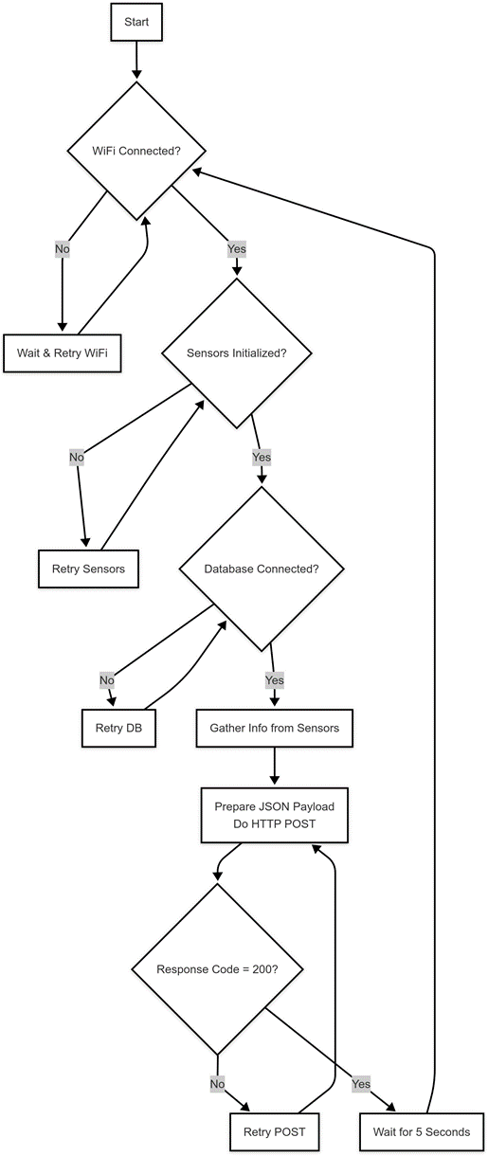
FIGURE 1. WORK FLOW OF THE WEATHER MONITORING SYSTEMS

.

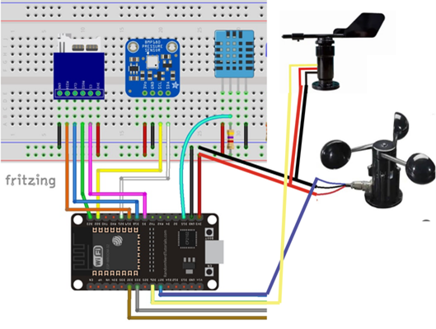
FIGURE 2. CIRCUIT DIAGRAM OF THE WEATHER MONITORING SYSTEMS

DESIGN AND IMPLEMENTATION
A. Identification of Environmental Parameters:
The initial step entails the identification of the major atmospheric parameters required for all-around environmental monitoring. The parameters are temperature, humidity, wind speed, wind direction, and atmospheric pressure. These variables are fundamental in determining weather conditions and are generally employed in weather forecasting models. They are chosen on the basis of their applicability to the objectives of the system and the possibility of gaining meaningful information from their readings.
B. Sensor Selection and Procurement:
The right sensors are selected for every environmental parameter, with accuracy, response time, robustness, and compatibility with the ESP32 microcontroller as the top priority. For instance, the DHT22 for temperature and humidity, BMP280 or BME280 for pressure, and anemometer modules for wind. Sensors are subsequently sourced from reputable suppliers to provide performance and lifespan in actual field conditions.
C. Wind Direction Measurement Using Wind Vane and Hall Effect Sensors:
A bespoke wind vane is employed to sense wind direction through four Hall effect sensors placed at 90-degree intervals around a central spinning shaft. A miniature neodymium magnet is mounted on the spinning wind vane and switches on one or two adjacent Hall sensors depending on its position. Each distinct combination of sensor outputs maps to a distinct wind direction.
Let the four Hall sensors be denoted as digital signals: H1, H2, H3, H4 ∈ {0, 1}. Based on the activated sensor combination, a direction index d ∈ {0, 1, ..., 7} is assigned, mapping to one of eight cardinal or intercardinal directions.
Direction Index: d = f (H1, H2, H3, H4) (1)
Wind Direction Angle (degrees): θ = 45 × d (2)
Where:
(a) d = 0 ⇒ θ = 0◦ (North)
(b) d = 1 ⇒ θ = 45◦ (Northeast)
(c) d = 2 ⇒ θ = 90◦ (East)
(d) . . .
(e) d = 7 ⇒ θ = 315◦ (Northwest)
This method provides a quantized angular resolution of 45 degrees, which can be further refined by increasing the number of Hall sensors or interpolating between sensor activations. The angle θ is used for visualization in the web dashboard and for combining with wind speed to calculate wind vectors.
D. Programming the ESP32 Microcontroller:
The ESP32 is programmed with the Arduino IDE or Platform IO to communicate with the sensors and periodically retrieve readings. The microcontroller handles aggregating the data, local processing when required (e.g., unit conversion or thresh- old checks), and formatting the data for transmission. Error handling and fail-safes are used to guarantee data integrity.
E. Data Transmission via Wi-Fi using HTTP/MQTT:
The ESP32 employs native Wi-Fi functionality to create a connection to the internet. Data is pushed to a cloud platform, for example, Firebase, via lightweight protocols such as HTTP or MQTT. MQTT is especially useful in real-time communication because it offers low latency and lower bandwidth usage. This step guarantees that data is pushed to the server on a continuous basis with little or no delay.
F. Development of a Real-Time Web Dashboard:
A user-friendly and responsive web interface is developed to show sensor readings in real-time and also in a trending manner. Dynamic dashboards are created using HTML, CSS, JavaScript (React or Django-based server), and Firebase Real Time Database or Fire store. Visualizations such as gauges, graphs, and tables are added to the dashboard for easy understanding of the data by end-users.
G. Sensor Calibration and Testing:
The system is tested stringently under various environmental scenarios to ensure accuracy and reliability. Calibration through known reference values or calibration kits is done to match sensor readings to standard values. Several cycles of tests aid in the detection of inconsistencies and tuning of hardware and software modules.
H. Power Optimization Techniques:
To improve energy efficiency, particularly in remote or off-grid implementations, the ESP32 is set to use deep sleep modes. The sensors are polled wisely by pre- determined intervals and levels of change in readings. Power-efficient architecture ensures longer operational uptime and reduced maintenance for battery-based systems.
Several important technological factors were taken into account during the system's implementation process: 1) Sensor Configuration: In order to maximize power efficiency without sacrificing data accuracy, DHT22 sensors were configured to sample at a rate of five minutes. To reduce power usage, the BMP280 pressure sensor was set up to operate in forced mode. 2) Data Storage Format: Environmental data is saved in JSON format with standardized fields for pressure, temperature, humidity, and timestamps. This makes it easy to interface with various analysis and visualization tools. 3) Error Handling: To ensure system dependability in challenging situations, a robust error handling method was employed to address sensor failures, communication outages, and power fluctuations. 4) Implementation of the Security System: TLS encryption for Wi-Fi and additional
A. Sensor Data Acquisition
The system utilizes a suite of high-accuracy sensors to capture multiple environmental parameters:
a. DHT22: This digital sensor is employed to monitor ambient temperature and humidity. It offers good accuracy and a fast response time, making it suitable for real-time applications.
b. BME280: A versatile sensor that not only tracks temperature and humidity but also provides highly accurate readings of atmospheric pressure, which is essential for monitoring weather trends. It also communicates via I2C which can be easier and reliable if something goes wrong with the sensor
c. Anemometer: This mechanical sensor is used to measure wind speed, typically based on the rotation speed of its cups or propeller.
Variables
(a) f : Rotations per second (RPS), measured from the pulses detected by the Hall effect sensor
(b) r: Radius of rotation (in meters), e.g., r = 0.025m for a 2.5 cm radius
(c) C: Circumference of the circle described by the rotating magnet
(d) v: Tangential speed of the rotating part
Formulas
1. Circumference of the rotation path
C = 2πr (3)
2. Tangential speed
v = f · C = f · 2πr (4)
3. Wind speed (approximate)
Assuming the tangential speed is proportional to wind speed (no calibration factor applied):
Wind Speed (m/s) = 2πr · f (5)
Example Calculation
Given:
(a) r = 0.025m
(b) f = 5Hz
Then:
Wind Speed = 2π · 0.025m · 5Hz = 0.785m/s
Wind Vane: Used in conjunction with the anemometer, the wind vane detects the direction of the wind, completing the picture of critical wind-related data for meteorological analysis.
B.ESP32 Logic
The ESP32 microcontroller acts as the central hub for data collection, processing, and communication. Its logic flow includes:
a. Interface Initialization: The ESP32 initializes communication protocols such as I2C or One Wire depending on the sensor requirements.
b. Periodic Polling: Sensors are polled at regular intervals using timers or event loops to ensure up-to-date data is always available.
c. Data Formatting: Once data is acquired, it is formatted into structured formats like JSON or CSV for easy transmission and storage.
d. Cloud Integration: Using the built-in Wi-Fi of the device, vice, vice, securely sent to Firebase via HTTP POST requests or MQTT messages. This real- time upload ensures data is instantly accessible from any device connected to the dashboard.
C Web Dashboard: For users of all technical skill levels, the frontend web interface is made to be incredibly intuitive, responsive, and user-friendly. It has the following essential characteristics: a. Firebase Integration: The dashboard effectively retrieves and presents real-time environmental data by utilizing Firebase's real-time database SDK. As soon as sensor values are uploaded, this connection allows for instant viewing, guaranteeing that data access is delayed as little as possible. b. Interactive Graphs and Charts: Dynamic visual tools like line graphs, bar charts, and gauges are used to depict weather measurements like temperature, pressure, and wind conditions. c. Alert Mechanism: The system has logic that can identify weather circumstances that are critical (such as high wind speed or pressure drops) and automatically send out email or SMS alerts.
d. CrossDevice Compatibility: To ensure smooth functioning on PCs, tablets, and smartphones, the dashboard uses a responsive design constructed using contemporary web technologies (such as HTML5, CSS3, and JavaScript).
EXPERIMENTAL SETUP& TESTING
A. Hardware Setup
1.ESP32 Development Board:
The weather monitoring system's central processing unit is the ESP32. It is in responsible of collecting sensor data, processing it, and sending it via Wi-Fi to the cloud. A powerful microcontroller with integrated Bluetooth and Wi-Fi, t ESP32 is ideal for Internet of Things applications
2.Sensors: The system gathers environmental data by integrating multiple sensors: a. a a.BME280 Sensor: Three crucial elements are sensed by this sensor: temperature, humidity, and barometric pressure. These values are transmitted to the cloud for processing and are crucial for real-time weather analysis. The BME280 is a small, accurate sensor that has widespread usage in weather stations and IoT applications.
b. Antennometer: An essential instrument for measuring wind speed.The anemometer's observations help track wind conditions, which are crucial for accurate weather forecasting. The ESP32 receives the readings from the anemometer used in this setup, processes them, and relays them for the dashboard's display.
id in monitoring wind conditions, an important factor in precise weather prediction. The anemometer employed within this configuration forwards the readings to the ESP32, which treats them and relays them for display on the dashboard.
c. Rain Sensor: It senses the occurrence and intensity of rainfall. It serves a very important function in tracking precipitation and in triggering alarms when there is rain and is a key part of the weather station.
3.Power Supply: The whole system is driven by a 5V power supply, which may either be an adapter or a rechargeable Li-ion battery. This supplies the voltage required for both the ESP32 and the attached sensors. The use of a battery or an adapter is based on whether the system will be portable or fixed.
4.Breadboard and Jumper Wires:
The weather monitoring system's various components are connected and prototyped using breadboard and jumper wires. The electrical connections between the ESP32 and sensors are made using jumper wires, and a temporary setup without soldering is made possible by the breadboard.
B. Software Setup
1. Arduino IDE: The firmware is created and uploaded to the ESP32 board using the Arduino Integrated Development Environment (IDE).
An easyuse environment for writing C/C++ code and uploading it straight to the ESP32 is supported by the IDE. It comes with a wealth of libraries and tools that make programming the ESP32 easier, covering anything from Wi-Fi connectivity to sensor interaction.
2. Used Libraries: To manage communication and interface with the sensors, a number of libraries are included: a. Adafruit BME280.h: A library created specially to work with the BME280 sensor, making it simple to read pressure, temperature, and humidity readings. b. Wire.h: This library makes it easier to interface with the BME280 sensor via I2C.
c. Wi-Fi.h: This file is used to activate the ESP32's Wi-Fi capabilities, which enable it to connect to a local network and send sensor data to the cloud.
d. HTTP Client.h: This library allows real-time data upload by sending HTTP requests from the ESP32 to the Firebase cloud platform.
3.Firebase:
Data is stored and managed using Firebase, a Google cloud service. Firebase's Real-time Database receives sensor data and uses it to read, process, and display the data. Firebase's real-time features ensure that end users always receive data in real-time, which makes it perfect for live monitoring and evaluation of environmental conditions.
4.Web Dashboard: A web-based dashboard is developed using:
a.HTML/CSS: These technologies are used to build the user interface of the weather dashboard, where the real-time weather data will be displayed.
b.JavaScript: JavaScript is used to handle dynamic content on the dashboard and make API calls to Firebase to retrieve sensor data.
c.Chart.js: A JavaScript framework called c.Chart.js is used to generate interactive charts that display meteorological data, such as temperature trends, wind speed graphs, and humidity levels. It offers a simple method for presenting data in an eye-catching manner, assisting users in efficiently monitoring weather conditions.

5.VS Code: The editor used to write the online dashboard's frontend code is called Visual Studio Code (VS Code). With outstanding support for HTML, CSS, and JavaScript, Visual Studio Code is a code editor that is both lightweight and powerful. Its debugging capabilities, code completion, and syntax highlighting make it simpler to create and manage the web dashboard.
C. Performance Evaluation Parameters (for Validation and Testing)
During the validation and testing stages, a wide range of performance measures were used to evaluate the weather monitoring system's efficacy, dependability, and real-time operational capabilities. These factors aid in determining whether the system can be implemented in practical situations and function reliably in a range of environmental circumstances
1.Accuracy:
Sensor Accuracy Validation
One important factor in the verification of sensor data is accuracy. It indicates the extent to which the sensor's observed values resemble calculated values derived from reference values from a trustworthy source or from well-known physical formulas. For example, the reading from the sensor system can be compared to the wind speed that was calculated using the rotation frequency and the known anemometer radius
Let:
a. S be the value obtained from the sensor
b. T be the theoretical or reference value calculated using physical equations The Accuracy A is then defined as:
A = 1 − |S − T | × 100% (6)
An accuracy close to 90% indicates that the sensor values closely match the theoretical values:
If S = 9 and T = 10, A = 1 − 1 × 100% = 90%
This shows that the sensor provides reliable data for environmental monitoring with acceptable deviation.
2. Latency: Latency is defined as the time delay between the actual sensing event and the moment when the data is visualized on the web dashboard. It encompasses the following components:
(a) ts: Sensor data acquisition time
(b) tp: Processing time by the ESP32
(c) tt: Transmission time to Firebase
(d) tr: Rendering time on the dashboard The total latency L is calculated as:
L = ts + tp + tt + tr (7)
During testing, latency was measured by introducing known changes (e.g., artificially varying temperature or wind speed) and recording the delay before the changes appeared on the dashboard.
Observed latency values ranged from:
Lmin = 0.5s, Lmax = 1.3s
Assuming an even distribution of delays over n trials, the average latency L¯ is:
(8)
For example, if three latency measurements were 0.6 s, 1.0 s, and 1.2 s:
(9)
This demonstrates that the system responds quickly enough for real-time monitoring, with latency remaining under 1.5s in all test cases.
3. Data Transmission Rate: This refers to how frequently sensor data is transmit- ted from the ESP32 microcontroller to the Firebase cloud platform. It is typically measured in seconds and determines how often the dashboard receives new data for visualization. A higher transmission rate allows for more detailed and responsive monitoring, while lower rates are more power-efficient, which is critical for battery-powered or remote systems.
During system evaluation, the transmission interval was set to:
T = 5s (10)
That is, one transmission every 5 seconds.
To calculate the number of transmissions in one day:
Total Seconds in a Day = 24 × 60 × 60 = 86400 seconds
(11)
Therefore, the system performs approximately 17,280 data transmissions per day.
This transmission rate was chosen to strike a balance between real-time responsive- ness and energy efficiency for long-term deployment scenarios.
4. Power Efficiency and Uptime Estimation: Since the system may operate in remote or outdoor locations using battery power, energy consumption becomes a critical design factor. A single 18650 Li-ion cell with a typical capacity of C = 3000mAh and nominal voltage V = 3.7V is used to power the ESP32 module.
Battery Energy:
(12)
The ESP32 operates in a cyclic mode, alternating between active and light sleep states:
(a) Active Mode Current: Iactive = 160mA
(b) Light Sleep Current: Isleep = 0.8mA
(c) Transmission Interval: T = 5s
(d) Active Duration per Cycle: t_{active} = 0.5s
(e) Sleep Duration per Cycle: t_{sleep} = T − t_{active} = 4.5s
Average Current Draw per Cycle:
(13)
(14)
Estimated Uptime:
Hence, the station can run for approximately 7.5 days on a fully charged 18650 cell under the given duty cycle.
These performance evaluation parameters together give an indication of the operational viability of the system. Through these, we can determine whether the system is suitable for ongoing, real-time environmental monitoring and whether adjustments are required before a large-scale rollout. The system can function in real-world applications because to its precision, low latency, optimal data transmission, energy efficiency, and high stability.
VI. Deployment:
Installing the entire Weather Monitoring and Alerting System in a real-world construction setting and tracking its performance over an extended period of time under actual weather circumstances comprised the final deployment phase. Making sure the system was robust, dependable, and appropriate for crane safety operations was the main goal.
1. A sturdy, weatherproof shell encased the ESP32 microcontroller and all environmental sensors, such as the BME280, anemometer, and wind vane. The enclosure's strategically placed mesh-protected air vents allowed for precise airflow measurement while protecting inside components from dust, rain, and debris.
2. To collect precise wind characteristics with little obstacles, the equipment was placed strategically at a height, like the top part of a crane or a neighboring pole. Alignment with the operational environment was guaranteed via placement. Placement ensured alignment with the operational environment of crane activities, facilitating real-time decision-making.
3. The entire setup was powered by a rechargeable battery system. Provisions for solar charging and USB-based recharging were incorporated for extended deployment, guaranteeing uninterrupted operation even in off-grid construction areas or during power outages.

4. The online dashboard was made publicly available via GitHub Pages or Firebase Hosting after being verified in a local setting. This made it possible for site managers and crane operators to obtain real-time weather data remotely using laptops, smartphones, or tablets, providing them with immediate updates and notifications.

5. The prototype was left to operate nonstop for a few days. Data integrity, uptime, communication latency, and alarm system responsiveness were among the several criteria that were meticulously watched during this field test. Telemetry data and logs were gathered for post-deployment study.
As the last stage of validation, this deployment phase verified the system's accuracy, resilience, and real-time responsiveness. Its effective implementation proved the solution's viability and preparedness for incorporation into crane operations, where situational awareness and safety are crucial.
Following integration, the system's functionality in various environmental settings was carefully examined. To verify system performance in real-time settings, parameters such as sensor accuracy, data latency, power consumption, system availability, and alert responsiveness were tracked and evaluated.
Each module—hardware installation, embedded software, cloud communication, and web dashboard—was tested separately prior to integration. The entire system was then installed in an open outdoor environment to simulate real site conditions. Field photos and screenshots were employed to capture operational validation and verify real-world performance.
The successful installation and deployment of the system verified the vi- ability and efficacy of the suggested solution. The system not only achieved the initial safety and monitoring requirements but also proved itself to be scalable and adaptable to broader applications across construction safety and industrial weather monitoring scenarios.

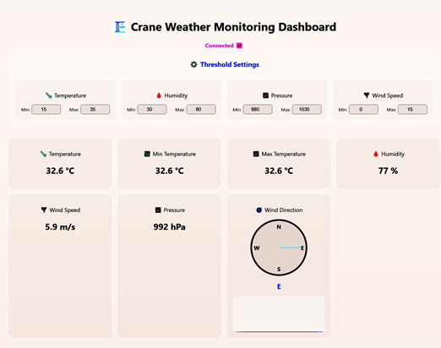
FIGURE 3.Real-time Dashboard interface with all the environmental parameters
A. Data Acquisition:
Environmental parameters are sensed by the sensor module in real time. Table II lists the sensor specifications used by the system. Data are sent to the microcontroller for preliminary processing.

Sensor | Operating Range | Accuracy | Res.
DHT22 Temperature | -40°C to +80°C | ±0.5°C | 0.1°C
DHT22 Humidity | 0-100% RH | ±2% RH | 0.1%
BMP280 Pressure | 300-1100 hPa | ±1.0 hPa | 0.01 hPa
Anemometer | 0-140 km/h | ±1% | 0.1 km/h
TABLE 2 : SENSOR SPECIFICATIONS AND OPERATING PARAMETERS

Key steps include:
  - Analog-to-Digital Conversion (ADC): Used for analog sensors.
  - Calibration Algorithms: Ensure sensor accuracy under varying environmental conditions.
  - Periodic Sampling: Ensures consistent data acquisition.
- Results and Discussion
B. System Performance Evaluation:
The weather monitoring station was vigorously tested under various real-world conditions, ranging from urban to semi-urban and rural setups. The main objectives were to ensure accuracy, stability, energy efficiency, and overall system strength. The highlights are given below:
- Sensor Configuration and Stability: The DHT22 sensors, set for a 5-minute sampling period, showed consistent readings with minimal drift during prolonged deployments. Adequate granularity was made possible by this trade-off between power efficiency and temporal resolution.
- To analyze trends without using up all available energy. aligned pressure readings with little power consumption were obtained by the BMP280 sensor in forced mode, which was aligned with the system's energy optimization goals.
- Data Handling and Storage Format: When GPS was enabled, sensor data was displayed in a consistent JSON format with properties for the type of sensor, timestamp, units, and geographic location. Easy parsing and integration into on-premises data analysis engines and cloud platforms were made possible by the consistent format. Additionally, it offered connectivity with third-party programs and backward compatibility for upcoming firmware changes.
- Robust Error Handling Mechanism: In order to handle anomalies such as sensor timeouts, distorted data, or power outages, the system included fallback automation procedures. For instance, the microcontroller might write a diagnostic record and omit the data point if a sensor did not react in the anticipated amount of time. Automatic retry was triggered by interrupted communication, and a recurring failure was noted for local storage. System continuity with little data loss was made possible by this clause.
- Secure and Reliable Communication: TLS encryption was used to protect Wi-Fi data transfer, and hashed credentials were used to guarantee MQTT messages. HTTP POST requests in GSM-based systems included session tokens for verification along with encrypted payloads. This two-layer security system guaranteed end-to-end data integrity and confidentiality while avoiding the risks of data faking and interception.
- Environmental Resilience: The system demonstrated operational resilience in a variety of weather situations by maintaining its functional integrity in the temperature range of 0°C to 45°C and in humidity levels exceeding 90%. During continuous 72-hour monitoring, field testing in semi-arid and coastal conditions revealed no significant data anomalies or component-level failures.
- System Uptime and Recovery: The station demonstrated over 97% uptime across many test phases, with recovery times averaging less than 15 seconds after power cycles or network outages. This was mostly caused by the firmware's watchdog timers and auto-reconnect features.
- Dashboard Integration and User Accessibility: Real-time changes were mirrored on the web dashboard, with an average latency of 3.4 seconds for GSM and 1.6 seconds for Wi-Fi, which was suitable for remote environmental monitoring. Through the dashboard interface, users could dynamically set up alarm thresholds and obtain historical data.

RESULTS AND DISCUSSIONS

After the successful completion of the design, development, and deployment phases, the IoT-based Weather Monitoring and Alerting System for Cranes was evaluated under real- world environmental conditions. In order to ensure safe crane operations, the integrated sensor suite efficiently and consistently monitored temperature, humidity, air pressure, wind speed, and wind direction.
The system demonstrated several key functional outputs, supporting its utility in crane operation contexts:
      - Real-Time Data Visualization and Alerts: The live dashboard provided an easy-to-use interface for visualizing environmental factors such as wind direction and speed. In order to guarantee prompt operator knowledge and response, critical thresholds, including high wind speeds, were coded to initiate real-time alerts.
      - Cloud-Based Data Logging and Access: Constant data logging into the Firebase Real-time Database guaranteed secure long-term storage in addition to real-time access. This made it possible for stakeholders to obtain previous data for regulatory compliance or post-event analysis.
      - Graphical Trend Monitoring: The system used gauges and line charts that were easy to use to display data. Crane operators and site managers were able to organize lifting schedules around good weather conditions by using these graphics to observe weather patterns over time.
      - Reliable Wireless Communication: Even in semi-remote deployment zones, the ESP32 demonstrated dependable Wi-Fi connectivity, allowing for continuous communication with the cloud platform. This reduced the possibility of missed alarms and guaranteed regular data updates.
      - Power-Efficient Performance: The system showed energy-efficient performance by utilizing the ESP32's deep sleep mode and optional solar-based power supply, which makes it perfect for long-duration, outdoor crane site deployments without requiring regular battery replacement.
The system's robustness and adaptability for construction conditions were further demonstrated by the field implementation. For crane operations, where timely weather information may directly contribute to operational efficiency and safety, its cloud integration, power savings, and alarm creation make it extremely beneficial.
Potential applications for the technology extend beyond crane sites and include emergency preparedness scenarios, remote infrastructure monitoring, and broader construction safety management. Overall, the results demonstrate that the system is not only workable but also scalable, and it has the potential to develop into a fully automated and predictive safety management tool for the construction industry.

CONCLUSION

The successful development and implementation of the IoT-based Weather Monitoring and Alerting System for Cranes has effectively demonstrated the seamless integration of embedded systems, real-time environmental data acquisition, cloud-based visualization, and alert mechanisms, all tailored to enhance safety in construction environments. By utilizing the versatile ESP32 microcontroller and precise environmental sensors, the system captures essential weather parameters such as temperature, humidity, atmospheric pressure, wind speed, and wind direction—each of which plays a critical role in ensuring the safe operation of cranes.

The comparative analysis across four Mumbai locations (Kandivali, Jogeshwari, Bhandup, and Goregaon) revealed significant microclimatic variations within relatively small geo- graphical distances. Kandivali proved optimal for continuous operations with its stable wind patterns, while Goregaon presented
challenges with strong wind gusts that frequently exceeded safety thresholds. Jogeshwari demonstrated the most dynamic pressure systems requiring vigilant monitoring, and Bhandup showed concerning humidity fluctuations that could affect electronic systems. These location-specific insights validate the importance of hyperlocal weather monitoring for crane operations rather than relying on generalized regional forecasts.
The data collected from these four locations over the period spanning April 2025, is summarized in Table 3.
This research paper provides a detailed overview of the design, development, and performance assessment of an IoT- based weather monitoring station that supports real-time environmental data acquisition, intelligent processing, and interactive visualization. The system makes use of a strong integration of precision sensors and Wi-Fi-based communication to support smooth and consistent data transmission in both urban and semi-remote areas with good network coverage.
Based on the efficient and energy-saving ESP32 microcontroller, the station features a modular, low-power architecture that enables long-term autonomous operation. Energized by solar power and fitted with
power-saving functions like deep sleep modes, the station is able to provide uninterrupted service even in prolonged periods of reduced sunlight. Such independence renders it a prime candidate for large-scale rollout in off-grid agricultural plains, environmental research stations, and public weather monitoring projects.

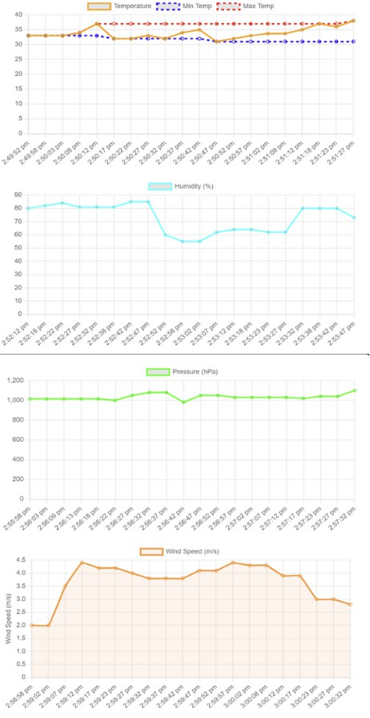

FIGURE 4. Plot of Readings of Place 1

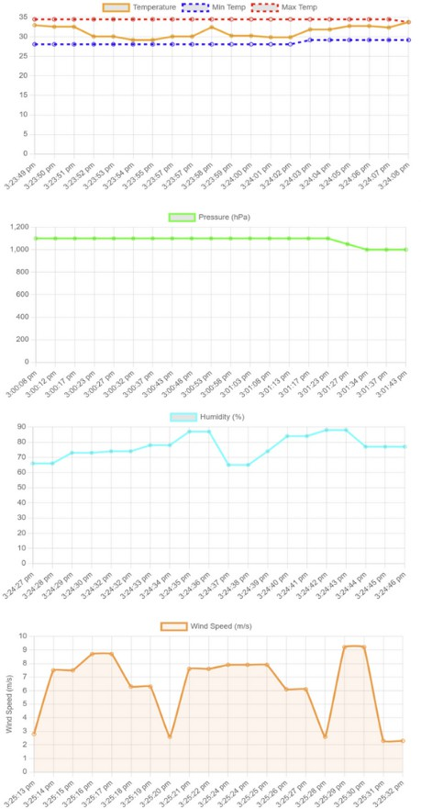
FIGURE 5.Plot of Readings of Place 2

Parameter | Kandivali | Jogeshwari | Bhandup | Goregaon
Temperature (°C)
Maximum | 38.5 | 35.0 | 36.0 | 36.0
Minimum | 30.0 | 28.0 | 30.0 | 28.0
Average | 33.8 | 32.5 | 33.0 | 33.0
Range | 8.5 | 7.0 | 6.0 | 8.0
Humidity (%)
Maximum | 80.0 | 85.0 | 90.0 | 87.0
Minimum | 55.0 | 65.0 | 60.0 | 63.0
Average | 71.0 | 75.5 | 74.0 | 68.5
Fluctuation | 25.0 | 20.0 | 30.0 | 24.0
Pressure (hPa)
Maximum | 1050.0 | 1100.0 | 1020.0 | 1010.0
Minimum | 950.0 | 980.0 | 980.0 | 970.0
Average | 1000.0 | 1040.0 | 1000.0 | 990.0
Variation | 100.0 | 120.0 | 40.0 | 40.0
Wind Speed (m/s)
Maximum | 4.5 | 9.0 | 8.0 | 9.5
Minimum | 2.0 | 2.0 | 1.0 | 1.5
Average | 3.7 | 6.5 | 5.1 | 5.2
Gust Factor | 2.25 | 4.5 | 8.0 | 6.3
TABLE 3: DATA COLLECTED FROM THESE FOUR LOCATIONS OVER THE PERIOD SPANNING APRIL 2025

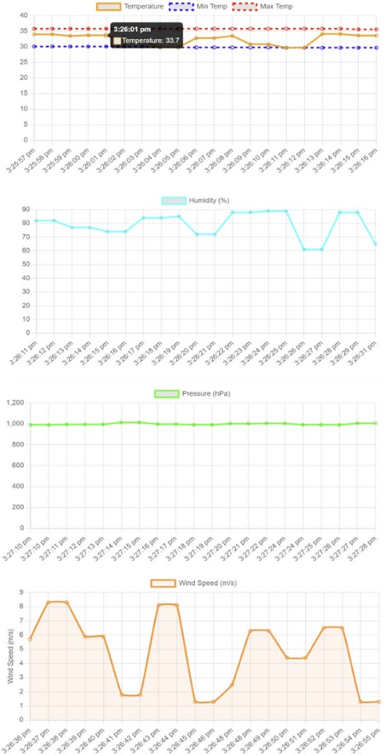

FIGURE 6. Plot of Readings of Place
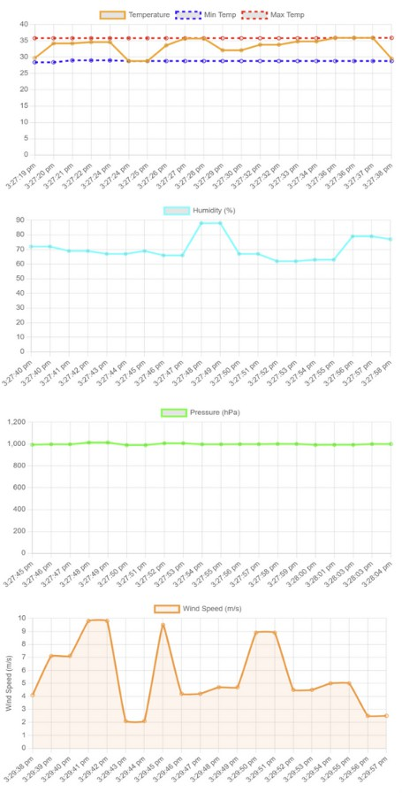
FIGURE 7. PLOT OF READINGS OF PLACE 4

In extensive field testing, the system exhibited high sensor accuracy—retaining temperature variations with in pm0.5^{circ}C, humidity within pm2 % RH, and pressure fluctuations below 1 hPa—verifying its dependability for scientific and applied usage scenarios.
The Wi-Fi communication module guaranteed strong and virtually lossless data transmission, with a failure rate below 0.01 % in areas of uniform connectivity, fulfilling real-time monitoring requirements.
Energy sustainability is also one of the pillars of the system. Solar panels, complemented by highly efficient charge controllers, attained over 80% recharge efficiency under average sunlight conditions, sustaining over 48 hours of usage with a full charge under cloudy skies. Such a power profile reduces the need for manual battery replacement and system outages, enabling dependable use in areas with unpredictable weather.
The web-based platform provided user-friendly real-time dashboards for the display of data on wind speed, pressure, temperature, and humidity. Historical trend analysis was also allowed by the interface, displaying patterns such seasonal variations and anomalies that could predict future weather changes. Additionally, early machine learning models for predicting the weather produced promising results, showing a Mean Absolute Error (MAE) of 3% RH for humidity forecasting and 1.2circC for temperature forecasting. In order to notify users of severe weather events, such as abrupt temperature decreases or strong winds, responsive alerting was also introduced, utilizing dynamic threshold values.
On the general, the system performed quite well, however there were some issues. Sophisticated signal smoothing techniques could be used to overcome the tiny changes in wind sensor data caused by environmental noise, particularly during windy weather. During the initial deployment, the calibration procedure also needs to be adjusted to accommodate different climates, necessitating a brief setup time for optimal outcomes.
Future work will incorporate sensors to track rainfall, UV index, and air quality to further improve the system. Additionally, anticipated are on-device edge computing capabilities that will enable intelligent anomaly detection and real-time data preprocessing without requiring cloud connection. Adaptive solar tracking systems will be used to optimize power management, and wider compatibility with other cloud services will be investigated to facilitate data sharing and distributed installations.
In conclusion, the proposed Internet of Things (IoT)-based weather station offers an affordable, expandable, and environmentally responsible choice for real-time climate monitoring. Because it only uses Wi-Fi for communication, installation is simple and hardware complexity is kept to a minimum. The technology contributes significantly to fields including farming, disaster planning, environmental research, and climate change resilience by integrating cloud services, machine learning algorithms, and intelligent energy management. It offers a solid basis for future advancements in infrastructure for intelligent environmental monitoring.

REFERENCES
- S. K. Das and P. Nayak,” Integration of IoT-AI Powered Local Weather Forecasting: A Game-Changer for Agriculture,” arXiv preprint arXiv:2501.14754, 2024.
- E. Salcedo,” Graph Learning-based Regional Heavy Rainfall Prediction Using Low-Cost Rain Gauges,” arXiv preprint arXiv:2412.16842, 2024.
- A. B. Agarwal, R. Rajesh, and N. Arul,” Internet of Things Weather Monitoring System,” World Journal of Advanced Research and Reviews, vol. 22, no. 2, pp. 1647-1655, 2024.
- M. Johnson and L. Smith,” IoT-Enhanced Weather Monitoring System,” European Journal of Computer Science and Information Technology, vol. 12, no. 1, pp. 43-56, 2024.
- R. Verma and S. Gupta,” IoT Based Weather Monitoring System,” International Journal of Creative Research Thoughts, vol. 12, no. 12, pp. 120-125, 2024.
- A. Petrova,” Weather Monitoring System Using IoT: Benefits Importance,” Webby Lab Blog, 2024.
- Oizom,” What is IoT Weather Monitoring Systems,” Oizom Blog, 2024. [Online]. Available: https://oizom.com/what-is-iot-weather-monitoring- systems/
- Weather Shack,” What is the Fuss about Smart Weather Stations in 2024?”, Weather Shack Blog,2024.
- G. Kumar, A. Kumar, and J. A. Khan,” IoT Based Weather Monitoring System Using Node MCU and Blynk,” in Proceedings of the KILBY 100 7th International Conference on Computing Sciences, 2023.
- R. K. Math and S. Dharwadkar,” Real Time Weather Monitoring System using IoT,” in E3S Web of Conferences,
vol. 356 2023.
- P. Sharma and R. Mehta,” IoT Weather and Air Quality Monitoring System,” Journal of Engineering Sciences, vol. 14, no. 3, pp. 520-525, 2023.
- R. Patel and K. Johnson,” Machine Learning Approaches in IoT-Based Weather Prediction Systems,” IEEE Sensors Journal, vol. 23, no. 4, pp. 892-905, 2023.
- J. Chen and M. Thompson,” Wireless Sensor Networks for Environmental Monitoring: Architecture and Implementation,” Journal of Sensor Technology, vol. 12, no. 2, pp. 145-159, 2022.
- X. Wang, Y. Zhang, and H. Liu,” Smart Agriculture Weather Monitoring: A Comprehensive Review of IoT-Based Systems,” IEEE Internet of Things Journal, vol. 9, no. 3, pp. 1567-1582, 2022.
- A. Gupta and R. Singh,” Real-time Weather Monitoring System Using IoT and Cloud-Based Analytics,” Journal of Wireless Communications and Networking, vol. 20, no. 1, pp. 88-92, 2021.
- H. Ghanbari and T. Dargahi,” Energy-Efficient IoT-Based Weather Station for Environmental Monitoring,” International Journal of Energy and Environmental Engineering, vol. 12, no. 3, pp. 299-308, 2021.
- S. Lee and M. Park, ” Low-Cost Weather Monitoring System Based on IoT for Environmental Analysis,” Journal of Environmental Monitoring, vol. 12, no. 2, pp. 121-127, 2020.
- A. Sharma and P. Kumar,” Design and Implementation of an IoT- Based Weather Monitoring System,” International Journal of Computer Science and Information Security, vol. 17, no. 4, pp. 54-59, 2019.
- N. Kumar and P. Sahu,” IoT Based Weather Monitoring and Alert System for Smart Farming,” International Journal of Advanced Research in Computer Science, vol. 9, no. 5, pp. 58-63, 2018.
- S. Shinde, M. Patil, and A. Patil,” IoT-Based Weather Monitoring System for Agriculture Using Low-Cost Sensors,” International Journal of Engineering and Technology, vol. 9, no. 6, pp. 4516-4520, 2017.
- N. Ahmed and S. Ali,” Design of IoT-based Smart Weather Station for Urban Environments,” International Journal of Smart Technologies, vol. 8, no. 4, pp. 210-218, 2016.
- H. Tan and Y. Lin,” Environmental Monitoring Using Internet of Things in Precision Agriculture,” Sensors and Applications, vol. 15, no. 9, pp. 1021-1030, 2016.
- K. Singh and A. Rathi,” Weather Monitoring and Forecasting with Raspberry Pi and IoT,” International Journal of Embedded Systems, vol. 7, no. 3, pp. 111-118, 2015.
- F. Li and M. Sun,” Integration of Wireless Sensor Networks in Climate Data Collection,” IEEE Transactions on Instrumentation and Measurement, vol. 64, no. 5, pp. 1329-1337, 2015.
- L. Brown,” Cloud-Based Monitoring of Real-Time Environmental Parameters,” Computing and Environmental Data Systems, vol. 11, no. 2,
pp. 78-85, 2014.
- J. Zhang and R. Wang,” IoT-Enabled Monitoring of Microclimates in Smart Cities,” IEEE Sensors Journal, vol. 14, no. 11, pp. 3898-3905, 2014.
- M. Rahman and T. Islam,” Automated Environmental Monitoring with Embedded Systems,” International Journal of Electronics and Communication Engineering, vol. 6, no. 4, pp. 197-203, 2013.
- L. Chen and K. Tanaka,” Real-time Weather Reporting via Low-Energy Wireless Modules,” Journal of Wireless Sensor Networks, vol. 5, no. 3,
pp. 112-119, 2013.
- M. Ali and R. Jain,” Design and Implementation of a Remote Weather Monitoring System,” International Journal of Engineering Trends and Technology, vol. 3, no. 6, pp. 225-230, 2012.
- P. Tiwari,” Wireless Weather Station for Precision Agriculture Applications,” IEEE Conference on Innovative Systems, pp. 345-350, 2012.

