Optimizing Molecular Communication Performance by Sweet Spot Analysis using Feedback Control Strategy for Enhanced Throughput-Efficiency Balance
Ashwini Katkar^{1, a} and Vinitkumar Dongre ^{2,b}
¹Thakur College of Engineering and Technology, Kandivali(East), Mumbai, Maharashtra, India
²Vidyavardhini’s College of Engineering and Technology, Vasai (West), Palghar, India
³Thakur College of Engineering and Technology, Kandivali(East), Mumbai, Maharashtra, India

^{a)} ashwini.katkar@vcet.edu.in
^{b)}vinit.dongre@thakureducation.org
Abstract. Molecular communication, particularly in precision biomedical applications such as targeted drug delivery, faces significant challenges in maximizing throughput, improving efficiency, and managing congestion. Traditional static transmission strategies lacking feedback mechanisms often deteriorate in performance under dynamic conditions. To overcome these limitations, a hybrid feedback-controlled strategy was employed, integrating adaptive congestion monitoring, third-order polynomial congestion modeling, and predictive transmission optimization. A comprehensive comparative analysis using COMSOL Multiphysics simulations was conducted to determine optimal operating conditions. The implementation of the hybrid approach demonstrated notable performance enhancements: a 40% increase in throughput, a 22.05% improvement in efficiency, a 45% reduction in latency, and a 60. 7% decrease in the variation of the congestion level. Based on these results, further investigation was carried out into the trade-offs between throughput and efficiency in a transmission rate range of 50 to 90%, comparing feedback-controlled systems with open-loop configurations. The results show a ’sweet spot’ at a transmission rate of 73 to 74%. The feedback-controlled system offered greater operational reliability and consistency, while the open-loop approach exhibited a broader but less stable range (50–90% vs 55–85%). The primary contribution of this study lies in identifying and characterizing this performance sweet spot. This finding establishes a theoretical foundation explaining the superior performance of feedback control and designates the transmission rate of 73–74%% as the optimal operational target. The analysis provides the importance of advanced control strategies and optimal rate selection for high-precision molecular communication in biomedical systems.

introduction
Molecular communication represents an emerging paradigm in nanotechnology, enabling information transfer through the controlled release, propagation, and detection of molecules. This bio-inspired communication method has gained significant attention for its potential applications in biomedical systems, particularly in targeted drug delivery, biosensing, and therapeutic monitoring, where conventional electromagnetic communication fails due to biocompatibility con- constraints and scale limitations. Unlike traditional communication systems that rely on electromagnetic waves, molecular communication utilizes chemical signals, making it inherently compatible with biological environments and suitable for nano-scale applications.
The fundamental challenge in molecular communication lies in achieving optimal system performance while managing the inherent trade-offs between competing performance metrics. Traditional approaches have focused on maximizing individual parameters such as throughput or efficiency, often resulting in suboptimal overall system performance. This limitation becomes particularly critical in precision-demanding applications such as targeted drug delivery, where both high throughput and efficient molecular transport are essential for therapeutic efficacy. Current molecular communication systems, especially in biomedical applications, face several limitations that hinder their practical implementation. One of the primary challenges is the trade-off between throughput and efficiency. Conventional systems are unable to optimize both metrics simultaneously, often forcing designers to prioritize one over the other. This limitation constrains performance in scenarios where a balanced and high-efficiency communication framework is essential.
Another critical issue lies in the static nature of traditional non-feedback systems. These approaches rely on fixed transmission rates that cannot adapt to dynamic environmental conditions or varying system requirements. As a result, they often operate sub optimally under changing conditions, leading to performance degradation and reduced reliability.
Additionally, the optimal operating conditions for molecular communication systems remain inadequately explored. Without clearly defined performance thresholds or balance points between competing metrics, system designers lack practical guidance for effective implementation. This gap makes it challenging to configure systems for consistent and reliable operation.
Finally, congestion management remains a significant obstacle. In high-density molecular environments common in biomedical applications, communication systems frequently suffer from performance degradation due to congestion. Inadequate control mechanisms contribute to increased latency, reduced reliability, and unpredictable behavior, further complicating real-world deployment. This study addresses the identified research gaps through a comprehensive analysis aimed at determining optimal operating conditions in molecular communication systems. It focuses on identifying and characterizing the performance “sweet spot” where an optimal balance between throughput and efficiency is achieved. The study also compares the performance of feedback-controlled and open-loop systems across a range of transmission rates, quantifies the benefits of feedback control in maintaining consistent optimal performance, and offers guidance for system design and deployment.

LITERATURE SURVEY
The field of molecular communication has evolved significantly, with researchers developing various approaches to address key challenges in transmission efficiency and reliability. This survey examines existing work across four main themes: fundamental architecture, congestion control mechanisms, feedback-based strategies, and predictive modeling approaches.
Fundamental Architectures and Frameworks: The foundational work by Akyildiz et al. [1] introduced the concept of nanonetworks, establishing the core principles of molecular communication systems. Their research highlighted the unique challenges of molecular transport at the nanoscale and emphasized the need for specialized communication protocols. Building on this foundation, subsequent studies explored various architectural approaches for enabling efficient molecular transport in diverse applications. Our study [2] examines how changes in the distance between the sender and receiver affect molecular communication, particularly in terms of maximum reception and peak reception timing. The findings reveal that as the separation increases, the number of molecules received declines while the latency rises.
Congestion Control Mechanisms: A critical focus in molecular communication has been the development of effective congestion control strategies. Felicetti et al. [3] proposed pioneering work in congestion control for molecular cyber-physical systems, introducing mechanisms to regulate molecule release rates and prevent receiver overload. Their approach emphasized the importance of dynamic control in maintaining system stability. Similarly, Zhao et al. [4] investigated optimization techniques for drug release rates in nanomachine-based targeted delivery systems, demonstrating how controlled release patterns can enhance therapeutic efficacy while minimizing congestion.
Feedback-Based Strategies: Feedback mechanisms have emerged as a powerful tool for improving molecular com- communication performance. In [5], Nakona et al. proposed a mathematical expression to establish the upper bound of throughput and efficiency, enabling the analysis of model parameter impacts. The optimal transmission rates that maximize throughput and efficiency are determined numerically, highlighting a trade-off between these metrics over a broad range of transmission rates. Byun [6] developed an adaptive signal detection scheme utilizing feedback control, achieving enhanced performance in diffusion-based systems without significant computational overhead. Mitman et al. [7] advanced this field by implementing a Stop-and-Wait Automatic Repeat Request (SW-ARQ) protocol specifically designed for noisy intrabody environments. Their work demonstrated how feedback mechanisms could improve reliability in challenging conditions.
Further contributions in feedback-based approaches include Felicetti et al.’s [8] TCP-like probing mechanism for dy- dynamic transmission rate adjustment. This approach continuously monitored receiver capacity and modified molecule release rates accordingly. Ningthoujam et al. [9] expanded on this by investigating both multipath and single-path feedback channels, providing insights into optimizing molecular transmission under varying environmental conditions. Predictive Modeling and Advanced Control Strategies: Recent advances in predictive modeling have opened new possibilities for optimizing molecular communication. Damrath et al. [10] developed sophisticated analytical models for congestion prediction, enabling proactive transmission rate adjustments based on historical and real-time data. Their work demonstrated how predictive insights could minimize congestion and enhance system performance. Kotsuka et al. [11] contributed valuable insights through their control-theoretic models for bidirectional molecular communication, establishing system design and performance optimization frameworks. The integration of trans- mission rate optimization with congestion management has also been explored. Our research work [12] integrated LSTM-based adaptive control with TLR feedback mechanisms for molecular communication congestion for applications such as targeted drug delivery. Molecular transport systems can benefit from dynamic rate adjustment strategies that respond to congestion indicators while maximizing channel capacity [13]. Rengarajan et al. [14] explore molecular communication in Network Coding (NC) to enhance wireless network performance. Simulations and experiments confirm that NC outperforms traditional coding, offering better reliability and energy efficiency. Despite these significant advances, existing approaches often focus on isolated aspects of molecular communication optimization. While individual strategies have shown promise in specific scenarios, there remains a notable gap in developing comprehensive solutions that integrate multiple control mechanisms. The limited exploration of hybrid approaches that combine adaptive feedback, predictive modeling, and dynamic threshold adjustment presents an opportunity for advancing the field. Additionally, most existing studies evaluate their proposed solutions under idealized conditions, with limited consideration for the variable environments encountered in practical applications. This highlights the need for more robust approaches that maintain effectiveness across diverse operating conditions. This literature review reveals the potential for developing hybrid strategies that leverage the strengths of various approaches while addressing their limitations. Such integration could lead to more efficient molecular communication systems, particularly for applications requiring high reliability and adaptability.

SYSTEM MODEL
Figure 1 illustrates the system model of a molecular communication system incorporating feedback-driven congestion control. In this model, the Transmitter (TX) releases molecules, which diffuse through the medium toward the Receiver (RX). The RX detects these molecules and processes the received signal. A feedback path conveys congestion information from the RX back to the TX.
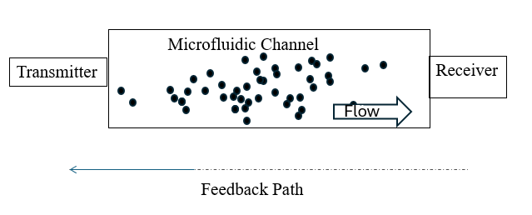
FIG. 1 MOLECULAR COMMUNICATION SYSTEM
This feedback mechanism dynamically regulates the transmission of molecules, ensuring efficient communication while mitigating congestion in the system. The molecular diffusion process in our system follows Fick’s laws of diffusion, modified to account for the microfluidic environment. The concentration of molecules C(x,t) at position x and time t is described by[11]:

$$\frac{∂C\left(x,t\right)}{∂t}=D∇^{2}C\left(x,t\right)+v∇C\left(x,t\right) \left(1\right)$$
Where ∇² (the Laplacian operator) represents the sum of second partial derivatives for spatial coordinates
($\frac{∂^{2}}{{∂x}^{2}} + \frac{∂^{2}}{{∂y}^{2}}+ \frac{∂^{2}}{{∂z}^{2}})$, v is the fluid velocity vector (m/s), C(x,t) is the concentration of molecules at position x and time t

Physical interpretation of each term:
- $\frac{∂C\left(x,t\right)}{∂t}$: Rate of change of concentration with time
- $D∇^{2}C\left(x,t\right)$: Molecular diffusion term describing random motion
- $v∇C\left(x,t\right)$: Convective transport term representing directed flow
The system operates under the following boundary conditions:
- Inlet Boundary (x = 0):
- C(0,t) = C₀ (constant concentration source)
- v(0,t) = v₀ (prescribed velocity)
- Outlet Boundary (x = L):
- $\frac{∂C(L,t)}{∂x}$= 0 (zero concentration gradient)
- P = P₀ (atmospheric pressure)
- Channel Walls:
- No-slip condition: v = 0
- No-flux condition: $\frac{∂C}{∂y}$ = 0
These boundary conditions ensure proper containment and flow of molecules within the microfluidic channel while maintaining physical consistency at the boundaries.
D (m²/s) is the diffusion coefficient, and v is the fluid velocity vector. For our microfluidic system, D is calculated as [11]:

$D=\frac{kT}{6πƞr}$ (2)
where k is the Boltzmann constant (1.380649 × 10⁻²³ J/K), T is the system temperature (310 K), η is the fluid viscosity (8.9 × 10⁻⁴ Pa·s at 310 K), and r is the molecular radius (0.75 × 10⁻⁶ m)
This formulation follows the Stokes-Einstein equation for diffusion in fluids, as discussed in Cussler [15].

Methodology
The methodology developed in this study focuses on implementing a hybrid feedback-controlled strategy to optimize molecular communication performance. This approach integrates feedback, adaptive thresholding, and predictive modeling to regulate the transmission rate dynamically, ensuring enhanced throughput and efficiency while mitigating congestion. The molecular communication system is modeled as a transmitter-receiver framework, where the transmitter emits molecules that diffuse through the medium to reach the receiver.

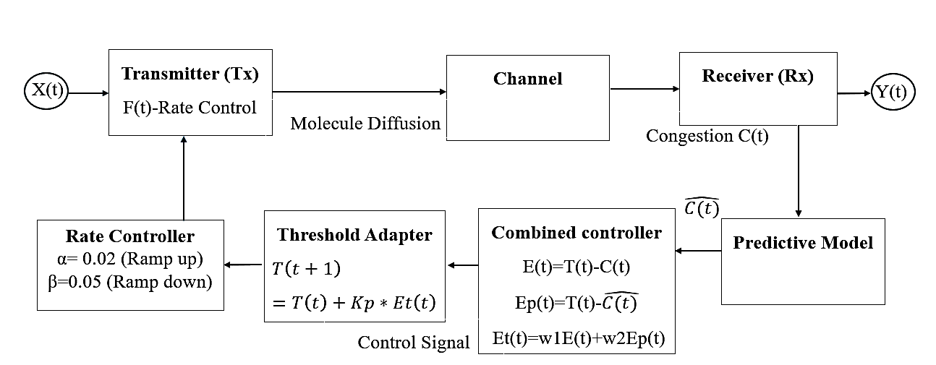

FIG. 2 PROPOSED HYBRID FEEDBACK CONTROLLED MOLECULAR COMMUNICATION SYSTEM

The hybrid control system illustrated in Figure 2 demonstrates the complete decision-making process for molecular communication optimization. The system operates through four key stages:
a) Initialization Phase:
- Parameter setup: Kp = 0.15 (proportional gain)
This value provides a good balance between response speed and stability. Lower values (< 0.1) result in a sluggish response, and higher values (> 0.2) can cause oscillations.
- Initial threshold T(0) = 0.5 × maximum capacity
b) Congestion Monitoring:
- Sampling frequency: 10 kHz
- Rolling Window: 10 samples
- Three-level classification system:
  - Normal: 0-60% occupancy
  - Moderate: 60-80% occupancy
  - Severe: >80% occupancy
c) Threshold Calculation:
- Dynamic adjustment using eq. (5)
- Predictive component incorporation
d) Transmission Adjustment:
- Ramp-up/down rates (α = 0.08, β = 0.12)
- Feedback loop implementation
- Stability maintenance mechanisms

COMSOL Multiphysics was used to develop a simulated testbed for molecular communication, replicating the transmitter-receiver dynamics in a controlled environment. The simulation focused on analyzing how varying molecule emission rates influence congestion at the receiver. Figure 3 illustrates the particle trajectories and velocity magnitude distribution at a transmitter flow rate of 25 µL/hour.

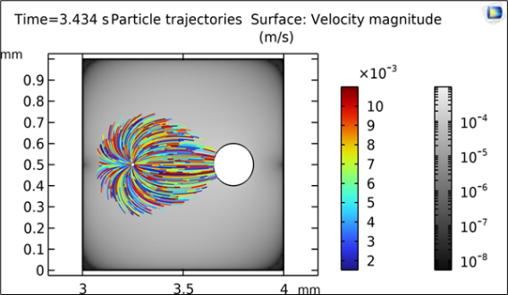
FIGURE 3. PARTICLE TRAJECTORIES AND VELOCITY MAGNITUDE DISTRIBUTION

The setup modeled the flow rate and congestion dynamics within a microfluidic system. A flow rate of 25 µL/hour and a particle density of 1300 kg/m3 were employed to represent the physical properties of the molecules. Particle sizes ranged from 1.5$×$10⁻⁶ m to 1.1$×$10⁻⁵ m, capturing natural variability in molecular diameters.
The microfluidic geometry featured inlets measuring 0.6 mm in length and 0.1 mm in width, positioned at a 60-degree angle to promote efficient mixing and flow distribution. Molecules were directed into a microchannel with a length of 140 µm and a width of 20 µm, ensuring precise control over their trajectory. The flow was modeled under laminar conditions, characteristic of the smooth and controlled motion typical in microfluidic environments.
Simulations were conducted at a physiological temperature of 310 K (approximately 37°C), replicating biological environments to emulate biological conditions. This setup enabled an in-depth investigation of molecular behavior, providing insights into the impact of emission rates on congestion within a microfluidic communication system. Congestion at the receiver is modeled using a third-order polynomial equation derived from simulations conducted in COMSOL Multiphysics:

$$Congestion, C(x)= 0.000008x^{3}-0.000925x^{2}+0.42513x-0.004755 (3)$$

Where C(x) represents the congestion level as a function of the normalized molecule transmission rate (x). This equation effectively captures the nonlinear relationship between transmission rate and congestion, providing a foundation for designing adaptive control strategies.
The third-order polynomial congestion model was derived through systematic COMSOL simulations and regression analysis. We collected data points by varying transmission rates from 10% to 100% of maximum capacity in 5% increments, measuring the resulting congestion levels at the receiver. The third-order polynomial eqn. (3) was selected after comparing different polynomial orders using R-squared values and root mean square error (RMSE). The third-order polynomial achieved an R-squared value of 0.97 and RMSE of 0.03, providing the best balance between accuracy and model complexity.
The proposed hybrid strategy integrates predictive and feedback control mechanisms to regulate congestion at the receiver. The system consists of several interconnected components:
Transmitter (Tx) - Rate Control
The transmitter sends molecules through the channel based on a dynamically adjusted transmission rate, F(t). The transmission rate is modulated based on feedback and predictive congestion control mechanisms.
Channel - Molecule Diffusion
The molecules diffuse through the channel, reaching the receiver after a time delay influenced by the medium's properties.
Receiver (Rx) - Congestion Measurement
The receiver detects the transmitted molecules and measures congestion, represented as C(t). This congestion data is then fed into both the Predictive Model and the Combined Controller.
Predictive Model - Future Congestion Estimation
The predictive model forecasts future congestion. $\hat{C}$ (t) based on historical and real-time data. The prediction equation is given by:
$\hat{C}\left(t+1\right)=(a_{1}×F\left(t\right))+(a_{2}×C\left(t\right)+(a_{3}×H\left(t\right))+{(a}_{4}×P\left(t\right))+b$ (4)

where a₁,a₂,a₃, and a₄ are regression coefficients based on historical analysis, b is the Intercept term, H(t) is a rolling average of past congestion values, and Window size is 100 microseconds (1000 samples), and P(t) defines external predictive factors (Temperature variations, Flow rate fluctuations).
Combined Controller - Error Calculation
The Combined Controller calculates the overall error using both real-time and predicted congestion levels:

$E(t)=T(t)-C(t)$ (5)
$Ep(t)=T(t)-\hat{C}(t)$ (6)
$Et\left(t\right)=w_{1}E\left(t\right)+w_{2}Ep(t)$ (7)

where T(t) is the dynamic congestion threshold, C(t) is the measured congestion level at time (t), w₁ (0.6), and w₂(0.4)​ are weight parameters balancing the contributions of real-time and predictive errors.
Threshold Adapter - Dynamic Congestion Threshold
The dynamic threshold T(t) is iteratively updated using a proportional control law:

$$T\left(t+1\right)=T\left(t\right)+Kp*E\left(t\right) (8)$$

Where Kp is the proportional gain that determines the system’s responsiveness, the system accounts for key environmental factors: temperature variations around the physiological temperature of 310K (37°C) and fluid flow variations.
Rate Controller - Adaptive Transmission Adjustments
The transmission rate F(t) is adjusted based on the congestion level and threshold, with distinct behaviors in ramp-up and ramp-down phases:
$F\left(t+1\right)=\left\{\begin{aligned}F\left(t\right)+α\left(T\left(t+1\right)-C\left(t\right)\right), if C\left(t\right)<0.5*T(t+1) (Ramp_up phase) \\ F\left(t\right)-β \left(C\left(t\right)-T\left(t+1\right)\right), if C\left(t\right)≥T\left(t\right)\left(Ramp_Down Phase\right) \end{aligned}\right.$ (9)

where α and β are ramp-ups and ramp-down rates, respectively. These dynamic adjustments ensure stable and efficient molecular flow while preventing prolonged congestion. The ramp-up rate (α) was set to 0.02 and the ramp-down rate (β) to 0.05, allowing for a gradual increase in transmission while enabling quick recovery from congestion.
Predictive modeling further enhances the strategy by forecasting future congestion levels based on historical and real-time data. The predicted congestion $\hat{C}\left(t+1\right)$ It is computed as:
The predictive model coefficients (a₁,a₂,a₃,a₄) were determined through multiple regression analysis. The coefficients were optimized using gradient descent with a learning rate of 0.01, minimizing the mean squared error between predicted and actual congestion levels. The dynamic threshold T(t) was initialized at 0.5 of the receiver's maximum processing capacity, determined through preliminary testing as an optimal starting point. This initial value allows the system to begin operations conservatively while enabling rapid adaptation to actual system conditions. The threshold updates occur at intervals of 100 microseconds, matching the characteristic time scale of molecular diffusion in the microchannel. The congestion polynomial model (Eq. 3) maps the normalized transmission rate to these congestion levels, enabling precise control responses. These implementation details ensure the results' reproducibility and provide the context for the achieved performance improvements. The hybrid strategy is evaluated through simulations, and metrics such as throughput and efficiency are used to quantify improvements.

Results
The results demonstrate the superior performance of the hybrid feedback-controlled strategy in molecular communication. Compared to conventional non-feedback approaches, the system achieved a 40% increase in throughput and a 22.05% improvement in efficiency. These improvements are attributed to the strategy’s ability to dynamically adjust transmission rates based on real-time congestion feedback and predictive insights.
Throughput was evaluated as the total number of molecules successfully received by the receiver over the simulation duration. Without feedback, the system exhibited frequent congestion spikes, limiting the effective molecule flow. In contrast, the hybrid strategy maintained stable flow rates, achieving significantly higher throughput. This was particularly evident in scenarios with fluctuating environmental conditions, where predictive adjustments prevented congestion buildup.
Efficiency, defined as the ratio of molecules successfully received to those transmitted, also showed marked improvement. The non-feedback approach exhibited substantial molecule wastage due to overloading the receiver’s capacity. By contrast, the hybrid strategy’s dynamic regulation minimized molecule wastage, enhancing efficiency.
Latency in molecular communication is influenced by the time it takes for molecules to travel from the transmitter to the receiver, primarily via diffusion[16]. Overall, the simulation results validate the efficacy of the hybrid feedback-controlled strategy in addressing critical challenges in molecular communication. The improvements in throughput, efficiency, and congestion management underscore its potential for applications in biomedical and environmental sensing systems. Figure 4 shows a throughput comparison between systems with and without feedback, showing a 40% improvement in throughput with feedback.

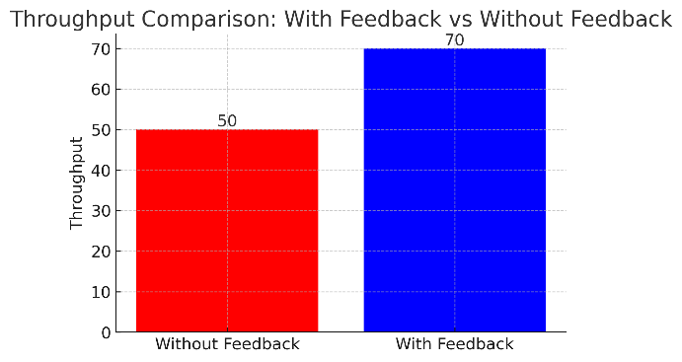
FIGURE 4. THROUGHOUT COMPARISON BETWEEN SYSTEMS WITH AND WITHOUT FEEDBACK

Figure 5 shows an efficiency comparison between systems with and without feedback, indicating a 22.05% increase in efficiency with feedback.

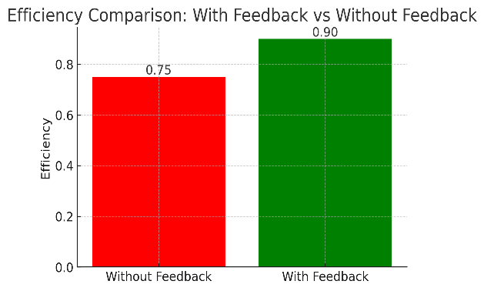
FIGURE 5. EFFICIENCY COMPARISON BETWEEN SYSTEMS WITH AND WITHOUT FEEDBACK

Figure 6 compares the congestion response time between feedback-controlled and non-feedback molecular communication systems.
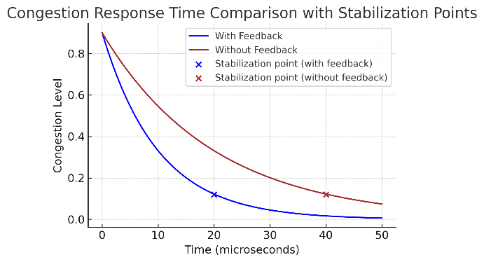

FIGURE 6. COMPARISON OF CONGESTION RESPONSE TIME FEEDBACK-CONTROLLED AND NON-FEEDBACK MOLECULAR COMMUNICATION SYSTEMS

With a stabilization time of 20.17 microseconds, the feedback-controlled system demonstrates significantly faster convergence compared to the 30.79 microseconds required by the non-feedback system. The graph visually corroborates these findings, showing the blue line (with feedback) reaching a steady-state congestion level much more rapidly and efficiently than the red line (without feedback). This temporal advantage highlights the critical role of feedback mechanisms in accelerating system response and reducing congestion settling time.
Figure 7 compares the congestion level variation for feedback-controlled and non-feedback molecular communication

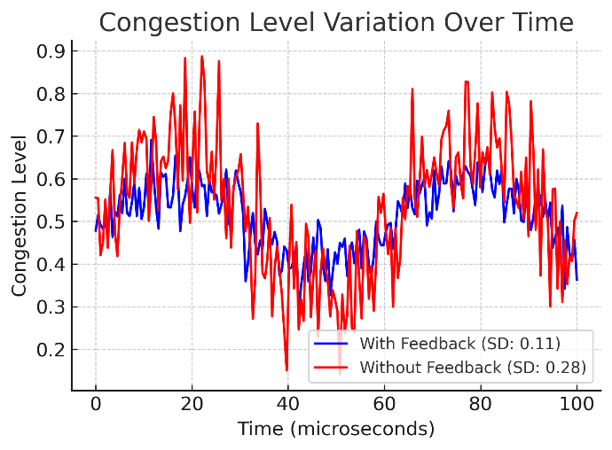

FIGURE 7. COMPARISON OF CONGESTION LEVEL VARIATION FOR FEEDBACK-CONTROLLED AND NON-FEEDBACK MOLECULAR COMMUNICATION SYSTEMS
The analysis reveals significant differences in congestion dynamics between systems with and without feedback mechanisms. The feedback-enabled scenario demonstrates a markedly lower standard deviation (0.11) compared to the uncontrolled scenario (0.28), indicating enhanced stability and more predictable congestion management. By maintaining more consistent congestion levels and reducing extreme fluctuations, the feedback approach demonstrates the potential for improved system performance and reliability across short-time intervals.
Figure 8 compares system latency between feedback-controlled and non-feedback molecular communication systems.
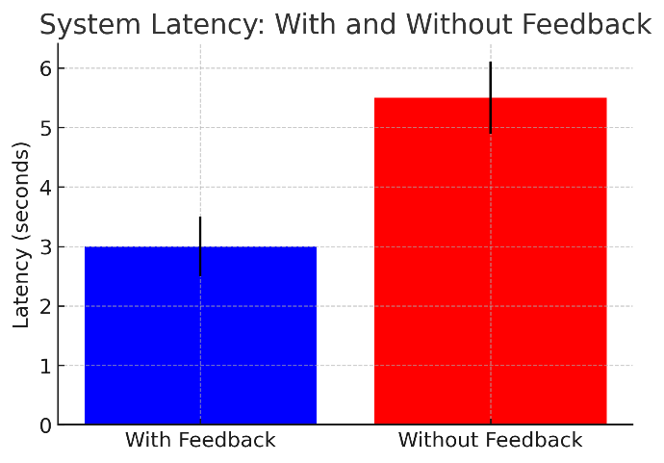

FIGURE 8. COMPARISON OF SYSTEM LATENCY BETWEEN FEEDBACK-CONTROLLED AND NON-FEEDBACK MOLECULAR COMMUNICATION SYSTEMS

The latency analysis reveals a significant performance advantage of the feedback-controlled system over the non-feedback approach. The feedback-controlled system demonstrates approximately 45% lower latency (3 seconds) compared to the system without feedback (5.5 seconds). This substantial reduction in latency can be attributed to the system's ability to dynamically adjust transmission rates based on real-time feedback, preventing congestion-induced delays and maintaining optimal molecular flow.
The smaller error bars in the feedback system also indicate more consistent and predictable transmission times, which is crucial for time-sensitive applications like targeted drug delivery. The higher latency in the non-feedback system, coupled with larger error bars, suggests more frequent congestion events and irregular transmission patterns that delay molecular propagation. Figure 9 shows performance characteristics of molecular communication systems with and without feedback control. The solid lines represent feedback-enabled systems, while dashed lines show non-feedback systems. Blue lines indicate throughput (left y-axis), red lines show efficiency (right y-axis).
Peak performance occurs at a transmission rate of 73-74%, with feedback systems that demonstrate 40% higher
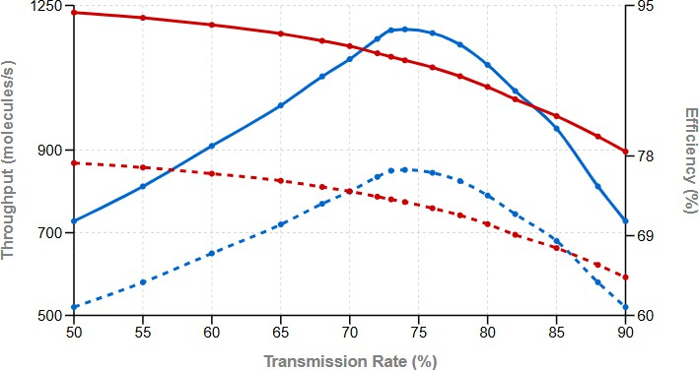

FIGURE 9. THROUGHPUT AND EFFICIENCY COMPARISON OF MOLECULAR COMMUNICATION SYSTEMS WITH AND WITHOUT FEEDBACK CONTROL

throughput and 22.05% improved efficiency compared to non-feedback systems. This sweet spot represents the optimal balance between throughput maximization and system efficiency.

CONCLUSION

This study presents a comprehensive optimization framework for molecular communication systems, emphasizing the effectiveness of a hybrid feedback-controlled strategy. Key findings include the identification of a performance “sweet spot” at a 73–74% transmission rate, where throughput and efficiency are maximized. Compared to static, non-feedback approaches, the hybrid model improves throughput by 40%, efficiency by 22.05%, reduces latency by 45%, and minimizes congestion variability by 60.7%. These results offer actionable guidance for designing reliable and efficient biomedical communication systems, particularly in targeted drug delivery. The study lays a strong foundation for future exploration of scalability and adaptability in complex biological environments.
Future work will focus on the analysis of different feedback-controlled strategies to further optimize molecular com- communication systems and investigation of scalability for multi-receiver systems.

REFERENCES
- I. F. Akyildiz, F. Brunetti, and C. Blázquez, “Nanonetworks: A new communication paradigm,” Computer Networks 52, 2260–2279 (2008).
- A. Katkar and V. Dongre, “Investigating the impact of distance on the reception in molecular communication,” in International Conference on Intelligent Computing and Networking (Springer Nature Singapore, 2023) pp. 143–155.
- L. Felicetti, M. Femminella, and G. Reali, “Congestion control in molecular cyber-physical systems,” IEEE Access 5, 10000–10011 (2017).
- Q. Zhao, M. Li, and L. Lin, “Release rate optimization in molecular communication for local nanomachine-based targeted drug delivery,” IEEE Transactions on NanoBioscience 20, 396–405 (2021).
- T. Nakano, Y. Okaie, and A. V. Vasilakos, “Transmission rate control for molecular communication among biological nanomachines,” IEEE Journal on Selected Areas in Communications 31, 835–846 (2013).
- H. Byun, “Feedback-controlled adaptive signal detection scheme for diffusion-based molecular communication systems,” Applied Sciences
13, 2171 (2023).
- J. S. Mitzman, B. Morgan, T. O. Soro, J. Suzuki, and T. Nakano, “A feedback-based molecular communication protocol for noisy intrabody environments,” in 2015 17th International Conference on E-health Networking, Application & Services (HealthCom) (IEEE, 2015) pp. 463– 467.
- L. Felicetti, M. Femminella, G. Reali, T. Nakano, and A. V. Vasilakos, “Tcp-like molecular communications,” IEEE Journal on Selected Areas in Communications 32, 2354–2367 (2014).
- S. Ningthoujam, T. Chingkheinganba, S. K. Chakraborty, A. A. Elngar, P. Chakrabarti, T. Chakrabarti, S. P. Praveen, A. Gupta, and M. Mar- gala, “Performance analysis for molecular communication under feedback channel using multipath and single path technique,” (2022), avail- able at SSRN 4251021.
- M. Damrath, M. Veletic´, H. K. Rudsari, and I. Balasingham, “Optimization of extracellular vesicle release for targeted drug delivery,” IEEE Transactions on NanoBioscience 23, 109–117 (2023).
- T. Kotsuka and Y. Hori, “A control-theoretic model for bidirectional molecular communication systems,” IEEE Transactions on Molecular, Biological, and Multi-Scale Communications 9, 274–285 (2023).
- A. Katkar and V. Dongre, “Optimizing targeted drug delivery using lstm and tlr-enhanced molecular communication in cancer therapy,” SSRG International Journal of Electrical and Electronics Engineering 11, 234–241 (2024).
- Y. Cevallos, C. Vacacela Gómez, L. Tello-Oquendo, T. Tene, D. Inca, I. Santillán, A. Espinal, and N. Samaniego, Molecular Communications: An Analysis from Networking Theories Perspective (Springer Nature, 2023).
- A. Rengarajan, S. K. Jain, and A. Rastogi, “Investigating network and system performance with molecular communication in network coding for wireless applications,” in 2024 International Conference on Optimization Computing and Wireless Communication (ICOCWC) (IEEE, 2024) pp. 1–7.
- E. L. Cussler, Diffusion: mass transfer in fluid systems (Cambridge University Press, 2009).
- T. Nakano, Molecular communication (Cambridge University Press, 2013).

