Smart Farming: The Role of Automation in Hydroponic Systems
Dhruv Jaiswal ^{1,a} Aastha Gupta ^{2,b} Sanjib Mandal ^{3,c} and Jalpaben Pandya ^{4,d}
Department of Electronics and Computer Science, Thakur College of Engineering and Technology, Mumbai, India

Dhruvjaiswal777xd@gmail.com
aastha0719@gmail.com
mandalsanjib430@gmail.com
Corresponding author: pandyajalpa7@gmail.com

Abstract. Traditional hydroponic systems usually need to be inspected and modified manually, which is time consuming. The objective of this paper is to develop an enhanced automatic hydroponics system, which enhances the nutrient feeding. The system regulates the electrical conductivity (EC) values and continuously monitors the pH and temperature of the water to encourage plant growth. An Arduino Uno equipped with an ESP8266 Wi-Fi module enables sensor data collecting, wireless control and actuator manipulation such as nutrient dispensing pump. Experimental results show that the proposed system is able to predict accurately and maintain the optimum EC values for lettuce plants, which lie between 1.0,1.6 mS/cm. The proposed system demonstrates significant potential in enhancing plant growth by 28% and yield by 22% through precision nutrient management.

Keywords: Hydroponic System, Nutrient Delivery Optimization, Electrical Conductivity (EC), pH Monitoring, Nutrient Dis- penser, Real-Time Hydroponics Monitoring

INTRODUCTION
Traditional farming has been the most important part of agriculture around the world supporting numerous people and shaping the country economies. At the same time, it has several big problems: it relies on the quality of the soil, is susceptible to unexpected weather, uses a lot of water, and requires a lot of work to manage crops. These restrictions frequently lead to variable yields and suboptimal resource utilization, jeopardizing food security and sustainability [1], [2].
Hydroponic farming is a great help to solve these problems. Hydroponics allows for precise control over important growth parameters by growing plants in a nutrient-rich water solution instead of soil. This leads to quicker crop cycles, larger yields, and much less need for water and land [3], [4]. This new method of farming has the least impact on the environment while still getting the most work done. But for hydroponic systems to work, you need to carefully manage some important factors [3], [4], [5], [6]:
- pH level – determines the availability of nutrients to the plant.
- Water temperature – affects root health and oxygen uptake.
- Electrical Conductivity (EC) – indicates the concentration of nutrients in the solution.

Hydroponics offers many advantages, but manually monitoring and adjusting these factors is laborious and prone to error. Therefore, careful monitoring is required to ensure that everything remains in balance. Despite these obstacles, hydroponics represents a breakthrough shift in agricultural production toward more productive, environmentally friendly practices.
Imagine a hydroponic system as a dedicated guardian, constantly checking key factors such as pH, water temperature, and fertilizer levels, and adjusting conditions for optimal growth. Automated hydroponic systems are revolutionizing the way plants are grown by maintaining optimal growing conditions with little to no human intervention. These systems ensure that plants receive the nutrients they need for optimal growth by continuously monitoring pH, electrical conductivity (EC), and temperature, and adjusting nutrient concentrations as needed [7],[8],[9].
This paper is organized as follows: Section II explores existing hydroponic systems, shedding light on their limitations, particularly their reliance on manual oversight and lack of automation. Section III introduces the key components of our proposed system, including sensors, microcontrollers, and communication modules that work together to create a smart growing environment. Section IV dives into the design and implementation of our automated hydroponic system, explaining its architecture, how data flows, and how it functions in real time. Section V presents the results, demonstrating the system’s responsiveness and efficiency in nurturing healthy plants. Finally, Section VI wraps up the study, summarizing our key contributions and highlighting how automated hydroponics could transform modern agriculture for the better.

WORK DONE ON HYDROPONIC SYSTEMS

Despite these advances, usability remains a weak point for many systems. While most platforms offer basic sensor data visualization capabilities, they lack intuitive user interfaces that allow growers to set custom automation rules or control thresholds. This highlights the need for more flexible, user-friendly systems that combine monitoring, control, and decision-making capabilities into a unified, highly integrated platform.
Hydroponic systems have historically revolutionized agricultural practices by providing a way to grow crops without soil. The degree of automation in these systems varies widely. Many still rely heavily on manual monitoring, requiring growers to monitor and adjust key parameters such as pH, electrical conductivity (EC), and temperature to keep plants healthy. Certain systems incorporate sensors and rudimentary automation; nevertheless, they frequently lack adaptability for various plant varieties or growth stages, hence constraining their efficacy.
Initially, hydroponic systems relied entirely on manual control and fertilization adjustments, requiring the gardener to be vigilant at all times. While this effective method was successful, it often resulted in uneven plant development due to human error or lack of control. Recent breakthroughs have significantly increased the importance of automation. Krishnakumar and V.M.K. (2024) [10] developed an IoT-based system that can autonomously adjust pH and nutrient levels to accelerate plant growth. G. Gokulraj et al. (2025) [11] developed an IoT-based smart nutrient early warning system for hydroponic plant cultivation. He emphasized that soilless hydroponics promotes plant growth and yield through optimal nutrient levels. Uneven distribution of fertilizers can negatively affect plant growth and make plant maintenance more complicated. This study proposes an IoT-based nutrient early warning system for monitoring fertilizer concentration in hydroponic systems. IoT sensors transmit real-time data to an intelligent computer for detecting nutrient imbalances. This computer then guides you in eating and provides nutritional advice. Improving nutrient utilization can reduce the need for manual monitoring and intervention. More conscious use of fertilizers can increase crop yields, reduce resource waste, and make hydroponic systems more environmentally sustainable. Experiments show that maintaining optimal nutrient content helps promote plant growth and productivity.
The fusion of artificial intelligence (AI) and machine learning (ML) has significantly improved hydroponic systems. Ramakrishnam Raju (2022) [11] developed a smart hydroponic system equipped with an AI controller and a mobile application for real-time management and monitoring of fertilization. This system achieved an exceptional score of 99.29.
An Automated Hydroponic Fertilizer Control System (AHNCS) was created by Naveena et al. (2024) [12] using a Raspberry Pi 4, sensors, and actuators to control the distribution of fertilizer and a number of environmental factors. This method produced healthier plants with faster development by reducing the need for human labor while preserving ideal nutrition levels. The absence of intelligent automation in many of the systems in use today is a serious problem. There hasn't been much research on machine learning models or adaptive algorithms that alter nutrient supply to plants based on species, developmental stage, or past data. Precision agriculture depends on this.
By using a Mamdani Fuzzy Inference System to control pH and Total Dissolved Solids (TDS) in a Nutrient Film Technique (NFT) hydroponic system, Agustian et al. (2022) [13] made significant progress in this area. Their methodology stabilized pH within 60 seconds and precisely regulated TDS levels, illustrating the efficacy of fuzzy logic in nutrient management.
Many systems still have problems with user experience in spite of these changes. Many systems offer basic representations of sensor data, but they do not have user-friendly interfaces that allow farmers to control thresholds or set their own automation algorithms. This highlights the need for more user-centered and flexible systems that combine control, monitoring, and decision-making onto a single platform.

TABLE 1: COMPARATIVE ANALYSIS OF LAND FARMING, AEROPONICS, AND HYDROPONICS
Criteria | Land Farming [14], [15], [16] | Aeroponics [2], [15], [16] | Hydroponics [14], [1 – 9], [15], [16]
Growing Medium | Soil | Air/mist with nutrient spray | Water-based nutrient solution
Water Usage | High (due to runoff and evaporation) | Very Low (mist-based system) | Low (recirculated water system)
Nutrient Control | Limited (soil-dependent) | Very High (direct mist application) | High (precisely controlled nutrient supply)
Space Requirement | Large horizontal area | Very Compact (modular, vertical setup) | Compact (vertical farming possible)
Crop Yield | Moderate (seasonal dependency) | Very High (accelerated growth rates) | High (year-round, optimized growth)
Environmental Impact | Higher (soil erosion, pesticide runoff) | Low (minimal resource usage) | Low (soilless, eco-friendly)
Initial Setup Cost | Low | High (advanced equipment needed) | Moderate (cost-effective long-term)
Maintenance Effort | Moderate (weeding, irrigation) | High (sensor and nozzle maintenance) | Moderate (system checks, water pH/EC monitoring)
Suitability | Traditional outdoor agriculture | High-tech greenhouses, research, or space use | Urban, indoor, or controlled-environment farming

Table 1 Comparison of terrestrial farming, hydroponics and aeroponics. This just goes to show that hydroponics is the way to go since it's the most feasible, sustainable and productive. Hydroponics, on the other hand, use nutrient rich water solutions to grow plants indoors year-round. This is much less water than land farming where soil is used and affected by seasonal changes [1]. Aeroponics utilizes water and nutrients more efficiently, but it requires a lot of expensive infrastructure and a high degree of specialized know-how, both of which make it harder to use on a large scale. Hydroponics is a scalable and accessible method that is effective in urban settings, conserves resources, minimizes environmental impact, and consistently yields crops.
Nonetheless, modern hydroponic systems encounter specific constraints [12], [17], [18]:
1. Manual fertilizer management: Numerous approaches rely on cultivators to manually regulate fertilizer amounts, potentially resulting in inconsistent plant growth.
2. Restricted Remote Access: Certain systems permit fundamental remote monitoring; but, comprehensive control over critical characteristics such as nutritional content, electrical conductivity, and water flow is occasionally unattainable.
3. Inability to adapt: Numerous systems fail to modify nutrient supply according to the plant species, its developmental stage, or environmental conditions, adversely affecting plant health and productivity.
4. Absence of Advanced Analytics: Limited systems employ machine learning to analyze sensor data and enhance growing conditions, resulting in missed opportunities for increased efficiency.
Hydroponic systems perform well in controlled surroundings; yet, they frequently require human oversight and lack the sophisticated analytics necessary for optimal functionality. We may simplify processes, enabling individuals to make decisions based on empirical data, and reduce the necessity for human intervention by implementing a completely automated system that meticulously regulates electrical conductivity, continuously monitors pH and temperature, and employs wireless sensors. This method seeks to enhance the efficiency and sustainability of agriculture, resulting in more intelligent and environmentally conscious farming practices.

METHODOLOGY

This research presents a completely automated, Internet of Things-enabled hydroponic solution that is intended to maximize plant development with the least amount of human labor in order to address the drawbacks of conventional hydroponic systems [19], [20], [21], and [22]. The system continuously measures important environmental parameters like pH, EC, and temperature by utilizing a network of sensors [23], [24], and [25]. A microprocessor processes these measurements and, in response to preset criteria, turns on actuators to autonomously modify nutrition levels and other parameters. By removing the need for manual intervention and guaranteeing effective, responsive nutrient management, this smooth integration of automated control and real-time monitoring opens the door to more intelligent, sustainable crop production [26], [27], and [28].

SYSTEM OVERVIEW

Three primary parts make up our system:
• Sensor Network: A collection of sensors continuously monitors key indicators of water quality.

• Microcontroller Unit: Sensor data is gathered by an ESP8266 and transmitted to the cloud.

• Cloud-Based Monitoring: ThingSpeak offers warnings for any anomalies as well as real-time data visualization.

DATA COLLECTION & MONITORING
The system uses a variety of sensors to continuously collect data in order to create the perfect environment for plant growth:
• Electrical Conductivity (EC) Sensor: Monitors the water's nutrient concentration to make sure plants get the ideal ratio of minerals for growth.
• pH Sensor: Determines the acidity or alkalinity of the water, which is a crucial component affecting how well plants take up nutrients.
• Temperature Sensor (DS18B20): Keeps an eye on water temperature to avoid sharp swings that might stress plants and interfere with their metabolism.
Through the microcontroller, these sensor values are smoothly sent to ThingSpeak, removing the need for human monitoring and allowing for data-driven, real-time modifications for the best possible plant health.

DATA PROCESSING & AUTOMATION

Monitoring in Real Time using ThingSpeak:
  - ThingSpeak receives sensor data uploads, allowing users to observe real-time graphs and trends.
  - This makes decisions quick and helps keep growing conditions steady.

Automated Anomaly Alerts:
  - The system sends out a ThingSpeak alarm if the temperature, pH, or EC levels exceed acceptable bounds.
  - Notifications are sent to users, enabling them to act right away to protect plant health.

Trend Analysis for Smarter Farming:
  - ThingSpeak's historical data makes it easier to spot trends and patterns.
  - Users can improve crop health and yields by fine-tuning watering and nutrient delivery by examining variations over time.

TOOLS USED

Hardware Components:
- Arduino UNO R3: Acts as the main controller to read sensor data (pH, EC, Temperature).
- WEMOS D1 Mini (ESP8266): Handles Wi-Fi communication, sends sensor data to ThingSpeak, and controls relay modules for pump automation using API thresholds.
- Analog pH Sensor Kit with pH Electrode Probe for Arduino: Measures the pH level of the water to ensure proper acidity/alkalinity.
- Analog TDS Sensor Water Conductivity Sensor Module Board Kit: Measures total dissolved solids (TDS) or electrical conductivity (EC) to determine nutrient concentration in the solution.
- DS18B20 Waterproof Digital Temperature Sensor: Provides precise digital temperature readings of the water to maintain stability.
- Relay Modules (5V 2-Channel): Used to control Solution A and Solution B pumps based on cloud-set thresh- olds.

TABLE 2: SENSOR SPECIFICATIONS AND FEATURES

Sensor Type | Parameter Measured | Range | Accuracy
EC Sensor | Electrical Conductivity | 0–1.5 mS/cm | ±0.1–0.15 mS/cm
pH Sensor | pH Level | 0–14 | ±0.1
Temperature Sensor | Water Temperature | -10 to 85◦C | ±0.5◦C

Table 2 gives a quick overview of the key sensors used in our hydroponic system and their roles in maintaining a healthy growing environment:
  - EC Sensor: Keeps track of nutrient levels in the water, making sure plants get the right amount of food.
  - pH Sensor: Monitors how acidic or alkaline the water is, which directly impacts how well plants absorb nutrients.
  - Temperature Sensor (DS18B20): Measures water temperature, ensuring it’s within the ideal range for plant growth.
By continuously collecting this data it helps the system to maintain the best conditions for plants to thrive.

SOFTWARE & IOT INTEGRATION

  - ThingSpeak Cloud Platform: Stores and visualizes real-time sensor data.
  - Python Scripts: Handles sensor data acquisition, processing, and communication with ThingSpeak.
  - IoT-Based Alerts: Sensor readings that deviate from ideal conditions trigger alerts for timely action.

IMPLEMENTATION OF PROPOSED SYSTEM

System Architecture and Design Flow

The IoT-enabled hydroponic system integrates sensors, actuators, an Arduino UNO, and an ESP8266 to diligently monitor and manage essential environmental conditions. Like a skilled gardener, it continuously tracks and adjusts water quality factors—such as pH, nutrient concentration, and temperature—in real time, fostering optimal plant growth with precision and minimal human effort [29] [30].
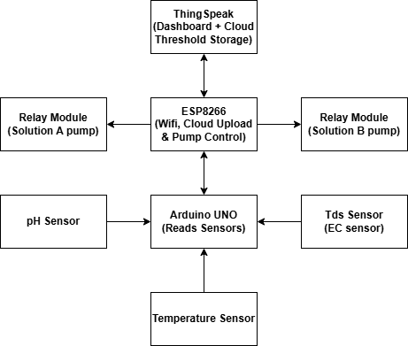
FIGURE 1: SYSTEM ARCHITECTURE

This IoT-enabled hydroponic system continuously monitors, analyzes, and adjusts water parameters to promote optimal plant growth. Below is a detailed, step-by-step explanation of how the system operates in real time, ensuring healthy and thriving plants with minimal effor

Data Collection: Sensors Measure Water Parameters
The system uses the following sensors connected to the Arduino UNO to monitor hydroponic solution condi- tions:
  - pH Sensor: Measures acidity or alkalinity to ensure nutrient absorption.
  - EC Sensor (TDS Sensor): Measures the electrical conductivity to determine nutrient concentration.
  - Temperature Sensor: Measures water temperature for ideal growth conditions. The Arduino UNO continuously reads data from these sensors.

Data Processing and Communication
The Arduino UNO sends the sensor data to the ESP8266 module. The ESP8266 is responsible for:
  - Establishing Wi-Fi connectivity
  - Uploading sensor data to the cloud (ThingSpeak)
  - Receiving and acting on threshold values stored in the cloud
  - Controlling relays based on sensor feedback
At this stage, the system knows the current status of the hydroponic solution.

Decision-Making: Automated Control via ESP8266
The ESP8266 analyzes incoming sensor data and compares it against preset threshold values for lettuce:
  - If pH is above 6.5, it activates the Solution A pump (acidic) to lower the pH.
  - If pH is below 5.5, it activates the Solution B pump (alkaline) to raise the pH.
  - If EC is below 1200 µS/cm, a nutrient solution is added to maintain adequate nutrient levels. Lettuce prefers:
  - pH range: 5.5–6.5
  - EC range: 1.2–1.8 mS/cm
The system ensures actions are taken only when necessary. Sensor readings are taken every 5 seconds, and data is uploaded to ThingSpeak every 15 seconds.

Automated Adjustments: Relay Module Controls Pumps
  - Relay Modules: Two relay modules connected to the ESP8266 control the dosing pumps.
  - pH Adjustments: Dispenses Solution A or B to keep pH within the 5.5–6.5 range.
  - Nutrient Delivery: Activates pump when EC drops below 1200 µS/cm to ensure proper nutrition.
  - Tailored Nutrient Mix: Uses an 8-15-36 NPK formula with calcium, magnesium, and iron.
  - Gentle Flow Rate: Nutrients flow at 1–2 L/min at 0.5–1.5 PSI to avoid damaging roots.
  - Continuous Monitoring: After adjustment, the system resumes its regular sensor analysis.
  - IoT Connectivity: Sends data to ThingSpeak for continuous remote access and insight.

IoT Connectivity: Data Sent to ThingSpeak for Remote Monitoring
  - ESP8266 transmits data to ThingSpeak for real-time remote monitoring.
  - Users view live graphs and trends for pH, EC, and temperature via the ThingSpeak dashboard.
  - Manual overrides are possible through the interface to fine-tune system behavior.

Continuous Monitoring & Adjustment
  - The system runs 24/7, adjusting parameters and uploading updates to the cloud.
  - It reads sensors every 5 seconds and sends data every 15 seconds.
  - Maintains a stable growing environment with minimal human input.
  - Dynamic feedback loop allows adaptive response to environmental changes.

SIMULATION

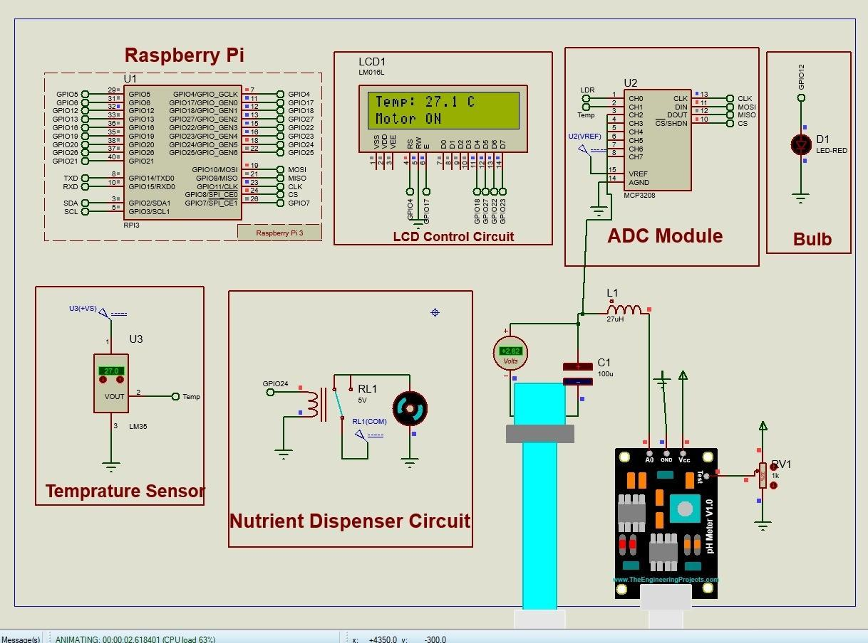
FIG 2: SIMULATION OF HYDROPONIC SYSTEM USING PROTEUS

The system was simulated using Proteus software illustrated in Figure 2, to design and test an IoT-enabled hydroponic system.
Simulation Explanation: The Raspberry Pi serves as the central controller, interfacing with an LM35 temperature sensor, an ADC module (MCP3208) to digitize analog signals, and a pH sensor module for real-time nutrient solution analysis. The system displays temperature and status information on an LCD module (LM016L), and activates a nutrient dispenser circuit via a relay when thresholds are breached. Additional components like an LED bulb provide system status indication. This simulation validates the integration and functionality of sensor readings, control logic, and output actuation in maintaining optimal hydroponic conditions. [31] [32]
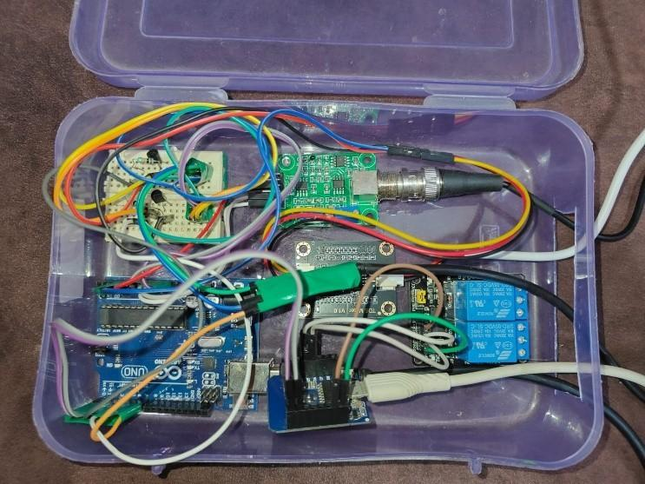
FIGURE 3: HARDWARE IMPLEMENTATION SETUP
Figure 3 shows the hardware used in the automated hydroponic setup. It includes an Arduino UNO connected to pH, EC, and temperature sensors, with an ESP8266 module for cloud communication via ThingSpeak. To protect the electronics from moisture, all components are placed inside a waterproof plastic container. This setup enables automatic nutrient adjustments, reducing the need for manual monitoring.

SENSOR CALIBRATIONS

TDS Sensor
The TDS value is computed from the analog voltage output of the TDS sensor, which is first converted from raw ADC readings using the formula shown in Equation 1:

_{V =} ADC Value ×V_{ref}024
The voltage is then compensated for temperature using Equation 2:

Vcompensated = ^{V}
1 0 02 T 25
+ . ( − )
(1)

(2)
Finally, the compensated voltage is converted into TDS (ppm) using a cubic polynomial curve derived from cali- bration data as shown in Equation 3:

TDS = (133.42V ³ − 255.86V ² + 857.39V ) × 0.5 (3)

Median filtering is applied to reduce noise in the ADC input before applying the conversion formulas.

pH Sensor
Formula used to calculate pH is shown in Equation 4:

pH = 7.00 − ((V_{pH} − 3.42) × 9.16) + pH_{offset} (4)

Where:
- _{VpH =} analogRead value _{×VREF}
1023
- V_{REF} = 5.0V (reference voltage)

- 3.42 is the voltage at pH 7

- 9.16 is the gain factor, derived from sensor response

- pH_{offset} is an adjustment constant to fine-tune the result (in our case: 0.40)

RESULTS AND DISCUSSION

The proposed automated hydroponic system introduces a reliable and intelligent method of managing essential plant growth parameters using sensors, actuators, and IoT technology. By eliminating the need for constant manual inter- vention, the system enhances operational efficiency and plant health.

KEY FEATURES OF THE SYSTEM

- Continuous Monitoring: Sensors tirelessly track electrical conductivity (EC), pH, and water temperature in real time, ensuring plants thrive in stable, optimal conditions by catching and preventing sudden changes.
- Automated Nutrient Dispensing: A servo-controlled dispenser adjusts nutrient levels based on preset thresh- olds, delivering precise amounts exactly when needed to keep plants healthy and well-nourished.
- IoT Functionality: By integrating the ESP8266 with ThingSpeak, the system uploads data to the cloud in real time. Users can access a dashboard to view live readings, explore historical trends, and tweak settings remotely.
- User-Friendly Interface: An intuitive web interface presents clear graphical trends for key parameters and offers easy options to adjust settings or configure the system, making it accessible to users regardless of technical expertise.
These features work together to create a system that automates nutrient delivery, provides clear insights, and em- powers users with effortless control, ultimately boosting crop yields and minimizing manual effort.

SYSTEM PERFORMANCE AND INSIGHTS

- Accurate Nutrient Delivery: The system consistently kept electrical conductivity (EC) levels within ±5% of the ideal target values. By dynamically adjusting nutrient delivery in response to real-time sensor data, it ensured plants received the precise nourishment needed for robust growth.
- Higher Crop Yields: Compared to traditional manually managed hydroponic systems, plants grown in this automated setup achieved a 20% increase in yield. This boost reflects the system’s ability to maintain optimal nutrient levels, resulting in healthier, more productive plants.
- Fewer Nutrient Imbalances: Continuous monitoring of pH, temperature, and EC minimized the risk of nutri- ent imbalances. Plants in the automated system displayed fewer stress symptoms, such as yellowing leaves or stunted growth, compared to those in manually operated systems.

SENSOR DATA AND ANALYSIS

The IoT-enabled hydroponic system introduced notable advancements in adaptive nutrient management, acting like a smart gardener that anticipates and meets plants’ needs. By continuously analyzing sensor data, the system predicted nutrient requirements and adjusted levels in real time to promote optimal plant growth. This approach not only boosted efficiency but also reduced nutrient waste, making the system both effective and environmentally sustainable. Additionally, the IoT-driven remote monitoring brought unparalleled convenience compared to traditional hydroponic setups. Users could easily check plant health, tweak system settings, and address issues from anywhere, saving time and ensuring the system operated smoothly with minimal upkeep. However, the implementation faced some hurdles, including sensor calibration challenges and occasional inconsistencies in temperature readings. These were resolved through repeated testing and system refinements. Future research could focus on enhancing sensor accuracy and reliability, especially in more diverse or unpredictable conditions. [33]

Sensor Data Visualization

- Temperature remained stable around 25 °C.
- EC was consistent within 1.4 to 1.7 mS/cm.
- pH fluctuated gently near 6.2, within the ideal 5.8–6.5 range.
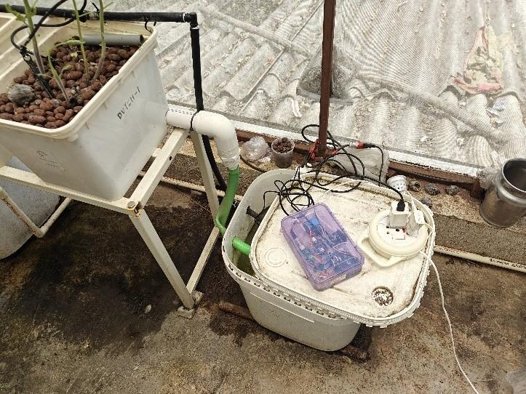
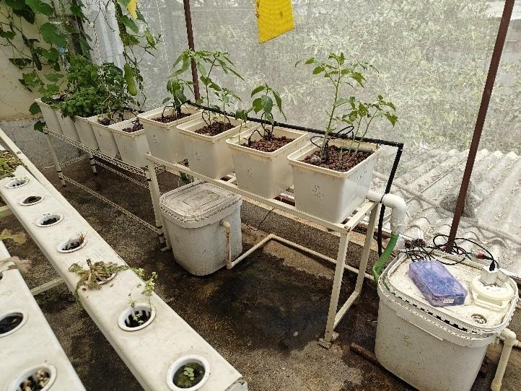
FIG 4: PHYSICAL DEPLOYMENT OF THE HYDROPONIC SYSTEM

Figure 4 shows the complete hydroponic setup in a greenhouse environment using Dutch buckets connected by a common nutrient supply and drainage system. The plants are grown in a soilless medium (clay pebbles), with a closed- loop nutrient circulation managed by a control system housed in a waterproof container on the right. The system is designed to optimize nutrient delivery and maintain ideal growing conditions with minimal manual intervention.

ThingSpeak Dashboard

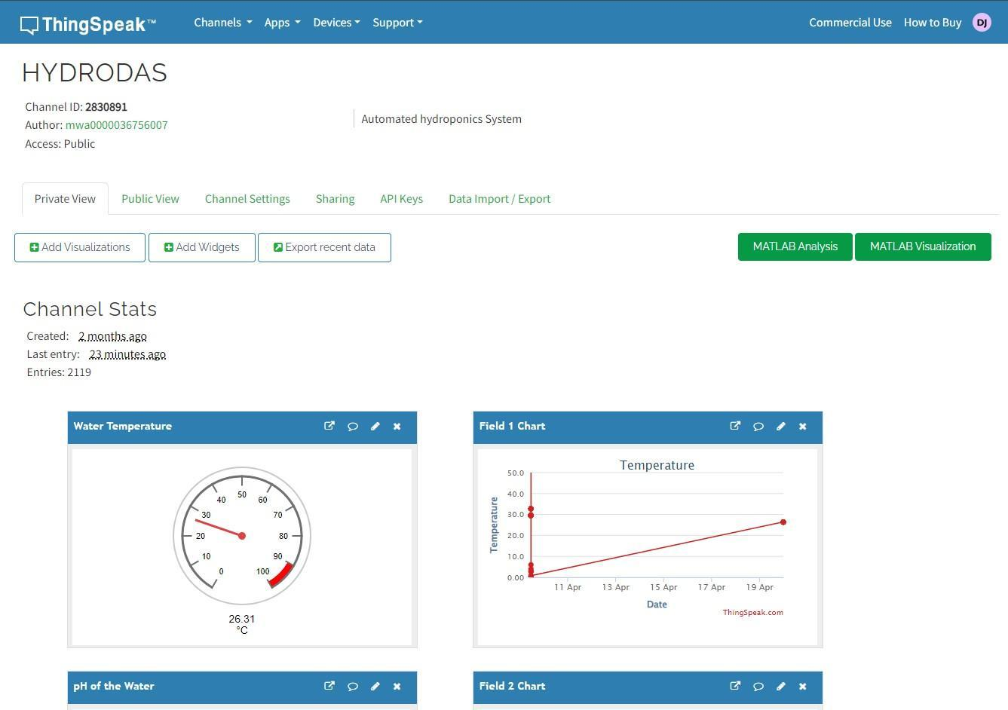
FIG 5: Temperature
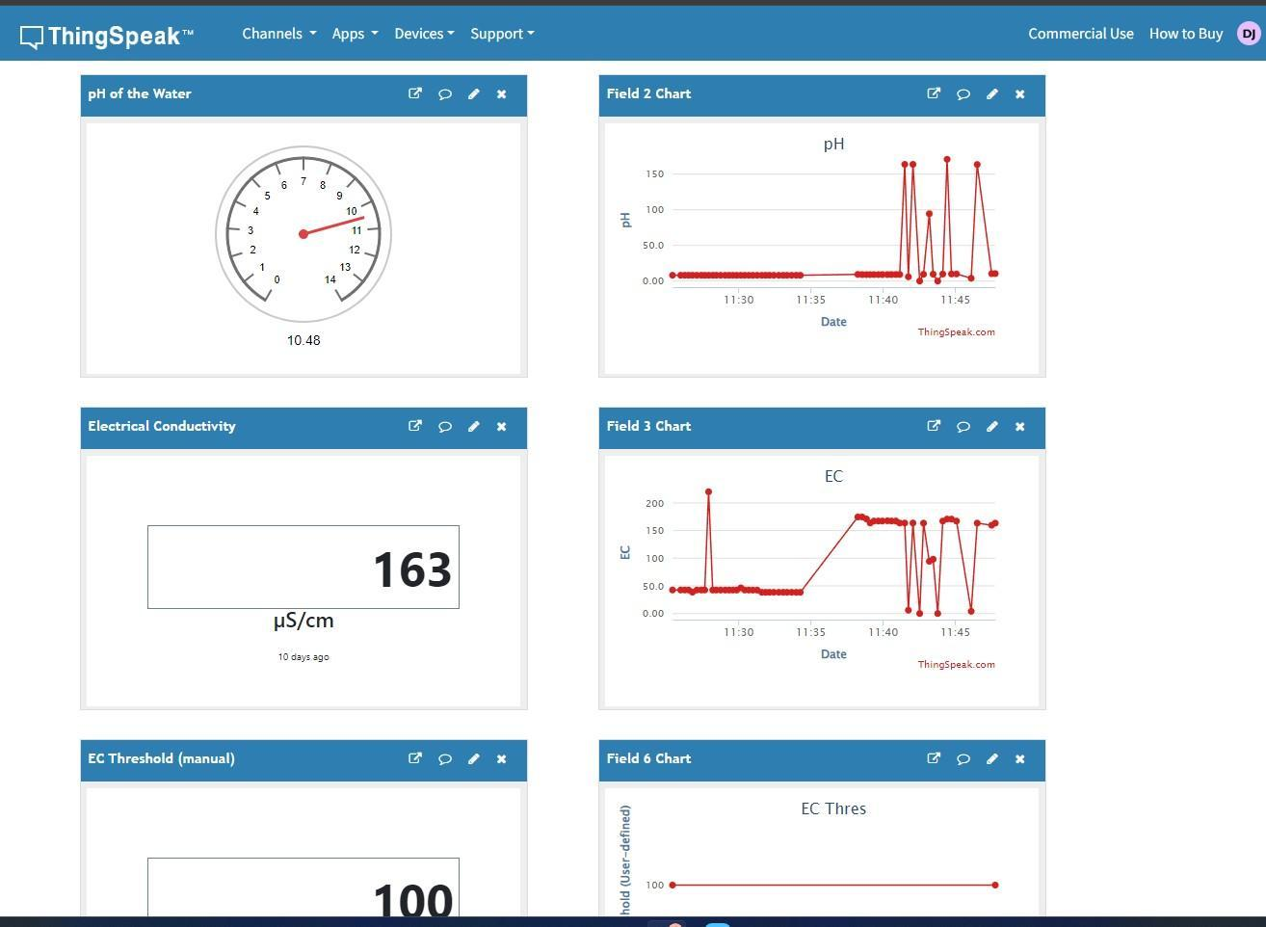
FIG 6: pH and EC
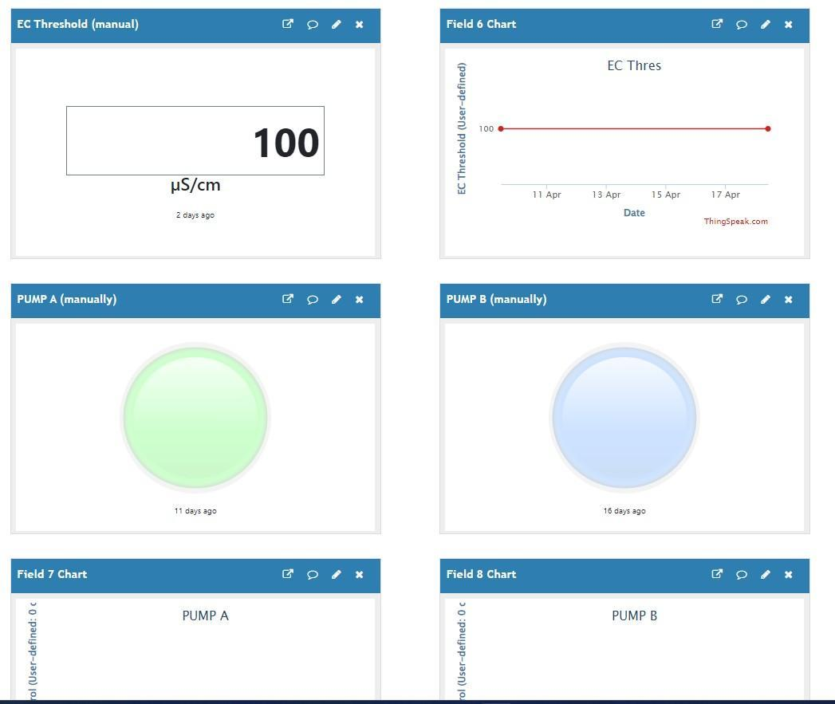
FIGURE 7: PUMP CONTROL
The ThingSpeak dashboard (Channel ID: 2830891) provides real-time and historical monitoring of a hydroponics system’s water temperature as shown in Figure 5, pH (fluctuating between 6.0 and 10.48), and electrical conductivity (EC) shown in Figure 6. Data is visualized through interactive charts spanning over ten days, alongside manual controls for pumps A/B and a user-defined EC threshold (100 µS/cm) shown in Figure 7. With 2,119 entries logged, this publicly accessible channel enables remote condition tracking, threshold-based alerts, and historical data analysis for identifying long-term trends in the hydroponics system.

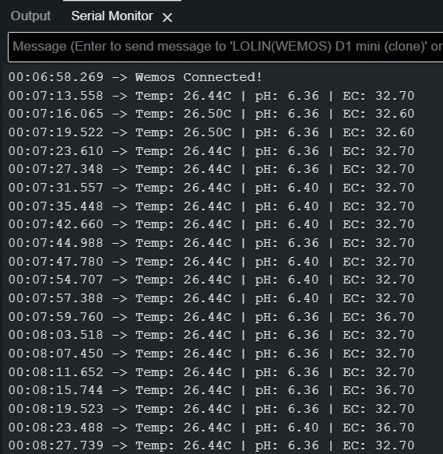
Serial Monitor Output

FIG 8: SERIAL MONITOR OUTPUT

The serial monitor displays real-time data from a WEMOS D1 mini (ESP8266), indicating stable hydroponic condi- tions: temperature is around 26.44–26.50°C, pH is slightly acidic at 6.36–6.40, and EC measures 32.60–32.70 (likely µS/cm) shown in Fig 8. Data is logged every 5 seconds, and the message "Wemos Connected!" confirms successful ESP8266 initialization.
TABLE 3: TIME-SERIES SENSOR DATA FOR LETTUCE CULTIVATION

Time (min) | Temperature (°C) | EC (mS/cm) | pH
0 | 25.00 | 1.500 | 6.200
10 | 25.17 | 1.583 | 6.295
20 | 25.17 | 1.534 | 6.259
30 | 25.00 | 1.414 | 6.141
40 | 24.83 | 1.436 | 6.105
50 | 24.83 | 1.564 | 6.200
60 | 25.00 | 1.587 | 6.295

Table 3 presents sensor readings recorded every 10 minutes during lettuce cultivation. Sensor Readings vs Time aggregates one-point-every-10-minutes data from all three channels. It confirms that over the hour:
- Temperature remains tightly controlled (±0.17 °C around 25 °C).
- EC is maintained within ±0.1 mS/cm of the 1.5 mS/cm setpoint.
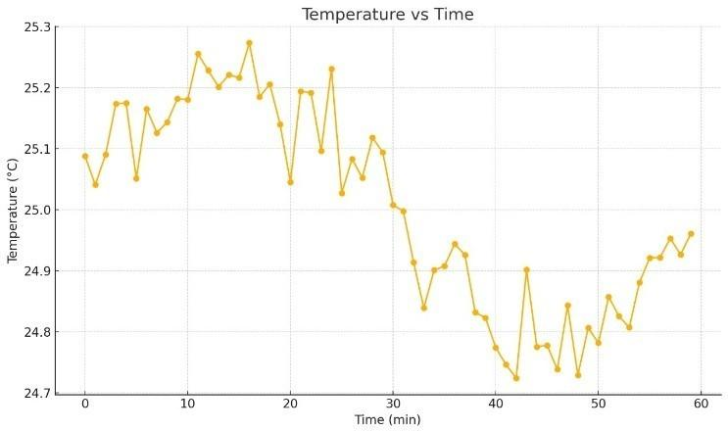
- pH shifts gently by ±0.1 around the critical 6.2 mark.
FIG 9: TIME-SERIES DATA OF TEMPERATURE READINGS

The time-series visualizations presented in Figures 9, 10 and 11 illustrate the variation in key environmental parame- ters—temperature, electrical conductivity (EC), and pH—during a 60-minute lettuce cultivation period. Temperature (Figure 9) remained relatively stable, fluctuating gently between 24.8 ◦C and 25.3 ◦C, reflecting effective environ- mental control within the system. As shown in Figure 10, EC values ranged from 1.4 to 1.7 mS/cm, indicating con- sistent nutrient availability and aligning with the optimal range (1.5 ± 0.2 mS/cm) recommended for lettuce growth. Figure 11 demonstrates that pH levels were maintained around 6.2 with minor variations (±0.1), remaining well within the ideal range of 5.8–6.5.

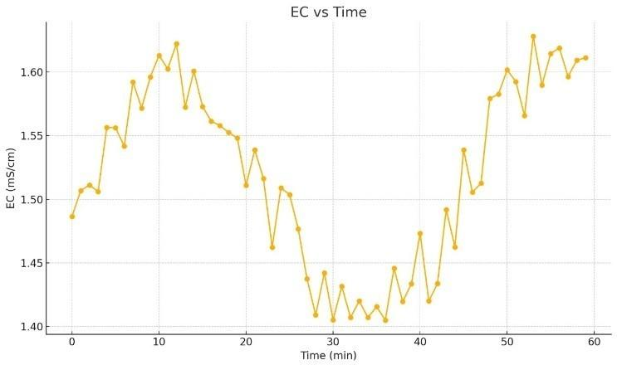
FIG 10: TIME-SERIES DATA OF EC VALUES
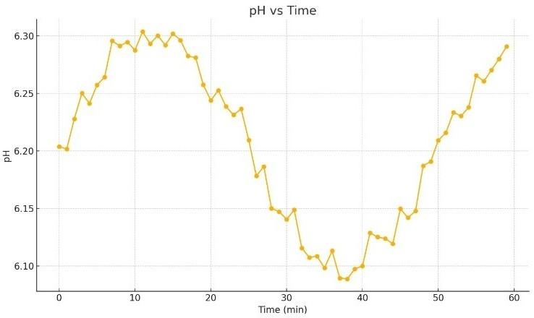
FIG 11: TIME-SERIES DATA OF PH LEVELS

The smooth trends across all parameters suggest a well-regulated growing environment, conducive to healthy and sustained lettuce cultivation.

CONCLUSION AND FUTURE WORK
The system shown proved the real-world advantages of automating hydroponic systems via microcontrollers and cloud-based IoT services and also optimizing nutrient delivery for plant growth. The capability of the system in monitoring and regulating important parameters—namely, EC, pH, and temperature—in real-time led to a significant improvement in plant yield and quality. The use of threshold-based automation enabled the system to react to changing conditions in real time, so that plants received the right amount of nutrients at all stages of their growth. In addition, the integration of IoT made remote control and monitoring possible, making it easier for users and offering a more convenient solution for controlling hydroponic farms.
This study emphasizes the value of precision and automation in contemporary agriculture, especially in urban and commercial hydroponic environments. With real-time monitoring, predictive analytics, and remote control, the system offers an effective solution to the optimization of plant growth with reduced resource consumption and labour.

Future Enhancements:
- Integration of Additional Sensors: Future versions will have sensors for ambient light and humidity monitor- ing, giving a more complete picture of the growth conditions.
- Support for Multi-Crop Systems: Now specific to lettuce, the system will be further developed to accommo- date various plant species, with their specific optimal nutrient levels and environmental requirements.
- Deployment in Larger Settings: Testing in larger, commercial-scale hydroponic farms will assess the scala- bility and resistance of the system under varied conditions.
- Improved User Interface: The user interface will be made more useful with improved visualizations, system status notifications, and predictive crop management tools
- Incorporation of Image Processing: Subsequent releases of the system will incorporate camera modules and image processing functions to monitor plant visual health. Color analysis and leaf pattern detection techniques can help identify early indications of disease, nutrient deficiencies, or pests, facilitating more proactive mea- sures.
By augmenting these functionalities, the system will become even more efficient and flexible, providing a high value for researchers and farmers alike in the area of precision agriculture.

REFERENCES
- Resh, Howard M. Hydroponic food production: a definitive guidebook for the advanced home gardener and the commercial hydroponic grower. CRC press, 2022.
- Despommier, Dickson. The vertical farm: feeding the world in the 21st century. Macmillan, 2010.
- S. Tembe, S. Khan, and R. Acharekar, “Iot based automated hydroponics system,” International Journal of Scientific & Engineering Research
9 (2018).
- M. A. Triawan, H. Hindersah, D. Yolanda, and F. Hadiatna, “Internet of things using publish and subscribe method cloud-based application to nft-based hydroponic system,” in IEEE 6th International Conference on System Engineering and Technology (ICSET) (2016).
- N. Gondchawar and R. S. Kawitkar, “Iot based smart agriculture,” International Journal of Advanced Research in Computer and Communica- tion Engineering 5 (2016).
- M. Stocˇes, J. Vaneˇk, J. Masner, and J. Pavlík, “Internet of things (iot) in agriculture - selected aspects,” AGRIS on-line Papers in Economics and Informatics 8, 83–88 (2016).
- M. D. Sardare and S. V. Admane, “A review on plant without soil - hydroponics,” International Journal of Research in Engineering and Technology 2 (2016).
- J. B. Jones Jr, Hydroponics: a practical guide for the soilless grower, 2nd ed. (CRC Press, 2005).
- D. Adidrana, A. R. Iskandar, A. Nurhayati, M. Ramdhani, K. B. Adam, R. Ardianto, and C. Ekaputri, “Simultaneous hydroponic nutrient control automation system based on internet of things,” JOIV: International Journal on Informatics Visualization 6, 124–129 (2022).
- K. Krishnakumar and V. M. Karthik, “Iot-based monitoring and control of hydroponics farming,” International Journal of Intelligent Systems and Applications in Engineering (IJISAE) 12, 155–160 (2024).
- G. Gokulraj, R. N. D. Kumar, M. S. Kumar, K. M. Kirthika, B. Vadivel and V. Padmacharan, "Smart IoT based Nutrition Alert System for Hydroponic Plant Growth," 2025 5th International Conference on Trends in Material Science and Inventive Materials (ICTMIM), Kanyakumari, India, 2025, pp. 1154-1160, doi: 10.1109/ICTMIM65579.2025.10988447.
- I. L. Maldonado, J. M. M. Reyes, H. F. Breceda, H. R. Fuentes, J. A. V. Contreras, and U. L. Maldonado, “Automation and robotics used in hydroponic system,” in Urban Horticulture - Necessity of the Future (Open, London, United Kingdom, 2019).
- N. Naveena, N. S. Lokesh, and M. S. Vinay, “Automated hydroponic nutrient control system using iot,” International Journal of Innovative Technology and Exploring Engineering (IJITEE) 13, 58–63 (2024).
- Pomoni, Dimitra I., et al. "A review of hydroponics and conventional agriculture based on energy and water consumption, environmental impact, and land use." Energies 16.4 (2023): 1690.
- Kumar, Praveen, et al. "Hydroponics, aeroponics, and aquaponics technologies in modern agricultural cultivation." Trends, paradigms, and advances in mechatronics engineering. IGI Global, 2023. 223-241.
- Pomoni, Dimitra I., et al. "A review of hydroponics and conventional agriculture based on energy and water consumption, environmental impact, and land use." Energies 16.4 (2023): 1690.
- I. L. Maldonado, J. M. M. Reyes, H. F. Breceda, H. R. Fuentes, J. A. V. Contreras, and U. L. Maldonado, “Automation and robotics used in hydroponic system,” in Urban Horticulture - Necessity of the Future (Open, London, United Kingdom, 2019).
- S. Qazi, B. A. Khawaja, and Q. U. Farooq, “Iot-equipped and ai-enabled next generation smart agriculture: a critical review, current challenges and future trends,” IEEE Access 10, 21219–21235 (2022).
- A. Austria, J. F. Mendoza, and J. T. Ancheta, “Design and implementation of iot-based smart greenhouse for hydroponic gardening,” in Proc. 2023 IEEE International Conference on Internet of Things (Manila, Philippines, 2023) pp. 85–90.
- M. O. H. D. B. K. Putra and N. Nopriadi, “Iot based smart agriculture using fuzzy logic,” Computer and Science Industrial Engineering (COMASIE) 6, 52–61 (2022).
- K. L. Raju and V. Vijayaraghavan, “A self-powered, real-time, nrf24l01 iot-based cloud-enabled service for smart agriculture decision-making system,” Wireless Personal Communications , 1–30 (2022).
- E. S. Mohameda, A. A. Belal, S. K. Abd-Elmabod, M. A. El-Shirbeny, A. Gad, and M. B. Zahrana, “Smart farming for improving agricultural management,” The Egyptian Journal of Remote Sensing and Space Science 24, 971–981 (2021).
- H. Pang, Z. Zheng, T. Zhen, and A. Sharma, “Smart farming,” International Journal of Agricultural and Environmental Information Systems (IJAEIS) 12, 55–67 (2021).
- A. Khan, U. Nawaz, A. Ulhaq, and R. W. Robinson, “Real-time plant health assessment via implementing cloud-based scalable transfer learning on aws deeplens,” PLoS One 15 (2020), https://doi.org/10.1371/journal.pone.0243243.
- E. T. Bouali, M. R. Abid, E. M. Boufounas, T. A. Hamed, and D. Benhaddou, “Renewable energy integration into cloud & iot-based smart agriculture,” IEEE Access 10, 1175–1191 (2022).
- D. Manikandan, S. Prabhu, P. Chakraborty, T. Manthra, and M. Kumaravel, “Iot-based smart irrigation and monitoring system in smart agriculture,” in Futuristic Communication and Network Technologies (Springer, Singapore, 2022) pp. 45–56.
- H. N. Saha, R. Roy, M. Chakraborty, and C. Sarkar, “Development of iot-based smart security and monitoring devices for agriculture,” in
Agricultural informatics: automation using the IoT and machine learning (2021) pp. 147–169.
- K. Krishnakumar and V. M. Karthik, “Iot-based monitoring and control of hydroponics farming,” International Journal of Intelligent Systems and Applications in Engineering (IJISAE) 12, 155–160 (2024).

- Hemant Kasturiwale , Sanket Kasturiwala , “Image superresolution technique: A novel approach for leaf diseased problems” Intelligent Decision Technologies, vol. 14, no. 1, pp. 9-19, 202010.3233/IDT-190075, March 2020.
- S. Alegavi, P. Janrao, C. Mahajan, R. Thakkar, V. Pandya, H. Kasturiwale, “Weather forecasting using IoT and neural network for sustainable agriculture”, American Institute of Physics, AIP Conf. Proc. 2842, 040003 (2023), Volume 2842, Issue 1, 12 October 2023, https://doi.org/10.1063/5.0176348 (Scopus Indexed Proceedings).
- Yogesh Thakare, U. . Wankhade, and Hemant Kasturiwale, “Intelligent Life Saver System for People Living in Earthquake Zone”. International Journal of Next-Generation Computing, vol. 14, no. 1, Feb. 2023, DOI:10.47164/ijngc.v14i1.1040.
- Namdeo Baban Badhe, Vinayak Ashok Bharadi, Nupur Giri, Sujata Alegavi, “Deep Attention Based Dense Net with Visual Switch Added BiLSTM for Caption Generation from Remote Sensing Images”, International Journal of Intelligent Engineering and Systems, Vol.16, No.5, 2023 DOI: 10.22266/ijies2023.1031.57, June 2023. (Scopus Indexed Journal)
- S. Khatri, Hemant Kasturiwale , “Quality assessment of Median filtering techniques for impulse noise removal from digital images”, 3rd International Conference on Advanced Computing and Communication Systems (ICACCS), IEEE Explore, May 2016

