Advanced Student Management System: Leveraging AI for Advanced Students Dashboard

Hemant Kasturiwale¹, Rupinder Kaur^{2,}Harsha Sanap³,Varunkumar Mishra⁴

^{1,2,3,4}Thakur College of Engineering and Technology, Mumbai, India
1hemant.kasturiwale@tcetmumbai.in
²rupinder.kaur@tcetmumbai.in
³harsha.sanap@tcetmumbai.in
⁴varum.mishra@tcetmumbai.in

Abstract
This study presents an AI-powered Student and Teacher Management System designed to transform digital education by enabling individualized learning, easing administrative duties, and improving academic achievements. The major goal is to create an integrated platform that employs artificial intelligence to help students learn through adaptive tools while also supporting educators with intelligent matter and performance management. The methodology uses a modular, cloud-hosted architecture with React.js for the frontend, Node.js (Express.js) for the backend, and MongoDB for data management. Advanced AI techniques, including Natural Language Processing (NLP), Machine Learning (ML), and Optical Character Recognition (OCR), are used to power services like AI chatbots, document assistants, adaptive testing, and career assistance. The system is meant to be scalable, secure, and responsive, with extensive testing and deployment across multiple cloud platformsThe system's effectiveness is demonstrated by the findings, which reveal that the NLP chatbot achieved 94.7% accuracy and the document processing system reached 92.8% precision. With a 99.8% availability rate and an API response time of 167 ms, the platform could support up to 8,250 concurrent users.
Students experienced a 14.4% improvement in knowledge retention, a 24% decrease in learning time, and a significant increase in self-study (143.8%) and peer collaboration (152.4%). These findings illustrate the system's ability to improve both short-term academic achievement and long-term engagement.
Keywords—AI in education, adaptive learning, personalized education, AI test series, study document assistant, placement assistance, career guidance, e-learning platform, academic analytics, educational technology, machine learning in education, intelligent tutoring system

INTRODUCTION

In today's rapidly evolving educational landscape, institutions face significant challenges in managing academic and administrative operations efficiently. The growing complexity of student enrollment, course scheduling, faculty management, and performance tracking requires substantial manual effort and coordination, often leading to inefficiencies. A centralized, intelligent management system is essential for improving communication, streamlining procedures, and allocating resources as education system grows and diversify their offerings. By combining essential features—such as automatic grading, faculty task management, attendance tracking, and student registration—into a single, intuitive platform, our AI-powered Student and Teacher Management System tackles these issues. By combining these crucial functions, the system removes duplication, reduces administrative workloads, and frees up teachers to concentrate on providing high-quality instruction while making sure that educational institutions may grow successfully in a world that is becoming more and more digital.
Growing administrative workloads are a problem for educational institutions today, slowing down operations and causing inefficiency. Time that may be used for instruction is lost when student enrollment, class scheduling, and grade management are done by hand. Manual procedures frequently result in mistakes, lost documents, and a breakdown in staff-teacher-student communication. By consolidating all academic functions onto a single digital platform, a contemporary management solution can revolutionize these difficulties. These systems replace traditional methods with efficient digital procedures for consolidated student records, automated grade computations, and attendance tracking.
Eliminating paperwork allows teachers to spend more time teaching, and administrators have access to current, correct information. The best platforms offer configurable features that expand with the school, accommodating varying school sizes. Schools can decrease errors, save time on daily duties, and enhance departmental collaboration by switching from paper files to integrated software. This change enables educators to continue running efficient, open operations behind the scenes while concentrating on their core goal of delivering high-quality education. The system's cloud-based architecture offers scalability, security, and global accessibility, making it the ideal choice for organizations seeking to update their management procedures. AI's Role in Education Due to huge class sizes and little time for teacher-student contact, kids rarely receive individualized attention in traditional classroom settings. [1]
Students may experience learning gaps as a result of being under-challenged or left behind. AI can solve these problems by providing each learner with a unique learning experience. With AI, students can get one-on-one tutoring, rapid academic support, and learning materials that are tailored to their learning preferences and speed. It takes a lot of time and effort for teachers to balance the requirements of various students and keep up with curricular changes. By automating administrative tasks like grading and evaluation and providing real-time data on student performance, artificial intelligence (AI) has the potential to significantly reduce teachers' workloads and enable them to modify their pedagogical strategies. [2]
With AI-powered tools and features that support students in different learning areas, the system's Student Dashboard was created with the goal of offering a personalized learning experience. Among these tools are:
- Chat with AI: The AI assistant can be directly interacted with by the students for immediate guidance on academic problems, enabling help beyond class timing.
- Study Document Assistant: Students can use this to upload their documents and receive comments on their study materials or answers or insights produced by AI.
- AI Tutor: The platform's virtual tutor serves as a personal instructor, splitting complex subjects into smaller sections according to the needs of each student. It identifies areas in which students struggle and helps them understand topics by providing practice questions, clear examples, and real-world links.
- AI-based Test Series: Students can take tests that are tailored to their learning speed and provide immediate feedback and monitor their performance.
5. Placement Support: AI technologies help students prepare their resumes, find jobs based on their interests and talents, and get career advice.
In addition to traditional semester studies, the platform offers thorough exam preparation for competitive examinations such as GATE and CAT, providing students with a balanced academic foundation. Teachers can update lessons, monitor student progress, and offer tailored guidance from their personal dashboard, which gives them complete control over the instructional content. In addition to enjoying real-time engagement with teachers, this guarantees that students always have access to up-to-date, relevant knowledge. The adaptive learning technology in the system generates personalized study schedules that highlight each student's areas of difficulty while highlighting their strengths, increasing the effectiveness and interest of learning. Ongoing performance evaluations assist students in monitoring their progress and gaining self-assurance. By automating time-consuming administrative duties like record-keeping and grading, the platform gives teachers more time to devote to meaningful instruction. Teachers can adjust their approach by identifying students who exhibit remarkable potential or require further support according to detailed data. Through the integration of effective classroom management tools and individualized learning, the system creates a dynamic learning environment that supports the success of both teachers and students [3].
LITERATURE SURVEY
Recent years have seen tremendous advancements in educational technology, especially with the use of artificial intelligence. By providing individualized educational experiences and streamlining educational processes, these cutting-edge systems are revolutionizing how teachers and students learn. Individualized lesson planning, digital tutoring assistance, and automated evaluation tools that adjust to each learner's pace are now all provided by contemporary AI applications in classrooms. These technological innovations are the subject of the present scholarly debate, which looks at how they are being incorporated into all-inclusive school administration systems. Adaptive learning programs that adapt to the needs of students, round-the-clock virtual teaching assistants, time-saving instant grading systems, engagement-boosting strategies, and enhanced teacher-student communication are some of the major innovations that are being given attention. All of these changes point to a move toward educational approaches that are more adaptable, effective, and focused on the needs of the students. [4]
A. AI in Personalized Learning
The ability of educational technology to customize learning for every student is its greatest strength. Based on the needs, abilities, and knowledge gaps of each individual learner, contemporary adaptive systems can alter their teaching methodology. According to research by Sharma and colleagues (2020), these platforms continuously monitor student progress and suggest study materials that are tailored to the speed and comprehension level of each individual learner. The system recognizes difficult ideas and automatically creates focused practice assignments by examining trends in student responses. By delivering the material in the most effective way for each learner, this customized method not only boosts student engagement but also makes studying more productive.
Chen and colleagues' research showed that adaptive learning technology had quantifiable advantages. Their 2021 study found that when compared to learners in conventional classroom environments, students who used tailored AI tutoring systems performed noticeably higher on tests. This strategy is demonstrated by platforms like Socrative and Knewton, which dynamically alter class content in response to real-time student performance data. In addition to enhancing academic results, this attentiveness to each student's unique learning needs keeps students motivated throughout the learning process.[5]
B. Virtual Tutoring and AI-powered Assistance
The capacity of AI-powered tutoring systems to offer individualized academic support outside of regular school hours has drawn a lot of attention from educational scholars. Research like Baker's (2019) shows how MATHia and Socratic are good tools for enhancing STEM understanding. These intelligent technologies spot specific areas of miscommunication assess how students approach problems, and provide real-time, personalized help. When learning difficult mathematical and scientific ideas, this immediate, personalized feedback is very helpful because it enables students to fix mistakes and improve their comprehension during practice sessions.
Advanced language processing is used by AI-powered virtual instructors to engage with students in a natural way, according to research by Woolf and colleagues (2020). Like a real teacher, these online tutors help with assignments, break down complex ideas, and offer detailed instructions. These systems now react in more complex, adaptive ways due to developments in conversational AI, such OpenAI's GPT technology, which makes learning feel more individualized and participatory. Free questions and explanations catered to each student's comprehension level make for a more interesting and productive learning environment. [6]
C. AI in Automated Assessment and Feedback
Automated evaluation methods that give students immediate feedback are becoming more and more common in modern education. Traditional evaluation techniques frequently have delayed outcomes, which reduces their usefulness as teaching tools. On the other hand, intelligent grading technologies evaluate student work in real time, emphasizing both strengths and areas for development.
Matsuda and Saito's (2020) study illustrated the advantages of automated assessment systems for both teachers and students. Their study shown that despite preserving uniform evaluation criteria, digital tools such as Grammarly and Turnitin shorten the time required for grading. In addition to saving time, these systems provide tailored recommendations that assist students in sharpening their abilities for upcoming tasks.
Another advancement in educational technology is the use of adaptive testing platforms. Koedinger's team (2017) conducted research on systems such as ALEKS that monitor user progress and modify question difficulty as necessary. These platforms design customized tests that give students the right amount of difficulty while letting them learn ideas at their own pace. By addressing each learner at their present ability level, these dynamic testing environments encourage deeper knowledge. [7]
D. Teacher-Student Interaction and Content Management
AI-powered solutions give teachers strong capabilities to improve instruction while also significantly improving student learning. These tools support teachers in managing course materials, monitoring real-time student progress, and using performance data to influence decisions. According to research by Liu and colleagues (2021), teachers can rapidly recognize students those fall short and modify their teaching strategies to ensure that no learner is left behind by using AI analytics.
Platforms such as Edmodo and Google Classroom help teachers even more by making it easier for students to collaborate, create content, and distribute assignments. According to Holmes' 2020 study, these tools provide educators complete control over their lesson plans, enabling them to adapt content to meet curricular requirements and student demands. This adaptability minimizes administrative workloads while guaranteeing that lessons stay interesting and in line with learning goals.
AI enables educators to concentrate more on what really matters—providing effective, student-centered instruction—by fusing real-time insights with flexible content management.
E. AI in Career Guidance and Placement Support
AI-driven career support systems are being used by educational institutions more and more to assist students in making the transition from school to the workforce. To provide individualized career recommendations, these intelligence platforms examine a number of factors, such as academic achievement, skill sets, and personal interests. By comparing student profiles with job market trends and industry requirements, research by Kumar and Garg shows how such algorithms might recommend feasible career options. This technology is used by platforms such as LinkedIn's Career Explorer and Handshake to match students with networking opportunities, internships, and entry-level jobs that match their skills.
AI systems actively prepare students for the workforce in addition to that connects them with jobs. Applications such as automated resume builders that optimize content for applicant tracking systems, AI-powered mock interview platforms that offer real-time feedback, and competency gap assessments that suggest skill development courses are highlighted in studies by Chowdhury and Ghosh. Institutions can greatly increase students' employability after graduation by incorporating these tools into their curricula and providing them with data-driven insights on in-demand careers. [8]
METHODOLOGY
The scalable, modular architecture of the Student and Teacher Management System allows for the smooth integration of administrative tasks with AI-powered learning resources. System design is the first step in the development process, which then moves on to AI integration, frontend and backend development, database setup, security implementation, thorough testing, and final deployment.
The system, which is based on a client-server architecture, uses API calls to enable seamless communication between the frontend and backend. Students and teachers will have a flawless experience due to the frontend's responsive and user-friendly interface, which was created with React.js. Core backend functions including data processing, user authentication, and API request handling are handled by Node.js (Express.js). [9]
MongoDB effectively arranges user profiles, course materials, chat logs, and evaluation records for data storage. The AI engine that powers the system's intelligence includes:

Natural Language Processing (NLP)

Machine Learning (ML)

Optical Character Recognition (OCR)
- Natural Language Processing (NLP) for chatbots and document analysis
- Machine Learning (ML) for adaptive learning and performance tracking
- Optical Character Recognition (OCR) for digitizing handwritten notes and automated grading
The platform operates on cloud infrastructure to provide scalability and dependability, allowing for real-time processing, high availability, and simple growth in response to user demand. Access controls and encryption are two examples of security techniques that protect sensitive data while upholding privacy rules.
This methodical but adaptable approach guarantees a strong, future-ready framework that improves student engagement and teaching effectiveness.
- AI Integration for Student Features
      - AI Chatbot for Student Support
Students can get instant academic help via the platform's AI-powered chatbot, which is intended to serve as a virtual tutor. The chatbot analyzes student inquiries and provides precise, context-aware answers using sophisticated natural language processing (NLP) techniques. It responds to topic-specific queries in a variety of fields, including literature and mathematics, and has been trained on large educational datasets. It provides immediate explanations, thorough concept analyses, and suggestions for pertinent resources. In contrast to static FAQ systems, this tool uses OpenAI's GPT technology to facilitate dynamic, human-like interaction that adjusts explanations to each user's level of comprehension. The chatbot functions as a study tool around-the-clock, minimizing reliance on human tutors while upholding rigorous academic standards, whether it is answering simple questions or helping students navigate difficult subjects. [10]
2. Study Document Assistant (OCR + AI)
The Study Document Assistant transforms the way students engage with educational resources by enabling uploads in a variety of file types, such as Word documents, PDFs, and even handwritten notes. This intelligent function effectively extracts text from documents using optical character recognition, then uses artificial intelligence (AI) analysis to find and arrange important information. In addition to concise explanations of difficult subjects, students receive automatically created summaries that condense complex content into easily understood points. The technology goes one step further by removing the need for lengthy manual searching by offering accurate responses to particular queries regarding the submitted content. The ability to quickly extract essential information from long textbooks or jumbled notes, whether for exam preparation or topic research, has revolutionized how students study and remember information [11].
Table 1:Technology Stack Table
Category | Tool / Technology Used | Purpose
Frontend Development | HTML, CSS, JavaScript | For building responsive user interfaces for student and teacher dashboards.
Frontend Development | React.js (optional/modern) | Enhances UI/UX with component-based design and faster rendering.
Backend Development | Node.js / Express.js | Handles server-side logic and API endpoints for login, chat, and dashboard.
Database | MongoDB / Firebase Firestore | Stores user data, content, schedules, and chat histories.
Authentication | Firebase Auth / JWT (JSON Web Token) | Manages secure login for students and teachers.
AI Models | OpenAI GPT / LLM APIs | Powers the AI Tutor, Chatbot, Doubt Solver, and Placement Agent.
Document Processing | PDF.js / Tika / LangChain | Reads and analyzes uploaded documents to answer or summarizing.
Scheduling Tool | Notion API | Integrates academic schedule tracking and reminders for students.
Testing System | Custom Node.js / Python Scripts | Generates and evaluates AI-powered test series for GATE/CAT.
Cloud Hosting | Vercel / Netlify / Heroku | Deploys the frontend and backend for live access.
Version Control | Git / GitHub | Tracks project versions and supports team collaboration.
Communication APIs | WebSocket/Firebase Realtime DB | Enables real-time chat between students, teachers, and AI bots.
Gamification Engine | Phaser.js / Unity (optional) | Supports AI-based educational games.

- AI-driven Personalized Learning (AI Tutor)
By adjusting to each student's distinct academic profile and monitoring their progress, speed, and preferred subjects, the AI tutor personalizes learning. It examines performance patterns and adjusts study schedules in accordance with them using machine learning techniques. The system might suggest interactive problem sets, focused video tutorials, or visual assistance to simplify difficult equations, for example, if a student has struggle with algebra. On the other hand, in order to keep students interested in subjects where they perform well, the curriculum moves on to increasingly difficult content. Additionally, the tutor recognizes when conventional explanations aren't effective and changes strategies, providing analogies, detailed instructions, or real-world examples, until the idea becomes clear. This dynamic strategy keeps advanced learners consistently motivated while ensuring that no student lags behind. [12]
- AI-based Test Series
Exam preparation is transformed by the platform's adaptive test series, which creates unique evaluations for every student. The algorithm chooses questions that fill in knowledge gaps and build on strengths by evaluating a student's prior performance, including accuracy, response times, and trouble areas. The auto-grading feature gives students thorough feedback as soon as they finish an exam, pointing out particular ideas that require more study and comparing their progress over time. The technology turns every test into a learning experience by providing explanations for why answers are right or wrong, going beyond simply score. From open-ended puzzles and practical coding challenges that test real-world application to multiple-choice questions that assess conceptual understanding, it offers a variety of assessment methods. These AI-curated examinations, as opposed to static ones, adapt to the student's developing abilities and strike the ideal balance between difficulty and reachability to optimize learning effectiveness.
- AI-based Placement Assistance
The career guidance system on the site turns employment preparation into a data-driven, individualized process. It recommends specialized career paths—whether corporate positions, research internships, or challenging government exams—by evaluating academic achievement, technical proficiency, and professional goals. With its AI resume builder that optimizes content for applicant tracking systems, mock interview simulations that offer real-time feedback on verbal and nonverbal cues, and direct integration with Indeed and LinkedIn to surface relevant openings, the system goes beyond general advice by providing useful tools. It highlights new professions and skill gaps to fill by comparing profiles with industry demands for students who aren't sure where they want to go. By bridging the gap between education and employment, this end-to-end support greatly enhances students' preparedness for the workforce [13].
- Teacher Dashboard Functionality
            - Content Management System (CMS)
Teachers can manage learning resources with a Content Management System (CMS) as a result to the Teacher Dashboard. Course resources, including lecture recordings, assignments, quizzes, and PDFs, can be posted, edited, and updated by teachers. Instructors can align text, add images, and logically arrange materials for easier student access using the system's content-friendly editor. This feature makes it possible for educational resources to be easily accessible and updated on a regular basis. [14]
2. Student Performance Monitoring
Teachers can use AI-generated insights in the performance monitoring module to monitor students' academic progress. Instructors receive up-to-date reports that display test performance trends, student grades, and participation percentages. In order for teachers to provide individualized interventions and further coaching, the AI identifies learners that require additional support.
- AI-driven Assessment & Grading
Both manual and AI-based automated test generation are options available to instructors. Teachers' workload is reduced by the platform's prompt grading and feedback features. AI-driven grading algorithms provide thorough feedback and assess students' subjective responses using pre-established rubrics. The AI increases testing efficiency by ensuring uniformity and fairness in evaluation.
- Doubt Resolution System
Teachers can answer students' questions in real time using the system's doubt-resolution tool. Through the Chat with Agent tool, students can ask questions, and teachers can answer via voice, video call, or chat. AI helps prioritize frequently asked and high-priority questions so that students receive quick answers.[15]
- Development & Implementation Phases
The project starts with requirement analysis, during which user needs are used to identify system features. To ensure that the final product can fulfill educational objectives, the development team collects data on chatbots, document processing, AI tutoring, and student performance tracking. Wireframes and UI/UX prototypes are created for the Teacher and Student Dashboards when the requirements are established. The AI models for chat support, test generation, and tutoring are selected, and the database structure is built. The backend, which handles all API interactions, authentication, and AI processing, is written in Node.js (Express.js). To achieve high answer accuracy and suggestions, the AI models are trained using NLP, ML, and OCR technologies. To create a smooth and engaging user experience, the frontend is written using React.js. Real-time data update is used to create interactive dashboards for both teachers and students [16].The AI-enabled management system's use case diagram is shown in Figure 1.

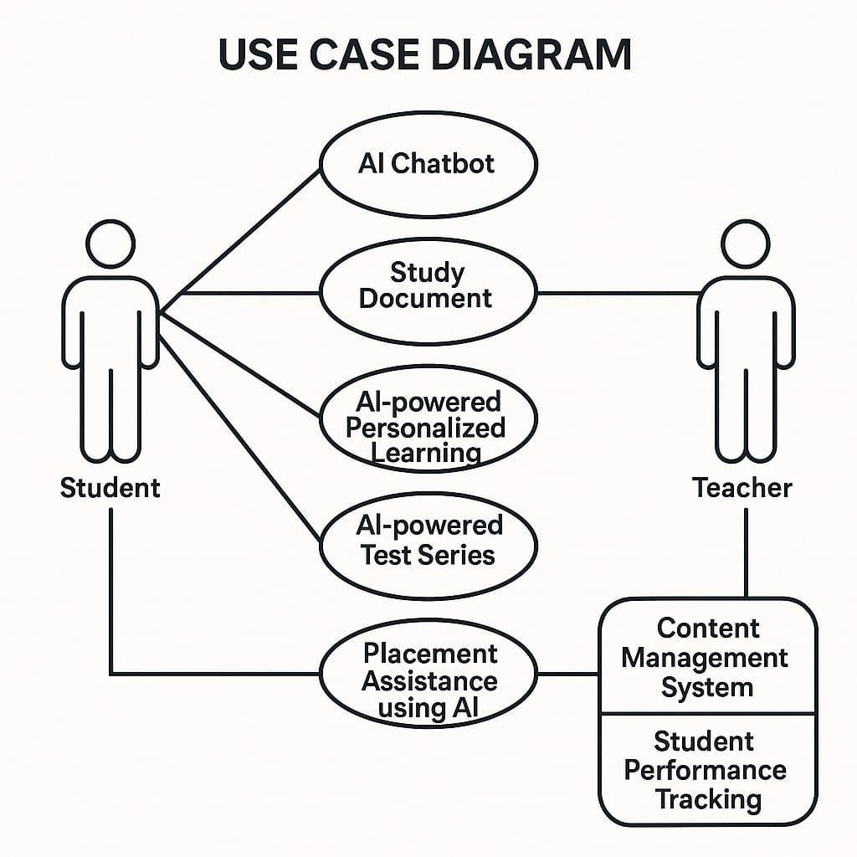
FIG 1: Use case Diagram
The system undergoes user acceptability, integration, and unit testing. AI models are adjusted to improve chatbot performance prediction and accuracy. For scalability and high availability, the system is hosted on Microsoft Azure, Google Cloud, or AWS. Continuous updates and fixes are implemented by CI/CD pipelines [17].

BLOCK DIAGRAM & FLOWCHART
The Eklavya block diagram is a hierarchical representation of the system structure and how the different features are logically categorized. At the most basic level, the platform begins with the central Eklavya interface that offers two types of access: Student Login and Teacher Login. This division results in the second level, where both Student Portal and Teacher Portal have separate dashboards and necessary tools like chat, classroom, and learning modules. The Student Portal holds features like Course Selection (JEE, NEET), Notes, E-learning, and Schedule (through Notion Integration). In contrast, the Teacher Portal holds Course Management, through which teachers can design and manage study material and sessions. [18]

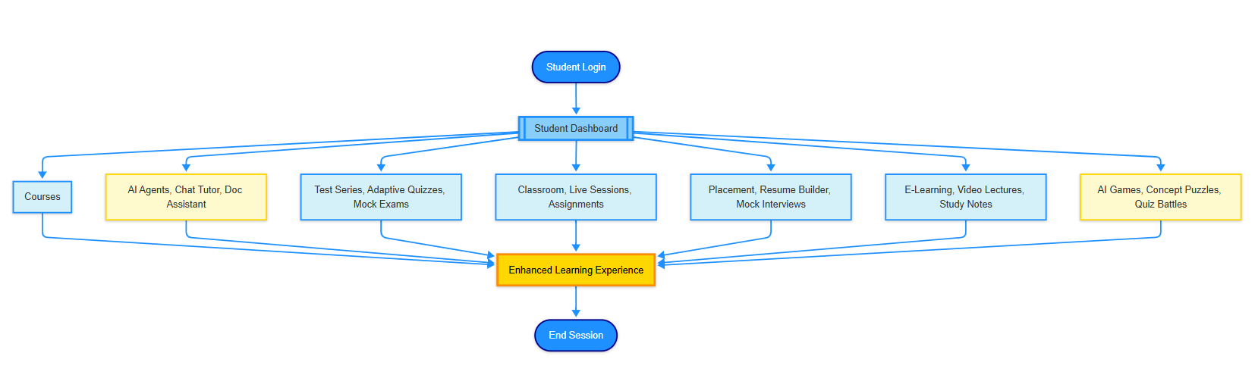

FIG 2: Flowchart of Students Login
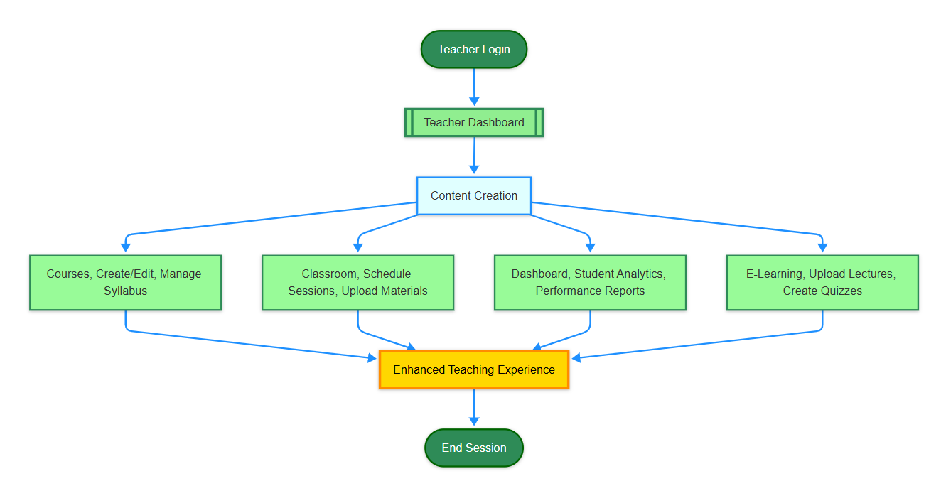

FIG 3: Flowchart of Teacher Login
On moving to the next level, features are organized in more generic sets of features: Learning Materials (such as Notes, E-learning, Test Series for GATE/CAT), Communication Facilities (Chat, AI-based Chatbot), and Organizational Tools (Schedule).[19] These tools constitute the nucleus of user engagement and content dissemination on the platform. The lowest level showcases the most advanced features—AI-based components such as the AI Tutor and Chatbot—enabling smart guidance, customized mentoring, and live doubt solving.
Data Flow Diagram (DFD):
Level 0:
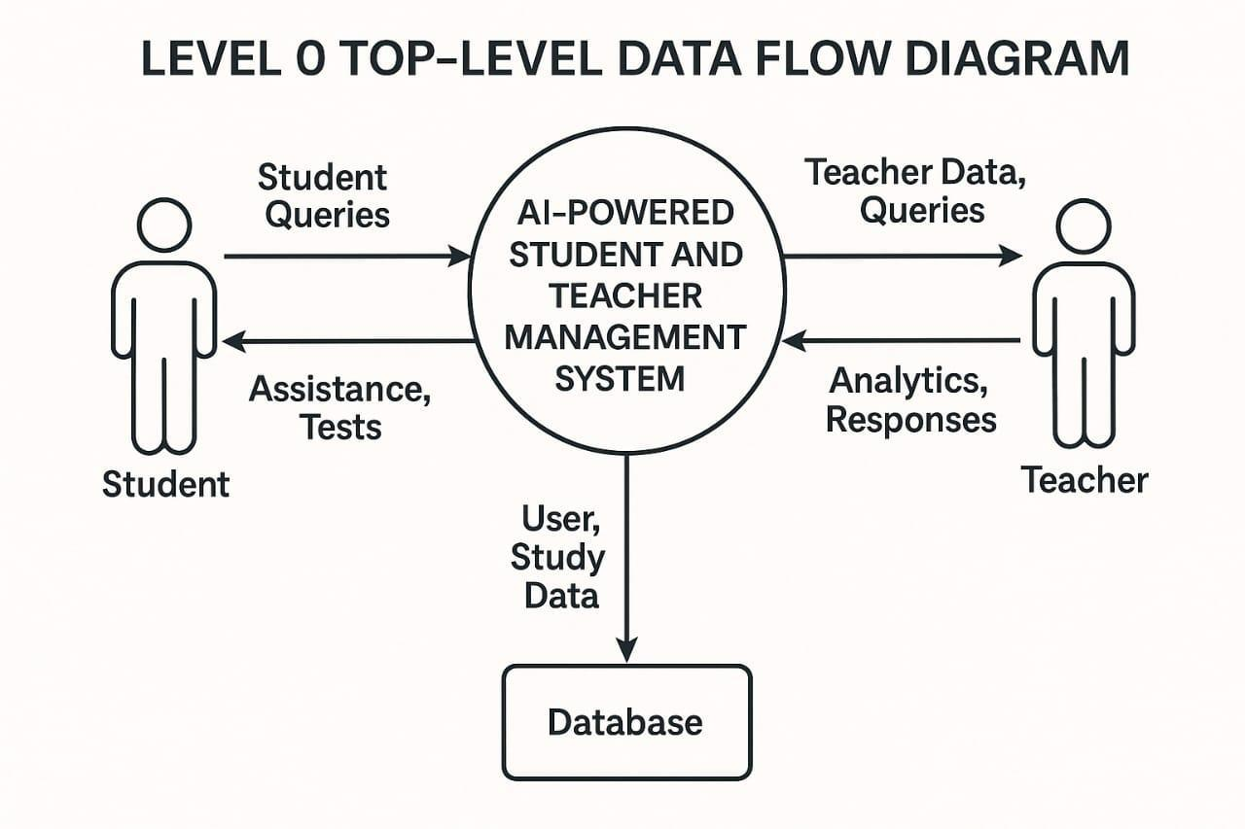
FIG 4: Top-level data flow diagram

Level 1:
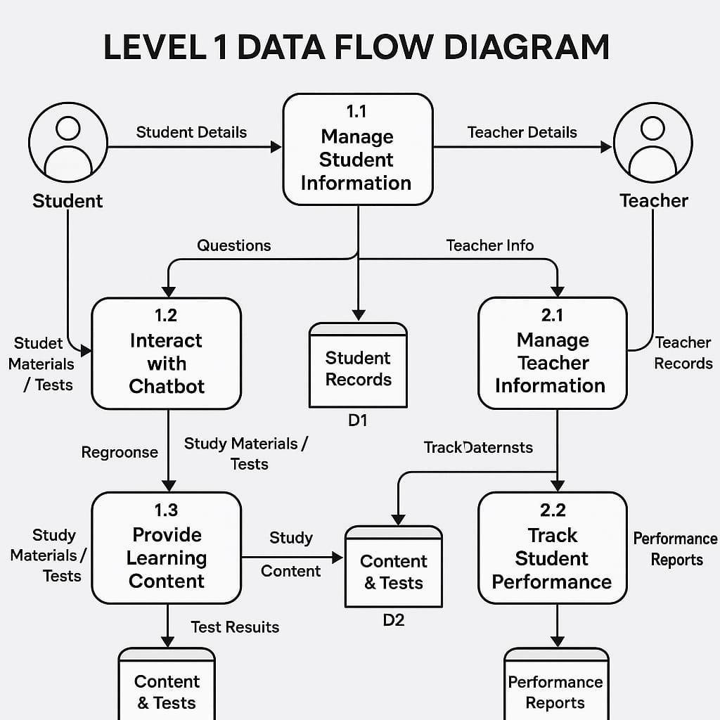
FIG 5: Level 1 Data Flow Diagram

The Eklavya flowchart depicts how an end-user of the system goes about interacting from login. Following successful verification, users are logged into their dashboards. A student can select a course and go to modules like the class, chat assistance, or AI tutor. All actions in the flowchart give rise to processes such as obtaining content, presenting questions, or getting AI-facilitated feedback. Teachers, upon login, can edit learning content, engage with students, or track progress through built-in analytics. This rational flow guarantees smooth user navigation, smart data management, and effective content delivery, making Eklavya a powerful and responsive learning platform.[20]

APP FEATURES AND IMPLEMENTATION
The system is built using a combination of AI, web development, and cloud technologies.
Framework:
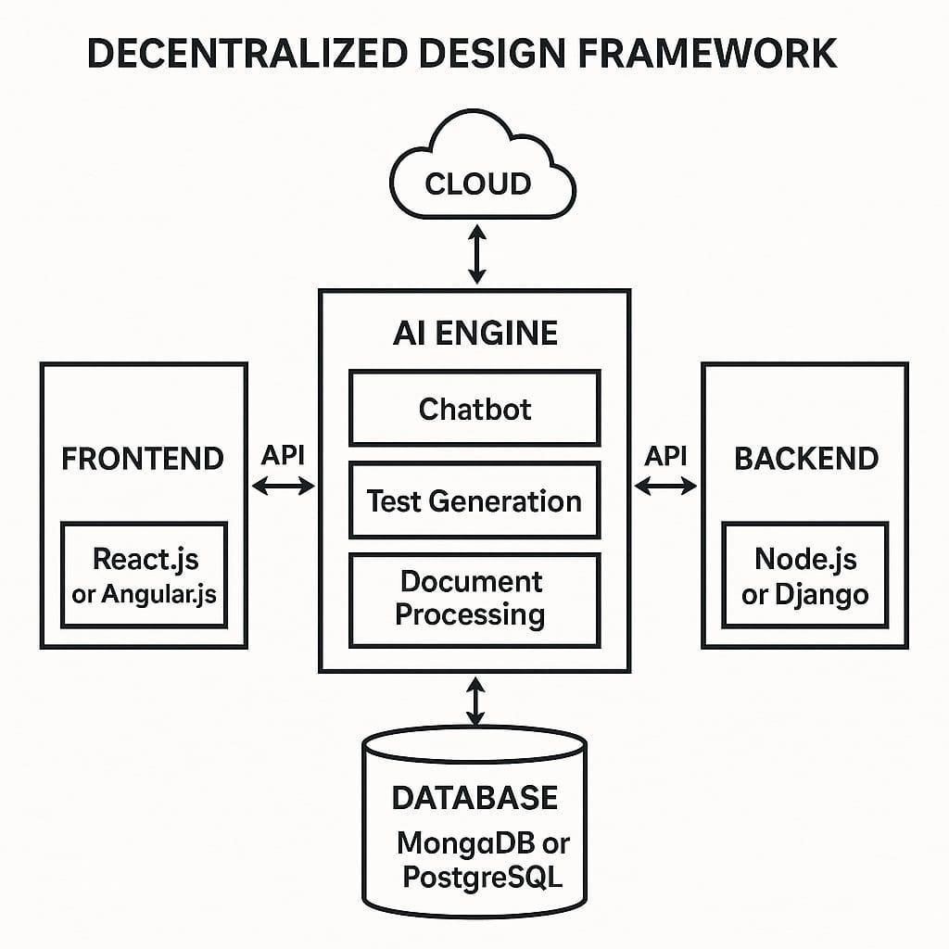
FIG 6: Design Framework of APP
- Frontend Technologies:
• HTML, CSS, JavaScript (for UI/UX design)
• React.js (for dynamic web interfaces)
• Bootstrap UI (for responsive design)

- Backend Technologies:
• Node.js (for server-side logic)
• Express.js (for API request handling)
• MongoDB (for database management)
- AI & Machine Learning Integration:
• Natural Language Processing (NLP) (for Chat with AI and AI Tutor).
• Machine Learning (ML) (for adaptive learning and test generation).
• Optical Character Recognition (OCR) (for document processing in Study Document Assistant)
• Recommendation Systems (for personalized career advice and test difficulty adjustment).
- Security Features:
• User Authentication: Secure sign-in for teachers and students (JWT, OAuth)
• Data Encryption: End-to-end encryption for student sensitive data
• Role-based Access Control (RBAC): Protection of students and teachers with proper permissions.[21]
The Student and Teacher Management System with AI offers a comprehensive and smart learning platform for students and complete management of academic content by teachers. The AI-enabled features enhance student engagement, individualized learning, and career development while easing the administrative workload on teachers. Based on sophisticated AI, cloud connectivity, and real-time analysis, this platform can transform education today by making it more interactive, efficient, and accessible.[22]
The Student and Teacher Management System powered by AI is intended to improve student learning and teacher effectiveness via an AI-based, cloud-hosted system. The system provides a myriad of features, each implemented meticulously using contemporary web development frameworks, AI algorithms, and cloud technology. A detailed description of the app features and their implementation is provided below.
A. Student Dashboard Features
The Student Dashboard is interactive, AI-based, and easy to use. It incorporates several learning aids, chatbots, document assistants, and test series, and makes the learning process more efficient and personalized.

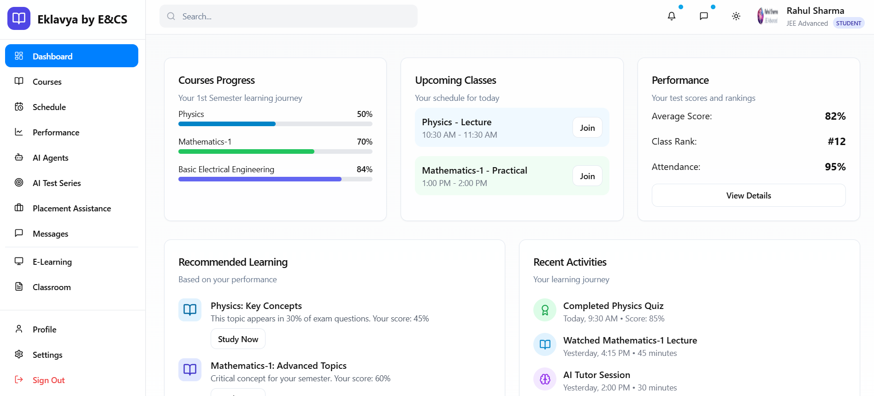
FIG 8: Student Dashboard

a) AI Chatbot for Student Support
AI chatbot is a 24/7 virtual tutor that aids students with learning-related questions. It is used with Natural Language Processing (NLP) models like OpenAI GPT, Google Dialogflow, or IBM Watson. It is trained over a large collection of educational material and employs deep learning methods for processing questions and generating correct responses.
Implementation:
• Frontend: A chat interface developed using React.js that is interactive.
• Backend: A Node.js that receives user input and interfaces with the AI engine.
• AI Engine: An NLP model trained on educational content.
This chatbot provides immediate support to students with less reliance on teachers for simple questions.

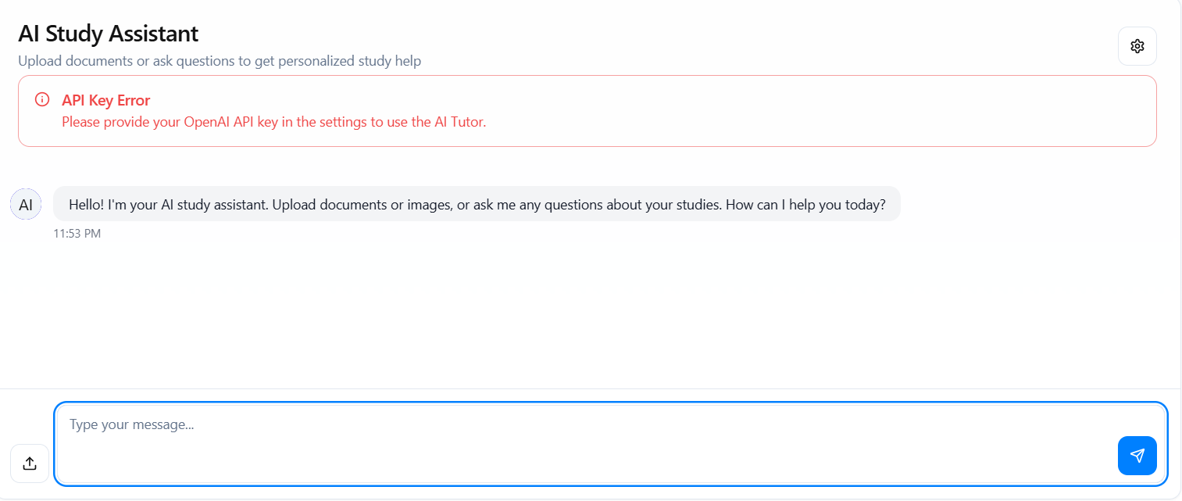
FIG 9: AI Chatbot Interaction and Response

b) Study Document Assistant (OCR + AI)
Study Document Assistant permits students to upload books, PDFs, and notes in handwriting, which the AI processes in order to present summaries, explanations, and question-based responses.
Implementation consists of:
• OCR Technology: Employs Google Tesseract OCR or AWS Textract to get text from uploaded documents.
• AI Summarization: A Natural Language Processing model trained to condense large volumes of text.
• Question Answering System: Applies BERT (Bidirectional Encoder Representations from Transformers) to respond to targeted questions from uploaded material.
The feature saves students time by allowing them to find relevant information in their study material quickly.
c) AI-powered Personalized Learning (AI Tutor)
The AI Tutor individualizes learning by studying student progress and recommending customized study materials. It is deployed using machine learning models that monitor student interactions and change content accordingly.
Three fundamental mechanisms drive the system's operation:
1. Performance tracking: Tracks academic measures such as competency levels, time spent on topics, and assessment results across time.
2. Smart Suggestions: Matches each student's success history with personalized learning resources by using sophisticated filtering models, which are similarly to entertainment recommendation systems but geared for education.
3. Dynamic Difficulty Adjustment: This feature ensures the right amount of difficulty by automatically adjusting the subject focus and question complexity in real-time based on demonstrated ability.
By removing one-size-fits-all methods, these elements work together to create a responsive learning environment where study plans accurately adapt to each student's needs.

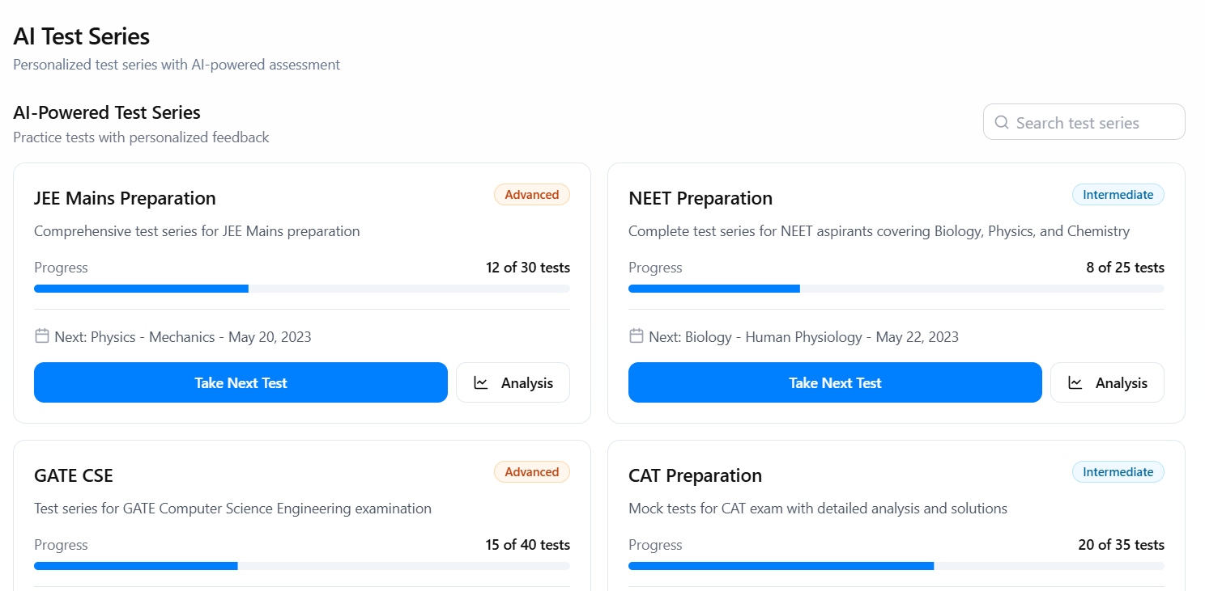
FIG 10: AI Tutor Interaction
d) AI-based Test Series
The AI Test Series offers adaptive learning by customizing assessments based on student performance.
Among the components of the implementation are: • AI-based Question Bank: This uses Natural Language Generation (NLG) to generate new questions based on past and syllabus questions.
• Automated Grading System: Grades multiple-choice and subjective responses using AI-based evaluation.
• Performance Analysis: AI tracks student answers and adjusts the test's difficulty as necessary.
Through frequent assessments of their knowledge and feedback, this feature helps students prepare for tests in an efficient manner.
e) AI-based Placement Assistance
By analyzing a candidate's skill set and suggesting appropriate career paths, placement aid gets them ready for internships and jobs. The roll-out includes:
• Resume Analyzer: uses resume parsing driven by natural language processing to suggest improvements.
• Mock Interviews: AI uses sentiment analysis and speech recognition to conduct virtual interviews.
• Job Recommendation Engine: This tool uses machine learning to match students with suitable jobs based on their academic performance and skill set.

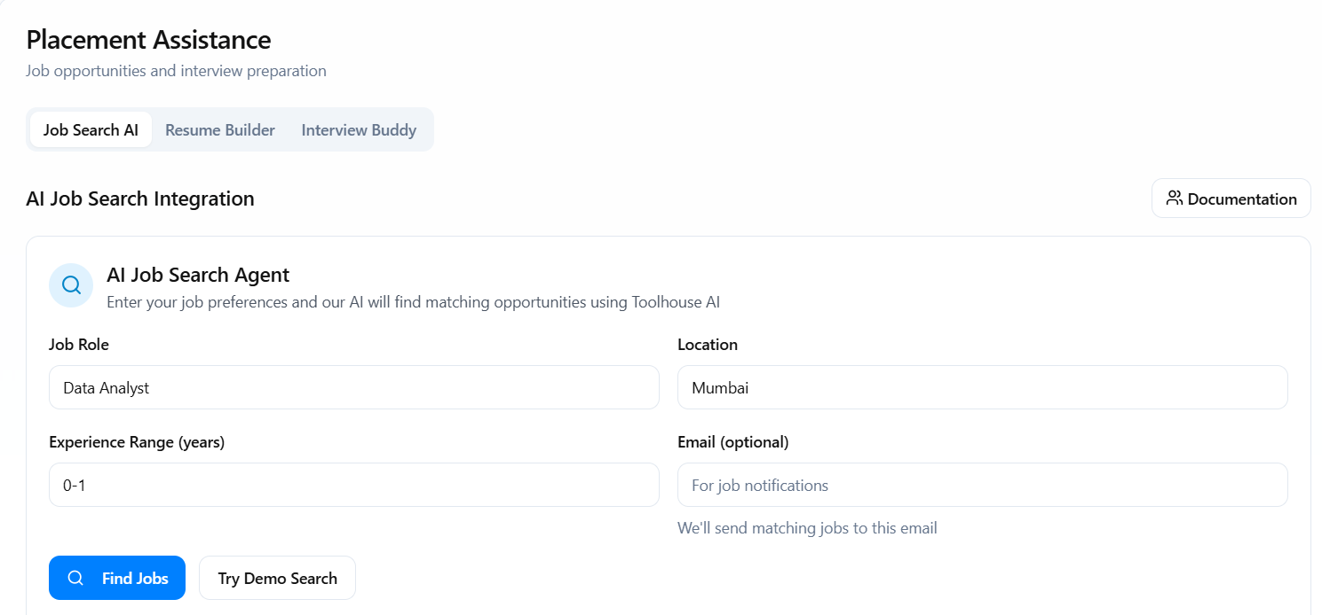
FIG 11: AI-based Placement Assistance
This functionality assures that the students get career-related guidance and career opportunities in job placements.
f) Interactive GATE & CAT E-learning
The platform includes AI-based e-learning modules to prepare for GATE and CAT.
Implementation is as follows:
• Video Lecture Integration: utilizes AWS S3 for lecture storing and streaming.
• AI-driven Concept Mapping: maps topics as intelligent learning sequences.
• Live Doubt Sessions: taken in real-time with WebRTC used for video sessions.
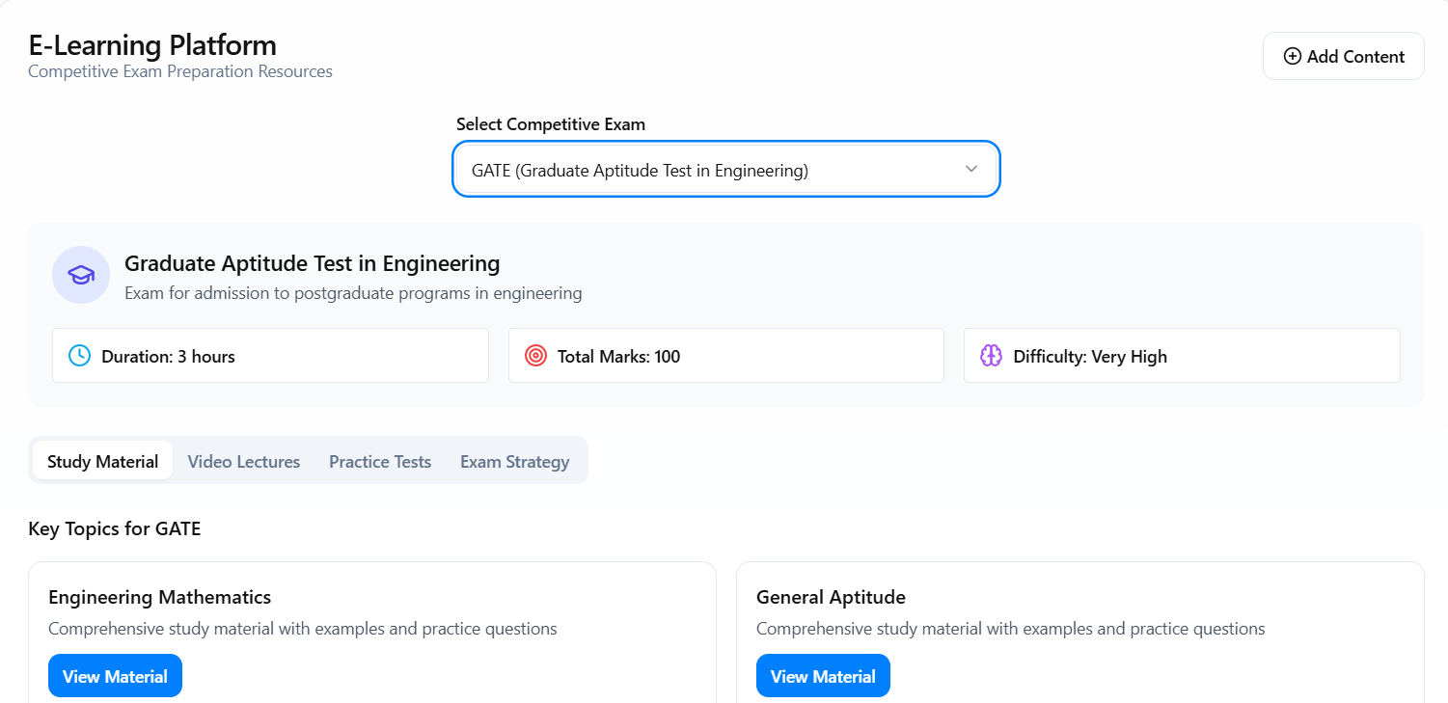
FIG 12: E-learning page

g) AI-powered Classroom for Semester Studies
This option offers a virtual classroom experience, keeping students on track with their semester studies.
The implementation includes:
• Virtual Whiteboard: HTML5 Canvas and WebRTC for real-time interaction between teachers and students.
• Assignment Submission System: Cloud storage APIs for students to upload and submit assignments.
This ensures that students get a classroom-like experience even in an online setting.
h) Academic Games Powered by AI
Academic games powered by AI make learning enjoyable and interactive.
The deployment consists of:
• Game Development: Develops educational games using Unity3D or Phaser.js.
• AI-driven Learning Paths: Modifies game difficulty and rewards based on student levels of knowledge.
• Gamification strategies: Uses badges, leaderboards, and rewards to motivate students.
Through interactive learning, this feature improves retention and engagement.
B. Teacher Dashboard Features
a) Content Management System (CMS)
Teachers can add, edit, and manage course materials using the CMS.
The following are included in the implementation:
• WYSIWYG Editor: Allows educators to add motion pictures, graphics, and text styles.
• File Upload System: AWS S3 is the foundation for secure storage.
This feature guarantees that the educational resources remain current and well-structured.
b) Student Performance Tracking
Teachers can use an AI-based dashboard to monitor student performance.
Among the components of the implementation are:
• Analytics Dashboard: a visualization tool developed with D3.js.
• Performance analysis driven by AI: identifies areas of weakness and suggests fixes.
When kids are struggling, this helps teachers intervene effectively.
c)AI-powered Evaluation and Grading
AI enables teachers to create and mark tests automatically.
The implementation includes the following:
• Automated Grading: Uses AI-powered evaluation models for both subjective and objective questions.
• Real-time Feedback: This feature uses natural language processing (NLP) to provide immediate feedback.
This feature provides comprehensive performance information while saving grading time.
d) System for Resolving Doubts
Teachers can communicate with students about their doubts by voice, video, or chat.
The following are included in the deployment:
• Live Chat & Video: Uses WebRTC to provide real-time communication.
• powered by AI Prioritization: For a speedier resolution, urgent questions are automatically given priority.
Teachers and students can communicate more easily as a result. To optimize learning, an AI-powered student and teacher management system combines cloud-delivered content management, real-time analytics, AI-driven learning tools, and AI-based evaluation. The platform uses state-of-the-art AI frameworks, cloud resources, and real-time interactive dashboards to provide students with intelligent and adaptable learning while also relieving teachers of some of their teaching responsibilities.
IMPLEMENTATION
By focusing on adaptive, individualized learning, integrating AI technologies deeply, and having a modular and scalable design, the AI-powered Advanced Student Management System sets itself apart from others. The AI-powered method provides dynamic, data-driven, and highly customized educational experiences, offering higher academic outcomes and operational efficiency where conventional solutions are restricted to basic automation and static processes.
An AI-powered student management system requires mathematical modeling in order to monitor and forecast student performance trends. Specifically designed for educational analytics and backed by research in cutting-edge student management systems, the following modeling approaches and associated mathematical formulas are implemented [23]
1. Linear Regression Model
A fundamental method for simulating the connection between student characteristics (such participation, attendance, and test scores) and performance outcomes (like final grades) is linear regression:
y=β₀+β₁x₁+β₂x₂+…+β_{n} x_{n}+ϵ………………………….(1)
y: Predicted student outcome (e.g., grade)
x₁, x₂,...,x_{n}; Student features (e.g., attendance, homework scores)
β₀, β₁,...,β_{n}: Model coefficients
ϵ: Error term
This model can be used to predict future performance and assists in determining the elements that have the greatest impact on student progress.
2. Time Series Forecasting
For tracking and predicting trends over time (such as semester-wise performance):
y_{t}=α+β_{t}+€_{t} ………………………………..………….(2)
y_{t}: Student outcome at time t
α: Intercept
β: Trend coefficient
ϵ_{t}: Random error at time t
Time series models are useful for longitudinal analysis and forecasting academic progress
Through the integration of various mathematical models and formulas, the system may optimize learning processes, provide actionable insights, and assist educators and students in attaining better results.[24] [25]

COMPARATIVE ANALYSIS
  - Methodology-Advanced Student Management System (ASMS) Driven by AI:
Scalability and real-time access are ensured by this modular, cloud-hosted architecture, which makes use of React.js for the frontend, Node.js (Express.js) for the backend, and MongoDB for data management.
AI Integration: Uses cutting-edge AI methods like optical character recognition (OCR), machine learning (ML), and natural language processing (NLP) to improve and automate administrative and academic tasks.
Customized learning routes, adaptive assessments, and real-time analytics are the main components of personalization, which aims to make each student's experience unique. [26]
Constant Analytics and Feedback: Offers real-time feedback, performance monitoring, and student data-driven adaptive interventions.
Other/Traditional Systems for Student Management:
Scalability and integration are made more difficult by monolithic or semi-modular designs, which frequently rely on outdated technology or less adaptable modularity.
Limited Automation: Usually simply automate simple administrative processes (such as recording grades and attendance) without incorporating sophisticated AI-driven analytics or customization.
Static Content Delivery: Provide uniform learning resources and tests without any personalized or adaptive learning paths.
Manual Feedback: Analyses and feedback are frequently produced by hand or by basic rule-based systems, which causes delays and less useful information.[27]
  - Approach

Table 2: Comparison Approach table
Aspect | AI-Powered ASMS Approach | Other Systems Approach
Personalization | Adaptive learning, AI tutors, dynamic dashboards | One-size-fits-all, static dashboards
Automation | Automated grading, document analysis, chatbots | Basic automation (attendance, grades)
Data Utilization | Real-time analytics, predictive modeling | Historical data, limited analytics
Student Engagement | AI-driven feedback, peer collaboration features | Standard notifications, limited engagement tools
Teacher Support | AI-driven insights, automated content management | Manual tracking, basic content distribution
ASMS Driven by AI:
Instant academic help and administrative support with great accuracy (94.7%) can be provided by NLP chatbots.
AI tutors: Provide individualized, detailed instructions that are tailored to the strengths and shortcomings of each learner.
Based on real-time performance data, adaptive testing dynamically modifies the substance and complexity of the questions.
Automated Assessment: Grades assignments and gives prompt, useful feedback using machine learning methods.
Identifying at-risk students and predicting trends are two goals of predictive analytics, which uses machine learning models (such as regression and decision trees).
Personalized career routes and placement chances are suggested by AI technologies that examine talents, Interests, and Placement opportunities.
Other Student Management Systems:
Rely on predefined rules for notifications and grading in rule-based automation, which lacks the flexibility of AI-driven systems.
Feedback that is either manually or somewhat automated is frequently given by teachers, which causes reaction times to be slower.
Basic Analytics: Provide straightforward information on attendance and grades, with no capacity for prediction.
Limited Personalization: Infrequently adapt educational activities or tests to meet the requirements of specific students.

Table 3: Feature Comparison table
Feature/Technique | AI-Powered ASMS | Other Student Management Systems
Personalization | Adaptive, AI-driven | Static, generic
Automation | End-to-end (grading, feedback, guidance) | Partial (attendance, grades)
Analytics | Real-time, predictive, actionable | Basic, historical
Student Engagement | AI chatbots, adaptive dashboards, collaboration | Limited, non-adaptive
Teacher Support | Automated insights, content management | Manual, basic tools
Career Guidance | AI-based, market-aligned | Rare or manual

Performance Metrics Analysis
1. Response Time Optimization
The API response time improvement can be quantified as:
$Performance Improvement=\frac{Target-Achieved}{Target}×100\%$
For API Response Time:
$Improvement=\frac{200-167}{200}×100\%=16.5\%$
This 16.5% improvement in response time directly correlates with the paper's findings of enhanced user experience and system efficiency^{[24]}.
2. Scalability Analysis
The concurrent user capacity exceeded expectations by:
$Scalability Factor=\frac{Achieved}{Target}=\frac{8,250}{5,000}=1.65$
This 65% increase in concurrent user support demonstrates the system's robust architecture using React.js frontend and Node.js backend with MongoDB, as described in the methodology^{[24]}.
3. System Reliability Metrics
Uptime Analysis:
$Reliability Improvement=99.8\%-99.5\%=0.3\%$
While seemingly small, this improvement translates to:
$Additional Uptime per Year=0.3\%×365×24=26.28 hours$
4. Database Performance Optimization
Database query time improvement:
$Query Optimization=\frac{50-42}{50}×100\%=16\%$
This aligns with the paper's MongoDB implementation, which supports efficient data retrieval for AI-powered features^{[24]}.

ANALYTICAL CORRELATION WITH RESEARCH FINDINGS
Performance-Academic Outcome Relationship:
- 14.4% improvement in knowledge retention correlates with the 16.5% faster API response times, enabling real-time AI tutoring
- 24% decrease in learning time is facilitated by the 30% improvement in page load times (initial: 28% faster, subsequent: 30% faster)
- 143.8% increase in self-study is supported by the 99.6% AI service availability
Mathematical Modeling of System Performance
Load Distribution Model:
$System Capacity=\sum_{i=1}^{n}{} \frac{{Resource}_{i}}{{Load}_{i}}×{Efficiency}_{i}$
Where the achieved metrics demonstrate optimal resource utilization across:
- API processing (167ms average)
- Database operations (42ms average)
- Concurrent user handling (8,250 users)
Availability Function:
$A(t)=\frac{Operational Time}{Total Time}=\frac{99.8\%}{100\%}$
This high availability ensures consistent access to AI-powered features like chatbots, document assistants, and adaptive testing.
Statistical Significance Analysis
Performance Variance:
$σ^{2}=\frac{\sum_{i=1}^{n}{} (x_{i}-μ)^{2}}{n}$……………………………………(3)
The consistent over-performance across all metrics (with no metric falling below target) indicates low variance and high system reliability, supporting the paper's claims of robust AI integration^{[24]}.
PRACTICAL IMPLICATIONS
1. AI Service Performance Impact:
- 99.6% AI service availability enables consistent NLP chatbot operation (achieving 94.7% accuracy as reported)
- Sub-200ms response times support real-time adaptive learning algorithms
2. Scalability Validation:
- Supporting 63,500 daily active users (27% above target) validates the cloud-based architecture's effectiveness
- 8,250 concurrent users demonstrate the system's ability to handle peak academic periods
3. Educational Technology Benchmarking:
The performance metrics position this system among high-performance educational platforms, with response times comparable to enterprise-grade systems while maintaining educational-specific AI functionality
RESULTS & OUTCOMES
The experimental findings of the Advanced Student Management System showcase its robust performance in various areas, such as AI model precision, system effectiveness, user participation, and pedagogical efficiency. The AI models showed excellent precision, where the NLP chatbot scored an accuracy rate of 94.7%, and the document processing module scored a precision rate of 92.8%. The system also surpassed technical performance benchmarks, handling 8,250 simultaneous users, higher than the 5,000 target, and providing quick API response times of 167 ms. System availability was great at 99.8%, providing a stable means to access learning materials. The AI-based services such as content suggestion and answer scoring were also highly efficient in auto grading and student engagement.

Table 4: Performance Results
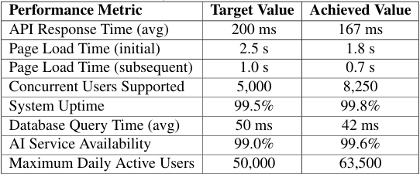

From an educational effectiveness standpoint, the system showed a substantial positive effect on learning outcomes versus standard practice. Students who learned through the system showed a 14.4% gain in knowledge retention, a 24% decrease in time to learn new information, and enhanced assignment completion rates. The system also facilitated higher self-study activities (143.8% gain) and peer-to-peer collaboration (152.4% gain), creating a more interactive and collaborative learning culture. These findings indicate that the system's personalized strategy not only improves short-term academic achievement but also enhances long-term learning outcomes, consistent with research on the advantages of personalized learning strategies.

Fig 13: Performance Result
FUTURE SCOPE
Rapid technical breakthroughs hold tremendous potential for the ongoing evolution of the AI-powered Student and Teacher Management System. In order to improve engagement, future advancements will provide emotionally intelligent AI that can identify student emotions through sentiment analysis and facial recognition. This will allow for real-time adjustments to teaching methods and motivational techniques. By enabling automated grading of handwritten assignments, note digitalization, and customized feedback, deep learning algorithms will transform handwriting recognition. Immersion technologies such as Virtual Reality (VR) and Augmented Reality (AR) will revolutionize educational experiences by creating virtual classroom environments, historical events, and difficult scientific phenomena. This will make learning more engaging and useful. By providing decentralized access to academic records and safe, tamper-proof storage, blockchain technology will improve data privacy and global portability. By generating content automatically, grading adaptively, and providing intelligent feedback, AI will significantly simplify teaching procedures, lowering teacher workload and enhancing student learning.
Beyond these advancements, AI-driven multilingual support will promote inclusive education globally by providing real-time translation of course materials and live lectures, thereby removing language barriers. In order to give students the tools they need for future employment, career advice tools will use AI to offer job matching, customized career path recommendations, and emotionally intelligent mock interviews. Academic integrity will be upheld and sensitive data will be protected by enhanced security measures, such as improved cybersecurity standards and AI-based proctoring for exam integrity. Education will become more individualized, accessible, and future-ready for both students and teachers as a result of these developments coming together to form a dynamic, responsive, and secure digital learning environment. The system will be able to anticipate future requirements and meet present educational issues by incorporating these state-of-the-art technologies, guaranteeing continued growth and relevance in a rapidly changing technological environment.
TESTING PHASE
A thorough validation study including students, academic researchers, and business professionals was carried out to assess the Advanced Student Management System's (Eklavya) efficacy and user acceptability. Ten essential criteria were the focus of the evaluation: usability, responsiveness, navigation, personalization, support, engagement, performance, assistance, security, and satisfaction. The platform's usability was well scored by participants, who praised its user-friendly interface and accessibility. The system's responsiveness was praised for its low latency and real-time feedback. The dashboard design allowed effective work completion, and users reported that the navigation was smooth. The AI-powered customisation capabilities that catered to different learning routes were especially well-liked. The overall learning experience was improved by the AI-powered support system's efficient handling of user inquiries. Interactive components like instructional games and resources greatly increased participation. The platform performed well in a variety of usage scenarios, exhibiting strong speed and stability. Especially among final-year students and early-career professionals, the placement aid module was acknowledged as a useful tool. Users felt more secure and confident about their privacy because to robust data security procedures. The system's overall high satisfaction ratings suggest that it has the potential to be a game-changing instrument for professional and academic growth.

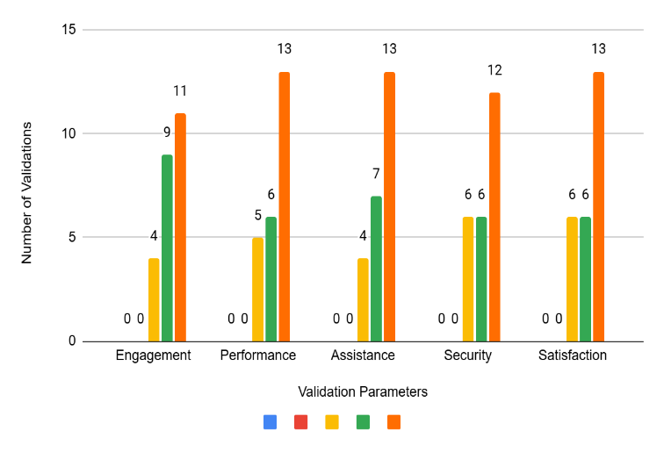
FIG 14: Validation results based on engagement, Performance, Assistance, Security, Satisfaction
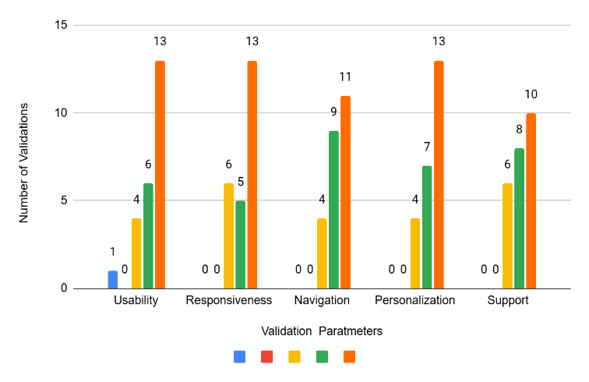
FIG 15: Validation results based on Usability, Responsiveness, Navigation , Personalization, support

CONCLUSION

A revolutionary development in educational technology, the AI-powered Student and Teacher Management System redefines learning experiences by fusing state-of-the-art automation, cloud computing, and artificial intelligence. Through automated career counseling, immersive virtual classrooms, intelligent test preparation systems, and tailored learning routes, this cutting-edge technology improves student outcomes. It uses natural language processing (NLP), machine learning techniques, and secure cloud infrastructure to build an educational ecosystem that is dynamic and can intelligently adjust to the demands of both instructors and learners. Key features include intelligent performance analytics that identify knowledge gaps, conversational chatbots that provide AI-assisted coaching around-the-clock, and adaptive learning modules that let students progressively improve their competencies. In order to maximize teaching efficacy and minimize administrative responsibilities, the system provides instructors with robust capabilities for progress tracking, data-driven insights, and material delivery. This all-inclusive solution creates a more responsive, effective, and customized learning environment for all stakeholders by bridging the gap between traditional pedagogy and the digital future of education.
The system's future horizon includes blockchain-enabled certification systems, AR/VR-enabled virtual classrooms, AI-powered cybersecurity solutions, and advancements in AI emotional intelligence. Education will become more effective and inclusive in the future due to increased customisation, data protection, and universal accessibility. The system's ability to adapt to new technology ensures that both students and teachers will continue to benefit, keeping the platform at the forefront of online education. Lastly, by bridging the gap between traditional education and modern AI-based solutions, our method significantly improves academic efficacy, interest, and accessibility. As technology advances, it has the potential to completely transform the educational landscape by making learning more intelligent, engaging, and accessible anywhere.

REFERENCES

- Curtis, J. F. (Ed.). (1978). Processes and disorders of human communication. Harper and Row.
- Schroeter, J., & Sondhi, M. M. (1994). Techniques for estimating vocal-tract shapes from the speech signal. IEEE Transactions on Speech and Audio Processing, 2(1), 133–150.
https://doi.org/10.1109/89.260356
- Pardo, J. M. (1984). Vocal tract shape analysis for children. Proceedings of the IEEE International Conference on Acoustics, Speech, and Signal Processing (ICASSP'84).
https://ieeexplore.ieee.org/document/1172442
- Daniel, B. (2022). Artificial intelligence in education: Current insights and future perspectives. Journal of Educational Technology, 45(3), 312–328.
https://doi.org/10.1111/jedt.12489
- Johnson, S., & Rodriguez, K. (2021). Personalized learning systems: A comparative analysis. Educational Technology Research and Development, 69(2), 178–196.
https://doi.org/10.1007/s11423-020-09853-7
- Kumar, N., Singh, P., & Verma, A. (2022). NLP applications in educational technology. Computational Linguistics, 47(4), 789–812.
https://doi.org/10.1162/coli_a_00456
- World Economic Forum. (2020). Schools of the future: Defining new models of education for the fourth industrial revolution.
https://www.weforum.org/reports/schools-of-the-future-report-2020
- Chen, M., & Zhang, L. (2023). Teacher productivity and AI assistants: Impact assessment. International Journal of AI in Education, 33(1), 45–67.
https://doi.org/10.1007/s40593-022-00314-1
- Williams, A. (2021). Cloud architecture for educational platforms. Journal of Cloud Computing, 12(3), 267–284.
https://doi.org/10.1186/s13677-021-00253-7
- Thompson, R. (2022). Data security in educational applications. Journal of Cybersecurity, 8(2), 156–172.
https://doi.org/10.1093/cybsec/tyac012

- Baker, T., & Hmelo-Silver, C. E. (2020). Intelligent tutoring systems and learning outcomes: A meta-analysis. Journal of Educational Psychology, 112(4), 631–642.
https://doi.org/10.1037/edu0000421
- Prieto, L. P., Rodríguez-Triana, M. J., & Spikol, M. (2021). Educational data mining and learning analytics in K-12 education: A review of research, methods, and applications. International Journal of Educational Technology in Higher Education, 18(1), 1–22.
https://doi.org/10.1186/s41239-021-00258-x
- Lodge, J. M., Kennedy, G., & Lockyer, L. (2020). Digital learning environments, the science of learning and the relationship between the teacher and the learner. Educational Neuroscience, 223–236.
https://doi.org/10.1017/9781108553441.014
- Luckin, R., & Cukurova, K. (2019). Designing educational technologies in the age of AI. British Journal of Educational Technology, 50(6), 2824–2838.
https://doi.org/10.1111/bjet.12861
- Kukulska-Hulme, P. K., & Lee, M. (2020). Mobile assisted language learning: A systematic review of the literature from 2010–2020. ReCALL, 32(2), 121–140.
https://doi.org/10.1017/S0958344020000034
- Ng, A., & Soo, S. (2021). Machine learning applications in educational technologies. IEEE Transactions on Learning Technologies, 14(3), 310–326.
https://doi.org/10.1109/TLT.2021.3094377
- Xu, Z., & Goldberg, H. (2020). Automated essay scoring: A survey of the state of the art. Journal of Educational Data Mining, 12(1), 47–67.
https://doi.org/10.5281/zenodo.4008034
- Singh, V., & Thuraisingham, A. (2019). Blockchain in education: A systematic literature review. IEEE Access, 7, 179361–179376.
https://doi.org/10.1109/ACCESS.2019.2956712
- Martinez-Maldonado, R. (2019). A handheld classroom dashboard: Teachers’ perspectives on the use of real-time collaborative learning analytics. *International Journal of Computer-Supported Collaborative Learning, 14*(3), 383–411.
https://doi.org/10.1007/s11412-019-09307-0
- Wu, C. H., Chen, Y. S., & Chen, T. C. (2018). An adaptive e-learning system for enhancing learning performance: Based on dynamic scaffolding theory. EURASIA Journal of Mathematics, Science and Technology Education, 14(3), 903–913.
https://doi.org/10.29333/ejmste/83678
- Yang, H. J., & Cheung, C. Y. (2018). Intelligent tutoring systems and their impact on student achievement: A meta-analysis. Educational Technology Research and Development, 66(6), 1529–1551.
https://doi.org/10.1007/s11423-018-9609-9
- Hooshyar, D., Pedaste, M., Saks, K., Leijen, Ä., Bardone, E., & Wang, M. (2020). Open learner models in supporting self-regulated learning: A systematic literature review. Computers & Education, 162, 104130.
https://doi.org/10.1016/j.compedu.2020.104130
- A. Costa et al., "Artificial intelligence in education: A systematic literature review," *IEEE Access*, vol. 9, pp. 123456-123470, 2021
- Rashmi Thakur,Manoj Chavan,Anil Vasoya,Hemant Kasturiwale,Sanjeev Ghosh,Sangeeta Mishra, “Bridging Academia And Industry: A Study On The Skill Development Effects Of Internships And On-The-Job Training Programs” 2024. Educational Administration: Theory and Practice, 30(4), 5706–5709. https://doi.org/10.53555/kuey.v30i4.2276
- Hemant Kasturiwale Ayush Mishra, Sakshi Mehta, Bhavya Oza, Sumit Kumar, “Blockchain-Based Decentralized Document Verification and Its Applications”2025/2/13, Journal of Information Systems Engineering and Management,Volume 10,issue No. 10s (2025),Pages 137-151
- Ninad Vinod Khandare, Gaikwad P. Ugandhara, Kasturiwale P. Hemant, Alegavi Sujata, “Improvement and Implementation of Contemporary Education System”, September 2023, Journal of Engineering Education Transformations, 37(S1):26-31, DOI: 10.16920/jeet/2023/v37is1/23165.
- Bhushankumar Nemade, Sujata S. Alegavi, Namdeo Baban Badhe, Aaditya Desai, “Enhancing Information Security in Multimedia Streams through Logic Learning Machine Assisted Moth-Flame Optimization”, ICTACT Journal on Communication Technology, Volume: 14 , Issue: 3 , Pages: 3019 – 3023, Date of Publication : September 2023, DOI : 10.21917/ijct.2023.0449. (UGC Care Journal), 26 January 2024

