“Smart Guard” - Comparative Analysis of Supervised and Unsupervised Learning for Fall Detection Using Wearable Sensors
Ms. Anam Khan^{1, a)} Mr. Aniket Deo^{2, b)} Ms. Priyanka Bolinjkar^{3, c)}
^{1, 2, 3}Assistant Professor
Department of Artificial Intelligence & Data Science
Thakur College of Engineering & Technology
Mumbai, India

^{a)}Corresponding author: anam.khan@tcetmumbai.in
^{b)}aniket.deo@tcetmumbai.in
^{c)}priyanka.bolinjkar@tcetmumbai.in
Abstract. Falls are still a prevalent cause of injury or loss of independence among older adults, highlighting the importance of precise high-quality detection systems. This paper demonstrates Smart Guard; a fall detection framework based on AI and wearable systems that use a mix of supervised and unsupervised machine learning approaches. Using a dataset of 500 samples with 8 sensor features, we compare supervised Random Forest to unsupervised approaches- Isolation Forest and One-Class SVM. From these experiments Random Forest had the highest metrics overall accuracy (82.0%) and specificity (99.2%), but none of the fall events were identified (Recall = 0.00, F1-score = 0.00) as there was class imbalance. Unsupervised approaches however had lower accuracy (66-75%); nevertheless, their recall was non-zero (0.12-0.23), demonstrating that at least a small proportion of fall events were identified. Therefore, these results provide three take-away points: 1) accuracy is not a good sole measure of performance in imbalanced healthcare datasets; 2) when working with fall detection in a safety-critical environment it is sensible to consider sensitivity and recall; and 3) hybrid approaches using supervised and unsupervised results can better suit the problem of real-time, wearable fall detection in elderly care.
Keywords— Fall Detection; Wearable Sensors; Random Forest; One-Class SVM; Isolation Forest; Anomaly
Detection; Healthcare AI

INTRODUCTION
Falls among older adults are an urgent public health concern due to potential severe injuries, loss of independence, and large healthcare costs. Many previous fall preventions approach typically involve some environmental modifications or caregiver interventions which are not bad but insufficient alone. However, wearable sensors [1] with the introduction of artificial intelligence (AI) enable continuous monitoring, and responsive recognition of fall events. The improved access to accelerometers, gyroscopes, and motion sensors with machine learning algorithms will further develop the use of [2] fall detection systems. Nevertheless, one of the main challenges within this field of study is the class imbalance between fall and every other activity, which can enable supervised models to identify fall events successfully while classifying legitimate fall events as no fall. It is thus worthwhile exploring supervised and additionally unsupervised learning [3] techniques to easily implement this in real-world settings, while also maintaining robustness and sensitive detection.
Objectives:
- To explore and develop and compare AI algorithms (supervised and unsupervised) to detect falls.
- To assess model performance using multiple levels of metrics (accuracy, recall, sensitivity, F1-score) and focus on class imbalance.
- To demonstrate the necessity for sensitivity focused evaluation in safety critical healthcare applications.
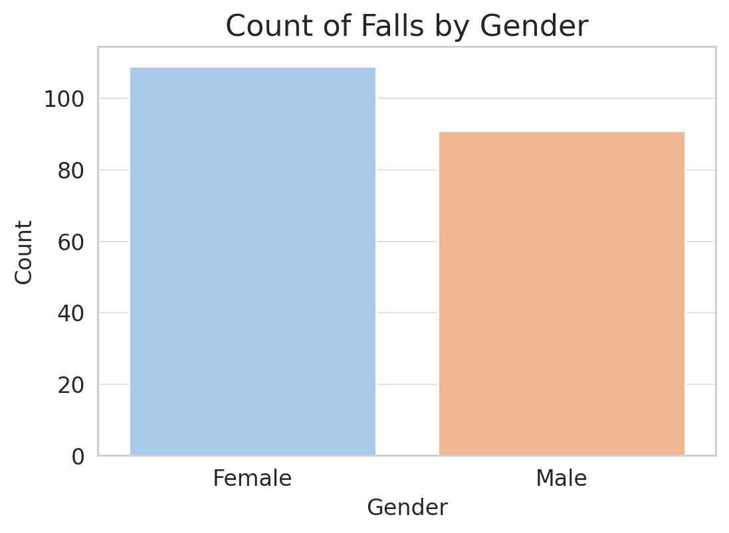 | 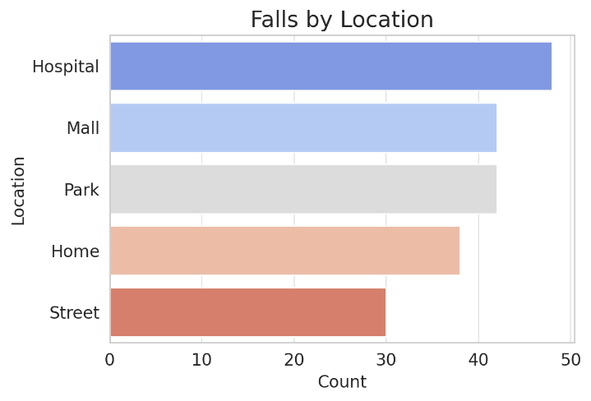
FIG 1: Count of Falls by Gender in Percentage | FIG 2: Count of Falls by Location
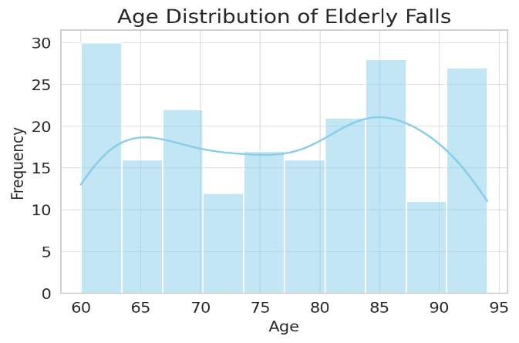
FIG 3: Age Distribution of Elderly Falls

It is evident from the variations in Figures 1-3 that falls among the elderly vary greatly depending on the environment and demographics. It is evident that women experience slightly more falls than men. Falls can happen at home or in public places. Falls occur in public and clinical settings, including parks, shopping centers, hospitals, and clinics, in addition to homes. Falls affect all older people between the ages of 60 and 95 and are not specific to any one age group. The early 1960s and the mid-1980s see notable peaks. These variations highlight the problem's considerable complexity, especially the requirement that fall prevention be carried out using intelligent real-time system functions.

LITERATURE SURVEY
BlockTheFall, a wearable device-based architecture for elder care that integrates blockchain and machine learning, was proposed by Saha and associates. Their research demonstrated how blockchain could be used to improve the security and dependability of managing health data, while machine learning algorithms' [4] capacity to identify falls ensured performance improvements. Their study did, however, acknowledge potential latency issues with blockchain integration and emphasized the need for more thorough real-world validation of their findings prior to deployment.
With their CareFall system, Ruiz-Garcia and colleagues automatically detected falls by using gyroscope and accelerometer [5] data that were subjected to machine learning classifiers. Their strategy generally produced encouraging results when employing controlled procedures; however, the limited sample size and diversity of the dataset may cause overfitting concerns and limit generalizability in practical settings.
A thorough analysis of wearable sensor-based human activity recognition (HAR) was provided by Liu and colleagues, who compared several sensor modalities, feature creation techniques, and AI model choices.
They also highlighted some of the challenges, including variability of placement of sensors [6], the inclusion of user activity patterns, and the importance of developing user-specific models that could improve ordinal model performance in older populations.
Gaya-Morey et al. performed a systematic review of deep learning and computer vision methods for recognizing activities of the elderly, as well as detecting falls. Although deep learning-based approaches were identified as producing high classification accuracy [7], the study revealed that deep learning models had significant limitations, such as high processing power requirements and privacy concerns with video-based monitoring, which are barriers for implementation in "real-life" elderly care contexts.
Kulurkar et al. created an AI-based fall prediction system for the elderly that uses wearable technology in conjunction with Internet of Things (IoT) devices and low-power wireless sensor networks. Their proposed solution was to implement a smart home-care solution and would allow for continuous monitoring by a health care [8] team with facilitated use of machine-learning models. Their study also recognized issues associated with processing real-time data and issues implementing these systems in existing health care environments.
The above studies demonstrate that AI-based wearable technology for fall detection in the elderly is a promising area of research, but important obstacles remain, including data set imbalance, limited diversity, computing power requirements, privacy issues and establishing real-time operation. These gaps provide justification for the present study, in which Smart Guard uses both supervised and unsupervised methods of classification, as a comparative framework to improve reliability and sensitivity for fall detection.

METHODOLOGY
The proposed Smart Guard framework leverages wearable sensor data and machine learning algorithms to identify falls in an aging population. The methodology consists of the following steps:

A. Exploratory Data Analysis (EDA)
EDA described the composition of the dataset, class imbalance, as well as individual feature behavior. A highly skewed distribution was displayed in the class distribution plots of the EDA. There is a possibility of unequal learning because the non-fall trials much outnumbered the fall samples (see Figure 1). Some insight into the relationship between the features and fall detection was given by statistical summaries and correlation maps.
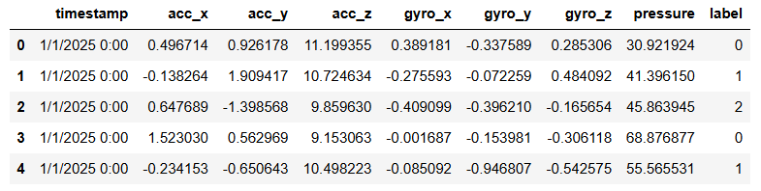
FIG 4: Detailed Description of the Dataset
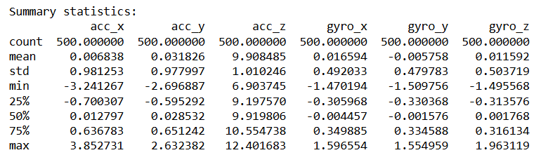

FIG 5: Summary Statistics of the Dataset

The dataset used for the study carries total 500 entries, starting from 0 to 499 and contains total 9 distinct columns

B. Data Preprocessing
The readings obtained by analyzing the gyroscopes and accelerometers were regressed to similar scales. Next, the data was divided into fixed-size windows, which correspond to brief activity areas and were separated by intervals of two to three seconds. Additional quality was added to the data through noise filtering, addressing missing values, and increasing data coverage.
C. Feature Extraction
From each time window, we extracted both statistical and dynamic information; some examples are shown below:
- The standard deviation, variance, and average.
- Entropy and energy.
- Modifications to acceleration and tilt angle.
We were able to employ characteristics that capture both the slow instabilities linked to falls and the sudden jerks.
D. Machine Learning Models
We used three models to assess the potential of both supervised and unsupervised approaches:
- Random Forest (supervised): An ensemble classifier that can consider intricate feature relationships and manage noisy sensor inputs.
- Unsupervised Isolation Forest: An anomaly detection system that treats the falls as outliers to normal activity and isolates an unusual pattern.
- One-Class SVM (unsupervised): This boundary-based model considers departures from the boundary as fits and depicts distributions of normal activity.
E. Model Evaluation
Several methods were used to evaluate the model's performance:
• Accuracy, or the model's overall accuracy.
• F1-score, precision, and recall for the minority fall class performance.
• Specificity to guarantee accurate identification of activities that do not involve falls.
• ROC AUC to evaluate false alarm and sensitivity tradeoffs.
To display the models' comparative findings, we employed bar charts, ROC curves, and confusion matrices.

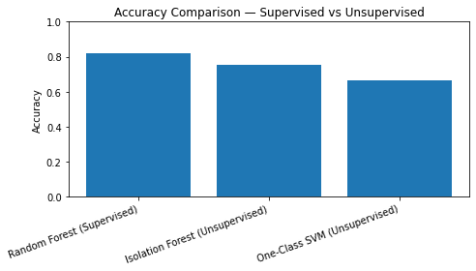 | 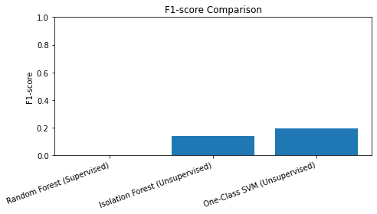
FIG 6: Accuracy Comparison for the three Models | FIG 7: F1-ScoreComparison for the three Models

RESULT
The comparative analysis reveals notable differences between supervised and unsupervised approaches to fall detection. The supervised Random Forest classifier reported the highest overall accuracy (82.0%) and specificity (99.2%), which demonstrates strong potential to classify non fall events accurately. However, the supervised Random Forest classifier's complete unused sensitivity in finding falls events (Precision = 0.00, Recall = 0.00, F1-score = 0.00) is an example of the accuracy paradox when evaluating models on imbalanced data sets, where accuracy is high but the sensitivity to rare critical events is poor.

In contrast, the unsupervised methods produced lower overall accuracy in relation to the supervised methods, but rather than having poor recall or sensitivity of detecting fall events, the unsupervised methods at least demonstrated the ability to detect fall events. Although the supervised Random Forest classifier did not report any true positives, the Isolation Forest reported 75.3% accuracy (Recall = 0.12, F1-score = 0.14), and the One-Class SVM reported 66.7% accuracy (Recall = 0.23, F1-score = 0.19). Although both the Isolation Forest and One-Class SVM unsupervised models produced more false alarms in classifying non-fall events, at least a portion of fall cases were detected and classified. In the case of safety-critical health care applications, this ability to detect a subset of fall incidents is more significant than obtaining accuracy alone. Thus, when assessing fall detection systems, criteria like recall, sensitivity, and F1-score should take precedence over raw accuracy.

CONCLUSION
This study shows that when using wearable sensors to detect falls, supervised and unsupervised methods behave quite differently. Because of its unbalanced classification, Random Forest was unable to detect fall events, while having the highest accuracy and specificity. Isolation forest and one-class SVM, two unsupervised techniques, were able to achieve lower overall accuracies but non-zero recall and F1-scores, suggesting that they provide far more appropriate techniques for detecting rare events. These findings highlight the shortcomings of accuracy as a performance metric in healthcare monitoring and highlight the necessity of sensitivity-based performance needs evaluation.

REFERENCES
- M. Johnson et al., "Wearable Technology for Fall Detection," IEEE Transactions on Biomedical Engineering, vol. 68, no. 4, pp. 1208-1217, 2021.
- A. Kumar et al., "AI-Based Solutions for Elderly Healthcare," Springer, 2022.
- J. Smith, "Applications of CNN and LSTM in Healthcare," Journal of International ACM SIGIR Conference on Research and Development in Information Retrieval, 2018.
- B. Saha, M. S. Islam, A. K. Riad, S. Tahora, H. Shahriar, and S. Sneha, "BlockTheFall: Wearable Device-based Fall Detection Framework Powered by Machine Learning and Blockchain for Elderly Care," arXiv preprint arXiv:2306.06452, Jun. 2023.
- J. C. Ruiz-Garcia, R. Tolosana, R. Vera-Rodríguez, and C. Moro, "CareFall: Automatic Fall Detection through Wearable Devices and AI Methods," CoRR, vol. abs/2307.05275, 2023.
- R. Liu, A. A. Ramli, H. Zhang, E. Henricson, and X. Liu, "An Overview of Human Activity Recognition Using Wearable Sensors: Healthcare and Artificial Intelligence," presented at the International Conference on Internet of Things (ICIOT), 2021.
- F. X. Gaya-Morey, C. Manresa-Yee, and J. M. Buades-Rubio, "Deep Learning for Computer Vision Based Activity Recognition and Fall Detection of the Elderly: A Systematic Review," Applied Intelligence, vol. 54, pp. 8982–9007, Jul. 2024.
- P. Kulurkar, C. K. Dixit, V. C. Bharathi, A. Monikavishnuvarthini, A. Dhakne, and P. Preethi, "AI based elderly fall prediction system using wearable sensors: A smart home-care technology with IOT," Measurement: Sensors, vol. 25, p. 100614, Feb. 2023.

