A Secure Fog and Blockchain-Enabled Framework for Real-Time Air Quality Monitoring
Pramod Ravindra Patil¹, Dr. Arvind W. Kiwilekar² And Dr. L D Netak³
^{1,2,3}Dr. Babasaheb Ambedkar Technological University Lonere Maharashtra 402103.
¹⁾patilpramod042@dbatu.ac.in ²⁾ awk@dbatu.ac.in ³⁾ldnetak@dbatu.ac.in
Abstract. Air Pollution is the major problem that affects the worldwide environment and human health. As per World Health Organization recognizes chemical industry activities generate various sources of air pollution which increases respiratory illnesses, premature death and heart disease. This research proposes to monitor the air quality system by including recent technology like fog computing for real time data analysis and blockchain technology used for maintaining transparency and IoT sensors used to sense air pollutants and generate the real time data. Real time alert generation data can be shared with all stakeholders and the public so that we can track and monitor air quality using blockchain technology. Meanwhile data latency can be calculated by comparing cloud and fog computing environments.

INTRODUCTION
The escalating concern over air quality, particularly in industrial zones, necessitates robust and real-time monitoring systems to mitigate adverse health and environmental impacts. The Centralised cloud based applications are having significant latency, which is not helpful for real time analysis systems for the critical industrial environment. This type of delay in response to data analysis in centralised data so that required localized processing data generally working with real time data analysis.
Fog computing emerges as a promising paradigm to address these limitations by extending computation, storage, and networking closer to the data sources, thereby enabling real-time data processing and reducing reliance on distant cloud infrastructures. The distributed data analysis significantly improves the response and efficiency of the Air quality monitoring system, in fog computing due to low latency data analysis done on data at the edge level and taking the appropriate action immediately.
Furthermore, the integration of blockchain technology can bolster the security and integrity of the collected air quality data, ensuring immutability and transparent data provenance, which is crucial for regulatory compliance and public trust. There may be a chance to tamper and get unauthorized access to the centralized data system which leads to reduced trust on the system. So blockchain contracts help to make results immutable after data collection. This paper proposes IoT sensors help to get real time data generation and fog computing based air quality monitoring at edge level all data operations and blockchain transactions save all air pollution alerts generated by the system. The objective of this research is to design, implement, and evaluate a system that: Uses fog computing to enable local data processing and reduce latency in air quality monitoring. Utilizes blockchain to ensure the security, transparency, and integrity of the data. Automates the decision-making process through smart contracts on the blockchain. Real-world deployment of blockchain and edge computing enables monitoring of emissions, including VOCs and hazardous gases, in chemical and industrial environments [8].

BACKGROUND
Air Quality Monitoring Systems
Air quality monitoring has emerged as a critical component of smart city initiatives due to the rising levels of urban pollution and its direct impact on public health. Generally Air quality monitoring systems are centralized systems. The collection of data, processing and storing data from the sensors at the cloud. Cloud has a large scale of storing capacity processing power but has some drawbacks like high latency, single points failure and required stable internet connection to communicate between edge note to server. To overcome this high latency of cloud computing, fog computers are introduced where all data processing is done at edge level on fog nodes[3]. Air quality monitoring done by low cost IoT sensors and blockchain technology is used for transparency and reliability in cloud based systems [2].
Nowadays improvement in Internet of things (IoT) sensors technologies. Where we use various low cost and portable sensors to deploy at the air quality monitoring system for measuring pollutants like COx, SOx, NOx, PM2.5 and volatile organic compounds [4]. This sensor can help to monitor industrial areas, urban environments, traffic corridors and residential areas. These sensors generate huge volumes of data that require real time processing, Analysis validation and shearing result in time so cloud computing approaches are not fit for this type of application [6]. Blockchain and Fog computing based smart cities data systems validating results of partial node failure can be calculated on large deployment of sensors [5].
In the centralised air quality monitoring system trust and security are the major concerns. A centralized system can compromise the truthfulness of environmental records due to unauthorised access and data tampering. This is critical for regulatory compliance and policy making. To overcome this problem the system needs data authenticity, temper resistance, scalability and low latency data processing [9]. Fog nodes in industrial IoT securely process environmental data, offering useful analogs for managing PM/VOC data in fog-based air quality systems under adversarial conditions [10].
Fog computing and blockchain technology solution for these limitations of cloud computing. Fog computing provides computational resources closer to the sensors, so that it reduces the latency and allows localized real-time analytics. Blockchain technology provides distributed and tamperproof ledgers that ensures transparent access control, secure data storage and trustworthy transactions. Integrating these two technologies the air quality monitoring system gets improved the reliability, security and responsiveness [11].
.

PROPOSED SYSTEM ARCHITECTURE
The proposed Fog Computing and Blockchain-based Air Quality Monitoring System is designed to overcome the limitations of existing cloud-based monitoring frameworks by enabling real-time, secure, and transparent processing of environmental data. The system architecture is organized into three major layers: the sensing layer, the fog node layer, and the blockchain layer. These layers are integrated together for ensuring low latency while processing data, immutable data transactions over the network and automatic transaction generation using smart contracts.
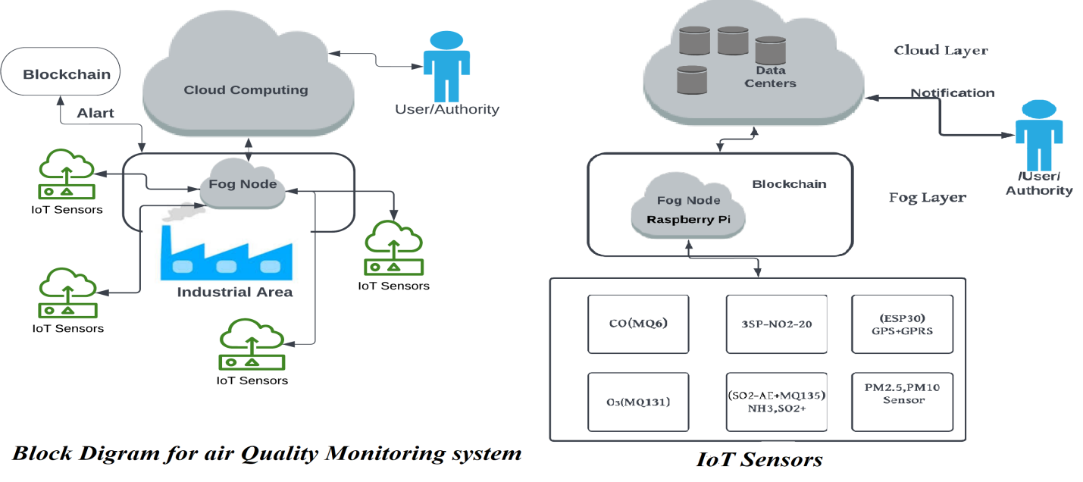 FIG 1 A)block diagram for air quality monitoring system B) IoT Sensors

System Overview
This system can be deployed over the critical and local regions where the chemical industry is surrounded by citizens. This system continuously measures the pollutants such as NOx, COx , SO2, PM2.5. The sensors are purposefully placed to capture the air pollutant. The generated data is transferred to nearby fog nodes. These fog nodes are generally worked as local processing units closer to the data source. This fog nodes have computation power for small scale of and particular data so system reduce dependence on centralised cloud servers, In that way we minimize latency and single point failure risk. After validating and prepossessed transaction of pollution alert sent to Blockchain layer for immutable storage and execute the automate alert, report to all stockholders
Fog Node Layer
The Fog nodes are generally done pre-processing of data which is generated by sensor networks. Fog nodes have limited storage capacity so they can process data which is more than the threshold limit. They are placed nearer to the sensors so that low latency and there are more fog notes are placed in the system so that single point failure does not arise. These nodes serve as the first line of defense against noisy, incomplete, or malicious sensor data. Data streams arriving from sensors via HTTP or lightweight IoT protocols such as MQTT are subjected to preprocessing operations, including noise filtering, outlier detection, and correction for environmental factors like humidity and temperature fluctuations common to Mumbai’s coastal climate.
Fog nodes are connected with multiple sensors which generally produce continuous data. Fog node Collects all dataset of pollutants like COx, SOx, PM2.5. The combination of all type data done at the fog node. Next step summarization process in which calculate the AQI and analysis result forwarded to the next level of fog computing. In case some variance detected any node that time before going to blockchain, the transaction checked the result with another fog node which is placed near to that node. After validation of the result the alert is generated and sent to local stockholders. This type of process of fog node reduces the overhead of the network and only analyses data is forwarded to the network.
Blockchain Layer
The Blockchain technology is open, immutable, transparent and trustworthy to all stockholders. Blockchain based transactions cannot modify or delete so that's why it is tamperproof. All types of data are placed on Blockchain transactions so that trust and transparency is maintained between all stockholders like industries, regulators and the citizens of the local area. Permission less Blockchain architecture system is developed in which no any number of persons can be added in the network. The proof of work (PoW) Consensus mechanisms is used for validation of the transactions effectively.

Smart Contract Functionality

Smart contracts are the self-executing programs where the predefined condition meets the contracts that are automatically executed. If any pollution control rules are violated then the smart contract executes and gets alert to all stockholders. So that necessary actions should be taken by pollution regulation bodies like the central pollution control board(CPCB) or Maharashtra pollution control board (MPCB). The action taken by this regulatory body can be sent to Blockchain next transaction so that citizens of that local area get acknowledged for transference of the air quality monitoring system.

After alerting smart contracts can enforce the regulatory body to automatically trigger the penalties or challans for air pollution. This smart contract helps for legal verification for transparent mechanisms for air pollution management systems. Only taking care of all fog nodes should work effectively. The faulty node should be detected and replaced so that false alerts can be avoided.

Integration and Benefits
The air quality monitoring system is integrating with new technology like advanced sensors, Blockchain technology and fog computing so we overcome the challenges like high latency, scalability, security and transparency. Fog node helps the real time data aggregation and generates results into execution of smart contracts. Blockchain provides permanent and temper-proof transactions of environment data. This type of architecture is helpful for controlling air quality monitoring for local industry.

SYSTEM IMPLEMENTATION

Hardware and Software Setup
The air quality monitoring system involves the arrangement of low cost IoT sensors, Fog nodes and blockchain based smart contracts. For air pollution detection MQ6 is used for COx and 3SP for NO2 and ESP30 for Gprs , particulate matter sensors (PMS5003) and gas sensors (MQ135). Raspberry Pi devices are used for connecting all these sensors. It is used for preliminary data collection and analysis. Raspberry Pi is used as a fog node for fog based layers which have sufficient computation ability, compact size, and lightweight data analysis. It handles the HTTP requests from sensors and manages real time data between blockchain contracts and sensors.

The blockchain layer is implemented on the Ethereum network, where we deploy smart contracts. Solidity is used to write smart contracts where rules and regulations are decided by the central pollution control board. The smart contract automatically executes when it meets the conditions and generates the alert for all stockholders. Web3.py library used for application to connect with ethereum nodes and execute blockchain transactions

Sensor Data Collection and Processing

Air quality monitoring data is collected through sensors in a regular time interval of10 seconds. Data is collected and passed through each fog node where the noise as well as irrelevant values generated by faulty sensors are removed. The pre-processing is done using an algorithm which includes outlier detections, thresholds of each pollutant and averaging the reliable data streams. After cleaning data in real time to detect pollutant spikes and calculate which pollutant is increasing in the atmosphere, calculate the air quality index and generate the alert according to smart contracts.

Smart Contract Deployment

The smart contract was designed and developed in solidity and deployed on the Ethereum network. The smart contract is responsible for storing the alerts generated by the IoT sensors. Due to blockchain technology used for development of smart contracts they are stored data distributed in nature so that every stockholder has one copy of data because of that it is immutable. Whenever the alert generates this data is shared to all nodes present in the blockchain network. The alerts are stored for forever in the blockchain link and regarding what actions are taken by regulatory authorities are also saved as one transaction. Furthermore, we can give penalties and generate challan in this system so that the process becomes transparent and automated without human intervention.

Integration and Testing

The prototype system is designed and developed according to hardware and software requirements. All sensors are generating continuous stream data and analyzed by fog nodes where successfully filtered all types of noisy and sudden spike data. After generating alerts comparing with another fog node data so that data should be correct. After Pollution alert generation smart contracts should be executed and store the transaction. Raspberry Pi is used as fog nodes, IoT sensors and ethereum smart contracts system which is reliable and suitable for local area real time air quality monitoring systems.

EVALUATION AND RESULTS
Latency Reduction
The integration of fog nodes in the system architecture resulted in a significant reduction in latency when compared to conventional cloud-based approaches. By performing pre-processing and anomaly detection locally at the fog layer, the system minimized the need for frequent communication with centralized servers. Experimental results showed that the fog-based implementation reduced overall data processing and transmission time by approximately 40%, thereby enabling near real-time insights into air quality conditions.
Security and Data Integrity
The centralized system can be managed by unauthorized access and modification can be done by any stockholder to overcome this problem. Blockchain based smart contracts are used for immutable and transparent data sets for a long time. Each pollution alert is generated using proper validation of neighbouring fog nodes and stored that alert smart contract. Using this technology, we eliminate human intervention for data validation. Data Integrity is maintained by this system by data analysis and processing at fog nodes and making average for data validation.

Scalability and Reliability
The proposed system was evaluated in a scalability test in which the number of sensors are increased and latency checked in different environments like Cloud based air monitoring system and fog based system. Cloud based system latency is increased due to distance of sensor nodes and cloud server. All data sets are sent to the cloud and analysis and alert generation takes more time. On other hand Fog computing gives proper result in less time less overhead is generated over the network. Fog based system performance is better than cloud based system for this local system. So that the result indicates that fog based architecture can handle efficiently in increasing the sensor data without change in performance. This system is not dependent on the single fog node that’s why single point failure is not possible as blockchain technology is distributed in nature so data is stored in various nodes. So this system is more fault tolerant and reliable for local air environment monitoring systems.

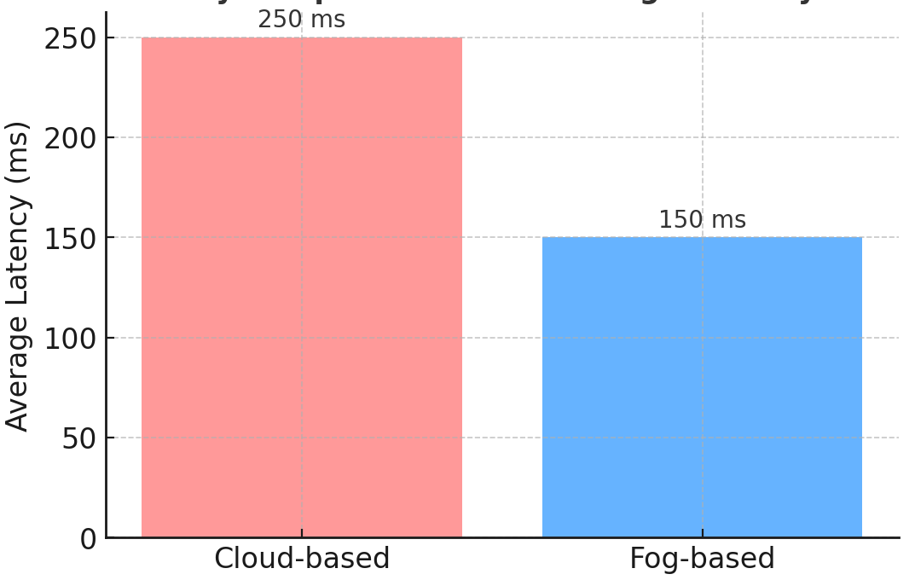 | 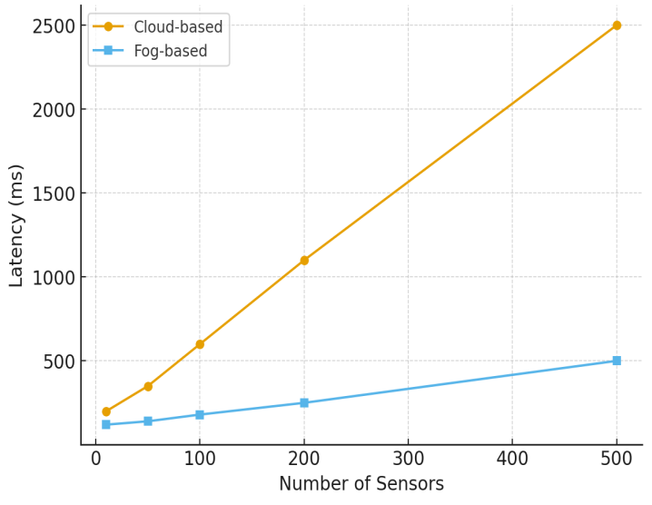
FIG 2. A) Latency Comparison Cloud-based Vs Fog Based System B) Scalability Test : Latency vs Numbers of Sensors

CONCLUSION

Fog computing and blockchain based air quality monitoring system design and development to meet the limitation of traditional cloud based air quality monitoring systems. Fog nodes are located at the edge or near to the sensor so that data operations like data pre-processing, analysis is done on the fog node layer and improve the response to the next layer. The fog node failure can be detected using mismatching results with other fog nodes that can check and remove that fog node. Blockchain technology is used for decentralised systems. All transactions are sheared to all stockholders so that transparency is maintained. The smart contracts are immutable so that integrity of data is maintained. The data modification cannot be happening because of distributed ledger so that unauthorised modification and tempering of data is highly impossible. The Result analysis of comparing cloud and fog computing, fog computing reduces the latency and improves the scalability for local area networks. Fog computing saves the bandwidth and there is no single point failure but fog nodes have less amount of memory to store the data so that average data is stored on cloud so that long term pollution analysis can be evaluated. Future work will focus on extending the system to monitor a broader range of environmental parameters, including toxic industrial emissions and volatile organic compounds (VOCs), particularly relevant to chemical and industrial zones. Furthermore, the incorporation of machine learning techniques at the fog node layer will enable predictive analytics, allowing proactive identification of pollution trends and early warnings. This direction has the potential to transform air quality monitoring systems into intelligent, self-adaptive frameworks that can support sustainable urban development and informed policymaking.

ACKNOWLEGEMENT

I would like to express my sincere gratitude to my esteemed guides, Dr. A. W. Kiwilekar and Dr. L. D. Netak, from Dr. Babasaheb Ambedkar Technological University, Lonere Maharashtra , for their invaluable guidance, continuous encouragement, and insightful suggestions throughout the course of this research work. Their expertise and constructive feedback have been instrumental in shaping this study and improving the quality of my research.

.

REFERENCES
- K. C. Serdaroglu, Ş. Baydere, B. Saovapakhiran and C. Charnsripinyo, "Location Aware Fog Computing Based Air Quality Monitoring System," 2023 International Conference on Smart Applications, Communications and Networking (SmartNets), Istanbul, Turkiye, 2023, pp. 1-6.
- A. K. Hassan, M. S. Saraya, A. M. T. Ali-Eldin, and M. M. Abdelsalam, “Low-Cost IoT Air Quality Monitoring Station Using Cloud Platform and Blockchain Technology,” Appl. Sci., vol. 14, no. 13, p. 5774, 2024.
- S. Stankiewicz, “AirChain: A Novel Blockchain Framework and Low-Cost Device for Democratized Air Quality Data Aggregation,” arXiv preprint arXiv:2408.05216, 2024.
- T. Johnson and K. Woodward, “Enviro-IoT: Calibrating Low-Cost Environmental Sensors in Urban Settings,” arXiv preprint arXiv:2502.07596, 2025.
- C. Vyas, H. Gupta, and S. Sahu, “Blockchain and Fog Computing for IoT-based Smart Cities,” IEEE Internet of Things Journal, vol. 9, no. 16, pp. 14312–14325, Aug. 2022.
- Ullah, M. K. Khan, and A. Al-Dhelaan, “Privacy-preserving data sharing using blockchain in IoT-enabled smart cities,” Future Generation Computer Systems, Elsevier, vol. 145, pp. 423–435, Oct. 2023.
- M. A. Hassan, Y. Li, and P. Zhao, “AI and Blockchain-enabled IoT Framework for Smart Cities,” Cluster Computing, Springer, 2024
- Y. Ma, H. Wang, and K. Liu, “Blockchain and Edge Computing for Industrial IoT in Environmental Monitoring,” IEEE Transactions on Industrial Informatics, vol. 19, no. 6, pp. 7892–7903, Jun. 2023
- E. S. Babu, M. S. R. Rao, G. Swain, A. K. Nikhath, and R. Kaluri, “Fog-Sec: Secure End-to-End Communication in Fog-Enabled IoT Network Using Permissioned Blockchain System,” Int’l Journal of Network Management (Wiley), vol. 33, no. 5, e2248, Aug. 2023
- A. N. Alvi, B. Ali, M. S. Saleh, M. Alkhathami, D. Alsadie, and B. Alghamdi, “Secure Computing for Fog-Enabled Industrial IoT,” Sensors (MDPI), vol. 24, no. 7, 2098, Apr. 2024.
- Arvind W. Kiwelekar, Pramod Patil, Laxman D. Netak, and Sanjay U.Waikar. Blockchain-Based Security Services for Fog Computing, pages 271–290. Springer International Publishing, Cham, 2021.

