“Distributed Vibration Detection System based on Michelson’s Interferometer Configuration”
Ms. Pratibha Sajwan^{1, a)} Dr. Lochan Jolly^{2, b)} Dr. Sujata Alegavi^{3, c)} Dr. Arpit Rawankar^{4, d)}
^{1,} Assistant Professor,^{2,} Professor,^{3,4,} Associate Professor
¹Department of Artificial Intelligence & Data Science,^{2,4}Elctronics and Telecommunication Engineering,²Internet of Things
Thakur College of Engineering & Technology
Mumbai, India

Corresponding author: ^{a)} pratibha.sajwan@tcetmumbai.in
^{b)} lochan.jolly@thakureducation.org
^{c)}sujata.algavi@gmail.com
^{d)} arpit.rawankar@thakureducation.org
Abstract. A novel approach to ground vibration prediction, leveraging the power of sensor-based networks and advanced non-contact type techniques is presented through the research. The implications of the model also extend to a wide range of applications such as the assessment of structural integrity, environmental impact assessment and urban planning. Continuous data collection and model refinement has the potential for enhancing the prediction model. Recommendations for data transmission, optimizing sensor placement and model training are provided to improve system’s cost-effectiveness. The optical sensor system i.e Michelson Interferometer will detect the ground vibrations in non-contact mode and provide the necessary data which results in forecast of ground vibrations in various environments. Ground vibrations, resulting from activities such as construction, mining, and transportation, can have significant impacts on nearby structures, human comfort, and the environment. With the help of this model, we can develop an accurate and efficient prediction model that give immense value for old heritage structures and buildings. We efficiency of the model is so efficient that is can monitor the lowest frequency from 2 Hz to 500 Hz.
Keywords— Ground Vibrations; Michelsons Interferometer; sensor system; Homodyne; Anomaly; Heterodyne;

INTRODUCTION
Ground vibrations brought on by a variety of human activities, such as drilling, construction, and the transportation of large vehicles, have a significant impact on the comfort, structural integrity, and environmental concerns of homes. To ensure the sustainability and safety of modern societies, it is necessary to understand and predict ground shaking. Building robust prediction models of ground vibrations is now possible because to recent advancements in sensor science and artificial learning techniques. This work's main goal is to create a system that uses sensor networks to predict ground vibrations in various situations. It does this by properly utilizing both machine learning and sensor network capabilities. Traditional forecasting techniques from the past, which were frequently based on speculative ideas and empirical linkages, may not have been sufficient to capture the adaptability and precision required to interpret real-world complexities. A feasible method that allows for data-based real-time forecasting is the employment of hybrid models combining machine learning strategies and networked sensors. It comprises the strategic placement of a network of sensors in seismically active regions. They constantly read and transmit data on critical factors like frequency content, acceleration, and displacement. These Data Collected are utilized as basis when training and testing the predictive model such that it is full and representative dataset. Machine learning programs, due to their capabilities of discovering correlations and patterns within huge datasets are utilized at the commencement of building the prediction model. Support vector machines, random forests, and neural Networks are amongst the tools employed when processing the data and selecting significant features. Feature engineering is then utilized to reduce the dimensionality of data and discover the best efficiency of the model. The developed model is tried and tested the derived prediction model is extensively tested against vibration detection through signal generator for observing and calculating accuracy and reliability. Model performance is evaluated through intercomparisons with industry benchmarks and other empirical models. To find out if a model can be used in different situations, you can look at how sensitive it is to other factors, like construction work, soil type, and weather. The goal of this study is to create a strong prediction model and show how it can be used in real life.
The frequencies of vibrations that are most harmful to buildings are usually between 0.1 Hz and ~20 Hz, though this depends on the height and natural frequency of the building. In this range, resonance can cause oscillations to get bigger, cracks to form, and even the structure to fall down.
- Building codes: High Vibration-resistant building codes can help to ensure that buildings can withstand the forces of an high frequency vibrations.
- Public awareness: Public education can help to raise awareness of the risks of earthquakes and teach people how to protect themselves during an earthquake.
- Disaster preparedness: Disaster preparedness can help communities to be better prepared for an earthquake by developing emergency plans and stocking up on supplies.

The primary focus of Designing and Constructing a Forecasting Model of Ground Vibrations utilizing the Michelson Interferometer. It is the result of the huge potential of combining sensor technology with machine learning algorithms. Sensor networks can always send and receive real-time data and can also offer and good dynamic view of ground vibration over time. It is a useful dataset with a lot of information that can be used to train and test prediction models, get insights from data, and make accurate predictions. Machine learning algorithms are defined by their ability to find patterns and relationships in large data sets. They hold the promise of highly predictive models that are always changing because of changing contexts and of making predictions in real time. It. Machine Learning algorithms defined by their ability at discerning pattern and relation from large data sets, have a promise of highly predictive models that are perpetually dynamic due to dynamic context and of generating real-time predictions. It can take account of complex interactions of numerous environmental and anthropogenic parameters, and infer in more predictable predictions and deep knowledge of ground vibration behavior.

LITERATURE SURVEY
Vibration Detection Using Michelson Interferometer Michelson interferometers were widely used in high-precision metrology and gained more use in vibration measurement because of their sub-nanometer displacement change detection feature. It is revealed by [1][2] that low-power laser sources can be used by Michelson-based configurations for the detection of micro-vibrations on reflective surfaces and hence are convenient when it comes to structural health monitoring.
. Usage in Structural Health Monitoring (SHM)-In [3][4], vibrations of heritage structures were monitored using an optical interferometric system while physical sensors were not introduced into the building. The system was proven to have higher sensitivity and did not disrupt the integrity of the heritage site and was therefore non-invasive.
Comparison with Traditional Sensors-In comparison with traditional accelerometer-based systems, [5][6] found that although contact-based sensors were challenged when it came to calibrating against drift and environmental noise, optical interferometers reliably offered cleaner output signals and greater operational life when deployed within inaccessible or sensitive regions.
Vibration Isolation and Sensitivity Enhancement: To detect low-frequency ground tremors, [7][8] created a Michelson Interferometer platform system that is vibration-isolated. They employed passive isolation while applying dampening materials and active isolation while applying feedback loops. The sensitivity of the system was increased to a level 40% greater than that of non-isolated schemes. This proposed non-contact type of sensor system will be employed to measure ground Vibrations. Proposed approach consists of designing and developing a Michelson Interferometer setup suited for ground vibration measurement in a non-contact manner. It works upon the phenomenon of measurement of phase variation in the interference pattern formed due to reflections coming from a solid reference mirror and a vibrating ground floor. Such phase variations associated with physical changes in position are interpreted by either homodyne or heterodyne detection schemes.[9][10] Procedure consists of the following below steps:
A. Algorithm
Michelson Interferometer –
• Michelson Interferometer is a device employed in the measurement of small displacements, refractive index
Changes and other physical parameters such as vibrations, amplitude and Intensity depending upon interference of light waves.
• It was discovered in 1881 by Albert Michelson and is used extensively these days even in physics, etc.,
engineering and biology.
• A beam splitter, two mirrors, and a detector constitutes a Michelson Interferometer. It consists of a light
It is a beam directed at the beam splitter. It divides the light into two beams and they proceed along two paths.
• The beams reflected by the mirrors.
•The pattern of interference is made up of a series of dark and bright fringes caused by the constructive and destructive interference of the two beams of light.
• The Michelson Interferometer can be utilized to find the space between the mirrors, variations of refractive index of a medium, and the wavelength of light.
• The Michelson Interferometer is equally applied in Fourier transform spectroscopy, laser stabilization, and detection of gravitational waves.
• The Michelson Interferometer is a very precise tool and can be utilized when appropriate to reveal displacements of a fraction of a nanometer.
Because of its accuracy, dependability, and versatility, the Michelson Interferometer is used extensively in both industry and research.
• Photodetector: It recognizes the recombined beams and converts the interference information pattern into an

electrical output.
• Signal Processing Unit: It generates vibration parameters based on the detected incoming signal. Correlation maps and statistical summaries provided some insight into the connection between fall detection and features.

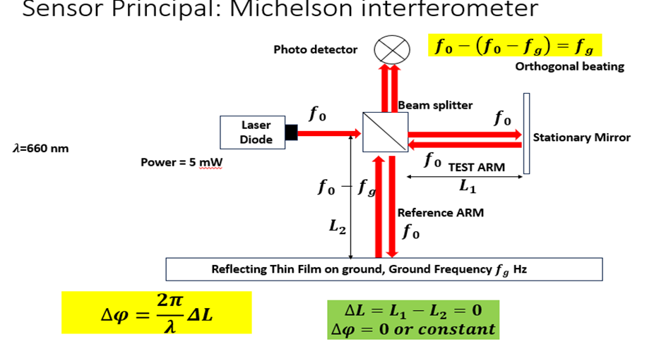

FIG 1: Detailed Description of Michelson Interferometer model.

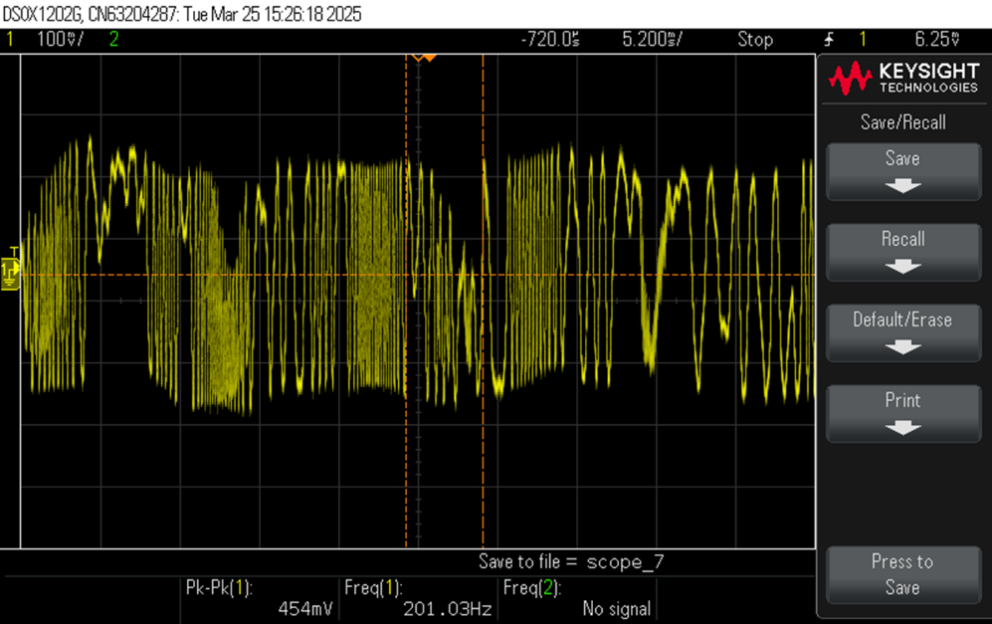

FIG 2: Reading recorded with the help of Michelson Interferometer setup.

- The measured signal is not purely sinusoidal but contains distortions and amplitude variations, possibly due to external noise, interference, or vibrations in the system under test.
- The relatively low frequency (≈201 Hz) suggests the source may be a vibration signal, mechanical oscillation, or low-frequency modulation captured through a sensor setup.
- The peak-to-peak value (454 mV) indicates the strength of the oscillation being measured, suitable for low-voltage sensing experiments.

The oscilloscope measurement shows a distorted/modulated waveform with a fundamental frequency of 201.03 Hz and a peak-to-peak amplitude of 454 mV. This means that there is a low-frequency oscillatory signal, which could be caused by vibrations or modulation effects from outside sources.[11][12]

B. Experiential Setup

TABLE 1: Components Requires for the set up
Component | Specification
Laser Source | Diode Laser, 650 nm, 5 mW
Beam Splitter | 50:50 Non-Polarizing Beam Splitter Cube
Mirrors (M1 & M2) | Front-coated plane mirrors
Optical Breadboard | Vibration-isolated (dual-layer with buffers)
Photodetector | Silicon PIN photodiode with preamp
Data Acquisition System | Oscilloscope / DAQ card connected to PC

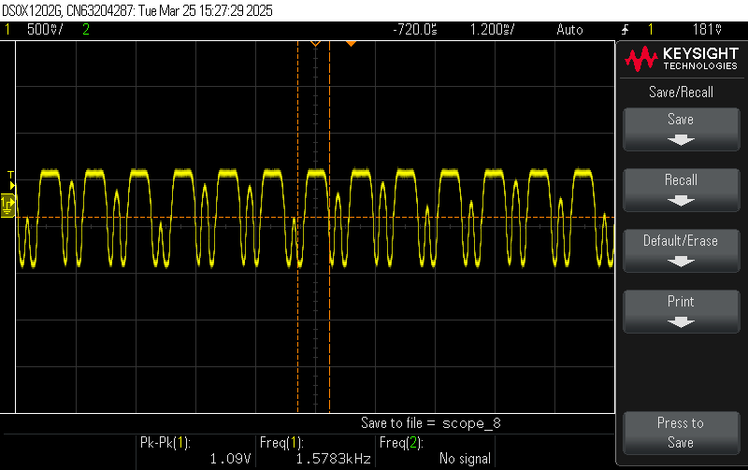
FIG 3: Low frequency vibration detection upto 2 HZ

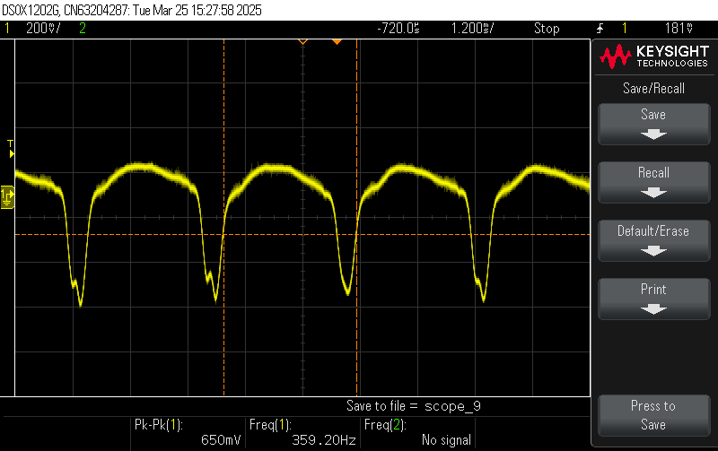
FIG 4: High frequency vibration detection upto 350 HZ
The gyroscope and accelerometer readings were regressed back onto comparable scales. The data was then divided into windows that were evenly spaced, corresponding to tiny activity patches and divided by two to three second intervals. Noise filtering and missing value management were used to add more quality to the data for greater coverage of data Components Used- For Single Model

RESULT
Variations in the Interference Pattern: Under typical circumstances, the Michelson Interferometer was able to generate stable interference fringes. Fringe shifts were seen when controlled vibrations were introduced, demonstrating the system's capacity to identify ground displacements. sensitivity to vibrations from the ground. Both high-amplitude vibrations from 400 Hz to 500 Hz and low-amplitude vibrations from 1 to 10 HZ (in the micrometre range) were highly precisely detected by the system. And Higher amplitude vibrations caused noticeable shifts in the interference pattern, demonstrating the system’s responsiveness. Real-Time Data Processing with NI My RIO: My RIO effectively captured and processed vibration signals, enabling real-time monitoring. Signal filtering techniques helped reduce noise and improve data accuracy.

CONCLUSION
The proposed vibration-free setup using two optical breadboards, shock absorption device as isolators, and buffers as dampers effectively minimizes vibrations on the upper board. Mechanical isolation using crazy balls significantly reduces high-frequency vibrations, preventing external disturbances from affecting the interferometer. The transmissibility ratio approaches zero for high-frequency ground vibrations, ensuring that the upper board remains stable. Buffers provide damping, preventing residual oscillations, making the system resistant to ground tremors. This setup allows the Michelson Interferometer to detect low-frequency seismic waves accurately, making it a promising method for earthquake vibration monitoring without external noise interference. Thus, this system can be used as a high-precision seismometer for detecting earthquake-induced ground vibrations by observing the phase shift in the interference pattern.

REFERENCES

- Shengfu Gao , Guohau Zhang ,Hao Li, Mishang qui, Ambing Wu (2024) Deep transfer Learning Based Bearing Fault Detection Method for Valve Cooling System.
- Aparna Sinha, Debanjan Das (2023) Machine Learning -Based Explainable stator Fault Diagnosis in Induction Motor using Vibration Signal
- Jun-Ki-Hong, Yang Kyoo Lee (2021) LLSTM -based Anomal Motor Vibration Detection, Machine Learning techniques for vibration
- Ahmed Shehata, Omar D. Mohammad (2024) Machine Learning techniques for vibration -based Condition Monitoring -A review,
- Xian Yeow Lee* , Aman Kumar*, Lasitha Vidyaratne*, Aniruddha Rajendra Rao*, Ahmed Farahat, Chetan Gupta, C. (2023). An ensemble of convolution-based methods for fault detection using vibration signals in IEEE International Conference on Prognostics and Health Management (ICPHM)
- Radmilovic, Z., Zehetner, J., & Watzenig, D. (2014). An ensemble of convolution-based methods for fault detection using vibration signals International Conference on Prognostics and Health Management (ICPHM)
- Nick, W., Asamene, K., Bullock, G., Esterline, A., & Sundaresan, M. (2015). A study of machine learning techniques for detecting and classifying structural damage. International Journal of Machine Learning and Computing, 5(4), 313.
- O. Avci, O. Abdeljaber, S. Kiranyaz, M. Hussein, M. Gabbouj, D. J. Inman, A review of vibration-based damage detection in civil structures: From traditional methods to machine learning and deep learning applications, Mechanical systems and signal processing 147 (2021)
- K. Vos, Z. Peng, C. Jenkins, M. R. Shahriar, P. Borghesani, W. Wang, Vibration-based anomaly detection using lstm/svm approaches,
- Mechanical Systems and Signal Processing 169 (2022) 108752
- Mitchell, T. (1997), Machine Learning , McGraw-Hill Education .
- X. W. Ye, T. Jin, C. B. Yun, A review on deep learning-based structural health monitoring of civil infrastructures, Smart Structures and Systems 24 (2019) 567–585

