Overview of Agricultural Harvesting of Fruits in India and Other Countries

Archana Talhar Belge^{1,a,*}, Pankaj Shelar^{2,b}, Kshama Shukla^{3,c}
(^{a,b,c} (Department of Mechanical and Mechatronics Engineering, Thakur College of Engineering and Technology/Mumbai University, Mumbai, Pincode 400101, India.) )
.

archana.belge@thakueducation.org
Abstract. Since two-thirds of India's population depends on agriculture for their livelihood, it is an important sector of the country's economy. Improving agricultural production is essential as the population expands and the need for food increases. This essay highlights developments, difficulties, and innovations in fruit harvesting methods in India and other nations. To encourage the comprehensive expansion of the horticulture industry, the Indian government has launched programs such as the Mission for Integrated Development of Horticulture (MIDH), which places a strong emphasis on post-harvest management, technology development, and research. Despite these efforts, challenges such as policy inconsistencies, accurate fruit localization, adaptability of robotic systems, and efficient component design persist. In order to maximise fruit harvesting and solve the problems of labour shortages, environmental variability, and system inefficiencies, nations such as the USA, Korea, and Taiwan. This study examines existing research, technological advancements, and innovative strategies in fruit harvesting, proposing actionable solutions for improved productivity and sustainability. Recommendations include the adoption of AI-driven imaging techniques, modular robotic systems, and interdisciplinary approaches to enhance efficiency and reduce dependency on manual labor.
Keywords- Agriculture, Fruit Harvesting, Horticulture, Robotics, Artificial Intelligence, IoT Robotics, Artificial Intelligence, IoT
INTRODUCTION
Agriculture forms the backbone of India's economy, providing a livelihood for nearly two-thirds of the population. With the nation's growing population and increasing demand for food, agricultural production must keep pace. Industrialization is essential for national progress, but sustainable agricultural growth is equally vital for long-term economic stability [1]. The Mission for Integrated Development of Horticulture (MIDH) is a centrally sponsored initiative aimed at the holistic growth of the horticultural sector. This includes fruits, vegetables, root and tuber crops, mushrooms, spices, flowers, aromatic plants, coconut, cashew, cocoa, and bamboo. The Government of India (GOI) funds 85% of developmental programs in all states except the Northeast and Himalayan states, where it provides 100% funding. Additionally, GOI fully supports initiatives for bamboo development and the programs of the National Horticulture Board (NHB), Coconut Development Board (CDB), Central Institute for Horticulture (CIH), Nagaland, and the National Level Agencies (NLA). The key objectives of this mission include [2]:Encouraging farmers to organize into groups such as Farmer Interest Groups (FIGs), Farmer Producer Organizations (FPOs), and Farmer Producer Companies (FPCs) to benefit from economies of scale. Promoting regionally tailored strategies for horticultural development, including research, technology, post-harvest management, processing, and marketing, based on agro-climatic conditions. Enhancing horticultural production, increasing farmers' income, and strengthening nutritional security. Improving productivity through high-quality planting material and efficient water-use techniques such as micro irrigation. Providing skill development opportunities, particularly in post-harvest management and cold chain industries, to create employment for rural youth. The mission will use the following tactics to accomplish these goals: To ensure that growers and producers receive the right returns, (a) implement a comprehensive end-to-end approach that covers pre-production, production, post-harvest management, processing, and marketing; (b) support research and development technologies for cultivation, production, post-harvest management, and processing, with a particular emphasis on cold chain infrastructure to prolong the shelf life of perishables; (c) increase productivity through quality by: (i) diversification, from traditional crops to plantations, orchards, vineyards, flowers, vegetable gardens, and bamboo plantations. (ii) Providing suitable technologies to farmers for precision farming and protected cultivation in high-tech horticulture. (iii) Extension of orchard and plantation crop acreage, including coconut and bamboo, especially in states where horticulture accounts for less than half of the total agricultural area. (d) Enhance marketing infrastructure, post-harvest management, and value-adding processes. At the national, regional, state, and sub-state levels, (e) take a coordinated approach and encourage collaboration, convergence, and synergy between R&D, processing, and marketing agencies in the public and private sectors; (f) support FPOs and their partnerships with Market Aggregators (MAs) and Financial Institutions (FIs) to ensure farmers receive sufficient returns. (g) Encourage the development of human resources and capacity-building at all levels, including any necessary modifications to the graduation course curriculum and syllabus at colleges, universities, ITIs, and polytechnics.
Based on data from States, Union Territories, and other government source agencies, the Department of Agriculture and Farmers' Welfare has published the Third Advance Estimates of 2023–24 of Area and Production of different Horticultural Crops. Fig. 1 displays the Highlights of 2023-24 (Third Advance Estimates) [3]. (i) According to the Third Advance Estimates, the nation's horticultural output in 2023–2024 is projected to be approximately 353.19 million tones, a drop of almost 22.94 lakh tones (0.65%) from the Final Estimates for 2022–2023. (ii) According to final estimates, there will be an increase in the production of fruits, honey, flowers, plantation crops, spices, aromatics, and medicinal plants between 2023 and 2024. (iii) It is anticipated that fruit production will rise by 2.29 percent in 2023–2024 compared to 2022–2023, or to 112.73 million tones, mostly as a result of increased production of mangoes, bananas, limes and lemons, grapes, custard apples, and other fruits. However, compared to 2022–2023, it is anticipated that production of apples, sweet oranges, mandarins, guavas, litchi, pomegranates, and pineapple will decline. (iv) It is estimated that 205.80 million tonnes of vegetables will be produced. Tomato, cabbage, cauliflower, tapioca, bottle gourd, pumpkin, carrot, cucumber, bitter gourd, parwal, and okra output is anticipated to rise, while production of potatoes, onions, brinjal, elephant foot yam, capsicum, and other vegetables is anticipated to decline. (v) According to the Third Advance Estimates, the production of onions is anticipated to reach 242.44 lakh tonnes in 2023–2024. (vi) The country's potato production is predicted to reach approximately 570.49 lakh tonnes in 2023–2024 (Third Advance Estimates), primarily as a result of a decline in production in West Bengal and Bihar. (vi) According to Third Advance Estimates, tomato production is anticipated to reach 213.20 Lakh Tonne in 2023–2024, up from approximately 204.25 Lakh Tonne the previous year.
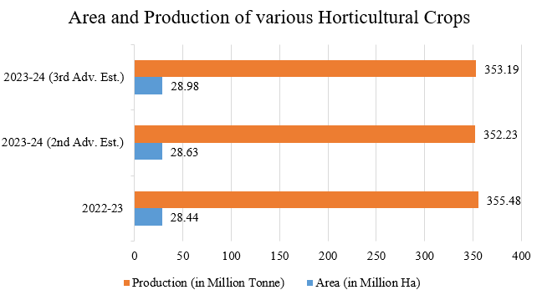
FIG.1. Area and Production of various Horticultural Crops [3]

INDIAN SCENARIO
The study critically analyses the advancements and difficulties of robotic arms for fruit harvesting in paper [4], focussing on the functionality and design of crucial parts including manipulators, vision systems, and end-effectors. Secondly, carried out rigorous study to identify technological gaps and propose strategies for improving system efficiency, adaptability, and affordability. Based on the gaps identified in the literature, the author concludes with recommendations for Incorporating AI and advanced imaging techniques, designing modular and multi-functional end-effectors and using lightweight, cost-efficient materials for manipulators.
In paper [5], authors conducted an extensive review of existing literature, reports, and studies on the cultivation, production, and economic significance of the Indian gooseberry (aonla). The review was based on: Government reports and statistics from the National Horticulture Board. Scientific articles and research papers on the cultivation practices, pest management, and benefits of the fruit. Data on the geographical distribution, production, and export trends of gooseberries in India. The author identified major pests affecting gooseberry cultivation, including Bark-eating caterpillars, fruit borers, aphids, and leaf rollers. It explored the impact of these pests on production and discussed current pest management practices in the field.
In paper [6], author focus on challenges persist due to policy inconsistencies, outdated regulations, and an unorganized agricultural sector struggling with systemic inefficiencies. The researcher presented the data to showcase Foreign Direct Investment (FDI) role in modernizing agriculture, enhancing productivity, and improving farmer incomes. The work concluded with recommendations for policy reforms to streamline FDI, address systemic challenges, and promote sustainable development in the sector.
The author of the study [7] suggests an inexpensive, Internet of Things-based smart solution that is simple to include into any fruit picker. The suggested approach aids farmers by serving as a tool for decision support during fruit picking. to identify the fruit on the tree and determine if it is ready for harvest. InceptionV3, ResNet50, and Mobile Net with transfer learning are three cutting-edge pertained image classification models that were employed. 400 photos gathered from the internet were used to train the model.

The review of the publication [Abdul Kaleem, Saddam Hussain] emphasises the dearth of reasonably priced robotic arms for controlled, selective fruit picking. It looks at studies conducted between 2000 and 2022, pointing out issues with manipulators, end-effectors, and vision systems.
The study emphasizes the need for advanced computer vision, adaptable kinematics, and specialized materials for efficient, gentle, and precise fruit harvesting.
In paper [N.B. Bharad & B.M. Khanpara], To address labor shortages and high production costs, robotic systems integrate computer vision, machine learning, sensors, actuators, and soft grippers for precise and efficient fruit harvesting. These systems enhance productivity and profitability by operating effectively under varying conditions, such as overlapping fruits and changing light. They promise improved sustainability, consistent yield quality, and reduced reliance on manual labor.
In paper [Shamshiri et al.], Precision agriculture robotics face challenges in weeding, scouting, and harvesting. Advances in multi-robot systems, swarm robotics, and task planning show promise, with the SWEEPER system nearing commercialization. Key issues include sensing, manipulation, and fruit detachment, requiring interdisciplinary efforts and improved sensors, deep learning, and integration for better speed and accuracy.
In paper [24], the authors of this work built an Automatic Fruit Plucking Machine that uses computer vision, robotic arm control, and machine learning techniques to automate fruit picking. Their work exhibits effective, damage-free fruit plucking using a robotic arm and fruit detection with high accuracy. The findings show better fruit quality, longer shelf life, and important advantages including fewer workers, cheaper production expenses, and higher fruit growers' output. Further field testing is advised to assess performance under actual farming settings. The authors also offer future improvements, such as improving robotic arm control, integrating sophisticated sensors, and optimizing machine learning algorithms.
In paper [33], the authors of this study suggested techniques for automated harvesting with robot arms and fruit localization outside. Using the SSD method, the system was able to recognize fruit outside with an accuracy of over 95%, even under backlit situations. Re-learning allowed detection to be adjusted to different fruit varieties, while multi-directional cameras helped to offset the accuracy decline for fruits obscured by leaves or clusters. Tests revealed that the harvesting time was 20 seconds per fruit or 10 seconds with dual-arm operation, which is similar to human performance and flexible enough to work with a variety of apples and pears.

STATUS OF OTHER COUNTRIES
In the paper [8], Based on the survey it is found that Vision challenges include accurate detection of fruits in dynamic environments, variability in lighting, and occlusion by foliage. Manipulators face issues in flexibility, kinematics, and adapting to diverse fruit sizes and orchard layouts. End-effectors need a balance between delicacy and efficiency, with different designs (e.g., suction, cutting, or grasping mechanisms) suited to specific crops.
In paper [9], This included evaluating cultivation trends, challenges, and market dynamics for five key berries like blueberries, black raspberries, black chokeberries, blackcurrants, and acai berries. Finally, the research concluded with improved farming techniques for disease prevention and yield optimization, explore innovative processing and marketing strategies to enhance consumer appeal for less popular berries, and Assess economic feasibility and long-term sustainability of small berry cultivation in different regions of Korea.
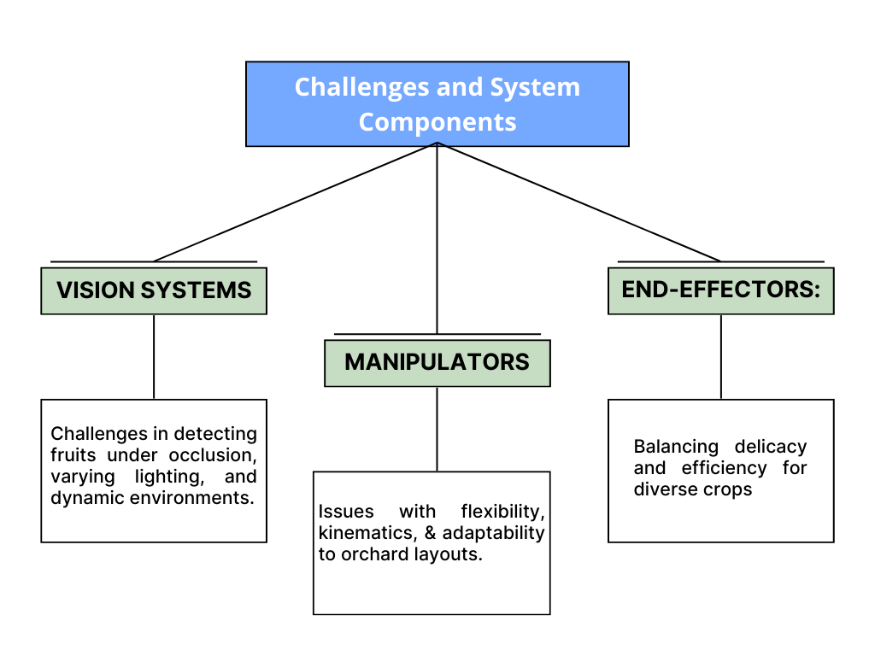
FIG.2 Challenges and System Components
In paper [10], The study aimed to assess the current status, challenges, and future potential of small fruit production in Taiwan, focusing on crops such as grapes, strawberries, mulberries, bayberries, kiwifruits, and Indian gooseberries. The primary goal was to explore strategies for improving production systems, introducing new cultivars, and optimizing Taiwan’s small fruit industry. The research highlights Taiwan’s capacity for developing unique and high-quality small fruits, aligning with growing consumer demand for functional and diverse fruit products. Additionally, the study provides valuable insights for bilateral agricultural collaboration between Taiwan and other countries, particularly Korea.
The authors of the research [11] talk on how agricultural technology, or AgTech, has advanced recently, increasing farm productivity and replacing tedious manual chores that are risky or ineffective for farm labour workers to perform by hand. Thus, SARDOG—a clever agricultural robot—was created and put into use. SARDOG aims to improve the efficiency, economy, and humaneness of several important farming operations while also implementing some novel, little-studied farming techniques.
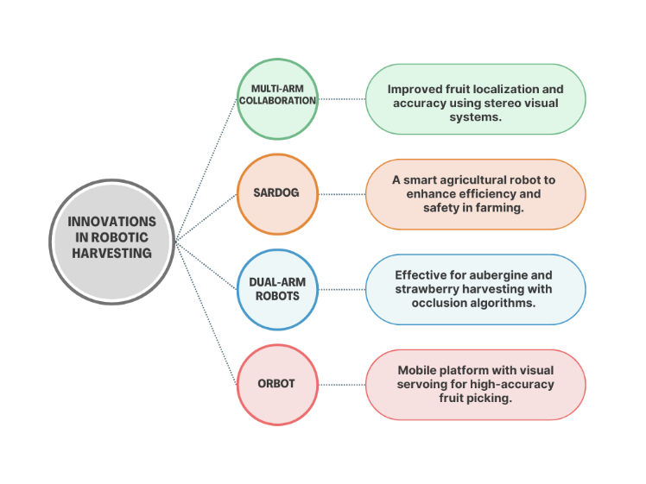

FIG.3 Innovations in Robotic Harvesting
In order to find the closest location of the arms' base frames to the trees inside an orchard row, robot-canopy non-interference geometric restrictions were added to the simulator in the paper [12]. Additionally, in order to quantify the impact of each of these limitations on the LFR, design constraints for such arms were created, including maximum reach, gripper size and type, and range of approach directions. The findings indicated that some SNAP-style tree species might be harvested using telescoping arms. Additionally, the design of robotic harvesters and fruit tree canopy management techniques can be guided by this concept.
The author of the work [13] suggests a technique for assessing the harvest ability of tomato fruit using a tomato harvesting robot.
The exact localisation of fruits utilising several stereo visual perception units in a multi-arm collaborative harvesting robot is the main emphasis of the work in paper [14]. The suggested approach lowers the likelihood of repeated erroneous detections and increases fruit localisation accuracy, according to experimental results. To demonstrate the efficacy of the suggested approach, point cloud data produced by the stereo cameras is shown visually.
A robotic harvesting system is used in the paper [T. Fujinaga, S. Yasukawa, and K. Ishii] to assess tomato fruit harvest ability. Harvest ability was evaluated quantitatively using a hand-mounted RGB-depth camera and qualitatively through greenhouse tests. One important indicator was the occlusion ratio, which was computed from RGB and depth images and demonstrated that decreased harvest ability is associated with increased occlusion. According to the study, the occlusion ratio's
In [K. M. Alaaudeen et al.'s paper],A robotic system with a low failure rate and great precision was created for autonomous fruit harvesting. It employed SSD contours for gripping point estimate and CNN-based fruit detection and segmentation with RGB-D pictures. With a cycle time of 6.3 seconds and reattempts below 12%, the system was able to recognise and grip fruit with over 95% success. Efficiency in both indoor and outdoor settings was demonstrated by the instance segmentation accuracy of 0.82.
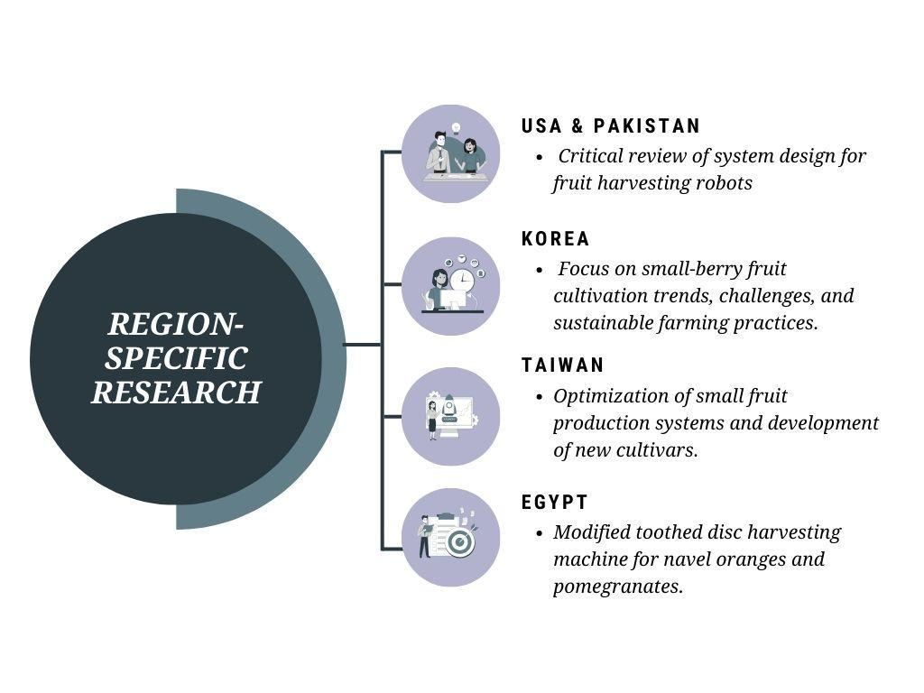
FIG.4 Region-Specific Research
In paper [Oliveira et al], A systematic review of 62 agricultural robotics systems addresses challenges like labor shortages, population growth, and resource efficiency. The study identifies trends and limitations in tasks such as planting, harvesting, and yield estimation, emphasizing improvements in locomotion, sensors, computer vision, and IoT integration. From 2014–2021, harvest success increased by 22.98%, and cycle times reduced by 42.78%. It recommends developing multi-purpose platforms and simple, efficient algorithms to improve robustness and usability.
In paper [Xiong et al.],A dual-arm robotic system was developed to address challenges in harvesting strawberries in cluttered environments. It achieved 50%–97.1% success on the first attempt, increasing to 75%–100% on the second, with picking speeds of 6.1s (single-arm) and 4.6s (dual-arm). Future work focuses on handling fully surrounded berries and improving field performance.
According to the research [Vrochidou et al.], detachment techniques, gripper types, and sensory control strategies provide difficulties for the development of robotic end effectors for fruit and vegetable harvesting. With applications concentrating on apples and tomatoes because of their uniform size and simplicity of detection, a review indicated that grasp-and-cut detachment and 2-3 finger contact-grasping grippers were the most effective. To improve end effector performance in the future, better sensors, clever control systems, and novel materials are needed.
Using a single RGB-D camera to split the field of view into tasks for two robotic arms, the authors of this study [25] created a "one eye-to-dual hands" vision servo system for grape picking. The system's performance was evaluated under various leaf shading conditions in a horizontal trellis environment. In 30 positioning accuracy tests, the harvesting success rate was 93.3% for 0–5% leaf shading, 86.7% for 6–20% shading, and 73.3% for 21–40% shading, with corresponding average harvesting times of 8.47 s, 8.23 s, and 8.66 s per grape cluster, respectively. Post-trellis performance testing yielded a visual positioning accuracy of 86.7%, with 13 out of 15 trials accurately identifying and harvesting grape clusters, achieving an average harvesting time of 8.76 s. These results demonstrated the system’s capability for rapid positioning and low-loss harvesting in real-world environments without neural network training. The authors noted that the harvesting speed still lags behind human performance.
In this study [26], The authors of this research examined how the visual unit functions in robotic harvesting systems, focusing on how it affects the working area and harvesting success rate in China. They concentrated on enhancing pose measurement, feature recognition, and steady photography in particular agricultural settings. The authors improved fruit target recognition, decreased system costs, and simplified vision system topologies by utilizing deep convolution networks and developments in RGB-D and laser sensors. Nevertheless, they noted difficulties in acquiring visual information, emphasizing the necessity of active fruit search techniques and a self-learning visual perception model to enhance flexibility and avoid obstacles in intricate agricultural settings.
In this study [27], the authors of this research created a harvesting robot called OrBot, which consists of a mobile platform, a personal computer, a For fruit recognition and steering, they created a visual servoing system that successfully centered the target fruit during fixation testing. These results demonstrate OrBot's potential for use in automated fruit harvesting in the future [28].
In this study [29], To improve harvesting success, the approach combines an occlusion algorithm, SVM pixel classifier. Either simultaneous dual-arm harvesting or single-arm operation is made possible by the planning algorithm, which decides arm movements based on workspace and fruit positions. By emulating human movements for fruit picking and leaf displacement, the occlusion algorithm overcomes visibility problems brought on by leaves. The system's effectiveness was confirmed by laboratory testing, which showed a 91.67% success rate in typical situations. These outcomes show how effective the system is and how it can advance automated aubergine harvesting.
The authors [30-32] have examined 47 applications from the previous 20 years based this research offers a thorough review of fruit harvesting robots.
. Re-learning allowed detection to be adjusted to different fruit varieties, while multi-directional cameras helped to offset the accuracy decline for fruits obscured by leaves or clusters. Tests revealed that the harvesting time was 20 seconds per fruit or 10 seconds with dual-arm operation, which is similar to human performance and flexible enough to work with a variety of apples and pears.
In this paper [34], Every robot has special features that help in harvesting. The sweet pepper robot achieves a high success rate by precisely detecting and gripping fruit using an inventive end-effector and vision system. For effective identification, the tomato robot uses a Kinect sensor for 3D location detection and color-based pattern matching. While the kiwifruit robot has an integrated grabbing-picking-sliding technique for the non-destructive harvesting of clustered fruits, the apple robot has a catching manipulator for precise and repetitive picking. In order to create sophisticated harvesting robots that will increase modern agriculture's production and sustainability, the study highlights the necessity of interdisciplinary cooperation.
In this paper [35], the authors have created a harvesting mechanism with a gripper and scissors that can each be operated independently by a single motor. The system successfully identified the coordinates of the fruit utilizing TVSM for depth measuring, combining a robotic arm, machine vision, and YOLOv3-tiny for apple recognition. To properly grasp the apple without using too much force, impedance control was used.

CHALLENGES OF FRUIT-HARVESTING
According to the study carried out in India and other countries following challenges were identified:
- Policy inconsistencies, outdated regulations, and an unorganized agricultural sector:
The fruit-harvesting business sector encounters substantial problems because of conflicting policies and outmoded laws and inadequate organization within the agricultural industry. The resulting confusion creates inefficiency as well as financial loss between farmers and harvesters and their stakeholder groups. Technology-based regulations fail to adapt to modern progress which slows down the integration of innovative harvest systems. When there is no united framework regulation barriers stop new competitors from entering the market which decreases both competition and innovation potentials..
- Accurate fruit localization in cluttered environments:
The accurate identification of fruits within crowded environment conditions remains a crucial issue in fruit-picking operations. The presence of leaves and branches and other items obscures fruits and leads to poorly visible targets for skilled harvesters to detect and effectively pick..
- Adaptability of robotic manipulators to various crop types and orchard layouts:
The challenge of robotic manipulators in fruit-harvesting relates to their capability of working with different crop types across diverse orchard layouts. Each agricultural breed demands special harvesting methods because it presents distinct features regarding its produce characteristics and branching elements. Plenty of variations occur in orchard layouts because tree spacing and pruning techniques and terrain features strongly impact the harvesting process. pruning practices, and terrain affecting the harvesting process. Robotic manipulators must be designed to adapt to these variations, requiring advanced sensors, machine learning algorithms, and flexible mechanical designs.
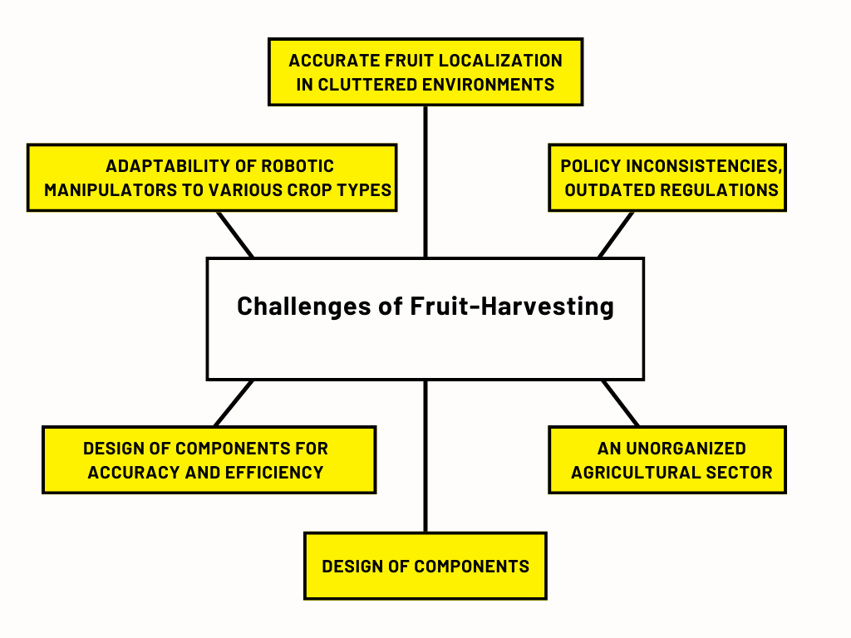
FIG.5 Challenges of Fruit Harvesting
- Design of components for accuracy and efficiency:
Device design represents a fundamental hurdle when it comes to fruit-harvesting operations. All components used for harvesting including grippers, cutters and conveyors must be designed to grip delicate fruits with both precision and gentle handling. Fruit-harvesting machines need components to work efficiently so that harvesting times stay brief and yields reach their highest possible levels. Material selection and mechanical design together with control systems testing must all be evaluated precisely for obtaining optimal performance.

PROBABLE SOLUTION TO MITIGATING CHALLENGES
5.1 Vision System Enhancement
The enhancement of vision systems faces significant challenges, such as difficulty in detecting fruits in occluded environments or under variable lighting conditions and the lack of robust algorithms for distinguishing ripe fruits from unripe ones. To address these issues, future work includes developing machine learning models trained on diverse datasets that incorporate various lighting conditions, fruit occlusion scenarios, and plant geometries. Multi-modal vision systems, combining RGB, hyperspectral, and depth cameras, will be employed to improve obstacle and fruit identification accuracy. Active learning methods will also be integrated to continually enhance detection accuracy in dynamic environments.
5.2 Tactile Sensing and Manipulation
Tactile sensing and manipulation require improvement due to the high incidence of fruit damage during detachment and the lack of precise tactile sensing for ripeness and stem strength assessment. Future developments include designing tactile sensors integrated with grippers to assess fruit ripeness and the structural integrity of stems. Gripper designs will be optimized to handle delicate fruits while minimizing damage to adjacent produce. Soft robotics technology will be utilized to create compliant end-effectors that adapt better to varying fruit sizes and shapes.
5.3 Obstacle Management and Path Planning
Robotic systems struggle with navigating complex environments featuring foliage and overlapping fruits, often leading to inefficiency and high time consumption in separating obstacles for fruit accessibility. To overcome these challenges, path-planning algorithms will be enhanced for dynamic obstacle avoidance and effective navigation in unstructured environments. Predictive algorithms for obstacle behavior will optimize the movement of robotic arms. Additionally, gripper-integrated obstacle separation techniques, such as pushing foliage aside, combined with real-time 3D mapping, will improve fruit accessibility.
5.4 Harvesting Speed and Efficiency
Current robotic harvesting systems are slower than human labor and consume significant energy due to inefficient movements and operations. Future advancements will focus on developing dual-arm or multi-arm systems with synchronized movements to reduce harvesting time. Energy-efficient actuation mechanisms will be optimized to prolong operation in field conditions. Reinforcement learning techniques will be explored to enhance robot performance through repeated field trials.
5.5 Data-driven Decision Making
Robotic decision-making is limited by the availability of real-time data and the lack of data integration across lifecycle stages. Future solutions include implementing IoT-based systems for real-time data collection on fruit location, ripeness, and environmental conditions.
CONCLUSION
Fruit harvesting faces several intertwined challenges across India as well as throughout different national territories Several intricate problems restrict the pace of fruit harvesting operations in India and similar nations and elsewhere. that reduce productivity and efficiency. The agriculture sector's lack of organisation, outmoded legislation, and inconsistent policies Various problems constitute the main challenges that researchers have documented shown to worsen operational inefficiencies. The situation becomes more challenging due to technological difficulties, which include major Accurate detection of fruit locations constitutes among those significant obstacles. in congested spaces and the ability of robotic manipulators to adjust to different crop varieties and orchard configurations. To Successful persistence would help defeat these difficulties. One needs to concentrate energy on designing basic robotic components properly. parts of robotic harvesting systems. Machine automation depends predominantly on visual technology for its operation. The technology requires dependable solutions capable of accurate detection between ripeness levels and distinction between fruit color and background color. accurately detect ripeness and differentiate fruits against similarly coloured backdrops. To guarantee smooth and dependable operation, The end-effectors require capable techniques to handle barriers during operations. including collision avoidance, effective contact-gripper designs, and the employment of cutting-edge materials in conjunction with precise kinematic configurations. The agricultural industry could transform toward a new strategy for production which requires better innovations. A solution will emerge through the development of efficient and sustainable techniques to deal with these issues. these structural and technological problems. Reducing labour dependency and increasing. The use of advanced technology may lead to a substantial increase in both efficiency levels and fruit production rates. revolution with the integration of cutting-edge technologies and governmental

REFERENCES
- Mubashir, Mohammad & Bhat, Arshad. (2021). Agriculture and Farming Community in India: Challenges, Problems and Possible Solutions.
- National Horticulture Board, “National Horticulture Mission”. https://www.nhb.gov.in/doc/Midhgl%20final(110214).doc
- Ministry of Agriculture & Farmers Welfare, Department of Agriculture & Farmers’ Welfare releases the Third Advance Estimates of 2023-24 of Area and Production of various Horticultural Crops,21 SEP 2024, https://pib.gov.in/PressReleasePage.aspx?PRID=2057249.
- Sawant, Shailesh & Lee, Byulhana & Janghoon, Song & Seo, Ho-Jin. (2023). Exploring Small-fruit Production in India: Present Landscape and Future Opportunities. Journal of the Korean Society of International Agriculture. 35. 104-111. 10.12719/KSIA.2023.35.2.104.
- Sawant, Shailesh & Lee, Byulhana & Janghoon, Song & Seo, Ho-Jin. (2022). The Indian Gooseberry (Emblica officinalis) Industry and Cultivation in India. Journal of the Korean Society of International Agriculture. 34. 199-204. 10.12719/KSIA.2022.34.3.199.
- Singh, Rajender. (2020). Foreign Direct Investment Inflows in Agricultural Sector of India: A Review.
- V. Meshram, K. Patil, V. Meshram, A. Dhumane, S. Thepade and D. Hanchate, "Smart Low Cost Fruit Picker for Indian Farmers," 2022 6th International Conference On Computing, Communication, Control And Automation (ICCUBEA, Pune, India, 2022, pp. 1-7, doi: 10.1109/ICCUBEA54992.2022.10010984.
- Kaleem, A.; Hussain, S.;Aqib, M.; Cheema, M.J.M.; Saleem,S.R.; Farooq, U. Development Challenges of Fruit-Harvesting Robotic Arms: A Critical Review. Agri Engineering 2023, 5, 2216–2237. https://doi.org/10.3390/agriengineering5040136
- Seo, Ho-Jin & Yoo, Hye-Gyoung & Ma, Kyeong-Bok & Hong, SeongSig & Lee, Byulhana. (2023). Current Status and Prospects of Small Berry Fruit Production in the Republic of Korea. Journal of the Korean Society of International Agriculture. 266-270. 10.12719/KSIA.2023.35.4.266.
- Seo, Ho-Jin & Yang, Sang-Jin & Janghoon, Song & Ma, Kyeong-Bok & Chen, Iou-Zen & Roan, Su-Feng. (2020). Current Status and Prospects of Small Fruit Production in Taiwan. Journal of the Korean Society of International Agricultue. 32. 31-37. 10.12719/KSIA.2020.32.1.31.
- H. Kulhandjian, Y. Yang and N. Amely, "Design and Implementation of a Smart Agricultural Robot bullDOG (SARDOG)," 2024 International Conference on Computing, Networking and Communications (ICNC), Big Island, HI, USA, 2024, pp. 767-771, doi: 10.1109/ICNC59896.2024.10556345.
- R. Arikapudi and S. G. Vougioukas, "Robotic Tree-Fruit Harvesting with Telescoping Arms: A Study of Linear Fruit Reachability Under Geometric Constraints," in IEEE Access, vol. 9, pp. 17114-17126, 2021, doi: 10.1109/ACCESS.2021.3053490.
- T. Fujinaga, S. Yasukawa and K. Ishii, "Evaluation of Tomato Fruit Harvestability for Robotic Harvesting," 2021 IEEE/SICE International Symposium on System Integration (SII), Iwaki, Fukushima, Japan, 2021, pp. 35-39, doi: 10.1109/IEEECONF49454.2021.9382603.
- F. Xie, N. Sun, J. Li, Q. Feng and T. Li, "Fruit Distribution Acquisition With Multi-Vision for Multi-Arm Harvesting Robots," 2023 8th International Conference on Control, Robotics and Cybernetics (CRC), Changsha, China, 2024, pp. 7-13, doi: 10.1109/CRC60659.2023.10488608.
- S. Bachche, “Deliberation on design strategies of automatic harvesting systems: A survey,” Robotics, vol. 4, no. 2, pp. 194–222, 2015, doi: 10.3390/robotics4020194.
- A. Kaleem, S. Hussain, M. Aqib, M. J. M. Cheema, S. R. Saleem, and U. Farooq, “Development Challenges of Fruit-Harvesting Robotic Arms: A Critical Review,” AgriEngineering, vol. 5, no. 4, pp. 2216–2237, 2023, doi: 10.3390/agriengineering5040136.
- K. M. Alaaudeen, S. Selvarajan, H. Manoharan, and R. H. Jhaveri, “Intelligent robotics harvesting system process for fruits grasping prediction,” Sci. Rep., vol. 14, no. 1, pp. 1–15, 2024, doi: 10.1038/s41598-024-52743-8.
- E. Vrochidou, V. N. Tsakalidou, I. Kalathas, T. Gkrimpizis, T. Pachidis, and V. G. Kaburlasos, “An Overview of End Effectors in Agricultural Robotic Harvesting Systems,” Agric., vol. 12, no. 8, 2022, doi: 10.3390/agriculture12081240.
- L. F. P. Oliveira, A. P. Moreira, and M. F. Silva, “Advances in agriculture robotics: A state-of-the-art review and challenges ahead,” Robotics, vol. 10, no. 2, pp. 1–31, 2021, doi: 10.3390/robotics10020052.
- et al., “Research and development in agricultural robotics: A perspective of digital farming,” Int. J. Agric. Biol. Eng., vol. 11, no. 4, pp. 1–11, 2018, doi: 10.25165/j.ijabe.20181104.4278.
- Y. Xiong, Y. Ge, L. Grimstad, and P. J. From, “An autonomous strawberry-harvesting robot: Design, development, integration, and field evaluation,” J. F. Robot., vol. 37, no. 2, pp. 202–224, 2020, doi: 10.1002/rob.21889.
- H. Zhou, X. Wang, W. Au, H. Kang, and C. Chen, “Intelligent robots for fruit harvesting: recent developments and future challenges,” Precis. Agric., vol. 23, no. 5, pp. 1856–1907, 2022, doi: 10.1007/s11119-022-09913-3.
- Seo, Ho-Jin & Yoo, Hye-Gyoung & Ma, Kyeong-Bok & Hong, SeongSig & Lee, Byulhana. (2023). Current Status and Prospects of Small Berry Fruit Production in the Republic of Korea. Journal of the Korean Society of International Agriculture. 266-270. 10.12719/KSIA.2023.35.4.266.
- Omkar Pati, Shivanand Nemane, Meet Nathwani, Saurabh Patil, “Automatic Fruit Plucking Machine Using Deep Learning”, International Journal for Research in Applied Science & Engineering Technology (IJRASET), ISSN: 2321-9653; IC Value: 45.98; SJ Impact Factor: 7.538, Volume 11 Issue XI Nov 2023- Available at www.ijraset.com
- Jiang Y, Liu J, Wang J, Li W, Peng Y and Shan H (2022) Development of a dual-arm rapid grape-harvesting robot for horizontal trellis cultivation. Front. Plant Sci. 13:881904. doi: 10.3389/fpls.2022.881904
- Li, Y.; Feng, Q.; Li, T.; Xie, F.; Liu, C.; Xiong, Z. Advance of Target Visual Information Acquisition Technology for Fresh Fruit Robotic Harvesting: A Review. Agronomy 2022, 12, 1336. https://doi.org/10.3390/agronomy12061336
- Bulanon, D.M.; Burr, C.; DeVlieg, M.; Braddock, T.; Allen, B. Development of a Visual Servo System for Robotic Fruit Harvesting. AgriEngineering 2021, 3, 840–852. https://doi.org/10.3390/agriengineering3040053
- El-Termezy G.A., A. I. Imam, Soha G. Abd El Hamid and Habiba E. Sabry, “Development of a Fruits Harvesting Machine,” Middle East Journal of Agriculture Research, Volume: 11, Issue: 01 Jan. – Mar 2022
- D. Sepúlveda, R. Fernández, E. Navas, M. Armada, and P. González-de-Santos, "Robotic Aubergine Harvesting Using Dual-Arm Manipulation," IEEE Access, vol. 8, pp. 121889– 121904, Jul. 2020, doi: 10.1109/ACCESS.2020.3006919.
- Zhou, H., Wang, X., Au, W., Kang, H., & Chen, C. (2022). Intelligent robots for fruit harvesting: Recent developments and future challenges. Precision Agriculture, 23(6), 1856–1907. https://doi.org/10.1007/s11119-022-09913-3
- Yuki Onishi, Takeshi Yoshida, Hiroki Kurita, Takanori Fukao, Hiromu Arihara and Ayako Iwai, “An automated fruit harvesting robot by using deep learning,” Onishi et al. Robomech J (2019), https://doi.org/10.1186/s40648-019-0141-2
- Yoshida, T., Onishi, Y., Kawahara, T., & Fukao, T. (2022), “Automated harvesting by a dual-arm fruit harvesting robot” ROBOMECH Journal, https://doi.org/10.1186/s40648-022-00233-9
- Meshram, V., Patil, K., Meshram, V., Hanchate, D., & Ramteke, S. D. (2021). Machine learning in agriculture domain: A state-of-art survey. Artificial Intelligence in the Life Sciences, 1, 100010. https://doi.org/10.1016/j.ailsci.2021.100010
- Hua, Y., Zhang, N., Yuan, X., Quan, L., Yang, J., Nagasaka, K., & Zhou, X.-G. (2019). Recent Advances in Intelligent Automated Fruit Harvesting Robots. The Open Agriculture Journal, 13, 101-106. https://doi.org/10.2174/1874331501913010101
- Bor-Jiunn Wen and Che-Chih Yeh, “Automatic Fruit Harvesting Device Based on Visual Feedback Control” Agriculture 2022, 12(12), 2050; https://doi.org/10.3390/agriculture12122050

