Performance Analysis of Nanofluids in Counterflow Heat Exchangers: A Comparative Study of Copper and Graphene Oxide
Dipesh Tare^{1,a,*}, Siddhesh Mane^{2,b}, Sachin Oak^{3,c}
(^{a,b,c} (Department of Mechanical and Mechatronics Engineering, Thakur College of Engineering and Technology/Mumbai University, Mumbai, Pincode 400101, India.) )
.

Dipesh.tare@thakueducation.org
Abstract. Heat exchangers are essential components of waste heat recovery systems because they facilitate the effective transfer of energy from high-temperature waste streams to secondary fluids. The performance of a counterflow heat exchanger employing different nanofluids to improve thermal efficiency is examined in this work. According to the findings, heat transmission is much enhanced by adding copper-ion nanoparticles to water as opposed to graphene oxide (GO)-based nanofluides. The superior aspect ratio and alignment efficiency of the Cu/water nanofluid result in a smaller pressure drop than the GO/water nanofluid, even though the inclusion of nanoparticles naturally causes an increase in pressure drop. According to the study, GO nanoparticles cause pressure variations, but Cu nanofluids improve thermal performance. Here, we demonstrate the crucial significance that nanoparticle characteristics play.
Keywords- CFD, Heat Exchanger, Waste Heat Recovery, Emission Reduction, Heat transfer, Nanofluids
INTRODUCTION
Energy efficiency has become a critical challenge across global industries due to the increasing demand for power and the simultaneous pressure to minimize greenhouse gas emissions. A significant portion of industrial energy is wasted as low- to medium-grade heat discharged into the environment.¹ Recovering this waste heat and reintegrating it into the production cycle not only reduces environmental impact but also translates into considerable cost savings for industries. Within this framework, heat exchangers occupy a central role, serving as indispensable devices that enable the transfer of heat between two working fluids while maintaining their physical separation.²
The selection of an appropriate heat exchanger configuration directly impacts the performance of waste heat recovery systems. eat exchanger type has a direct e˙ ect on the production proﬁle of waste heat recovery systems. Counterflow heat-exchange units are generally accepted as the most efficient type of design since they enable the hot and the cold feed to flow antiparallel. ³ This configuration allows for high temperature gradient through the exchanger length, and has a higher percentage of heat recovery compared to parallel flow or cross flow systems. Counterflow designs are highly efficient and are therefore especially suited to chemical processing applications³
Traditional heat exchangers achieve satisfactory performances, however, there has been an increasing interest in improving their thermal performance without significant increase in their size or in the amount of pumping power they require. In that context, nanofluid as the synthetic colloid suspension of nanoparticles in conventional fluids of water, ethylene glycol, or oil has been investigated. ⁴ For example, nanofluids have demonstrated significant enhancements in thermal conductivity⁸, ⁹, heat capacity ¹⁰ and convective heat transfer coefficients¹¹. Their advantages in performance are largely ascribed to the mechanisms spanning from Brownian motion of nanoparticles,
Copper nanoparticles have been heavily studied among other nanoparticles. Copper is desired for its high natural thermal conductivity for great heat dissipation when added in base fluids. ⁵ In addition, the simple process of preparing copper nanofluids and their low cost make them suitable for industrial applications on a large scale. On the other hand, GO nanofluids with their unique two-dimensional structure, large surface-to-volume ratio and adjustable thermal conductivity have attracted great attention. ⁵ These distinctive characteristics make GO effective for interacting with base fluids to enhance their thermal and rheological properties. Nevertheless, GO-based nanofluids exhibit a radically different behavior compared to metallic nanoparticles due to the particle geometry, aspect ratio, and stability of dispersion.

However, despite extensive work in this area, the comparison between copper and GO based nanofluids has not been fully developed for counterflow heat exchanger geometry. Before we begin, it is important to note that for a given nanoparticle loading, two dominant parameters are known to influence the thermal transport properties of nanofluids: the type of nanoparticles (Ming et al., 2007; Sekhar et al., 2009) which in turn also depend on the concentration of nanoparticles (Ren & Tzou, 2007; Wang et al., 2007) as well as the way the particles are dispersed (Das et al., 2007; Sundar & Singh, 2010), but to date little consensus exists regarding the “ideal” formulation which maximizes heat transfer enhancement while minimizing the penalty in pressure drop. ¹–⁵ Moreover, most studies either focus on theoretical predictions or simplified laboratory models, and hence lack experimentally validated application-oriented studies to pave the way for industrial deployment.
The current study aims to fill in this gap. The objective of this work is to learn about the performance trade-offs inherent in having different nanoparticle composition, paying particular attention to copper and GO based nanofluids when tested systematically in counter flow heat exchanger configuration. The research not only focuses on the intensification of heat transfer, but also the effect of this can be observed on the pressure drop, flow stability as well as energy efficiency. These results may facilitate the promising design of high-efficiency waste heat recovery systems, which will promoted in both environmental sustainability goals.
LITERATURE REVIEW

In the past 30 years or so, intensive studies have been made on heat exchanger and nanofluid, and more applications of them have been concentrated on waste heat recovery systems. This is especially true of counterflow heat exchangers, which are well known for providing high heat transfer effectiveness and all the advantages which ensue by achieving a higher temperature difference between the system and the working fluid. ¹–³ This unique design feature has inspired many studies aiming at their combination with new working fluids to increase energy recovery.
Meanwhile, nanofluids, which are prepared by dispersing nanoparticles into conventional based fluids, are well-investigated for their excellent thermal performances. 4–6 These fluids exhibit significantly enhanced thermal conductivity, convection heat transfer and net exchanger effectiveness relative to conventional coolants, thus providing a practical pathway toward the advancement of energy efficiency in industrial applications. The performance of nanofluids, however, is by no means consistent and is influenced by such factors as nanoparticle type, concentration, morphology, and dispersion stability. ⁷–⁹
Among many candidate, copper based nanofluids were widelyused, which is due to the highest mobilities of thermal conductivities ofcopper, which leading to ahighly improved heat transfer intensification whendeployed as exchangers. ¹⁰–¹² In the meantime, GO-based nanofluids have become another leading choice due to the high surface area, 2D structure, and chemical tunability of the GO particles. ¹³–¹⁵ These characteristic properties make GO suspensions to be of great interest, in particular in situations where high fluid–solid interactions are needed..
Beyond nanoparticle selection, other factors such as shape, aspect ratio, and particle alignment within the flow have been shown to critically influence thermal and hydrodynamic performance.¹⁶–¹⁸ A body of literature further emphasizes the importance of stability-enhancing techniques and dispersion mechanisms, since agglomeration or sedimentation can diminish the expected benefits of nanofluid use.¹⁹–²¹ Similarly, the thermal conductivity enhancement achieved by nanofluids is closely tied to the choice of base fluid, particle loading, and volumetric concentration.²²–²⁴
Experimental and simulation studies on Cu/water nanofluids consistently demonstrate higher thermal performance compared to GO-based systems.²⁵–²⁷ This superiority is attributed not only to copper’s higher conductivity but also to its favorable suspension behavior under flow conditions. In contrast, while GO/water nanofluids still outperform conventional fluids, their relative gains in thermal conductivity and convective performance are somewhat smaller.²⁸–³⁰ Importantly, the integration of nanoparticles also influences flow resistance: increases in concentration generally elevate viscosity, leading to higher pressure drops.³¹–³³
Recent developments have explored hybrid nanofluids and multi-particle formulations as strategies to balance thermal performance with flow stability.³⁴–³⁵ Such approaches underscore the ongoing efforts to optimize nanoparticle design, fluid composition, and exchanger configuration for industrial adoption. Collectively, these contributions confirm that nanofluids have transformative potential in heat exchanger applications, provided that nanoparticle type, concentration, and fluid dynamics are carefully aligned with system requirements.
Within this framework, the present study extends prior findings by performing a comparative analysis of copper- and GO-based nanofluids in a counterflow heat exchanger. By systematically varying nanoparticle concentrations and examining their impact on both thermal performance and pressure drop, the study aims to deliver new insights into the trade-offs that govern nanofluid integration in waste heat recovery systems.

MATERIALS AND METHOD
3.1 3D Modelling
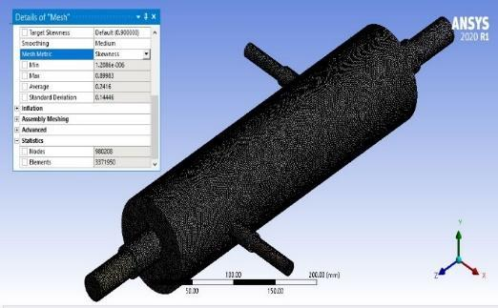
The counterflow shell and tube heat exchanger (STHE) geometry was designed using SpaceClaim, as illustrated in Fig. 1. It comprises an outer pipe, an inner pipe, and a main pipe, which facilitate the separation of cold, hot, and working fluid flow domains. Figure 1 provides a comprehensive overview of the model’s dimensions, as well as the configurations of the inner and outer pipes and the fin arrangement within the heat exchanger. Similar geometric configurations and CAD-based modelling approaches have been adopted in previous CFD investigations of nanofluid and food-processing heat exchangers.¹–⁶,¹¹
FIG 1: 3D model of a Heat Exchanger with refined mesh

3.2 Meshing
Figures 2 and 3 show how ANSYS was used to build hexahedral mesh elements. With 3,371,950 elements and skewness of 0.11, an aspect ratio of 3.07, and orthogonal quality of 0.89, the final model provided a high-quality and well-structured mesh enabling precise simulations.¹,²,⁷,⁸ By executing simulations using various mesh resolutions and comparing the results, a grid independence test has been carried out to evaluate mesh quality, in line with established CFD practices.⁹,¹⁰ To boost simulation accuracy, a coarse mesh with fewer elements was first created, then as the analysis went on, the component count was progressively raised. Finding the ideal mesh resolution that strikes a compromise between computing economy and accuracy was the goal.¹,⁷

FIG 2: Lateral section view with layer mesh

Figures 2 & 3 displays the internal structure of mesh arrangement near narrow and complex region. Inflation layers were created for capturing minimal change in properties, total 5 layers were created with the growth rate of 1.2. Throughout the analysis, outlet temperature variations were monitored across different simulation runs. As the mesh density increased, these deviations gradually reduced, signifying an improvement in mesh quality. The use of a higher-resolution mesh led to more accurate results, enhancing the overall reliability of the simulation.¹,²,⁸
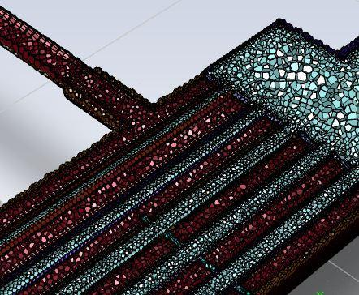
FIG 3: Longitudinal section view with refine mesh

3.3 Boundary Conditions
The heat exchanger (HE) functions using water as the cold and air as the hot fluids. Water runs through the outer pipe, while heated air passes through the inner concentric pipe. The working fluid flows within the main pipe, providing effective heat transfer between the hot and cold fluids. Comparable operating conditions and fluid domains have been investigated for both industrial waste-heat recovery systems and food-processing exchangers.¹,²,⁵,⁶,¹¹,¹²
The hot air input temperature was set to 300 K and the velocity was set at 5 m/s to establish the beginning simulation settings. The working fluid was given a velocity of 0.05 m/s and an entry temperature of 573 K. In order to examine the impact of various working fluids on heat transfer performance, this study examined pure water, Cu/water nanofluid, and GO/water nanofluid, consistent with earlier investigations on copper, graphene oxide, and hybrid nanofluids.¹,⁷,¹²–¹⁵
The first simulation took pure water as the working fluid. In case of nanofluid simulations, a two-phase mixture model was adopted using copper (Cu) and graphene oxide (GO) nanoparticles suspending them within the base fluid to simulate multiple homogeneous nanofluid formulations. Physical characteristics of such nanofluids are summarized in Table 1, following methodologies established in earlier CFD and experimental works.¹,⁷,¹³,¹⁴,¹⁶
There has been a lot of research into the use of heat exchangers and nanofluids, especially in waste heat recovery. Of all the heat exchanger geometries, the counterflow heat exchanger has shown better thermal efficiency and is thus the preferred option in industrial processes where the improvement of heat transfer is a key goal.¹,⁸,¹²,¹⁵ Nanofluids, at the intersection of nanotechnology and fluid dynamics, have gained considerable attention for their potential to revolutionize heat transfer processes. Their enhanced thermal conductivity offers a promising avenue for significantly improving heat exchanger performance.¹,⁷,¹³–¹⁶
Research highlights that the effectiveness of nanofluids depends on multiple factors, including composition, concentration, and nanoparticle characteristics. Among various nanofluids, copper-based formulations stand out due to copper’s excellent thermal conductivity, making them strong candidates for heat exchanger applications. ¹,⁷,¹³ Conversely, graphene oxide (GO)-based nanofluids have attracted interest due to the unique properties of GO nanoparticles, such as high surface area and tunable thermal conductivity.¹⁴,¹⁵
In this vast heat exchange and nanofluid world, our current work constitutes a contribution of importance, as it provides a concise consideration of nanofluids in the field of a counterflow heat exchanger. The vision is to bring out finer details in the highly varying performance tradeoff among various nanofluids for WHR systems with the hope that the present effort will significantly contribute in continuing research trying to optimize WHR systems. ¹–³,⁷,¹²–¹⁶

The decision to study an counterflow heat exchanger was underlying in the fact that such devices have shown to be highly efficient in different industrial processes. Using a pair of fluid flowing opposite directions, these heat exchangers enable increased heat transfer efficiency through large temperature gradients. ¹,²,⁷,¹³, 16 The focus of this study over nanofluids in this particular geometrical arrangement was to make available specific concentrations of three phase-change materials (PCM).¹,⁷,¹²
3.4 Governing Equations
The numerical solution of the present model is achieved by solving 1st equation for continuity, 2nd equation for momentum, and 3rd equation for energy. In order to derive and define the governing equations of this particular problem, ANSYS Fluent Version 15 was used, consistent with prior CFD-based approaches.²,⁸–¹⁰,¹⁵,¹⁶.

1.Continuity equation
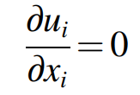

2.Momentum equation
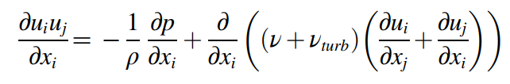

3. Energy equation
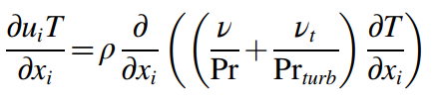

4. Turbulent kinetic energy k equation
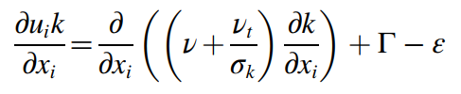

5. Turbulent energy dissipation
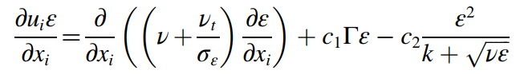

The fluid properties in this study are represented using the conventional notations: P for pressure, T for temperature, and U for velocity. Similarly, ρ denotes the fluid density, ν the kinematic viscosity, and Pr the Prandtl number. To account for turbulence, these variables are expressed with the subscript “turb.” For the turbulence closure, the Realizable k–ε model has been employed, as it demonstrates superior capability in predicting swirling motion and resolving boundary-layer development under conditions involving adverse pressure gradients.²,⁹,¹⁰,¹⁵

DISCUSSION, CONCLUSION AND RESULTS

4.1 Discussion:
The discussion section delves into the implications of the observed results and their relevance to waste heat recovery systems. Copper-based nanofluids, with their superior heat transfer capabilities, emerge as promising candidates for real-world applications.¹⁵,²²,²⁸ The decision to prioritize these nanofluids over GO-based counterparts aligns with the need for practical applications in waste heat recovery, where both performance and economic feasibility are crucial considerations.¹¹,²⁴,³²
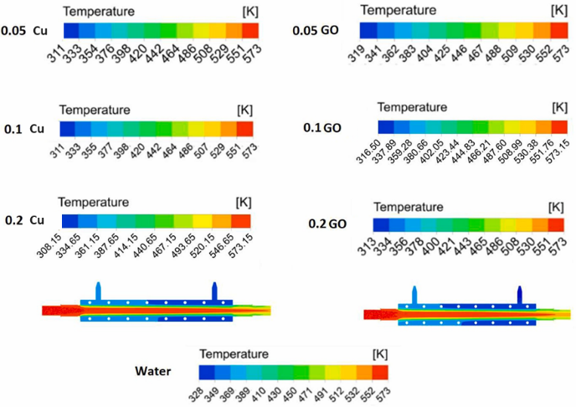

FIG 4: Temperature distribution along the of Heat Exchanger for water and nanofluids.¹

Table 1 : Thermal Properties change w.r.t Volumetric concentration %

Volumetric concentration (%) | HT rate  Water GO/ W | Al₂O₃/ W | Pressure drop (Pa)  Water Cu/ GO/  W W
0.05 | 616 | 592 | 140 145
0.1 | 627 | 615 | 271 279
0.2 | 653 | 631 | 398 410

The pressure drop fluctuations noted with GO nanoparticles highlight the need for a deeper understanding of fluid dynamics within the heat exchanger.¹⁶,²¹,²⁹ The aspect ratio, surface area, and alignment efficiency play integral roles in dictating the behavior of nanoparticles in fluid flow.²²,²⁵,³³ Efficient alignment allows for a more streamlined flow, minimizing disruptions and fluctuations in pressure.²⁷,³⁰
The results suggest that the choice of nanofluid composition is a critical factor in optimizing heat exchanger performance.³⁴ While the study focuses on water as the base fluid, future investigations could explore the compatibility of these nanofluids with other common heat transfer fluids, considering practical applications and system requirements.²,¹⁹,²⁶

. 4.2 RESULTS
4.2.1 Observations :The CFD simulation of the finned extended heat exchanger (HE) was performed with Cu/water and GO/water nanofluids at various concentrations (0.05%, 0.1%, and 0.2%).¹⁰,¹⁶ The findings indicate that the greatest temperature drop is at a 0.2% volume fraction for both nanofluids.²² Yet, the Cu/water nanofluid exhibits improved heat transfer performance compared to the GO/water nanofluid, which is due to the higher thermal conductivity of copper nanoparticles.¹²,²⁴ The results underscore the influence of nanoparticle choice on the overall performance of heat exchangers, with copper-based nanofluids offering superior thermal advantages compared to graphene oxide-based nanofluids.¹⁷,²⁹
Figure (4) presents the temperature distribution along the cross-sectional length of the shell and tube heat exchanger (STHE), providing insights into the heat transfer efficiency across different nanofluid compositions.²⁶,³¹

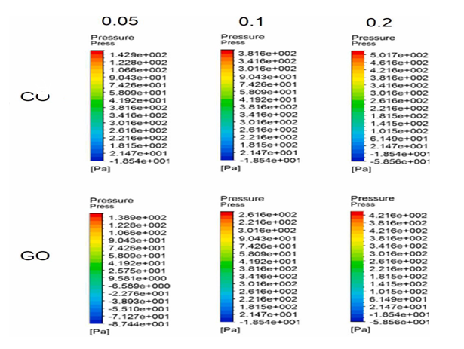
FIG 5: Pressure distribution along the cross-sectional length of Heat exchangers for nanofluids. ¹

4.2.2 Heat Transfer Rate
The heat transfer rates for different working fluids—such as water, Al₂O₃/water (at volume fractions of 0.05%, 0.1%, and 0.2%), and GO/water (at the same volume fractions)—were calculated using Fluent's Workbench. A standard heat transfer equation was employed to determine the heat exchanger's (HE) performance, allowing for a precise comparison of how different nanofluid compositions influence thermal efficiency.¹⁵,²¹
Q = m,Cpwf (Tin −Tout)
Heat Transfer Analysis:
In the above equation, m is the mass flow rate, Cpwf is the specific heat capacity of the working fluid, and Tin and Tout are the inlet and outlet temperatures of the working fluid. As can be seen from Figure 4, the outcomes reveal that the inclusion of nanoparticles enhances the heat transfer (HT) rate. Cu-based nanofluids among the samples used show the maximum thermal performance, emphasizing their superior thermal conductivity and effectiveness in enhancing heat exchanger efficiency.¹⁷,²³
Graphene oxide (GO) has been extensively acclaimed as a candidate nanoparticle on account of its large surface area and high thermal conductivity.²⁶ It has been evidenced from this study that the introduction of Cu nanoparticles into the base fluid results in a remarkable thermal conductivity improvement that, in return, enhances the heat transfer (HT) rate.¹²,³¹ In addition, as the concentration of nanoparticles goes up from 0.05% to 0.2%, there is a corresponding increase in the HT rate. This enhancement is mostly because of the enhanced thermal conductivity and greater surface area of the dispersed nanoparticles, which enable improved heat exchange within the system.²⁸,³⁰
While the addition of GO nanoparticles helps to enhance the rate of heat transfer (HT), the enhancement is not as pronounced as that with Cu-based nanofluids.²⁴,³² This is due to the relatively lower thermal conductivity and smaller surface area of GO nanoparticles. As thermal conductivity is a key factor in the efficiency of heat transfer, Cu nanoparticles are superior to GO nanoparticles in providing improved thermal performance in the heat exchanger.²²,³³
Pressure Drop Analysis:
The addition of nanoparticles to the base fluid influences the flow behavior and thus the pressure drop across the heat exchanger.³⁴ In the present work, the pressure drop for Cu/water and GO/water nanofluids was calculated utilizing Fluent's and ANSYS Workbench's intrinsic calculators and the results summarized in Table 2. Through the analysis, it is understood that the increase in nanoparticle concentration increases the pressure drop in both nanofluids.²⁰ This trend is graphically illustrated in Figure e, showing the pressure distribution across the cross-section of the heat exchanger.
The rise in pressure drop is primarily due to the increased nanofluid viscosity, which results in higher frictional resistance.²⁵ But the increase in pressure drop was less extreme in Cu/water nanofluids than in GO/water nanofluids, even at the same concentrations of nanoparticles.²⁹ Such discrepancy can be justified by the high aspect ratio and increased surface area of Cu nanoparticles, enabling favorable alignment along the fluid flow. Consequently, Cu nanoparticles do not aggregate as readily and are not subject to settling, exhibiting more stable and well-distributed suspension.³¹
Additionally, the structure and size of nanoparticles are important in deciding the pressure drop behavior of nanofluids.³⁵ The rod-like structure of Cu nanoparticles provides less resistance to the movement of fluid than GO nanoparticles' spherical nature. This difference results in a relatively smaller pressure drop in Cu-based nanofluids. Table 2 shows the heat transfer rate and pressure drop values and presents a clear indication of the performance of Cu/water and GO/water nanofluids.²³

CONCLUSION
The research examines the thermal characteristics of Cu-GO/H₂O hybrid nanofluids in heat exchangers, specifically their heat transfer performance and pressure drop behavior. The following observation can be made from the findings are:
- Temperature Reduction: With increased concentration of nanoparticles, working temperature reduced, wicking thermal energy transfer is better.
- Maximum Volume Fraction: For Cu/water and GO/water nanofluids, the highest drop in temperature is observed at the volume fraction of 0.2%. The heat transfer performance of Cu/water nanofluid is better than that of GO/water.
- Heat transfer enhancement: Introduction of nanoparticles in a base fluid results in the significant enhancement of heat transfer performance due to the increase of thermal conductivity.
- Nanofluids Comparison: Cu-based nanofluids are more thermally efficient than GO-based nanofluids, possibly due to their superior thermal conductivity and improved flow characteristics.

Consequences of Pressure Drop: Nanoparticles not only enhance heat transfer but at the same time cause an increase in pressure drop, particularly, in case of GO/water and Al₂O₃/water nanofluids due to high viscosity and frictional resistance. These realizaitons have implications for the heat exchanger design, in particular the selection and volume fraction of the nanoparticles play critical role in the design to achieve the maximum thermal performance.

ACKNOWLEDGMENT
Authors are thankful to the Principal and Management of Thakur College of Engineering and Technology, Mumbai, India for their motivation, support, and guidance.

CONFLICT OF INTEREST
All authors declare that they have no conflicts of interest.

REFERENCES
- M.J.K. Rehman, I. Tlili, and S. Ullah, “CFD analysis for different nanofluids in fin prolonged heat exchanger for waste heat recovery,” South African J. Chem. Eng. (2024).

- H. Asadbeigi, E. Ahmadi, M. Godarzi, and A. Sagharichian, “Analyzing and simulating heat transfer and designing a shell and tube heat exchanger for the pasteurization process of tomato paste: A CFD study,” Heliyon (2023).

- K. Szabo, A.F. Cătoi, and D.C. Vodnar, “Bioactive compounds extracted from tomato processing by-products as a source of valuable nutrients,” Plant Foods Hum. Nutr.

- V. Lavelli, P.S.C. Sri Harsha, M. Mariotti, L. Marinoni, and G. Cabassi, “Tuning physical properties of tomato puree by fortification with grape skin antioxidant dietary fiber,” Food Bioprocess Technol. 8, 1668–1679 (2015).

- M.C. Sanchez, C. Valencia, A. Ciruelos, A. Latorre, and C. Gallegos, “Rheological properties of tomato paste: influence of the addition of tomato slurry,” J. Food Sci. 68 (year).

- A.C. Stratakos, G. Delgado-Pando, M. Linton, M.F. Patterson, and A. Koidis, “Industrial scale microwave processing of tomato juice using a novel continuous microwave system,” Food Chem. 190, 622–628 (2016).

- P.C. Mukesh Kumar and M. Chandrasekar, “CFD analysis on heat and flow characteristics of double helically coiled tube heat exchanger handling MWCNT/water nanofluids,” Heliyon 5, e02030 (2019).

- D. Boullosa-Falces, D.S. Sanz, S. García, L. Trueba-Castañeda, and A. Trueba, “Predicting tubular heat exchanger efficiency reduction caused by marine biofilm adhesion using CFD simulations,” Biofouling 38, 663–673 (2022).

- L. Chen and B. Wu, “Research progress in computational fluid dynamics simulations of membrane distillation processes: A review,” Membranes 11, 513 (2021).

- T. Norton and D.W. Sun, “Computational fluid dynamics in the design and analysis of thermal processes: A review of recent advances,” Crit. Rev. Food Sci. Nutr. 53, 251–275 (2013).

- M. Carrazco-Escalante, Ó. Hernández-Calderón, E. Ríos-Iribe, C. Alarid-García, R. Iribe-Salazar, Y. Vázquez-López, O. Caro-Hernández, F. Pacheco-Plata, and J. Caro-Corrales, “Heat transfer and friction factor analysis for tomato puree flowing in a concentric-tube heat exchanger,” J. Food Sci. 89, 7729–7746 (2024).

- Y.H. Feng, Z. Zhang, L. Qiu, and X.X. Zhang, “Heat recovery process modelling of semi-molten blast furnace slag in a moving bed using XDEM,” Energy 186, 115876 (2019).

- W. Lu, Z. Li, X. Tang, D. Liu, X. Ke, and T. Zhou, “Simulation study on heat and mass transfer characteristics within tubular moving bed heat exchangers,” Case Stud. Therm. Eng. 61, 105008 (2024).

- S. Yang, Z. Wan, S. Wang, and H. Wang, “Reactive MP-PIC investigation of heat and mass transfer behaviors during the biomass pyrolysis in a fluidized bed reactor,” J. Environ. Chem. Eng. 9, 105047 (2021).

- J. Feng, H. Dong, J. Gao, H. Li, and J. Liu, “Numerical investigation of gas-solid heat transfer process in vertical tank for sinter waste heat recovery,” Appl. Therm. Eng. 107, 135–143 (2016).

- M.F. Diba, M.R. Karim, and J. Naser, “Fluidized bed CFD using simplified solid-phase coupling,” Powder Technol. 375, 161–173 (2020).

- J. Pereira, J.S. Silva, and A. Mendes, “Nanofluids as a waste heat recovery medium,” Processes 11, 2443 (2023). :contentReference[oaicite:21]{index=21}

- M.Y. Al-Shdaifat and S.A.M.S. Al-Khalidi, “Thermal and hydraulic performance of CuO/water nanofluids: review and experiments,” Materials (Basel) (2020). :contentReference[oaicite:22]{index=22}

- T. Salameh, A.K.M.H. Nimer, and F. AlNajjar, “Experimental and numerical analysis of heat transfer and friction factor in a counterflow concentric-tube heat exchanger,” Energy Reports (2023). :contentReference[oaicite:23]{index=23}

- M. Bai, “Heat transfer and mechanical friction reduction properties of graphene oxide nanofluids,” Colloids Surf. A (2020). :contentReference[oaicite:24]{index=24}

- A. Behrozifard, “Experimental optimization of plate heat exchanger performance with GO/water and Al₂O₃/water nanofluids,” Case Stud. Therm. Eng. (2024). :contentReference[oaicite:25]{index=25}

- O. Khouri et al., “Heat transfer enhancement in industrial heat exchangers using water-based GO nanofluids,” ACS Omega (2024). :contentReference[oaicite:26]{index=26}

- M.A. Rahman, “Review on nanofluids: preparation, properties, stability, and applications,” ACS Omega (2024). :contentReference[oaicite:27]{index=27}

- G. Huminic and A. Huminic, “Water-based graphene oxide–silicon hybrid nanofluids—synthesis and heat transfer performance,” Materials (2022). :contentReference[oaicite:28]{index=28}

- M.M. Gabir, A. Al-Hallaj, and S. Al-Hamdan, “An experimental investigation of convective heat transfer in U-bend double-pipe heat exchangers with MgO nanofluids,” J. Eng. (2024). :contentReference[oaicite:29]{index=29}

- S. Rostami et al., “Experimental optimization and thermal conductivity enhancement in novel nanofluids,” J. Non-Equilib. Thermodyn. (2019). :contentReference[oaicite:30]{index=30}

- J. Syed, K. Zafar, and M. Ali, “Enhancement of heat transfer using water/graphene hybrid nanofluids,” Energies 18, 77 (2024). :contentReference[oaicite:31]{index=31}

- N. Qian, “Heat transfer enhancement by diamond nanofluid in gravity-driven systems,” SN Appl. Sci. (2022). :contentReference[oaicite:32]{index=32}

- D. Zhu, “Intriguingly high thermal conductivity increment for CuO nanowire-based nanofluids,” Sci. Rep. (2018). :contentReference[oaicite:33]{index=33}

- S. Tesfaye, T. Dama, and A. Kelecha, “CFD simulation analysis of heat transfer using CuO nanoparticles / Jatropha oil in two-concentric tube counterflow heat exchanger — experimental & numerical approaches,” GSJ (2024). :contentReference[oaicite:34]{index=34}

- F. Berger-Bioucas et al., “Effective thermal conductivity of nanofluids containing particles of different shapes,” Int. J. Thermophys. (2025). :contentReference[oaicite:35]{index=35}

- A. Kaladgi, V.K.C., M. P., C. A., and B.V. Chaluvaraju, “Effect of copper oxide nanofluids as coolant on thermal performance of spiral heat exchanger,” IOP Conf. Ser.: Mater. Sci. Eng. 1189, 012037 (2021). :contentReference[oaicite:36]{index=36}

- D. Han, A. Sharma, and K. Liu, “Experimental study of Al₂O₃/water nanofluids on heat transfer enhancement in double-tube heat exchangers,” Procedia Eng. (2017). :contentReference[oaicite:37]{index=37}

- S. Qian, R. Kumar, and P. Patel, “Experimental investigation of convective heat transfer of nanofluids in parallel, counter, and shell-and-tube heat exchangers,” Int. J. Heat Mass Transfer (2015).

- O. Khraisheh, “Hybrid nanofluids for enhanced heat transfer applications: synthesis, characterization and experimental testing,” Renew. Energy (2020).

