Effect of Green Algae Gel (Chlorella vulgaris) on The Amount of Blood Vessels in The Healing Process of Traumatic Ulcer
Dwi Setianingtyas^{1, a)}, Cane Lukisari^{1, b)}, Syamsulina Revianti^{2, c)} ,Monika Elidasari^{3, d)}, Jenifer Karina^{4, e)}, Yessy Andriani Fauzia^{5, f)}
Author Affiliations
¹Department of Oral Medicine, Faculty of Dentistry, Universitas Hang Tuah, Surabaya, Indonesia
²Department of Oral Biology, Faculty of Dentistry, Universitas Hang Tuah, Surabaya, Indonesia
³Department of Oral Surgery, Faculty of Dentistry, Universitas Hang Tuah, Surabaya, Indonesia
⁴General Practioner, Surabaya, Indonesia
⁵School of Dental Medicine, Ciputra University Surabaya, Indonesia
Author Emails
^{a)} Corresponding author: dwi.setianingtyas.anik@gmail.com
^{b)} cane.lukisari@gmail.com
^{c)}syamsulina.revianti@hangtuah.ac.id
^{d)}monika.elidasari@gmail.com
^{e)}jenniferkarinaa17@gmail.com
^{f)}yessy.andriani@ciputra.ac.id
Abstract. Traumatic ulcer is a layer of epithelium that exceeds the basement membrane which can reach the lamina propria caused by trauma. The prevalence of traumatic ulcers reaches 25% in the world. Traumatic ulcers can heal by itself within 7-10 days after the cause has been removed. Complete traumatic therapy, one of which is like a microalgae type of green algae (Chlorella vulgaris). Chlorella vulgaris contains phytochemicals such as alkaloids and triterpenoids which contain anti-inflammatory in the wound healing process. Other ingredients found in Chlorella vulgaris are protein, vitamin B12, vitamin C, and calcium which help the proliferation of blood vessels. The aim of this study was to determine the effect of Chlorella vulgaris gel to the amount of blood vessels in the process of healing traumatic ulcers. 50 Wistar rats, divided into 5 groups, control groups (K + and K-), the Chlorella vulgaris gel group with a concentration of 7.5% (P1), 10% (P2), and 12.5% ​​(P3). Wistar rats were treated on the lower labial mucosa using a heated cement stopper. On the 3rd day and 7th day the mice were sacrificed and then cut into the lower labial mucosa, after which the histopathological preparations were made by HE painting to count the amount of PMN using a 400x magnification light microscope. The results from the Kruskal-Wallis test analysis showed differences in each group. In the Mann Whitney Post Hoc Test. The Mann Whitney test showed significant results (p <0.05) on the second day except in groups P1 with P2 and P3 and P2 with P3. On the sixth day, the Mann Whitney Test showed significant results in the K + group with P1, P2, and P3 and group P1 with P2. Chlorella vulgaris gel with concentration of 7.5% is the most effective in improving the recovery process of traumatic ulcers.
Keywords: traumatic ulcer, blood vessels, Chlorella vulgaris.

introduction
Traumatic ulcer is a loss of the epithelial layer beyond the basement membrane, even able to reach the lamina propria, caused by trauma.¹ According to Sunarjo et al. (2015), the prevalence of traumatic ulcers in the oral cavity reached 15-39%, while the global average was 25%.² Traumatic ulcers can be caused by physical trauma, such as accidentally biting the lip, cheek, or tongue, chewing hard food, as well as suffering from thermal and chemical trauma.³
The clinical presentation of traumatic ulcer is a single, yellowish-white, oval or round spot with reddish edges, often accompanied by pain.⁴ Traumatic ulcers can heal spontaneously within 7-10 days after the cause is eliminated.⁵
The wound healing process of traumatic ulcer goes through four phases, namely hemostasis, inflammation, proliferation, and remodeling. The hemostasis phase occurs immediately after the wound occurs. This phase involves blood clotting. The inflammation phase occurs from the first to the fourth day after the wound occurs. The inflammation phase plays a role in bacterial phagocytosis. The proliferation phase occurs from day 4 to day 21. The proliferation phase involves fibroplasia, extracellular matrix deposition, granulation tissue formation, angiogenesis, and epithelialization.^{6,7}
The treatment of traumatic ulcers can include topical corticosteroid medications, such as 0.1% triamcinolone acetonide, but its prolonged use can increase fungal growth as well as thin epithelial cells.^{8,9} Antiseptic mouthwashes, such as 0.2% chlorhexidine gluconate and benzydamine hydrochloride, can also be used. Medications containing hyaluronic acid are increasingly being used as a therapy for traumatic ulcers due to their anti-inflammatory effects.²
Angiogenesis is the process of new blood vessel formation that occurs naturally in the human body. The role of angiogenesis in wound healing is to maintain the function of damaged tissues and organs by forming new blood vessels and replacing damaged ones.¹⁰
Angiogenesis is characterized by the formation of new capillaries that arise from surrounding small blood vessels. Areas where new blood vessels are forming usually appear reddish (erythema) because new blood capillaries are forming in those areas due to the presence of erythrocytes.⁷
Angiogenesis involves several stages, started with the initiation process, which involves the release of protease enzymes from activated endothelial cells; the formation of vascular blood vessels, which includes the degradation of the Extracellular Matrix (ECM); the migration and proliferation of endothelial cells; and the creation of new ECM. The next process involves the maturation of new blood vessels to meet tissue needs and accelerate the wound healing process.¹¹
Chlorella vulgaris, also known as green algae, is a type of aquatic plant with indistinguishable roots, stems, and leaves. Chlorella vulgaris is widely used in various fields due to its ability to grow well and quickly, and often found in both fresh and marine waters. Chlorella vulgaris contains nutrients that can be used as medicine, thus promoting natural wound healing. Furthermore, Chlorella vulgaris is used in various fields, such as cosmetics, food additives, and biodiesel alternatives.¹²
Chlorella vulgaris contains carbohydrates, proteins, fats, calcium, magnesium, and vitamins, such as vitamins B12, C, and E. Chlorella vulgaris also contains several phytochemical compounds, such as alkaloids and triterpenoids. A study conducted by Mardiyantoro et al (2014) reveals that the supply of protein in wound healing is important in the synthesis of collagen, the process of angiogenesis, the proliferation of fibroblasts and endothelial cells, and the remodeling of tissue. In the process of angiogenesis, protein helps endothelial cells respond to angiogenic signals that will later form new blood vessels and stabilize the growth of growing blood vessels. Protein deficiency will prolong the inflammatory phase, as well as disrupt fibroblast proliferation and collagen synthesis.⁶ Vitamin B12 is important in Red Blood Cell (RBC) formation, tissue repair, and DNA synthesis. Vitamin B12 deficiency can lead to reduced red blood cell production due to impaired red blood cell production.¹³ Vitamin C plays a role in increasing angiogenesis, stimulating blood vessel formation and iron absorption, as well as controlling endothelial cell production of nitric oxide (NO) to modulate blood flow.¹⁴ Calcium acts as a primary secondary messenger involved in signaling essential for wound healing. Calcium plays a crucial role in hemostasis and endothelial cell proliferation. Alkaloids act as antibacterials by disrupting the peptidoglycan component of bacteria. Triterpenoids help accelerate epithelialization.¹⁵
As a result, this study aims to determine the effect of green algae (Chlorella vulgaris) gel at concentrations of 7.5%, 10%, and 12.5% ​​on the number of blood vessels during traumatic ulcer healing on days 2 and 6.

MATERIALS AND METHODS
This study was conducted as true experimental research with a post-test only control group design. The experimental animals used were Rattus novergicus of the Wistar strain. Fifty rats were divided into five groups, namely K- (untreated), K+ (0.2% Hyaluronic Acid Gel), P1 (7.5% Chlorella vulgaris Gel), P2 (10% Chlorella vulgaris Gel), and P3 (12.5% ​​Chlorella vulgaris). The treatments were respectively administered for two and six days. The use of these animals in this study received approval from the Ethics Committee of the Faculty of Dentistry, Hang Tuah University, Surabaya.
First, those Wistar rats were anesthetized with ketamine xylazine by injecting into their thickest muscle, and then allowed to fall asleep. Second, ketamine was injected at a rate of 0.1 ml/g/bw along with xylazine at a rate of 0.01 ml/g/bw in a single injection. Third, the labial mucosa of their lower lip was injured with an amalgam stopper heated in alcohol for 1 minute, and then it was lightly touched to the labial mucosa of those Wistar rats for 1 second without pressure. Fourth, after the rats recovered from anesthesia, they were kept in their cages and fed adequately. Fifth, green algae gels with concentrations of 7.5%, 10%, and 12.5% ​​were prepared. The green algae gel with a dose of 0.05 gram then was applied once daily at 7:00 a.m to the ulcer using a microbrush, with a total weight of 0.56 grams (weight of the microbrush and green algae gel) for all samples in the treatment group for 2 days (2 applications) and 6 days (6 applications). Topical application of the green algae gel was performed on day 1 after the ulcer formed.
Next, those experimental animals were sacrificed on days 3 and 7 after the treatment. The animals were then anesthetized with ketamine and xylazine. The labial mucosa of their lower lip was then excised to the corner of the mouth, including the ulcerated area. Afterwards, the normal area was fixed in 10% buffered formalin for 24 hours. The biopsied animals were euthanized using cervical dislocation (separation of the neck and skull), and the dead mice were then burned.
Subsequently, HPA slides were prepared using hematoxylin-eosin (HE) staining. Blood vessel counts then were measured using an Olympus light microscope at 400x magnification in five fields of view. This research was conducted in the Oral Biology Laboratory, Faculty of Dentistry, Hang Tuah University, Surabaya.

RESULTS
Data analysis was conducted using a ratio scale. Normality test then was performed using the Shapiro-Wilk to determine whether the data were normally distributed or not. If the data were not normally distributed, homogeneity test could not be performed. Next, non-parametric Kruskal-Wallis test was conducted to determine changes in the number of blood vessels between the negative control group and all treatment groups. A post-hoc Mann-Whitney test was then performed to determine significant differences in the number of blood vessels between each group. All tests were performed using SPSS version 25.0.
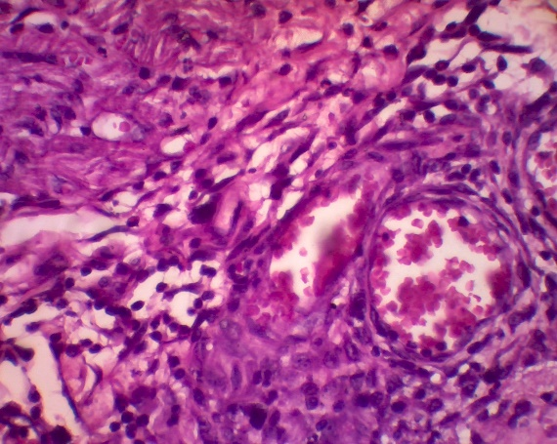
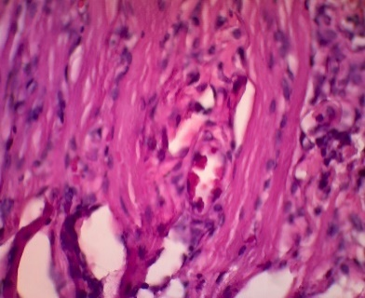
B
A

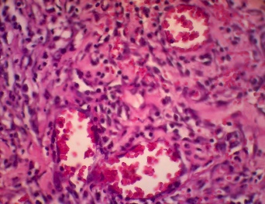
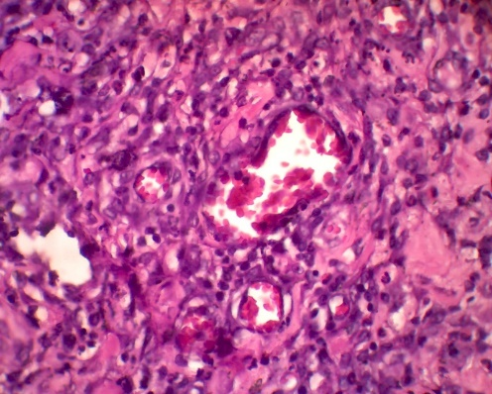
D
C

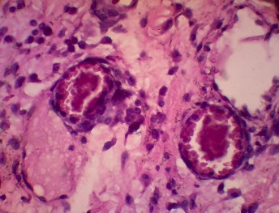
E

FIGURE 1. Histological images of blood vessels on day 2. Black arrows indicate blood
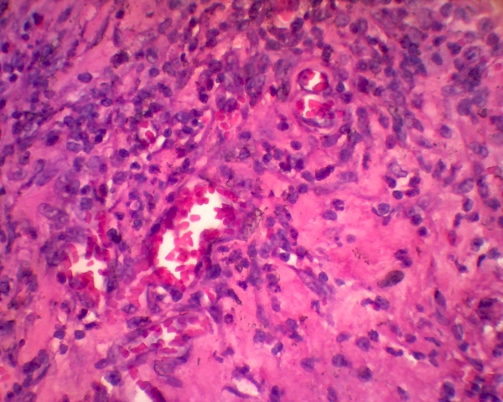
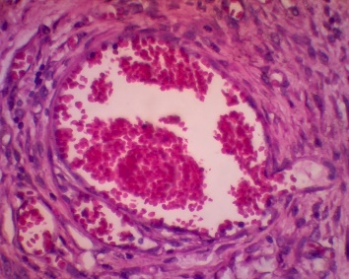
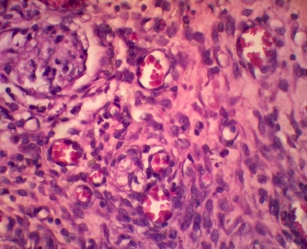
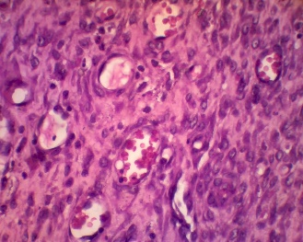
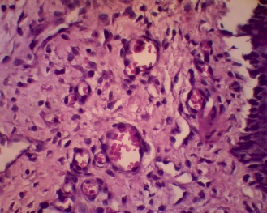
vessels at 400x magnification in the treatment groups. A: negative control (K-), B: positive group (K+), C: group with 7.5% C. vulgaris gel (P1), group with 10% C. vulgaris gel (P2), group with 12.5% ​​C. vulgaris gel (P3).
A
B
C
D
E
FIGURE 2. Histological images of blood vessels on day 6. Black arrows indicated blood vessels at 400x magnification in the treatment groups. A: negative control (K-), B: positive group (K+), C: group with 7.5% C. vulgaris gel (P1), group with 10% C. vulgaris gel (P2), group with 12.5% ​​C. vulgaris gel (P3).
Next, the research data were analyzed descriptively to obtain a distributional overview and summarize the data to clarify the presentation of the results. Hypothesis testing was then performed using SPSS version 25.0 with a significance value (p) of less than 0.05.
TABLE 1. Mean and standard deviation of blood vessel counts in the lower labial mucosa of Wistar rats in the treatment groups.
 | Groups | Mean±St. Deviasi
Day 2 | K-  K+  P1  P2  P3 | 7.44 ± 0.82  8.96 ± 0.35  13.6 ± 0.64  13.28 ± 0.17  13.36 ± 0.38
Day 6 | K-  K+  P1  P2  P3 | 8.08 ± 0.94  13 ± 1.06  14.36 ± 0.99  13.24 ± 0.35  12.56 ± 0.32

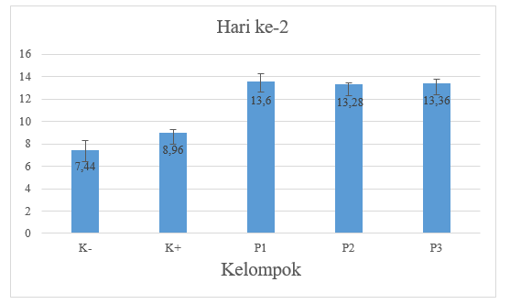
Group
Day-2
FIGURE 3. Diagram of the mean and standar deviation of blood vessel
counts in the lower labial mucosa of Wistar rats on day 2
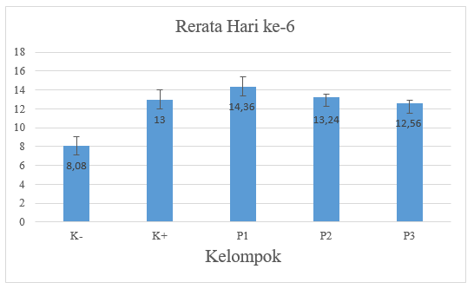
Mean days 6
Group
FIGURE 4. Diagram of the mean and standard deviation of blood vessel
counts in the lower labial mucosa of Wistar rats on day 6
Table 1 and Figure 3 show that on day 2, the highest mean blood vessel count was in the P1 group (13.6), while the lowest was in the K- group (7.44). Table 1 and Figure 4 show that on day 6, the highest mean blood vessel count was in the P1 group (14.36), while the lowest one was in the K- group (8.08).
Afterwards, the research data were analyzed using the non-parametric Kruskal-Wallis and Post Hoc Mann-Whitney statistical tests to determine differences in blood vessel counts in each treatment group.
Subsequently, the post-hoc LSD test on day 2 showed a p-value of less than 0.05 in the K- group compared with in K+, P1, P2, and P3, as well as in the K+ group compared with in P1, P2, and P3. This indicates a significant difference between the treatment groups. Meanwhile, a p-value of more than 0.05 was found in the P1 group compared with in P2 and P3, as well as in the P2 group compared with in P3, indicating no significant difference between the treatment groups.
Next, the post-hoc LSD test on day 6 showed a p-value of less than 0.05 in the K- group compared with in K+, P1, P2, and P3, in the P1 group compared with in P3, as well as in the P2 group compared with in P3. This indicates a significant difference between the treatment groups. Meanwhile, a p-value of more than 0.05 was found in the K+ group compared with in P1, P2, and P3, in the P1 group compared with in P2, as well as in the P2 group compared with P3, indicating no significant difference between the treatment groups.

DISCUSSION
This research used three-month-old male Wistar rats, Rattus novergicus, weighed 150-200 grams. Those male Wistar rats were selected as research subjects since they were readily available, easy to care for, having a fast metabolic rate, and not affected by estrogen, thus avoiding uterine bleeding and pregnancy. Chlorella vulgaris gel was applied to the lower labial mucosa of those Wistar rats with traumatic ulcers for 2 and 6 days, followed by biopsies on days 3 and 7.¹⁶
The results of the blood vessel count measurement on day 2 (Table 1) showed that the K- group (7.44) had the lowest average compared to the K+ group (8.96), P1 (13.6), P2 (13.28), and P3 (13.36). The average number of blood vessels in the K- group was higher because the K- group was only given 5% HPMC (hydroxypropylmethylcellulose) commonly used as a base ingredient in gels that lack of anti-inflammatory properties, thus not able to accelerate the healing of traumatic ulcers.¹⁷
The results of the blood vessel count measurement on day 6 (Table 1) showed that the P1 group (14.36) had the highest average number of blood vessels compared to the K- group (8.08), K+ (13), P2 (13.24), and P3 (12.56) since angiogenesis occured during the proliferation phase from day 4 to 21 after the injury. Furthermore, the maximum VEGF activity occured from day 4 to 7 after the injury. This indicates that the 7.5% Chlorella vulgaris was the most effective one in increasing blood vessel count. The P1 group had the lowest Chlorella vulgaris concentration compared to P2 (10%) and P3 (12.5%). This indicates that exceeding the dosage limit could reduce the effectiveness of Chlorella vulgaris.¹⁸
The results of the Mann-Whitney post-hoc test showed a significant difference between the positive control group (K+) using 0.2% hyaluronic acid on the second day (a) and the positive control group on the sixth day (b). In the positive control group on the sixth day, the average count increased compared to the second day because of the 0.2% - 0.9% hyaluronic acid found in commercially available drugs, such as Gengigel that has been shown to be effective in healing traumatic ulcers. Gengigel gel can help promote the natural healing of inflamed or damaged tissue in the oral cavity.²
Based on the research results, administering Chlorella vulgaris at a concentration of 7.5% (P1) for two days (a) did not significantly differ compared to administering Chlorella vulgaris at a concentration of 7.5% (P1) for six days (b). This explains that administering Chlorella vulgaris with a concentration of 7.5% for two days is sufficient and can accelerate the growth of blood vessels in the healing process of traumatic ulcers. The 7.5% Chlorella vulgaris is the best concentration because it has a more liquid consistency than Chlorella vulgaris at the concentrations of 10% and 12.5%. This is because Chlorella vulgaris at the concentration of 7.5% has a lower molecular weight than Chlorella vulgaris at the concentrations of 10% and 12.5% ​​so that the 7.5% concentration has high solubility, biocompatibility, bioadhesiveness, and properties that facilitate absorption and more easily penetrate the pores of the oral mucosa. Meanwhile, chlorella vulgaris at 10% and 12.5% ​​have a higher molecular weight, resulting in a thicker consistency and delaying the release of the active ingredient, and then making more difficult to penetrate the pores of the oral mucosa.^{19,20}

CONCLUSION
The administration of green algae gel (Chlorella vulgaris) at concentrations of 7.5%, 10%, and 12.5% ​​for 6 days is the most effective in increasing blood vessel counts during the healing process of traumatic ulcers.

Acknowledgments
Thank you to all co-authors for their support and cooperation in completing this research

References
- P. Arief, B. Adiwinarno, L. O. Mayasari. “Efektivitas Pemberian Ekstrak Gel Belimbing Manis (Averrhoa Carambola Linn) Terhadap Kesembuhan Ulkus Traumatikus Studi In Vivo Terhadap Mukosa Tikus (Strain Wistar),” Prosiding Seminar Nasional Publikasi Hasil-Hasil Penelitian dan Pengabdian Masyarakat. 2017; p 39-44
- S. Lanny, R. Hendari, H. Rimbyastuti. “Manfaat Xanthone Terhadap Kesembuhan Ulkus Rongga Mulut Dilihat dari Jumlah Sel PMN dan Fibroblast,” ODONTO. Dental. Journal 2(2), 14-21 (2015).
- G. Anil and S. Mhaske. Textbook of Oral Pathology (Jaypee Brothers Medical Publishing, New Delhi, (2008). Pp. 154-159.
- A. M. Laillyza. “The Management of Chronic Traumatic Ulcer in Oral Cavity,” Dental Journal 45(2). 68-72 (2012).
- L. A. O. Michael and R. C. K. Jordan. “Penyakit Mulut Diagnosis dan Terapi 2nd Edition. Jakarta: EGC; 2014: pp. 16-17.
- M. Fredy, K. Munika, V. S. M. Cahyati, and A. R. Pratiwi, “Penyembuhan Luka Rongga Mulut. Malng” UB Press; 2018
- P. A. Rezky, N. Wathoni, and T. Rusdiana. “Peranan Faktor Pertumbuhan Terhadap Penyembuhan Luka Diabetes,” Farmaka 15(2), 43-53 (2017).
- P. S. Anindita, B. Hutagalung, S. K. P Manoppo. “Gambaran Ulkus Traumatik pada Mahasiswa Pengguna Alat Ortodonti Cekat di Program Studi Kedokteran Gigi Fakultas Kedokteran Universitas Sam Ratulangi,” e-Journal. Unsrat 1(2), 1-9 (2013).
- R. Sri, R. F. Hakim, and P. Rahmina, “Pengaruh Ekstrak Daun Pacar Kuku (Lawsonia Inermis) 7,5% Terhadap Penyembuhan Ulkus Traumatik pada Mukosa Oral,” Cakradonya Dental Journal 4(2), 475-542 (2012).
- P. Nova, A. Basori, D. S. Perdanakusuma, “Proses Penyembuhan Luka Ditinjau dari Aspek Mekanisme Seluler dan Molekuler,” Qanun Medika-Medical Journal Faculty of Medicine Muhammadiyah Surabaya 3(1), 31-43 (2019).
- F. Caroline, T. Sardjono and F. Sandra, “Angiogenesis: Patofisologi dan Aplikasi Klinis,” Jurnal Kedokteran Maranatha 8(2), 174-182 (2019).
- R. Ambeng, M. Litaay, and M. R. Umar, “Pengaruh Pemberian Vermikompos Cair Lumbricus Rubellus Hoffmeister pada Pertumbuhan Chlorella Sp. Bioma,” Jurnal Biologi Makassar 2(1), 1-8 (2017).
- N.R. Lestari, Suhaema, N.K.S. Sulendri and F. Luthfiyah, “Karakteristik dan Tingkat konsumsi vitamin B6,,B12 dan asam folat pada pasien stroke rawat inap” Jurnal Gizi Prima 4(2), 106-113 (2019).
- B.S.C. Sugiarto, R.P. Sari, and D. Setyaningtyas, “Perbedaan Efektivitas Antara Ekstrak Air dan Ekstrak Etanol Teripang Emas (Stichopus Hermanii) Terhadap penyembuhan Ulkus Traumatikus di Rongga Mulut” Denta Journal Kedokteran Gig 8(2), 175-185 (2014).
- K. Kawai, Larson B J, Ishise H, Carre A L, and Nishimoto S, “Calcium Based Nonaparticles Accelerate Skin Wound Healing,” Plos One,6(11) (2011) .
- Olayaki, Soladoye, Salman, and Joraiah, “Effects of Photoperiod on Testicular Functions in Male Sprague-Dawley Rats. Nigerian Journal of Physiological Sciences,” 23 (1-2), 27-30 (2008).
- Dewi Christine Citra dan Nyi Mekar Saptarini, “Hidroksi Propil Metil Selulosa dan Karbomer Serta Sifat Fisikokimianya Sebagai Gelling Agent,” Farmaka. 14(3). 1-10 (2016).
- Destri Ch, I Ketut Sudiana, dan Jusak Nugraha, “Potensi Ektrak Jatropha Multifida Terhadap Ekspresi VEGF Apthous Ulcer Rat norvegicus,” Jurnal SainHealth. . 1(2), 5-11 (2017)
- Wen Fan, Wei Yan, Zushun Xu, and Hong Ni. Erythrocytes Load of Low Molecular Weight Chitosan Nanoparticles As A Potential Vascular Drug Delivery System. Colloids and Sufaces. B, Biointerfaces. Elsevier’s Health Science Rights Department. 2015: 258-265.
- Cheung Randy Chi Fai, Tzi Bun Ng, Jack Ho Wong and Wai Yee Chan, “Chitosan: An Update on Potential Biomedical and Pharmaceutical Applicarions,” Marine Drugs 13(8). 5168-5169 (2015).

