Postbiotic Delivery Systems, Challenges, and Future Directions
Arya Adiningrat^{1,2 a)} and Muhammad Farikh^{1, b)}
Author Affiliations
¹Molecular Medicine and Therapy Laboratory, Research and Innovation Center, Universitas Muhammadiyah Yogyakarta, Yogyakarta City, Special Region of Yogyakarta, Indonesia
²Oral Biology and Biomedical Sciences, Faculty of Dentistry, Universitas Muhammadiyah Yogyakarta, Bantul, Special Region of Yogyakarta, Indonesia
Author Emails
^{a)} Corresponding author: adiningrat@umy.ac.id
^{b)}bukittinggi.farikh12@gmail.com
Abstract. Drug Delivery System (DDS) is an important innovation in improving the effectiveness and safety of therapies, especially for bioactive molecules such as postbiotics and therapeutic proteins. Postbiotics, which are metabolites or bioactive components of non-living microorganisms, offer the advantages of stability, safety, and shelf life over live probiotics, so they are increasingly being developed as alternatives in functional and pharmaceutical products. Advances in DDS technology, including the use of nanoparticles, nano-emulsions, gels, liposomes, and polysaccharide-based systems, enable targeted delivery of postbiotics, improve stability during storage and travel in the body, and maximize therapeutic effects. However, the development of postbiotic DDS still faces major challenges, such as production standardization, consistent characterization, protection from degradation, and unclear global regulations. In addition, therapeutic proteins as medicinal agents are highly susceptible to degradation and require a delivery system that is able to protect the structure and regulate release in a controlled manner. Recent approaches, such as the integration of nanotechnology and cell therapy, offer solutions to improve the bioavailability and effectiveness of protein and postbiotic delivery. Although the potential of DDS is enormous, further research and large-scale clinical validation are still needed to ensure safety, effectiveness, and widespread implementation in the medical world. This article comprehensively reviews the progress, challenges, and future direction of DDS for postbiotics and proteins, with a focus on the stability, safety, and suitability of delivery systems particularly for oral and dental therapy.
Keywords: Postbiotics, Drug Delivery System, Biocompatibility, Nanoparticle

introduction
Drug delivery systems (DDS) are essential technologies designed to formulate and store drug molecules in forms suitable for administration. They facilitate the efficient distribution of drugs to specific target sites within the body, thereby enhancing therapeutic efficacy while minimizing off-target effects [1, 2].Medications can be administered through various routes, including oral, buccal, sublingual, nasal, ophthalmic, transdermal, subcutaneous, anal, transvaginal, and intravesical pathways [3]. The physicochemical properties of a drug's components significantly influence its behavior in the body and its therapeutic outcomes.
Recently, Novel Drug Delivery Systems (NDDS) have emerged, offering more convenient and targeted drug administration. These systems possess distinct physical, chemical, and morphological characteristics that influence their release mechanisms. The primary mechanisms of drug release identified in NDDS include diffusion, chemical reactions, solvent interactions, and stimulus-responsive control [4].
With the advancement of drug delivery systems, postbiotics have emerged as a promising innovation. Defined as metabolites or bioactive compounds derived from non-viable microorganisms, postbiotics confer health benefits to the host [5]. Unlike live probiotics, postbiotics offer superior stability, safety, and shelf life, along with greater ease of incorporation into functional foods and pharmaceutical formulations. They are increasingly recognized as viable alternatives or adjuncts to probiotics, particularly in addressing safety concerns and dosage limitations associated with live microbial therapies [6].
Progress in postbiotic delivery systems is critical to preserving bioactivity and enhancing therapeutic efficacy [7]. A range of novel delivery technologies has been developed, including nanoparticles, nanoemulsions, hydrogels, liposomes, orodispersible films, and polysaccharide-based carriers. These systems enable controlled and targeted release of postbiotics, while offering biocompatibility, biodegradability, and the capacity to encapsulate both hydrophilic and hydrophobic molecules. Such versatility supports various administration routes, including oral, intradermal, and intravenous delivery [8].The primary objectives of these delivery platforms are to improve postbiotic stability during storage and transit within the body and to optimize their therapeutic potential [9].
Despite the significant potential of postbiotics, the development of effective delivery systems faces several critical challenges. These include the lack of standardized, reproducible methods for postbiotic production and characterization; susceptibility of postbiotic compounds to degradation; limited understanding of their mechanisms of action and interactions with host microbiota; and difficulties in formulating delivery systems that protect postbiotics until they reach their target site while ensuring appropriate dosing and biological capacities. Additionally, the scarcity of robust randomized controlled trials limits the evidence base for postbiotic safety and efficacy across diverse clinical conditions.
This review aims to carefully evaluate various drug delivery systems (DDS) designed for postbiotic administration, with a focus on enhancing stability and safety. It will assess the compatibility of postbiotic compounds with different DDS platforms, considering their physicochemical properties and how these influence the selection and performance of delivery technologies [10, 11].

DRUG DELIVERY SYSTEM AND APPLICATIONS
In recent years, significant advancements have been made in DDS, particularly those utilizing organic, inorganic, and hybrid nanoparticles with active targeting capabilities, most notably in chemotherapy. Modern DDS are engineered with enhanced features, including reduced particle size, improved permeability and solubility, increased therapeutic efficacy and stability, precise site-specific targeting, and reduced toxicity. These improvements markedly enhance the performance of therapeutic agents compared to conventional formulations. Consequently, advanced DDS are regarded as a pivotal innovation in the development of more effective and efficient therapeutic strategies.
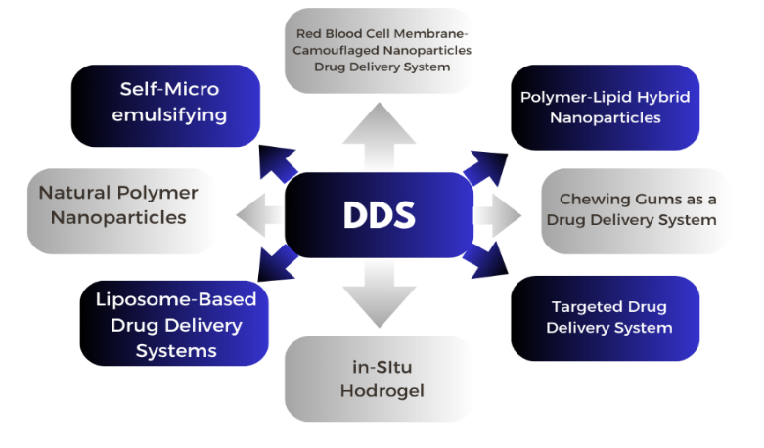

FIGURE 1. Several types of drug delivery systems for different therapeutic purposes
The commercial and therapeutic success of advanced drug delivery systems (DDS) is highly dependent on the selection of an appropriate delivery mechanism. Therefore, active involvement in the development process is essential to identify potential challenges and ensure that the final system delivers optimal therapeutic benefits. Current efforts in DDS innovation focus on minimizing toxicity and enhancing treatment efficacy. An overview of the various types of drug delivery systems is presented in Figure 1.

Red Blood Cell Membrane-Camouflaged Nanoparticles Drug Delivery System
Nanotechnology has long been recognized for its potential to revolutionize drug delivery. A particularly promising innovation is the use of nanoparticles cloaked with red blood cell (RBC) membranes [12]. The inherent biological properties of erythrocytes—such as biocompatibility, biodegradability, immune evasion, and prolonged circulationtime—make them ideal candidates for nanoparticle camouflage [13].
Red blood cells (RBCs), the most abundant cells in the circulatory system, are well-suited as vehicles for drug delivery. Engineered erythrocytes have been extensively studied as carriers for various bioactive compounds, including enzymes, drugs, proteins, and macromolecules [14]. By coating nanoparticles with RBC membranes, these systems retain the natural properties of erythrocytes—such as biocompatibility, immune evasion, and extended circulation—while leveraging the functional advantages of nanomaterials.
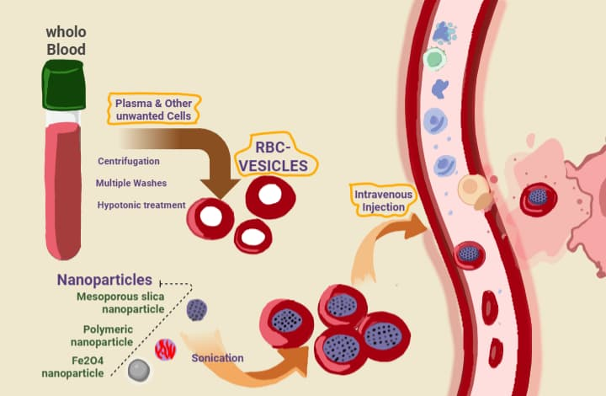

FIGURE 2. Synthetic strategies for RBCM-NPs preparation for antitumor activity. Whole fresh blood is centrifuged and washed multiple times to remove the plasma and other unwanted cells. The resulting pure red blood cells are subjected to hypotonic hemolysis and are used to coat selected nanoparticles, which are intravenously injected into the blood to maintain long systemic circulation. Modified from [3]
Innovative techniques have been developed to load therapeutic agents into RBCs without compromising their structural integrity or physiological function. Upon administration, RBC membrane-coated nanoparticles mimic native erythrocyte behavior, enabling prolonged systemic circulation [15]. Among the fabrication methods, sonication is the most commonly employed technique for enveloping nanoparticles with RBC membranes. Other approaches include in situ polymerization, microfluidic electroporation, and extrusion, each offering distinct advantages and limitations regarding synthesis efficiency, scalability, product consistency, and final nanoparticle characteristics. Prior to membrane fusion, erythrocyte vesicles are typically prepared via hypotonic treatment—such as dialysis, hemolysis, or dilution—to remove plasma and unwanted cellular components [12].
RBC membrane-coated nanoparticle drug delivery systems (RBCM-NPs) hold considerable promise due to their low immunogenicity and extended circulation time (up to 120 days). Additionally, the abundant availability of RBC membranes, combined with their biocompatibility and degradability, allows for high drug payload capacity and enhanced accumulation at target sites. This nano-coating strategy has shown encouraging results in cancer therapy and is being explored for applications in cardiovascular and neurological disorders, including encephalopathy [16].

Polymer-Lipid Hybrid Nanoparticles Drug Delivery System
Among the most widely used nanoparticles in pharmaceutical applications are liposomes and polymeric nanoparticles. Liposomes, composed of lipid bilayers, offer excellent biocompatibility but are limited by drug leakage and poor storage stability. In contrast, polymeric nanoparticles provide superior drug encapsulation efficiency and enhanced physicochemical stability, though they often exhibit lower biocompatibility [17].
To address the limitations of each system, researchers have developed polymer-lipid hybrid nanoparticles (PLHNPs), which integrate the advantages of both liposomes and polymeric carriers. PLHNPs exhibit high biocompatibility, improved storage stability, controlled drug release, small particle size, and reduced drug leakage—making them a promising platform for advanced drug delivery [17].
The structure of polymer-lipid hybrid nanoparticles (PLHNPs) comprises three key components: a polymeric core that encapsulates both hydrophilic and hydrophobic drugs and enables sustained release; a lipid layer that enhances biocompatibility and structural integrity; and an outer lipid–polyethylene glycol (PEG) shell that provides steric stabilization, evades immune recognition, and prolongs systemic circulation [18].

Self-Micro Emulsifying Drug-Delivery System
Lipid-based drug formulations have recently gained increasing attention, particularly in the form of Self-Microemulsifying Drug Delivery Systems (SMEDDS) [19]. A major challenge in oral drug development is the low bioavailability of many compounds, often due to poor aqueous solubility [20]. Since optimal absorption in the gastrointestinal tract typically requires the drug to be in solution, hydrophobicity becomes a significant barrier to effective absorption.
This solubility issue is common among many pharmacologically active compounds. In fact, approximately 30% of marketed drugs and nearly 50% of newly developed drug candidates exhibit poor water solubility [21]. As a result, lipid-based delivery systems have emerged as a promising strategy to enhance bioavailability by maintaining hydrophobic drugs in a solubilized state throughout the digestive process [21].
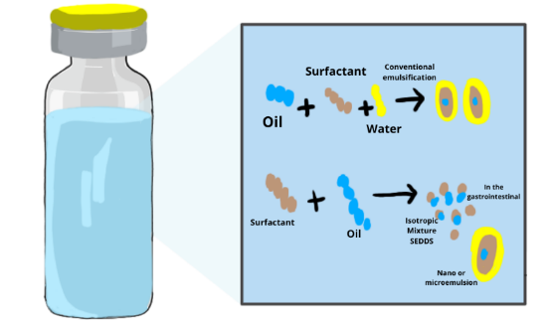

FIGURE 3. Mechanism of Self-emulsification in an Aqueous Environment. SEDDS comprise a mixture of drugs, surfactants, oil, stabilizers, and cosolvents. Like conventional emulsification, SEDDS (ionotropic mixture) form (o/w) nano or microemulsion within the gastrointestinal tract with very small energy input. Modified from [3]
Lipid-based drug delivery systems exist in various forms, including suspensions, dry emulsions, microemulsions, and self-emulsifying systems such as Self-Emulsifying Drug Delivery Systems (SEDDS) [22]. SEDDS have evolved into more refined formulations, including Self-Microemulsifying Drug Delivery Systems (SMEDDS) and Self-Nanoemulsifying Drug Delivery Systems (SNEDDS). Unlike conventional emulsions, these systems spontaneously form emulsions upon oral administration, without requiring external energy input.
Emulsions are mixtures of two immiscible liquid phases—typically oil and water—stabilized by surfactants. They are thermodynamically unstable, semi-transparent to opaque, and exhibit viscous, liquid-like behavior. Based on phase composition, emulsions are classified as water-in-oil (W/O), oil-in-water (O/W), or double emulsions [23].
Microemulsion formation requires both a surfactant (S), which is water-soluble, and a co-surfactant (CoS), which is more oil-soluble. Co-surfactants reduce interfacial tension, facilitating the formation of stable microemulsions [24, 11]. In contrast, nanoemulsions—characterized by droplet sizes below 100 nm—require mechanical or chemical energy input for formation [25]. Although thermodynamically unstable, nanoemulsions are kinetically stable, exhibiting minimal destabilization and remaining intact for extended periods (up to several months) [26].
TABLE. 1 Four basic types of lipid-based drug-delivery system (LBDDS) with their merits and demerits
Characteristics | SMEDDS | SNEDDS | SEDDS
Size of the globule | <250 nm | <100 nm | >300 nm
The system appearance | High Optical clarity | High Optical clarity | Cloudy
The surfactant HLB value | >12 | >12 | >12
LFCS Classification | Type IIIB | Type IIIB | Type II
Oil phase | >20% | >20% | 40–80%
Surfactants Concentration | 40–80% | 40–80% | 30–40%
HLB=Hydrophilic/lipophilic balance; LFCS = lipid formulation classification system; SEDDS = self-emulsifying drug-delivery systems; SMEDDS = self-microemulsifying drug-delivery systems; SNEDDS = self-nanoemulsifying drug-delivery system [22][21].

In-Situ Hydrogel Drug Delivery System
An effective drug delivery system (DDS) plays a critical role as a therapeutic tool in the management of various oral diseases [27]. This necessitates the use of high-performance biomaterials capable of functioning as efficient drug delivery platforms. Conventional DDS for oral applications include gels, tablets, and lozenges. However, the complex anatomy of the oral and maxillofacial region, along with the unique characteristics of the oral environment, presents significant challenges for targeted drug delivery. For instance, the presence of multiple fascial planes and cavities in the maxillofacial area can facilitate the rapid spread of infection, complicating its control. Sustained and localized drug concentrations are essential for effective infection management [28].
Moreover, the high humidity of the oral cavity and continuous tongue movement hinder the retention of topical therapies, such as patches, at the lesion site. This poses a major obstacle in the treatment and prevention of oral mucosal diseases. Therefore, the development of DDS that are practical, responsive, and capable of maintaining therapeutic efficacy under these conditions is both essential and urgent [29].
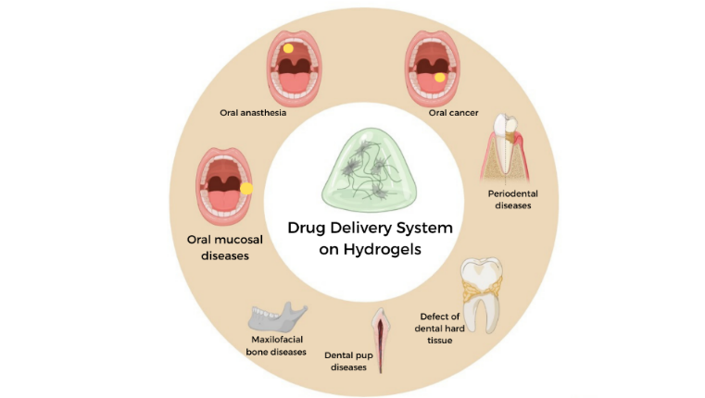

FIGURE 4. Application of hydrogels in drug delivery for oral and maxillofacial diseases modified from [30]
One promising innovation in drug delivery is the development of hydrogels, which exhibit unique structural and functional properties compared to other biomaterials [31]. Hydrogels are three-dimensional polymer networks formed through physical or chemical crosslinking of monomers [32]. A representative example is a methacrylate-based hydrogel synthesized from N-vinylpyrrolidone (NVP), 2-hydroxyethyl methacrylate (HEMA), glycerol monomethacrylate (GMMA), and methacrylic acid (MA). Crosslinking can be initiated via thermally induced free radical polymerization, ultraviolet (UV) irradiation, or redox reactions [33].

Liposome-Based Drug Delivery Systems
Liposomes have significantly advanced modern therapeutics by enhancing the efficacy and precision of drug delivery (Figure 6). By encapsulating drugs within lipid bilayers, liposomes reduce systemic toxicity..Moreover, liposomes can alter drug pharmacokinetics to promote accumulation in target tissues. PEGylation extends circulation time and facilitates passive targeting of tumor sites via the enhanced permeability and retention (EPR) effect [34].
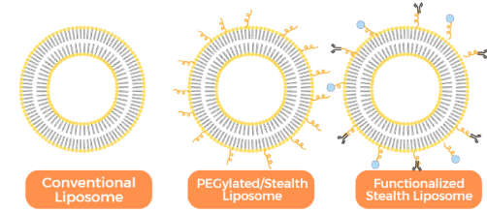

FIGURE 5. Struktural and function tunability of conventional liposomes modified from [34]
Liposomes also support combination therapy by enabling the co-encapsulation of multiple therapeutic agents within a single formulation. Their surfaces can be functionalized with polyethylene glycol (PEG) or specific targeting ligands to achieve active targeting of specific cells or tissues. These features position liposomes as a foundational platform in nanomedicine, particularly for addressing complex diseases that are inadequately managed by conventional therapies.
The clinical success of various liposomal formulations validates laboratory-developed concepts and accelerates the translation of liposome-based technologies into clinical practice. Overall, liposome-based drug delivery systems offer a versatile and advanced therapeutic platform capable of enhancing a drug’s therapeutic index—making treatments safer, more effective, and better aligned with improving patient quality of life [35].

Chewing Gums as a Drug Delivery System
Given its unique characteristics, orally administered chewable drug delivery—particularly in the form of medicated chewing gum—has emerged as a promising therapeutic approach. Key advantages include rapid onset of action, ease of administration, minimal side effects, and targeted local effects for treating oral diseases [36, 37].
During mastication, the active pharmaceutical ingredient is gradually released into the oral cavity, where it can be absorbed directly through the oral mucosa or swallowed for systemic absorption via the gastrointestinal tract. Beyond its role as a drug delivery medium, chewing gum has also been shown to enhance alertness, calmness, and cognitive focus, as demonstrated in multiple studies [38].
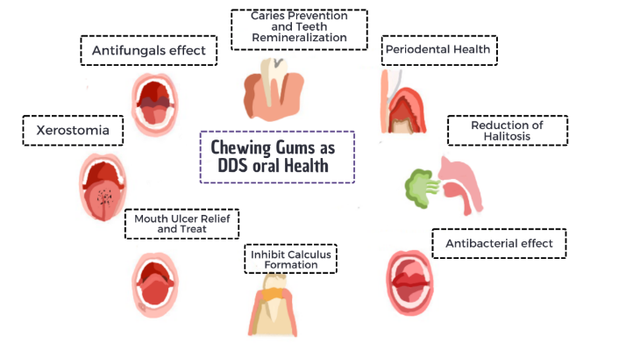

FIGURE 6. Chewing gums as a drug delivey approach for oral health [39]
The first commercially available medicinal chewing gum was Aspergum, containing acetylsalicylic acid. Since the introduction of nicotine chewing gum in the 1980s, medicated chewing gum (MCG) has become a widely adopted method in nicotine replacement therapy [40]. Today, MCG is officially recognized as a drug delivery system by both the European Pharmacopoeia (Ph. Eur.) and the United States Pharmacopeia (USP) [41].
Numerous studies have demonstrated the versatility of MCG in delivering a range of active pharmaceutical ingredients, including antiallergics, nicotine, antiemetics, aspirin, caffeine, and antifungals such as nystatin. Clinically, MCG has been applied in the prevention of dental caries, treatment of motion sickness, smoking cessation, pain management, and therapy for oral fungal infections. Due to its ease of administration and broad therapeutic potential, MCG is increasingly recognized as a practical and patient-friendly drug delivery platform [42].

The summary of recent drug delivery systems
TABEL 2. The summary of recent drug delivery systems, their uses and advantages, and disadvantages, and the result
Recent DDS | Advantages | Disadvantages | Therapeutic Use | Main Results[Reference]
Red Blood Cell MembraneCamouflaged Nanoparticles Drug Delivery System | Avoids triggering the immune system and achieves long-term circulation. Inherent biocompatibility and biodegradability thus avoiding accumulation-related toxicity | Because it is disguised as part of a biological system, complex regulatory issues can arise, as well as the identification, purification, and conjugation | Erythrocyte membrane-coated nanoformulations have been applied in antitumor and anticancer research with substantial achievement | Erythrocyte membrane surface proteins such as CD47 help avoid recognition by the immune system, so that nanoparticles have a long circulation time and reduce clearance by macrophages. In vitro and in vivo studies demonstrate the physical and chemical stability of nanoparticles during controlled drug circulation and release[43]
Polymer-Lipid Hybrid Nanoparticles Drug Delivery System | Physical stability in encapsulation and biocompatibility, efficacy of cell delivery in vivo | Drug entrapment and poor loading capacity, Inflammation and tissue damage | Targeted anticancer therapy. kombinasi doxorubicin (Dox) dan mitomycin C ( | DMsPLN was significantly more effective than PLD (liposomal doxorubicin) and controls. DMsPLN shows very low toxicity to normal tissues, almost undetectable[44]
Self-microemulsifying drug-delivery system | Availability of low-solubility drugs, long-term stability, protection of drug-sensitive materials, availability of drugs in liquid and solid forms | Drug interactions have the potential to accelerate physical aging in patients due to the interaction of glycerides. | Relugolix (RLGL) antagonis reseptor GnRH | The S-SMEDDS developed has been proven to be safe and effective in improving the absorption and oral bioavailability of RLGL. The system has great potential to improve drug therapy with low solubility and poor bioavailability[20]
Hidrogel drug delivery system | High Biocompatibility, Controlled Release Ability, Supports Tissue Proliferation and Regeneration, Formulation Flexibility, Easy to Use and Administer | Limited Physical and Chemical Stability, Uncontrolled Protein Release, Limited Tissue Penetration | Terapi protein platelet-rich plasma (PRP) | Hydrogels are effective as therapeutic protein carriers, able to release proteins in a controlled manner and support the growth of fibroblast cells. The system could potentially be used as a protein delivery scaffold for wound tissue regeneration[45]
Liposome-Based Drug Delivery Systems | Increased Drug Solubility, Toxicity Reduction, Increased Bioavailability and Efficiency, Controlled Release, Biocompatibility and Biodegradability, This method does not require organic solvents or chemical modifications to proteins, thus preserving the original function of proteins | Short Half-Life in Circulation, | superoxide dismutase (SOD) protein | In in vivo (rat) tests, SOD encapsulated with this method showed a more stable distribution and circulation in the blood than free SOD or lipoplex without freeze–thawing. Overall, the freeze–thaw method on liposomes can improve physical and chemical stability, and offer a good safety profile for the delivery of active proteins such as superoxide dismutase (SOD) [46]
Chewing Gums as a Drug Delivery System | Drugs released in the oral cavity can be directly absorbed through the buccal mucosa, Rapid Onset of Effects, Controlled and,Increased Saliva | Limited Dosage and Inconsistent Release, Unpleasant Taste, Potential Swallowing | xylitol | provides optimal therapeutic time and lower side effects due to sustained release capabilities and lower drug thresholds compared to other delivery methods[39]

CHALLENGES ASSOCIATED WITH CURRENT POSTBIOTIC DELIVERY SYSTEMS
In recent decades, nanoparticle-based drug delivery systems (DDS) have made significant progress, particularly in the delivery of bioactive compounds derived from natural sources such as plants, proteins, and postbiotics. Despite their potential, several challenges continue to limit their clinical translation and therapeutic efficiency.
A major barrier is the inconsistency and variability in the scientific literature, particularly regarding microencapsulation techniques and characterization methods. These discrepancies hinder standardization and reproducibility, which are essential for advancing nanomedicine from experimental research to clinical application. This issue is especially relevant in the development of protein- and postbiotic-based delivery systems.
Therapeutic proteins—including enzymes, hormones, and antibodies—hold great promise but are highly susceptible to enzymatic degradation and exhibit poor oral bioavailability [47]. Nanoparticle carriers have been employed to protect protein structures from harsh biological environments and to facilitate targeted delivery. However, proteins’ large molecular size and specific surface charges can impede cellular uptake and may trigger immune responses if not properly encapsulated [48].
Postbiotics, which are byproducts of the metabolism of microorganisms such as antimicrobial peptides, short-chain fatty acids, and exopolysaccharides, are gaining attention thanks to their immunomodulatory, anti-inflammatory, and antimicrobial properties, particularly in gastrointestinal and oral health, and has activities that inhibit qurom sensing and biofilm formation [49, 52]. However, the use of postbiotics still faces challenges, including the risk of degradation in the digestive tract and difficulties in achieving specific targets in the desired tissues. In the context of oral health, postbiotics are considered promising as therapeutic agents, but research on their specific applications, for example in the root canals of teeth, is still limited [51].
Both proteins and postbiotics face common obstacles in nanoparticle delivery, including rapid clearance by liver macrophages (Kupffer cells), renal filtration, enzymatic degradation, and limited ability to cross biological barriers such as the blood–brain barrier (BBB). Even when nanoparticles reach the target site, inappropriate particle size or surface charge can reduce absorption and distribution efficiency.
To overcome current limitations in protein and postbiotic delivery, various strategies like Hidrogels, biodegradable polymers, and PEGylation have been explored to improve circulation, reduce immunogenicity, and enhance biocompatibility. However, comprehensive toxicity assessments are crucial, as materials like carbon nanotubes, gold, and silver nanoparticles, while improving bioavailability, have shown toxic effects on vital organs [50]. Thus, future research must prioritize developing safe, efficient, and targeted nanocarriers for delivering proteins and postbiotics, especially for inflammatory, infectious, and degenerative diseases.
Ultimately, the development of effective and safe postbiotic DDS requires multidisciplinary collaboration across synthetic biology, materials science, and clinical research to overcome biological and technical barriers while meeting regulatory standards. Nanoparticle-based systems incorporating proteins and postbiotics offer promising opportunities for personalized medicine and chronic disease management.

FUTURE DIRECTION AND CONCLUSION SYSTEMS
Drug delivery and nanomedicine have become central themes in contemporary biomedical research, with rapid advancements spanning basic science, laboratory experimentation, and clinical trials. Despite ongoing challenges in clinical translation, these systems hold substantial therapeutic potential. To maximize their effectiveness, multidisciplinary collaboration among researchers, clinicians, pharmacists, and biomedical engineers is essential to bridge the gap between laboratory innovation and clinical application.
Proteins, including enzymes, antibodies, and hormones, are powerful therapeutics but face issues with degradation and low bioavailability. Nanoparticle or cell-based carriers can protect these proteins and enable controlled release. Similarly, postbiotics—microbial metabolites like short-chain fatty acids and exopolysaccharides—provide immunomodulatory and anti-inflammatory benefits but also need specialized delivery systems for stability.
According to the latest literature, hydrogels show very promising potential as a next-generation delivery system. Research by Xu and colleagues [53] highlights the advantages of probiotic hydrogels based on extracellular polysaccharides (EPS) and hyaluronic acid methacrylate (HAMA) that encapsulate Lactobacillus paracasei TYM202. This hydrogel emerged as a leading and highly visible candidate as the best wound dressing, as it was able to significantly accelerate wound healing in animal models. With its high biocompatibility and excellent safety profile, this hydrogel effectively addresses the toxicity issues that often arise in conventional nanocarriers, making it an innovative solution that is safe and effective for future medical applications.

Acknowledgments
The author extends sincere gratitude to all individuals and institutions who provided intellectual support and encouragement throughout the preparation of this article. Special appreciation is directed to [Name of Institution] for granting access to essential resources and facilities that greatly facilitated the literature review and critical analysis. It is the author’s hope that this work contributes meaningfully to the advancement of knowledge in the relevant field.

References
- B.M. Rayaprolu, J.J. Strawser, and G. Anyarambhatla, “Excipients in parenteral formulations: selection considerations and effective utilization with small molecules and biologics,” Drug Development and Industrial Pharmacy 44(10), 1565–1571 (2018).
- A.M. Vargason, A.C. Anselmo, and S. Mitragotri, “The evolution of commercial drug delivery technologies,” Nat Biomed Eng 5(9), 951–967 (2021).
- T.C. Ezike, U.S. Okpala, U.L. Onoja, C.P. Nwike, E.C. Ezeako, O.J. Okpara, C.C. Okoroafor, S.C. Eze, O.L. Kalu, E.C. Odoh, U.G. Nwadike, J.O. Ogbodo, B.U. Umeh, E.C. Ossai, and B.C. Nwanguma, “Advances in drug delivery systems, challenges and future directions,” Heliyon 9(6), e17488 (2023).
- B.D. Mattos, O.J. Rojas, and W.L.E. Magalhães, “Biogenic silica nanoparticles loaded with neem bark extract as green, slow-release biocide,” Journal of Cleaner Production 142, 4206–4213 (2017).
- A. Kumar, K.M. Green, and M. Rawat, “A Comprehensive Overview of Postbiotics with a Special Focus on Discovery Techniques and Clinical Applications,” Foods 13(18), 2937 (2024).
- N.N.Y. Sulaiman, N.A. Mohd Noor, M.S. Aazmi, M.I. Ismail, A.H. Jasni, Y.S. Wu, A.M. Alabsi, S.M. Lim, K. Ramasamy, and M.F. Ismail, “Unveiling Postbiotics: Advancing Definitions, Mechanisms and Their Impact on Health and Other Functional Applications,” Trends Sci 22(7), (2025).
- S. Salminen, M.C. Collado, A. Endo, C. Hill, S. Lebeer, E.M.M. Quigley, M.E. Sanders, R. Shamir, J.R. Swann, H. Szajewska, and G. Vinderola, “The International Scientific Association of Probiotics and Prebiotics (ISAPP) consensus statement on the definition and scope of postbiotics,” Nat Rev Gastroenterol Hepatol 18(9), 649–667 (2021).
- P. Viji, B. Madhusudana Rao, J. Debbarma, and C.N. Ravishankar, “Research developments in the applications of microwave energy in fish processing: A review,” Trends in Food Science & Technology 123, 222–232 (2022).
- Y. Yi, M. Yu, W. Li, D. Zhu, L. Mei, and M. Ou, “Vaccine-like nanomedicine for cancer immunotherapy,” Journal of Controlled Release 355, 760–778 (2023).
- A.M. Faheem, and D.H. Abdelkader, “Novel drug delivery systems,” in Engineering Drug Delivery Systems, (Elsevier, 2020), pp. 1–16.
- H.S. Rahman, H.H. Othman, N.I. Hammadi, S.K. Yeap, K.M. Amin, N. Abdul Samad, and N.B. Alitheen, “Novel Drug Delivery Systems for Loading of Natural Plant Extracts and Their Biomedical Applications,” IJN Volume 15, 2439–2483 (2020).
- A. Vincy, S. Mazumder, Amrita, I. Banerjee, K.C. Hwang, and R. Vankayala, “Recent Progress in Red Blood Cells-Derived Particles as Novel Bioinspired Drug Delivery Systems: Challenges and Strategies for Clinical Translation,” Front. Chem. 10, 905256 (2022).
- G. Qi, Y. Zhou, X. Zhang, J. Yu, X. Li, X. Cao, C. Wu, and P. Guo, “Cordycepin promotes browning of white adipose tissue through an AMP-activated protein kinase (AMPK)-dependent pathway,” Acta Pharmaceutica Sinica B 9(1), 135–143 (2019).
- T. Hanley, R. Vankayala, C.-H. Lee, J.C. Tang, J.M. Burns, and B. Anvari, “Phototheranostics Using Erythrocyte-Based Particles,” Biomolecules 11(5), 729 (2021).
- G. Qi, Y. Zhou, X. Zhang, J. Yu, X. Li, X. Cao, C. Wu, and P. Guo, “Cordycepin promotes browning of white adipose tissue through an AMP-activated protein kinase (AMPK)-dependent pathway,” Acta Pharmaceutica Sinica B 9(1), 135–143 (2019).
- C. Wang, X. Sun, L. Cheng, S. Yin, G. Yang, Y. Li, and Z. Liu, “Multifunctional Theranostic RBC For Magnetic‐Field‐Enhanced in vivo Combination Therapy of Cancer,” Advanced Materials 26(28), 4794–4802 (2014).
- Md. Rizwanullah, M. Alam, Harshita, S.R. Mir, Mohd.M.A. Rizvi, and S. Amin, “Polymer-Lipid Hybrid Nanoparticles: A Next-Generation Nanocarrier for Targeted Treatment of Solid Tumors,” CPD 26(11), 1206–1215 (2020).
- A. Mohanty, S. Uthaman, and I.-K. Park, “Utilization of Polymer-Lipid Hybrid Nanoparticles for Targeted Anti-Cancer Therapy,” Molecules 25(19), 4377 (2020).
- Z. Vinarov, M. Abdallah, J.A.G. Agundez, K. Allegaert, A.W. Basit, M. Braeckmans, J. Ceulemans, M. Corsetti, B.T. Griffin, M. Grimm, D. Keszthelyi, M. Koziolek, C.M. Madla, C. Matthys, L.E. McCoubrey, A. Mitra, C. Reppas, J. Stappaerts, N. Steenackers, N.L. Trevaskis, T. Vanuytsel, M. Vertzoni, W. Weitschies, C. Wilson, and P. Augustijns, “Impact of gastrointestinal tract variability on oral drug absorption and pharmacokinetics: An UNGAP review,” European Journal of Pharmaceutical Sciences 162, 105812 (2021).
- B. Tang, G. Cheng, J.-C. Gu, and C.-H. Xu, “Development of solid self-emulsifying drug delivery systems: preparation techniques and dosage forms,” Drug Discovery Today 13(13–14), 606–612 (2008).
- K. Rajpoot, M. Tekade, V. Pandey, S. Nagaraja, S.R. Youngren-Ortiz, and R.K. Tekade, “Self-microemulsifying drug-delivery system: ongoing challenges and future ahead,” in Drug Delivery Systems, (Elsevier, 2020)393–454.
- M.M. Mehanna, and A.T. Mneimneh, “Formulation and Applications of Lipid-Based Nanovehicles: Spotlight on Self-emulsifying Systems,” Adv Pharm Bull 11(1), 56–67 (2020).
- A. Kumar, R. Kaur, V. Kumar, S. Kumar, R. Gehlot, and P. Aggarwal, “New insights into water-in-oil-in-water (W/O/W) double emulsions: Properties, fabrication, instability mechanism, and food applications,” Trends in Food Science & Technology 128, 22–37 (2022).
- N. Parmar, N. Singla, S. Amin, and K. Kohli, “Study of cosurfactant effect on nanoemulsifying area and development of lercanidipine loaded (SNEDDS) self nanoemulsifying drug delivery system,” Colloids and Surfaces B: Biointerfaces 86(2), 327–338 (2011).
- N.A.N. Azmi, A.A.M. Elgharbawy, S.R. Motlagh, N. Samsudin, and H.Mohd. Salleh, “Nanoemulsions: Factory for Food, Pharmaceutical and Cosmetics,” Processes 7(9), 617 (2019).
- J. Rao, and D.J. McClements, “Food-grade microemulsions and nanoemulsions: Role of oil phase composition on formation and stability,” Food Hydrocolloids 29(2), 326–334 (2012).
- J. Bakó, M. Szepesi, I. Márton, J. Borbély, and C. Hegedûs, “[Synthesis of nanoparticles for dental drug delivery systems],” Fogorv Sz 100(3), 109–113 (2007).
- B. Wang, H.E. Booij-Vrieling, E.M. Bronkhorst, J. Shao, P.H.J. Kouwer, J.A. Jansen, X.F. Walboomers, and F. Yang, “Antimicrobial and anti-inflammatory thermo-reversible hydrogel for periodontal delivery,” Acta Biomaterialia 116, 259–267 (2020).
- C. Barber, R. Powell, A. Ellis, and J. Hewett, “Comparing pain control and ability to eat and drink with standard therapy vs Gelclair: a preliminary, double centre, randomised controlled trial on patients with radiotherapy-induced oral mucositis,” Support Care Cancer 15(4), 427–440 (2007).
- L. Liu, D. Wu, H. Tu, M. Cao, M. Li, L. Peng, and J. Yang, “Applications of Hydrogels in Drug Delivery for Oral and Maxillofacial Diseases,” Gels 9(2), 146 (2023).
- N. Oliva, J. Conde, K. Wang, and N. Artzi, “Designing Hydrogels for On-Demand Therapy,” Acc. Chem. Res. 50(4), 669–679 (2017).
- M. Salar Amoli, M. EzEldeen, R. Jacobs, and V. Bloemen, “Materials for Dentoalveolar Bioprinting: Current State of the Art,” Biomedicines 10(1), 71 (2021).
- S.R. Bollareddy, V. Krishna, G. Roy, D. Dasari, A. Dhar, and V.V.K. Venuganti, “Transfersome Hydrogel Containing 5-Fluorouracil and Etodolac Combination for Synergistic Oral Cancer Treatment,” AAPS PharmSciTech 23(2), 70 (2022).
- S. Basak, and T.K. Das, “Liposome-Based Drug Delivery Systems: From Laboratory Research to Industrial Production—Instruments and Challenges,” ChemEngineering 9(3), 56 (2025).
- A.C. Newby, “Metalloproteinases and Vulnerable Atherosclerotic Plaques,” Trends in Cardiovascular Medicine 17(8), 253–258 (2007).
- D. Khatiwara, P. Ranabhat, M. Paul, and A. Bagchi, “An emerging technique of medicated chewing gum in drug delivery system: a review,” JAPR 9(4), 1–8 (2021).
- S.A. Chaudhary, and A.F. Shahiwala, “Medicated chewing gum – a potential drug delivery system,” Expert Opinion on Drug Delivery 7(7), 871–885 (2010).
- A.P. Allen, and A.P. Smith, “Chewing gum: cognitive performance, mood, well-being, and associated physiology,” Biomed Res Int 2015, 654806 (2015).
- M. Banakar, S. Moayedi, E. Shamsoddin, Z. Vahedi, M.H. Banakar, S.M. Mousavi, D. Rokaya, and K. Bagheri Lankarani, “Chewing Gums as a Drug Delivery Approach for Oral Health,” International Journal of Dentistry 2022, 1–10 (2022).
- U. Wadgave, and L. Nagesh, “Nicotine Replacement Therapy: An Overview,” Int J Health Sci (Qassim) 10(3), 425–435 (2016).
- J. Gajendran, Performance Testing of Medicated Chewing Gums with the Goal of Establishing in Vitro in Vivo Correlation, Johannes Gutenberg-Universität Mainz, 2017.
- T. Al Hagbani, and S. Nazzal, “Medicated Chewing Gums (MCGs): Composition, Production, and Mechanical Testing,” AAPS PharmSciTech 19(7), 2908–2920 (2018).
- Q. Xia, Y. Zhang, Z. Li, X. Hou, and N. Feng, “Red blood cell membrane-camouflaged nanoparticles: a novel drug delivery system for antitumor application,” Acta Pharmaceutica Sinica B 9(4), 675–689 (2019).
- P. Prasad, A. Shuhendler, P. Cai, A.M. Rauth, and X.Y. Wu, “Doxorubicin and mitomycin C co-loaded polymer-lipid hybrid nanoparticles inhibit growth of sensitive and multidrug resistant human mammary tumor xenografts,” Cancer Letters 334(2), 263–273 (2013).
- A.R. Radzali, C.H. Cheng, R. Radzi, M.F.W. Cheng, A.M. Jaafar, P.-S.J. Tsai, and M. Ajat, “Preparation and Characterization of Gellan Gum Hydrogel as Therapeutic Protein Delivery for Wound Healing,” Mal. J. Fund. Appl. Sci. 19(5), 885–891 (2023).
- H. Koide, H. Ochiai, H. Suzuki, S. Hirata, M. Watanabe, S. Yonezawa, T. Dewa, N. Oku, and T. Asai, “Easy preparation of a liposome-mediated protein delivery system by freeze–thawing a liposome–protein complex,” J. Mater. Chem. B 10(35), 6768–6776 (2022).
- B. Leader, Q.J. Baca, and D.E. Golan, “Protein therapeutics: a summary and pharmacological classification,” Nat Rev Drug Discov 7(1), 21–39 (2008).
- B.J. Bruno, G.D. Miller, and C.S. Lim, “Basics and Recent Advances in Peptide and Protein Drug Delivery,” Ther. Deliv. 4(11), 1443–1467 (2013).
- J.E. Aguilar-Toalá, R. Garcia-Varela, H.S. Garcia, V. Mata-Haro, A.F. González-Córdova, B. Vallejo-Cordoba, and A. Hernández-Mendoza, “Postbiotics: An evolving term within the functional foods field,” Trends in Food Science & Technology 75, 105–114 (2018).
- I. Khan, K. Saeed, and I. Khan, “Nanoparticles: Properties, applications and toxicities,” Arabian Journal of Chemistry 12(7), 908–931 (2019).
- A. Adiningrat, I. Maulana, A.G. Fadhlurrahman, and H. Yumoto, “Probiotic bacteria from asymptomatic necrotic tooth can regulate the microbiome homeostasis,” Microb. Pathog. 206, 107791 (2025).
- Adiningrat, R.A. Kusnadi, A.S. Allam, E. Sofiani, I. Maulana, and H. Yumoto, “The Effect of Probiotic Lactobacillus acidophilus and Ethanolic Propolis Compound toward Nucleic Acid Deposition in the Extracellular Polymeric Substance of Root Canal Bacteria,” Eur. J. Dent. 17(02), 418–423 (2023).
- H. Xu, Y. Li, J. Song, L. Zhou, K. Wu, X. Lu, X. Zhai, Z. Wan, and J. Gao, “Highly active probiotic hydrogels matrixed on bacterial EPS accelerate wound healing via maintaining stable skin microbiota and reducing inflammation,” Bioact. Mater. 35, 31–44 (2024).

