Biomaterials Advancements for Ultrasonic Dental Instrumentation: Assessing Tip Vibration Performance
Laelia Dwi Anggraini^{1, a)}, Fitri Yuniawati², Lasmi Dewi Nurnaini³, Thomas Oka Pratama^{4, b)}, Memory Motivanisman Waruwu^{4, c)}, Rony Wijaya^{4, d)}, Bambang Pamungkas^{4, e)}, Hermin Kartika Sari^{4, f)}, Anggi Nurcahyo^{4, g)}
Author Affiliations
¹Department Pediatric Dentistry, Faculty of Dentistry, Universitas Muhammadiyah Yogyakarta, Jl Brawijaya Tamantirto, Bantul, 55183, Indonesia
²Department Periodontology, Faculty of Dentistry, Universitas Muhammadiyah Yogyakarta, Jl Brawijaya Tamantirto, Bantul, 55183, Indonesia
³Department Pediatric Dentistry, Faculty of Dentistry, Universitas Muhammadiyah Surakarta, Surakarta, Indonesia
⁴Laboratorium System Sensor and Telecontrol, Departement Technic Nuclear and Technic Physic, Faculty of Technic, Universitas Gadjah Mada, Yogyakarta, Indonesia.

Author Emails
^{a)} Corresponding author: laelia.dwi@umy.ac.id
^{b)} thomas.o.p@ugm.ac.id
^{c)} morymw@gmail.com
^{d)} r.wijaya80@gmail.com
^{e)} bp.sleman@gmail.com
^{f)} hrmnkrtksari@gmail.com
^{f)} angginurcahyo@gmail.com

Abstract. Dental health prevention, regarding ultrasonic technology, it is known that ultrasonic technology has been widely used in various medical applications, including in teeth cleaning. Ultrasonic dental cleaning devices use sound waves to remove tartar and plaque from the tooth surface. Accessibility and cost challenges: although the effectiveness of ultrasonic dental cleaning devices has been proven, many patients may face accessibility barriers or high costs when trying to obtain this treatment. The opportunity for innovation in this paper is that there is an opportunity to develop ultrasonic dental cleaning devices that are more affordable, faster, and more cleanser. This paper compares the tip vibration test on ultrasonic dental cleaning tool prototype type 2.0 to the old ultrasonic model. This paper aims to make this technology accessible to patients and dental practitioners. This paper can provide significant benefits in increasing the accessibility of ultrasonic dental care, which can help prevent dental and oral problems early on. It can also reduce long-term dental care costs and improve patient's quality of life. Novelty. This study used Clear Smile Ulltra, a new scaler tool that uses non-PLN electricity. This study compared the tip vibration test on ultrasonic dental cleaning tool prototype type 2.0 to the old ultrasonic model. The study results showed that the new scaler model is faster than the old type of scaler. The study concluded that the new scaler model is recommended for dental care, especially in cases requiring immediate treatment.
Keywords: ultrasonic scaler type 2,0; old ultrasonic model.

introduction
An inventive device that uses ultrasonic vibrations to remove tartar, the home stand-alone ultrasonic dental cleaning tool may be used independently and is ideal for emergencies and remote locations. Since dental patients of all ages can benefit from this breakthrough, all Indonesian dentists are prospective users of this product. Additionally, this innovation can be run independently, making it available to volunteers providing social services, media teams, small-to medium-sized dental clinics, and those living in rural places. The use of piezoelectric materials and high-frequency ultrasonic technologies, which provide safe and smooth mechanical vibrations, is an advantage of this product innovation. Additionally, this instrument features a cavitation effect that produces tiny bubbles to efficiently clear plaque and tartar, as well as a standalone power generator that enables its use in remote areas. This product will undergo multiple phases, including prototype design and development, laboratory and field testing, feedback gathering, validation and certification, and large-scale production preparation, in order to reach Technology Readiness Level 6. In order for the product to be marketed and utilized by the general public right away, this step makes sure the prototype has been tested in an appropriate setting and is prepared for additional manufacturing. Additionally, this product has been submitted for a simple patent, named Stand-alone Power Generator Circuit for Ultrasonic Dental Scaler, with registration number 500202405986. The piezoelectric reaction to vibration variations is the basis for the Benetech GM63A vibration meter's operation. Vibration sensors frequently use piezoelectric crystals, such quartz, or piezoelectric ceramic compounds. The surface or structure whose vibration is being measured will have this sensor installed on it. When the structure vibrates, the piezoelectric sensor will provide an electrical signal that is proportional to the vibration's frequency and amplitude. The electrical charge on the piezoelectric crystal will alter in response to pressure or vibration applied to the piezoelectric sensor. For additional examination, the ensuing electrical signal can be detected and recorded. Signal processing electronics can be used to process the signal.
Piezoelectric-based vibration meters are often quick to react to vibration changes, which makes them appropriate for detecting high-frequency or rapid vibrations. Numerous applications, such as predictive maintenance, machine condition monitoring, and structural testing, make extensive use of vibration meters. Approach. When the valve switch sensor changes to be monitored on site, the probe is operated by affixing it to the region or place where vibration occurs. Vibrations on the valve and the valve position sensor device are included in the measurements. comprises a set of valve actuators, a short and long probe, and a Benetech Vibration Meter GM63A Probe Multimeter. Both high frequency (HI) and low frequency (LO) vibrations can be measured with a Short Probe (S). A Long Probe (L) is only appropriate for measurements at low frequencies. When measuring acceleration or when the frequency rises above 1KHz, the short probe needs to be changed. High frequency (HI) will immediately transition to low frequency (LO) when the acceleration measurement mode (high frequency, or HI) is switched to speed or displacement mode. If the electricity is not used for 60 seconds, it will automatically cut off. In seven seconds, the backlight won't be able to function. The tool's components include an LCD screen, a probe, buttons for power and measurement, a frequency selection button (only used for acceleration measurement), and a measuring mode selection button (acceleration, speed, and displacement). To turn the device on, press once. Keep pressing throughout.
The tool's components include an LCD screen, a probe, buttons for power and measurement, a frequency selection button (only used for acceleration measurement), and a measuring mode selection button (acceleration, speed, and displacement). To turn the device on, press once. Throughout the measurement procedure, press consistently. release for data storage: Quick instruction label, Battery slot, AC signal output socket

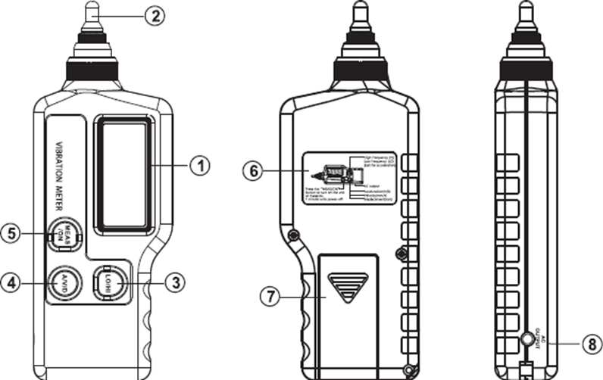
FIGURE 1. Vibrator Meters
The vibration frequency, the proper measurement mode (acceleration, velocity, displacement), and the frequency (high frequency/low frequency) were chosen based on the structure to be measured. Hold the "MEAS/ON" button down with the right thumb. Apply 500g to 1kg of force to the measured object's vibration dial. On the LCD panel, the outcome is shown. The outcome will be recorded on the LCD panel after the button is released. A new measurement can be taken after pressing the "MEAS/ON" button once more, which will cancel the current value. as depicted in the figure below
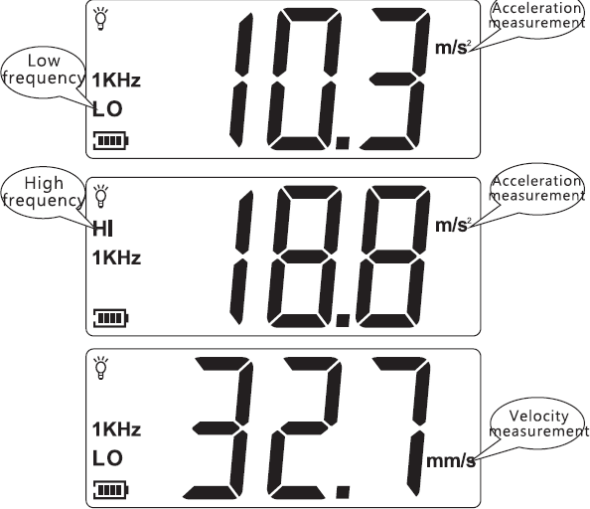
FIGURE 2. Measurement Results

RESULTS
This prototype's scaler invention is Model M3+, SN: U3LD60134. Using a Benetech Vibration Meter GM63A, the prototype scaler's vibration test results were compared to those of other scaler brands, including the ART-Piezo Brand, which was utilized at RSGM UMY Yogyakarta. Table 1 displays the vibration comparison data results.

Vibration Measurement on the Ultrasonic Scaler Prrototype (model M3+SN U3LD60134) |  |  |  | Vibration Measurement on the Ultrasonic Scaler Prototype (Model ART-Piezo)
No |  | Unit | Voltage | No. |  | Unit | Voltage
 | LOW | m/s² | 62.5 |  |  | m/s² | 13.8
 | LOW | mm/s² | 199.9 |  | LOW | mm/s² | 151.5
 | LOW | Mm | 199.9 |  |  | mm | 1.230
 | HIGH | m/s² | 1447 |  |  | m/s² | 63.4
 | HIGH | m/s² | 33.3 |  | HIGH | m/s² | 4.9
 | HIGH | m/s² | 133.7 |  |  | m/s² | 970
TABLE 1. Comparative Data between Prototype Scaler and ART-Piezo Model Scaler
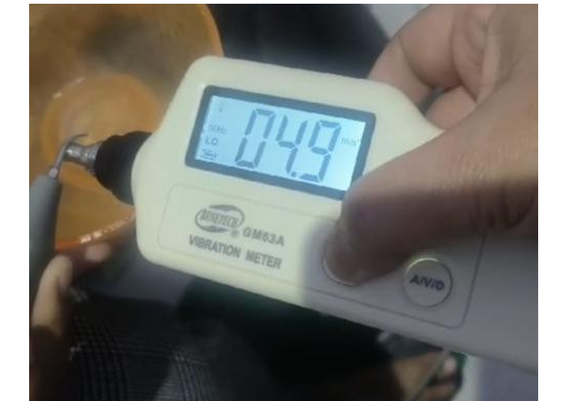

FIGURE 3. Scaler Model Used as a Reference for Comparison with its Vibration Value Reference
According to the data presented in Table 1, the vibration at the tip of the ultrasonic scaler prototype is greater than that of the ART-Piezo scaler. This higher vibration magnitude is crucial, as it implies a greater ability to remove dental calculus or tartar from tooth surfaces. In general, the more intense the vibration at the scaler’s tip, the more efficient it is in clinical use.
TABLE 2. Vibration Measurement on Ultrasonic Scaler Prototype (Model M3+ SN: U3LD60134)
No | Mode | Acceleration (m/s²) | Acceleration (mm/s²) | Amplitude (mm)
1 | LOW | 62.5 | 199.9 | 1.999
2 | HIGH | 1447 | 33.3 and 133.7 | —

Two distinct vibration settings were evaluated on the ultrasonic scaler prototype to assess performance under varying operational intensities. The LOW mode likely represents a light or maintenance-level operation, whereas the HIGH mode suggests a setting designed for more intensive scaling procedures. The primary parameters measured include acceleration in m/s², indicating the vibration intensity; acceleration in mm/s², as the converted unit; and amplitude in mm, representing the vibration range.
In LOW mode, the prototype exhibited an acceleration of 62.5 m/s², which corresponds to 199.9 mm/s² upon unit conversion, with a vibration amplitude of 1.999 mm. In contrast, HIGH mode showed a significantly higher acceleration value of 1447 m/s², with additional readings of 33.3 m/s² and 133.7 m/s², potentially recorded from different measurement axes or sensor positions. The amplitude for HIGH mode was not reported, which may require further clarification or measurement in future testing.
TABLE 3. Comparison with ART-Piezo Ultrasonic Scaler:
Mode | Acceleration (m/s²) | Acceleration (mm/s²) | Amplitude (mm)
LOW | 13.8 | 151.5 | 1.230
HIGH | 63.4 | 4.9 and 970 | —

In the LOW mode of the ART-Piezo scaler, the relatively low acceleration indicates minimal mechanical stress, making it potentially suitable for delicate or precision-based dental procedures. The reported amplitude of 1.230 mm reflects a moderate level of movement, sufficient for light scaling tasks. However, the conversion of acceleration from 13.8 m/s² to 151.5 mm/s² appears inconsistent, as the accurate conversion should yield 13,800 mm/s², highlighting the need for revalidation of the recorded values.
In the HIGH mode, the primary acceleration recorded at 63.4 m/s² suggests a significantly more powerful operation, likely intended for more demanding clinical applications. Additional acceleration values, such as 4.9 m/s² and 970 mm/s², may indicate multi-axial vibration or measurements taken from different parts of the device. While amplitude data is not available for this mode, the substantial increase in acceleration implies that the scaler operates with greater intensity for more thorough debridement.
TABLE 4. Comparative Summary
Parameter | LOW | HIGH | Description
Acceleration (m/s²) | 13.8 | 63.4 | HIGH mode exhibits ~4.6× greater acceleration.
Amplitude (mm) | 1.230 | — | Amplitude possibly reduced in HIGH mode for control.
Operational Stability | More stable | Less stable | HIGH mode may cause more vibration-related instability.

EVALUATION AND IMPLICATIONS
Patient Safety and Comfort
The use of HIGH mode, which generates substantial acceleration, may pose risks such as patient discomfort or even soft tissue damage if not properly regulated. In contrast, LOW mode offers gentler vibrations, making it more appropriate for precision-oriented procedures that require minimal mechanical impact.

Device Material and Durability
Continuous exposure to high levels of vibration, such as 970 m/s², can result in material fatigue over time. To ensure the long-term durability of the device, it is crucial to select appropriate materials and apply adequate structural reinforcement during the design and manufacturing phases.
Clinical Application
The distinct differences in acceleration between the two modes indicate the scaler's potential versatility in clinical practice. LOW mode is suitable for routine maintenance and conservative treatments, while HIGH mode may be employed for more aggressive debridement in cases requiring intensive cleaning.

Based on the findings, several recommendations are proposed to enhance the performance and safety of the ultrasonic scaler prototype. First, long-term testing under HIGH mode should be conducted to assess the structural stability of the device and ensure it can withstand continuous high-intensity operation without degradation. Second, the conversion of acceleration values from m/s² to mm/s² should be carefully revalidated to ensure consistency and accuracy across all measurements, as discrepancies were noted in the current data. Lastly, it is advisable to consider reducing the amplitude in HIGH mode to enhance patient safety by minimizing excessive vibration, while still preserving the device’s overall cleaning effectiveness.

CONCLUSION
The vibration at the prototype scaler's tip is higher than the ART-Piezo scaler. This more significant vibration has an important implication: the more substantial the vibration at the scaler's tip is, the more effective the tool will be in removing calculus or tartar from the tooth surface. In other words, the greater the vibration produced by the scaler tip is, the more optimal its effectiveness will be.

Acknowledgments
This research was supported by funding from the Directorate of Research and Community Service. The authors gratefully acknowledge this support, which contributed significantly to the successful completion of this study.

References
- S. Kumar, Evidance-Based Update on Diagnosis and Management of Gingivitis and Periodontitis (Dental Clinics of North America, 2018).
- M. Rathee and P. Jain, Stat Pearls (StatPearls Publishing, Treasure Island, FL, 2022, updated 16 June 2022).
- Badan Penelitian dan Pengembangan Kesehatan, Riset Kesehatan Dasar 2018 (Kementerian Kesehatan Republik Indonesia, 2018).
- K. Carranza, Carranza's Clinical Periodontology, 12th ed. (Elsevier, St. Louis, MO, 2015), ISBN: 9780323188241.
- G. F. Cope, “Gingivitis: Symptoms, causes and treatment,” Dental Nursing J. 7(8), (2018).
- J. O. Kistler, V. Booth, D. J. Bradshaw, and W. G. Wade, “Bacterial Community Development in Experimental Gingivitis,” PLoS ONE 8(8), e71227 (2013).
- M. Vyas and S. Vyas, “Assessment Of Tetracycline As An Adjunct To Scalling and Root Planing in Periodontitis Patients,” Int. J. Contemp. Med. Surg. Radiol. 3(1), 126–128 (2018).
- I. Andriani and F. A. Chairunnisa, “Periodontitis Kronis dan Penatalaksaan Kasus dengan Kuretase,” Insisiva Dental Journal 8(1), 25–28 (2019), published 23 May 2019.
- M. S. Zafar, “Comparing the effects of manual and ultrasonic instrumentation on root surface mechanical properties,” Eur. J. Dent. 10(4), 517–521 (2016). doi:10.4103/1305-7456.195162.
- F. Yuniawati, I. Andriani, H. Hartanti, G. H. Cahyo, and C. Lestari, “Edukasi Kesehatan Gigi dan Mulut pada Kegiatan Pengabdian Masyarakat Kelurahan Lubuk Minturun Kota Padang,” J. Kreativitas Pengabdian Kepada Masyarakat 6(8), 3159–3167 (2023).

