Angiogenic Potential of Platelet-Rich Fibrin Incorporated into Synthetic Coral Scaffold: An In Vivo Study Post Tooth Extraction
Erlina Sih Mahanani^{1, a)}, Rismananda Putri Salsabila^{2, b)}, Zalfa Kamila Siti Rahma^{2, c)}, Ferly Aulia Putri^{2, d)}, Tamara Istna Ramadhanti^{2, e)}, Etny Dyah Harniati^{3, f)}, and Hastoro Pintadi^{4, g)}
Author Affiliations
¹Dental Biomedical and Oral Biology Department, Faculty of Dentistry, Universitas Muhammadiyah Yogyakarta, JL Brawijaya, Tamantirto, Kasihan, Bantul, Indonesia, 55183.
²School of Dentistry, Faculty of Dentistry, Universitas Muhammadiyah Yogyakarta, JL Brawijaya, Tamantirto, Kasihan, Bantul, Indonesia, 55183.
³Fakultas Kedokteran Gigi, Universitas Muhammadiyah Semarang, Indonesia
⁴Prosthodontic Department, Faculty of Dentistry, Universitas Muhammadiyah Yogyakarta, JL Brawijaya, Tamantirto, Kasihan, Bantul, Indonesia, 55183.

Author Emails
^{a)} Corresponding author: erlinasihmahanani@yahoo.co.id
^{b)}r.putri.fkik22@mail.umy.ac.id
^{c)}zalfa.kamila.fkik22@mail.umy.ac.id
^{d)}ferly.aulia.fkik22@mail.umy.ac.id
^{e)}tamara.itsna.fkik22@mail.umy.ac.id
^{f)}etny.harniati@unimus.ac.id
^{g)}hastoro.pintadi@umy.ac.id
Abstract. Tooth extraction is one of the actions that a dentist often performs. This action can cause bone resorption. Synthetic coral scaffolds can support bone regeneration because they have a bone-like structure and properties. The scaffold can be combined with Platelet-Rich Fibrin (PRF), which is rich in growth factors. Angiogenesis is also a mandatory prerequisite for bone regeneration, as it can restore the blood supply by bringing nutrients and oxygen. The aim of this study was to determine the effect of using synthetic coral scaffolds incorporated with PRF on the number of blood vessels in the bone regeneration process after tooth extraction in white rats (Rattus norvegicus). The research design was an in vivo laboratory experiment with a post-test control group design. The subjects of the study were 48 male white rats of the Wistar strain, which were divided into four groups: the povidone iodine group (negative control), the Curaspon® group (positive control), the scaffold group, and the PRF incorporation scaffold group. Observations were made on the 7th, 14th, 21st, and 28th days. The rats were decapitated, and the rats' upper jaw was taken, then histological preparations were made to see the number of blood vessels. The results of the One-Way ANOVA and LSD statistical analysis showed a significant difference in the formation of minimal angiogenesis between the two groups (p<0.05). This study indicates that the PRF-incorporated scaffold group could accelerate the occurrence of angiogenesis after rat tooth extraction.
Keywords: Synthetic coral scaffold, platelet-rich fibrin, angiogenesis, extraction.

INTRODUCTION
Tooth extraction is one of the procedures frequently performed by a dentist. One complication that can occur after tooth extraction is bone resorption, especially on the buccal side, which causes loss of alveolar bone volume [1]. The presence of bone damage must be treated immediately to prevent further damage. Along with the development of science and technology, various alternative treatments have been developed to repair bone damage. One of the alternative bone reconstructive therapies that is currently developing rapidly is bone tissue engineering. Tissue engineering aims to regenerate damaged tissue using biological substitutes to repair, maintain, or improve tissue function [2]. Three main factors play an important role in tissue engineering technology: signals, cells, and scaffolds [3].
In this case, marine coral can be used as a scaffold in bone tissue engineering and has been studied since the early 1970s in animals and in 1979 in humans [4]. However, if marine coral is used continuously in large quantities, it can cause damage to marine habitats and disrupt the balance of marine ecosystems. For this reason, synthetic coral is needed that resembles natural coral and can replace the function of natural coral. One material that can be used is an synthetic coral scaffold with alloplastic material, which has been developed and designed to resemble natural coral and has interconnectivity between pores [3].
Moreover, scaffolds must meet several specific criteria to be able to regenerate bone, including mimicking the shape of the extracellular matrix, being biocompatible, biodegradable, osteoinductive, angioinductive, having porosity, good mechanical properties, and facilitating mineral deposition and hydroxyapatite formation [5,6]. One of the basic materials that can be used to manufacture synthetic coral scaffolds is bovine gelatin and CaCO3. Scaffolds made from gelatin and CaCO3 have high porosity, a large surface area, and a 3-dimensional, biocompatible and biodegradable structure [6].
In general, adequate blood supply and the formation of new blood vessels (angiogenesis) are essential prerequisites for bone regeneration [7]. Vascularization can restore blood supply to bone defects, bringing nutrients and oxygen. In addition, it carries all the essential molecules required for bone regeneration and development [8]. To increase the vascularization potential in the scaffold, a combination is required, for example, of angiogenic growth factors [9,10]. Bone tissue engineering methods that can improve angiogenic properties clinically are still limited, primarily due to regulatory reasons. However, the presence of autologous platelet concentrates such as platelet-rich fibrin (PRF), which is now widely used in dental and craniomaxillofacial regeneration, can potentially overcome this limitation [11]. PRF is a second-generation or developed version of platelet-rich plasma (PRP), obtained from blood centrifugation without the addition of anticoagulants or thrombin [12]. PRF is also rich in growth factors with the potential to improve wound healing and bone regeneration. PRF has the ability to release growth factors such as platelet-derived growth factor (PDGF), transforming growth factor-β1 (TGF-β1), vascular endothelial growth factor (VEGF), epidermal growth factor (EGF), and insulin-like growth factor (IGF) [13].
When combined with alloplastic materials, PRF has a significant pro-angiogenic effect. Therefore, the researchers want to know the effect of synthetic coral scaffolds incorporated with PRF on new blood vessel formation (angiogenesis) in bone regeneration after tooth extraction in white rats (Rattus norvegicus).

MATERIALS AND METHODS
This in vivo laboratory experimental study employed a post-test control group design. The experimental animals used in this study were male Rattus norvegicus of the Wistar strain, aged 2-3 months and weighing 150-200 grams. A total of 48 experimental animals were divided into four treatment groups: the povidone iodine group (A), the Curaspon® group (B), the scaffold group (C), and the PRF-incorporated scaffold group (D). Each group consisted of 12 rats that would be decapitated on days 7, 14, 21, and 28.
The research began with taking care of ethical clearance at the Ethics Commission of the Faculty of Medicine and Health Sciences, Universitas Muhammadiyah Yogyakarta, No. 009/EC-KEPK FKIK UMY/II/2022. Scaffold preparation was carried out using type B gelatin (Nitta Co., Osaka, Japan) and calcium carbonate (CaCO₃) in powder form (Wako, Osaka, Japan) in a ratio of 7:3 and 3:7 at a concentration of 10% w/v in distilled water. The preparation of PRF refers to preliminary research, by putting the donor blood sample into a Vacutainer tube and then centrifuging using a Rotina 35R refrigerated centrifuge at 3000 rpm for 10 minutes. After that, the supernatant layer and PRF were separated from the red blood cells using scissors, then transferred into a microtube, and left to sit in the refrigerator for 24 hours. Next, PRF was incorporated into the scaffold using a drop method of 40 μl and waited for 15 minutes to obtain maximum absorption into the scaffold.
Tooth extraction was performed on the maxillary incisors of rats using deciduous tooth extraction forceps. Prior to tooth extraction, the rats were anesthetized using ketamine at a dose of 40 mg/kg body weight and xylazine at a dose of 5 mg/kg body weight. The sockets where the teeth were extracted were then treated according to the group. The rats were then decapitated, and the maxillae were removed for fixation with buffered formalin and decalcification with EDTA solution. The tissue was then prepared for histology and stained with HE.
Observation and counting of blood vessels were carried out under an Olympus CX31 light microscope equipped with an OptiLab camera at 4x magnification to view all fields of view and 100x in five fields of view. The research data were then analyzed statistically using the SPSS 26.0 for Windows XP program. Data analysis began with a normality test using the Shapiro-Wilk, and its homogeneity was tested with Levene's Test, then analyzed using a parametric test, One-Way Anova, to determine the significance of the difference in the average number of angiogenesis between the four groups and continued with the Least Significant Difference (LSD) test to determine the difference between one group and another.

RESULTS
Blood vessel formation (angiogenesis) in post-tooth extraction sockets of rats was assessed based on the amount of angiogenesis with each treatment. Then, angiogenesis was observed on days 7, 14, 21, and 28, and the amount of angiogenesis was calculated for each histology slide. The results of histological observations using a microscope with 4x magnification are illustrated in Figure 1. The average number of angiogenesis in the post-tooth extraction socket of rats increased on the 21st day in the povidone iodine and Curaspon® group and on the seventh day in the scaffold and scaffold + PRF groups. Based on Figures 1 and 2, the highest number of angiogenesis was found in the group with scaffold treatment, with a final average number of angiogenesis of 0.9500. After obtaining the average number of angiogenesis results for each treatment.

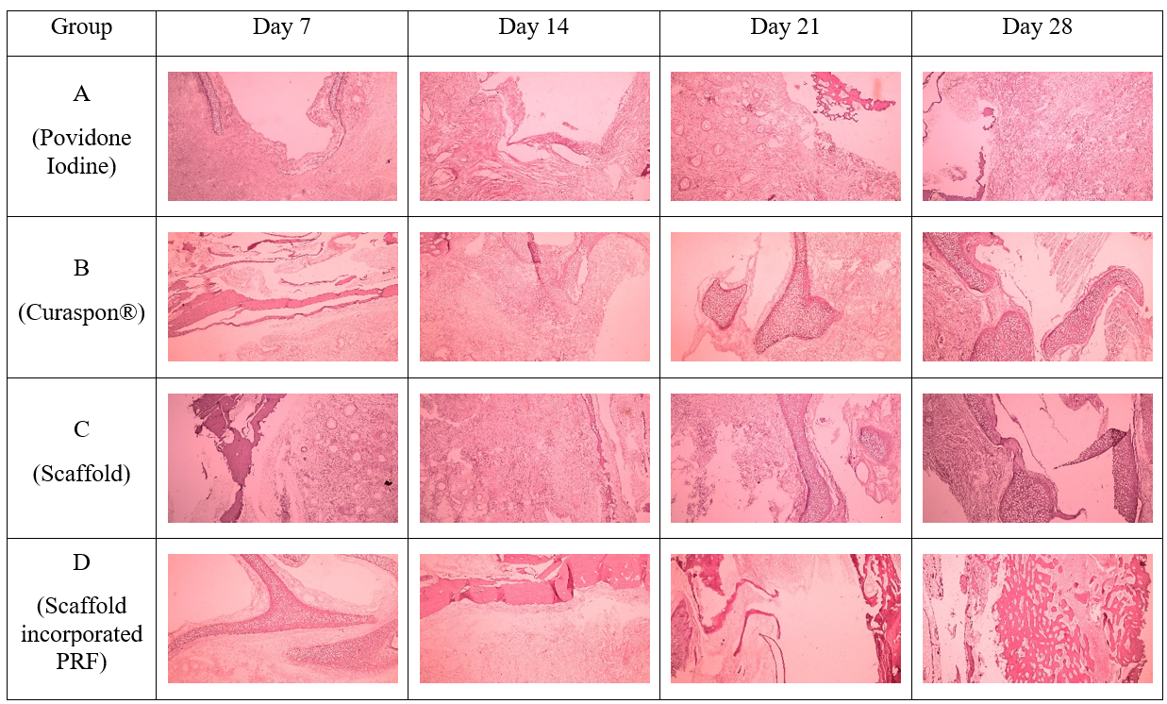
FIGURE 1. Histological image of the post-extraction socket of a rat tooth with HE staining.

TABLE 1. A descriptive description of angiogenesis in each treatment group.
Group | Time | Mean | Std. Deviation | Median | Modus | Minimum | Maximum
Povidone Iodine | H7 | 0.333 | 0.30551 | 0.4 | 0.0 | 0.0 | 0.6
 | H14 | 0.733 | 0.80829 | 0.6 | 0.0 | 0.0 | 1.6
 | H21 | 1.733 | 1.41892 | 2.0 | 0.2 | 0.2 | 3.0
 | H28 | 0.933 | 0.30551 | 1.0 | 0.6 | 0.6 | 1.2
Curaspon® | H7 | 0.333 | 0.11547 | 0.4 | 0.4 | 0.2 | 0.4
 | H14 | 0.333 | 0.30551 | 0.4 | 0.0 | 0.0 | 0.6
 | H21 | 1.000 | 1.2490 | 0.6 | 0.0 | 0.0 | 2.4
 | H28 | 0.267 | 0.23094 | 0.4 | 0.4 | 0.0 | 0.4
Scaffold | H7 | 1.267 | 1.33167 | 0.6 | 0.4 | 0.4 | 2.8
 | H14 | 1.000 | 0.34641 | 1.2 | 1.2 | 0.6 | 1.2
 | H21 | 0.800 | 0.00000 | 0.8 | 0.8 | 0.8 | 0.8
 | H28 | 0.733 | 0.23094 | 0.6 | 0.6 | 0.6 | 1.0
Scaffold+PRF | H7 | 0.4000 | 0.52915 | 0.2 | 0.0 | 0.0 | 1.0
 | H14 | 0.3333 | 0.57735 | 0.0 | 0.0 | 0.0 | 1.0
 | H21 | 0.1333 | 0.11547 | 0.2 | 0.2 | 0.0 | 0.2
 | H28 | 0.0667 | 0.11547 | 0.0 | 0.0 | 0.0 | 0.2

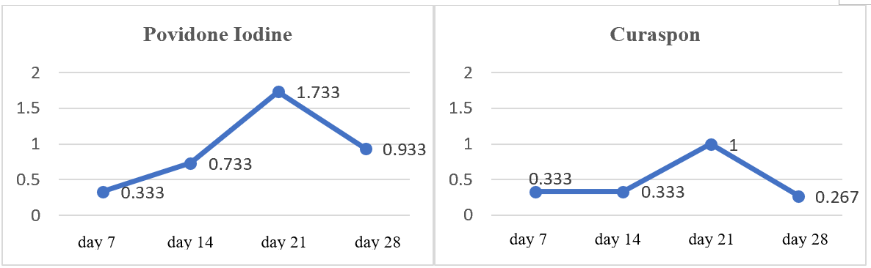
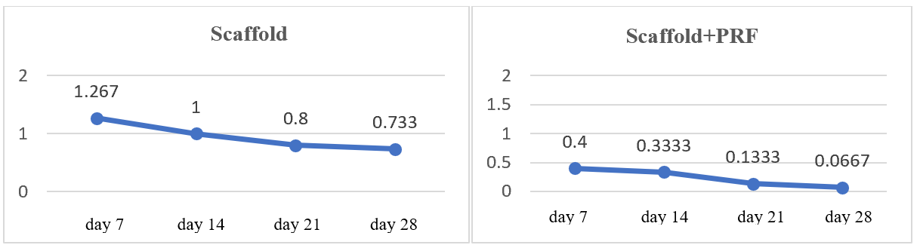
FIGURE 2. Average number of angiogenesis per day in each group.

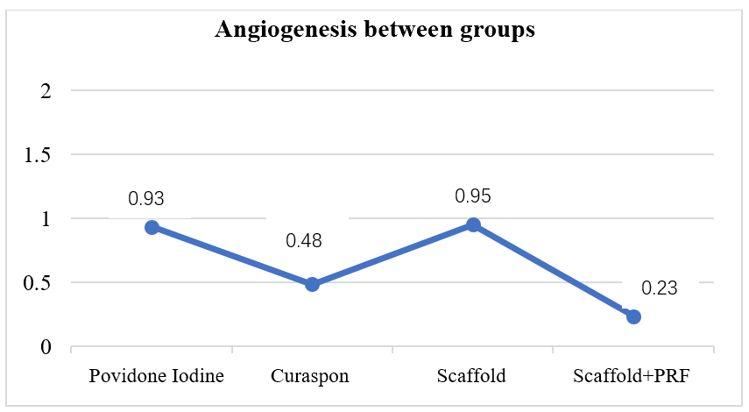
FIGURE 3. The average number of angiogenesis in the four treatment groups
Therefore, the One-Way ANOVA statistical test was carried out with a 95% confidence level (α ≤ 0.05) to see or prove the significance of the differences between treatment groups.
TABLE 2. One-Way ANOVA statistical test
Intervention | Mean (day 7,14, 21,28) | Standard Deviation | *p
Povidone Iodine | 0.9300 | 0.58878 | 0.046*
Curaspon® | 0.4815 | 0.34698
Scaffold | 0.9500 | 0.24207
Scaffold + PRF | 0.2325 | 0.15756

Table 2 reveals the One-Way ANOVA test of angiogenesis between treatment groups. Based on the test results, a p-value of 0.046 was obtained, denoting a significant difference in the formation of minimal angiogenesis between the two groups after each group was given povidone iodine, Curaspon®, scaffold, or scaffold + PRF. This was then followed by a Post Hoc LSD (Least Significant Difference) test on Table 3 to determine whether one group had a significant difference from the other.
TABLE 3. Post Hoc LSD test
Group (1) | Group (2) | Mean Difference | Std. Error | p | 95% Confidence Interval
 |  |  |  |  | Lower Bound | Upper Bound
Povidone Iodine | Curaspon® | 0.44850 | 0.26232 | 0.113 | -0.1230 | 1.0200
Povidone Iodine | Perancah | -0.02000 | 0.26232 | 0.940 | -0.5915 | .5515
Povidone Iodine | Scaffold+PRF | 0.69750* | 0.26232 | 0.021* | 0.1260 | 1.2690
Curaspon® | Scaffold | -0.46850 | 0.26232 | 0.099 | -1.0400 | .1030
Curaspon® | Scaffold+PRF | 0.24900 | 0.26232 | 0.361 | -0.3225 | .8205
Scaffold | Scaffold+PRF | 0.71750* | 0.26232 | 0.018* | 0.1460 | 1.2890

Based on Table 3 above, the Post Hoc LSD test of two unpaired or independent groups exhibited a significant difference in the average angiogenesis between the Povidone Iodine group compared to scaffold + PRF (p=0.021) and scaffold compared to scaffold + PRF (p=0.018).

DISCUSSION
Based on the research results, the One-Way ANOVA test demonstrated a significant difference in the amount of angiogenesis between the four treatment groups, where the highest average was in the scaffold group and the lowest average was in the scaffold + PRF group (Figure 2). These results contradict the theory that the use of PRF as an autologous platelet concentrate has been shown to support tissue regeneration and wound healing by releasing a number of growth factors over time. This is due to the low average rate of angiogenesis in the scaffold + PRF group, as angiogenesis occurred more rapidly than in the other groups and began to decline on day 14 (Figure 1). Research by Puspita et al. (2015) reported that angiogenesis increased on day 7 and decreased on day 14 [14]. Furqoni et al. (2022) also showed that the average rate of angiogenesis began to increase on day 3, although the increase was not significant, and continued to increase on days 5 and 7 [15]. This aligns with the theory of Kumar et al., stating that angiogenesis begins to decrease on day 10 and indicates the start of the remodeling phase [16]. This can also be proven in the histological image of the scaffold + PRF group (Figure 4), where the formation of new bone can be seen, which is characterized by spicules that are fused, dense and smooth compared to the other groups. These results suggest that the scaffold + PRF group can support cell activity and provide a good environment for cells to accelerate the formation of new blood vessels in the bone formation process.
However, in this study, the highest average angiogenesis rate in the povidone iodine and Curaspon® groups occurred on day 21 (Figure 1). This is not in accordance with the theory that the amount of angiogenesis should have decreased on day 14 and remodeling began on day 21. The increase in the amount of angiogenesis is hypothesized because in both groups, a healing process is still undergoing, so the formation of new blood vessels is still needed to supply nutrients and oxygen to support the next healing phase [17].
The results of research conducted by Mahanani et al. (2016) also showed that the proliferation of Human Mesenchymal Stem Cells (h-MSC) was found to attach more and faster to the synthetic coral scaffold compared to the control group, indicating that the use of synthetic coral scaffolds can increase the proliferation of h-MSC, where h-MSC plays an important role in the process of tissue repair including the formation of new blood vessels [6]. This corroborates the results of this study, which showed a high average number of angiogenesis in the scaffold group (Graph 2).
In its use, scaffolds can be combined with PRF by incorporation. The addition of PRF to the scaffold functions as a signal molecule, an important component in tissue regeneration. In addition, PRF also has properties as a scaffold due to the presence of fibrin in it.3 Growth factors released by PRF, such as transforming growth factor-β (TGF-β), platelet-derived growth factor (PDGF), vascular endothelial growth factor (VEGF), insulin growth factor (IGF), and epidermal growth factor (EGF) [18,19]. These growth factors can then stimulate and attract stem cells to the injury site, thereby encouraging cell mitosis and inducing angiogenesis [20]. This is in line with this study, showing that angiogenesis proceeds faster in the scaffold + PRF group compared to the other groups, which is indicated by the beginning of a decrease in the number of angiogenesis on day 14 (Figure 1) and the beginning of new bone formation on day 21 (Figure 4).

CONCLUSION
Based on the results of this study, it can be concluded that the PRF-incorporated scaffold treatment group can accelerate the occurrence of angiogenesis after rat tooth extraction, and there is a significant difference in the average amount of angiogenesis between the four treatment groups.

Acknowledgments
The authors would like to thank Universitas Muhammadiyah Yogyakarta for providing research grant funding, so that this research can be carried out.

References
- N. Cohen, J. Cohen-Lévy, “Healing processes following tooth extraction in orthodontic cases.” J. Dentofacial Anom. Orthod. 17(3), 304 (2014).
- F.J. O’Brien. “Biomaterials & scaffolds for tissue engineering.” Materials Today. 14(3), 88–95 (2011).
- E.S. Mahanani, I. Bachtiar, I.D. Ana, “The Porosity and Human Gingival Cells Attachment of Synthetic Coral Scaffold for Bone Regeneration.” KEM. 840. 305–10 (2020).
- K.A. AL-Salihi, “In vitro evaluation of Malaysian Natural coral Porites bone graft substitutes (CORAGRAF) for bone tissue engineering: a preliminary study.” Brazilian Journal of Oral Sciences. 8(4). 210-216 (2013).
- H.A. Rather, D. Jhala, R. Vasita, “Dual functional approaches for osteogenesis coupled angiogenesis in bone tissue engineering.” Materials Science and Engineering: C. 103. 109761 (2019).
- G. Shineh, K. Patel, M. Mobaraki, L. Tayebi, “Functional Approaches in Promoting Vascularization and Angiogenesis in Bone Critical-Sized Defects via Delivery of Cells, Growth Factors, Drugs, and Particles.” Journal of Functional Biomaterials. 14(2), 99 (2023).
- E.S. Mahanani, I. Bachtiar, I.D. Ana, “Human Mesenchymal Stem Cells Behavior on Synthetic Coral Scaffold.” KEM. 696, 205–11 ( 2016 ).
- E. Dohle, K.B. El, R. Sader, J. Choukroun, C.J. Kirkpatrick, S. Ghanaati, “Platelet-rich fibrin-based matrices to improve angiogenesis in an in vitro co-culture model for bone tissue engineering.” J. Tissue Eng. Regen. Med. 12(3), 598-610 (2018).
- S. Blatt, D.G.E. Thiem, A.Pabst, B. Al-Nawas, P.W. Kämmerer, “Does Platelet-Rich Fibrin Enhance the Early Angiogenetic Potential of Different Bone Substitute Materials? An In Vitro and In Vivo Analysis” Biomedicines. 10(1), 61 (2021).
- D.L.R. Barbosa, E.S. Lourenço, D.A.D.J.V. Azevedo, R.S.N. Rocha, C.F. Mourão, G.G. Alves, “The Effects of Platelet-Rich Fibrin in the Behavior of Mineralizing Cells Related to Bone Tissue Regeneration-A Scoping Review of In Vitro Evidence.” J. Funct. Biomater. 9.14(10), 503 (2023).
- K.J. You, Y. Zhu, M. Li, S. Chen, S. Ren, S. Chen, J. Zhang, H. Wang, Y. Zhou, “Platelet-rich fibrin as an autologous biomaterial for bone regeneration: mechanisms, applications, optimization.” Front Bioeng Biotechnol. 16. 12-1286035 (2023).
- D.M. Dohan, J. Choukroun, A. Diss, S.L. Dohan, A.J.J. Dohan, J. Mouhyi, “Platelet-rich fibrin (PRF): A second-generation platelet concentrate. Part I: Technological concepts and evolution.” Oral Surgery, Oral Medicine, Oral Pathology, Oral Radiology, and Endodontology. 101(3), e37–44 (2006).
- E. Kobayashi, L. Flückiger, M. Fujioka-Kobayashi, K. Sawada, A. Sculean, B. Schaller, “Comparative release of growth factors from PRP, PRF, and advanced-PRF.” Clin Oral Invest. 20(9), 2353–60 (2016).
- B.S. Puspita, S. Sularsih, D.w. Damaiyanti, “Differences in the Effect of High and Low Molecular Weight Chitosan on the Number of Blood Vessels in the Tooth Extraction Wound Healing Process.” DENTA. 1.9(2), 209 (2015).
- A. Furqoni, M.N. Amin, R.C. Prasetya, “Potential combination of puger gypsum scaffold and aloe vera on angiogenesis in post-tooth extraction sockets of male Wistar rats. Padjadjaran Journal of Dental Researchers and Student. 6(1), 82-89 (2022).
- P. Kumar, G. Fathima, B. Vinitha, “Bone grafts in dentistry.” J. Pharm. Bioall. Sci. 5(5), 125 (2013).
- R.J. Miron, J. Choukroun, editors. Platelet-rich fibrin in regenerative dentistry: biological background and clinical indications. Hoboken, NJ: Wiley; 2017. 1 p. M. P. Brown and K. Austin, The New Physique (Publisher Name, Publisher City, 2005), pp. 25–30.
- E. Borie, D.G. Oliví, I.A. Orsi, K. Garlet, B. Weber, V. Beltrán, R. Fuentes, “Platelet-rich fibrin application in dentistry: a literature review.” Int. J. Clin. Exp. Med. 15;8(5), 7922-9 (2015).
- G.K. Patel, S.S. Gaekwad, S.K. Gujjari, S.C.VK. “Platelet-Rich Fibrin in Regeneration of Intrabony Defects: A Randomized Controlled Trial.” J. Periodontol. 88(11), 1192-1199 (2017).
- S. Al-Maawi, E. Dohle, W. Kretschmer, J. Rutkowski, R. Sader, S.A. Ghanaati, “Standardized g-Force Allows the Preparation of Similar Platelet-Rich Fibrin Qualities Regardless of Rotor Angle.” Tissue Eng. Part A. 28(7-8), 353-365 (2022).

