Study of Dimensional Changes in Alginate Impression Materials Using Ethanol Extract of Garlic Bulbs
(Allium sativum L.) as Solvent
Dendy Murdiyanto^{1, a)} and Yudha Hismawan^{2, b)}
Author Affiliations
¹Department of Biomaterials, Faculty of Dentistry, Universitas Muhammadiyah Surakarta
²Department of Dental Educational Program, Faculty of Dentistry, Universitas Muhammadiyah Surakarta
Author Emails
^{a)} Corresponding author: @dm124@ums.ac.id
^{b)}ghany@ums.ac.id
Abstract. Alginate impression materials can be a source of infection transmission in dental practice, and disinfection methods may impact their dimensional stability. Garlic, known for its antimicrobial properties, offers potential as an alternative disinfectant. This study aims to evaluate the effect of using ethanol extract of garlic bulbs as a solvent for alginate impression materials on dimensional changes, and to assess whether increasing concentrations of the extract influence those changes. A true experimental laboratory design with a post-test only control group was used in this research. The material used in this research used ethanol extract of garlic bulbs as a solvent for the alginate impression material, then printing was carried out using a tube mold measuring 32 mm in diameter x 22 mm in height, then incubation was carried out for 30 minutes at a temperature of 25°C and humidity of 96%. Measure the diameter and height of the mold using a caliper and calculate the average change in dimensions and the average percentage change in dimensions. The results of this study show that there is no effect of ethanol extract of garlic bulbs as a solvent on changes in the dimensions of the alginate impression material in accordance with the results of the one-way ANOVA analysis, which shows a significance value of p>0.05 and all groups meet ADA standard No. 18 by 3%. The conclusion drawn from the research is that the alginate impression material using the ethanol extract solvent of garlic bulbs does not experience dimensional changes
Keywords : Alginate, Dimensional Changes, Ethanol Extract of Garlic Bulbs

introduction
Alginate impression materials have several disadvantages, including tearing requiring immediate filling with plaster stone, being single-use only, having porous surfaces, and imbibition, or water absorption, which makes them more susceptible to expansion and syneresis, or shrinkage, when left exposed to air for extended periods. These imbibition and syneresis properties can cause dimensional changes and inaccuracies in impressions.¹
Dimensional changes are usually caused by various factors, including pH², the cross-linking density of the alginate's chemical components³, the storage room temperature⁴, the ability to recover elasticity, and the storage time.⁵ According to the American Dental Association No. 18, the limit for dimensional change in alginate impression materials is 3%. If the impression experiences dimensional changes exceeding this limit, the impression is considered inaccurate.⁶
Several studies have suggested that the use of alginate impression materials poses a risk of infectious agents in dentistry, three times higher than other dental treatments. This is because alginate impressions contain various infectious agents from the patient's body, such as saliva, pus, debris, and blood.⁷ Disinfection is a procedure to prevent cross-infection in alginate impressions. There are two methods for disinfecting alginate impressions: spraying and immersion.⁸ Spraying and immersion disinfection procedures have various drawbacks, including causing dimensional changes in the form of expansion or swelling of the alginate impression and being less effective in killing microorganisms.⁹
Various studies have reported that the use of disinfectant solutions as solvents for alginate impressions is known to be effective in preventing cross-infection without statistically changing its dimensional stability.¹⁰ Commonly used disinfectant chemicals for disinfecting alginate impressions are sodium hypochlorite, glutaraldehyde, iodophor, and phenol, but these chemicals have various drawbacks.¹¹ Currently, many herbal ingredients are starting to be used as disinfectants. One plant that has antimicrobial and antibacterial activity and can be used as an alternative disinfectant is garlic (Allium sativum L.).¹² The active ingredients in garlic (Allium sativum L.) include allicin, flavonoids, ajoene, tannin, essential oils, and various other organosulfur compounds.¹³ Various studies have explained that garlic ethanol extract has long been known to have antibacterial activity against various pathogenic bacteria in the human body.^{14,15}

MATERIALS AND METHODS
This study employed a true experimental laboratory method with a Post-Only Control Group Design. Twenty-five samples of regular-set alginate impression material were cast using a 32 mm x 22 mm tube mold. The control group used distilled water as the solvent, while the treatment group used garlic bulb ethanol extract at concentrations of 5%, 10%, 20%, and 40% diluted with distilled water.
All samples were incubated for 30 minutes at 25°C and 96% humidity. Their diameter and height were then measured using vernier calipers. The measurement data were then entered into the tube volume formula, then subtracted from the volume of the tube mold used to obtain the average dimensional change. The calculated data, expressed as a percentage, is then compared with the ADA No. 18 statute, which states 3%. This data is used to evaluate whether the results are in line with the specified standards.

RESULTS AND DISCUSSION
The measurement results were obtained by measuring the diameter and height of the samples. The sample measurements were then entered into the cylinder volume formula and subtracted from the volume of the alginate impression used. The average dimensional change and standard deviation are presented in Table 1.

TABLE 1. Mean and standard deviation of dimensional changes (mm³)
 |  | Dimensional Change
Treatment Group | N | Dimensional Change
 |  | ( X ± SD)
Control | 5 | 160.49 ± 7.068
Garlic extract 5% | 5 | 165.30 ± 11.927
Garlic extract 10% | 5 | 167.70 ± 7.632
Garlic extract 20% | 5 | 170.09 ± 8.730
Garlic extract 40% | 5 | 172.33 ± 8.937

The data were then tested for normality using the Shapiro-Wilk test and for homogeneity using Levene's test. All groups yielded significance values greater than 0.05, indicating that all data were normally distributed and homogeneous, or had equal variance.
The results of the normality and homogeneity tests met the requirements for a parametric One-Way ANOVA. Based on the results of the One-Way ANOVA test, the significance value was 0.310 (p>0.05), indicating that there was no significant effect or significant dimensional change between the control and treatment groups. The non-significant difference between the control and treatment groups indicates that the ethanol extract of garlic bulbs (Allium sativum L.) at concentrations of 5%, 10%, 20%, and 40% as a solvent for alginate impression materials had no effect on dimensional change.
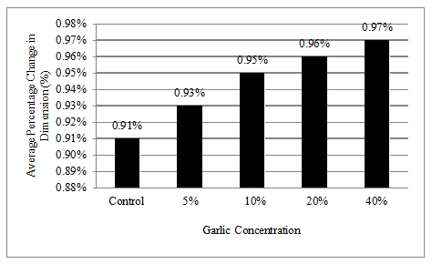
The calculated percentage data were then compared with ADA No. 18, which states 3%. This data was used to evaluate whether the results met or did not meet the specified standard.¹⁶ The results of the calculation of the average percentage change in dimensions of alginate impression materials are presented in Figure 1.
FIGURE 1. Graph of the average percentage change in dimensions of alginate impression material with ethanol extract of garlic bulbs (Allium sativum L.) in various concentrations.
Figure 1 shows that the average percentage change in the dimensions of the alginate impression material in each group increased. The results of this study indicate that all concentrations of garlic (Allium sativum L.) ethanol extract as a solvent for alginate impression material on dimensional changes showed less than the specified ADA standard of 3% and did not significantly affect the control group and treatment groups. This is consistent with research on changes in the dimensional stability of alginate impressions between spraying and immersion disinfection techniques, showing no significant differences.¹⁷
The replacement of the alginate impression solvent with the disinfectant ethanol extract of garlic (Allium sativum L.) bulbs containing allicin (C₆H₁₀S₂₀), ajoene, essential oils, and flavonoids will disrupt the cross-linking of dissolved alginate with calcium sulfate, which will react to form insoluble calcium alginate during the gelation process and undergo an imbibition process that causes expansion or swelling of the alginate impression.¹⁸ The damage to the alginate cross-links during the gelation process will result inthe alginate having a less dense surface structure. The chemical reaction of dissolving the ethanol extract of garlic bulbs as a solvent for alginate impression materials is explained in the following reaction: Na Alginate (s) + CaSO₄ + C₆H₁₀S₂₀ + H₂O → CaH₁₀S₂₀ (gel) + Na₂SO₄ + H₂O

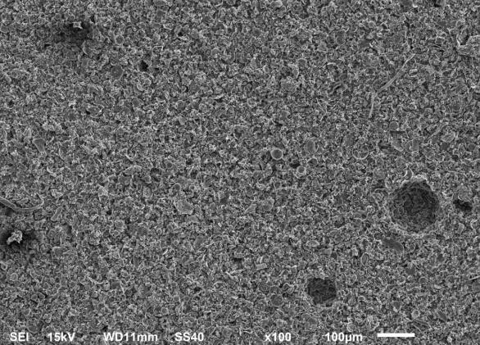
FIGURE 2. Scanning Electron Microscopy (SEM) of control alginate impressions
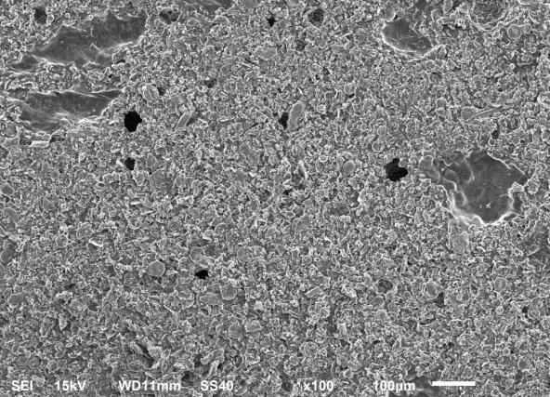
FIGURE 3. Scanning Electron Microscopy (SEM) of alginate impressions treated with concentration 4
Figures 2 and 3 show the difference between the control and treated alginate impressions using ethanol extracted from garlic bulbs (Allium sativum L.) at a concentration of 40%. The Scanning Electron Microscopy (SEM) results show that alginate impressions treated with a 40% ethanol extract of garlic bulbs have a less dense surface structure compared to the control alginate impressions. This conclusion is consistent with the previously discussed theory that adding ethanol extract of garlic bulbs (Allium sativum L.) as a solvent in alginate impression materials can disrupt cross-linking, affecting the surface structure of the alginate impression material and causing imbibition, which results in expansion or swelling of the alginate impression. ¹⁹

conclusion
Based on the research results above, it can be concluded that the use of ethanol extract of garlic bulbs (Allium sativum L.) as a solvent for alginate impression materials did not statistically affect dimensional changes, and increasing the concentration of ethanol extract of garlic bulbs (Allium sativum L.) did not affect dimensional changes.

Acknowledgments
We gratefully acknowledge the Faculty of Dentistry, Universitas Muhammadiyah Surakarta, for their support of this research through the Lecturer Individual Development Program. Our sincere appreciation also goes to all students and research team members whose contributions ensured the smooth and successful execution of this study.

References
- K.J. Anusavice, Phillips’ Science of Dental Materials (Anusavice Phillip’s Science of Dental Materials) (2021).
- M. Muhtadi, E. Mugiyanto, N.N. Fajriyah, U. Waznah, D.B. Pambudi, E.D. Safitri, and F.N. Rosyidand. "Formulation and evaluation of topical nano-hydrogel of Zinc and Annona Muricata extract." Indonesian Journal of Pharmacy, 291-301(2023)
- J.A. Todd, L.J. Oesterle, S.M. Newman, and W.C. Shellhart, “Dimensional Changes of Extended-Pour Alginate Impression Materials,” American Journal of Orthodontics and Dentofacial Orthopedics 143(4 SUPPL), (2013).
- M. Palone, G. Greco, and E. Morin, “Dimensional Stability of Impression Elastic Materials: An In Vitro Study,” J Biol Regul Homeost Agents 36(2 S4), (2022).
- A. Rohanian, G. Ommati Shabestari, S. Zeighami, M.J. Samadi, and A.R. Shamshiri, “Effect of Storage Time of Extended-Pour And Conventional Alginate Impressions On Dimensional Accuracy of Casts.,” J Dent (Tehran) 11(6), (2014).
- M. Febriani, “Alginate Impression Vs Alginate Impression Plus Cassava Starch: Analisis Gambaran Mikroskopik,” Stomatognatic 8(2), (2011).
- M.R. Ahsan, K.Z. Islam, and J. Begum, “Study on Antimicrobial Effect of Disinfecting Solutions on Alginate Impression Materials,” Update Dental College Journal 3(1), (2014).
- J.F. McCabe, and A.W.G. Walls, Applied Dental Materials 9th (2013).
- H.A. Ismail, H. Asfour, and S.A. Shikho, “A Self-Disinfecting Irreversible Hydrocolloid Impression Material Mixed With Povidone Iodine Powder,” Eur J Dent 10(04), 507–511 (2016).
- J. Wang, Q. Wan, Y. Chao, and Y. Chen, “A Self-Disinfecting Irreversible Hydrocolloid Impression Material Mixed With Chlorhexidine Solution,” Angle Orthodontist 77(5), (2007).
- A. Rentzia, D.C. Coleman, M.J. O’Donnell, A.H. Dowling, and M. O’Sullivan, “Disinfection Procedures: Their Efficacy and Effect on Dimensional Accuracy and Surface Quality of An Irreversible Hydrocolloid Impression Material,” J Dent 39(2), (2011).
- M.T. Giardi, G. Rea, and B. Berra, “Bio-Farms for Nutraceuticals. Functional Food and Safety Control by Biosensors. Preface.,” Adv Exp Med Biol 698, (2010).
- G. Gebreyohannes, and M. Gebreyohannes, “Medicinal Values Of Garlic: A Review,” International Journal 5(9), (2013).
- E.R. Wikantyasning and U. Hasanah. "Review on Sensitivity and Selectivity of Colorimetric Sensor Based on Responsive Polymer against Pathogenic Bacteria." Research Journal of Pharmacy and Technology 16.10, 4663-4670 (2023).
- D. Murdiyanto, A. Faizah, and M.D. Mustikaningrum, “Inhibition of Garlic Ethanol Extracts (Allium Sativum L.) as a Solvent in Alginate Impression Materials in the Growth of Candida Albicans,” Journal of Medicinal and Chemical Sciences 5(2), (2022).
- M.P. Walker, J. Burckhard, D.A. Mitts, and K.B. Williams, “Dimensional Change Over Time Of Extended-Storage Alginate Impression Materials,” Angle Orthodontist 80(6), (2010).
- M. Harlinda, and J. Handojo, “Pengaruh Teknik Desinfeksi Dengan Ekstrak Daun Salam (Syzygium Polyanthum w.) Terhadap Stabilitas Dimensi Cetakan Alginat (Laporan Penelitian),” Jurnal Kedokteran Gigi Terpadu 4(2), (2022).
- D. Murdiyanto, and V.R.A. Putra, “Perubahan Dimensi Bahan Cetak Alginat Dengan Pelarut Ekstrak Kayu Manis (Cinnamomum burmannii),” Cakradonya Dental Journal 13(1), (2023).
- T.A. Imbery, J. Nehring, C. Janus, and P.C. Moon, “Accuracy And Dimensional Stability Of Extended-Pour And Conventional Alginate Impression Materials,” in Journal of the American Dental Association, (2010).

