Correlation of Pressure During Packing and Water Sorption of Heat-Activated Acrylic Denture Base Material
Arief Waskitho^{1, a)}, Fahmi Yunisa^{1, b)}, Widyapramana Dwi Atmaja^{2, c)}, Zuhri Nurisna^{3, d)}, Muhammad Rizky Syuhada^{4, e)}, and Arsyad Cahya Subrata^{5, f)}
Author Affiliations
¹ Department of Prosthodontics, 55183 Universitas Muhammadiyah Yogyakarta, Indonesia
^{2 ﻿}Department of Dental Material, 55183 Universitas Muhammadiyah Yogyakarta, Indonesia
³ ﻿Department of Automotive Engineering Technology, 55183 Universitas Muhammadiyah Yogyakarta, Indonesia
⁴ Undergraduate Study Program, 55183 Universitas Muhammadiyah Yogyakarta, Indonesia
⁵Department of Electrical Engineering, 55191 Universitas Ahmad Dahlan Yogyakarta, Indonesia
Author Emails
^{a)} Corresponding author: arief.waskitho@umy.ac.id
^{b)} fahmi_yunisa@umy.ac.id
^{c)} widyapramana.dwi@umy.ac.id
^{d)} zuhrinurisna@umy.ac.id
^{e)} rizkysyuhada216@gmail.com
^{f)} arsyad.subrata@te.uad.ac.id

Abstract. Heat-activated acrylic denture bases (HAADBs) are still commonly used in Indonesia. However, this material has several drawbacks, such as porosity and water sorption. Insufficient pressure during packing could lead to porosity. The fabrication method related to pressure during packing shows a relation between porosity and water sorption. This study reports the relation between pressure during packing and material water sorption. As a result, there was no significant difference between the higher-pressure method and the other lower-pressure method. Meanwhile, the higher-pressure method exhibited lower water sorption, probably due to an indirect relationship between lower porosity and water sorption.
Keywords: Acrylic resin, Denture, Pressure, Water sorption

introduction
Acrylic denture base has been utilized for denture fabrication for more than 85 years [1]. The utilization of heat-activated acrylic denture base (HAADB) as a material for denture fabrication remains prevalent in Indonesia [2]. HAADB, as a denture base material, presents multiple drawbacks, including porosity, water absorption, and solubility [3]. Pressures are related to the fabrication of dentures using HAADB during resin packing, and pressure is applied to insert resin into the mold as precisely as possible. The related pressure techniques include compression molding and injection molding [4].
Porosity arises from the vaporization of unreacted monomers and low-molecular-weight polymers when the resin temperature hits or exceeds the boiling temperatures of these substances [1]. Porosity is associated with the processing of HAADB, necessitating appropriate trial pressure during packing to eliminate porosity [5]. Insufficient pressure during polymerization may result in porosity within the mold. The extensive presence of these voids can render the resultant resin significantly lighter and more opaque than its desired color [1].
The water sorption of HAADB mostly results from the polar characteristics of resin macromolecules via a diffusion mechanism [1,6]. Water absorption can disrupt the adhesion of the polymer, leading to dimensional changes in the denture base. Water absorption may marginally enlarge the polymerized mass; nevertheless, it could also function as a plasticizer [1,7]. Moreover, expansion due to water sorption may influence the dimensional stability of acrylic resins and the functionality of dentures within the oral cavity [7,8].
The fabrication method related to the pressure during processing of HAADB may be linked to water sorption [7,8]. However, the relationship between pressure during HAADB packing and water sorption remains unclear. This research, therefore, aims to find the relationship between pressure during the packing of HAADB and water sorption.

METHODOLOGY
For water sorption analysis, specimens (n = 8) were prepared using the pressure method, with dimensions of 50 x 4 x 2 ± 0.1 mm [9]. Laboratory wax with an extra 5 mm over the dimensions was molded using laboratory silicone and embedded into the gaps inside the metal flask. After boiling out, the HADDB plate (Basis, Yamahachi Dental MFG. Co.) was manufactured according to the manufacturer's specifications. The powder-to-liquid mixing ratio was 100 g to 43 mL. The pressure methods during packing are described as follows:
TABLE 1. Pressure methods of HAADB during packing
Pressure method | First trial pressure  (kg/cm²) | Second trial pressure  (kg/cm²) | Final pressure  (kg/cm²)
Hand press | Hand pressure | Hand pressure | Hand pressure
Hydraulic press 1 | 80 | 100 | 120
Hydraulic press 2 | 100 | 150 | 240

The hand press was operated using a custom-made hand rotary press, and the hydraulic press was a similarly custom-made device that measured pressure using a pressure gauge. After the final pressure was applied, the clamped flask was cured by immersing it in water and gradually applying heat for about 30 minutes, until it boiled, then letting the resin cure for approximately 30-40 minutes in boiling water. The flask was cooled naturally until the water temperature reached room temperature.
The HAADB plates were finished using an Arkansas stone and a carbide bur, then polished with 320-grit sandpaper until the desired dimension was achieved. The plates were measured using a digital sliding caliper (Digimatic, Mitutoyo Corp.). The plates were divided into groups, inserted into a vacuum-sealed plastic bag with desiccant, and weighed using an electronic balance (accuracy of 1 mg) (JM-B, Hanyu Co., Ltd.) until a stable weight was achieved. After that, the plates were immersed in distilled water (Waterone, Onemed) for 30 days. Before weighing, the plates were dried with a paper towel until all moisture had disappeared. The water sorption was calculated with the following formula [10]:

$Water sorption \left(\frac{mg}{{cm}^{2}}\right)= \frac{Final weight-Initial weight (mg)}{Superficial area ({cm}^{2})}$ (1)

One-way ANOVA was used for statistical analysis, utilizing the Statistical Package for the Social Sciences (SPSS) version 29, to analyze the data. A probability value of less than 0.05 was considered statistically significant.

RESULTS AND DISCUSSION
The HAADB plates' weights after drying with desiccant are as follows: the hand press group with a mean of 433.875±5.396, the hydraulic press 1 group with a mean of 430.25±4.300, and the hydraulic press 2 group with a mean of 436.625±6.120. The HAADB plates' weights after soaking in distilled water for 30 days were the hand press group with a mean of 438± 5.510, the hydraulic press 1 group with a mean of 434± 4.3752, and the hydraulic press 2 group with a mean of 439.25± 6.4358 (Fig. 1).
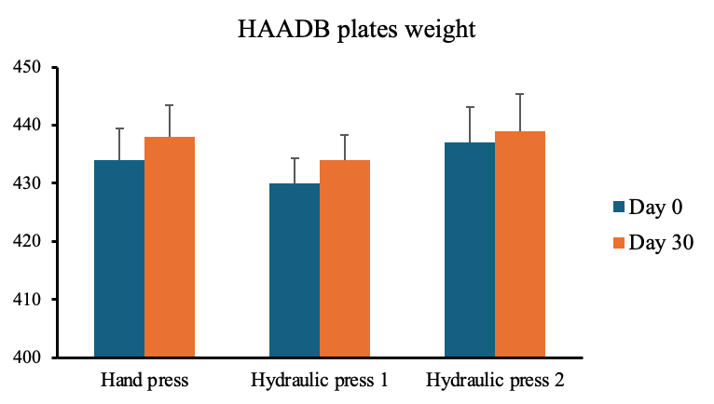
FIGURE 1. HAADB plates were weighed before (Day 0) and after immersion in distilled water (Day 30) (mg) (data presented as mean ± standard error of mean) (n=8)

The water sorption data shown in the hand press group were 0.6696 ± 0.1205, Hydraulic press 1: 0.6087 ± 0.0797, and Hydraulic press 2: 0.4261 ± 0.0917. The water sorption data were analyzed for normality (p-value > 0.05) and homogeneity (p-value > 0.05), showing that the data were normal and homogeneous. The One-Way ANOVA revealed no significant difference among the groups, with a p-value of 0.217 (p> 0.05) (Fig. 2).
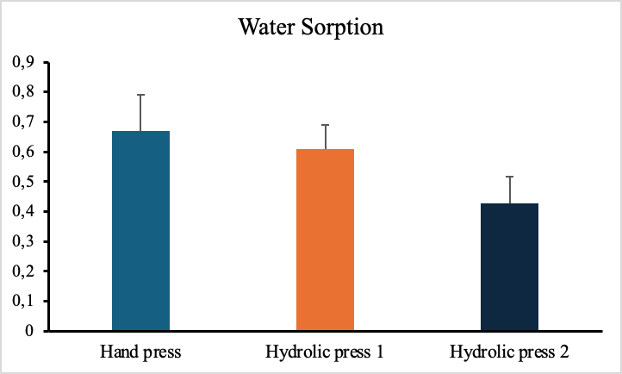
FIGURE 2. HAADB plates’ water sorption (mg/cm²) (data presented in mean± standard error of mean) (n=8)
As a result, there was a slight difference in water sorption among the higher-pressure group compared to the two lower-pressure groups; however, this difference was insignificant. Presumably, the difference was indirectly a product of the lower porosity of the higher-pressure group. There are correlations between lower porosity and lower water sorption, even though it is also related to the composition of the resin material [3]. In other research, residual monomers can increase porosity, as incomplete polymerization leaves voids within the resin matrix [11,12]. Due to incomplete polymerization, higher levels of residual monomer can also lead to increased water absorption because the unreacted monomer is hydrophilic and attracts water [13]. Despite the difference in water sorption between groups, the values did not exceed the standards from Phillips (< 0.69 mg/cm²) and ADA (< 0.8 mg/cm²) [1].

CONCLUSION
Higher pressure during the packing of HAADB may lower water sorption compared to lower pressure, although the difference was insignificant. Probably, the difference is indirectly due to lower porosity resulting from higher pressure packing.

Acknowledgments
The authors would like to thank the Directorate of Research and Community Service, Universitas Muhammadiyah Yogyakarta, and RSGM, Universitas Muhammadiyah Yogyakarta, for their invaluable support of this research.

References
- K.J. Anusavice, C. Shen, H.R. Rawls, Phillips’ science of dental materials, 12th ed. (Elsevier Saunders, USA,2013) pp. 475-490.
- N. Zakiyah, N. F. N. Hanifah, A. Waskitho, J. Dalanon, “Non-invasive management of maxillary labial undercuts in complete removable dentures using soft liners in a patient with maxillary labial undercut: A case report,” Padjadjaran J. Dent. 37, 1–9 (2025).
- R. H. Hasan, R. R. Aziz, M. M. Shehab, J. Abduo, “Evaluating the physical properties of microwave-cured and heat-cured acrylic denture base materials after the addition of ZrO2 nanoparticles,” J. Bagh. Coll. Dent. 36, Article 3 (2024).
- A. Waskitho, F. Yunisa, D. Triswari, Z. Nurisna, W.D. Atmaja, “An Overview of Pressure Effect on Heat-Activated Acrylic Denture Base Processing Techniques" in Proceedings of the 2nd New Dental Research Exhibition and Meeting (New Dream) 2024, (AIP Publishing, Yogyakarta, Indonesia, August 2024).
- W.F. Yau, Y.Y. Cheng, R.K. Clark, T.W. Chow, “Pressure and temperature changes in heat-cured acrylic resin during processing,” Dent. Mater. 18, 622-9 (2002).
- C. M. Rizzatti- Barbosa, M. A. Fraga, T. de M. Gonçalves, “Acrylic resin water sorption under different pressure, temperature and time conditions,” Mater. Res. 4, 01–06, (2001).
- E. Ghasemi, R. Mosharraf, S. Mirzaei, “Comparison of Water Sorption of Two Injection Acrylic Resins with a Conventional Pressure-Packed Acrylic Resin,” J Iran Dent Assoc 31, 177–181 (2019).
- E. Moslehifard, T. Ghaffari, H. Abolghasemi, S. Maleki Dizaj, “Comparison of Conventional Pressure-packed and Injection Molding Processing Methods for an Acrylic Resin Denture based on Microhardness, Surface Roughness, and Water Sorption,” Int. J. Dent. 2022, 7069507 (2022).
- R. M. S. Figuerôa, B. Conterno, C. A. G. Arrais, C. Y. C. Sugio, V. M. Urban, K. H., “Porosity, water sorption and solubility of denture base acrylic resins polymerized conventionally or in microwave,” J. Appl. Oral Sci. 26, e20170383 (2018).
- Council on Dental Materials and Devices, “Revised American Dental Association Specifications No. 12 for denture base polymers,” J. Am. Dent. Ass. 90, n. 2, p. 451-458 (1975).
- H. Yilmaz, C. Aydin, A. Cağlar, A. Yaşar T, “The effect of glass fiber reinforcement on the residual monomer content of two denture base resins,” Quintessence Int. 34, 148-53. (2003).
- A. Köroǧlu, T. Özdemir, A. Duru Pamir, A. Usanmaz, “Residual acrylic monomer content of denture base resins with different fiber systems,” J. Appl. Polym. Sci. 125, 471-476 (2012).
- M.M. Gad, S. Z. Alshehri, S.A. Alhamid, A. Albarrak, S.Q. Khan, F.A. Alshahrani, F.K. Alqarawi, Water Sorption, Solubility, and Translucency of 3D-Printed Denture Base Resins, Dent J. 10, 42 (2022).

