Postbiotic-Loaded Alginate-ESM Hydrogel for Endodontic Disinfection: A Biocompatible Drug Delivery Approach
Arya Adiningrat^{1,2 a)} and Muhammad Farikh^{1, b)}
Author Affiliations
¹Molecular Medicine and Therapy Laboratory, Research and Innovation Center, Universitas Muhammadiyah Yogyakarta, Yogyakarta City, Special Region of Yogyakarta, Indonesia
²Oral Biology and Biomedical Sciences, Faculty of Dentistry, Universitas Muhammadiyah Yogyakarta, Bantul, Special Region of Yogyakarta, Indonesia
Author Emails
^{a)} Corresponding author: adiningrat@umy.ac.id
^{b)}bukittinggi.farikh12@gmail.com
Abstract. Postbiotics, defined as bioactive metabolites derived from inactivated microorganisms, contribute to host health by modulating the microbiota, reinforcing epithelial barrier integrity, and regulating immune responses. Among promising candidates, the cell-free culture supernatant (CFCS) of Lacticaseibacillus paracasei—rich in linoleic acid and antimicrobial peptides—exhibits potent biological activity but suffers from limited stability and bioavailability. This study aimed to develop a hybrid hydrogel composed of alginate and eggshell membrane (ALG–ESM), incorporating CFCS to enhance its therapeutic potential. Eggshell membrane was extracted via 70% acetic acid demineralization followed by ultrasonic processing, then blended with 3% (w/v) alginate and 80% CFCS in a 1:4 (v/v) ratio to form the ESM–AC composite. Comprehensive characterization included infiltration capacity, biostability in phosphate-buffered saline (PBS), water uptake, water vapor transmission rate (WVTR), and antibacterial efficacy against Enterococcus faecalis. The ESM–AC hydrogel demonstrated significantly improved infiltration (61.11 ± 2.98%) compared to ESM–A (38.88 ± 3.65%), retained structural integrity after 24-hour PBS immersion (mass loss ~55%), exhibited high water absorption (446–602%), and maintained optimal WVTR (62.42 ± 7.09 mg/cm²/48 h). Its antibacterial activity was comparable to that of pure CFCS. These findings suggest that CFCS-loaded ALG–ESM hydrogels possess favorable physicochemical and antimicrobial properties, supporting their potential as a biocompatible postbiotic delivery system for intracanal therapy and sustained oral disinfection.
Keywords: Postbiotics, Drug delivery system, eggshell membrane, Lacticaseibacillus paracasei

introduction
Postbiotics, comprising bioactive compounds derived from microorganisms—including inactivated microbial cells, cellular fragments, and low-molecular-weight metabolites—have emerged as promising agents for promoting host health through microbiota modulation, epithelial barrier reinforcement, and immune regulation at both local and systemic levels [1,2]. Their mechanisms of action include influencing microbial composition and activity, enhancing mucosal integrity, modulating immune responses, and engaging systemic signaling pathways, including neuroimmune axes [3,4].
Among the various forms of postbiotics, the cell-free culture supernatant (CFCS) of Lacticaseibacillus paracasei represents a potent candidate. CFCS is the metabolite-rich liquid fraction of the culture medium, containing secreted bioactive molecules produced during microbial growth [5]. Notably, CFCS from L. paracasei has been shown to contain linoleic acid (9,12-octadecadienoic acid), a polyunsaturated fatty acid with demonstrated anti-inflammatory and antimicrobial properties, including inhibition of key virulence factors implicated in periodontal disease [6]. Thus, CFCS serves not only as a reservoir of specific bioactive metabolites such as linoleic acid but also as a source of antimicrobial agents with potential applications in oral health through immunomodulatory and protective mechanisms.
Despite their therapeutic promise, postbiotics face challenges related to low bioavailability, environmental instability, and uncontrolled release kinetics. To address these limitations, the development of an effective drug delivery system (DDS) is essential—one that can preserve bioactivity, enhance stability, and enable targeted release. Natural polymer-based hydrogels offer a compelling DDS platform due to their biocompatibility, high water retention, and capacity for encapsulating bioactive agents for sustained and controlled delivery [7–9]. Particularly, pH-responsive hydrogels are advantageous in oral applications, as they can adapt to the dynamic microenvironment of the oral cavity and dentin, making them suitable for intracanal medication and oral disinfection (Huang).
Material selection plays a pivotal role in hydrogel design. Alginate, a naturally occurring polysaccharide extracted from brown algae, is widely utilized for its biocompatibility, biodegradability, and ability to form hydrogels via ionic crosslinking with calcium ions [5]. Alginate-based hydrogels provide a moist, semi-permeable environment conducive to gradual bioactive release, making them ideal for postbiotic delivery in endodontic therapy.
Complementing alginate, the eggshell membrane (ESM) offers a unique natural scaffold characterized by its porous architecture, high biocompatibility, and rich composition of structural proteins including collagen, keratin, proteoglycans, and glycoproteins such as osteopontin and fibronectin—components that closely resemble the extracellular matrix (ECM) [10,11]. The dual-layered fibrous structure of ESM facilitates water and gas permeability, enhancing its function as a semi-permeable scaffold. When combined with alginate, the resulting gel-fiber hybrid exhibits improved mechanical integrity, enhanced fluid retention, and superior biological compatibility. This composite structure mimics ECM properties and supports efficient infiltration and retention of bioactive agents, positioning it as a promising platform for postbiotic delivery in oral environments.
Therefore, integrating CFCS into an alginate ESM hydrogel matrix offers a novel strategy to overcome the inherent limitations of natural bioactives, providing a stable and controlled delivery system. This approach holds potential for intracanal applications in endodontic therapy and oral disinfection, where sustained release of bioactive compounds is critical for inhibiting pathogenic bacteria, attenuating virulence, and promoting periapical tissue health. Accordingly, this study aims to formulate an alginate/ESM-based hydrogel enriched with CFCS and evaluate its physicochemical properties and preliminary efficacy as a candidate for intracanal medicament in root canal disinfection.

METHODS
Materials
The primary materials utilized in this study included sodium alginate (Sigma, PT Indolab), analytical-grade acetic acid (PT Kairos), and fresh chicken eggs sourced from a local supermarket in Yogyakarta, Indonesia, which were used for the isolation of eggshell membrane (ESM). The postbiotic agent employed was the cell-free culture supernatant (CFCS) derived from Lacticaseibacillus paracasei, previously isolated and characterized at the University of Muhammadiyah Yogyakarta.
CFCS preparation followed a modified protocol designed to optimize metabolite yield, involving adjustments to incubation time and temperature. The resulting supernatant was sterilized by filtration through a 0.2 μm pore-size membrane filter (Minisart®, Sartorius Stedim, Bohemia, NY, USA). For antimicrobial testing, Enterococcus faecalis ATCC 29212 was used as the reference strain. This pathogen was cultured aerobically in Brain Heart Infusion (BHI) broth (Oxoid, Basingstoke, UK) at 37 °C for 24 hours prior to use. All formulation procedures were conducted using deionized distilled water (DDW) to ensure system purity and minimize interference from extraneous ions or contaminants.
Isolation of Eggshell Membrane (ESM)
The eggshell membrane was isolated using a chemical demineralization approach involving 70% acetic acid. Fresh chicken eggs were manually cracked, and the shells were thoroughly rinsed with deionized distilled water (DDW) to eliminate residual albumen. Cleaned shells were then immersed in 70% acetic acid for 48 hours to facilitate demineralization and membrane separation. Following incubation, the ESM was carefully retrieved from the acidic solution, rinsed three times with DDW to remove residual acid, and stored at 4 °C under sterile conditions until further use.
Expansion of ESM
To enhance the porosity and microstructural distribution of the eggshell membrane, ultrasonic waves were applied to disrupt and expand its dense fibrous architecture. In this study, the ESM was subjected to ultrasonic exposure for 10 minutes at 48% of the device’s maximum output power (250 W). These parameters were adapted from the protocol reported by Nazari [12], which demonstrated the efficacy of ultrasonic treatment in improving fiber dispersion and porosity in electrospun biomaterials.
Hidrogel ESM Preparation
To fabricate the gel–fiber hybrid composite, a hydrogel precursor solution was infiltrated into the previously expanded eggshell membrane (ESM). The precursor was prepared by dissolving sodium alginate (ALG) at a concentration of 3% (w/v) in deionized distilled water (ddH₂O) under continuous stirring until a homogenous solution was obtained. For infiltration, a dual-syringe system connected via a sterile adapter was employed—one syringe containing the alginate solution and the other housing the ESM. The hydrogel solution was repeatedly passed through the membrane using a back-and-forth motion for 10 minutes to ensure uniform distribution throughout the fibrous matrix.
Subsequently, the syringe assembly containing the ESM and hydrogel solution was placed in an ultrasonic bath for 15 minutes to enhance infiltration through mechanical vibration. Following sonication, the membrane was incubated overnight in the hydrogel solution using a shaker incubator to allow sufficient time for the alginate to permeate the ESM structure.
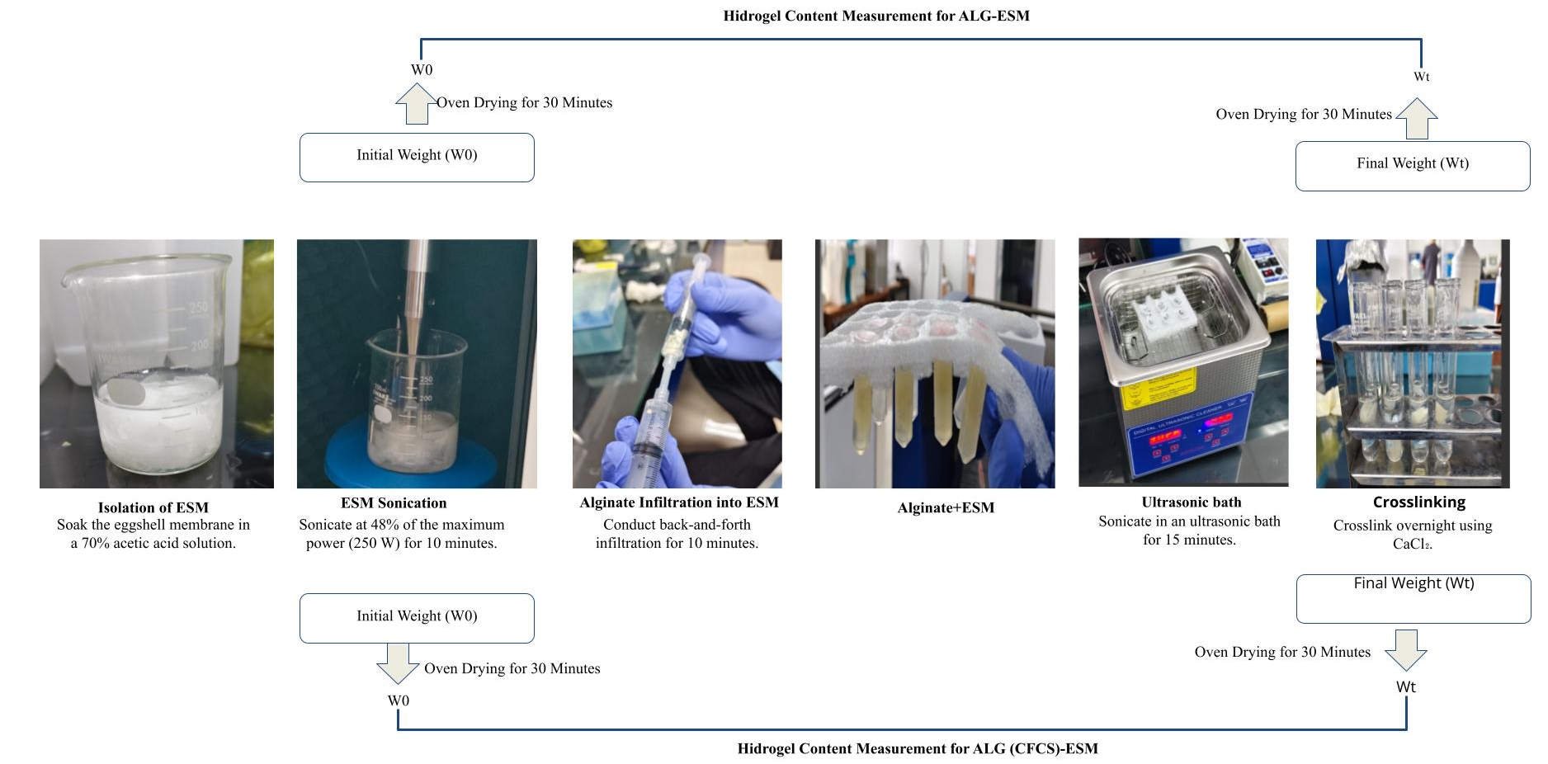
To initiate ionic crosslinking and stabilize the hydrogel network, the membrane was immersed in a 4% (w/v) calcium chloride solution for 15 minutes. After crosslinking, the sample was rinsed three times with ddH₂O to remove any unbound alginate residues. The resulting hybrid constructs were designated as ESM-A (alginate only) and ESM-AC (alginate combined with CFCS).

FIGURE 1. Schematic of the representative process of ESM hydrogel preparation
Incorporation of CFCS into Hybrid Structure and Evaluation of Its Inhibitory Effect
The cell-free culture supernatant (CFCS) derived from Lacticaseibacillus paracasei was incorporated into an alginate–eggshell membrane (ALG–ESM) matrix to produce bioactive hydrogel–fiber composites. CFCS at a concentration of 80% was blended with a 3% (w/v) sodium alginate solution at a volumetric ratio of 1:4 under gentle stirring until a uniform mixture was achieved. This composite solution was then diffused into the preformed ALG–ESM scaffold to ensure homogeneous distribution of the postbiotic throughout the hydrogel network. The resulting CFCS-loaded composite was designated as ESM–AC, while the CFCS-free control formulation was referred to as ESM–A.
To assess antibacterial efficacy, in vitro testing was conducted against Enterococcus faecalis ATCC 29212. Bacterial growth inhibition was quantified by measuring optical density (OD) at 600 nm (OD₆₀₀) using a UV–Vis spectrophotometer. Cultures of E. faecalis were incubated aerobically at 37 °C, and OD readings were recorded at 0, 4, and 8 hours to monitor growth kinetics. Untreated cultures served as the negative control, while pure CFCS was used as the positive control due to its established antimicrobial activity.
Evaluation of Gel-Fiber Hybrid Structure
To evaluate the extent of hydrogel infiltration into the eggshell membrane (ESM) structure, the dry weight of each sample was measured before (W₀) and after (W₁) the infiltration process. The degree of hydrogel incorporation was expressed as the percentage increase in mass, calculated using the following equation (1):

(1)
This approach provides a quantitative assessment of hydrogel uptake within the fibrous matrix of the ESM, reflecting the effectiveness of the infiltration procedure.
The percentage increase in sample mass following hydrogel infiltration provides a quantitative measure of the extent to which the hydrogel is embedded within the fibrous network of the eggshell membrane (ESM). This metric is critical for assessing both infiltration efficiency and the structural integration of the resulting hybrid composite.
To evaluate the structural stability of the hydrogel under physiologically relevant conditions, the hybrid samples were first dried to a constant weight and subsequently immersed in phosphate-buffered saline (PBS, pH 7.4) at 37 °C for 24 hours. After incubation, the samples were gently rinsed to remove residual PBS and dried again to a constant weight. This procedure simulates in vivo conditions and allows for the assessment of hydrogel retention and matrix integrity over time.
To evaluate the structural integrity of the hydrogel–ESM composite following immersion under simulated physiological conditions, the percentage of weight loss was calculated. This was determined by comparing the sample’s dry weight before and after PBS incubation, using the following equation (2):

(2)
This measurement provides insight into the material’s degradation profile and its stability in aqueous environments, which is critical for assessing its suitability as a postbiotic delivery platform. With W₀ and W₁ representing dry weight before and after incubation, respectively. The low weight loss value indicates a high level of biostability and a strong interaction between the hydrogel and the ESM fiber network.
The next evaluation analysis was to measure water uptake to assess the ability of the sample to absorb wound exudate and maintain a moist environment that supports the wound healing process. The dried sample is weighed (W₀), then immersed in PBS at 37 °C. At a certain time interval, the sample is taken, the surface is dried using filter paper, and re-weighed (Wt). The percentage of water absorption is calculated using Equation (3):

(3)
This measurement provides insight into the material’s degradation profile and its stability in aqueous environments, which is critical for assessing its suitability as a postbiotic delivery platform. These parameters reflect the hydrophilic properties and porosity of the material, which play an important role in maintaining the balance of moisture and gas diffusion in the wound area.
The WVTR test was conducted to evaluate the permeability of the composite dressing to water vapor, a critical parameter for maintaining optimal moisture balance at the wound interface—preventing both fluid accumulation and desiccation. A fixed volume of distilled water was placed into a cylindrical container, the opening of which was sealed with the prepared hydrogel–ESM sample. The initial weight of the container and sample (W₀) was recorded, after which the assembly was incubated at 37 °C to simulate physiological conditions. At predetermined time intervals, the container was reweighed (Wt) to determine mass loss attributable to water vapor evaporation.
WVTR was calculated using the following equation (4):

(4) This measurement provides insight into the dressing’s ability to regulate moisture exchange, which is essential for supporting wound healing and preventing microbial colonization. In the WVTR assessment, the exposed surface area (A) was calculated using the formula for the area of a circle, where R represents the radius of the container’s opening. A balanced WVTR value reflects the dressing’s ability to maintain appropriate moisture levels while permitting adequate gas exchange—an essential condition for optimal wound healing.
Quantitative data obtained from the WVTR test were expressed as mean ± standard deviation (SD), based on triplicate measurements for each sample group. Statistical comparisons between groups were performed using Student’s t-test and one-way analysis of variance (ANOVA). A p-value of less than 0.05 was considered statistically significant, indicating meaningful differences between experimental conditions.
Statistical Analysis
Quantitative data were expressed as mean ± standard deviation (SD), based on triplicate measurements for each test sample. Statistical comparisons between groups were performed using independent t-tests to identify significant differences across experimental conditions.

RESULTS AND DISCUSSION
Hydrogel Content Analysis
To quantify the extent of hydrogel penetration into the eggshell membrane (ESM) matrix, each sample was oven-dried and weighed before and after the infiltration process. As illustrated in Figure 2, the hydrogel was successfully distributed throughout the fibrous network of the ESM. The percentage increase in dry weight—reflecting infiltration efficiency—was calculated for both composite types. The ESM-A (alginate only) group exhibited a mass increase of 38.88 ± 3.65%, while the ESM-AC (alginate with CFCS) group showed a significantly higher infiltration efficiency of 61.11 ± 2.98%, indicating enhanced hydrogel integration in the presence of postbiotic compounds.
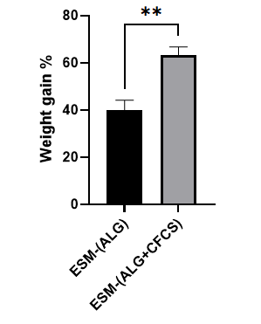

FIGURE 2. Hydrogel Content Measurement

The greater weight increase observed in the ESM–AC group indicates that the incorporation of CFCS significantly enhances both hydrogel retention and infiltration efficiency within the eggshell membrane (ESM) fiber network. This enhancement is likely driven by physicochemical interactions between calcium ions (Ca²⁺), which mediate alginate crosslinking, and the bioactive constituents present in CFCS. These bioactive molecules may function as auxiliary binding agents, reinforcing the adhesion between the hydrogel matrix and the collagen-rich structure of the ESM. As a result, a denser and more stable hydrogel network is formed, tightly integrated into the porous architecture of the membrane, thereby contributing to the substantial increase in post-infiltration mass.
Furthermore, the elevated hydrogel content in the ESM–AC composite reflects improved diffusion efficiency and superior water-binding capacity, which directly influence the mechanical robustness and structural stability of the hybrid material. This phenomenon can be attributed to enhanced hydrogel density and stronger crosslinking interactions facilitated by the synergistic effects of alginate polymers and CFCS-derived bioactive compounds.
In contrast, the ESM–A group exhibited a comparatively lower weight gain, suggesting partial hydrogel loss during the washing phase. This may be due to the limited crosslinking capacity of alginate when relying solely on ionic interactions with calcium chloride, in the absence of CFCS-mediated molecular reinforcement. Consequently, portions of the hydrogel may remain loosely bound and fail to integrate stably within the ESM matrix.
These findings underscore the critical role of CFCS in augmenting the crosslinking mechanism, thereby improving the structural integrity and retention of the hydrogel within the ESM scaffold. This enhanced infiltration efficiency and matrix stability highlight the potential of CFCS-enriched composites for applications in tissue engineering and biomimetic material development, where controlled bioactive delivery and scaffold integration are essential.
In-Vitro Biostability Analysis
The biostability of the hydrogel–fiber hybrid structures, composed of alginate (ALG) and eggshell membrane (ESM), with or without the incorporation of CFCS, was evaluated under simulated physiological conditions. Each sample was immersed in phosphate-buffered saline (PBS, pH 7.4) and incubated at 37 °C for 24 hours. This setup mimics the aqueous and thermal environment encountered in vivo. The structural integrity of the composites post-incubation was assessed to determine their resistance to degradation and suitability for biomedical applications.
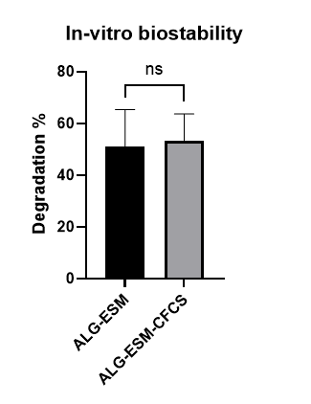

FIGURE 3. Immersion in PBS for 24 h and Mass loss (%)

As shown in Figure 3, the percentage of mass loss following 24-hour immersion in phosphate-buffered saline (PBS, pH 7.4) at 37 °C was 51.0 ± 7.39% for the ESM-A group and 53.33 ± 5.30% for the ESM-AC group. These values indicate partial degradation of the hydrogel component, primarily due to dissolution of the alginate matrix into the surrounding medium. Importantly, the structural integrity of the ESM scaffold remained intact, consistent with previous reports demonstrating that ESM does not undergo degradation in aqueous environments over similar timeframes [13,14]. Therefore, the observed mass loss is attributed predominantly to the breakdown of the hydrogel phase rather than the fibrous ESM network.
This degradation behavior aligns with the known ion displacement mechanism in alginate hydrogels. Alginate forms ionic crosslinks via interactions between its carboxylate groups and divalent calcium ions (Ca²⁺). When exposed to ionic solutions such as PBS, sodium (Na⁺) and chloride (Cl⁻) ions compete with Ca²⁺, disrupting these crosslinks and facilitating the release of alginate polymer chains into solution [15]. This process represents the primary pathway of hydrogel degradation in alginate-based systems.
Interestingly, the incorporation of CFCS did not significantly alter the degradation rate compared to the control group (ESM-A), suggesting that the bioactive constituents within CFCS do not interfere with the ionic stability of the alginate–calcium network. However, the slightly higher mass loss observed in the ESM-AC group may reflect subtle changes in hydrogel microstructure induced by CFCS components—such as peptides, proteins, or growth factors—which could enhance water diffusion and matrix porosity.
These findings are consistent with the study by Franco [16], which reported that in a PCL–PLGA fiber composite system combined with chitosan/gelatin hydrogels, the fibrous scaffold remained structurally stable while the hydrogel component exhibited controlled degradation. Similarly, in the present study, the ESM serves as a mechanical backbone, preserving the overall integrity of the hybrid structure.
The lack of statistically significant differences between ESM-A and ESM-AC is further supported by the inherent chemical properties of alginate. Its degradation is primarily hydrolytic and enzymatic, both of which proceed slowly and are highly dependent on crosslinking density and ionic composition of the surrounding medium [17]. As long as the availability of divalent cations and the structural configuration of the scaffold remain unchanged, degradation rates are expected to be comparable across formulations.
According to these findings, both ESM-A and ESM-AC composites exhibit favorable biostability under in vitro conditions, with moderate degradation rates and preserved scaffold architecture. The retention of ESM integrity post-immersion confirms the structural resilience of the hybrid system, supporting its potential application as a biological scaffold or cell-adhesive matrix. Moreover, hydrogel stability in physiological media is a critical parameter for tissue regeneration applications, as it ensures sustained water retention, oxygen permeability, and controlled release of bioactive agents—key factors in promoting wound healing and soft tissue repair.
Hydration and Swelling Behavior
In dental tissue engineering—particularly in pulp regeneration and root canal therapy—the water absorption and swelling characteristics of hydrogels are critical parameters that influence their performance in biological environments. An ideal hydrogel should exhibit efficient fluid uptake to maintain moisture, facilitate nutrient and oxygen diffusion, and serve as a responsive carrier for bioactive molecules.
As illustrated in Figure 4, the ESM-A composite demonstrated a rapid increase in weight, reaching 270% ± 8.66% within the first 2 hours of immersion, and further swelling to 601.67% ± 22.54% after 6 hours. In contrast, the ESM-AC formulation exhibited a more gradual and stable swelling profile, with a 345% ± 27.83% increase at 2 hours and reaching 446.66% ± 41.63% at 6 hours. These results confirm that both formulations possess high water absorption capacity, with final swelling values ranging from 270% to 640%, which fall within the optimal range for biomaterials (38–600%) as reported in previous studies [16,18].
Supporting literature reinforces these findings. For instance, Chen et al. demonstrated that alginate hydrogels crosslinked with Ca²⁺ ions exhibit excellent water retention and can effectively deliver bioactive proteins for dental tissue regeneration [19]. Similarly, Anitua et al. (2017) reported that alginate–gelatin hydrogel systems maintain a moist microenvironment conducive to cell adhesion and migration, making them suitable for pulp capping and scaffold-based applications [20].
The observed differences in swelling behavior between ESM-A and ESM-AC may be attributed to the presence of CFCS bioactive components, which could influence the microstructure and porosity of the hydrogel matrix. Nonetheless, both composites exhibit favorable hydration profiles, supporting their potential use as moisture-retentive scaffolds in regenerative endodontics.

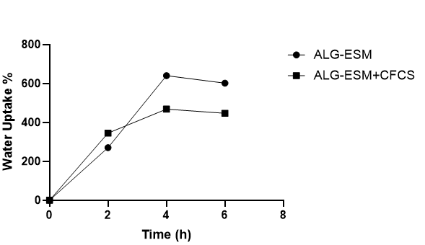

FIGURE 4. Water Uptake
The pronounced water absorption capacity observed in alginate-based hydrogels is primarily attributed to the presence of hydrophilic carboxylate groups (–COO⁻), which readily interact with water molecules through ionic bonding and hydrogen interactions. Additionally, the intrinsic fibrous architecture of the eggshell membrane (ESM) contributes to fluid uptake via capillary action and expansion of intermolecular spaces during immersion.
In the ESM-AC formulation, the slightly reduced swelling compared to ESM-A may be explained by the presence of bioactive constituents in CFCS. These molecules likely enhance the crosslinking density through electrostatic interactions with alginate’s carboxylate groups, resulting in a more compact hydrogel network. This denser structure modestly restricts water penetration, yet still maintains sufficient imbibition capacity to support biological functionality.
Such swelling behavior is particularly relevant in endodontic contexts, where moisture retention within the root canal is essential for creating a conducive microenvironment for tissue regeneration. Controlled water uptake also facilitates the gradual release of bioactive compounds from CFCS, ensuring sustained therapeutic effects.
These findings are supported by previous studies. Mohabatpour et al. reported that poly-L-lactic acid–alginate–hyaluronic acid hydrogels exhibited water absorption capacities approaching 600%, highlighting their suitability for biomedical applications [21]. Similarly, polysaccharide-based hydrogel systems have demonstrated absorbency levels between 350–430%, as reported by Farooq, Faheem, and Sheraz [22–24]. In contrast, native ESM membranes typically absorb only 220–250% of water within the first hour of immersion, underscoring the enhanced performance of the hybrid composites developed in this study.
The superior absorption capacity of both ESM-A and ESM-AC is likely driven by two synergistic mechanisms: (1) the hydrophilic nature of alginate’s carboxylate groups, which attract and retain water molecules, and (2) osmotic interactions between calcium ions (Ca²⁺) in the hydrogel and sodium or potassium ions (Na⁺/K⁺) in the PBS medium, which promote polymer expansion and fluid uptake. This dual mechanism enables the hydrogel to reach saturation without compromising its structural integrity, making it a promising candidate for regenerative dental applications.
WVTR
WVTR is a critical parameter in evaluating the functional performance of biomedical materials, particularly therapeutic hydrogels and wound dressings. An optimal WVTR value reflects the material’s ability to regulate moisture at the tissue interface—preventing excessive accumulation of exudate while avoiding desiccation of the wound surface. This balance is essential for maintaining a microenvironment conducive to cellular activity, tissue regeneration, and accelerated healing.

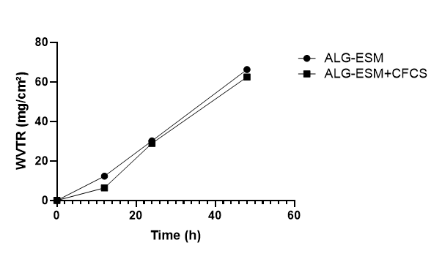

FIGURE 5. Assessment of Water Vapor Transmission Rate
As presented in Figure 5, the WVTR of the ESM-A hydrogel (ALG–ESM) increased from 12.31 ± 2.58 mg/cm² at 12 hours to 30.14 ± 1.12 mg/cm² after 24 hours. In comparison, the ESM-AC composite (ALG–ESM + CFCS) exhibited a WVTR of 6.36 ± 3.20 mg/cm² at 12 hours, rising to 28.87 ± 4.72 mg/cm² at 24 hours, and further reaching 62.42 ± 7.09 mg/cm² by 48 hours. These results indicate a progressive increase in vapor permeability over time, particularly in the CFCS-enriched formulation.
The WVTR values observed for both composites are lower than those typically associated with damaged skin, suggesting their capacity to retain moisture and prevent desiccation. However, the relatively reduced WVTR compared to healthy skin may pose a risk of exudate accumulation if not counterbalanced by sufficient fluid absorption.
Notably, the ESM-AC hydrogel demonstrated a high fluid uptake capacity, absorbing up to 446% of its initial weight. This property effectively mitigates the risk of exudate buildup, thereby reducing the potential for secondary infection. In the context of endodontic or intraoral therapeutic applications, a moderate WVTR is advantageous. It helps maintain a humid microenvironment conducive to tissue regeneration, while allowing for gas exchange and nutrient diffusion essential for pulp and periapical healing.
Moreover, controlled vapor transmission contributes to the prevention of hydrogel dehydration and preserves its viscoelastic properties, which are critical for maintaining mechanical stability during clinical use. These findings support the suitability of ESM-AC as a bioactive delivery platform in moist oral environments, where balanced hydration and structural integrity are essential for therapeutic efficacy.
Inhibitory Effect of Hydrogel-Fiber Composites on E. faecalis Growth
To evaluate the antimicrobial efficacy of the ESM-AC hydrogel–fiber composite, the material was immersed in phosphate-buffered saline (PBS) to facilitate the gradual release of postbiotic bioactive compounds. This experimental setup was designed to mimic the moist and fluid-rich conditions of the root canal environment, enabling sustained therapeutic delivery. The released bioactives were expected to exert antimicrobial effects comparable to those of pure CFCS, which served as the positive control due to its well-documented antibacterial activity in previous studies.
The results demonstrated that the ESM-AC composite exhibited inhibitory effects against bacterial growth that closely matched those of the pure CFCS control. This finding confirms that the hydrogel matrix does not compromise the biological activity of the postbiotic agents. Instead, it functions effectively as a delivery platform, facilitating controlled release while preserving antimicrobial potency. These outcomes support the potential application of ESM-AC hydrogels in endodontic therapy, where sustained antimicrobial action is essential for root canal disinfection and periapical tissue preservation.

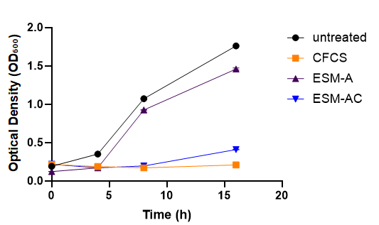

FIGURE 6. E. faecalis growth profile (OD₆₀₀) at 0, 4, 8, and 16 h in untreated control, CFCS (cell-free culture supernatant, positive control), demonstrated growth inhibition comparable to CFCS, confirming retained postbiotic bioactivity following hydrogel incorporation.
Optical density (OD₆₀₀) measurements revealed distinct differences in bacterial growth across treatment groups, as shown in Figure 6. The untreated control group exhibited a sharp increase in OD from 0.19 to 1.7625 over 16 hours, indicating uninhibited proliferation of Enterococcus faecalis. In contrast, the CFCS group maintained a stable OD of approximately 0.2095, confirming its potent antibacterial activity. Notably, the ESM–AC hydrogel composite, which incorporates CFCS, sustained low OD values ranging from 0.19 to 0.4095 at the 16-hour mark—closely mirroring the pure CFCS group. Meanwhile, the ESM-A hydrogel (without CFCS) showed a significant increase in OD, reaching 1.46, indicating limited antibacterial efficacy.
These findings affirm that the antimicrobial effect observed in the ESM–AC group is attributable to the bioactive constituents of CFCS, particularly linoleic acid (9,12-Octadecadienoic acid (Z,Z)), which has been previously reported to inhibit bacterial growth [6]. These results are also consistent with previous findings reporting that L. paracasei and its metabolites may inhibit the formation of pathogenic biofilms through the production of organic acids, bacteriocins, and fatty acid derivatives such as linoleic acid. These bioactive compounds interfere with quorum sensing, cell membrane integrity, and extracellular polymer substance (EPS) synthesis in pathogens, thereby reducing the virulence and resistance of their biofilms [32]. The alginate hydrogel matrix itself does not contribute to antibacterial activity but serves as a biocompatible carrier, enabling sustained release of postbiotic compounds. Alginate’s hydrophilic nature and ability to form a three-dimensional network support its role as an effective drug delivery system [5]. The inclusion of ESM further enhances the composite’s structural integrity and biological compatibility, owing to its collagen-rich protein matrix and favorable mechanical properties, as supported by prior studies on eggshell membrane-based biomaterials [25].
The implications of these results are significant for contemporary endodontic therapy. Conventional chemical irrigants such as sodium hypochlorite (NaOCl) and calcium hydroxide, while effective, are associated with cytotoxicity and limited efficacy against mature E. faecalis biofilms [26]. In contrast, postbiotic-loaded hydrogels offer a biologically safer alternative with reduced risk of antimicrobial resistance. The ESM–AC formulation demonstrated efficacy during the early planktonic phase of bacterial growth, suggesting its potential utility in preventing recolonization following root canal instrumentation and prior to obturation.
Future investigations should focus on evaluating the composite’s performance against multispecies biofilms, characterizing the release kinetics of CFCS-derived bioactives, and assessing biocompatibility with periapical tissues. Ex vivo root canal models, along with advanced imaging techniques such as scanning electron microscopy (SEM), will be instrumental in validating the hydrogel’s clinical applicability and elucidating its impact on biofilm architecture and bacterial morphology.

CONCLUSION
In this study, a hybrid hydrogel composed of alginate and eggshell membrane (ALG–ESM) was developed and supplemented with cell-free culture supernatant (CFCS) from Lacticaseibacillus paracasei, intended as a postbiotic component. The combination of ALG and ESM demonstrated favorable physicochemical properties, including structural stability, appreciable water absorption, and WVTR values that may be suitable for the oral environment. The inclusion of CFCS retained antibacterial activity against Enterococcus faecalis, suggesting that this system holds potential as a biocompatible platform for postbiotic delivery. While preliminary findings are encouraging, further investigation is warranted to validate its applicability in intracanal therapies and oral wound care under clinical conditions.
ACKNOWLEDGMENTS
We extend our sincere appreciation to the Research Center of UMY for their generous financial support, which made this work possible. Our deepest gratitude is also owed to the MMT Laboratory at the Research and Innovation Center of UMY for providing exceptional facilities, advanced equipment, research materials, and invaluable technical guidance throughout the study. Their dedication and expertise significantly enriched the quality and progress of this research.

References
- S. Salminen, M.C. Collado, A. Endo, C. Hill, S. Lebeer, E.M.M. Quigley, M.E. Sanders, R. Shamir, J.R. Swann, H. Szajewska, and G. Vinderola, “The International Scientific Association of Probiotics and Prebiotics (ISAPP) consensus statement on the definition and scope of postbiotics,” Nat Rev Gastroenterol Hepatol 18(9), 649–667 (2021).
- G. Vinderola, M.E. Sanders, and S. Salminen, “The Concept of Postbiotics,” Foods 11(8), 1077 (2022).
- E. Hijová, “Postbiotics as Metabolites and Their Biotherapeutic Potential,” IJMS 25(10), 5441 (2024).
- A. Kumar, K.M. Green, and M. Rawat, “A Comprehensive Overview of Postbiotics with a Special Focus on Discovery Techniques and Clinical Applications,” Foods 13(18), 2937 (2024).
- J.Y. Lee, Y. Kim, J.-I. Kim, H.-Y. Lee, G.-S. Moon, and C.-H. Kang, “Improvements in Human Keratinocytes and Antimicrobial Effect Mediated by Cell-Free Supernatants Derived from Probiotics,” Fermentation 8(7), 332 (2022).
- A. Adiningrat, A.N. Prastyo, and A.F.A. Farabi, “Gingipain R inhibitory potency of octadecadienoic acid from clinically isolated Lacticaseibacillus paracasei,” (Yogyakarta, Indonesia, 2025), p. 020009.
- L. Zhao, Y. Zhou, J. Zhang, H. Liang, X. Chen, and H. Tan, “Natural Polymer-Based Hydrogels: From Polymer to Biomedical Applications,” Pharmaceutics 15(10), 2514 (2023).
- A.H. Karoyo, and L.D. Wilson, “A Review on the Design and Hydration Properties of Natural Polymer-Based Hydrogels,” Materials 14(5), 1095 (2021).
- N.H. Thang, T.B. Chien, and D.X. Cuong, “Polymer-Based Hydrogels Applied in Drug Delivery: An Overview,” Gels 9(7), 523 (2023).
- M.K. Sah, and S.N. Rath, “Soluble eggshell membrane: A natural protein to improve the properties of biomaterials used for tissue engineering applications,” Materials Science and Engineering: C 67, 807–821 (2016).
- C. Han, Y. Chen, L. Shi, H. Chen, L. Li, Z. Ning, D. Zeng, and D. Wang, “Advances in eggshell membrane separation and solubilization technologies,” Front. Vet. Sci. 10, 1116126 (2023).
- N. Nazari, R. Imani, and L.R. Nasiraie, “Fiber/hydrogel hybrid wound dressing based on eggshell membrane containing postbiotic ingredients,” Biomaterials Advances 165, 214004 (2024).
- M. Baláž, “Eggshell membrane biomaterial as a platform for applications in materials science,” Acta Biomaterialia 10(9), 3827–3843 (2014).
- G.D. Mogoşanu, and A.M. Grumezescu, “Natural and synthetic polymers for wounds and burns dressing,” International Journal of Pharmaceutics 463(2), 127–136 (2014).
- K. Yamamoto, Y. Yuguchi, B.T. Stokke, P. Sikorski, and D.C. Bassett, “Local Structure of Ca2+ Alginate Hydrogels Gelled via Competitive Ligand Exchange and Measured by Small Angle X-Ray Scattering,” Gels 5(1), 3 (2019).
- R.A. Franco, T.H. Nguyen, and B.-T. Lee, “Preparation and characterization of electrospun PCL/PLGA membranes and chitosan/gelatin hydrogels for skin bioengineering applications,” J Mater Sci: Mater Med 22(10), 2207–2218 (2011).
- D. Massana Roquero, A. Othman, A. Melman, and E. Katz, “Iron( iii )-cross-linked alginate hydrogels: a critical review,” Mater. Adv. 3(4), 1849–1873 (2022).
- N.H. Sloane, “alpha-Naphthoflavone activation of 6-hydroxymethylbenzo(alpha)pyrene synthetase,” Cancer Res 35(12), 3731–3734 (1975).
- L. Chen, R. Shen, S. Komasa, Y. Xue, B. Jin, Y. Hou, J. Okazaki, and J. Gao, “Drug-Loadable Calcium Alginate Hydrogel System for Use in Oral Bone Tissue Repair,” Int J Mol Sci 18(5), 989 (2017).
- E. Anitua, M. Zalduendo, M. Troya, I. Erezuma, I. Lukin, R. Hernáez-Moya, and G. Orive, “Composite alginate-gelatin hydrogels incorporating PRGF enhance human dental pulp cell adhesion, chemotaxis and proliferation,” International Journal of Pharmaceutics 617, 121631 (2022).
- F. Mohabatpour, A. Karkhaneh, and A.M. Sharifi, “A hydrogel/fiber composite scaffold for chondrocyte encapsulation in cartilage tissue regeneration,” RSC Adv. 6(86), 83135–83145 (2016).
- F. Azam, F. Ahmad, S. Ahmad, M.S. Zafar, and Z. Ulker, “Preparation and Characterization of Alginate Hydrogel Fibers Reinforced by Cotton for Biomedical Applications,” Polymers 14(21), 4707 (2022).
- F. Azam, F. Ahmad, S. Ahmad, M.S. Zafar, and Z. Ulker, “Synthesis and characterization of natural fibers reinforced alginate hydrogel fibers loaded with diclofenac sodium for wound dressings,” International Journal of Biological Macromolecules 241, 124623 (2023).
- F. Ahmad, B. Mushtaq, F.A. Butt, M.S. Zafar, S. Ahmad, A. Afzal, Y. Nawab, A. Rasheed, and Z. Ulker, “Synthesis and Characterization of Nonwoven Cotton-Reinforced Cellulose Hydrogel for Wound Dressings,” Polymers 13(23), 4098 (2021).
- A. Torres-Mansilla, M. Hincke, A. Voltes, E. López-Ruiz, P.A. Baldión, J.A. Marchal, P. Álvarez-Lloret, and J. Gómez-Morales, “Eggshell Membrane as a Biomaterial for Bone Regeneration,” Polymers 15(6), 1342 (2023).
- N. Farhadmollashahi, E. Saberi, and H. Karkehabadi, “Evaluation of Cytotoxic Effects of Various Endodontic Irrigation Solutions on the Survival of Stem Cell of Human Apical Papilla,” Iranian Endodontic Journal, (2016).
- L.I.F. Moura, A.M.A. Dias, E. Carvalho, and H.C. De Sousa, “Recent advances on the development of wound dressings for diabetic foot ulcer treatment—A review,” Acta Biomaterialia 9(7), 7093–7114 (2013).
- H. Naderi-Meshkin, R. Amirkhah, A. Heirani-Tabasi, and M. Irfan-maqsood, “Critical Issues in Successful Production of Skin Substitutes for Wound Healing,” Gnc 4, 10 (2018).
- L.N. Kasiewicz, and K.A. Whitehead, “Recent advances in biomaterials for the treatment of diabetic foot ulcers,” Biomater. Sci. 5(10), 1962–1975 (2017).
- S. Nour, R. Imani, G.R. Chaudhry, and A.M. Sharifi, “Skin wound healing assisted by angiogenic targeted tissue engineering: A comprehensive review of bioengineered approaches,” J Biomedical Materials Res 109(4), 453–478 (2021).
- F. Yu, A.U.R. Khan, Y. Li, B. Zhao, X. Xie, M. EL-Newehy, H. EL-Hamshary, Y. Morsi, J. Li, J. Pan, and X. Mo, “A multifunctional nanofiber reinforced photo-crosslinking hydrogel for skin wound healing,” Composites Part B: Engineering 247, 110294 (2022).
- A. Adiningrat, I. Maulana, A.G. Fadhlurrahman, and H. Yumoto, “Probiotic bacteria from asymptomatic necrotic tooth can regulate the microbiome homeostasis,” Microb. Pathog. 206, 107791 (2025).

