Differences In Microleakage of Flowable Nanofiller Composite Resin (3M Filtek Supreme), Composite Nanosisal, And Composite Nanosisal with Coupling Agent
Dwi Aji Nugroho^{1, a)} and Sakti Rangga Dewa^{2, b)}
Author Affiliations
¹Department of Dental Biomaterials, Faculty of Dentistry, Universitas Muhammadiyah Yogyakarta, Indonesia.
²Undergraduated Programme, Faculty of Dentistry, Universitas Muhammadiyah Yogyakarta, Indonesia.
Author Emails
^{a)} Corresponding author: dwiajidrg@umy.ac.id
^{b)}dewasaktirangga@gmail.com
Abstract. Cavities or caries are a disease of the hard tissue of the teeth that characterized by damage to the enamel and dentin, even it can reach the pulp caused by bacterial invasion in plaque which causing demineralization due to interactions between the products of microorganisms. The dental treatment for this case is restorations. Composite resin is a dental restorative material consisting of matrix, inorganic filler and coupling agent which is often used in dentistry to replace lost tooth structure and has the ability to produce good tooth color and contour, thereby increasing the aesthetic factor in terms of dental restoration. Natural fibers are expected to be a substitute for inorganic materials because they have low density, specific strength, biocompatibility and high modulus. One of natural fiber that has the potential to be developed as an alternative filler at this time is nanosisal, because the hardness of the fiber is produced from the sisal plant (Agave Sisalana). In this study, sisal nanofiber were used as filler for dental composite. The purpose of this study was to analyze the differences in microleakage of flowable nanofiller composite (3M Filtek Supreme), nanosisal composite, and nanosisal composite with coupling agent (DGEBA). The sisal fibers were reduced to nano size and combined with BisGMA, UDMA, TEGDMA, and Champhorquinone. The nanofiller flowable composite resin (3M Filtek Supreme) was labeled group A, nanosisal composite (group B), and nanosisal composite with coupling agent (DGEBA) (group C). Healthy free-caries molar teeth were used for the samples. Molars teeth that have been preparations will be restored using composite resin so that 3 test groups can be formed, namely flowable nanofiller composite reisn (3M Filtek Supreme), nanosisal composite, and nanosisal composite with coupling agent (DGEBA). Soaking using methylene blue in the 3 test groups was carried out for 3 days. After that, a scanning electron microscopy (SEM) test was carried out to determine the distance of the microleakage that occurred. The data obtained was processed using SPSS and continued with the non-parametric test, namely Kruskal-Wallis test. The average microleakage value for the flowable nanofiller resin composite group was 8.70 μm, for the nanosisal composite group it was 38.34 μm, and for the nanosisal composite with coupling agent it was 11.23 μm. The results of the data normality test were 0.891, 0.032, and 0.462 which showed a sig value <0.05. Nanofiller flowable composite resin (3M Filtek Supreme) was the lowest microleakage. Nanosisal composite was the highest microleakages. This study made a contribution to the invention of a new dental composite restorative material with organic filler (sisal nanofibers).
Keywords: Nanosisal, Dental Composite, Microleakage

introduction
Cavities or caries are a disease of the hard tissue of the teeth that characterized by damage to the enamel and dentin, even it can reach the pulp caused by bacterial invasion in plaque which causing demineralization due to interactions between the products of microorganisms [1]. Bacterial activity in dental plaque produces an acidic atmosphere (pH <5.5) in the oral cavity, which can cause demineralization of the tooth structure, so the pH atmosphere in the oral cavity must be neutral (>5.5) so that the remineralization process can occur. stops the demineralization process [2]. Treatment in dentistry to treat this condition is restoration of the teeth [3]. Composite resin is a dental restorative material consisting of matrix, inorganic filler and coupling agent which is often used even today to replace lost tooth structure and has the ability to produce good tooth color and contour, thus increasing the aesthetic factor in terms of dental restoration [4]. Composite resin also has very biocompatible properties, so the safety level of this material is considered very high [5]. The composite resin the most often used today is nanofiller composite resin, because it has a very small filler particle size so it has a shiny and smooth surface, minimal risk of shrinkage, and better durability [6]. Nanofiller composite resin is a universal restorative material that is activated by visible light for the anterior and posterior restoration teeth [7]. The filler used in composite resin comes from inorganic materials such as quartz, glass and silica because these materials have strong, hard and stable properties. Inorganic materials in composite resin still show several weaknesses, such as the production process is very dependent on fossil fuels, unrenewable, and cannot be recycled [8]. Shrinkage is the main disadvantage of composite resin which can cause failure of the adhesive bond, micro-gaps, and cuspid deflection due to the pressure created between the tooth and the restoration [9]. Shrinkage or failure in restoration can cause secondary caries to emerge, also known as Caries Associated with Restoration or Sealants (CARS). Restorative materials capable of releasing fluoride into the oral cavity have proven effective in preventing secondary caries in areas around fillings by forming a layer of fluorhydroxyapatite on the hard tooth tissue [10]. One of them was the discovery of a way to prevent secondary caries with bioactive composite resin which has antibacterial properties. The antibacterial effect is further enhanced by replacing the filler composition with antibacterial properties [11].
Natural fibers are expected to be a substitute for inorganic materials because they have low density, specific strength, biocompatibility and high modulus. One natural fiber that has the potential to be developed as an alternative filler at this time is nanosisal because the hard fiber is produced from the sisal plant (Agave Sisalana). Sisal fiber has a high cellulose and lignin content which functions as an antibacterial.
Resin matrix with nanosisal filler can be combined to make composite resin without using a coupling agent because both are organic materials. The bonds formed between nanosisal and the resin matrix can be considered as chemical bonds of OH groups [8]. Diglycidyl Ether of Bisphenol A (DGEBA) resin is one of the most significant thermosetting polymers. Diglycidyl Ether of Bisphenol A (DGEBA) functions as an organic component in making composites and is widely used in high performance adhesive and matrix resin applications. Diglycidyl Ether of Bisphenol A (DGEBA) can be combined with nanosisal composite as a coupling agent because it has similar properties, namely organic. Excellent adhesion to a wide range of substrates, excellent chemical and corrosion resistance, superior electrical insulation, high tensile, flexural and compressive strengths, thermal stability, wide drying temperature range and minimal shrinkage during curing is a characteristic of DGEBA resin [12]. The low degree of polymerization shrinkage possessed by composite nanofillers can minimize microleakage [13].
This research was carried out to determine the difference in microleakage between inorganic and organic resin composite fillers, namely sisal fiber which comes from the sisal plant (Agave Sisalana). It is hoped that natural fibers can be a good substitute as a filler in composite resins. Sisal fiber is believed to have several advantages that can influence the mechanical, physical and thermal properties of composite resins. Composite resin that will bond with nano-sized sisal fibers can be the newest innovation in the world of dentistry because it has similar properties, namely organic. Diglycidyl Ether of Bisphenol A (DGEBA) can also be combined with nanosisal composite as a coupling agent because it comes from organic materials. It is hoped that the bonding of these three components can produce a composite resin containing organic materials that is good, strong and biocompatible, so that microleakage can be prevented. Microleakage can be determined through the Scanning Electron Microscopy (SEM) test. The main objective of this research is to determine the difference in microleakage of flowable nanofiller composite resin (3M Filtek Supreme), composite nanosisal, and composite nanosisal with coupling agent (DGEBA).

MATERIAL AND METHODS
The type of research carried out is laboratory experimental. In this research, 3 samples were used, namely flowable nanofiller composite resin (3M Filtek Supreme), composite nanosisal, and composite nanosisal with coupling agent. The formula used to determine the number of samples for each group is the Federer Formula. This research began with obtaining ethical clearance and a research permit. The research subjects used were healthy molar teeth free of caries. Molar tooth preparation is carried out by creating a Class I G.V cavity. Black depth 2mm. Cleaning of the cavity remaining from preparation debris was carried out, then continued with generation V etching and bonding. After completion of preparation, etching and bonding, the sample was continued by mixing nanosisal.
The sisal fiber that has been obtained will go through several stages to become nanosisal. There are 3 stages in making nanosisal, namely scouring, bleaching, and freeze-dried. Making nanosisal begins with cutting the sisal fiber using scissors with strands measuring 5 cm long and weighing 3 grams. Scouring is the first stage in making nanosisal. At this stage the fiber is soaked in 15 grams of NaOH solution which is then dissolved in 250 ml of water at a temperature of 80oC for 2 hours. While soaking is in progress, stir using a magnetic stirrer. This process is carried out 3 times to clean dirt or remaining ingredients other than cellulose in the fibers. Then, the fiber is filtered and washed using distilled water until the pH becomes neutral. Dry the washed sisal fiber using a hair dryer and store it. Then, the second stage continues, namely bleaching, where at this stage the sisal fibers that have been dried and stored will be bleached to create space between the cellulose so that the microfibrils can be easily separated. Dissolve 2.5 grams of NaOH in 50 ml of distilled water and add 25 ml of 50% H2O2 solution. Then, the solution was shaken and added with distilled water again until the total solution mixture reached 250ml. The bleaching process in the second stage was carried out at a temperature of 80oC for 2 hours with stirring using a magnetic stirrer and repeated 4 times. Strain and wash the fibers after each bleaching process is completed. Next, dry the fibers using a hair dryer.
Third stage, namely freezed-dried. The process of making nanosisal at this stage consists of smoothing the dried sisal fibers using a grinder. The acid in the fine fiber is hydrolyzed at a temperature of 50ºC for 50 minutes using 65 wt% sulphuric acid, stirred with a magnetic stirrer. During this chemical process, the fiber content produced is around 5-6 wt%. Next, melt the suspension with a block of ice to stop the reaction and wash using a centrifuge at 10ºC with a speed of 5000 rpm for 30 minutes. Perform dialysis on this distilled water to remove free acids in the dispersion. The sonification stage is carried out to obtain the perfect nano-whisker disperse. Then, the dispersion is filtered with fritted glass filter number 1 when finished to remove any remaining aggregate, and continues with the freeze-dried stage. Nanosisal can be obtained in semi-solid powder form at the freeze-dried stage using a freeze-dryer.
The finished nanoscale will be mixed into the composite resin using a stirring process. After mixing, 3 test group samples were formed, namely making flowable nanofiller composite resin (3M Filtek Supreme), composite nanosisal, and composite nanosisal plus coupling agent (DGEBA). The finished composite resin was applied into the cavity and after all the samples were formed, they were soaked using methylene blue liquid for 3 days. The function of methylene blue liquid is to determine whether there is fluid entering the cavity, so that microleakage can be detected. Samples that have been soaked in methylene blue will be tested microscopically using scanning electron microscopy (SEM). The SEM test was carried out to get a microscopic picture of the microleakage that occurred in each group. In the SEM test, the microleakage distance that occurs between the restoration material and the tooth structure will be visible. The microleakage distance obtained was then analyzed and processed using SPSS to determine the average microleakage value in each group.

RESULTS AND DISCUSSION
Research on the differences in microleakage of flowable nanofiller composite resins, nanosisal composites, and nanosisal composites with coupling agents has been carried out. Calculation of the average microleakage in each test group was then carried out to determine the microleakage level. The average microleakage value for the flowable nanofiller resin composite group (3M Filtek Supreme) was 8.70 μm, for the nanosisal composite group it was 38.34 μm, and for the nanosisal composite plus coupling agent it was 11.23 μm. The average microleakage results show that the flowable nanofiller resin composite group (3M Filtek Supreme) has the lowest microleakage level, namely 8.70 μm, while the nanosisal composite group shows the highest microleakage level, namely 38.34 μm. Flowable nanofiller composite resin (3M Filtek Supreme) has nano-sized filler that is lighter and stronger. Individual nanoparticles and nanoclusters are a combination of filler particles in a unique nanofiller composite resin. The combination of these two particles can reduce the amount of interstitial space between filler material particles thereby minimizing shrinkage [14].
Composite nanosisal is a restorative material based on matrix resin which is added with natural fiber, namely sisal (Agave Sisalana) [15]. The combination of composite resin with filler from sisal fiber produced from the sisal plant (Agave Sisalana) can make a strong composite resin. Sisal fibers which are processed to become nano-sized fillers in composite resins can bond without requiring a coupling agent, because both materials are of organic origin. Nanoscale composites have the advantages of excellent durability and biocompatibility. Shrinkage remains the main weakness of this nanosisal composite if the polymerization process is inadequate, making it very susceptible to microleakage [16]. Composite nanosisal has a high level of microleakage due to the absence of a coupling agent role which can help in strengthening the nanosisal bond with the resin matrix. Natural fiber (sisal) also has weaknesses, namely porosity and can affect the mechanical properties of the composite resin itself. Microleakage is very susceptible to occurring in nanosisal composites during polymerization because nanosisal and the resin matrix will become unstable without a coupling agent [15].
Nanosisal composite combined with a coupling agent has much better resistance to microleakage than without a coupling agent, namely nanosisal composite. The difference in average microleakage is not very significant between flowable nanofiller composite resin and nanosisal composite plus coupling agent, indicating the important role of coupling agent in strengthening the mechanical properties of composite resin. Diglycidyl Ether of Bisphenol A (DGEBA) is a type of epoxy that is commonly used as a coupling agent, especially in composite resins. Nanosisal composite added with a coupling agent (DGEBA) produces a high strength composite because it can provide strong adhesion bonds between the matrix and nanosisal fibers. Diglycidyl Ether of Bisphenol A (DGEBA) which goes through a curing process can show excellent adhesion. The combination of composite nanosisal with coupling agent (DGEBA) can provide thermal stability, minimize shrinkage, and good electrical insulation [12].
TABLE 1. Microleakage’s Average Results
Microleakage’s Average (μm)
 | Nanofiller Flowable Composite Resin (3M Filtek Supreme) (A) | Nanosisal Composite (B) | Nanosisal Composite with Coupling Agent (DGEBA) (C)
1 | 10,29 μm | 45,24 μm | 12,13 μm
2 | 8,63 μm | 128,45 μm | 18,17 μm
3 | 7,21 μm | 3,98 μm | 10,49 μm
4 | 7,81 μm | 5,65 μm | 15,7 μm
5 | 9,53 μm | 8,41 μm | 0 μm
Mean | 8,70 μm | 38,34 μm | 11,23 μm
SD | 1.24 | 53.18 | 7.00
Table 1. Showed the result of microlekage’s average on flowable nanofiller composite resin, nanosisal composite, and nanosisal composite with coupling agent. These results show the average microleakage value in each test group. The average microleakage value for the flowable nanofiller resin composite group was 8.70 μm, for the nanosisal composite group it was 38.34 μm, and for the nanosisal composite plus coupling agent it was 11.23 μm.

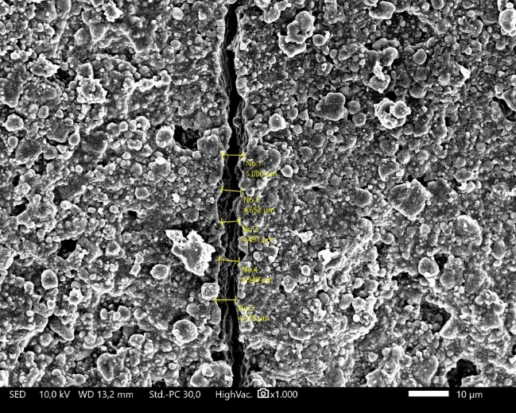
FIGURE 1. Results of the SEM microleakage test of flowable nanofiller composite resin (3M Filtek Supreme).
Figure 1 is the result of an SEM test on flowable nanofiller composite resin filling material (3M Filtek Supreme) which shows the presence of microleakage on the tooth structure. Flowable nanofiller composite resin (3M Filtek Supreme) showed very small microleakage results. The microleakage distance of the flowable nanofiller composite resin (3M Filtek Supreme) had an average result of 8.70 μm from the five samples tested. Based on the SEM test results, flowable nanofiller composite resin (3M Filtek Supreme) has much better adhesion results compared to composite nanosisal.

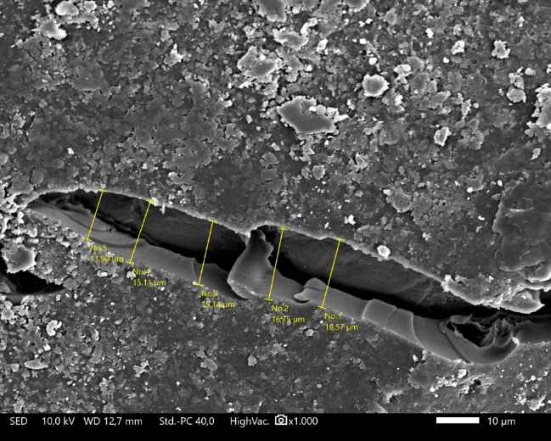
FIGURE 2. Results of the SEM microleakage test of nanosisal composite.
Figure 2 Shows the microleakage in nanosisal composite materials without coupling agents. In the SEM test results, it can be seen that the distance between microleakage on a very large micro scale and the tooth structure when compared to flowable nanofiller composite resin (3M Filtek Supreme). Nanosisal composite had the largest average microleakage results among the three test groups, namely 38.34 μm. Based on these results, it can be concluded that the nanosisal composite without coupling agent has a poor attachment to the tooth structure.

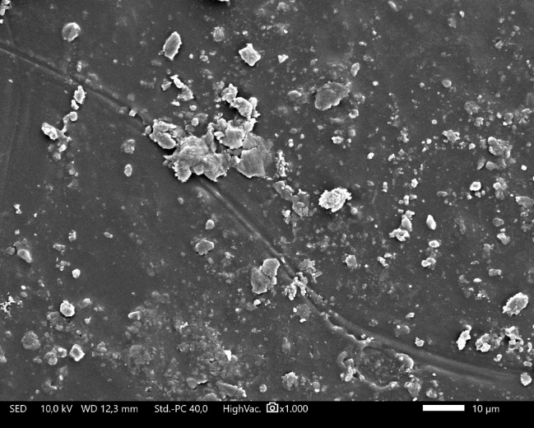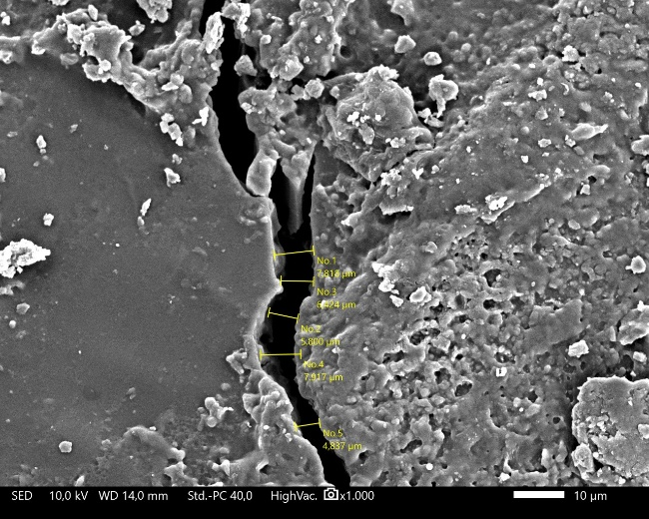
FIGURE 3. Results of the SEM microleakage test of nanosisal composite with coupling agent (DGEBA).
Figure 3 Showed a microscopic picture of the attachment of nanosisal composite with coupling agent (DGEBA) to the tooth structure. In the SEM test results, it can be seen that there are several sides where microleakage did not occur, but on the other side, microleakage was found with quite wide distances. Based on the SEM test results, it can be said that the nanosisal composite with added coupling agent (DGEBA) has quite good adhesion.

TABLE 2. Normality Test of Microleakage
 | Shapiro-Wilk
 | Statistic | df | Sig.
Nanofiller Flowable Composite Resin (3M Filtek Supreme) (A) | .973 | 5 | .891
Nanosisal Composite (B) | .753 | 5 | .032
Nanosisal Composite with Coupling Agent (DGEBA) (C) | .909 | 5 | .462
Information: p>0.05 = Normal Data
Table 2. Showed the results of microleakage normality test calculations on flowable nanofiller composite resins, nanosisal composites, and nanosisal composites with coupling agents. The normality test used Shapiro-Wilk because the number of samples is less than 50. The data is said to be normally distributed if the sig value is> 0.05, but the results of the data normality test are 0.891, 0.032, and 0.462 which indicate a sig value <0.05 so it can be concluded that the data is not normally distributed.
TABLE 3. Uji Non Parametrik Kruskal-Wallis
 | Kruskal-Wallis |  | Kruskal-Wallis H .980
 | N | Mean Rank | df | Asymp Sig
Nanofiller Flowable Composite Resin (3M Filtek Supreme (A) | 5 | 6.60 | 2 | .613
Nanosisal Composite (B) | 5 | 8.00 | 2 | .613
Nanosisal Composite with Coupling Agent (DGEBA) (B) | 5 | 9.40 | 2 | .613
Total | 15 |  | 2 | .613
Information: a. Kruskal-Wallis Test, b. Grouping Variable : Group

Tabel 3. Showed the results of the non-parametric Kruskal-Wallis test which has been carried out between flowable nanofiller composite resin, nanosisal composite, and nanosisal composite with coupling agent. From the test above in the statistical test table, the sig value is 0.613>0.05. From these results it can be concluded that there is no difference in microleakage between the three groups of samples, namely flowable nanofiller composite resin, nanosisal composite, and nanosisal composite with a significant coupling agent.

CONCLUSION
Based on the study that have done about the differences microleakage of nanofiller flowable composite resin (3M Filtek Supreme), nanosisal composite, and nanosisal composite with coupling agent, it can be concluded if there is differences microleakage between nanofiller flowable composite resin (3M Filtek Supreme), nanosisal composite, and nanosisal composite with coupling agent. Flowable nanofiller composite was the lowest microleakage and nanosisal composite was the highest microleakage.

Acknowledgments
Researchers appreciate the funding and resources provided by Lembaga Riset Inovasi (LRI) Universitas Muhammadiyah Yogyakarta and the Skills Lab room of Universitas Muhammadiya Yogyakarta (UMY) Dentistry Study Program.

References
- Adnyani,N. P., Made,I, and Artawa,B, “The Effect of Dental and Oral Diseases on Halitosis,” J. Kesehatan Gigi 4(1), 24-28 (2016)
- Andries, J. R., Gunawan,P.N., and Supit,A, “Antibacterial Effect Test of Clove Flower Extract Against Streptococcus mutans Bacteria In Vitro”, e-GIGI Journal 2(2) (2014)
- S.D. Rathi, P. Nikhade, M. Chandak, N. Motwani, C. Rathi, and M. Chandak, “Microleakage in Composite Resin Restoration- A Review Article,” J. Evol. Med. Dent. Sci. 9(12), 1006–1011 (2020).
- L.D. Randolph, W.M. Palin, G. Leloup, and J.G. Leprince, “Filler characteristics of modern dental resin composites and their influence on physico-mechanical properties,” Dent. Mater. 32(12), 1586–1599 (2016).
- K.T. Fitria, and S. Riyadi, “The Effect of Composite Brushing with Different Types of Toothpaste on Stain Due to Immersion in Coffee, Tea and Cuko Pempek Water,” J. Kesehat. Gigi 9(1), 9–15 (2022).
- El-Damanhoury, H. M., and Platt, J. A, “Polymerization shrinkage stress kinetics and related properties of bulk-fill resin composites,” Operative Dentistry, 39(4), 374–382 (2014)
- Y. Wang, M. Zhu, and X.X. Zhu, “Functional fillers for dental resin composites,” Acta Biomater. 122, 50–65 (2021).
- D.A. Nugroho, W. Widjijono, N. Nuryono, W. Asmara, W.D. Aastuti, and D. Ardianata, “Effects of filler volume of nanosisal in compressive strength of composite resin,” Dent. J. Maj. Kedokt. Gigi 50(4), 183 (2017).
- Yudistian, “Bulk Fill Composite Resin Restoration Techniques Replace Incremental Techniques,” Interdental J. Kedokteran Gigi (IJKG) 17(1), 9–14 (2021)
- R.Z. Ramadhan, I. Dwiandhono, and P.N. Widyaningsih, “The Effect Of Different Curing Time on Giomer’s Fluoride Release,” J. Kesehat. Gigi 10(1), 64–70 (2023).
- D.A. Nugroho, A.W. Chairunnisa, R.N. Luqmana, Y. Pasril, and N. Wijayanti, “In vitro study of streptococcus mutans adhesion and microscopic description on sisal nanofiber and nanofiller composite,” (Yogyakarta, Indonesia, 2024), p. 020017.
- T.S. Sasikala, S. Raman, P. Mohanan, C. Pavithran, and M.T. Sebastian, “Effect of silane coupling agent on the dielectric and thermal properties of DGEBA-forsterite composites,” J. Polym. Res. 18(4), 811–819 (2011).
- M. Milosevic, “Polymerization Mechanics of Dental Composites – Advantages and Disadvantages,” Procedia Eng. 149, 313–320 (2016).
- Alzraikat, H., Burrow, M., Maghaireh, G, and Taha, N., “Nanofilled Resin Composite Properties and Clinical Performance: A Review,” Operative Dentistry 43(4), 173–190 (2018)
- A. Amanda, D.N. Ratih, and E. Mulyawati, “The effect of sisal (Agave Sisalana) nanofiber in epoxy resin sealer on root canal obturation’s push-out bond strength,” Maj. Kedokt. Gigi Indones. 7(3), 137 (2022).
- F. Zotti, E. Falavigna, G. Capocasale, D. De Santis, and M. Albanese, “Microleakage of Direct Restorations-Comparisonbetween Bulk-Fill and Traditional Composite Resins:Systematic Review and Meta-Analysis,” Eur. J. Dent. 15(04), 755–767 (2021).

