Comparative Analysis of the Behavior of Vertical Links with Hollow Square Cross-sections in EBF Earthquake Resistant High-rise Building Structures with Variation of Link Lengths
Putra Agil Nasrullah^{a)}, Alfida Rahmawati Wibowo^{b)}, Erwin Rommel^{c)}, and Aulia Indira Kumalasari^{d)}
Department of Civil Engineering, University of Muhammadiyah Malang, Malang, Indonesia

^{d)} Corresponding author: auliaindira@umm.ac.id
^{a)} putraagilnasrullah@gmail.com
^{b)} alfidarahmawatiwibowo@gmail.com
^{c)} erwin_r@umm.ac.id

Abstract there are three possible beam link criteria in the Eccentrically Braced Frames (EBF) structural system namely short link, intermediate link, and long link. These criteria are determined by normalizing the link length with the ratio between plastic momen capacity (Mp) and plastic shear capacity (Vp). This research will analyze the behavior of vertical links with hollow square cross sections in hight-rise buildings with different dimensions and link lengths, namely structural drift, interstory drift, drift ratio, stress ratio, base shear, ductility, and stiffness. The results of this study obtained, the structure using EBFV-S produces a smaller structural drift than the structure using EBFV-I, which is 46,00 mm and 50,791 mm. For the interstory drift, the structure with EBFV-S produces a smaller value than the structure with EBFV-I, which is 24,020 mm and 27,068 mm by not exceeding the drift limit of 61,538 mm. The structure with EBF-S produces a smaller drift ratio value than the structure with EBFV-I, which is 0,001163 mm and 0,001270 mm by not exceeding the drift ratio limit (Δa) of 0,0025 mm. For the structure EBFV-S, the maximum stress ratio value is greater than the structure with EBFV-I, which is 0,708 and 0,686, both of which are located on the 3rd floor and do not exceed the strees ratio limit of 1,00. For base shear the structure with EBFV-S produces smaller values of 8079,728 KN and 320,00 mm while the structure with EBFV-I is 8926,921 Kn and 428,494 mm. For ductility, the structure with EBFV-S produces a greater value than the structure with EBFV-I, which is 2,133 and 1,867. For the stiffness of the structure with EBFV-S produces a value greater than the structure with EBFV-I, which is 25.249,151 KN/m and 20.833,246 KN/m.
Keyword: EBF, earthquake, link, pushover, respon spectrum analysis

INTRODUCTION
In this study, the behavior of a 10-story vertical eccentric braced frame system was evaluated using SAP 2000 application and numerical validation modeling based on Rahnavard's journal with cyclic load analysis using Abaqus. SAP 2000 modeling showed that the use of King Cross columns, beams and bracing using Wide Flange, double tubular SHS links with a vertical link length of 400 mm and a spacing between vertical links of 800 mm was in accordance with the design control. Validation and journal modeling resulted in shear forces of 389.9 kN and 400 kN respectively with a difference of 2.75%.[1]
The analysis is performed by imposing a static lateral load pattern on the structure, which is then gradually increased by a multiplier factor until a target lateral displacement of a reference point is reached. For the results of the Target Displacement parameter review, the structure using EBF Type K has better ductile properties than the Type V EBF based; while the results of the Base Shear parameter review, the structure using EBF Type V adds more structural stiffness than the structure using Type K. The installation of a lateral force resisting system that is not in the direction of the review does not have a significant effect on both the structure installed with EBF Type K and Type V. As the link length increases, (the ratio of link length to span width), the structure using EBF Type V decreases in its ability to bear lateral-direction external load applications, and this is exactly the opposite of the structure using EBF Type K, where as the link length increases, the strength to bear lateral-direction external loads increases.[2]
To overcome the problems in the H-EBF system, a system has been proposed, called Vertical-EBF (V-EBF). Links with WF and tubular profiles are two profiles commonly used in structures. In this study, the modeling of horizontal link EBF specimens was compared with EBFs with vertical links with tubular profiles. The results show that the structure with V-EBF has a lighter weight. The melting of the V-EBF only occurs in the link section so that it is better in earthquake rehabilitation.[3]
A 10-story building structure with a vertical EBF link structural system was analyzed using SAP 2000 software in the form of linear and non-linear analysis. Furthermore, a cyclic load analysis was carried out for a 1-story frame specimen with a vertical link EBF structural system using Abaqus CAE software. The results of the analysis show that the modeling of the 10-story EBF building structure and the 1-story EBF frame specimen experienced element failure first in the link, this is in accordance with the concept of the Eccentrically Braced Frames (EBF) structure.[4]
The study variables were ten modeling variations of brace configurations. The test models were subjected to nonlinear static thrust loads from elastic to collapse conditions to obtain their performance. All structural models are at the Damage Control performance level. Based on its inelastic behavior, structure A EBF F is the strongest structure in the X direction and C EBF F is the strongest structure in the Y direction. In terms of structural stiffness and ductility, C EBF F is the stiffest and most ductile structure in both X and Y directions.[5]
Based on the comparative analysis of the behavior of the Two story-X and Inverted-V eccentric brace frame structures using the SAP 2000 auxiliary program, the mass of the Two Story X brace structure is 0.014% greater than the Inverted-V structure, and the period value generated by Inverted V is 1.618 seconds while the Two Story X period is 1.676 seconds. And the largest deviation value occurs in the Two story X structure which is 0.024372 mm and Inverted V 0.022072 mm. The stability coefficient 𝜃 of the two structures, Two Story-X and Inverted-V are obtained 0.081 and 0.090 respectively.[6]
From the analysis, the type A brace, placed at spans 1 and 5, and using L 50x50x5 angle steel profiles is the best model, as the first melting occurs at the brace. The value of the response modification factor (R) in the X direction is 6.4848, and for the Y direction is 6.9641. The value of the over strength factor (Ω0) for the X direction is 3.1346, and for the Y direction is 2.4483. The value of the deflection magnification factor (𝐶𝑑) for the X direction is 1.2692, and for the Y direction is 1.1745. The performance level based on ATC-40 and FEMA 440 for X direction and Y direction is immediate occupancy.[7]
This study analyzes the comparison of behavior and performance of the eccentric system structure of Tow Story-X and Split-K using the help of the SAP 2000 program. The results of the analysis obtained the mass of the Tow Story-X brace structure is 0.058% lighter than Split-K, for the deviation value with the difference between the two structures is 1.9% and the value of the teta with a difference of 2.1%.[8]
From the results of previous studies, it is found that research related to the behavior of EBF structures on link length has not been widely carried out. Therefore, this study will analyze the behavior of vertical links with square hollow cross sections in high-rise buildings with different dimensions and link lengths, namely short and intermediate with ETABS application. The behavior reviewed in this study includes structural drift, inter-story drift, drift ratio, stress ratio, base shear, ductility, and stiffness. The results of this study are expected to complement innovations in seismic technology, especially technology related to Eccentrically Braced Frames (EBF).

METHODS
Two 10-story steel building structures with EBF-type earthquake resisting system with vertical bracing type, with varying dimensions and link lengths, were modeled. The structural link beams composed of HW 200 x 200 x 12 x 12 profiles were selected with a length of 100 cm and HW 200 x 200 x 9 x 9 profiles were selected with a length of 150 cm. These sizes represent the EBF structure with short and intermediate links illustrated in FIGURE 1
The modeled structure is an office building that has a building length of 20 m, a building width of 12 m, and a height between floors of 4 m with a total of 10 floors, so that the loading used is in accordance with the function of the building structure. The material used in the structure is steel with Fy 250 MPa and Fu 410 MPa or can be categorized into BJ 41 steel quality.
In addition to the HW profiles used in the link beams, the types of profiles used in other sections are listed in TABLE 1. The structure that has been preliminary designed is then modeled to be given linear and nonlinear static loads, where for the linear static method a load is given in the form of a spectrum response to find out how the structure behaves after being given an earthquake load, while the nonlinear method is given a load in the form of a pushover to find out the performance of the analyzed structure. Then the modeling results are analyzed through the stability, performance, and ductility of the structure. For ease of writing, the naming of the tested structures is written as shown in TABLE 2. The EBFV code indicates that the structure has an earthquake resisting system in the form of EBF with a vertical link type, the capitals S and I stand for short link and Intermediate link, for HW indicates the type of profile used, namely square hollow.

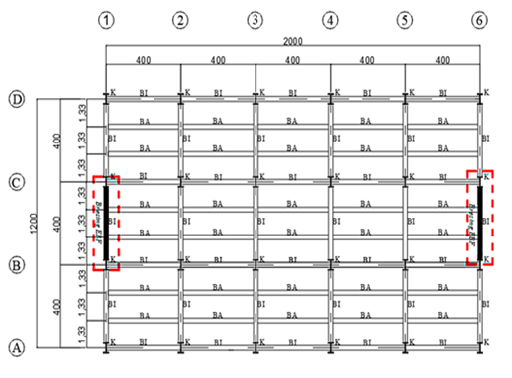 | 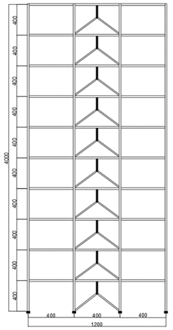
(a) | (b)
FIGURE 1. (a) Floorplan (b) Front of Structure
TABLE 1. Structure Properties
No | Part of EBF | Specification
1 | Coloum 1-10 story | WF 454.7 X 419.1 X 42.2 X 67.6
2 | Structure Beam 1-3 story | WF 256.5 X 203.7 X 8.9 X 15.7
3 | Structure Beam 4-6 story | WF 252 X 202.9 X 8 X 13.5
4 | Structure Beam 7-10 story | WF 247.1 X 202.2 X 7.4 X 11
8 | Bracing 1-3 story | WF 209.6 X 205 X 9.1 X 14.2
9 | Bracing 4-6 story | WF 206.2 X 203.7 X 7.9 X 12.6
10 | Bracing 7-10 story | WF 203.2 X 203.2 X 7.2 X 11
Source: ETABS
TABLE 2. Link Beam Properties
No | Name | Dimension of the Link | Calssification
1 | EBFV-S HW | 100 cm | EBF with short link
2 | EBFV-I HW | 150 cm | EBF with Intermediate link

RESULT AND DISCUSSION

STRUCTURE DRIFT, INTERSTORY DRIFT, AND DRIFT RATIO
The drift that occurs in the EBF structure shows that the longer the link used, the greater the drift that occurs in the structure, where those using intermediate links have a drift value of 50,791 mm, while short links have a drift value of 46,500 mm, as illustrated in FIGURE 2(a).
The resulting drift story or inter-story drift is the ratio of the inter-story drift to the inter-story height, the value should not be more than 0,0020 times the inter-story height or the limit used is 61,538 mm. From the modeling and analysis results for EBFV-S, the largest value of 24,02 mm was obtained at the 4th floor while for EBFV-I the largest value of 27,068 mm was obtained at the 4th floor, as illustrated in FIGURE 2 (b).
In addition to drift, the drift ratio of the structure is also used as a parameter for designing a building. The drift ratio itself is obtained by dividing the deviation that occurs at the top of a tall building structure, where the resulting ratio value cannot be more than H/400 or 0,0025. Just like the structural deviation, the drift ratio shown by the structure with intermediate link is 0,001270, while the structure with short link is 0,001163. In the short link and intermediate link the ratio increases by 11,63% and 12,70% respectively as illustrated in FIGURE 2(c).

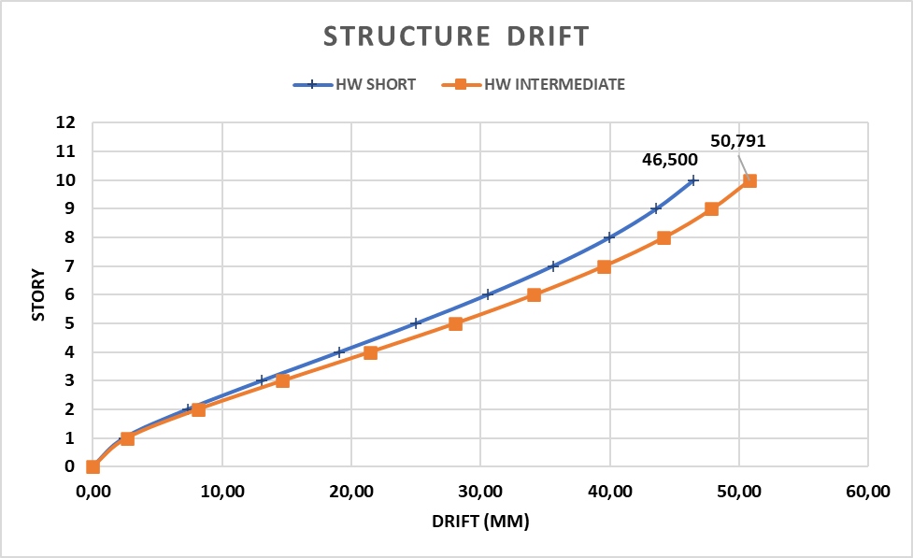 | 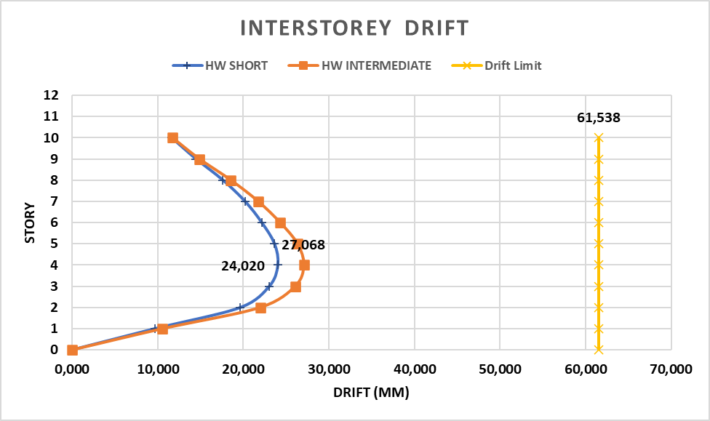
(a) | (b)

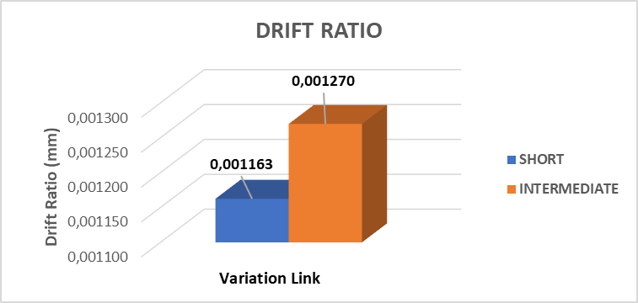
(c)
FIGURE 2. (a) Structure Drift (b) Interstorey Drift (c) Drift Ratio

STRESS RATIO
Stress ratio is the ratio between the ultimate load compared to the capacity of the cross section used in the structure, where the stress ratio can show the effectiveness of the cross section used to withstand loads that work either due to moment forces, axial forces or a combination of both, and the maximum value for the stress ratio should not be more than 1,00. The stress ratio resulting from the modeling and analysis of EBF structures using short links and intermediate links, shows that both are able to meet the stress ratio requirements, which are not more than 1,00 where the maximum value of the stress ratio for EBFV-S is 0,708 on the 3rd floor while for EBFV-I it is 0,686 on the 3rd floor. The stress ratio results for each structure can be seen in Table 3 and illustrated in FIGURE 3.
TABLE 3. Stress Ratio of The Structure
Type of Structure | Maximum Stress Ratio | Element
EBFV-S | 0,708 | Link beam at the 3th floor
EBFV-I | 0,686 | Link beam at the 3th floor

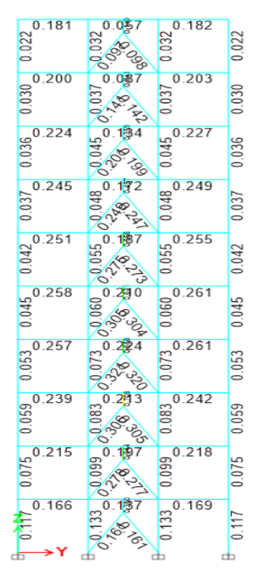 | 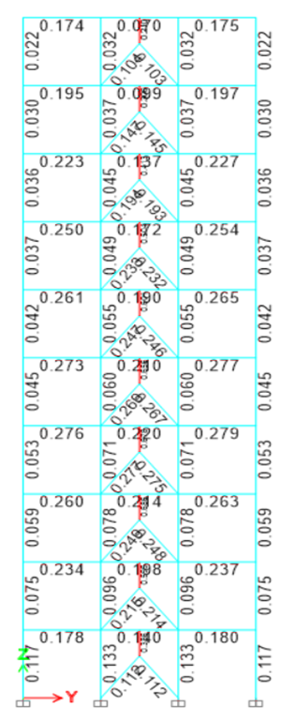
(a) | (b)

FIGURE 3. (a) Stress Ratio of Short Link (b) Stress Ratio of Intermediate Link

BASE SHEAR
The difference in pushover curves can be seen from the difference in link length where each modeling has a different first yield. First yield is a condition where the first plastic joint is formed in the modeled structure. For the amount of each base shear and deviation when the first yield occurs in the EBFV-S portal is 8079,728 KN and 320,00 mm while in the EBFV-I portal it is 8926,921 KN and 428,494 mm. The analysis results are illustrated in FIGURE 4.
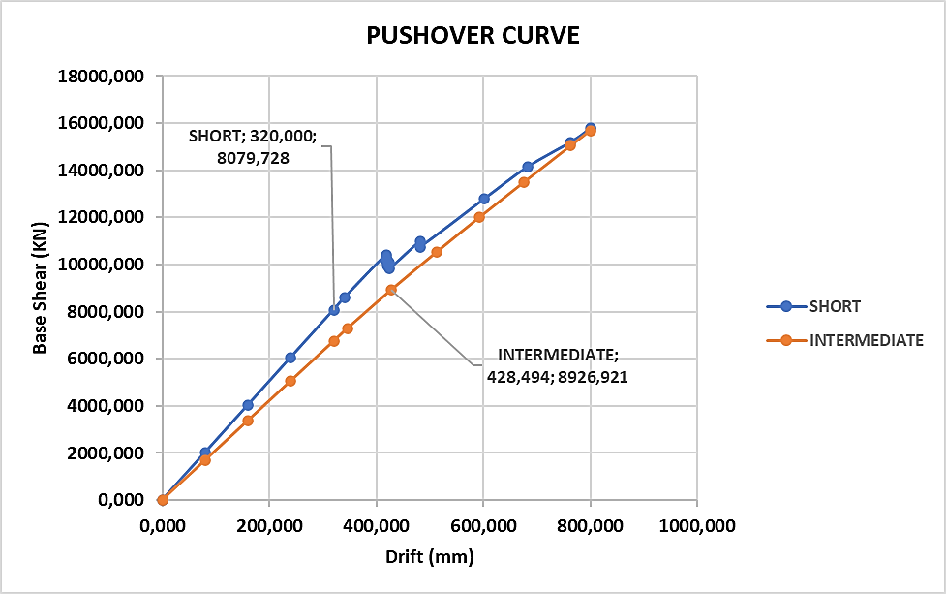
FIGURE 4. Pushover Curve

STRUCTURE DUCTILITY AND STIFFNESS
From the pushover curves, we can see a comparison of the ductility of each structural modeling after receiving earthquake loads. Ductility is the ratio of yield point and ultimate point that occurs in the pushover curve. Ductility can be measured by the amount of displacement produced after the first plastic joint is formed, which generally occurs at the link. The larger the displacement that can be achieved, the more ductile the structure is. It can be seen from FIGURE 5 that the EBFV-S portal has a larger ductility value of 2,133 m while the EBFV-I portal is 1,867 m.
In addition to ductility, stiffness can also be determined from the results of pushover curves. Structural stiffness can be obtained from the ratio between shear force and displacement when the building yields for the first time. It can be seen in Figure 6 that the EBFV-S portal has a greater stiffness value of 25.249,151 KN/m while the EBFV-I portal is 20.833,246 KN/m.

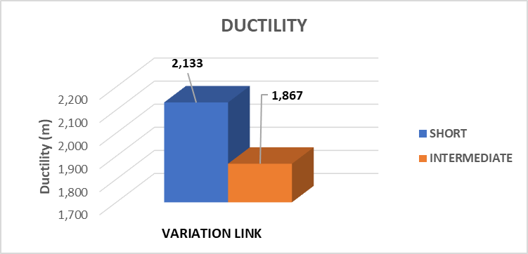

(b)
FIGURE 5. (a) Ductility and (b) Stiffness

CONCLUSION
Based on the research that has been conducted, it can be concluded that the link length configuration is able to affect the behavior of the EBF structure due to earthquake loads, where the behavior in question is, deviation, stress ratio, base shear, ductility, and structural stiffness. The structure using EBFV-S HW is able to produce a smaller structural deviation than the structure using EBFV-I HW, which is 46,500 mm and 50,791 mm. For the deviation between floors, the structure with EBFV-S HW produces a smaller value than the structure with EBFV-I HW, which is 24,020 mm and 27,068 mm by not exceeding the drift limit of 61,538 mm. The structure with EBFV-S HW produces a smaller drift ratio value than the structure with EBFV-I HW, which is 0,001163 mm and 0,001270 mm by not exceeding the drift ratio limit (Δa) of 0,0025 mm. For the structure with EBFV-S HW, the maximum stress ratio value is greater than the structure with EBFV-I HW, which is 0,708 and 0,686, both of which are located on the 3rd floor and do not exceed the stress ratio limit of 1,00. For base shear the structure with EBFV-S HW produces smaller values of 8079,728 KN and 320,00 mm while the structure with EBFV-I HW is 8926,921 KN and 428,494 mm. For ductility, the structure with EBFV-S HW produces a greater value than the structure with EBFV-I HW, which is 2,133 and 1,867. The stiffness of the structure with EBFV-S HW produces a greater value than the structure with EBFV-I HW, which is 25.249,151 KN/m and 20.833,246 KN/m.

REFERENCE

- S. Kaffah, "Analisis Perilaku Vertical Eccentrically Braced Frame Menggunakan Profil Tubular Ganda," Jurnal Aplikasi Teknik Sipil, vol. 19, no. 4, pp. 395-406, 2021.
- R. F. Manope, H. Manalip, and B. M. M. Ointu, "Analisis portal struktur baja berdasarkan konfigurasi tipe Dan variasi panjang link sistem Ebf (Eccentrically Braced Frames)," Jurnal Sipil Statik, vol. 7, no. 9, 2019.
- D. F. Muhammad and B. Suswanto, "Studi Numerik Performa Rangka Bresing Eksentrik Link Vertikal Profil Tubular," Jurnal Aplikasi Teknik Sipil, vol. 18, no. 1, pp. 95-106, 2020.
- P. A. Pangestuti and B. Suswanto, "Analisis Performa Eccentrically Braced Frames (EBF) Vertikal Link Menggunakan Wide Flange (WF) Link," Jurnal Aplikasi Teknik Sipil, vol. 19, no. 3, pp. 247-256, 2021.
- D. Khairinnisa, R. Kurniawan, and S. H. Hg, "Kinerja Seismik Berbagai Konfigurasi Bresing Eksentrik Pada Gedung Struktur Baja Tidak Beraturan," Jurnal Aplikasi Teknik Sipil, vol. 21, no. 3, pp. 213-220, 2023.
- S. N. Afrida, "PERBANDINGAN PERILAKU STRUKTUR BAJA SISTEM RANGKA BRESING EKSENTRIS TIPE TWO STORY-X DAN INVERTED-V," INFOMANPRO, vol. 12, no. 1, pp. 66-74, 2023.
- D. Christianto and R. Hendrawan, "FAKTOR DAKTILITAS STRUKTUR BETON BERTULANG DENGAN BRESING BAJA EKSENTRIS," JMTS: Jurnal Mitra Teknik Sipil, pp. 881-888, 2022.
- M. F. Mazaruddin and R. Trimurtiningrum, "Analisis Perbandingan Perilaku dan Kinerja Struktur Baja Terbreis Eksentris Tipe Split K-Bresing dan Two Story X-Bresing," Jurnal Teknik Industri Terintegrasi (JUTIN), vol. 7, no. 2, pp. 1129-1138, 2024.

