Structural Performance of the Pasuruan Regent's Office Building Upper Structure Using Composite Steel and the Load Resistance Factor Design (LRFD) Method
Zamzami Septiropa^{a)}, Fitriani^{b)}, Rizki Amalia Tri Cahyani^{c)}, and St Nur Aisyah^{d)}
Department of Civil Engineering, Universitas Muhammadiyah Malang, Malang, Indonesia

^{b)} Corresponding author: fitriynikarman@webmail.umm.ac.id
^{a)} zamseptiropa@umm.ac.id
^{c)} rizkiatcahyani@umm.ac.id
^{d)} ais82603@gmail.com
Abstract. The Pasuruan Regent's Office serves as the center of regional government, facilitating administrative operations and supporting community service and development policies. In the current construction project for the Pasuruan Regent's Office building, reinforced concrete is used as the primary structural material. However, using reinforced concrete for long-span building structures is often less effective, as it requires larger beam dimensions, which increases the dead load. This increased weight can reduce the structure's ability to resist earthquake forces effectively. Therefore, an alternative design using composite steel structures is proposed. This redesign follows the Load Resistance Factor Design (LRFD) method and incorporates a Special Moment Resisting Frame (SMRF) system.
Keywords: Composite Steel Structure, LRFD, SRPMK

INTRODUCTION
In the construction project for the Pasuruan Regent's Office building, reinforced concrete is currently used as the primary structural material. This building's longest transverse spans are 10.9 m, while the longest longitudinal spans are 7.2 m. These long spans require large section dimensions, which significantly increase the structure's dead load. In general, using reinforced concrete in long-span structures is considered less efficient, as the increased beam dimensions raise the dead load, potentially compromising the structure’s earthquake resistance [1], [2]. To address this issue, an alternative design using composite steel structures is proposed in this study.
The use of steel-concrete composites leverages the complementary properties of both materials. Concrete is effective for resisting compressive loads but is less effective under tension, whereas steel can withstand both tensile and compressive loads, though it is prone to buckling under compression. The concrete-steel composite structure minimizes member cross-sections while addressing the individual limitations of each material. It offers greater load-bearing capacity and stiffness than steel sections, along with improved resistance to fire and corrosion [3]. In addition, this hybrid approach in structural system significantly enhances its seismic resistance by utilizing concrete's stiffness and steel's ductility [4]. In this redesign, composite steel materials will be used for the upper structural elements, including the slabs and beams, while steel profiles will be used for the columns.
Composite slabs consist of corrugated steel decking topped with cast-in-place reinforced concrete. The decking serves as permanent formwork and creates a shear bond with the concrete, which contributes to the overall strength of the composite slab [5]. Composite beams are typically steel sections that act compositely with the concrete slab. Shear connectors attached to the top flange of the beam ensure that the steel beam and concrete slab function together structurally. This composite action efficiently utilizes the strengths of each material: the steel beam primarily resists tensile stresses, while the concrete slab primarily resists compressive stresses. Additionally, the concrete slab provides lateral restraint to the steel beam to prevent buckling [6].
Indonesia is located in a seismically active region, making it imperative to construct buildings that can withstand earthquakes [7]. Composite steel-concrete moment frames have proven to be a reliable option for the primary seismic-force resisting system in building structures [8]. Given the geological conditions at the study site, the redesign of the Pasuruan Regent's Office building will incorporate a Special Moment Resisting Frame (SMRF) system. The Load and Resistance Factor Design (LRFD) method is a widely adopted approach in structural engineering, particularly for steel structures. This method follows the principles of limit state design, where a structure’s performance is evaluated under specific load conditions to ensure it meets various limiting conditions [9]. This design method is adopted in this study to ensure safety and performance of the building structure.
This study focuses on redesigning the upper structure of the Pasuruan Regent’s Office building using a composite steel system, employing the Load Resistance Factor Design (LRFD) method. The primary aim is to develop a structural design that optimizes the use of composite steel components to enhance the building's performance under gravity and seismic loads. The scope of the design includes key structural elements: composite slabs, composite beams, and the connection systems between these elements.

METHODS
The Pasuruan Regent's Office building is redesigned as a four-story office structure with a composite steel framework. The building has an overall height of 19 meters, with floor heights set at 3.95 meters from the first to the second floor, 6 meters from the second to the third, 4.5 meters from the third to the fourth, and 4.45 meters from the fourth floor to the roof. The building’s footprint spans 38.25 meters in length and 42 meters in width. FIGURES 1 and 2 show the structural frame of the building in the longitudinal and transverse directions. The building materials for this project are summarized in TABLE 1. The design process followed in this study is illustrated in FIGURE 3.

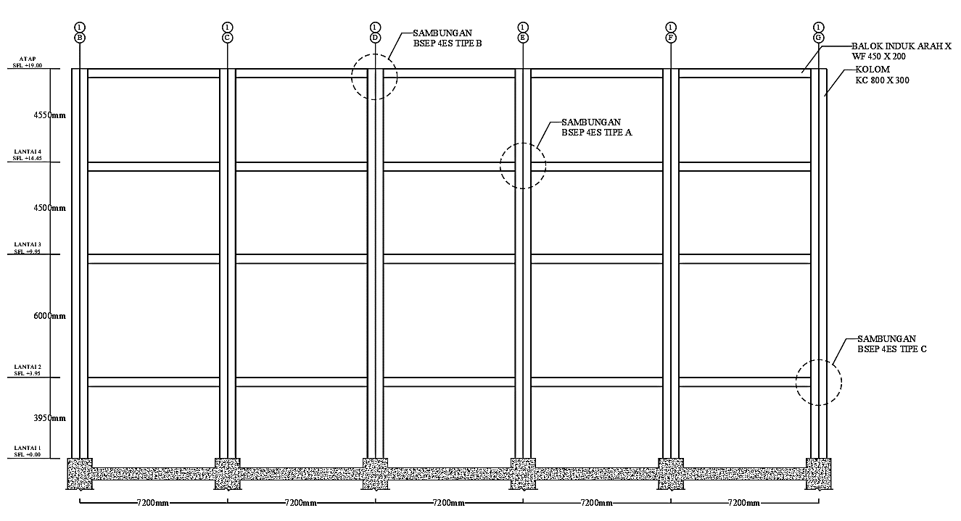
FIGURE 1. Longitudinal frame (x-axis)

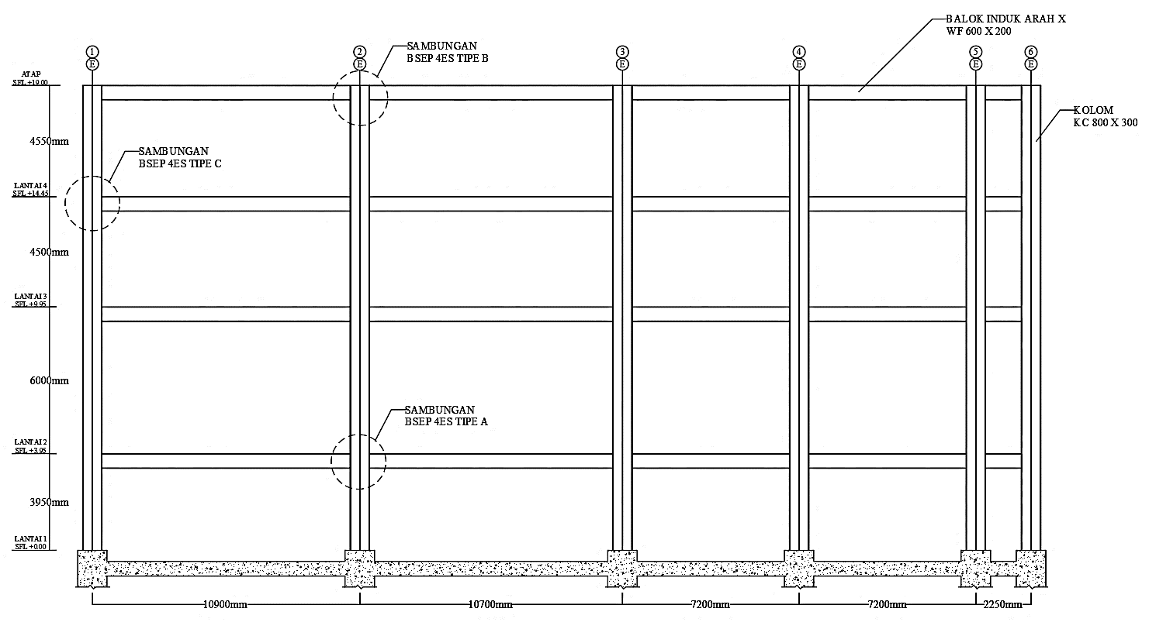
FIGURE 2. Transverse frame (y-axis)

TABLE 1. Building materials and specifications
Building Materials |  | Specification
Composite Slab | Floor deck type | Floor Deck W-1000
 | Steel yield strength, | 560 MPa
 | Concrete compressive strength | 28 MPa
WF Steel Profile | Type | WF Hot-rolled
 | Yield strength, | 250 MPa
 | Ultimate strength, | 410 MPa
King Cross Steel Profile | Yield strength, | 290 MPa
King Cross Steel Profile | Ultimate strength, | 500 MPa
Joint | Bolt grade | ASTM A325
 | Anchor bolts | ASTM F1554
 | Welding electrode | E70XX

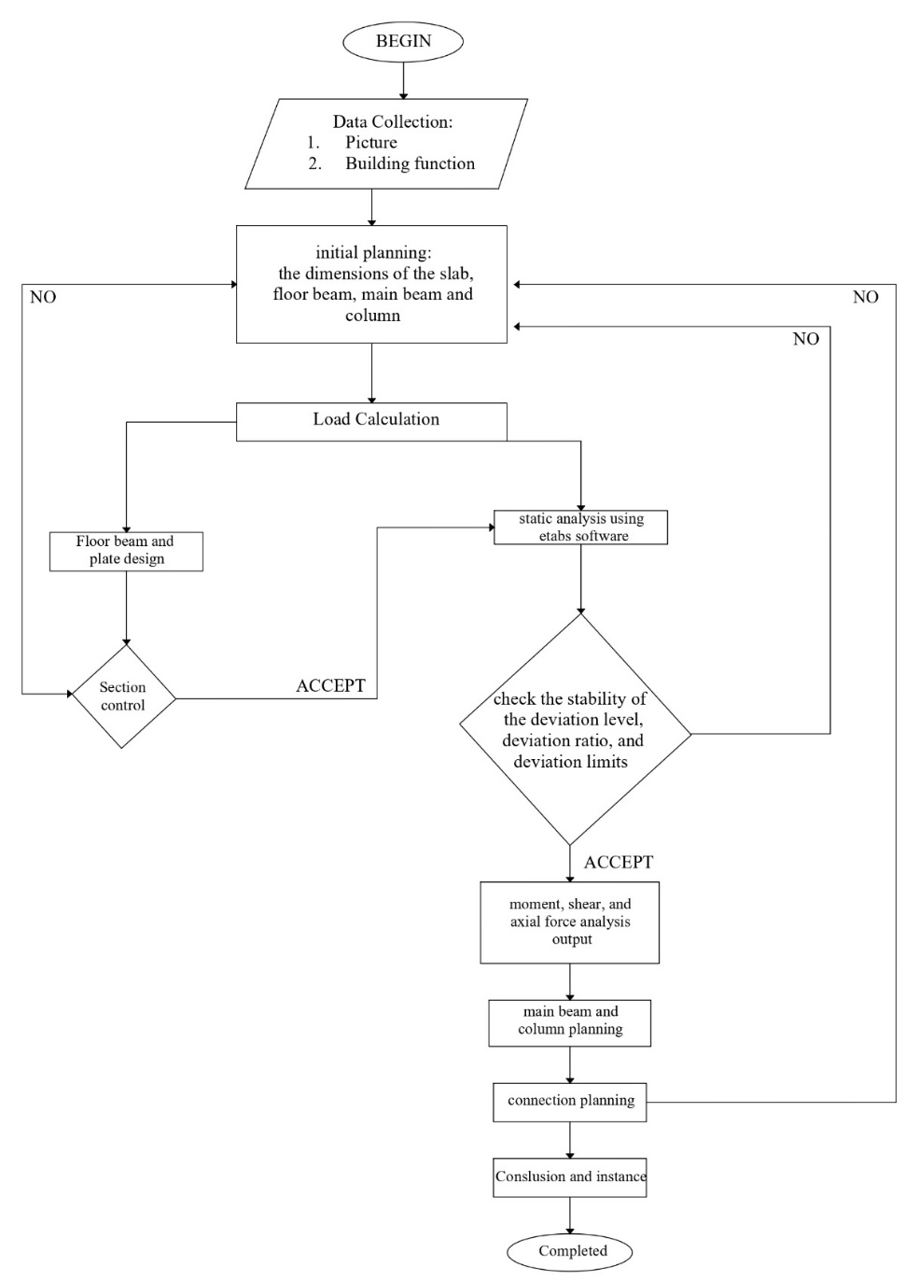
FIGURE 3. Flowchart of the building design process

RESULTS AND DISCUSSION

DESIGN OF COMPOSITE SLAB
The composite slab consists of a steel floor deck and an in-situ concrete topping. The steel deck acts as permanent formwork and provides longitudinal reinforcement once the concrete gains strength [10]. The concrete is cast in situ on profiled steel sheeting with a profile height of 50 mm, resulting in an overall slab thickness of 120 mm (FIGURE 4). Mesh M10 is incorporated within the concrete slab to control cracking at the support due to flexural tension and the concrete's shrinkage.

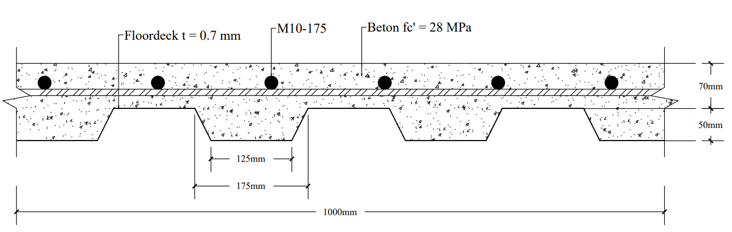
FIGURE 4. Composite slab details

DESIGN OF SECONDARY BEAM
This project includes two types of beams: secondary beams and primary beams. The secondary beam spans continuously between the primary beams, while the primary beam is rigidly connected to the columns and serves as the primary framing system of the building. The secondary beam is designed using WF 350x175x7x11 steel profiles. The design process must consider two stages: the construction stage and the normal stage. During construction, the bare steel profiles must support the self-weight of the beam section as well as the concreting operation, which includes the weight of wet concrete, personnel, and equipment. Additionally, the deflection (Δ) of the bare steel beam must be limited to no more than the effective mid-span (L) divided by 240, as excessive flexibility and deflection could lead to a significant increase in the weight and volume of concrete that needs to be supported. The steel beam is analyzed for its bending and vertical resistance under ultimate conditions, represented by Mu and Vu, respectively, in TABLE 2.
TABLE 2. Summary of the calculations for secondary beams in construction stage
Construction Stage
Description | Floor 2-4 | Roof | Unit
Mu | 35.15 | 35.48 | kN.m
Vu | 29.84 | 29.73 | kN
ɸ Mn | 189.19 | 189.19 | kN.m
Δ | 13 | 13 | mm
L/240 | 30 | 30 | mm

TABLE 3. Summary of the calculations for secondary beams in normal stage
Normal stage
Description | Floor 2-4 | Roof | Unit
Mu (+) | 98.57 | 65.78 | kNm
Mu (-) | 103.91 | 67.11 | kNm
Vu | 83.26 | 54.93 | kN
ɸ Mn (+) | 392.92 | 392.92 | kNm
ɸ Mn (-) | 249.97 | 249.97 | kNm
ɸ Vn | 330.75 | 330.75 | kN
Stud @½ Span | 24 | 24 | pieces
Δ | 6.24 | 4.18 | mm
L/240 | 30 | 30 | mm

The actions considered in the composite beam at the normal stage include permanent actions, such as the self-weight of the elements, finishes, and service loads, as well as variable actions, which consist of the occupancy loads depending on the building’s usage. As shown in TABLE 3, the beam is analyzed for deflection limits (L/240), as well as its bending and vertical resistance under ultimate conditions. Shear connectors should be spaced along the beam according to the distribution of the longitudinal shear force. Based on the analysis, 48 studs are uniformly spaced along the beam to prevent separation between the steel and concrete.

SEISMIC LOAD ANALYSIS
In this study, the seismic load of the building was determined using the Response Spectrum Analysis (RSA) method. TABLE 4 presents the seismic load parameters, which are based on the building's location in Pasuruan, East Java, Indonesia, along with other supporting data. Due to the inability to clearly identify the soil characteristics at the site, the SE site class was adopted (SNI 1726-2019 Article 6.1.3). These seismic load parameters were then used to calculate the seismic load using the RSA method.

TABLE 4. Seismic load parameters for RSA
Parameter | Value
Site Class | SE
S_{S} | 0.702
S₁ | 0.334
F_{a} | 1.376
F_{V} | 2.7
S_{MS} | 0.967
S_{M1} | 0.890
S_{DS} | 0.644
S_{D1} | 0.593
R | 8
Cd | 5.5
Ω₀ | 3

The next steps involve calculating the seismic response coefficient and the building's base shear using the static lateral force procedure. Based on the analysis, with a total building weight of 28,717 kN and an applied seismic response coefficient of 0.081, the building's static base shear is calculated to be 2,313 kN (TABLE 5). The dynamic base shear was obtained using the RSA method. According to SNI 1726-2019 Article 7.9.1.4.1, if the base shear determined by dynamic analysis is less than that obtained using the static lateral force procedure, it must be scaled to match the value determined by the equivalent static force procedure. TABLE 6 summarizes the dynamic base shear both before and after the scaling factor is applied.

TABLE 5. Static base shear
Parameter | Value
C_{S} | 0.081
C_{S, min} | 0.028
C_{S, max} | 0.097
W | 28717 kN
V | 2313 kN

TABLE 6. Dynamic base shear
 | Output case | Case Type | Base Shear (kN)
 | Output case | Case Type | x-direction | y-direction
Dynamic Base Shear | Spectrum EX | LinRespSpec | 1748.56 | 1.135
Dynamic Base Shear | Spectrum EY | LinRespSpec | 1.135 | 1814.27
Scaling of Dynamic Base Shear | Spectrum EX | LinRespSpec | 2313.11 | 1.501
Scaling of Dynamic Base Shear | Spectrum EY | LinRespSpec | 1.447 | 2313.11

ASSESSMENT OF STORY DRIFT
Drift ratios are critical in assessing the seismic performance of structures [11]. Effective management of story drift ratios is essential to ensure that buildings can withstand earthquakes without experiencing severe damage. The seismic performance of the building has been evaluated in terms of both elastic and inelastic story drifts at various heights (TABLE 7). The analysis indicates that although displacements and drifts increase with height, all values remain within the allowable drift limits prescribed by the design codes (SNI 1726-2019). This suggests that the building is expected to not undergo excessive inelastic deformation during seismic events, thereby ensuring its safety and stability.

TABLE 7. Story drift of the building
Story | Total Height | Displacement |  | Elastic Story Drift |  | Story Height | Inelastic Story Drift |  | Allowable Story Drift
 | (mm) | (mm) | (mm) | (mm) | (mm) | (mm) | (mm) | (mm) | (mm)
Roof | 19000 | 18.72 | 9.76 | 3.89 | 1.51 | 4550 | 21.39 | 8.30 | 70.00
Story-4 | 14450 | 14.83 | 8.28 | 5.17 | 2.52 | 4500 | 28.42 | 13.88 | 69.23
Story-3 | 9950 | 9.66 | 5.76 | 7.42 | 4.34 | 6000 | 40.79 | 23.84 | 92.31
Story-2 | 3950 | 2.25 | 1.43 | 2.25 | 1.43 | 3950 | 12.39 | 7.85 | 60.77
Story-1 | 0.00 | 0.00 | 0.00 | 0.00 | 0.00 | 0.00 | 0.00 | 0.00 | 0.00

DESIGN OF PRIMARY BEAM
The primary beam is rigidly connected to the columns and functions as the framing system of the building. The main beam is designed using WF 600x200x11x17 steel profiles. Like the design of secondary beam, the main beam design process considers two critical stages: the construction phase and the normal operational phase. During construction, the bare steel profiles must be capable of carrying their own weight along with the loads imposed by the concreting process, which includes the weight of fresh concrete, workers, and equipment. Furthermore, the deflection (Δ) of the bare steel beam should be restricted to a maximum of the effective mid-span (L) divided by 240. The assessment of the steel beam’s bending and shear capacities is shown in TABLE 8.

TABLE 8. Summary of the calculations for primary beams in construction stage
Construction Stage
Description | Floor 2-4 | Roof | Unit
Mu | 45.51 | 29.44 | kNm
Vu | 66.85 | 29.12 | kN
Pu | 8.39 | 20.42 | kN
ɸ Mn | 547.25 | 547.25 | kNm
Δ | 2.58 | 2.58 | mm
L/240 | 30 | 30 | mm

At the normal operational stage, the composite beam design accounts for permanent actions, including the self-weight of the elements, finishes, and service loads, along with variable actions, such as occupancy loads that depend on the building’s intended use. TABLE 9 presents an analysis of the beam's deflection limits (L/240) and its bending and shear capacity under ultimate load conditions. Shear connectors are placed along the beam in alignment with the distribution of longitudinal shear forces. Based on this analysis, 96 studs need to be evenly spaced along the beam to ensure the composite action between steel and concrete.

TABLE 9. Summary of the calculations for primary beams in normal stage
Normal Stage
Description | Floor 2-4 | Roof | Unit
Mu, midspan (+) | 57,0083 | 35,412 | kNm
Mu, support (+) | 59,7421 | 44,0416 | kNm
Mu, support (-) | 149,6079 | 79,8161 | kNm
Vu | 85,6699 | 38,5207 | kN
Pu | 12,71 | 28,8621 | kN
ɸ Mn (+) | 988,702 | 988,702 | kNm
ɸ Mn (-) |  |  | kNm
ɸ Vn | 802,125 | 802,125 | kN
Stud @½ Span | 48 | 48 | buah
Δ | 2,866 | 0,980 | mm
L/240 | 30 | 30 | mm

CONNECTION DESIGN
In this study, connections are designed for the secondary beam to primary beam (FIGURE 5), primary beam to column (FIGURES 6-8), and column to column (FIGURE 9). A bolted stiffened extended end-plate (BSEP) joint is used for the beam-to-column connections in the steel frames. Bolted end-plate joints are widely used in practice due to their ease of fabrication and erection [12].
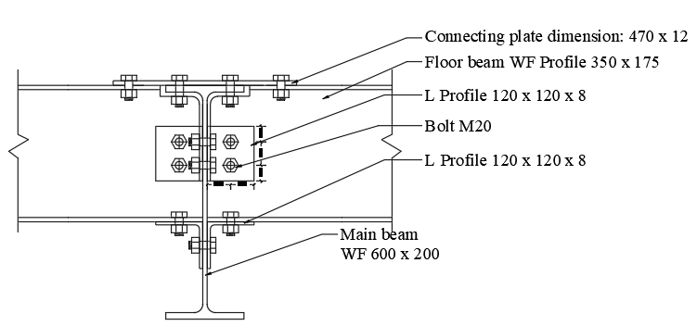
  Number of bolts | : | 2 bolts per row on the flange
  Bolt diameter | : | M20
  Edge distance (St) | : | 30 mm
  Spacing between wraps (S) | : | 60 mm
FIGURE 5. Secondary beam-primary beam connection details

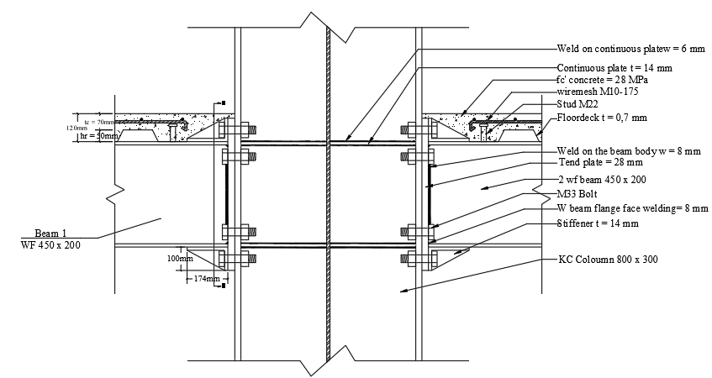
  Bolt diameter | : | M33
  End plate thickness | : | 28 mm
  Continuous plate thickness | : | 14 mm
FIGURE 6. BSEP 4ES (Type A) primary beam-column connection details

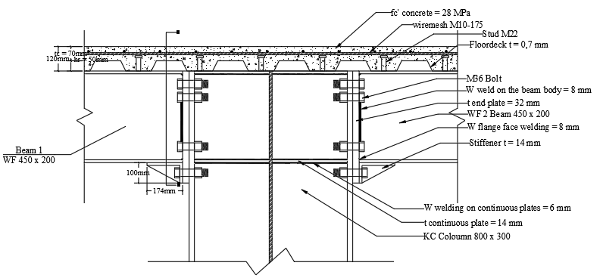 | 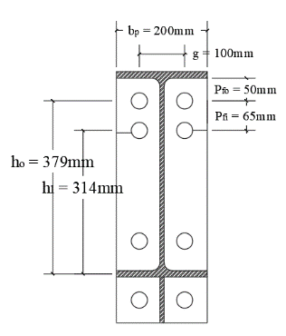
  Bolt diameter | : | M36
  End plate thickness | : | 32 mm
  Continuous plate thickness | : | 14 mm
FIGURE 7. BSEP 4ES (Type B) primary beam-column connection details

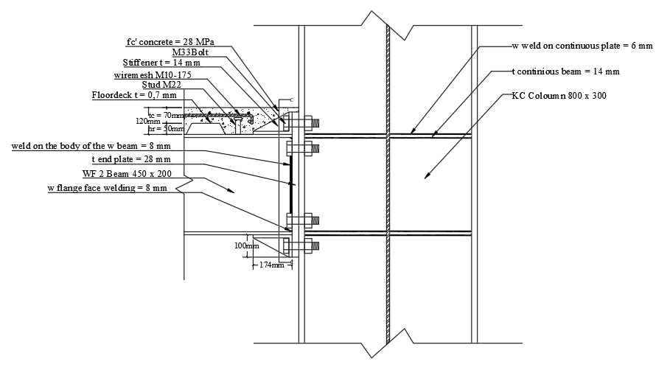 | 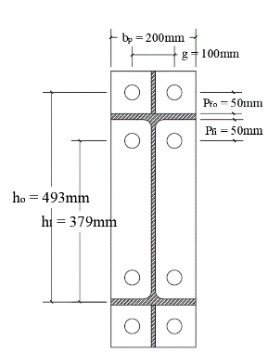
  Bolt diameter | : | M33
  End plate thickness | : | 28 mm
  Continuous plate thickness | : | 14 mm
FIGURE 8. BSEP 4ES (Type C) primary beam-column connection details

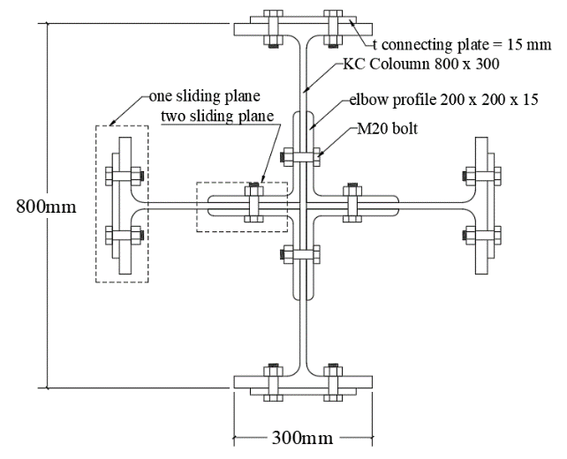 | 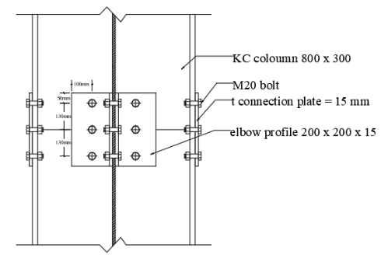
  Bolt diameter | : | M20
  Number of bolts on flange | : | 24 mm
  Number of bolts on web | : | 12 mm
FIGURE 9. Column-column connection details

CONCLUSIONS
The redesign of the Pasuruan Regent’s Office building using a composite steel system demonstrates a viable alternative to the traditional reinforced concrete structure. By applying the Load Resistance Factor Design (LRFD) method and implementing a Special Moment Resisting Frame (SMRF) system, this study achieves an optimized design that enhances the building's structural performance under both gravity and seismic loads. The composite steel design addresses the limitations of reinforced concrete in long-span applications by reducing the required beam dimensions and overall dead load, which improves the building's ability to resist earthquake forces. This redesigned approach for the upper structure, including composite slabs, beams, steel columns, and their connections, offers an alternative solution for creating a more resilient, efficient structural system for the Pasuruan Regent’s Office.

Acknowledgments
Further studies are recommended to explore variations in column design for steel structures, with careful consideration of construction management and architectural aspects to ensure the plan aligns with on-site conditions.

References
- R. Kant and M. S. Thakur, “Study on Seismic Performance of Reinforced Concrete High-Rise Building with Buckling Restrained Braces Dissipation Devices,” E3S Web Conf., vol. 505, pp. 1–15, 2024, doi: 10.1051/e3sconf/202450503001.
- M. D. Astawa, W. Kartini, and F. X. E. Lie, “Partial Prestress Concrete Beams Reinforced Concrete Column Joint Earthquake Resistant on Frame Structure Building,” J. Phys. Conf. Ser., vol. 953, no. 1, 2018, doi: 10.1088/1742-6596/953/1/012221.
- J. Liang, W. Zou, C. Wang, and W. Li, “Flexural performance of partially encased steel-concrete composite beams with web opening,” Structures, vol. 64, p. 106666, 2024, doi: https://doi.org/10.1016/j.istruc.2024.106666.
- A. Zona, F. Freddi, G. Leoni, and A. Dall’asta, “Steel and concrete hybrid structures: recent advancements and their implications for seismic design,” no. September, pp. 1–6, 2019.
- H. S. Abbas, S. A. Bakar, M. Ahmadi, and Z. Haron, “Experimental studies on corrugated steel-concrete composite slab,” Gradjevinar, vol. 67, no. 3, pp. 225–233, 2015, doi: 10.14256/JCE.1112.2014.
- N. Loqman, N. A. Safiee, N. A. Bakar, and N. A. M. Nasir, “Structural Behavior of Steel-Concrete Composite Beam using Bolted Shear Connectors: A Review,” MATEC Web Conf., vol. 203, pp. 1–12, 2018, doi: 10.1051/matecconf/201820306010.
- Kukuh Kurniawan Dwi Sungkono, E. A. Krisdianti, and G. Gunarso, “Analisis Kinerja Struktur Pada Gedung Bertingkat Dengan Analisis Pushover Berdasarkan Atc-40,” J. Tek. Sipil dan Arsit., vol. 29, no. 2, pp. 7–16, 2024, doi: 10.36728/jtsa.v29i2.3300.
- M. D. Denavit, J. F. Hajjar, T. Perea, and R. T. Leon, “Seismic performance factors for moment frames with steel‐concrete composite columns and steel beams,” Earthq. Eng. Struct. Dyn., vol. 45, no. 10, pp. 1685–1703, Aug. 2016, doi: 10.1002/eqe.2737.
- Xiao-Ling Zhao, Tim Wilkinson, and G. Hancock, Cold-Formed Tubular Members and Connections. Elsevier, 2005. doi: 10.1016/B978-0-08-044101-6.X5000-2.
- M. Eissa and M. Celikag, “Use of Slab composite with galvanized steel deck in reinforced concrete frame,” IOP Conf. Ser. Mater. Sci. Eng., vol. 800, no. 1, pp. 0–6, 2020, doi: 10.1088/1757-899X/800/1/012014.
- R. Manisana and S. S. Mayengbam, “Limitation of Inter-Storey Drift Ratio in Seismic Design of Lead Rubber Bearing Isolated R. C. Building BT - Recent Trends in Civil Engineering,” 2023, pp. 743–754.
- Y. Bu, Y. Wang, and Y. Zhao, “Study of stainless steel bolted extended end-plate joints under seismic loading,” Thin-Walled Struct., vol. 144, no. March, p. 106255, 2019, doi: 10.1016/j.tws.2019.106255.

