Generating Historical Daily River Flow Data Series Using DISPRIN-Codeq Model
Sulianto
Civil Engineering Department, University of Muhammadiyah Malang, Malang, Indonesia

Corresponding: sulianto@umm.ac.id
Abstract. This article proposes a new model from the results of combining the simulation method based on DISPRIN model and the multi-parameter optimization method based on Codeq algorithm. This smodel can be used to generate historical daily river flow data series based on input climate data sets and watershed physical characteristics. The model application uses the MATLAB MFILE code program so that the model calibration and validation processes can work automatically. Model testing uses 15-year hydroclimatology data set in the Welang watershed, namely 2016–2020. The data series from January 1, 2006 to December 31, 2010 is used as a training data set for the DISPRIN model parameter calibration process, and the data series from January 1, 2011 to December 31, 2020 as a testing data set for model validation. The test results show that the DISPRIN-Codeq model can qualitatively work very well and effectively. Input parameter value of outlet coefficient (C) = 0.001 – 0.99, outlet position of tank (h) and initial water level in tank = 100 – 800 mm can produce the best fitness. Calibration stage produces RMSE = 0.058 m³/s, NSE = 0.84 and validation stage produces RMSE = 0.035 m³/s, NSE = 0.89.
Keyword: disprin model, codeq algorithm, rainfall, discharge

INTRODUCTION
Facts in the field show that the availability of observation discharge data series is a classic problem in water resource development activities. Historical discharge data series are often available in minimal quantities obtained from observations during the study period. Quantitatively, these data will not be sufficient to determine design benchmarks in hydraulic engineering activities, so they need to be extended by transforming climate data series into discharge data series. The DISPRIN (Dee Investigation Simulation Program for Regulating Network) model was developed through a research program on the River Dee, UK [1]. The DISPRIN model is similar to the Sugawara Tank model. Both assume that the flow of water in a watershed is analogous to the flow through a series of tanks. The Sugawara Tank model consists of 4 tanks arranged in series and has 17 parameters [2]. The original DISPRIN model consists of 8 tanks and has 25 parameters [3] [4]. Like other types of lumped models, the fundamental weakness of the DISPRIN model lies in the large number of parameters whose values must be determined simultaneously before the model is applied. This condition causes the DISPRIN model to be considered inefficient for solving practical problems. The development of a revolutionary and reliable metaheuristic method in solving large and complex equation systems makes it interesting to be applied to solve multi-parameter model problems [5]. The metaheuristic method was successfully applied to solve the automatic calibration problem of the Tank model by Sugawara [6] [7] [8] [9] [10] [11] [12] [13]. The combination of the simulation method based on DISPRIN model with parameter optimization based on the Differential Evolution (DE) Algorithm has been successfully applied to solve the problem of transforming monthly rainfall-discharge data series [3] and daily periods in the Tawangrejeni watershed [4]. The results obtained are qualitatively quite good, but there are indications that they are not yet accurate in anticipating the occurrence of sharp fluctuating flows that usually occur in small watersheds in the archipelago. This article proposes a new model called the DISPRIN-Codeq model. This model is a combination of the DISPRIN model 25 parameter and the Codeq algorithm. The model is designed for daily period data analysis and its solution uses the MFILE MATLAB code program. The reliability test of the model uses observation data sets from the Welang Watershed (473.59 Km2) in Pasuruan Regency, East Java.

METHODS
The research steps are explained as follows;
1) Literature study from various related references.
2) Compiling algorithms and application program codes for the DISPRIN-Codeq model using MFILE MATLAB, and testing the consistency and logic of the model using hypothetical data sets.
3) Collecting hydroclimatology data for 15 years and watershed maps:
- Daily rainfall data for the period 1 January 2006 to 31 December 2020, from the Purwosari, Lawang and Tutur Rainfall Stations.
- Monthly average climate data, including; air temperature, air humidity, wind speed, and sunshine duration for the period January 2006 to December 2020, from the Tretes Climatology Station.
- Welang River hydrograph data at the AWLR Dhompo Station for the period 1 January 2006 to 31 December 2020.
- Welang Watershed Map.
4) Processing data, including;
- Analysis of potential evapotranspiration using the Modified Penman method, and using monthly average climate data sets as input.
- Analysis of daily average rainfall of the watershed using the Thiesen Polygon method.
- Test the homogeneity of the rainfall and discharge data series using the t-test and F-test.
5) Divide the hydroclimatology data into 2 (two) groups, namely; 1) training data set for model calibration, and 2) testing data set for model validation.
6) Running the program from the models produced in point 2), using the training data set and testing data set as input data.
7) Compiling a discussion based on the analysis results obtained from the previous steps, and drawing conclusions that are relevant to the problem.

DISPRIN MODEL SIMULATION CONCEPT
In the application of the DISPRIN model, a watershed must be divided into three hydrological zones, namely the up-land, hill-slope and bottom-slope zones. Each zone consists of two non-linear reservoirs, then interconnected with a routing procedure that presents the overland flow, interflow (quick return flow) and base flow processes [1]. The Original DISPRIN model has 25 parameters as shown in the original DISPRIN model simulation scheme in FIGURE 1. The amount of runoff coming out of a tank is proportional to the height of the water above the outlet tank (storage depth, h(t)), expressed as; q(t) = hw(t).C, with q(t) = runoff (mm/day), hw(t) = height of the water level in the tank (mm), and C = outlet coefficient (1/day).

MODEL CALIBRATION AND VALIDATION
The objective function of optimization is to find the optimum value of DISPRIN model parameters directed at minimizing the deviation of the observed discharge curve (Qobs) and the model simulation discharge (Qsim). In the heuristic method, the objective function is stated as a fitness function. The fitness function in this study is to minimize the root mean square error (RMSE) value, stated:
$F=\min\left[RMSE\right]=\min\left[\sqrt{ \frac{\sum_{t=1}^{n}{{\left(Q_{t}^{sim} - Q_{t}^{obs}\right)}^{2}}}{n} }\right]$ (1)
As a constraint function in the optimization process is:
The DISPRIN model simulation equation system, expressed as;
$Q_{t}^{sim}$ = f(P(t), Ep(t), Au, Ah, Ab, 25 DISPRIN model parameters)
Minimum and maximum initial water height limits in all tanks (S).
Minimum and maximum horizontal outlet height limits in all tanks (h).
Minimum and maximum outlet coefficient limits in all tanks (C).
Model validation using a testing data set, which is a data set that is not involved in the calibration process. Model performance evaluation using RMSE, NSE and (MAE) indicators, calculated by the equation:

$MAE=\frac{1 }{n}\sum_{i=1}^{n}{\left|Q_{t}^{obs} - Q_{t}^{sim}\right|}$ (2)
$NSE = 1 - \frac{\sum_{t=1}^{n}{{\left(Q_{t}^{sim} - Q_{t}^{obs}\right)}^{2}}}{\sum_{t=1}^{n}{{\left(Q_{t}^{obs} - Q_{t}^{mean}\right)}^{2}}}$ (3)
where,
F : fitness value,  $Q_{t}^{sim}$ : discharge model simulation period t,  $Q_{t}^{obs}$ : discharge observation period t,  n : number of data points,  P(t) : rainfall period t, | Ep(t) : Evapotranspiration period t,  RMSE : root mean square error,  MAE : mean absolute error,  NSE : Nash-Shutcliffe efficiency,

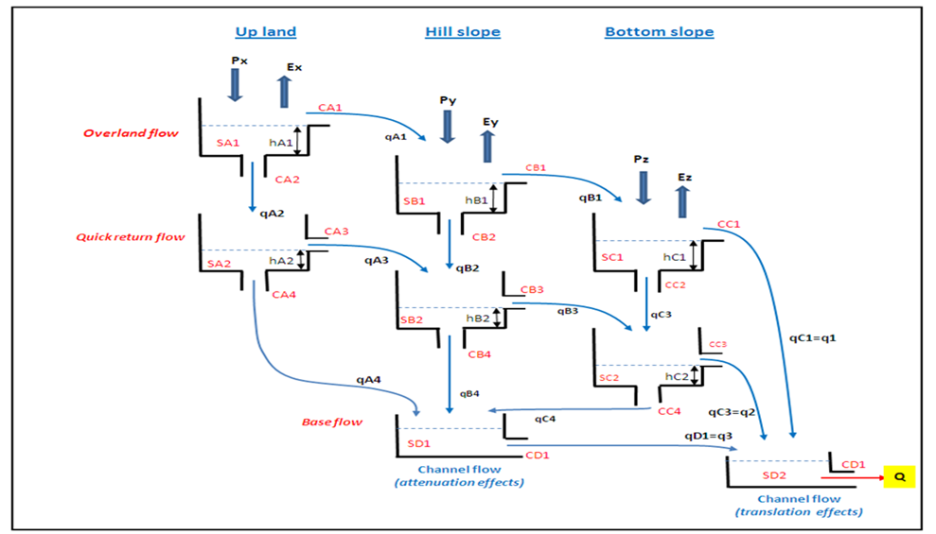
FIGURE 1. DISPRIN model simulation scheme [D.G. Jamieson & J.C. Wilkinson (1972).
CODEQ ALGORITHM CONCEPT
The Codeq algorithm was proposed by Omran & Salman (2009). This algorithm is a synthesis of chaotic search, opposition-based learning, differential evolution and quantum mechanism [14] [15] [16]. The Codeq algorithm has been successfully applied to solve the hydraulic equation system of a complex pipe network [17]. In this case, the Codeq algorithm has the same good performance as the DE, PSO and SCE algorithms. The application of the Codeq algorithm for optimizing the DISPRIN model parameters in the MFILE MATLAB program code consists of the following stages: 1) declaration of Codeq algorithm parameters, 2) Individual initialization, 3) individual replacement, 4) crossover, 5) replacement of new individuals.

DISPRIN-CODEQ MODEL ALGORITHM
The model algorithm from the results of combining the DISPRIN model simulation equation system and the parameters optimization method based on Codeq algorithm is explained in FIGURE 2. The model input data is the watershed area for the up-land, hill-slope and bottom slope zones, training and testing hydroclimatology data sets, and the relevant Codeq algorithm parameter declarations. The analysis to achieve the best fitness is carried out iteratively from generation to generation using the Codeq algorithm rules, and the iteration process will stop at the maximum number of iterations or the maximum number of generations set (Iter_max). In the best fitness condition, the optimum value of the DISPRIN model parameters will be obtained. Furthermore, the DISPRIN model simulation using the optimum parameter values that have been found and with the input of the training data set will produce model discharge and model performance indicators for the calibration stage, and using the input of the testing data set will produce model discharge and model performance indicators for the validation stage.

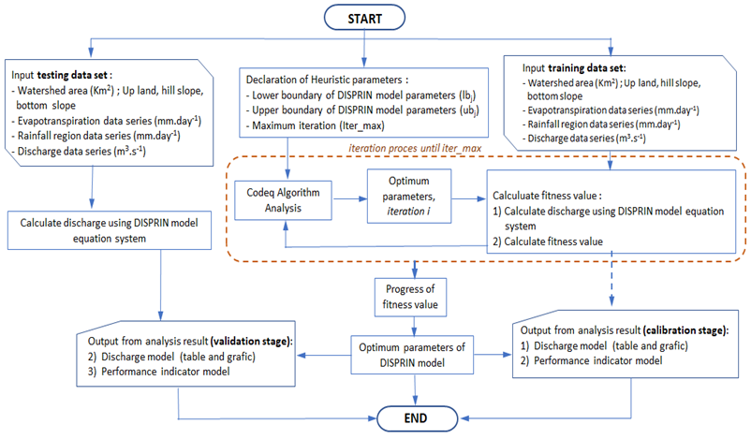
FIGURE 2. DISPRIN-Codeq model algorithm

RESEARCH DATA
The case study of the research is the Welang Watershed at the control point of the Dhompo station Automatic Water Level Record (AWLR) as shown in FIGURE 3. The Welang Watershed has an area of ​​473.39 km2 geographically located at 7°40'0" - 8°0'0" South Latitude and 112°35'0" - 112°55'0" East Longitude, and administratively located in Pasuruan Regency, East Java Province, Indonesia. The area of ​​the up-land, hill-slope and bottom-slope zones of the Welang Watershed are respectively 119.74, 156.40, 197.25 km2. Hydroclimatology data as input in the application of the DISPRIN model, namely; evapotranspiration, rainfall and discharge. The hydroclimatological data series involved spanned 15 years, recorded from January 1, 2006 to December 31, 2020. Evapotranspiration data were obtained from the results of the Penman method analysis based on data from the Tretes Climatology Station. The average evapotranspiration of the Welang watershed was 1056.25 mm/year, a minimum of 828.94 mm/year and a maximum of 1160.87 mm/year. Rainfall data involved daily period data recorded at Purwosari Station, Lawang Station and Tutur Station. Regional rainfall was calculated using the Thiessen Polygon method. The weighting factors for the three rainfall stations were 0.49; 0.32 and 0.19, respectively. The average regional rainfall of the Welang watershed was 2355 mm/year, a minimum of 1492 mm/year and a maximum of 3626 mm/year. The discharge data series in AWLR Dhompo shows an average value of 7.30 m3/s, a minimum of 0.40 m3/s occurs in the dry season and a maximum of 37.56 m3/s occurs in the rainy season. Evapotranspiration, rainfall and discharge data for daily periods are shown in FIGURE 4.
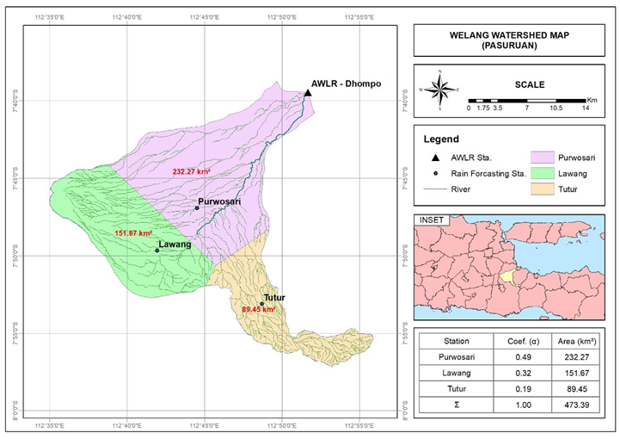
FIGURE 3. Case studi, Welang Watershed
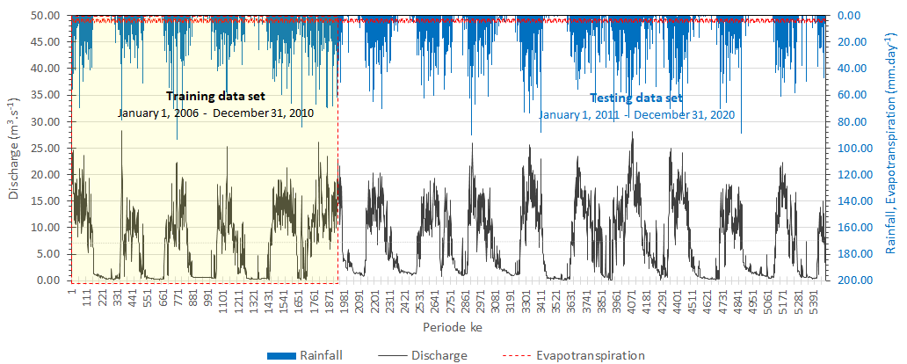
FIGURE 4. Set data hidroklimatologi Welang watershed

RESULT AND DISCUSSION
The DISPRIN-Codeq model application uses the MFILE MATLAB program code, consisting of a main program and 9 (nine) sub programs. The Codeq algorithm equation system as the main program, and 9 sub programs include; 1) fitness function, 2) calibration process, 3) validation process, 4) training rainfall data series, 5) training evapotranspiration data series, 6) training discharge data series, 7) testing rainfall data series, 8) testing evapotranspiration data series and 9) testing discharge data series. In an effort to find the global optimum value of the DISPRIN model parameters, the analysis in this study uses 6 scenarios, each with varying parameter value limit inputs. For each scenario, the lower and upper boundary parameter C (outlet coefficient) have the same value, the lower boundary = 0.001 and the upper boundary = 0.99. The lower boundary of the parameter h (height of horizontal outlet tank) and S (initial water level in the tank) is 0.0001 and the upper boundary value increases as shown in TABLE 1.

TABLE 1. Model testing scenarios
Parameter | Boundary | scenario-1 | scenario-2 | scenario-3 | scenario-4 | scenario-5 | scenario-6
hA1, hA2, SA1_0, SA2_0, hB1, hB2, SB1_0, SB2_0, hC1, hC2, SC1_0, SC2_0, SD1_0, SD2_0 | Lower | 0,001 | 0,001 | 0,001 | 0,001 | 0,001 | 0,001
 | Upper | 50,00 | 100,00 | 200,00 | 400,00 | 600,00 | 800,00
CA2, CA3, CA4, CB2, CB3, CB4, CC2, CC3, CC4, CD1, CD2 | Lower | 0,0001 | 0,0001 | 0,0001 | 0,0001 | 0,0001 | 0,0001
CA2, CA3, CA4, CB2, CB3, CB4, CC2, CC3, CC4, CD1, CD2 | Upper | 0.99 | 0.99 | 0.99 | 0.99 | 0.99 | 0.99

Running program the DISPRIN-Codeq model using 250 iterations input produces the best fitness value of scenario-1 of 0.068 and other scenarios produce the same value, which is 0.058. The progress of achieving the best fitness value from generation to generation is shown in FIGURE 5. The performance of the model at the calibration stage is shown in TABLE 2. The RMSE, MAE and NSE values ​​of scenario-1 are relatively large, scenario-2 to scenario-6 show equivalent values. However, scenario-1 still shows an NSE value > 0.7 which means it is still quite good and acceptable. At the validation stage, the performance of madel is still able to show its consistency. The analysis results of scenario-1 show increasingly worse results with NSE < 0.7, but scenarios-2, 3, 4, 5,6 show increasingly better results with NSE values ​​> 0.8.
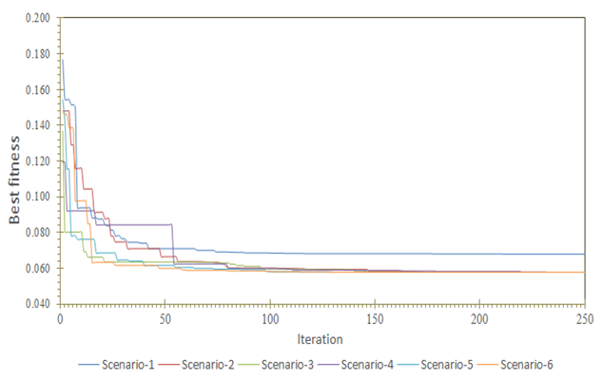
FIGURE 5. Progress in achieving the best fitness.
TABLE 2. Model performance indicators at the calibration and validation stages
Tahap | Indikator kinerja model | Simbol | Sc-1 | Sc-2 | Sc-3 | Sc-4 | Sc-5 | Sc-6
Kalibrasi | Root Mean Square Error | RMSE | 0.068 | 0.058 | 0.058 | 0.058 | 0.058 | 0.058
Kalibrasi | Mean Absolute Error | MAE | 2.045 | 1.641 | 1.634 | 1.637 | 1.621 | 1.631
Kalibrasi | Nash-Sutcliffe Efficiency | NSE | 0.785 | 0.843 | 0.844 | 0.842 | 0.844 | 0.843
Validasi | Root Mean Square Error | RMSE | 0.061 | 0.036 | 0.035 | 0.035 | 0.035 | 0.036
Validasi | Mean Absolute Error | MAE | 3.001 | 1.613 | 1.601 | 1.601 | 1.579 | 1.605
Validasi | Nash-Sutcliffe Efficiency | NSE | 0.678 | 0.888 | 0.891 | 0.890 | 0.892 | 0.889
Note : Sc = Scenario
Comparison of model discharge fluctuations at the calibration and validation stages are shown in FIGURE 6 and FIGURE 7. The results of the analysis of scenarios-2,3,4,5,6 show that the model discharge fluctuation trend can follow the observed discharge fluctuations, both at the calibration and validation stages. The results of the analysis of scenario-1 tend to overestimate at low discharge. Comparison of the discharge distribution curve at the calibration stage is shown in FIGURE 8 and the validation stage in FIGURE 9. The discharge distribution curves from scenarios-2,3,4,5,6 tend to overlap at the calibration and validation stages. This shows that the analysis of the 5 scenarios produces an equivalent level of accuracy and emphasizes that the upper limit input of the parameters h (height of horizontal outlet each tank) and S (initial water level in the tank) of more than 50 mm is a more realistic choice. This condition is inversely proportional to the results of the analysis of scenario-1, where the discharge distribution curve shows a significant deviation. At the calibration and validation stages, the model's output discharge tends to overestimate. This condition occurs at all flow conditions. The calibration stage shows a relatively small deviation and becomes wider at the validation stage. Qualitatively, the DISPRIN-Codeq model can present the relationship between rainfall data series and daily discharge in the Welang watershed very well. The errors that occur are caused by the inconsistent relationship between the climate data set and discharge. This is due to certain factors that are not accommodated in the developed equation system.
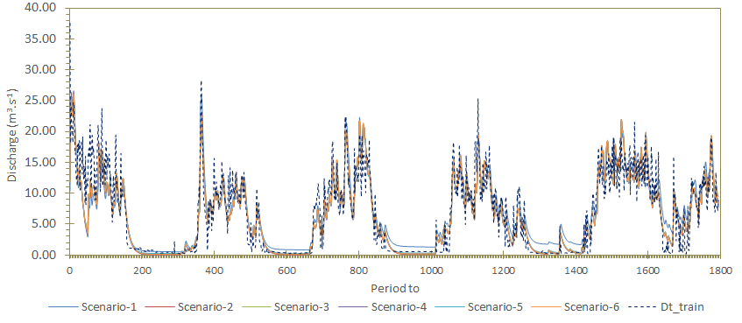
FIGURE 6. Comparison of fluctuations training discharge and model discharge at the calibration stage.
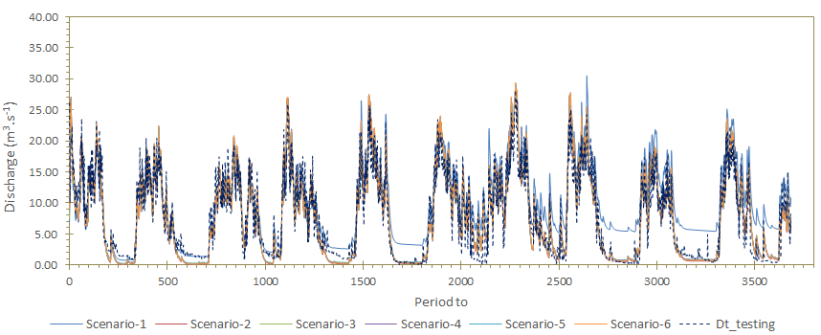
FIGURE 7. Comparison of fluctuations testing discharge and model discharge at the validation stage.
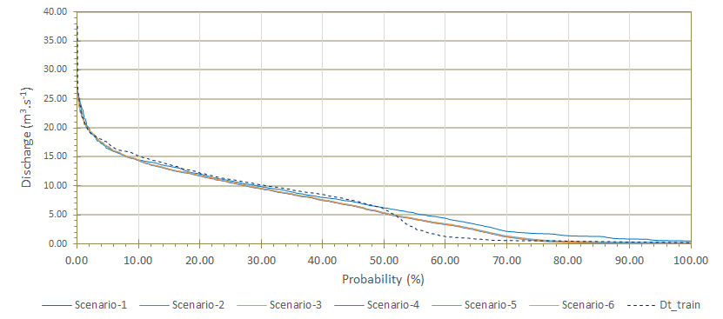
FIGURE 8 Comparison of the distribution curve of training discharge and model discharge at the calibration stage.

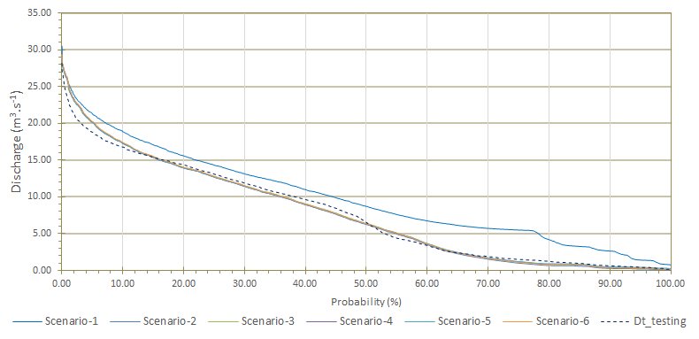
FIGURE 9 Comparison of the distribution curves of testing discharge and model discharge at the validation stage.
The optimum values of the DISPRIN model parameters from the analysis of five scenarios are shown in TABLE 3. The optimum values of all parameters generally show quite significant differences, although all show the best fitness values that are equivalent. This can occur due to the complexity of the parameters and the non-linear nature of the DISPRIN model equation system, as well as the random nature of the metaheuristic method. The feasibility region of each DISPRIN model parameter value is a superposition of the resulting values. Of course, this value only applies to the Welang watershed case study. The range of parameter values indicates the level of sensitivity of the DISPRIN model parameters to the model performance indicators. The smaller the range of parameter values obtained, the more sensitive the influence of the parameter is, and vice versa. TABLE 3 shows that the CD2 and hC2 parameters are the most sensitive compared to other parameters.
TABLE 3. Optimum parameter values ​​of the DISPRIN model
Parameter | Optimum parameter value |  |  |  |  |  | Statistic
Parameter | Sc-1 | Sc-2 | Sc-3 | Sc-4 | Sc-5 | Sc-6 | Maximum | Minimum | Average | Range
hA1 | 2.103 | 0.010 | 88.115 | 346.953 | 550.527 | 798.249 | 798.249 | 0.010 | 297.659 | 798.239
hA2 | 5.962 | 9.256 | 200.000 | 325.487 | 600.000 | 536.633 | 600.000 | 5.962 | 279.556 | 594.039
SA1_0 | 9.030 | 13.103 | 22.993 | 345.212 | 600.000 | 794.941 | 794.941 | 9.030 | 297.546 | 785.911
SA2_0 | 47.011 | 3.412 | 200.000 | 171.943 | 383.688 | 77.898 | 383.688 | 3.412 | 147.325 | 380.276
hB1 | 48.676 | 100.000 | 141.847 | 131.812 | 600.000 | 795.820 | 795.820 | 48.676 | 303.026 | 747.144
hB2 | 5.887 | 22.768 | 103.927 | 362.290 | 600.000 | 10.848 | 600.000 | 5.887 | 184.287 | 594.113
SB1_0 | 50.000 | 14.246 | 200.000 | 33.781 | 0.010 | 172.960 | 200.000 | 0.010 | 78.499 | 199.990
SB2_0 | 50.000 | 79.782 | 0.010 | 320.593 | 51.545 | 4.074 | 320.593 | 0.010 | 84.334 | 320.583
hC1 | 49.870 | 0.010 | 0.010 | 0.010 | 0.010 | 0.010 | 49.870 | 0.010 | 8.320 | 49.860
hC2 | 49.971 | 26.482 | 23.007 | 333.473 | 600.000 | 1.243 | 600.000 | 1.243 | 172.363 | 598.757
SC1_0 | 14.762 | 99.085 | 35.289 | 66.406 | 97.266 | 97.426 | 99.085 | 14.762 | 68.372 | 84.323
SC2_0 | 43.778 | 0.010 | 200.000 | 343.860 | 517.228 | 754.800 | 754.800 | 0.010 | 309.946 | 754.790
SD1_0 | 39.468 | 7.553 | 200.000 | 27.444 | 600.000 | 52.948 | 600.000 | 7.553 | 154.569 | 592.447
SD2_0 | 0.621 | 0.499 | 0.990 | 0.982 | 0.990 | 0.006 | 0.990 | 0.006 | 0.681 | 0.984
CA2 | 0.99000 | 0.78055 | 0.00010 | 0.65655 | 0.00010 | 0.00030 | 0.990 | 0.000 | 0.405 | 0.990
CA3 | 0.99000 | 0.00010 | 0.00010 | 0.64728 | 0.99000 | 0.29156 | 0.990 | 0.000 | 0.487 | 0.990
CA4 | 0.93277 | 0.00021 | 0.99000 | 0.00315 | 0.99000 | 0.97117 | 0.990 | 0.000 | 0.648 | 0.990
CB2 | 0.99000 | 0.90035 | 0.99000 | 0.67108 | 0.65985 | 0.24486 | 0.990 | 0.245 | 0.743 | 0.745
CB3 | 0.99000 | 0.00010 | 0.00010 | 0.00010 | 0.00010 | 0.00010 | 0.990 | 0.000 | 0.165 | 0.990
CB4 | 0.99000 | 0.00010 | 0.00010 | 0.00010 | 0.00010 | 0.00010 | 0.990 | 0.000 | 0.165 | 0.990
CC2 | 0.98755 | 0.72269 | 0.72443 | 0.74089 | 0.74805 | 0.72248 | 0.988 | 0.722 | 0.774 | 0.265
CC3 | 0.00010 | 0.00010 | 0.00010 | 0.82442 | 0.99000 | 0.00010 | 0.990 | 0.000 | 0.302 | 0.990
CC4 | 0.00010 | 0.01025 | 0.00357 | 0.52212 | 0.99000 | 0.53093 | 0.990 | 0.000 | 0.343 | 0.990
CD1 | 0.96906 | 0.00010 | 0.00010 | 0.00010 | 0.00010 | 0.00010 | 0.969 | 0.000 | 0.162 | 0.969
CD2 | 0.09113 | 0.08317 | 0.08083 | 0.08377 | 0.08365 | 0.08261 | 0.091 | 0.081 | 0.084 | 0.010
Note : Sc = Scenario

CONCLUSIONS
The DISPRIN-Codeq model developed in this study has been proven to work effectively in presenting the relationship between climate data series and daily discharge data series in the Welang Watershed. In the optimization process, the best fitness value can be achieved at the 250th iteration. The best fitness value of scenario-2,3,4,5,6 has an equivalent value, which is 0.058. The feasible value of parameter C between 0.001 - 0.99, parameters h and S between 100 - 800 mm can show very satisfactory results. At the calibration stage, the model's output discharge curve tends to coincide, but when compared to the training discharge data, there is a deviation in moderate flow conditions, although not too significant. At the validation stage, the high flow curve from the model output tends to be overestimated and the low flow curve tends to be underestimated, when compared to the testing discharge data. The global optimum condition of the DISPRIN model equation system is difficult to find, because of the many parameters that determine the non-linearity of the equation. Efforts to find the global optimum condition by applying discrete analysis with narrow parameter value limits can be done, but are technically inefficient. Determining the relationship between physical characteristics of watershed variables and the characteristics of the relationship between climate and discharge data to the feasibility limits of watershed parameter values is very necessary for further research, so that the application of the DISPRIN model can be applied more practically. The DISPRIN model is a high-dimensional and non-linear equation system. Each parameter has a different level of sensitivity. As an effort to find a global optimum solution, a sensitivity analysis of the DISPRIN model parameters is needed. A simple way can be done by conducting experiments several times running the program with input of varying lower and upper boundary values for each parameter.

References
1. Shaw, M., Hydrology in Practice. 1985, Van Nostrand Reinhold (UK) Co. Ltd.
2. Sulianto, S., E. Setiono, and L.E. Orfa, The Effect of Training Data Series Length on the Performance of the Tank Model for Transforming Rainfall into Runoff Data Series. Environmental Research, Engineering and Management, 2022. 78(3): p. 39-55.
3. Sulianto, S., et al., Automatic calibration and sensitivity analysis of DISPRIN model parameters: A case study on Lesti watershed in East Java, Indonesia. Journal of Water and Land Development, 2018(37): p. 141-152.
4. Sulianto, S., et al., Performance of The Dispin Models with Automatic Parameter Calibration on The Transformation of Rainfall to Runoff Data. Civil and Environmental Science Journal (CIVENSE), 2019. 2(2): p. pp.84-94.
5. Talbi, E.G., Metaheuristics: From Design to Implementation. John Wiley & Sons google schola, 2009. 2: p. 268-308.
6. Santos, C.A.G., et al., Application of a particle swarm optimization to the tank model. IAHS Publ, 2011. 347: p. 114-120.
7. Setiawan, B.I., T. Fukuda, and Y. Nakano, Developing procedures for optimization of Tank Model’s Parameters. Agricultural Engineering International: CIGR Journal, 2003.
8. Ngoc, T.A., K. Hiramatsu, and M. Harada, Optimizing Parameters for Two Conceptual Hydrological Models Using a Genetic Algorithm: A Case Study in the Dau Tieng River Watershed, Vietnam. Japan Agricultural Research Quarterly: JARQ, 2013. 47(1): p. 85-96.
9. Kuok, K.K., S. Harun, and P.-C. Chiu, Comparison of particle swarm optimization and shuffle complex evolution for auto-calibration of hourly tank model’s parameters. Int. J. Advance. Soft Comput. Appl, 2011. 3(3): p. 1-17.
10. Zhang, X., et al., Evaluation of global optimization algorithms for parameter calibration of a computationally intensive hydrologic model. Hydrological Processes: An International Journal, 2009. 23(3): p. 430-441.
11. Hsu, P.-Y. and Y.-L. Yeh, Study on Flood Para-Tank Model Parameters with Particle Swarm Optimization. J. Inf. Hiding Multim. Signal Process., 2015. 6(5): p. 911-923.
12. Kenji, T., et al., Tank model and its application to predicting groundwater table in slope. Chinese Journal of Rock Mechanics and Engineering, 2008. 27(12): p. 2501-2508.
13. Huang, X.-L. and J. Xiong, Parameter optimization of multi-tank model with modified dynamically dimensioned search algorithm. Proceedings of the Third International Symposium on Computer Science and Computational Technology, 2010. 5978: p. 283-288.
14. Omran, M.G.H. and F. al-Adwani, Using CODEQ to Train Feed-forward Neural Networks. arXiv preprint arXiv:1002.0745, 2010.
15. Omran, M.G.H. and A. Salman, Constrained optimization using CODEQ. Chaos, Solitons & Fractals, 2009. 42(2): p. 662-668.
16. Omran, M.G.H. and A.A. Salman, Improving the Performance of CODEQ using Quadratic Interpolation, in International Conference on Agents and Artificial Intelligence. 2010. p. 265-270.
17. Sulianto, Effectiveness of Several Metaheuristic Methods to Analyze Hydraulic Parameters in a Drinking Water Distribution Network. World Journal of Engineering and Technology, 2020. 8(03): p. 456-484.

