Comparative Behavior Study of Earthquake Resistant Steel Structure of 10-Storey Building Using Concentrically Braced Frames (CBF) Type V-Inverted and Moment Resisting Frames (MRF)
M Hubby Maulana^{a)}, Sunarto^{b)}, Rafli Achmadtama^{c)}, Yunan Rusdianto^{d)}, and Aulia Indira Kumalasari^{e)}
Department of Civil Engineering, University of Muhammadiyah Malang, Malang, Indonesia

^{b)} Corresponding author: narto.ahsan@gmail.com
^{a)} mhubby159@gmail.com
^{e)} auliaindira@umm.ac.id
^{c)} rafliachmaditama9293@gmail.com
^{d)} yunan@umm.ac.id
Abstract. Indonesia is a region located in a high earthquake area where almost every day there are records of frequent earthquakes according to BMKG reports. This shows that it is important to consider the attitude to review the earthquake load in the construction of buildings in Indonesia. The selection of buildings with steel structures is very appropriate to carry earthquake loads. The high ductility that is the background of steel is expected to be able to overcome the problems of earthquake-resistant buildings that exist in earthquake-prone areas such as in Indonesia. Although the price spent is not small, the building structure with steel profiles can certainly be used to minimize the force generated by the earthquake on the building structure. This study will discuss the comparison of steel building structures using inverted V braces and without braces with Pushover Analysis earthquake analysis. Based on the results of the analysis conducted, the building with the use of V Inverted I braces (model 1) is more stable when receiving lateral loads compared to the building without braces (model 2). This can be seen from the parameters obtained, namely the value of the deviation (drift) in model 1 amounting to 68.182 mm where this value is smaller than the structure without bracing model 2 which has a value of 84.548 mm. the results of the performance level analysis issued by the Pushover Analysis Method in the Y direction show the results of the same performance level, namely Collapse Prevention (CP).
Keywords: concentrically,braced_frames, CBF, earthquake, respond_spectrum_analysis

INTRODUCTION
Earthquake resistant building is one of the important solutions to reduce the risk of damage due to earthquakes. Based on SNI 03-1726-2019 there are three types of earthquake or lateral load resisting structural system configurations consisting of a moment resisting portal (Moment Resisting Frame), diagonal stiffener system (Braced Frame), and shear wall system (Shear Wall). The addition of diagonal stiffeners (Braced Frame) to steel frame structures is more widely used. Structures with this system are also commonly called Braced Frame Systems (SRB) [1]. This is certainly not an easy thing because it must pay attention to the lateral load-bearing system to plan a steel structure building. Moreover, it must consider the advantages and disadvantages. In the world of construction, it is necessary to strengthen and repair structures in buildings to anticipate damage when hit by an earthquake. The collapse of multi-storey buildings is a dangerous thing that results in injuries and even fatalities [2].
Concentrically Braced Frame (CBF) is one of the commonly used methods in earthquake resistant building design because this system involves the use of concentrically placed brace elements to increase the stiffness and durability of the structure to withstand lateral loads such as earthquakes. Concentrically Braced Frame (CBF) is also a development of Moment Resisting Frame (MRF). Where the ability of ductility and small absorption of dissipation energy results from the presence of stiffeners. CBFs are ideal for frame systems because they are strong, rigid and elastic. Steel frames are also often used in high earthquake prone areas due to the fact that the seismic response quality of CBFs is determined by the performance of the stiffeners. In order to achieve the best performance of the CBF, the stiffeners must fail first before the other components of the truss system itself. Evaluation to estimate the condition of the building structure during an earthquake is necessary to obtain assurance that its performance is satisfactory during an earthquake. One of the trends in earthquake-resistant building planning is performance-based design [3]. Braces can be used to dissipate the forces that occur in the structure due to vertical and horizontal forces[4]. Braces have many advantages to increase the lateral strength of a building and allow for more efficient use of materials, reducing the need for shear walls and weight. But in terms of advantages, braces also have some disadvantages that can affect the interior layout, reducing the aesthetic value of a building.
The purpose of using stiffening frames is to maintain stability due to lateral loads. In CBFs, the stiffener element is the weakest structural element compared to other elements such as columns, beams, and connections. Hence, the failure of the structure that occurs is expected to melt the stiffeners first. This study will investigate how the stiffness of the braces affects the building's response to earthquakes. The selection of an appropriate brace configuration also needs to be considered in order to maximize the effectiveness of the system. Therefore, in this research, the Vnterved type CBF brace configuration will be selected because there are not many previous studies that discuss braces with this model. This study will also show a comparison of structural deviation results with and without stiffening braces.

METHODS
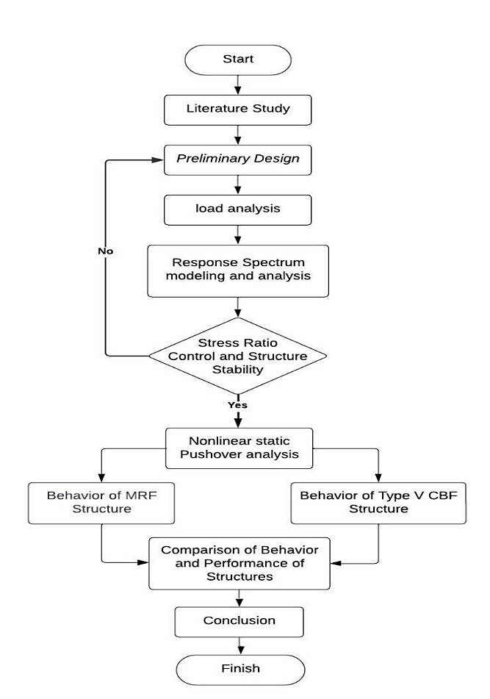
FIGURE 1. Flowchart

The method used in this research uses quantitative methods. Where in the planning of steel structure buildings following the SNI 1729-2020 regulations to find out the profiles used in accordance with the loads that occur in steel building structures and also for planning earthquake loads in accordance with SNI 1726-2019. After planning the loading and obtaining the profile size, data analysis is then carried out using numerical methods. In this study, an analysis was carried out in the form of a comparison of stiffeners with the presence of braces and without braces using ETABS software. The stages of implementation of this research can be seen in accordance with the flow chart in FIGURE 1.
The research begins with a literature study stage of the Concentrically Braced Frame (CBF) type V inverted structural system based on journals, book references and applicable regulations such as SNI 03-1726; 2019: Earthquake Resistance Planning Procedures for Buildings and Non-Buildings, SNI 03-1727; 2020: Minimum Design Loads and Related Criteria for Buildings and Other Structures, and SNI: 1727; 2020 concerning Specifications for Structural Steel Buildings, see FIGURE 2 and FIGURE 3. Furthermore, it enters the Preliminary Design stage where at this stage dimensional experiments are carried out on the structure, so as to obtain strong dimensions. The Preliminary Design data includes in TABLE 1.
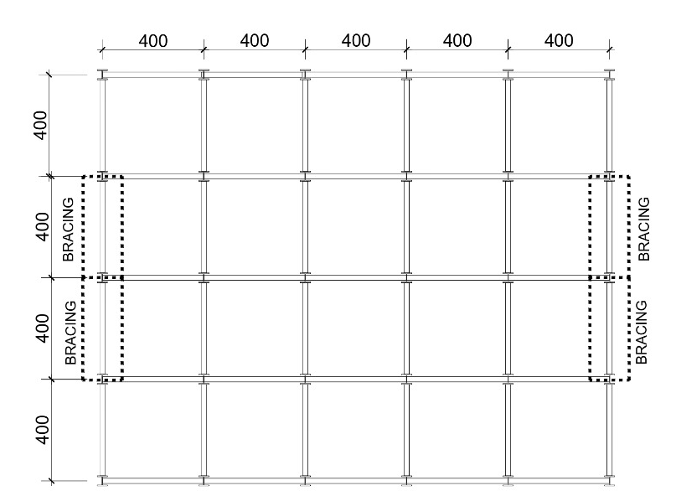
FIGURE 2. Building Plan

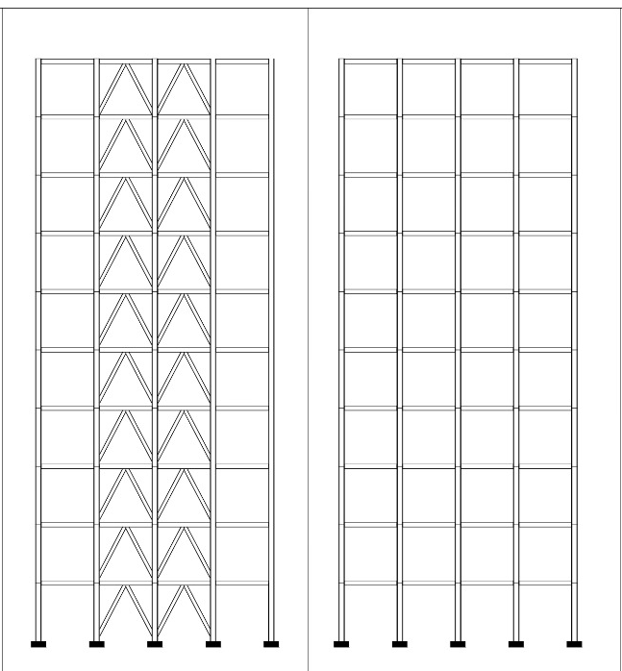
FIGURE 3. Side View of CBF and MRF

TABLE 1. Structure Profile of CBF and MRF Models
Description | Column W14x211 | Structural Beam w12x79 | Bracing w10x33 | unit
total depth (D) | 398,8 | 315 | 247,1 | mm
top range width (Bf) | 401,3 | 307,3 | 202,2 | mm
top range thicknes (tf) | 39,6 | 18,7 | 11 | mm
web thickness (tw) | 24,9 | 11,9 | 7,4 | mm

With a predetermined profile plan, a building will be built located in Surabaya, East Java show in FIGURE 4. The building with a length of 20 meters and a width of 16 meters has 10 floors with a height between floors of 4 meters and has a function for office buildings. The material to be used is steel with an inverted V-type Concentrically Braced Frame (CBF) structural system. The steel has a quality of A992fy50 (fy = 344.74Mpa, fu = 448.16). The next step is loading based on SNI 1727:2020 regarding the minimum load for planning buildings and other structures to be reviewed including live load, dead load, and earthquake load. Live load is the occupancy load, dead load is the structural load, and earthquake load is the lateral force that will occur due to the earthquake. The design response spectrum needs to use the spectra Indonesia application to obtain the following acceleration parameters:

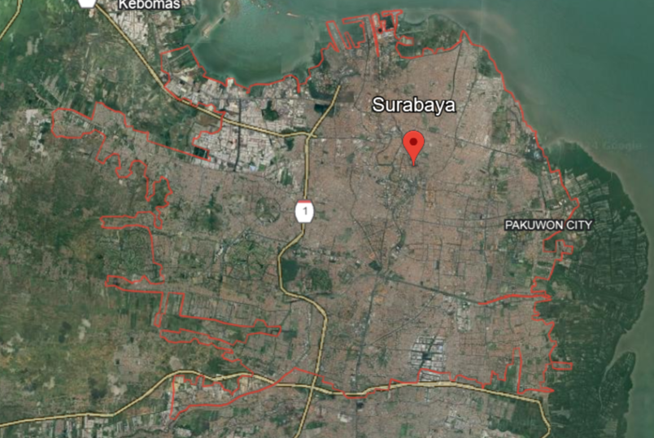
FIGURE 4. Research Location
Source: Author's analysis and Google Earth, 2024

By using the Indonesian spectra application http//puskim.pu.go.id obtained spectra acceleration parameters in the city of Surabaya. From the web data above, it can be analyzed again by obtaining the following earthquake parameters show in TABLE 2:

TABLE 2. Earthquake Parameter Analysis Results
Parameters | Value
Structure Risk Category | II
Faktor Keutamaan | I
Ss | 0,6785
S₁ | 0,3037
Site Class | SE
Fa | 1,4144
Fv | 2,7852
S_{DS} | 0,6398
S_{D1} | 0,5639
Seismic Design Category | D
Response Modification Coefficient, R | 3,25
Overpower Factor, Ω | 2
Deflection Magnification Factor, Cd | 3,25
Building Height, Hn | 40
Ct | 0,0488
x | 0,75
Cu | 1,4
Ta minimum, Ct.Hn^{x} | 1,543
Ta maksimum, Cu.Ta | 0,877
Tx Model | 1,087
Ty Model | 0,877
Source: MS.excel calculation

The next stage is analyzed to determine the stress ratio until the predetermined limit ≤ 1.00. In addition, control of structural stability, namely the drift ratio and storey drift, is also carried out to determine whether it meets the specified allowable deviation. If the stress ratio control, drift ratio, and storey drift do not meet, it will return to the Preliminary Design stage. If the spectrum response analysis has been fulfilled, then proceed to the nonlinear Pushover analysis. Spectrum response analysis was conducted to compare the performance of the CBF and MRF models. The analysis carried out to run Pushover is the analysis of gravity loads acting on the structure, the structure is loaded with a gravity load multiplied by a certain load factor, and the structure is loaded with a lateral load that is increased by a certain scale factor gradually. In the last stage, a comparison of the results of stability, performance behavior and energy dissipation is carried out.

RESULTS AND DISCUSSION

STRUCTURE DEVIATION
Structural deviations that occur due to lateral loads, namely earthquakes. To reduce the occurrence of earthquakes in steel buildings, braces are needed, where braces in steel building structures have a function to absorb earthquake energy.

FIGURE 5. Structure Deflection Graph

FIGURE 5 shows the deviation of the portal reviewed from the earthquake retaining system shows the building with the CBF model has a smaller deviation of 68.182 mm compared to the MRF model with a value of 84.548 mm.

DRIFT RATIO
After obtaining the results of structural deviation from the MRF and CBF models. Then the drift ratio control is carried out, in the form of deviation at the peak divided by the total height of the building. The drift ratio contained in the MRF and CBF must not exceed the drift ratio limit. That is 0.0025 (104) or H/400.

FIGURE 6. Drift ratio comparison results

After reviewing the drift ratio of the comparison of earthquake retaining systems, the results of the drift ratio are obtained, namely there is a maximum value for the CBF portal of 17.05 mm in contrast to the MRF which has a greater value of 21.14 mm show in FIGURE 6.

DRIFT STOREY
Storey drift or inter-storey deviation is the ratio of the deviation that occurs between floors to the height that occurs between levels. The value of the deviation between floors is multiplied by Cd and divided by I. The value of Cd in accordance with SNI 1726: 2020 article 7.2.2 is 3.25 for the coscentric brace frame system. The storey drift should not be more than the allowable inter-storey deviation. At all levels with earthquake risk category II, the calculated deviation should not exceed 0.020 times the floor height or 80 mm in accordance with SNI 1726: 2020 article 7.12.3.

FIGURE 7. Comparison of CBF and MRF storey drifts

From FIGURE 7 shows that the storey drift is reviewed from different uses of earthquake retaining systems. The storey drift has a maximum value for CBF of 26.45 mm and a structural period of 0.877 seconds, in contrast to the MRF portal which has a value of 67.19 mm and a time period of 0.794 seconds.

STRESS RATIO
Stress ratio is the ratio between the ultimate load and the cross-sectional capacity of the structural element. Stress ratio explains the effectiveness of the cross section in resisting loads that work either due to moments, axial loads or a combination of both show in FIGURE 8. All models were created in 3D and analyzed based on AISC 360-16 stress ratio criteria.
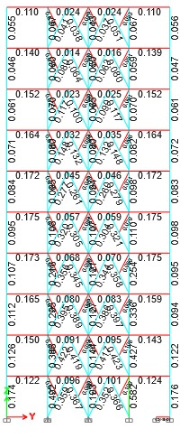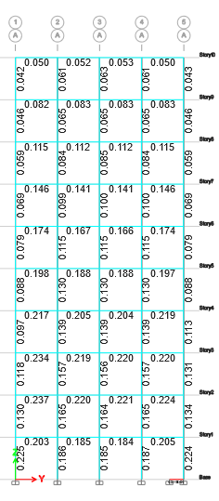
FIGURE 8. Comparison of CBF and MRF stress ratios
The following is a comparison TABLE 3 of the maximum Stress Ratio results below

TABLE 3. Maximum Stress Ratio Result
Model Structure | Maksimum Stress Ratio | Area
CBF | 0,175 | Lantai 2
MRF | 0,237 | Lantai 1
Source: Etabs Calculation Results

Based on the stress ratio value in this study, it is obtained to meet the results of the structural model design must meet the structural strength requirements, namely with a value of ≤ 1.00. FIGURE 6 shows the stress ratio of CBF of 0.175 ≤ 1.00. While the stress ratio on the CBF¬-ordinary is 1.248 ≥1. While the MRF model has a stress ratio of 0.237 ≤ 1.00.

BASE SHEAR
In the static nonlinear pushover analysis using ETABS, pushover curves are obtained that show the relationship between deviation and base shear for each portal model.

- CBF

- MRF
FIGURE 9. Comparison of CBF and MRF Pushover Curves

It can be seen from FIGURE 7 the comparison of pushover curves in terms of differences in each model. In this case of the three models that have been made there is a condition where the first yield. First yield is the condition where the first plastic joint is formed. In FIGURE 9 CBF formed base shear and deviation at first yield of 62,143.818 kN and 24.417mm. (b) MRF model formed base shear and deviation at first yield of 24,583.417 kN and 553.995 mm.

STRUCTURAL DUCTILITY
The amount of review of the ductility value obtained in each model received due to the earthquake load through a comparison that can be made to each model. And from the pushover curve can be known structural ductility of each model. Ductility is the comparison of the first melting point and the ultimate point that occurs on the pushover curve. The ductility of the CBF structure is measured by the amount of deviation generated after the formation of the first plastic joint which generally occurs in the bracing element. Furthermore, the larger the deviation, the more ductile the structure will be.

FIGURE 10. Comparison of Ductility Values
From the results of the comparison of the ductility values above, the result is 2.212 for CBF - Child Truss which is the largest result compared to ordinary CBF with a value of 1.294 and MRF with a value of 1.005. Where these results have the best ductility (strength) compared to ordinary CBF and MRF show in FIGURE 10.

STIFFNESS OF THE STRUCTURE
Not only ductility, but stiffness can also be determined from the pushover curve. Structural stiffness is obtained based on the ratio between shear force and displacement at the time of the first yield of the building structure show in TABLE 4.

TABLE 4. Structure Stiffness Comparison
Model | Kekakuan
Model | x10^4
CBF | 254.510
MRF | 2580.838
Source: MS.excel calculation

STRUCTURE PERFORMANCE LEVEL
The structural performance level is an assessment or measure of how well a building structure can withstand loads, prevent damage and even collapse, and provide protection to occupants during certain conditions, such as strong winds, heavy loads and of course earthquakes. The structural performance level show in TABLE 5.

TABLE 5. Structure performance level comparison results
Model | Dt | H | Drift Ratio | Description
Model | mm | mm | Drift Ratio | Description
CBF | 68,182 | 40000 | 0,00170455 | IO
MRF | 84,548 | 40000 | 0,0021137 | IO

Based on TABLE 5 Drift Ratio Limits According to ATC 40 described above, the results of the structural performance level fall into the Immediately Occupany (IO) category because the results of the maximum total deviation of the Drift Ratio of the CBF and MRF building models <0.01. Where this category is included in a condition that is still safe for operational activities immediately after the earthquake occurred. There is minor damage, but the repairs do not interfere with building users. Therefore, buildings at this level can also almost immediately be used after an earthquake.

CONCLUSIONS
From the analysis results in ETABS software, several parameters are obtained, namely the structure with CBF braces has a deviation value of 26.45 mm and a structural period of 0.877 seconds, in contrast to MRF which has a value of 67.19 mm and a time period of 0.794 seconds. These values indicate that structures without braces tend to be unstable when receiving lateral loads. Meanwhile, the results of the Y-direction performance level analysis in the modeling above have the same performance level, namely the Immeduate Occupancy (IO) level so that if the building structure receives an earthquake load, no significant damage occurs and the building can still be used.

References
1. Richo Okdian Darma Putra, R., Perbandingan Kinerja Struktur Gedung Baja 8 Lantai Tanpa Bresing Dan Dengan Bresing Menggunakan METODE PUSHOVER ANALYSIS. 2022.
2. Adila, R., E. Widayanto, and K.A. Wiswamitra, Perbandingan Nilai Simpangan Horizontal yang Menggunakan Bresing Tipe Diagonal dengan Inverted V dalam Menahan Gaya Lateral pada Studi Kasus Hotel Loji Kridanggo Boyolali. Rekayasa Sipil, 2023. 17(3): p. 249-253.
3. Wibawa, I.M.S., I.K.D.K. Tubuh, and P.P.L.A. Prawira, Analisis Kinerja Struktur Gedung Dengan Analisis Pushover Pada Proyek Gedung Rektorat Universitas Mahasaraswati Denpasar. Jurnal Ilmiah Kurva Teknik, 2021. 10(2): p. 53-61.
4. Sibagariang, I.S. and S.D. Tarigan, Analisis Struktur Portal Baja Dengan Sistem Rangka Bresing Konsentrik Khusus (SRBKK) Dengan Menggunakan Peta Gempa 2017. Jurnal Rekayasa Konstruksi Mekanika Sipil (JRKMS), 2022. 5(2): p. 69-81.

