Assessing the Impact of Trusses on V Inverted Braced Frames Compared to Moment Resisting Frames in Steel Buildings
Rafli Achmaditama^{a)}, M Hubby Maulana^{b)}, Yunan Rusdianto^{c)}, Aulia Indira Kumalasari^{d)}, and Sandi Wahyudiono^{e)}
Department of Civil Engineering, Universitas Muhammadiyah Malang, Malang, Indonesia

^{e)} Corresponding author: sandi@umm.ac.id
^{a)} rafliachmaditama9293@gmail.com
^{b)} mhubby159@gmail.com
^{c)} yunan@umm.ac.id
^{d)} auliaindira@umm.ac.id
Abstract. In Indonesia, the challenge faced in building high-rise buildings is the risk due to earthquakes. The method used to analyze the earthquake load in this study is spectrum response analysis. Spectrum response analysis is a dynamic analysis method used to design earthquake-resistant structural buildings. The research aims to determine the behavior of the structure by comparing CBF Frame (CBF-Special) and MRF by knowing how much the maximum deviation resisted by the structure, the deviation between floors and the stress ratio of the building structure. The building structure is made of steel, 10 floors, the height of each floor is 4 meters, and the distance between spans is 4 meters. The analysis standard refers to the earthquake resistance planning procedures for buildings SNI 1726: 2019, ATC 40 and FEMA 356. The structural analysis used in this study used ETABS software. This study resulted in a maximum base shear force of 10209.851 kN with a maximum displacement of 0.003329 m for CBF Frame (CBF-Special), and MRF which is 24583.417 kN, with a maximum displacement of 0.024417m.
Keywords: CBF, MRF, Steel structure, Respon spectrum analysis, ETABS

INTRODUCTION
In Indonesia, the challenge faced in building high-rise buildings is the threat of natural disaster risk in the form of earthquakes. This often happens because Indonesia is located at the confluence of four active plates of the world, namely the Indo-Australian, Eurasian, Philippine and Pacific plates. This creates a risk of earthquakes that cannot be prevented. To reduce the risk during an earthquake, it is necessary to plan structures with materials that are resistant to earthquakes [1]. The materials often used to construct a building are concrete and steel. Steel structures are known for their high strength and ductility. Because of this ductility, steel has the ability to prevent collapse under tensile stress [2].
In building structures, the taller the building, the more susceptible it is to lateral forces generated by earthquakes. To overcome the damage to the building, an earthquake resisting system is needed, including Moment Resisting Frames (MRF) and Concentric Braced Frames (CBF). One way to increase the vertical stiffness of a building structure is with braces that are used to resist forces. The addition of braces minimizes the magnitude of lateral deviation [3]. In buildings with inverted V-type Concentrically Braced Frames have better shear values [4]. In this case the selection of Concentrically Braced Frames (CBF) bracing is a good solution. The addition of bracing to the building structure to increase the strength and stiffness of the structure so that it can effectively reduce drift and resist deformation in a building [5].
In previous research that has been done, it explains that buildings designed using braces in buildings make a significant contribution in reducing the deviation between floors [6]. This is because the brace is the main means of energy dissipated lateral force resistance. Therefore, the selection of a specific concentric brace configuration type must be done by not only considering the technical aspects, but also the aesthetic and architectural aspects of the building [7]. Therefore, further research is needed on the variation of building height and the location of brace placement in order to know the comparison of building behavior [8].
From previous research, there is still no journal that discusses Concentrically Braced Frames type-V inverted building with the addition of truss (CBF-Special). This research discusses the comparison of the behavior of the inverted Concentrically Braced Frames type-V structure with the addition of a child truss (CBF-Special) with a Moment resisting frame (MRF) structure. To find out the behavior of the building, it is necessary to analyze to find out how much the maximum deviation is held by the structure, ductility, stress ratio, multi-storey building structure due to earthquake loads.

METHODS
The method used in this research uses quantitative methods. This research discusses the comparison between two structural systems Concentrically Brace Framed type-V Inverted with the addition of frame (CBF-Special) and Moment resisting frame (MRF).
In the first stage of collecting literature studies such as book references, journals and regulations related to the topics discussed. The regulations used in the SNI 7850-2020 concerning seismic provisions for structural steel buildings, SNI 1726-2020 concerning earthquake resistance planning procedures for building and non-building structures. SNI 1727-2020 concerning Minimum Loads for the Design of Buildings and Other Structures. SNI 1729-2020 concerning specifications for structural steel buildings.
In the next stage, do a preliminary design. The location of this research building is in Surabaya, East Java, Indonesia. The building has a function as an office with a length of 20 m, a width of 16 m and a height between floors of 4 m with a total of 10 floors. The building structure uses structural materials in the form of steel using WF steel profiles derived from ETABS. The quality of steel used in this study uses Quality A992fy50 (fy = 344.74Mpa, fu = 448.16). After obtaining the profile data and the quality of steel used, the next analysis is carried out by inputting data using ETABS software by modeling the building structure in the form of three dimensions (3D).
Furthermore, loading is carried out in accordance with SNI-1727: 2020 regulations regarding earthquake load planning in accordance with the planning location area. The loads used in building structures such as live loads, namely occupancy loads, dead loads, namely structural loads, and earthquake loads, namely lateral forces that occur due to earthquakes. In earthquake loads using analysis using spectrum response analysis with Peak Ground Accel (PGA) = 0.3152 g, Short Period Spectral Response Parameter (Ss) = 0.6785 g, 1 Second Period Spectral Response Parameter (S1) = 0.3037 g, Site Class = SE (Soft Soil). The following is the design response spectrum graph in FIGURE 1 and information about structure properties show in TABLE 1.

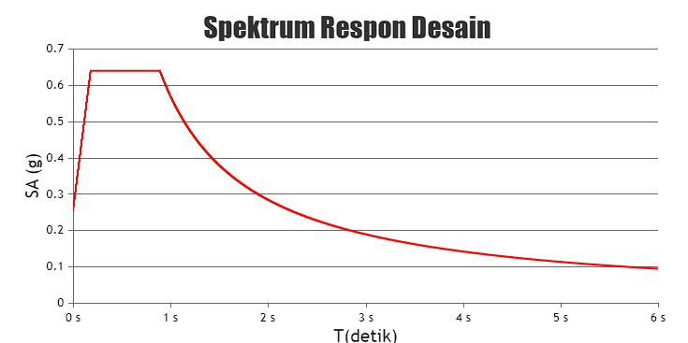
FIGURE 1. Response Spectrum Design for Surabaya Region
Source: rsa.ciptakarya.pu.go.id
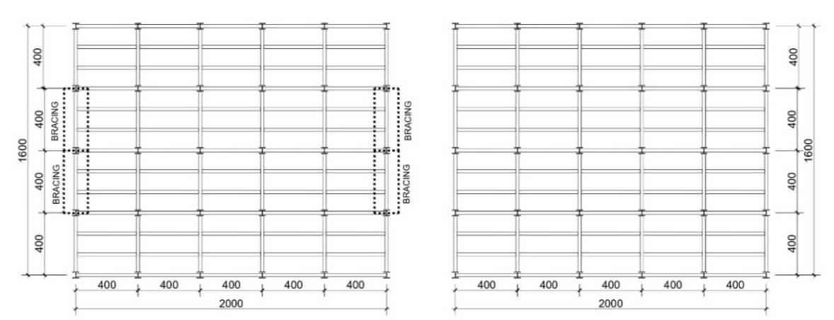
- CBF-Special (b) MRF
FIGURE 2. Floorplan (a) CF-Special (b) MRF

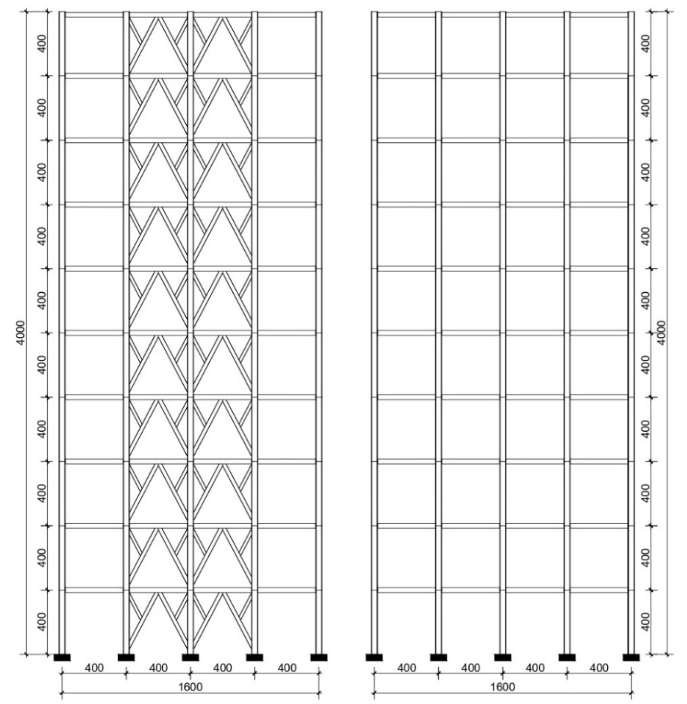
- CBF-Special (b) MRF
FIGURE 3. (a) Font of structure CBF-Special (b) Font of structure MRF

TABEL 1. Structure Properties
No | Information | Part of CBF-Spesial | Part of MRF
1 | Column | W 14 X 211 | W 14 X 211
2 | Main Beam | W 12 X 79 | W 12 X 79
3 | Child beam | W 8 X 35 | W 8 X 35
4 | Bracing | W 10 X 33 | -
5 | Child Truss | W 8 X 31 | -
Source: Structure Properties From ETABS

RESULTS AND DISCUSSION

STRUCTURE DRIFT
The deviation of the structure occurs due to the lateral load acting on the structure, which in modeling, the lateral load in question is the earthquake load. FIGURE 4 shows the results of the portal deviation from the earthquake resisting system which shows that the CBF-Special type building has a smaller deviation of 43.557 mm compared to the MRF type building of 84.548mm.

FIGURE 4. Structure Drift

DRIFT RATIO
In addition to the deviation, the drift ratio of the structure is also used as a parameter in designing a structure. The drift ratio itself is obtained by dividing the deviation that occurs at the top of the structure by the height of the building where the resulting ratio value cannot be more than H/400 or 0.0025.
FIGURE 5 shows the results of the drift ratio analysis of various earthquake resisting systems, indicating that the CBF - Special portal has a maximum value of 10.89 mm, while the MRF is 21.14 mm.

FIGURE 5. Drift Ratio

DRIFT STOREY
Storey drift, or inter-storey deviation, is the ratio of the deviation that occurs between floors to the height of the level. This value is multiplied by Cd and divided by I. According to SNI 1726:2020 article 7.2.2, Cd for CBF - Special is 5, and for MRF is 5.5. Storey drift should not exceed the permissible inter-storey deviation. For all levels with earthquake risk category II, this deviation should not exceed 0.020 times the floor height or 80 mm according to SNI 1726:2020 article 7.12.3. FIGURE 6 shows that the results of the storey drift analysis on the CBF-Special structure have smaller results than the MRF structure.

FIGURE 6. Drift Storey

STRESS RATIO
Stress ratio is the ratio between the ultimate load and the cross-sectional capacity of a structure, which indicates the effectiveness of the cross-section in resisting the applied loads, including moment forces, axial forces, or a combination of both. The stress ratio value should not exceed 1.00 show in TABLE 2. Proper calculation of the stress ratio is very important in structural design to ensure the safety and efficiency of the building, as well as to provide design recommendations that can improve the structure's resistance to lateral loads. FIGURE 7 shows the results of the stress ratio on the CBF-Special structure of 0.582 ≤1.00 which occurs on the 2nd floor, while the MRF structure shows the results of the stress ratio of 0.237≤1.00.

TABLE 2. Stress Ratio
Type of Structure | Maximum Stress Ratio | Element | Control ≤ 1,00
CBF-Special | 0,583 | Beam at the 1st floor | Ok
MRF | 0,237 | Beam at the 2nd floor | Ok

BASE SHEAR
Base shear is the base shear force that occurs at the base of a building due to lateral loads, such as earthquakes. This force is very important in the design of building structures because it plays a role in resisting and distributing lateral loads so as not to cause collapse. FIGURE 8 shows a comparison of the pushover curves based on variations of each model. Both models show the moment at which the first yield creates the first plastic joint. In FIGURE 7(a), the CBF-Special model experienced a base shear of 10,209.851 kN and a deviation of 3.329 mm at first yield. While in FIGURE 8(b), the MRF model experienced a base shear of 24,583.417 kN and a deviation of 553.995 mm at first yield.
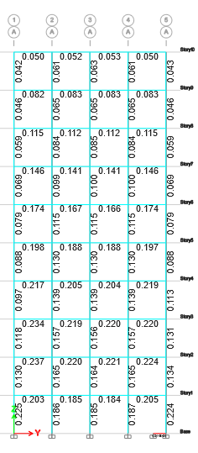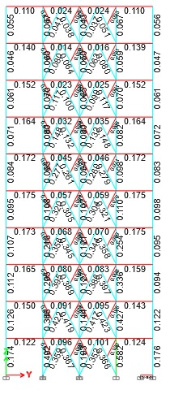
- CBF-Special (b) MRF
FIGURE 7. Stress Ratio (a) CBF-Special, (b) MRF

- CBF-Special | (b) MRF
FIGURE 8. Base Shear (a) CBF-Special, (b) MRF

CONCLUSIONS
The results based on the conducted research show that bracing is effective in resisting significant earthquake loads, covering various behavioral aspects such as deviation response, stress ratio, base shear, ductility, and stiffness of the structure. Structures applying CBF exhibit smaller deformation and stiffness compared to MRF structures. In terms of ductility, the CBF-Special structure has a higher value compared to the MRF structure. As for the stress ratio, both structures meet the requirements by not exceeding the value of 1.00 for both CBF-Special and MRF.

References
1. Tirta, S.D.Y. and R. Sugesty, PERANCANGAN ULANG STRUKTUR TAHAN GEMPA GEDUNG FASILITAS PENDIDIKAN 10 LANTAI DENGAN STRUKTUR UTAMA PORTAL BAJA. 2024.
2. Arifi, E. and D. Setyowulan, Perencanaan Struktur Baja: Berdasarkan SNI 1729: 2020. 2020: Universitas Brawijaya Press.
3. Nelwan, I.T., S.E. Wallah, and S.O. Dapas, Respon Dinamis Bangunan Bertingkat Banyak dengan Soft First Story dan Penggunaan Braced Frames Element terhadap Beban Gempa. Jurnal Sipil Statik, 2018. 6(3).
4. Santoso, A.N. and Sumaidi, COMPARISON OF MRF AND CBF STRUCTURAL RESPONSE TO EARTQUAKE IN OFFICE BUILDING SURABAYA. Jurnal Teknik Sipil, 2022. 18(1): p. 152-165.
5. Candra, Y., Analisa Nilai Simpangan Horizontal (Drift) Pada Struktur Tahan Gempa Menggunakan Sistem Rangka Bresing Eksentrik Type Braced V. Teras Jurnal: Jurnal Teknik Sipil, 2017. 7(2): p. 301-312.
6. Sibagariang, I.S. and S.D. Tarigan, Analisis Struktur Portal Baja Dengan Sistem Rangka Bresing Konsentrik Khusus (SRBKK) Dengan Menggunakan Peta Gempa 2017. Jurnal Rekayasa Konstruksi Mekanika Sipil (JRKMS), 2022. 5(2): p. 69-81.
7. Mira, W. and F. Rina, Penggunaan Struktur Bressing pada Perencanaan Bangunan Penahan Beban Gempa. Jurnal Teknik Sipil Bandar Lampung, 2021. 12(2): p. 1290-1306.
8. Maulidin, D.J., ANALISIS PENGARUH PENGGUNAAN BRESING TIPE X 1-STORY DAN TIPE X 2-STORY TERHADAP STABILITAS STRUKTUR PADA BANGUNAN BAJA BERTINGKAT BANYAK (ANALYSIS OF BRACING X 1-STORY AND 2-STORY TYPE EFFECT ON STABILITY OF MULTI-LEVEL STEEL BUILDINGS). 2018.
9. Pu, P., Desain Spektra Indonesia. 2021, Diambil dari://puskim. go. id/Apkasi/desain_spektra_gempa_indonesia_2021.

