Use Of Green Mussel Shells Waste as a Fine Aggregate on Marshall Test Value in Mixtures Class B Latasir
Alik Ansyori Alamsyah^{a)}, Ernawan Setyono^{b)}, and Salma Amara Labiba^{c)}
Department of Civil Engineering, University of Muhammadiyah Malang, Malang, Indonesia

^{a)} Corresponding author: alik.syah@yahoo.com
^{b)} ernawan_s@umm.ac.id
^{c)} salmaalabiba@gmail.com
Abstract. Utilizing green mussel shell waste as a fine aggregate in asphalt mixtures is an appropriate and strategic step. The use of green mussel shell waste is intended to obtain a mixture that has good stability and strength so that the material can be used as an alternative substitute for fine aggregate. From the results of the Marshall test analysis, it is known that fine aggregate with green mussel shells provides Marshall strength characteristics that are still above the specifications required by the Indonesian National Standard (2008). The Marshall characteristic value of the Latasir class B mixture which uses natural sand and green mussel shells as fine aggregate at an asphalt content of 8.48% has a Marshall stability value of 1737.69 kg, Marshall quotient 3.60 kN/mm, film thickness 8.03 υm , and void water volume 5.80%.
Keywords: Latasir B, Fine Aggregate, Green Mussel Shells

Introduction

Background
Green mussel shells contain higher levels of calcium carbonate (CaCO₃) compared to limestone, egg shells, ceramics or other materials. This can be seen from the level of hardness of the shells. The harder the shell, the higher the calcium carbonate content. The production of green mussel waste per hectare per year itself can reach ± ​​200 – 300 tons of whole shellfish or around 60 – 100 tons of shellfish meat.
According to Sukirman (2003: 111), Latasir (Thin Layer Sand Asphalt) is a type of asphalt concrete for roads with light traffic. Specifications for thin layer asphalt sand (latasir), which refer to The Aspalt Institute, Specification Series-1 (SS-1). The type of latasir mixture consists of two classes, namely latasir class A or SS-A (Sand sheat-A) with a nominal aggregate or sand grain size of 9.5 mm (3/8 inch), and latasir class B or SS-B (Sand sheet-B) with a nominal aggregate or sand grain size of 2.36 mm (No.8). Latasir class B has a minimum nominal thickness of 2 cm. The materials that make up the Latasir class B mixture are coarse aggregate (crushed stone), fine aggregate (natural sand and stone ash), filler and asphalt. Fine aggregate is aggregate with a grain size finer than sieve No. 4 (= 4.75 mm).
The initial examination of the green mussel shell was sand equivalent of 93.34%. The apparent specific gravity is 2.73 and 100% passes sieve no. 3/8. 99.6% passed filter No. 4. 95.40% passed filter No. 8. 27.40% passed filter No. 30. 2.07% passed filter No. 200. Thus, green mussel shells qualify as fine aggregate in the Latasir class B mixture.
Considering this, it is deemed necessary to study the use of green mussel shell waste as a substitute for fine aggregate in class B Latasir mixtures.

Problem Formulation
- Is there an effect of using green mussel shell waste as a substitute for fine aggregate in Latasir class B mixtures on Marshall characteristics?
- Which mixture with green mussel shell waste as a substitute for Latasir class B fine aggregate has the best quality based on Marshall characteristics?

Problem Limitations
- Does not discuss chemical analysis of green mussel shell waste.
- Not reviewing from an economic perspective the use of green mussel shell waste in Latasir class B asphalt mixtures.
- Does not take into account research cost analysis.

Study Objectives
- Find out what effect the use of green mussel shell waste as a substitute for fine aggregate in Class B Latasir type mixtures has on Marshall characteristics.
- Find out the proportion of the mixture with green mussel shell waste as a substitute for fine aggregate, which Latasir class B has the best quality based on Marshall characteristics.

Research Methods
According to Sukirman (2003: 10), latasir is asphalt concrete for roads with light traffic, especially where coarse aggregate is not or is difficult to obtain. This layer specifically has low rutting resistance. Therefore, it is not permitted to be used in heavy traffic areas or uphill areas. Latasir is also commonly referred to as SS (Sand Sheet) or HRSS (Hot Rolled Sand Sheet). According to the aggregate gradation, latasir mixtures can be divided into:
- Latasir class A, known as HRSS-A or SS-A. The minimum nominal thickness of HRSS-A is 1.5 cm.
- Latasir class B, known as HRSS-B or SS-B. The minimum nominal thickness of HRSS-B is 2 cm.
HRSS-B aggregate gradation is coarser than HRSS-A.
According to SNI 03-1737-1989, the specification for the coarse aggregate fraction for class B latasir design is that retained by sieve #8 (2.36 mm). Meanwhile, according to SNI 03-6819-2002, fine aggregate from the source material must consist of sand or the results of sieving crushed stone, and consist of #8 (2.36 mm) sieve material.

Latasir Class B Construction Materials
The Directorate General of Highways (1996: 27) explains that the Latasir class B mixture consists of coarse, fine aggregate, filler and asphalt. Aggregates consisting of several fractions must be mixed in appropriate proportions to obtain the required mixed gradation (Department of Settlements and Regional Infrastructure, 2001; Department of Public Works, 1987). The gradation of the aggregate combination with filler materials must be such that it meets the requirements.

Methods for Planning and Determining Nominal Mixture
According to Sukirman (2003: 123), a series of tests in the laboratory are needed to obtain a mixture with characteristics that meet the requirements as specified in the specifications. The mixed planning methods commonly used in Indonesia are (Muhamad, 2005; Agassi, 2010):
- Bina Marga Method
This method is sourced from BS594 and was developed for needs in Indonesia by CQCMU (Central Quality Control & Monitoring Unit) of Bina Marga (TABLE 1).
To get the batch proportion, it is solved using mathematical - algebraic equations (eg matrix method). CA + FA + FF + B = 100% with B = total asphalt content.

TABLE 1. Limits of the fractional composition of the planned mixture
Component Percent of total weight of the mixture
Mixture Latasir B
Coarse aggregate fraction (CA) > sieve #8 5 – 23
Fine aggregate fraction (FA) sieve #8- #200 53.6-72.6
Filler fraction (FF) < #200 sieve 8-13

Source: Directorate General of Bina Marga (1996)

Study Stages
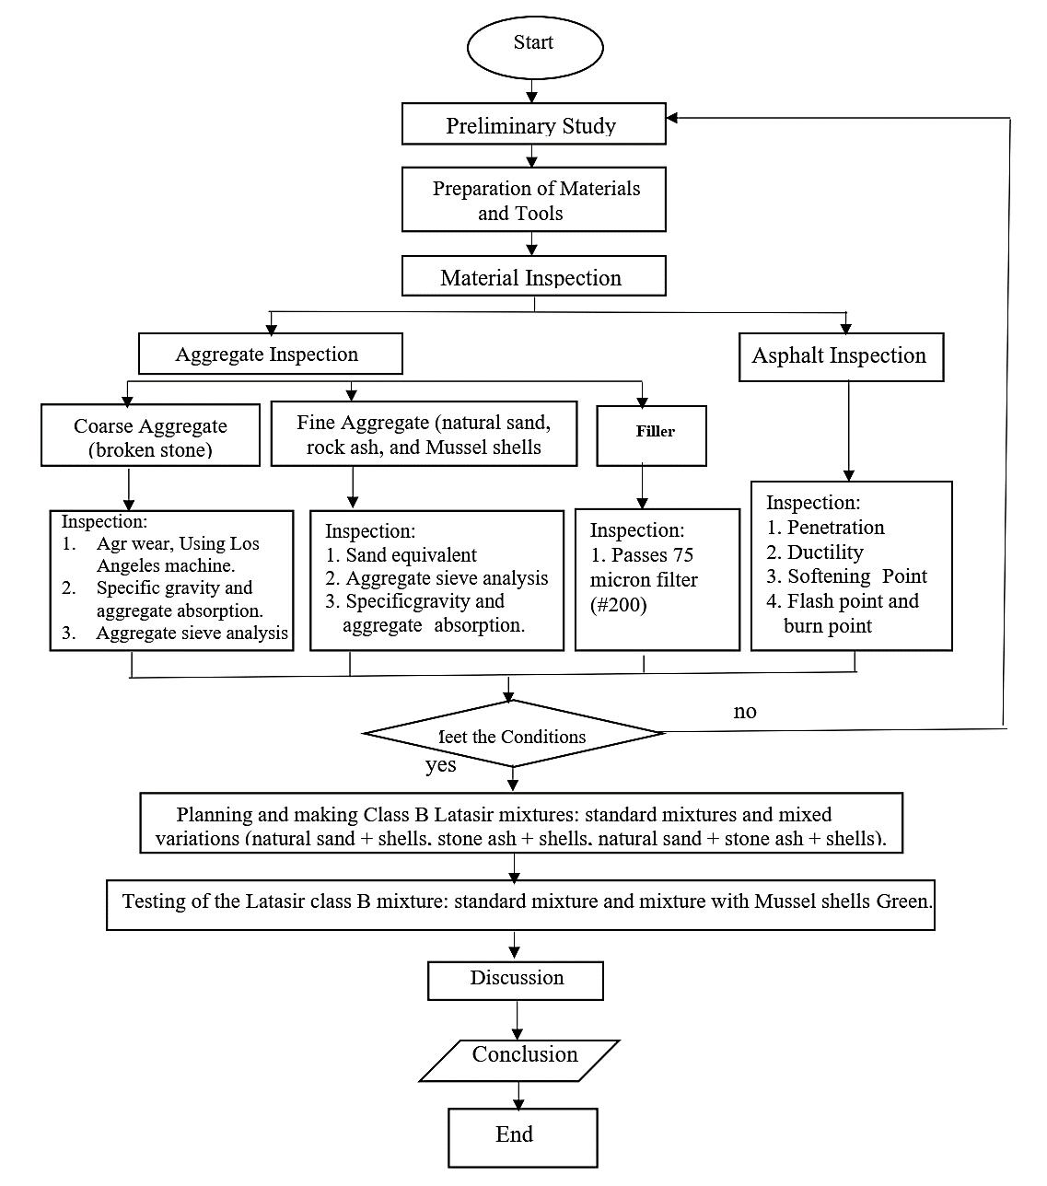
FIGURE 1. Flowchart of Study Stages

FIGURE 1. shows the flowchart of study stages for this research.

Results and Discussion

Material Inspection Results
1. Coarse Aggregate, Coarse Aggregate inspection results as in TABLE 2.
TABLE 2. Results of checking the coarse aggregate of the graded layer mixture
Type of Inspection | Results | Terms Max/Min
Coarse aggregate wear  Bulk specific gravity (on oven dry basis)  Bulk specific gravity (on surface dry basis)  Apparent specific gravity  Water absorption  Sieve analysis :  Graduation pass no. ½  Gradation pass no.⅜  Graduation pass number 8  Graduation pass number 200 | 12,18 %  2,63 gr/ cm3  2,67 gr/ cm3  2,74 gr/ cm3  1,65 %  95,74 %  61,04 %  5,76 %  0,72 % | Max 40 %  Min 2,5 gr/ cm3  Min 2,5 gr/ cm3  Min 2,5 gr/ cm3  Max 3 %  95 – 100 %  50 – 100 %  0 – 50 %  0 – 5 %
Source: Inspection Results

2. Fine Aggregate. The results of fine aggregate inspection for Latasir B standard, variation 1 (natural sand: shells: stone ash), are as in TABLE 3.
TABLE 3. Results of inspection of Latasir B fine aggregate
Type of Inspection | Natural Sand | Stone Ash | Mussel Shell | Conditions
- Sand Equivalent (SE) Value  - Bulk specific gravity (On  an oven dry basis )  - Bulk specific gravity (on  surface dry basis)  - Apparent specific gravity  - Water absorption  Sieves Analysis :  # 4 Gradation passes  # 8 Gradation passes  # 30 Gradation passes  # 200 Gradation passes | 78.26,74%  2,66 gr/ cm3  2,72 gr/ cm3  2,84 gr/ cm3  2,36 %  98,70 %  94,07 %  59,20 %  5,67 % | 85,71 %  2,73 gr/ cm3  2,75 gr/ cm3  2,81 gr/ cm3  1.101 %  99,63 %  95,37 %  64,30 %  4,83 % | 93,34 %  2,54 gr/ cm3  2,60 gr/ cm3  2,71 gr/ cm3  2,36 %  99,60 %  94,76 %  26,30 %  1,87 % | Min 50 %  Min 2,5 gr/ cm3  Min 2,5 gr/ cm3  Min 2,5 gr/ cm3  Max 3 %  72 % - 100 %  72 % - 100 %  25 % - 100 %  0 % - 8 %
Source: Inspection Results

3. Fillers. The filler uses Portland Cement (PC) with the Semen Gresik Brand which passes filter no. 200 is 100% (>75%)
4. Asphalt. The asphalt used as a binder is 60/80 penetration asphalt from Pertamina.

Nominal Mixture
In this study, 2 (two) Latasir B mixtures were made, namely standard fine aggregate mixture (natural sand: stone ash), variation 1 fine aggregate mixture (natural sand: shellfish: stone ash).
- Nominal Mixture of Latasir B Standard Fine Aggregate.
The nominal mixture for Latasir B standard fine aggregate (natural sand: stone ash) is planned referring to the fractional composition limits of the planned mixture. Based on the nominal mixed asphalt content obtained from the planning of 8.90% which is the minimum requirement, the nominal mixture is designed based on variations in the nominal asphalt content of 8.90% with additions and subtractions of 0.5%, 1.0% and 1.5%. The proportion of coarse aggregate (15.38%) and filler (9.41%) remains, while the proportion of natural sand (33.15%) and stone ash (33.15%) needs to be adjusted so that the total value remains 100%, based on the analysis graph. fine aggregate sieve (TABLE 4).
TABLE 4. Adjustment of nominal mixture proportions of standard Latasir B
Material | Adjusted Nominal Mix
 | 1 | 2 | 3 | 4 | 5 | 6 | 7
Coarse Aggregate  Natural Sand  Stone Ash  Filling Material  Asphalt (A)  Total | 15,38  33.90  33,90  9,41  7,40  100 | 15,38  33,65  33,65  9,41  7,90  100 | 15,38  33,40  33,40  9,41  8,40  100 | 15,38  33,15  33,15  9,41  8,90  100 | 15,38  32,90  32,90  9,41  9,40  100 | 15,38  32,65  32,65  9,41  9,90  100 | 15,38  32,40  32,40  9,41  10,40  100
Source: Calculation Results

- Nominal Mixture of Latasir B Fine Aggregate Variation 1.
The nominal mixture for Latasir B fine aggregate variation 1 (natural sand: clam shells: stone ash) is planned referring to the fractional composition limits of the planned mixture. Based on the nominal mixed asphalt content obtained from planning of 8.90% which is the minimum requirement, the nominal mixture is designed based on variations in nominal asphalt content of 8.90% with additions and subtractions of 0.5%, 1.0% and 1.5%. The proportion of coarse aggregate (15.68%) and filler (10.69%) remains, while the proportion of natural sand (30.42%), green shells (32.10%) and stone ash (2.20%) needs to be adjusted so that the total value remains 100%, based on the fine aggregate sieve analysis graph (TABLE 5).
TABLE 5. Adjustment of the nominal mixture proportions of Latasir B fine aggregate variations1 ( Natural Sand: Mussel Shell: Stone Ash )
Material | Adjusted Nominal Mix
 | 1 | 2 | 3 | 4 | 5 | 6 | 7
Coarse Aggregate  Natural Sand  Mussel Shell  Stone Ash  Filling Material  Asphalt (A)  Total | 15,68  30.92  32,60  2,70  10,69  7,40  100 | 15,68  30,75  32,44  2,53  10,69  7,90  100 | 15,68  30,59  32,27  2,37  10,69  8,40  100 | 15,68  30,42  32,10  2,20  10,69  8,90  100 | 15,68  30,25  31,94  2,03  10,69  9,40  100 | 15,68  30,09  31,77  1,87  10,69  9,90  100 | 15,68  29,92  31,60  1,70  10,69  10,40  100
Source: Calculation Results

Properties of High Durability Asphalt Mixtures
Based on the results of examining the properties of the aggregate, examining the asphalt, combined aggregate gradation and aggregate surface area, the total surface of the standard latasir B surface, fine aggregate latasir B variation 1 (natural sand: shells), results of examining the properties of the High Durability Asphalt mixture using the method Marshall is presented in table 6. A summary of the properties of the High Durability Asphalt mixture, as in TABLE 6.
TABLE 6. Marshall characteristics of latasir B mixture using the Marshall Method
 |  | Asphalt Content
Mixture | Marshall Characteristics | 7,40% | 7,90% | 8,40% | 8,90% | 9,40% | 9,90% | 10,40%
Latasir B Mixture :  Standard fine aggregate  Latasir B Mixture :  Fine aggregate variation 1 | Marshal Stability ( kg )  Marshal Quotient ( kn/mn )  Film Thicknes (mm )  Volume air void ( % )  Marshal Stability ( kg )  Marshal Quotient ( kn/mn )  Film Thicknes (mm )  Volume air void ( % ) | 615,25  2,10  6,20  6,42  1738,2  5,00  6,81  6,20 | 686,79  2,16  6,61  4,80  1812,1  4,48  7,26  5,02 | 861,40  2,91  7,02  4,25  1560,9  2,90  7,72  3,06 | 1011,40  3,35  7,43  4,16  1576,6  2,68  8,18  3,12 | 822,02  2,14  7,84  3,72  1227,1  2,03  8,64  1,69 | 647,15  1,31  8,26  3,29  1044,0  1,51  9,10  1,36 | 585,25  1,11  8,68  2,71  940,70  1,18  9,57  1,49
Source: Calculation Results

Discussion

Marshall Stability
Based on the marshall stability value (SN.13.6000.03.06, 2012), the standard mixture at an asphalt content of 7.40% to 8.90% experienced an increase from 615.25 kg to 1011.06 kg and then experienced a decrease in the marshall stability value at an asphalt content of 9. 40% to 10.40% from 822.02 kg to 585.25 kg, while the asphalt content is 8.38% to 9.30% exceeding the Marshall Stability specifications for the Latasir B mixture. And for the Marshall stability value of the Latasir B mixture for fine aggregate variation 1 at an asphalt content of 7.40% to 7.90%, the marshall stability value for the latasir B fine aggregate mixture, variation 1, increased from 1738.25 kg to 1812.26 kg and then decreased to 1560.94 kg at an asphalt content of 8. 40% then experienced an increase again to 1576.62 kg at an asphalt content of 8.90% then decreased again from 1227.11 kg to 940.70 kg at an asphalt content of 9.40% to 10.40%.

Marshall Quotient
Based on the marshall quotient value of the standard mixture at asphalt content of 7.40% to 8.90%, it increased from 2.10 kN/mm to 3.35 kN/mm and then decreased from 2.14 kN/mm to 1.11 kN/mm. mm at an asphalt content of 9.40% to 10.40%. And for the marshall quotient value of the latasir B fine aggregate mixture variation 1 at an asphalt content of 7.40% to 10.40%, it decreased from 5.00 kN/mm to 1, 18 kN/mm, while the asphalt content is 7.40% to 8.05%, exceeding the Marshall Quotient specifications for the Latasir B mixture.

Void Water Volume
Based on the value of the volume of void water in the standard mixture at an asphalt content of 7.40% to 10.40%, it decreased from 6.42% to 2.71%, while at an asphalt content of 9.03% to 10.40% it did not meet the volume specifications. void water in the latasir B mixture. And for the value of the volume of void water in the fine aggregate latasir B mixture variation 1 at asphalt content 7.40% to 8.40% decreased from 6.20% to 3.06% then increased to 3 .12% at an asphalt content of 8.90% then drops back to 1.69% to 1.36% at an asphalt content of 9.40% and 9.90%.

Conclusion
a) The use of green mussel shells as fine aggregate in the Latasir B mixture has an influence on the Marshall characteristic value. With Marshall characteristic values ​​as follows:
• Latasir B standard: Marshall Stability 783.63 kg, Marshall Quotient 2.48 kN/mm, Film Thickness 6.92 υm, Air Void Volume 5.27%.
• Latasir B fine aggregate variation 1: Marshall Stability 1673.71 kg, Marshall Quotient 3.75 kN/mm, Film Thickness 7.37 υm, Air Void Volume 4.30%.
b) The latasir B mixture which utilizes/uses green mussel shells as the best quality fine aggregate, is a mixture of latasir B fine aggregate variation 1 with fine aggregate natural sand and green mussel shells, with a proportion of coarse aggregate 17.16%, natural sand 33.45% , green mussel shells 37.68%, and fillers 11.77%.

Reference
- Ansyori, Alik. Relationship between variations in compaction and marshall stability values ​​in hot mixed welding, Malang : DPPM-UMM. 2010.
- Ansyori, Alik. Correlation between temperature in Recycled Mixed Concrete Asphalt and Marshall Stability, Malang : DPPM-UMM. 2013
- Department of Settlements and Regional Infrastructure. New Specifications for Hot Mix Asphalt Concrete. 2001
- Department of Public Works. Guidelines for Planning the Thickness of Highway Flexible Pavement Using the Component Analysis Method. Jakarta : PU Publishing Agency Foundation. 1987
- Directorate General of Highways. Instructions for Inspecting Asphalt Mixing Equipment. Jakarta.1996.
- Sukirman, Silvia. Hot Mix Asphalt Concrete, Bandung : Nova Publisher, 2003
- Sukirman, Silvia. Highway Flexible Pavement, Bandung : Nova Publisher, 2013.
- Bahri, Syamsul; Ali, Muhammad. Sea Shells as a Partial Substitute for Fine Aggregate inAsphaltMixtures,[Online].Available:http://elib.pdii.lipi.go.id/katalog/index.php/searchkatalog/byId/47468.html; 2005
- Rohadi, M.B., Firdaus, F., Agassi, T.N. Functionalization of Green Mussel Shells. Bogor Agricultural Institute, [https://banuajiwijayanto.wordpress.com.html], 2010.
- SN.13.6000.03.06. Calibration Figures for Compression Test Equipment - Marshal Test No. Series 03.6000.03.06. Jakarta; 2012.
- SNI 03-6749-2002, Specifications for Thin Layer Sand Asphalt Material (Latasir).
- SNI 06-2456-1991, Penetration Testing Method for Bituminous Materials.
- SNI 06-2434-1991, Testing Method for Softening Point of Asphalt and Tar.
- SNI 06-2433-1991, Flash Point and Burn Point Testing Method with the Cleveland Open Cup.
- SNI 06-2440-1991, Test Method for Weight Loss of Oil and Asphalt.
- SNI 06-2432-1991, Ductility Testing Method for Asphalt Materials.
- SNI 06-2441-1991, Test Method for Specific Gravity of Solid Asphalt.
- SNI 03-1737-1989, Implementation of Hot Mixed Asphalt Layers.

