The Use of Zeolite and Water Hyacinth Charcoal to Improve the Quality of River Water into Raw Water
Azhar Adi Darmawan^{1,a)}, Chairil Saleh^{1,b)}, Ussy Andawayanti^{2,c)}, Ery Suhartanto^{2,d)}, Muhammad Bintang Savero^{1,e)}, Ivanya Anindhi Subekti^{1,f)}, and Jago Yudha Mohamad Cendekia Putra Rizma^{1,g)}
¹Civil Engineering Department of University of Muhammadiyah Malang, Malang, Indonesia
²Water Resorces Engineering Department, Brawijaya University, Malang, Indonesia

^{a)} Corresponding author: azharadidfts@umm.ac.id
^{b)} chairil@umm.ac.id
^{c)} uandawayanti@ub.ac.id
^{d)} erysuhartanto@ub.ac.id
^{e)} princebintang7@gmail.com
^{f)} ivanyaanindhi170805@gmail.com
^{g)} jagocendekia@gmail.com
Abstract. Community problems related to clean raw water are complex issues and involve various aspects, ranging from availability, quality, to accessibility. Addressing the problem of raw water requires collaborative efforts between the government, the community, and the private sector to create sustainable solutions. The problem currently faced by the community is that it is difficult to get a supply of clean water, electrical energy, foodstuffs, various primary needs, and the most important need is drinking water or raw water. The purpose of this study is to determine the effectiveness of filtration of surface runoff water entering the river by adsorption using zeolite media and activated charcoal of water hyacinth as adsorbents. The method used is an experimental method in the form of water treatment that is taken randomly in the river channel using the adsorption method. River water treatment is carried out using a filtration column that is operated continuously with zeolite adsorbents and water hyacinth charcoal. The results of hard water treatment with the two adsorbents will be compared to their effectiveness in reducing the levels of each water quality parameter. The use of zeolite has the highest effectiveness in reducing Mg 63.83%, Ca 45.01%, hardness 48.85%, and TDS 52.08%. The use of water hyacinth charcoal had the highest effectiveness in reducing Mg 49.40%, Ca 55.30%, hardness 43.42%, and TDS 12.45%. From the results of the data analysis, suitable for application in the research area is a household-scale water filter treatment using activated zeolite adsorbents, although it can also be made in combination with hyacinth charcoal adsorbents.
Keywords: adsorption, zeolite, hyacinth charcoal.

INTRODUCTION
Community problems related to clean water are complex issues and involve various aspects, ranging from availability, quality, to accessibility. Some areas, especially those with arid or semi-arid climates, often experience water shortages due to the lack of natural water sources such as rivers, lakes, or springs. In addition, phenomena such as prolonged droughts, irregular rainfall, and rising sea levels due to climate change, exacerbate the scarcity of clean water [1]. Available water is often contaminated by industrial, agricultural waste (e.g., excessive use of pesticides and fertilizers), or domestic waste. This pollution can cause water to be unsafe for consumption and can trigger disease. In many places, adequate water treatment facilities are not available, so the water distributed to the community does not always meet clean water quality standards. In many areas, infrastructure for clean water distribution (e.g., pipelines, water tanks, and storage facilities) is inadequate or damaged, hindering people's access to clean water [2]. In urban areas, especially in densely populated areas or informal settlements, the distribution of clean water is often uneven, so some community groups have difficulty getting clean water [1]. In some places, clean water is sold at high prices, so it becomes a burden for low-income people. Poor water resource management, such as ineffective water policies or a lack of strict regulation of pollution, exacerbates the problem of clean water. The community often lacks education about the importance of maintaining the cleanliness of water sources and good water management, so that practices that damage water sources still occur a lot. Unclean water can be a source of various diseases such as diarrhea, cholera, and skin diseases, which have a serious impact on public health, especially children. Investments in better water infrastructure, such as the construction and repair of pipelines, water treatment, and water storage. The government needs to strengthen policies in water resource management, as well as provide fair access for all levels of society. The community needs to be educated about the importance of clean water and how to maintain water cleanliness.
Addressing the problem of clean water requires collaborative efforts between the government, the community, and the private sector to create sustainable solutions. The problem that the community is currently facing is having difficulty getting a supply of clean water, electrical energy, foodstuffs, various primary needs, and the most important need is drinking water [3]. The geographical condition of Indonesia, which is located on the equator, Indonesia is a country with a tropical climate. As a country with a tropical climate, Indonesia has a high level of rainfall. On January 21, 2024, annual rainfall is predicted to be around more than 2500 mm/year . Naturally, rainwater that falls on the ground surface will seep into the soil and the rest will flow into surface runoff. Surface runoff is water that flows from the mainland to the river without soil infiltration [4]. Therefore, there is a need for a solution in filtering surface runoff water into raw water so that it can be used directly without disturbing the stability of groundwater [5, 6].
Filtration is the process of filtering or removing solids in a mixture of water using a medium with very small gaps. The way it works is to inhibit these solids with a small gap and then the solids collect in the gap, so that the water can be separated [6]. In liquid waste treatment, the filtration method used is usually in the form of multi-stage filtration. Cascade filtration is the process of filtration in several containers, the filtration occurs from one container to another gradually in more than 1 container so that in each container there is a change in moisture content [7]. Filtration is the process of separating solids dissolved in water. In this process, the filter plays a role in separating water from solid particles. It also aims to get clear water. The media used for filter materials has conditions, namely pores that are sized according to the size of the solids to be filtered and are weatherproof. Materials commonly used as filter media include sand, palm oil, charcoal, gravel, and zeolite stone [8]. Where the crystal structure of natural zeolite minerals is tetrahedral, consisting of silicon or aluminum surrounded by oxygen atoms [9]. Zeolite material is a relatively cheap material and is not difficult to obtain for water treatment. However, the working system of zeolite can be greatly affected by the properties of the material being screened [10]. Due to its negative effects, the fight against climate change is essential. Reducing carbon dioxide (CO2) levels in the atmosphere is a very important step to do so. Zeolite-based adsorbents are known for their unique structural features and attract attention because they are able to capture CO2 effectively, especially at lower temperatures. The use of solid adsorbents is a commonly used approach to remove CO2 in runoff water. But modification techniques are essential to optimize CO2 absorption [11]. Cheap solid fuel made from carbonized biomass is called water hyacinth charcoal briquettes. The focus of this research is the potential of water hyacinth charcoal (Eichhornia crassipes) to be converted into briquettes through molasses [12]. By containing 30.5% cellulose, 20.8% hemicellulose, and 21.3% lignin, water hyacinth can be used for the manufacture of activated charcoal. Growing wild in aquatic ecosystems, water hyacinth can inhibit fish growth, cause problems with irrigation, and cause ecosystems to be damaged. So that this water hyacinth does not become a weed, it can be used as a base material for activated charcoal [13].
In this study, surface runoff water that enters the river is treated by adsorption using zeolite media and activated charcoal of water hyacinth as adsorbents.[14] mentioned that zeolite can function as an adsorbent and as an ion exchanger in water, if the larger the surface area of zeolite, the more ions can be absorbed. Zeolite also easily releases cations and is replaced by other cations, for example zeolite releases sodium and is replaced by binding calcium or magnesium. Zeolite contains many impurity compounds, so to remove these compounds, it is necessary to activate them physically and chemically. Surface runoff water that has Ca and Mg content will increase when it comes into contact with zeolite that has impurities such as Ca2+ and Mg2+ [15]. Research conducted by [16] shows that the process of zeolite activation with a combination of physical and chemical methods with HCL can reduce Ca levels by 78.99% and Mg levels by 49.91%. Hyacinth activated charcoal has a number of interesting chemical and physical properties, including being able to absorb organic and inorganic matter, can be used as a cation exchanger, and as a catalyst for various reactions . The absorption capacity of activated charcoal of water hyacinth can be increased through the activation process so that the surface area is larger so that it is able to absorb contaminants [14] It was also explained that the activation process of activated charcoal of water hyacinth can be carried out through heating and this process can form new pores due to the erosion of carbon atoms. The purpose of this study is to determine the level of effectiveness of zeolite filters and activated charcoal of water hyacinth in the treatment of surface runoff water.

METHODS
The water quality improvement method in this study uses the adsorption method with zeolite adsorbent and activated charcoal of water hyacinth which both have a grain size of 0.3 cm. The zeolite used is chemically activated first by adding HCL 1N solution while stirring for 80 minutes and then washed with aquades until its pH becomes neutral. After the neutral pH is calcined at a temperature of 300°C for 1 hour, the activated carbon to be used is washed first with aquades and then calcined at a temperature of 150°C for 1 hour. Where all of the processes have been carried out by a competent third party in their field, so the research team just needs to use it directly. The water used as raw water in the experiment came from river water which represented as surface runoff water.
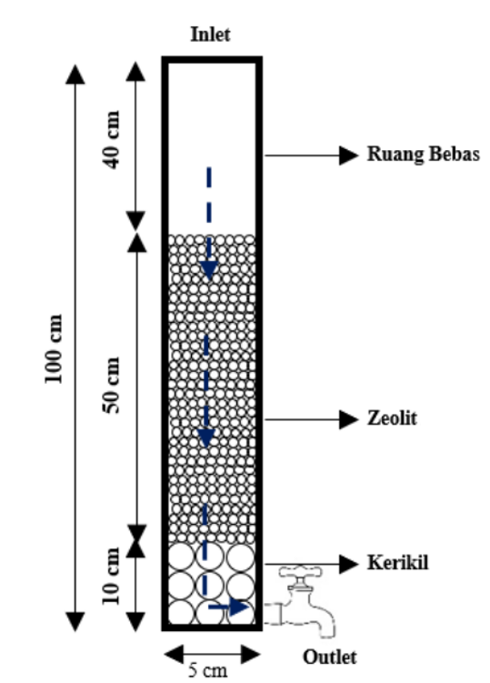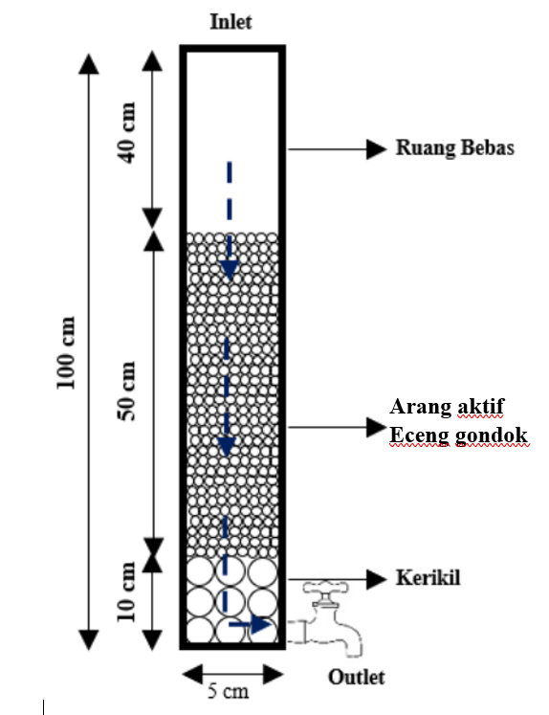
FIGURE 1. Filtration Device Experimental Design

The adsorption process was carried out continuously using 2 test tubes with a diameter of 5 cm and a height of 100 cm (FIGURE 1). The contact time used in this experiment is 40 minutes with a Hydraulic Loading Rate (HLR) of 1.2 m/hour. The experiment was carried out for 7 days with 1 experiment per day. The tested water quality parameters consisted of TDS, Hardness (CaCO3), Magnesium (Mg), and Calcium (Ca). The results of laboratory tests are used as data to calculate the effectiveness of adsorbents in improving water quality. The calculation of processing effectiveness is expressed in percent (%) with the following formula (Equation 1):

$Effectiveness=\left(\frac{Initial concentration-Final concentration}{Initial concentration}\right)x100\%$ (1)

RESULTS AND DISCUSSION
This research was carried out in the Brantas River, Malang City, East Java, Indonesia. Water samples before treatment were taken from several river channel points and water quality tests were carried out based on the parameters of TDS, Hardness (CaCO3), Magnesium (Mg), and Calcium (Ca). TDS testing was carried out quickly with a TDS meter while other parameters were tested at the PDAM Malang Water Quality Laboratory. The following is a table of the results of water quality tests before treatment from the sampling location with quality standard provisions based on the regulation of the Minister of Health of the Republic of Indonesia No. 32 of 2017 (TABLE 1).

TABLE 1. Results of Water Quality Test Before Filtration
No | Parameter | Unit | Value | Quality Standards (max)
1 | Magnesium (Mg) | Mg/L | 23.5 | 50
2 | Kalsium (Ca) | Mg/L | 61.9 | 75
3 | Kesadahan (CaCO3) | Mg/L | 256.66 | 500
4 | TDS | Mg/L | 265 | 1000
Source: Field Samples and Water Quality Lab Test Results (2024)
Total Dissolve Solid (TDS) is the number of organic and inorganic substances dissolved in water which can be in the form of ions, compounds, and colloids [17] Solutes in water can come from weathering rocks around springs or from soil carried by surface runoff water that enters the water stream. The TDS content in water will not disappear just by boiling it so that if the TDS level in water is high, it can have a bad impact on health because these substances will be difficult to get out of the body so that they settle in the body. The existence of ions and dissolved substances in a water is able to conduct electric currents so that the more dissolved ions are contained in the water, the higher the electrical conductivity value of the water [18].
Hardness is a description of divalent metal cations that can react with soap and form deposits or react with anions in water that will form deposits or rust on metals. The water hardness value of the surface runoff water flow of 256.66 mg/l is not included in the quality standard, but this value according to the United States Geological Survey (USGS) classification is included in the hard water classification. Hard water, if consumed continuously, can trigger disturbances in human health, one of which can cause kidney disease. In addition, hard water, when used, can result in blockages in water pipes and waste of soap use. Magnesium (Mg) and Calcium (Ca) are alkaline metal elements that are one of the causes of hardness in the waters so that if the levels of Mg and Ca in a water are high, it can cause the waters to become hard. The results of the water filtration experiment can be seen in the following TABLE 2-5 and graph.

TABLE 2. Results of Filtration of Sample Water with Zeolite Adsorbent
No | Parameter | Unit | Pre-Filtration Value | Trial Value After Filtration
 |  |  |  | 1 | 2 | 3 | 4 | 5
1 | Magnesium (Mg) | Mg/L | 23.5 | 9.96 | 10.44 | 12.86 | 8.5 | 9.96
2 | Kalsium (Ca) | Mg/L | 61.9 | 34.04 | 52.35 | 42.77 | 53.14 | 49.16
3 | Kesadahan (CaCO3) | Mg/L | 256.66 | 131.28 | 179.04 | 165.11 | 157.15 | 179.04
4 | TDS | Mg/L | 265 | 127 | 184 | 144 | 148 | 163
Source: Data Analytics (2024)

TABLE 3. Effectiveness of Reducing Sample Water Filtration Results with Zeolite Adsorbents
No | Parameter | Unit | Pre-Filtration Value | Effectiveness (%)
 |  |  |  | 1 | 2 | 3 | 4 | 5
1 | Magnesium (Mg) | Mg/L | 23.5 | 57.62% | 55.57% | 45.28% | 63.83% | 57.62%
2 | Kalsium (Ca) | Mg/L | 61.9 | 45.01% | 15.43% | 30.90% | 14.15% | 20.58%
3 | Kesadahan (CaCO3) | Mg/L | 256.66 | 48.85% | 30.24% | 35.67% | 38.77% | 30.24%
4 | TDS | Mg/L | 265 | 52.08% | 30.57% | 45.66% | 44.15% | 38.49%
Source: Data Analytics (2024)

TABLE 4. Results of Filtration of Sample Water with Hyacinth Charcoal Adsorbent
No | Parameter | Unit | Pre-Filtration Value | Trial Value After Filtration
 |  |  |  | 1 | 2 | 3 | 4 | 5
1 | Magnesium (Mg) | Mg/L | 23.5 | 12.37 | 21.08 | 14.79 | 12.86 | 11.89
2 | Kalsium (Ca) | Mg/L | 61.9 | 39.61 | 27.67 | 34.04 | 34.83 | 54.63
3 | Kesadahan (CaCO3) | Mg/L | 256.66 | 155.16 | 161.13 | 151.18 | 145.21 | 188.99
4 | TDS | Mg/L | 265 | 237 | 241 | 232 | 235 | 248
Source: Data Analytics (2024)

TABLE 5. Effectiveness of Reducing Sample Water Filtration Results with Hyacinth Charcoal Adsorbent
No | Parameter | Unit | Pre-Filtration Value | Effectiveness (%)
 |  |  |  | 1 | 2 | 3 | 4 | 5
1 | Magnesium (Mg) | Mg/L | 23.5 | 47.36% | 10.30% | 37.06% | 45.28% | 49.40%
2 | Kalsium (Ca) | Mg/L | 61.9 | 36.01% | 55.30% | 45.01% | 43.73% | 11.74%
3 | Kesadahan (CaCO3) | Mg/L | 256.66 | 39.55% | 37.22% | 41.10% | 43.42% | 26.37%
4 | TDS | Mg/L | 265 | 10.57% | 9.06% | 12.45% | 11.32% | 6.42%
Source: Data Analytics (2024)

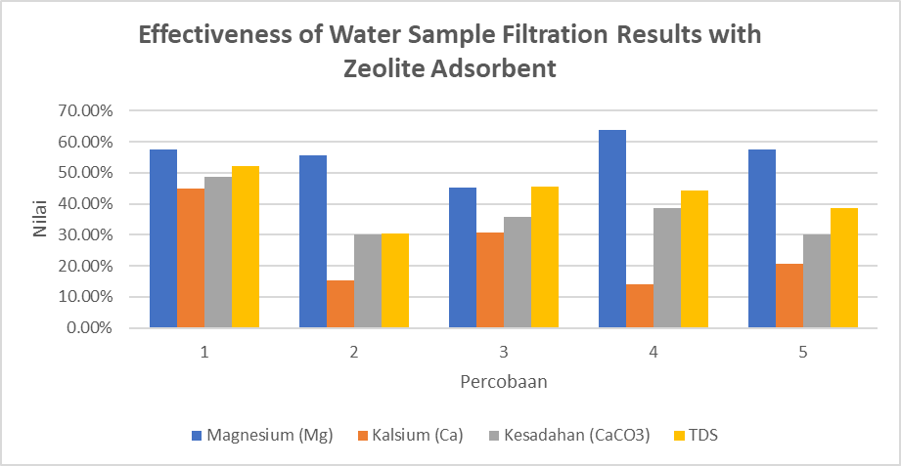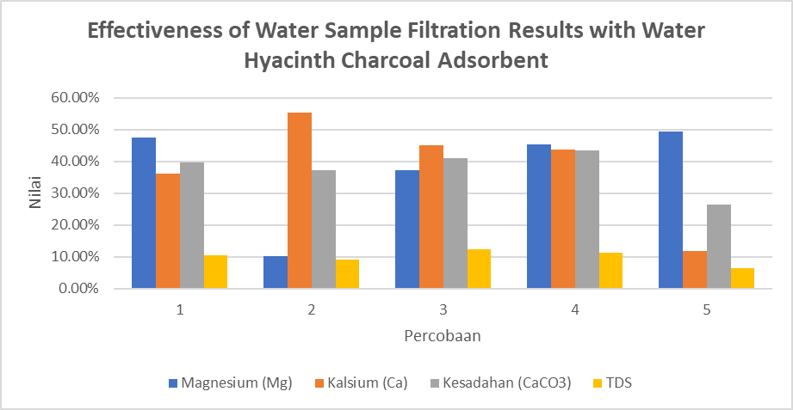
FIGURE 2. Comparison of Adsorbent Effectiveness Results for Each Parameter
Source: Data Analytics (2024)

The effectiveness of reducing magnesium (Mg) levels in water treatment with zeolite has the largest value compared to water hyacinth charcoal, which is 63.83%, as shown in FIGURE 2. The effectiveness of reducing calcium (Ca) levels in water treatment with water hyacinth charcoal has the largest value compared to zeolite, which is 55.30%. The effectiveness of reducing the hardness level (CaCO3) in water treatment with zeolite media has the largest value compared to water hyacinth charcoal, which is 48.85%. The effectiveness of reducing TDS levels in water treatment with zeolite media has the largest value compared to water hyacinth charcoal, which is 52.08%. The results of the experiment showed that the zeolite adsorbent was able to absorb the ions or parameters dissolved in water better than the hyacinth charcoal adsorbent. This can be because zeolite in addition to having the ability as an adsorbent also has the ability to be an ion exchanger so that it can help improve water quality. Based on this, water treatment that is suitable to be applied in the research area is household-scale water filter treatment using zeolite adsorbents. The water treatment medium used is adjusted to laboratory scale experiments that have been carried out previously. The height of the gravel at the base of the column is 10 cm with a grain size of 1-2 cm and the height of natural zeolite is 50 cm with a weight of around 136 kilograms and a grain size of 0.3 cm. The addition of gravel at the bottom of the water filter column functions as a supporting layer to hold or buffer small particles from zeolite so that it does not escape to the water flow to the faucet because it can cause blockage.

CONCLUSIONS
The use of zeolite has the highest effectiveness in reducing Mg 63.83%, Ca 45.01%, hardness 48.85%, and TDS 52.08%. The use of water hyacinth charcoal had the highest effectiveness in reducing Mg 49.40%, Ca 55.30%, hardness 43.42%, and TDS 12.45%. The results of the experiment showed that the activated zeolite adsorbent was able to absorb the turbidity causing ions dissolved in water better than the water hyacinth charcoal adsorbent. Based on this, runoff water treatment that is suitable to be applied in the research area is a household-scale water filter treatment using activated zeolite adsorbents, and can also be made in combination with hyacinth charcoal adsorbents.

Acknowledgments
Gratitude is addressed to the Faculty of Engineering, University of Muhammadiyah Malang through an internal research scheme that has provided support and facilities in the implementation of this research.

References
1. Darmawan, A.A., et al. Changes in Runoff Coefficient Index as a Result of Land Use Change (Case Study: Malang City). IOP Publishing.
2. Darmawan, A.A., et al., PENGELOLAAN JARINGAN DISTRIBUSI AIR BERSIH PERKOTAAN DI KABUPATEN GRESIK. INDONESIAN JOURNAL OF CONSTRUCTION ENGINEERING AND SUSTAINABLE DEVELOPMENT (CESD), 2022. 5(2): p. 7-14.
3. Hendrasari, R.S. and N.A. Dwipurnama. Pengaruh Tanaman Kayu Apu Pada Parameter Kualitas Air Dalam Proses Pengolahan Air Sungai.
4. Darmawan, A.A. and E. Setyono. Analisa Hubungan Curah Hujan Dan Debit Serta Korelasi Pengaruh Parameter Lain Di Daerah Aliran Sungai Brantas Hulu.
5. Asnaning, A.R., S. Surya, and A.E. Saputra. Uji kualitas air hujan hasil filtrasi untuk penyediaan air bersih.
6. Mashadi, A., et al., Peningkatan kualitas pH, Fe dan kekeruhan dari air sumur gali dengan metode filtrasi. Jurnal Riset Rekayasa Sipil, 2018. 1(2): p. 105.
7. Faradila, R., H.S. Huboyo, and A. Syakur, Rekayasa Pengolahan Air Limbah Domestik Dengan Metode Kombinasi Filtrasi Untuk Menurunkan Tingkat Polutan Air. Jurnal Kesehatan Lingkungan Indonesia, 2023. 22(3): p. 342-350.
8. Liandi, A.R., et al., Pyrolysis of PP and HDPE from plastic packaging waste into liquid hydrocarbons using natural zeolite Lampung as a catalyst. Case Studies in Chemical and Environmental Engineering, 2023. 7: p. 100290.
9. Velarde, L., et al., Adsorption of heavy metals on natural zeolites: A review. Chemosphere, 2023. 328: p. 138508.
10. Meiramkulova, K., et al., Comparative analysis of natural and synthetic zeolite filter performance in the purification of groundwater. Water, 2023. 15(3): p. 588.
11. Bahmanzadegan, F. and A. Ghaemi, Modification and functionalization of zeolites to improve the efficiency of CO2 adsorption: A review. Case Studies in Chemical and Environmental Engineering, 2023: p. 100564.
12. Carnaje, N.P., et al., Development and characterisation of charcoal briquettes from water hyacinth (Eichhornia crassipes)-molasses blend. PloS one, 2018. 13(11): p. e0207135.
13. Putri, L.O.N. and O. Nurhilal, PEMANFAATAN ARANG AKTIF ECENG GONDOK UNTUK MATERIAL ELEKTRODA SUPERKAPASITOR.
14. Azizah, N., et al. Penggunaan Zeolit Alam Teraktivasi dan Karbon Aktif dalam Menurunkan Kesadahan Air Di Kalurahan Girisuko, Kapanewon Panggang, Kabupaten Gunungkidul, DIY.
15. Yogafanny, E., K.O. Yohan, and A. Sungkowo. Treatment of brackish groundwater by zeolite filtration in Sumur Tua Wonocolo, Kedewan, Bojonegoro, East Java. IOP Publishing.
16. Sufra, R., et al., Intensifikasi Pengolahan Limbah Cair Laboratorium Melalui Proses Koagulasi dan Adsorpsi Studi Pengolahan Limbah Cair Laboratorium dengan Metode Kombinasi Fisika-Kimia. Jurnal Talenta Sipil, 2024. 7(1): p. 266-275.
17. Kustiyaningsih, E. and R. Irawanto, Pengukuran total dissolved solid (tds) dalam fitoremediasi deterjen dengan tumbuhan Sagittaria lancifolia. Jurnal Tanah dan Sumberdaya Lahan, 2020. 7(1): p. 143-148.
18. Effendi, H., Telaah kualitas air. yogyakarta: Kanisius. 2003.

