Simulation Model of Precast Building Structure
(Case Study on the Indonesian Building Competition 2024)
Muhammad Ibnu Nursholeh^{a)}, Fikri Haiqal Febrian Adha^{b)}, Moh. Abduh^{c)}, Lintang Satiti Mahabella^{d)}, and Zamzami Septiropa^{e)}
Department of Civil Engineering, Universitas Muhammadiyah Malang, Malang, Indonesia

^{c)} Corresponding author: abduh@umm.ac.id
^{a)} mohamadibnu475@gmail.com
^{b)} hakermy1234@gmail.com
^{d)} lintangsmahabella@umm.ac.id
^{e)} zamseptiropa@umm.ac.id
Abstract. This study discusses the design of a 10-story building structure developed by “Nusatech Stiratva” using an open frame structural system based on the strong column weak beam concept for earthquake resistance. The columns used have dimensions of 15 mm × 13 mm and the beams are 8 mm × 12 mm with concrete quality fc' 40 MPa, optimized for earthquake resistance on the weak axis and reduction of building weight. Concepts of durability and rapid construction are applied in the design of weather-resistant and easily executed connections. Bolt and plate connections with holes larger than the bolt diameter are chosen to create optimal deformation. The total weight of the building is 12,778 kg, including precast reinforced concrete structure, plywood on the base slab, plywood as floor slabs, connection weight, as well as paper walls and additional accessories. The maximum deflection recorded is 0.166 mm at a frequency of 5.5 Hz on the 10th floor, which meets the allowable deflection requirements.
Keywords: Structure, Building, Precast-concrete, Model.

INTRODUCTION
Infrastructure development is a vital element in supporting the progress of a country. In Indonesia, to promote equitable development, various new areas and regions are being developed, including the construction of the National Capital City (IKN) in East Kalimantan. The development of the IKN area requires various supporting infrastructures, including buildings that function as facilities for office activities and new residential areas. The challenge for engineers in this context is to design buildings that can be constructed quickly, be strong, efficient, and earthquake-resistant, in line with the acceleration of development in Indonesia.
Indonesia is a region with a high risk of earthquakes, including areas such as Kutai Kartanegara and Penajam Paser Utara in East Kalimantan Province, which will become the location for the new IKN area. Although Kalimantan Island is not traversed by volcanic mountain ranges, there are currently several earthquake sources such as the Maratus Fault, Mangkalihat Fault, Tarakan Fault, Maratua Fault, Sampurna Fault, and Paternoster Fault [1]. This condition requires that building designs be earthquake-resistant, and to anticipate the possibility of an earthquake, buildings need to be robust and capable of remaining standing without experiencing damage or collapse during an earthquake.
The risk of earthquake damage to buildings can be minimized through earthquake-resistant structural planning using precast reinforced concrete. The use of precast concrete allows for better connection detail control and concrete quality that meets these needs. By leveraging the advantages of precast concrete, the design of connections must be capable of reducing the rigidity of the structural frame and combining high-quality reinforced concrete with additional elements that function to reduce and minimize potential tensile and compressive forces.
In order to develop and innovate earthquake-resistant precast building structures, the government, through the Indonesian Talent Development Center, National Achievement Center, Ministry of Education, Culture, Research, and Technology, is organizing the Indonesian Building Competition (KBGI) XV in 2024. This competition focuses on the planning of earthquake-resistant multi-story buildings with the theme 'Fast, Strong, Durable, and Earthquake-Resistant Buildings for Accelerating National Development'. The innovation of connection models in precast concrete continues to evolve in order to provide technological ease for fast and high-quality construction implementation.

METHODS
The building model with a precast concrete structure must adhere to concepts that align with the existing guidelines, including earthquake resistance, quick construction, and durability of the precast concrete building model. The design model includes the number of floors, concrete quality, reinforcement quality, and connection models with steel plates and bolts as per the competition requirements. The chosen model and methods prioritize environmental friendliness and sustainability in line with the theme of the competition.
In this model, the earthquake-resistant building is designed with the Strong Column Weak Beam concept, where columns are designed to be stronger than the beams [2]. This concept is a structural engineering approach intended so that during an earthquake, the beams are flexible enough to deflect and absorb stress, while the columns are capable of supporting the loads above [3]. The design of the structural components in the frame uses reinforced concrete, with structural dimensions following the guidelines of this competition. The study process flow is outlined as shown in FIGURE 1 below.
FIGURE 1. Research flowchart

The composition of the main structural materials, columns, and beams in the precast reinforced concrete building model is designed using a concrete mix intended to withstand high compressive forces, thereby also being capable of withstanding tensile and compressive forces due to loading [4]. The quality of the concrete is designed to meet the standards and requirements specified to ensure safety, strength, and durability, using concrete quality (fc') of 40 MPa. The building dimensions used refer to the guidelines in the KBGI 2024.
The connection devices in precast concrete use connection plates and bolts, which function to join structural components into a cohesive and secure unit. The steel connection plates serve as the linking medium between main structural elements, such as columns and beams [5]. The plates are designed to withstand tensile, compressive, and shear forces occurring at the connections as shown in FIGURE 2. The bolts used to fasten the connection plates and other precast concrete components are designed to resist tensile, shear, support, and other forces caused by various vibration frequencies experienced by this building model.

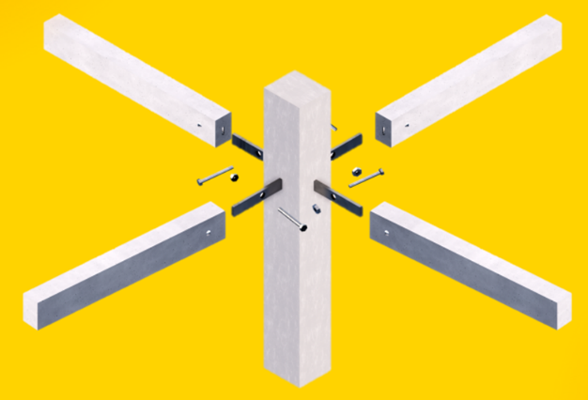  (a) | 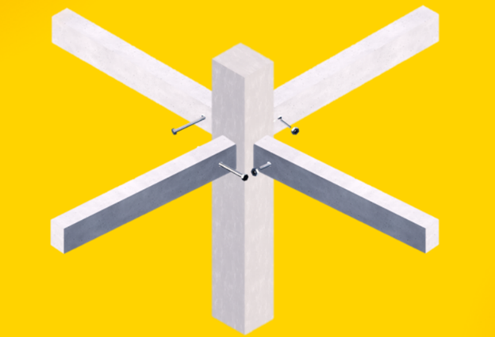  (b)
FIGURE 2. Model of connection (a) connection system, (b) column-beam connected

The connection model consists of structural elements in the form of columns and beams. The connection system includes a plate complete with locking bolts on the beam. The connecting plate is installed as one unit when the column is cast, creating a bond between the beam and the plate. The design of the plate must meet the capacity of the internal forces acting on it and is simulated during structural analysis. This method offers a simple connection model and allows for ease of implementation.
Structural analysis and load simulation are conducted to ensure the safety of the building structure against earthquakes. This process involves a detailed assessment of the building's structural elements, including materials, design, and component interactions. By performing load simulations, we can predict the building's response to various conditions and loads, both static and dynamic. This allows for the identification of potential weak points and optimization of the design to ensure optimal performance of the building [6]. Through careful analysis, the risk of structural failure and damage can be reduced.
Cross-sectional capacity control and analysis of the special moment-resisting frame refer to SNI 2847:2019 [2]. Meanwhile, maximum deflection control due to earthquakes refers to SNI 1726:2019 [7]. The cross-sectional capacity control includes several reviews as outlined in Eq. 1 and Eq. 2.

Planned balk strength SNI 2847:2019 9.5 $ϕ Mn Mu$
$$ϕ Vn Vu$$
$$ϕ Tn Tu$$
$ϕ Pn Pu$ (1)
Planned column strength SNI 2847:2019 10.5 $ϕ Mn Mu$
$$ϕ Vn Vu$$
$$ϕ Tn Tu$$
$ϕ Pn Pu$ (2)

Special Moment-Resisting Frame (SMRF) shown in Eq. 3 and Eq. 4.

Minimum bending strength of columns based on SNI 2847:2019 10.5
$∑Mnc≥(1,2)∑Mnb$ (3)
Maximum Deflection Control based on SNI 1726:2019 17.12.1
$0,02h$ (4)
In designing connections, it is important to perform strength control of the connection plates. Eq. 5, Eq. 6, Eq. 7, and Eq. 8 is the connection strength control and bolt requirement analysis according to SNI 1729:2020.
Tensile Capacity using SNI 1729: 2020 J3.6
∅Rn = ∅ Fnt Ab (5)
Shear Capacity using SNI 1729:2020 J3.6
∅Rn = ∅ Fnv Ab (6)
Tear Capacity using SNI 1729:2020 J3.10
∅Rn= ∅1,2 𝑙ct Fu (7)
Support Capacity using SNI 1729:2020 J3.10
∅Rn= ∅ 2,4 d t Fu (8)

RESULTS AND DISCUSSION

SYSTEM OF STRUCTURE
The earthquake-resistant design principle for this building employs an open frame structural system [8]. An open frame structure consists of columns and beams connected with moment-resisting joints, without using shear walls or bracing. In designing an earthquake-resistant building, the main components (beams and columns) are designed to withstand seismic loads by applying the Strong Column Weak Beam concept [9, 10] with a special moment-resisting frame approach [11]. The structural system chosen for this model study is an open frame system as described above, shown in FIGURE 3.

FIGURE 3. Open Frame Structural System

In this study, the selection of the model and structural system follows the guidelines outlined in the Indonesian Building Competition 2024. The chosen structural system model is an open frame system [12], which is suitable for application because this model building is designed with a precast system. This choice is intended for a quick and sturdy structural model, allowing for rapid on-site implementation and reducing the negative environmental impact.

MODEL OF STRUCTURE
In structural modeling, the elements of the structural system (such as columns and beams) are modeled using structural analysis software to determine the capacity to withstand loads on the designed structural cross-sections [7, 13]. The configuration of the model building, named “Nusatech Stiratva”, is modeled in three dimensions (3D). The model specifications include reinforced concrete with a concrete strength of fc' 40 MPa and reinforcement steel with fy 340 MPa. Other material specifications are in accordance with guidelines and regulations applicable to building construction. The choice of shape in a building, in addition to its aesthetic appeal, also needs to consider ease of construction as well as the rigidity and durability of the structure against seismic effects, shown in FIGURE 4.
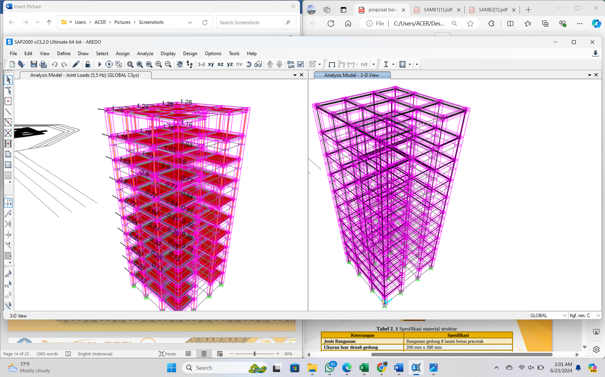
FIGURE 4. 3D Model Based on Structural Analysis

LOADING SYSTEM
The model building design was created with reference to the specifications outlined in the Indonesian Building Competition 2024. The structural dimension design began with a preliminary design to achieve an optimal cross-section that can withstand loads and seismic forces with safe deflections. The loads acting on this building model include live loads, dead loads, and seismic loads. The live load consists of a 1.5 kg slab placed on each floor, shown in TABLE 1.
TABLE 1. Load Distribution
Load | Description
Dead load | Self-weight of structure 12.778 kg
Live Load | Steel plate 1.5 kg/floor
Earthquake | Earthquake - 1.5 Hz  Earthquake - 2.5 Hz  Earthquake - 3.5 Hz  Earthquake - 4.5 Hz  Earthquake - 5.5 Hz

ANALYSIS OF STRUCTURE
The determined configuration is then analyzed to determine the strength of the building to be designed. The analysis includes cross-sectional capacity control, bending strength control, deflection control, and earthquake load determination using the equivalent static method [14]. The equivalent static method converts vibrations due to frequency into acceleration values, which are then converted into base seismic loads and horizontal loads distributed to the outermost frame on the weak axis, as described in TABLE 2 below.
TABLE 2. Cross-section Analysis (Beam)
Beam analysis | Control | Nominal result | Ultimate Beam | Description
Moment (kgm) | Mn > Mu | 0,00384 | 0,00198 | Safe
Shear (kg) | Vn > Vu | 0,32600 | 0,03650 | Safe
Axial (kg) | Pn > Pu | 2,48900 | 0,02150 | Safe
Torque (kgm | Tn > Tu | 0,00287 | 0,00012 | Safe

TABLE 3. Cross-section Analysis (Column)
Column analysis | Control | Nominal result | Ultimate Column | Description
Moment (kgm) | Mn > Mu | 0,00489 | 0,00235 | Safe
Shear (kg) | Vn > Vu | 0,86100 | 0,07706 | Safe
Axial (kg) | Pn > Pu | 2,94800 | 2,40500 | Safe
Torque (kgm | Tn > Tu | 0,00845 | 0,00091 | Safe

Based on the analysis results shown in TABLE 2 and TABLE 3, the capacity of the forces acting on the columns and beams has achieved values greater than the ultimate forces generated from the loading process on the building model. Although the capacity values are still too large compared to the ultimate values, ideally the analysis results would show a balance between working loads and capacity. This means that the capacity should always be greater than the ultimate, but the difference should not be too wide or should be closer to the capacity. Therefore, in reality, the dimensions of the columns and beams could still be reduced, but since this design concept is a model, it is not possible to reduce those dimensions further.
TABLE 4. Bending Strength Control
Total Moment [kg.mm] |  | Equation | Description
Column | Beam | Equation | Description
229.46 | 98.95 | ΣMoment Kolom ≥ ΣMoment Balok + 20% ΣMoment Balok | Satisfied

Based on TABLE 4 above, the strong column-weak beam concept in this design has been fulfilled, as shown by the results in the table. This concept was chosen with the intention that, in the event of an earthquake exceeding the building's design capacity, the beams will be the first to suffer damage, such as cracking, allowing the occupants to evacuate according to the earthquake mitigation guidelines for buildings. The goal is to minimize casualties during an earthquake, especially for the occupants of tall buildings like the one in this model design.

TABLE 5. Results of Deflection Analysis
Floor Loading | Deflection (mm)
Floor Loading | 1,5 Hz (N) | 2,5 Hz (N) | 3,5 Hz (N) | 4,5 Hz (N) | 5,5 Hz (N)
1 | 0.0008 | 0.0023 | 0.0046 | 0.0076 | 0.0114
2 | 0.0024 | 0.0067 | 0.013 | 0.020 | 0.032
3 | 0.0041 | 0.0113 | 0.022 | 0.036 | 0.055
4 | 0.0057 | 0.0158 | 0.0309 | 0.051 | 0.076
5 | 0.0072 | 0.020 | 0.0393 | 0.065 | 0.097
6 | 0.0086 | 0.024 | 0.0469 | 0.0775 | 0.116
7 | 0.010 | 0.0273 | 0.0537 | 0.089 | 0.133
8 | 0.011 | 0.0302 | 0.059 | 0.098 | 0.146
9 | 0.012 | 0.0324 | 0.064 | 0.105 | 0.157
10 | 0.0123 | 0.034 | 0.067 | 0.110 | 0.166

TABLE 6. Deflection Control
Node number | Δ (mm) | Δ limit capacity (mm) | Control | Status
27 | 0.17 | 1.40 | Δ < Δ limit capacity | Satisfied

Referring to the analysis results shown in TABLE 5 and TABLE 6, using equivalent static earthquake analysis and conducting simulations with the existing loads as well as frequency testing from 1.5 Hz to 5.5 Hz, the maximum deflection obtained from the earthquake simulation is 0.17 mm, while the deflection capacity that can be provided by the building model is 1.40 mm. This means that the building model is still very safe from the risk of collapse, as indicated by the deflection safety values from the applied earthquake behavior simulation.

DESIGN OF CONNECTION
In designing connections, important factors to consider include the forces acting, the connection model, stability control of the connection model, and the connecting devices. A good connection is one where the control results in a balanced (optimal) ratio between the acting forces and the connection capacity. This means the capacity provided by the connection is not excessive but remains safe. Below is the strength control of the connection against the acting forces.
TABLE 7. Connection Control
Control | Equation | Loads (kg) | Design Capacity (kg) | Description
Tension | F’nt×Ab | 4.48 | 408.08 | Satisfied
Shear | F’nv×Ab | 2.27 | 244.85 | Satisfied
Support | 2,4×d×t×Fu | 3.53 | 179.03 | Satisfied
Tear | 1,2×d×t×Fu | 4.55 | 89.50 | Satisfied

Based on the results of the analysis in TABLE 7, it shows that the values obtained from the load calculations are quite low and far below the capacity. In this simulation case, because the dimensions of the building analyzed are of the actual model, the cross-sections still need to be reduced as the capacity obtained is still too large, which can be considered wasteful. However, since this study is a model, the dimensions cannot be reduced or minimized further. Based on the analysis results above, the innovation of precast concrete connection models used provides sufficient support to withstand loads and seismic forces occurring in this building model study.
Overall, the results of the analysis and model simulation conducted on the building model with up to 10 floors demonstrate the reliability achieved from the design and model simulation. This provides a good representation in the selection of the form and structural system chosen, ensuring that each planned and constructed building, whether for residential or office facilities, offers a sense of security to its occupants. This activity is also beneficial in providing insight into selecting the model and construction system for building design, contributing to the acceleration of development and meeting the needs for residential and office buildings, especially in urban areas that require infrastructure for housing and offices.

CONCLUSIONS
The 10-story reinforced concrete precast building model named “Nusatech-Stiratva” is designed with reference to the theme of the Indonesian Building Competition 2024, namely 'Fast-Built, Strong, Durable, and Earthquake-Resistant Buildings for Accelerating the Development of Nusantara.' The design of this building model uses an open frame structural system with a strong column-weak beam concept as an earthquake-resistant structure. The concrete quality of fc' 40 MPa is intended to optimize earthquake resistance along the weak axis and reduce the building’s weight. The chosen precast connection system includes nut-bolt (m2) and plate connections, with the bolt hole size being larger than the bolt diameter, aimed at providing a damping system. The self-weight of the building model is 12,778 kg, which includes the precast structure, connections, and other accessories used. The maximum deflection occurring in “Nusatech-Stiratva” is 0.17 mm at a frequency of 5.5 Hz, happening on the 10th floor. This deflection is smaller than the allowable deflection capacity or its permitted limit. Based on the analysis results above, the innovation of precast concrete connection models used provides sufficient support to withstand loads and seismic forces occurring in this building model study. This connection method offers a simple connection model and allows for ease of implementation.

Acknowledgments
With deep gratitude, the author wishes to thank all parties who have provided support and facilities in the completion of this work, especially to the university and faculty leaders, the lecturers in the Civil Engineering Program, and all members of the Surya Team at Muhammadiyah University of Malang for their support and cooperation during the research process, as well as the mentors for their guidance, motivation, and invaluable support in completing this work in a better and more meaningful way.

References
1. Rusmilawati, D., D. Djayus, and P. Lepong, Studi Mekanisme Sumber Gempabumi di Wilayah Kalimantan Berdasarkan Gerak Awal Gelombang P. Geosains Kutai Basin, 2019. 2(2).
2. Indonesia, S.N., Persyaratan beton struktural untuk bangunan gedung. SNI, 2013. 2847(2013): p. 91-080.
3. Surana, M., Y. Singh, and D.H. Lang, Effect of strong-column weak-beam design provision on the seismic fragility of RC frame buildings. International Journal of Advanced Structural Engineering, 2018. 10: p. 131-141.
4. Ximenes, A., A. Halim, and A. Suraji. Pengaruh komposisi campuran beton dan jenis semen terhadap kelecakan (concrete workability) dan kuat tekan beton. in The 4th Conference on Innovation and Application of Science and Technology (CIASTECH 2021). 2021. Ciastech.
5. Da Conceição, G.D.C. and A. Lisantono, SAMBUNGAN BALOK BETON BERTULANG PRACETAK DENGAN LAPISAN CFRP DAN PLAT BAJA. Jurnal Teknik Sipil, 2019. 15(2): p. 124-132.
6. Firdha, R.A., et al., Analisis Kinerja Struktur Gedung Bertingkat Terhadap Beban Gempa Dengan Metode Pushover Analysis (Studi Kasus: Gedung Rawat Inap Non–Bedah Rumah Sakit Umum Daerah Dr. H. Abdul Moeloek). Jurnal Rekayasa Sipil dan Desain, 2021. 9(4): p. 486195.
7. Nasional, B.S., Tata cara perencanaan ketahanan gempa untuk struktur bangunan gedung dan non gedung. Sni, 2012. 1726: p. 2012.
8. Fujii, K., Peak and cumulative response of reinforced concrete frames with steel damper columns under seismic sequences. Buildings, 2022. 12(3): p. 275.
9. Ying-nan, S., et al. Seismic performance of the ST-RC columns to RC beams exterior joint with assembled connection details. 2024. Structures: Elsevier.
10. Dong, J., et al., Experimental study on seismic performance of RC beam-CFST column joint combination using ECC. Engineering Structures, 2024. 312: p. 118188.
11. Irawan, D. and S.P. Machmoed, Perencanaan struktur beton bertulang gedung perkantoran dira 10 lantai dengan metode sistem rangka pemikul momen khusus di Kabupaten Ende. axial: jurnal rekayasa dan manajemen konstruksi, 2024. 12(2): p. 083-092.
12. Peng, W.-J. and M.-X. Tao, Column-to-beam flexural strength ratio for rigorous strong-column–weak-beam design for steel–concrete composite frames. Journal of Building Engineering, 2024. 96: p. 110669.
13. Hasibuan, S.A.R.S. and A.A. Qolby, Solution of Beam Structure Analysis Using SAP2000. International Journal of Innovative Research in Computer Science & Technology, 2023. 11(1).
14. Rifandi, I., Analisis Beban Gempa dengan Metode Statik Ekuivalen Berdasarkan SNI 1726-2019 pada Gedung IPAL. Jurnal Konstruksi, 2020. 18(2): p. 72-82.

