Patterns of Land Use Change in Malang City on Flood Discharge (Case Study: Land Use Changes from 2002 to 2022)

Muhamad Ilham Abdullah^{1,a)}, Azhar Adi Darmawan^{1,b)}, Sulianto^{1,c)}, Farah Antika Sari^{1,d)} and Wahyu Eko Adi Saputro^{2,e)}

¹Civil Engineering Department, University of Muhammadiyah Malang, Malang, Indonesia
²Esri Indonesia, Capital Place, South Jakarta, Indonesia

^{a)} muhamadilhamabdullah@gmail.com
^{b)} Corresponding author: azharadidfts@umm.ac.id
^{c)} sulianto@umm.ac.id
^{d)} farahantika741@gmail.com
^{e)} weasaputro@esriindonesia.co.id

Abstract. Land use change is a peculiarity coming about because of the improvement of an area as seen from populace development, financial development and changes in monetary patterns from the farming area to repayments. Malang City keeps on encountering changes in land use as confirmed by a decline in the space of rural land. This study plans to examine and recognize the circumstances and examples of land use change and their area dissemination in Malang City in 2002-2022. This review utilizes the directed order technique with ArcGIS 10.8 apparatuses. This strategy is utilized to examine changes in land use through map overlays. The information utilized are Landsat 7+ETM and Landsat 8 OLI Satellite Symbolism information as well as information from Terrasar-X/Demnas Satellite Imagery. The issue of water flood in Malang City which regularly immerses a few regions is a different errand for the public authority and occupants living in overwhelmed regions. This is indistinguishable from the impact of changes in land utilize that exist in each separate area. Changes in land use in the City of Malang brought about an expansion in flood release on the Brantas Waterway which courses through the City of Malang. Developed land use in 2002 was 29.47 Km2 in 2022 it was 68.69 Km2 or an increment of around 133%. In the mean time, the stream coefficient (C) changed from 0.2468 in 2002, 0.2899 in 2007, 0.3457 in 2012, 0.3895 in 2017 and 0.4119 in 2022, with a typical increment of 13.78%. In this review, to see the pattern of expanding flood release utilizing flood release plans Q2th, Q5th, Q10th, Q25th, Q50th, and Q100th. The Thiessen polygon strategy is utilized to ascertain provincial precipitation. Precipitation force is determined by the Mononobe technique. 3. In view of the consequences of the examination, there has been an adjustment of the worth of the Common Obligation throughout the course of recent years. In the principal decade, in particular 2012, the Q25 esteem was 125.60 m³/s with an overflow coefficient (C) worth of 0.3457. Though in the subsequent 10 years, in particular 2022, the Q25 esteem increments to 149.65 m3/s with a C worth of 0.4119.

INTRODUCTION

Urban land use is a reflection of the organization of urban activities; land use has a great potential to change both the area of space and the functions of roads and activities in line with the facilities and infrastructure supporting these activities[1]. The development of infrastructure and the rapid increase in population growth have resulted in changes in land use functions. Many areas that were originally agricultural sectors or green open spaces are now being converted into residential, industrial, and commercial areas[2]. The conversion of land also causes the soil to become harder due to human processing, thereby reducing the soil's infiltration capacity, which can lead to an increase in the occurrence of floods[1][5].
The flood disaster in Malang City is a natural disaster that continues to occur due to the shrinking catchment areas. This can disrupt both the quality of life and the economic changes in the community, and one of the impacts of the flood is the numerous potholes in the roads.[3] This study aims to discuss how the pattern of land use changes from 2002 to 2022 affects flooding events in the city of Malang, so that it can provide input for the Malang City Government to be more cautious in Issuing Building Permits (IBP)[2][3].
The utilization of Geographic Information Systems (GIS) is one way in the mapping process, including the creation of flood vulnerability maps which will be the focus of this research. Flood vulnerability can be identified quickly, easily, and certainly accurately through Geographic Information Systems (GIS) using the overlay method on flood parameters, such as: rainfall, topography/slope, soil characteristics, and the average water level of rivers[4][5]. make GIS, it is expected to facilitate the presentation of information regarding spatial data, especially related to determining the level of flood vulnerability and to analyze and obtain new information in identifying areas that are frequently flooded[6]. The utilization of Geographic Information Systems (GIS) is one of the ways in the mapping process, including the creation of flood vulnerability maps, which will be the focus of this research. Flood vulnerability can be identified quickly, easily, and certainly accurately through Geographic Information Systems (GIS) using overlay methods on flood parameters such as: rainfall, topography/slope, soil characteristics, and average river water level[5][8].
This research is located on the Brantas River that flows in the city of Malang, where administratively the city of Malang is divided into 5 districts, namely Blimbing District, Kedungkandang District, Klojen District, Lowokwaru District, and Sukun District. This study aims to re-evaluate land use over the past 20 years in the city of Malang by determining the runoff coefficient (C) over 20 years with a 5-year interval and calculating the magnitude of changes in discharge return periods over the last 20 years in the city of Malang.
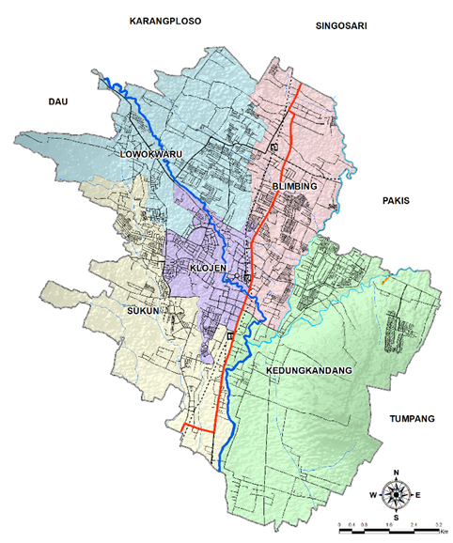
FIGURE 1. Administrative Boundaries of Malang City

METHODS

The analysis method used in this research is Descriptive-Evaluative. In addition, this research also uses geographic information systems in the analysis part, namely ArcGIS and Global Mapper for modeling. Thedata used in this research comes from primary data, namely direct data collection in the field and also secondary data obtained from relevant stakeholders. Some related data are as follows:
- Rupa Bumi Indonesia (RBI) Scale 1:25.000- Badan Informasi Geospasial (BIG).
- Landsat 8OLI TIRS Satellite Imagery Year 2022.
- Terrasar-X/ Demnas Satellite Imagery.
- Landsat Satellite Data 2002 – 2022.
- Rainfall 2002 – 2022 at 4 Rain Station: Ciliwung, Sukun, Dau, and Tangkilsari.
- Regional Spasial Planning Data of Malang City.
- Land use Data 2002 – 2022.
- Population Data; and
- Brantas River Data.

In hydrological analysis is also carried out in accordance with applicable regulations, among others:
- Calculation of maximum area average rainfall using the Thiessen polygon method.
- Calculating the design rainfall using the Log Pearson Type III distribution method.
- Frequency distribution using the Chi-Square method and the Smirnov-Kolmogorov method to determine the correctness of the hypothesis.
- Determine the value of conveyance coefficient based on land use.
- Calculating the effective hourly rainfall using the Mononobe method.
Based on the calculation of rainfall intensity for the period from 2002 to 2022, the planned flood discharge can be calculated. The planned flood discharge is calculated using the Rational Method with a return period of 5 years[8]. Geographic Information Systems are used to analyze flood-prone areas using overlay functions and assessments on flood parameters such as slope, rainfall, soil type, land use, topography, and river buffers. The output produced will be a map of potential flood vulnerability in the city of Malang. To analyze the relationship between the runoff coefficient (C) and flood return periods, projections will be made for several years with land use changes using linear trend analysis. Thus, changes in flood discharge with a certain return period can be observed[7][9].

RESULT

Analysis of Land Use

The analysis of land use in this study was conducted using supervised classification from 2002 to 2022 at 5-year intervals. The analysis was performed with ArcGIS 10.8.2 software, and the area of land use obtained is as follows:

Table 1. Land Use Area of Malang City from 2002 to 2022
No | Land use | 2002 | 2007 | 2012 | 2017 | 2022
No | Land use | Area (Km²) | Area (Km²) | Area (Km²) | Area (Km²) | Area (Km²)
1 | Open land | 20,04 | 1,69 | 3,49 | 5,47 | 4,81
2 | Settlement | 29,47 | 42,68 | 54,01 | 63,55 | 68,69
3 | Agriculture | 46,96 | 52,75 | 51,21 | 36,33 | 31,30
4 | Undergrowth | 14,59 | 13,94 | 2,36 | 5,71 | 6,27
 | Summary | 111,06 | 111,06 | 111,06 | 111,06 | 111,06

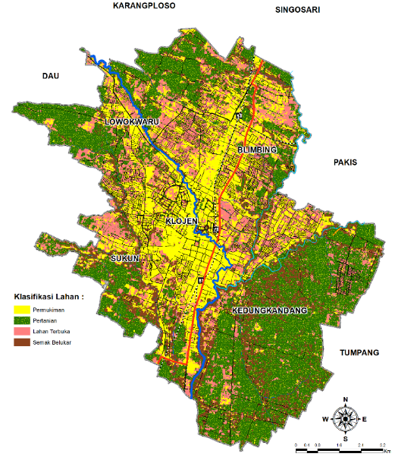  (a) | 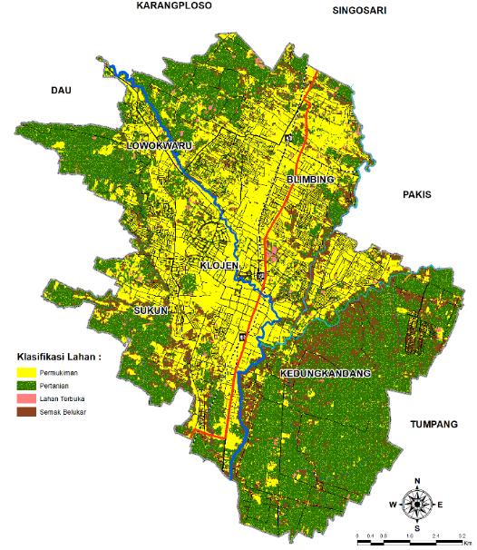  (b)
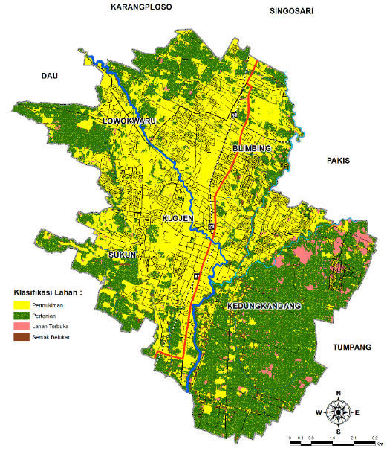  (c) | 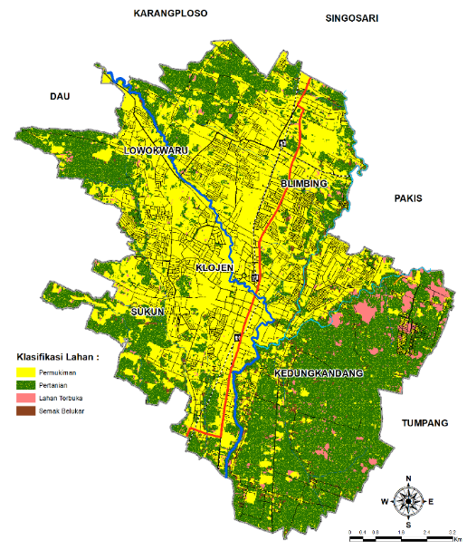  (d)
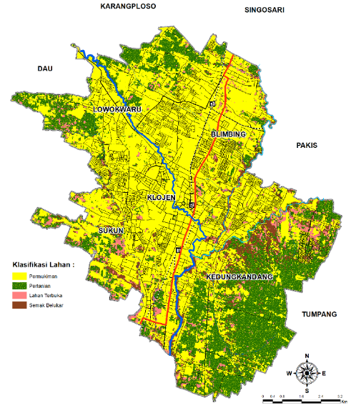
(e)
FIGURE 2. Land Use Map of Malang City year a) 2002 b) 2007 c) 2012 d) 2017 e) 2022

TABLE 2. Score of Runoff Coeficient (C) Malang City from 2002 - 2022
Year | Coeficient Runoff
2002 | 0,2468
2007 | 0,2899
2012 | 0,3457
2017 | 0,3895
2022 | 0,4119

It can be seen from (FIGURE 2 and TABLE 2) that the value of the runoff coefficient (C) from 2002-2022 has increased mainly due to the decrease in non-built land (open land, agricultural land). This is due to the increasing population that requires space for housing, economy, education, and others.

Analysis of Hidrology

The following are the result of the calculation of the area of influence of each rain post from the hydrological analysis for average rainfall using the Polygon Thiessen (FIGURE 3 and TABLE 3). In additional, the distribution analysis of the Log Pearson distribution used has also been calculated, as well as the results of the hourly rainfall distribution analysis with various return periods of 2, 5, 10, 25, 50, and 100 years (TABLE 4).

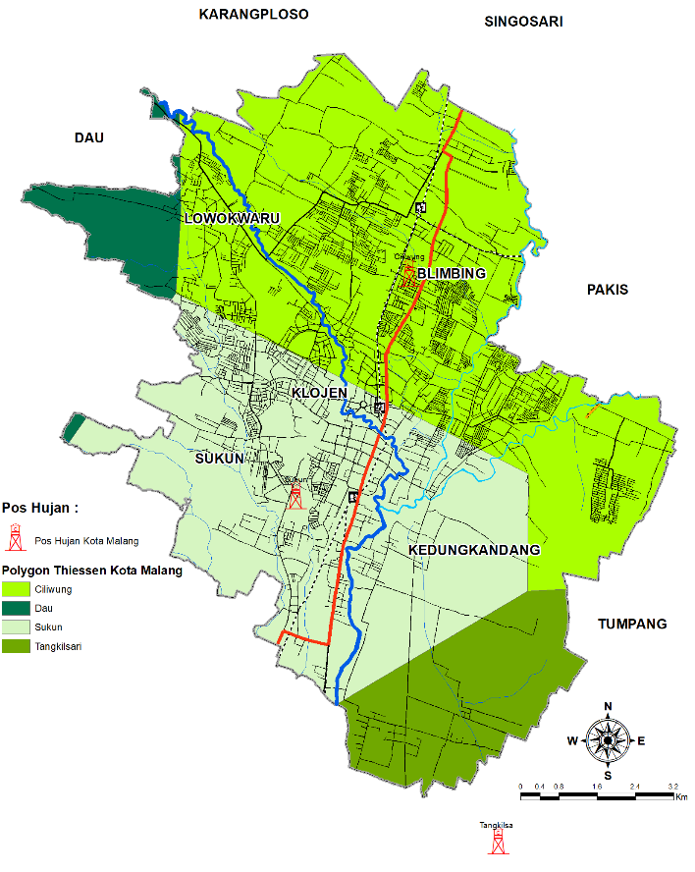

FIGURE 3. Thiessen Polygon Map of Malang City

TABLE 3. Calculation Result of Area of Influence of Rainfall Post Polygon Thiessen Method
Year | Description | Rain Post (Km2) |  |  |  | Rainfall Area (mm/hr) | Max
Year | Description | Ciliwung | Sukun | Dau | Tangkilsari | Rainfall Area (mm/hr) | Max
Year | Description | 52,3 | 40,6 | 4,86 | 12,3 | Rainfall Area (mm/hr) | Max
Year | Description | 44 | 23 | 38 | 87 | 40,43 | Max
2002 | Maximum Daily Rainfall | 73 | 45 | 55 | 76 | 61,65 | 73,64
2002 | Maximum Daily Rainfall | 61 | 101 | 56 | 50 | 73,64 | 73,64
2002 | Maximum Daily Rainfall | 44 | 54 | 101 | 69 | 52,52 | 73,64
2002 | Maximum Daily Rainfall | 55 | 69 | 66 | 104 | 65,53 | 73,64
2003 | Maximum Daily Rainfall | 60 | 71 | 72 | 72 | 65,34 | 70,83
2003 | Maximum Daily Rainfall | 57 | 62 | 49 | 71 | 59,52 | 70,83
2003 | Maximum Daily Rainfall | 70 | 55 | 73 | 73 | 64,35 | 70,83
2003 | Maximum Daily Rainfall | 65 | 87 | 43 | 59 | 70,83 | 70,83
2004 | Maximum Daily Rainfall | 74 | 96 | 45 | 76 | 80,33 | 80,33
2004 | Maximum Daily Rainfall | 111 | 48 | 44 | 74 | 79,94 | 80,33
2004 | Maximum Daily Rainfall | 77 | 49 | 60 | 85 | 66,21 | 80,33
2004 | Maximum Daily Rainfall | 51 | 83 | 68 | 84 | 66,64 | 80,33
2005 | Maximum Daily Rainfall | 82 | 97 | 62 | 23 | 79,34 | 82,28
2005 | Maximum Daily Rainfall | 76 | 92 | 94 | 79 | 82,28 | 82,28
2005 | Maximum Daily Rainfall | 51 | 69 | 49 | 99 | 62,35 | 82,28
2005 | Maximum Daily Rainfall | 45 | 33 | 89 | 67 | 44,57 | 82,28
2006 | Maximum Daily Rainfall | 54 | 71 | 58 | 52 | 59,68 | 82,60
2006 | Maximum Daily Rainfall | 86 | 58 | 40 | 45 | 68,44 | 82,60
2006 | Maximum Daily Rainfall | 45 | 36 | 59 | 81 | 45,90 | 82,60
2006 | Maximum Daily Rainfall | 110 | 55 | 47 | 78 | 82,60 | 82,60
2007 | Maximum Daily Rainfall | 56 | 83 | 87 | 96 | 71,35 | 90,68
2007 | Maximum Daily Rainfall | 60 | 100 | 39 | 87 | 75,81 | 90,68
2007 | Maximum Daily Rainfall | 107 | 77 | 28 | 97 | 90,68 | 90,68
2007 | Maximum Daily Rainfall | 51 | 47 | 67 | 88 | 53,88 | 90,68
2008 | Maximum Daily Rainfall | 100 | 85 | 44 | 91 | 90,15 | 90,15
2008 | Maximum Daily Rainfall | 41 | 71 | 61 | 82 | 56,81 | 90,15
2008 | Maximum Daily Rainfall | 53 | 78 | 70 | 48 | 61,69 | 90,15
2008 | Maximum Daily Rainfall | 73 | 84 | 63 | 51 | 73,67 | 90,15
2009 | Maximum Daily Rainfall | 98 | 81 | 67 | 41 | 83,24 | 83,24
2009 | Maximum Daily Rainfall | 41 | 61 | 57 | 93 | 54,44 | 83,24
2009 | Maximum Daily Rainfall | 41 | 57 | 105 | 64 | 51,80 | 83,24
2009 | Maximum Daily Rainfall | 40 | 95 | 63 | 36 | 60,36 | 83,24
2010 | Maximum Daily Rainfall | 60 | 53 | 86 | 61 | 58,10 | 60,39
2010 | Maximum Daily Rainfall | 57 | 68 | 38 | 65 | 60,39 | 60,39
2010 | Maximum Daily Rainfall | 70 | 36 | 33 | 78 | 56,12 | 60,39
2010 | Maximum Daily Rainfall | 61 | 65 | 35 | 41 | 58,95 | 60,39
2011 | Maximum Daily Rainfall | 110 | 58 | 78 | 65 | 83,64 | 83,64
2011 | Maximum Daily Rainfall | 80 | 80 | 65 | 71 | 77,83 | 83,64
2011 | Maximum Daily Rainfall | 83 | 53 | 19 | 58 | 65,42 | 83,64
2011 | Maximum Daily Rainfall | 63 | 51 | 47 | 43 | 54,85 | 83,64
2012 | Maximum Daily Rainfall | 86 | 84 | 76 | 30 | 77,91 | 85,84
2012 | Maximum Daily Rainfall | 96 | 75 | 31 | 88 | 83,48 | 85,84
2012 | Maximum Daily Rainfall | 76 | 99 | 60 | 101 | 85,84 | 85,84
2012 | Maximum Daily Rainfall | 59 | 50 | 35 | 34 | 51,24 | 85,84
2013 | Maximum Daily Rainfall | 95 | 81 | 97 | 42 | 83,12 | 83,12
2013 | Maximum Daily Rainfall | 44 | 92 | 28 | 44 | 60,25 | 83,12
2013 | Maximum Daily Rainfall | 58 | 81 | 28 | 49 | 63,51 | 83,12
2013 | Maximum Daily Rainfall | 63 | 51 | 47 | 43 | 54,85 | 83,12
2014 | Maximum Daily Rainfall | 103 | 93 | 74 | 85 | 95,00 | 95,00
2014 | Maximum Daily Rainfall | 36 | 70 | 82 | 68 | 53,69 | 95,00
2014 | Maximum Daily Rainfall | 56 | 47 | 44 | 47 | 50,81 | 95,00
2014 | Maximum Daily Rainfall | 45 | 57 | 35 | 43 | 48,32 | 95,00
2015 | Maximum Daily Rainfall | 73 | 101 | 63 | 103 | 85,45 | 85,45
2015 | Maximum Daily Rainfall | 82 | 85 | 8 | 90 | 80,11 | 85,45
2015 | Maximum Daily Rainfall | 58 | 81 | 80 | 87 | 70,07 | 85,45
2015 | Maximum Daily Rainfall | 47 | 68 | 34 | 39 | 52,72 | 85,45
2016 | Maximum Daily Rainfall | 82 | 39 | 54 | 52 | 60,68 | 60,68
2016 | Maximum Daily Rainfall | 51 | 46 | 102 | 77 | 53,54 | 60,68
2016 | Maximum Daily Rainfall | 55 | 80 | 9 | 37 | 59,47 | 60,68
2016 | Maximum Daily Rainfall | 51 | 42 | 33 | 77 | 49,51 | 60,68
2017 | Maximum Daily Rainfall | 54 | 69 | 94 | 70 | 62,56 | 62,95
2017 | Maximum Daily Rainfall | 86 | 25 | 59 | 18 | 54,39 | 62,95
2017 | Maximum Daily Rainfall | 81 | 50 | 54 | 41 | 62,95 | 62,95
2017 | Maximum Daily Rainfall | 73 | 34 | 56 | 83 | 58,30 | 62,95
2018 | Maximum Daily Rainfall | 60 | 103 | 49 | 23 | 70,56 | 91,44
2018 | Maximum Daily Rainfall | 45 | 78 | 109 | 64 | 61,51 | 91,44
2018 | Maximum Daily Rainfall | 67 | 67 | 77 | 101 | 70,54 | 91,44
2018 | Maximum Daily Rainfall | 100 | 95 | 69 | 60 | 91,44 | 91,44
2019 | Maximum Daily Rainfall | 94 | 96 | 67 | 59 | 88,71 | 88,71
2019 | Maximum Daily Rainfall | 61 | 58 | 44 | 76 | 60,33 | 88,71
2019 | Maximum Daily Rainfall | 68 | 101 | 76 | 37 | 76,45 | 88,71
2019 | Maximum Daily Rainfall | 62 | 37 | 31 | 55 | 50,45 | 88,71
2020 | Maximum Daily Rainfall | 60 | 38 | 59 | 103 | 56,15 | 75,32
2020 | Maximum Daily Rainfall | 37 | 58 | 79 | 96 | 52,86 | 75,32
2020 | Maximum Daily Rainfall | 69 | 103 | 30 | 34 | 75,32 | 75,32
2020 | Maximum Daily Rainfall | 68 | 76 | 75 | 44 | 68,12 | 75,32
2021 | Maximum Daily Rainfall | 87 | 110 | 67 | 101 | 95,30 | 95,30
2021 | Maximum Daily Rainfall | 88 | 100 | 101 | 47 | 87,67 | 95,30
2021 | Maximum Daily Rainfall | 103 | 91 | 70 | 88 | 94,46 | 95,30
2021 | Maximum Daily Rainfall | 51 | 66 | 62 | 94 | 61,42 | 95,30
2022 | Maximum Daily Rainfall | 99 | 98 | 69 | 103 | 96,83 | 96,83
2022 | Maximum Daily Rainfall | 55 | 55 | 98 | 69 | 58,23 | 96,83
2022 | Maximum Daily Rainfall | 95 | 63 | 36 | 63 | 76,44 | 96,83
2022 | Maximum Daily Rainfall | 62 | 55 | 61 | 65 | 59,24 | 96,83

TABLE 4. Calculation Result of Log Person Type III Disribution Analysis
No | Tr | Log X | Sd | Possibility | K | CH Plan
No | (year) | Log X | Sd | (%) | K | Log | mm
1 | 2 | 1,9048 | 0,0633 | 50 | 0,1305 | 1,9131 | 81,86
2 | 5 | 1,9048 | 0,0633 | 20 | 0,8561 | 1,9590 | 91,00
3 | 10 | 1,9048 | 0,0633 | 10 | 1,1676 | 1,9788 | 95,23
4 | 25 | 1,9048 | 0,0633 | 4 | 1,4518 | 1,9968 | 99,26
5 | 50 | 1,9048 | 0,0633 | 2 | 1,611 | 2,0069 | 101,60
6 | 100 | 1,9048 | 0,0633 | 1 | 1,740 | 2,0150 | 103,52

TABLE 5. Calculation Result of the Rainfall Intensity Planned Mononobe Method
Kala Return | CH Average (mm) | Tc (hour) | I (mm/hour)
2 | 81,86 | 5,00 | 9,71
5 | 91,00 | 5,00 | 10,79
10 | 95,23 | 5,00 | 11,29
25 | 99,26 | 5,00 | 11,77
50 | 101,60 | 5,00 | 12,05
100 | 103,52 | 5,00 | 12,27

From the analysis conducted, it was found that the recap of the Log Pearson Type III distribution using the Chi Square test provided a 1% probability of obtaining a critical value of 11.345 and a 2.5% probability of obtaining a critical value of 9.348, with a calculated D max of 6.4889, both probabilities are accepted (TABLE 4). Additionally, using the Smirnov-Kolmogorov test gives a 1% probability of obtaining a critical value of 0.3486 and a 5% probability of obtaining a critical value of 0.2849, with a calculated Dmax of 0.120, both probabilities are accepted.

Analysis of Flood Discharge

After knowing the coefficients of drainage and rainfall intensity, flood discharge calculations are carried out. In this research task, the planned flood discharge and runoff discharge are calculated in cubic meters per second (m3/s) using the rational method, because the length of the river flow that drains the city of Malang is less than 50 km2, so the flood discharge can be calculated as shown in the following table:

TABLE 6. Calculation Result Flood Discharge Recurrence of the Rational Method Year 2002 - 2022
Kala Return | 2002 | 2007 | 2012 | 2017 | 2022
Kala Return | C | C | C | C | C
Kala Return | 0,2468 | 0,2899 | 0,3457 | 0,3895 | 0,4119
2 | 73.95 | 86.87 | 103.58 | 116.71 | 123.42
5 | 82.21 | 96.57 | 115.14 | 129.74 | 137.20
10 | 86.03 | 101.06 | 120.50 | 135.77 | 143.58
25 | 89.67 | 105.34 | 125.60 | 141.52 | 149.65
50 | 91.78 | 107.82 | 128.55 | 144.85 | 153.18
100 | 93.52 | 109.86 | 130.99 | 147.60 | 156.08

FIGURE 4. Diagram Flood Discharge Recurrence of the Rational Method Year 2002 – 2022
From (FIGURE 4), it can be concluded that the flood discharge is increasing because the runoff coefficient (C) changes and increases every year. The runoff coefficient (C) affects the value of I (rainfall intensity) and the value of Q (water discharge). This is analogous to how the greater the value of C in built-up areas, the greater the greenhouse effect, which should retain water in the atmosphere; instead, it falls directly without any filtration. With high rainfall intensity, the value of Q (water discharge) also rises, without being accompanied by the capacity available in the city of Malang.

Analysis of Flood Prone Areas

Before conducting the flood vulnerability index analysis, a recap is made of the areas that frequently experience flooding in the study area. This preliminary information is needed as a reference and also for validation of the analysis to be conducted. Below are the results of the recap of areas that are often prone to flooding in the study area.[10]
Flood Vulnerability Index In the final stage, a weighting process is applied to each parameter used to determine the level of flood vulnerability. According to the parameters mentioned above, an overlay is performed using ArcGIS software to obtain the results of the flood vulnerability index in the study area. Based on the classes or values of the parameters and the weighting in the flood vulnerability classes, the study area is divided into 3 vulnerability classes[11].
The results of the flood vulnerability index analysis indicate that the study area is dominated by areas with moderate inundation potential, covering an area of 51.45 Km2. Meanwhile, the area with a high vulnerability level covers 58.85 Km2. (FIGURE 5 and TABLE 7. Result of Hourly Rain Distribution Calculation)

TABLE 7. Result of Hourly Rain Distribution Calculation
Vulnerability Class | Nilai | Luas Km²
Low | 1,00 - 1,60 | 0,16
Medium | 1,61 - 3,30 | 51,45
High | 3,31 – 5,00 | 58,85
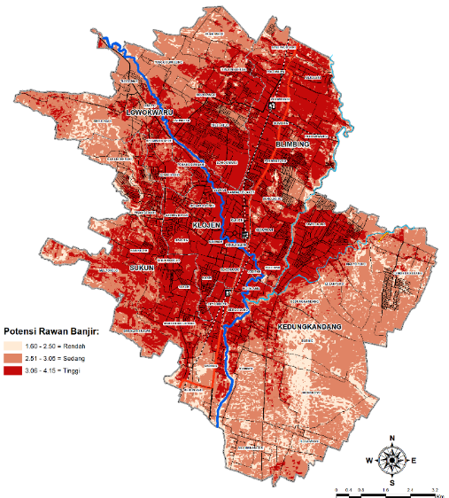
FIGURE 5. Flood Vulnerability Index Map

Connection Coeficient Runoff and Flow Discharge Kala Return
FIGURE 6. Trend Diagram of Linear Analysis of Flood Discharge Period 2002-2022

From (FIGURE 6), it can be seen that the trend in 2022 shows a continuous increase in flood discharge. The discharge continues to rise due to changes in the runoff coefficient value from 2002 to 2022. The relationship between the runoff coefficient and flood discharge in Malang City shows a correlation value using Excel, with an average of 0.9828 for Q2, Q5, Q10, Q25, Q50, and Q100, which is positive. With this return period flood discharge value, it can be observed that the trend is continuously increasing due to changes in the coefficient runoff. One preventive action to reduce the runoff coefficient in order to control the increasing numbers is through reforestation, the presence of infiltration wells, and raising awareness among the government and city residents about environmental concepts.

CONCLUSION

Changes in Land Use in the City of Malang from 2002 to 2022 based on Landsat Satellite Imagery data show that the types of land use that have changed significantly are settlements and agriculture. The settlement area in 2002 was 29.47 Km2, which changed to 68.69 Km2 in 2022, resulting in an average annual change of +24.28%. Meanwhile, agricultural land use decreased from 46.96 Km2 in 2002 to 31.3 Km2, representing a change of -8.37% each year. Based on the analysis results regarding land use, it was found that the runoff coefficient value from 2002 to 2022 has increased. In 2002, the runoff coefficient was 0.2468; in 2007 it was 0.2899; in 2012 it was 0.3457; in 2017 it was 0.3895; and in 2022 it was 0.4119. The average annual change value is approximately 13.78%. In the return period discharge values over the last 20 years, in the first decade, namely the year 2012, the Q25 was 125.60 m3/s with a runoff coefficient of 0.3457, and in the second decade, which is the year 2022, the Q25 was 149.65 m3/s with a runoff coefficient of 0.4119. The changes in flood discharge for the return period are directly proportional to the changes in the runoff coefficient and also the return period of the existing rainfall intensity, where the greater the runoff coefficient, the greater the value of the return period flood discharge.

REFERENCES

- Chapin, F.S., & Kaiser, E.J. 1979. Urban Land Use Planning. Third Edition.Chicago: University of Illinois Press.
- Jayadinata, T. Johara. 1999, Land Use in Urban and Rural Regional Planning. Bandung Institute of Technology.
- Government of the Republic of Indonesia. 2007. Law Number 26 of 2007. Concerning Spatial Planning. Law of the Republic of Indonesia.
- Purnama, A. 2008. Mapping of Flood-Prone Areas in the Cisadane River Basin Using Geographic Information System. Faculty of Forestry, IPB University.
- Sutiyono, Yogi. 2021, Analysis of Land Use Change on Flood Discharge in the Upper Bengawan Solo River Basin, Published by the Islamic University of Indonesia, Yogyakarta.
- Warpani, Suwardjoko. 1990, Planning Transportation Systems, Publisher Institute of Technology Bandung
- Wiwik W O, Samsudin A & Musdaliana. 2013. Land Use Patterns in the Coastal Area of Makassar City, Department of Architecture, Faculty of Engineering, Hasanuddin University, South Sulawesi.
- Asdak, C. 2014 Hydrology and River Basin Management, published by Gadjah Mada University Press, Yogyakarta.
- Abbas, Y.A. 2004. The Relationship of Suburbanization with Changes in Rice Field Land Use and the Factors Affecting It (Case Study of Bekasi City and Regency). Department of Soil Science and Land Resources. Faculty of Agriculture. Bogor Agricultural University.
- Azizah, Nur Sitty dkk. 2021. Analysis of Flood Risk Mapping Level in Bontang Barat District, Bontang City Based on Geographic Information System. Indonesian University of Education.
- Rajiyowiryono, H. 1999. Analytical Methods in Geographic Information Systems, Geographic Information Systems Training, Center for Education and Training of Mining Personnel (PPTP), Department of Mining and Energy, Bandung.

