Analysis of Disaster-Affected Areas Due to the Collapse of the Bagong Dam
Dandy Achmad Yani^{1,a)} ,Suwignyo^{1,b)}, Azhar Adi Darmawan^{1,c)} and
Khoirin Nissa^{2,d)}
¹ Civil Engineering Department, University of Muhammadiyah Malang, Malang, Indonesia
² Postgraduate Students of Water Resources Engineering, Brawijaya University, Malang, Indonesia

^{a)} dandyachmad@umm.ac.id
^{b)} Corresponding author: suwignyo@umm.ac.id
^{c)} azharadidfts@umm.ac.id
^{d)} khoirinnissa26@gmail.com

Abstract. Dam failures can cause massive flooding, which can cause significant damage to property, loss of life, and environmental damage. The failure analysis of the Bagong Dam was conducted using Hydrologic Engineering Center-River Analysis System (HEC RAS) version 6.5 software. The principle is to use a numerical simulation model for dam failure analysis. Three scenarios were created: normal water level conditions without piping (scenario 1), probable maximum flood (Q _{PMF} ) conditions with piping in the center of the dam (scenario 2), and Q _{PMF} conditions with piping in the lower part of the dam (scenario 3). The analysis results showed that the second scenario had the most widespread impact, involving 24 villages.

INTRODUCTION
A dam failure can involve the collapse of part or all of the dam, causing not only material losses but also loss of life. Common causes of dam failure are internal erosion of the embankment or foundation [1], overtopping, and seepage. One action a planner can take is to simulate a dam failure to determine the extent of the affected area and minimize the risk [2].

When a dam collapses and the river capacity is insufficient to accommodate the flowing discharge, water will overflow and inundate the surrounding banks according to lower topographic areas [2]. The inundated areas are not only residential areas, but can also be industrial areas, public facilities, and agricultural/plantation land. Previous research simulated dam collapse due to overtopping from the occurrence of probable maximum flood discharge (Q _{PMF} ) and seepage that occurred in the foundation section [3]. In fact, seepage can occur in other parts of the dam body, especially in the type of earth or rock embankment dam [4].

The primary objective of this study was to determine the extent of the area affected by the collapse of the Bagong Dam. Simulations were conducted considering not only overtopping conditions [5]but also predicted seepage within the dam body. Three scenarios were prepared. The dam collapse scenario was necessary because it is an evaluation process used to predict the potential impacts of a dam collapse.

The analysis was conducted by modeling using the HEC-RAS 1D and 2D programs [6]. The first scenario simulates dam failure when the reservoir is fully filled to the normal water level (without overtopping) and seepage occurs at the diversion intake elevation. The second scenario is overtopping occurs when Q _{PMF} and seepage occurs in the middle of the dam (low water level elevation). The third scenario is overtopping occurs when Q _{PMF} and seepage occurs at the bottom of the spillway.

METHODS
The Bagong Dam is located in Trenggalek Regency, Indonesia. As of 2025, the Bagong Dam is still under construction, and its construction must comply with new dam construction regulations issued by the Indonesian government [7]. The analysis of the areas affected by the Bagong Dam collapse aims to map the inundation of the area downstream of the dam due to reservoir overflow flooding. In general, the analysis consists of four stages (Figure 1):
- Hydrological Analysis
- Dam Collapse Analysis Using the HEC-RAS Program
At this stage, the failure analysis of the Bagong Dam was conducted using the dambreak analysis software, HEC-RAS.6.5. In principle, the dam failure analysis in the HEC-RAS.6.5 program, which is used to conduct the dam failure analysis, uses a numerical simulation model for the dam failure analysis according to the conditions of the three specified scenarios.
- Flood Tracking Analysis & Flood Inundation Analysis and Flood Inundation Map Creation
- Analysis of Affected Areas According to Hazard Zone Classification Provisions

- FIGURE 1. Research Stages for Analysis of the Area Affected by the Collapse of the Bagong Dam

TABLE 1. Bagong Dam Collapse Scenario.
Scenario | Description
I | Dam collapse in conditions (Sunny Day) Reservoir is fully filled to MAN height Piping occurs at El.+258.00 (Intake diversion) Reservoir inflow = 0 m3/sec Ngasinan River (Receiving River) Lateral discharge (Temon River, Plumuran River, etc.) = Baseflow
II | Collapse occurred at PMF flood discharge. Piping occurred in the middle of the dam (Low Water Level) Elv.+297.00 Ngasinan River (Receiving River) Lateral discharge (Temon River, Plumuran River, etc.) = Q10 years
III | Collapse occurred at the PMF Piping flood discharge occurred at the base of the spillway/dam spillway wall contact) Elv.+322.00 Ngasinan River (Receiving River) Lateral discharge (Temon River, Plumuran River, etc.) = Q10 years

The research data was obtained through the relevant agencies, namely from the Brantas River Basin Office as the authorized agency in the construction of the Bagong Dam. The data used in the analysis are the technical data of the Bagong Dam, the design flood discharge of the probable maximum flood (Q _{PMF} ) at peak time of 554.6 m ³ /s, the digital elevation modeling (DEM) map of the Bagong Dam measurements (Figure 2a.), and the situation map of the Bagong Dam resulting from topographic measurements (Figure 2b.). Table 1 below is a detailed condition of the three scenarios:
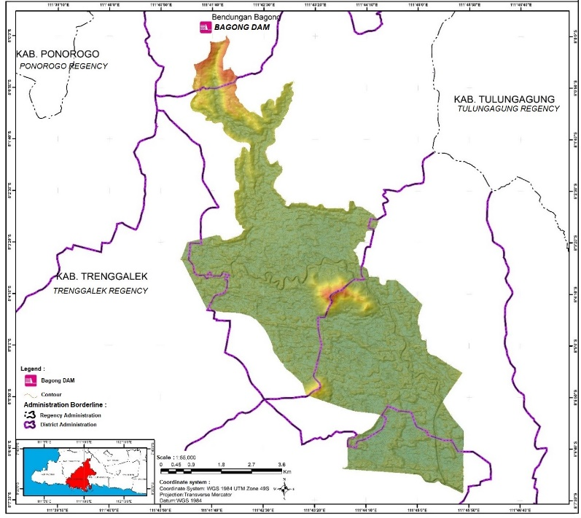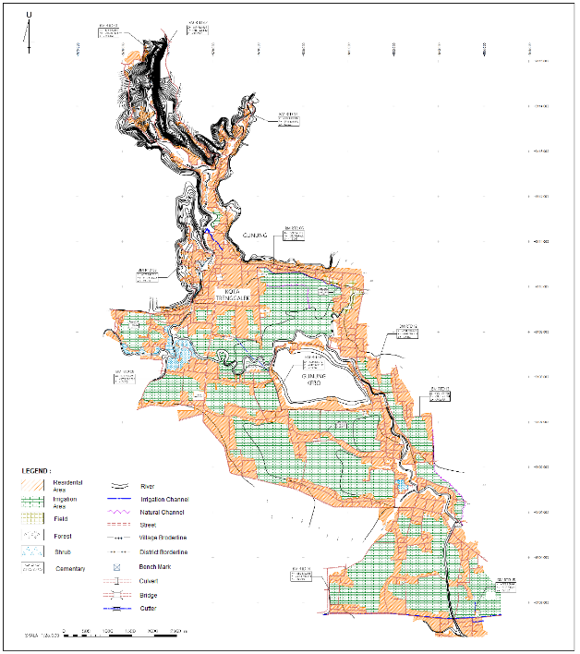
( a) ( b)
FIGURE 2. Map of Bagong Dam Measurement Dem (a), Bagong Dam Situation Map (b)

RESULTS AND DISCUSSIONS
Based on the analysis results of the Bagong Dam collapse using Hec.Ras 6.5 software with 3 (three) collapse scenarios, Scenario II was chosen because it has the greatest impact on the downstream area of the Bagong Dam (Table 2, Figure 3a). The results of Hec-Ras 6.5 overlaid with administrative boundaries, show that 4 (four) sub-districts and 24 (twenty-four) villages in Trenggalek Regency will be affected by flooding. The affected areas are then further analyzed regarding the danger zones experienced. Determination of the Classification of the level of danger of the dam, refers to the "Guidelines for determining the Classification of the Level of Danger of Dams" (Dam Hazard Classification No. 257 / KPTS / 2022, May 30, 2011) issued by the Dam Engineering Center [8]. The results of the analysis of other scenarios in the form of inundation maps can be seen in Figure 3b for Scenario I and Figure 3c for Scenario III.

TABLE 2. Areas Affected by Flooding Due to the Collapse of the Bagong Dam Based on Each Collapse Scenario
SCENARIO | AFFECTED AREAS
SCENARIO | SUBDISTRICT | VILLAGE
I | 4 | 20
II | 4 | 24
III | 3 | 14

The flooding that occurs in flood risk areas from the analysis of the Bagong Dam collapse is used to determine the risk level of the dam in question [6]. The hazard zone classification system is based on water level and inundation speed. This classification system is divided into 3 (three) hazard levels, namely: Low Hazard Zone (Green), Medium Hazard Zone (Yellow), and High Hazard Zone (Red) [8]. From the analysis results of the 24 (twenty-four) villages in scenario II, more details are shown in Table 3 which presents the classification of hazard zones along with the affected area and characteristics of inundation for each village. From the inundation map by depth (Figure 3a) then combined with the inundation map by speed (Figure 4a) will produce an inundation map by hazard zone (Figure 4b).

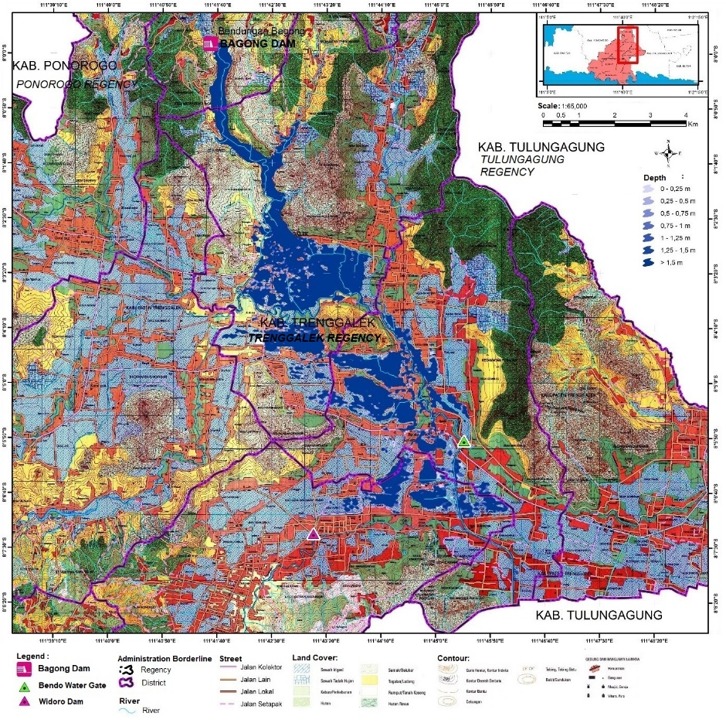  (a) | 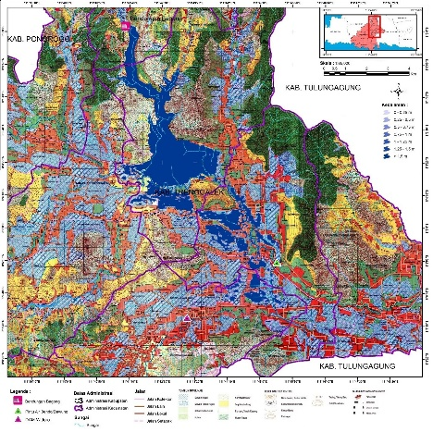  (b)
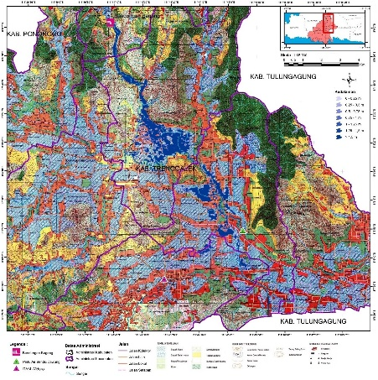
(c)

FIGURE 3. Inundation Map According to Depth Due to the Collapse of the Bagong Dam Scenario II (a), Inundation Map According to Depth Due to the Collapse of the Bagong Dam Scenario I (b), Inundation Map According to Depth Due to the Collapse of the Bagong Dam Scenario III (c)

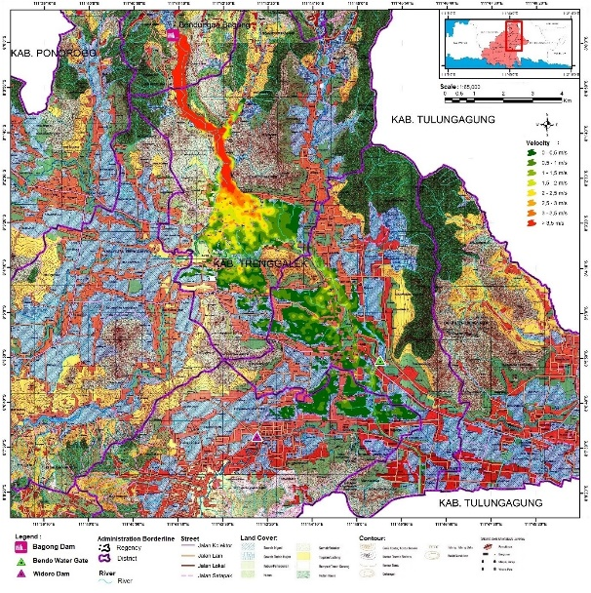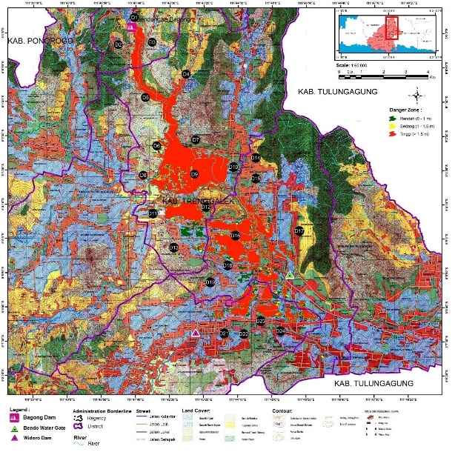
( a) ( b)
Figure 4. Inundation Map Based on Speed (a) and Inundation Map Based on Danger Zone (b).

TABLE 3. Characteristics of Flooding in the Affected Area
NO. | AFFECTED AREAS |  | Area Affected (Ha) | CHARACTERISTICS OF PUDDING |  |  |  | DANGER ZONE
NO. | Village | Subdistrict | Area Affected (Ha) | Flood Arrival Time (hours) | Flood Depth (m) | Speed (m/s) | Low Tide Time (hours) | DANGER ZONE
1 | Sumurup | Dam | 4,487 | 0 | 58.20 | 5.61 | 0.10 | Tall
2 | Sengon | Dam | 41,624 | 0.3 | 9.60 | 5.82 | 12.80 | Tall
3 | Srabah | Dam | 28,802 | 0.3 | 7.50 | 4.54 | 12.80 | Tall
4 | Sumberdadi | Trenggalek | 22,128 | 0.60 | 3.70 | 0.85 | 18.30 | Tall
5 | Ngares | Trenggalek | 126,734 | 0.50 | 2.40 | 4.72 | 18.30 | Tall
6 | Waiting | Trenggalek | 150,038 | 1.00 | 1.90 | 1.08 | 21.20 | Tall
7 | Surodakan | Trenggalek | 162,326 | 1.00 | 2.00 | 1.57 | 21.20 | Tall
8 | Garden | Trenggalek | 19,138 | 1.30 | 1.10 | 0.79 | 21.20 | Tall
9 | Sumbergedong | Trenggalek | 219,166 | 1.10 | 0.90 | 1.65 | 27.50 | Tall
10 | Rejowinangun | Trenggalek | 35,442 | 1.10 | 1.00 | 0.48 | 27.50 | Currently
11 | Kelutan | Trenggalek | 80,643 | 2.00 | 0.70 | 1.22 | 27.50 | Currently
12 | Sambirejo | Trenggalek | 110,653 | 2.00 | 3.70 | 1.42 | 18.30 | Currently
13 | Karangsoko | Trenggalek | 26,216 | 5.20 | 2.40 | 0.66 | 18.30 | Low
14 | Pogalan | Pogalan | 27,830 | 1.60 | 0.50 | 0.65 | 27.50 | Tall
15 | Ngulan Kulon | Pogalan | 1,729 | 1.60 | 0.80 | 0.48 | 30.10 | Tall
16 | Ngadirenggo | Pogalan | 306,331 | 2.30 | 1.00 | 0.84 | 26.10 | Tall
17 | Gembleb | Pogalan | 40,953 | 1.80 | 0.40 | 0.76 | 26.10 | Currently
18 | Ngetal | Pogalan | 41,965 | 5.60 | 0.50 | 0.44 | 27.50 | Currently
19 | Wonocoyo | Pogalan | 20,470 | 6.50 | 0.20 | 0.23 | 26.50 | Low
20 | Bendorejo | Pogalan | 143,417 | 2.60 | 1.40 | 1.01 | 30.30 | Tall
21 | Karanganyar | Gandusari | 18,459 | 13.30 | 0.20 | 0.24 | 31.20 | Low
22 | Melis | Gandusari | 55,811 | 6.30 | 0.30 | 0.39 | 28.00 | Low
23 | Krandegan | Gandusari | 87,952 | 6.10 | 1.20 | 0.55 | 35.00 | Low
24 | Sukorame | Gandusari | 91,369 | 6.30 | 0.80 | 0.57 | 31.20 | Low

As shown in Table 3, Scenario II as the selected scenario has a flood height of 0.2 m – 58.20 m with the highest flood being in Sumurup Village which is the location of the Bagong Dam with an average flood propagation speed of 0.38 m/s. Meanwhile, the flood arrival time is estimated to be between 0.5 hours to 13 hours. Trenggalek District is estimated to receive the greatest impact compared to the other 3 (three) districts, namely Bendungan District, Pogalan District and Gandusari District. It is estimated that economic losses due to the disaster will reach more than two hundred billion. Therefore, as a form of handling, coordination between agencies is needed to support the programmed evacuation plan [9].

In terms of the magnitude of the impact, the scenario that implements piping in the center of the dam actually results in a more extensive inundation. This is due to the faster flow rate or arrival time compared to the other scenarios. This condition, if implemented with the same discharge as scenario III, would certainly affect the river's capacity to accommodate overflow. The faster the flood arrives, the greater the volume of flow, making the river more vulnerable to flooding. This is supported by previous research, which found that the faster the flood arrival time, the deeper the inundation in the upstream and middle reaches [10].

From scenarios I and III, the relationship between the extent of inundation and seepage events in the dam section can be seen. When the elevation where seepage occurs is at the bottom of the dam, flood overflow will be faster so that inundation will be wider, whereas when seepage occurs at a higher elevation, namely closer to the top of the dam, the flood overflow will tend to be slower, resulting in smaller inundation. Therefore, researchers and practitioners more often compile conditions for seepage in the foundation section. Because from a construction perspective, dam foundation work is a crucial part because seepage can appear due to cracks that arise due to consolidation rather than only due to hydrostatic water pressure [11].

CONCLUSION
This study aimed to determine the extent of the area affected by the collapse of the Bagong Dam. Using the HEC-RAS analysis program, flood parameters were obtained, which were then used to map flood inundation from three scenarios. The results of this study indicated that Scenario II resulted in the most extensive inundation compared to the other two scenarios. This could be due to the location of the seepage within the dam. Unfortunately, this study cannot further explore the differences in the location of the seepage, as seepage can occur anywhere in the dam.

References

[1] | MAH Pramudawati, MI Tanjung and R. Ghafara, "DAM SAFETY RISK ASSESSMENT IN EAST JAVA," Jurnal Teknik Hidrolik, vol. 11, no. 2, pp. 93-102, 2020.
[2] | YK Wardana, SK Aziz, RRR Alam and D. Indriyani, "Collapse Simulation of Jatibarang Dam in Semarang City using HEC-RAS 2D Program," Journal of Civil Engineering Applications, pp. 181-188, 2024.
[3] | M. Arifin and MA Budiyanto, "DAM BREAK ANALYSIS IN DISASTER MITIGATION EFFORTS (CASE STUDY IN TEMPURAN DAM/RESERVOIR)," Civil Engineering and Technology Journal, vol. 3, no. 1, 2021.
[4] | Y.-LLQDSSYLBZBSAA-ENASSFAWJ Muhammad Ishfaque, "Hydraulic and Hydroclimatic impact on dam seepage of civil and structural mechanisms with application of deep learning models," Results in Engineering, vol. 23, 2024.
[5] | KWMZJLHC Yongjiang Chen, "Risk analysis and intelligent prediction of dam overtopping considering dynamic reservoir capacity," Engineering Failure Analysis, p. 181, 2025.
[6] | HYDR Aung Pyae Phyo, "Managing dam breach and flood inundation by HEC-RAS modeling and GIS mapping for disaster risk management," Case Studies in Chemical and Environmental Engineering, vol. 8, 2023.
[7] | DAWS Ricky Zefri, "Failure Risk Analysis of Paselloreng Dam Using Event Tree Method," SIKLUs: Jurnal Teknik Sipil, vol. 8, no. 2, pp. 149-160, 2022.
[8] | BTB Indonesia, "File Guidelines: TECHNICAL GUIDELINES FOR DAM HAZARD CLASSIFICATION," May 2011. [Online]. Available: https://sda.pu.go.id/balai/teknikbendungan/pedoman. [Accessed 08 August 2025].
[9] | ZFZCYXJCPZXY Yakun Wang, "Uncertainty analysis of dam-break flood risk consequences under the influence of non-structural measures," International Journal of Disaster Risk Reduction, vol. 102, 2024.
[10] | SYYZXHZLYLJHDWJZJYYX SJHLYL Shubing Dai, "Numerical study of impact pressure and force of cascading dam-break floods on the downstream dam," Journal of Hydrology, p. 648, 2025.
[11] | CFDHCZLY Tianlong Zhao, "Simulation of Landslide Dam Failure Due To Seepage Erosion Considering Vertical Soil Particles Distribution," KSCE Journal of Civil Engineering, p. 29, 2025.

