The Impact of Shear Wall on Medium and High-Rise Buildings Based on The Performance-Based Seismic Evaluation
Maulidah^{1,a)}, Putri Faujiah^{1,b)}, Rizki Amalia Tri Cahyani^{1,c)}, Zamzami Septiropa^{1,d)}
Author Affiliations
¹Department of Civil Engineering, Universitas Muhammadiyah Malang, Malang, Indonesia
Author Emails
^{c)}Corresponding author: rizkiatcahyani@umm.ac.id
ª)maulmaulidah731@webmail.umm.ac.id
^{b})putrifaujiah@webmail.umm.ac.id
^{d})zamseptiropa@umm.ac.id
Abstract. This study evaluates the seismic performance of multi-story reinforced concrete buildings using pushover analysis as part of a Performance-Based Seismic Evaluation (PBSE). Two seismic-resisting systems are examined: special moment-resisting frames (SMRF) and dual systems incorporating shear walls, with building heights of 6, 15, and 30 stories. Capacity curves, performance points, plastic hinge distribution, base shear, and roof displacement are analyzed to assess the structural response under seismic loading. The results indicate that the addition of shear walls in low-rise structures tends to reduce overall capacity due to excessive stiffness. In contrast, for mid- and high-rise buildings, dual systems exhibit higher structural capacity compared to SMRF. Performance point analysis shows that SMRF systems generally perform better across different heights, with performance points shifting less toward higher displacements. Plastic hinge evaluation reveals that SMRF models achieve better seismic performance, with most hinges remaining in the Immediate Occupancy range, while dual systems show slightly greater damage tendencies though still within safe limits. Moreover, dual systems demonstrate higher base shear capacity and lower roof displacements, reflecting improved stiffness and lateral resistance. The comparative analysis suggests that SMRF systems may be more advantageous for lower- and mid-rise buildings, while dual systems provide enhanced lateral resistance in taller structures.
Keywords: Seismic Performance; Special Moment-Resisting Frame; Dual System; Pushover Analysis

INTRODUCTION
Shear walls and building frames generally provide the strength required to resist lateral loads in multi-story buildings. In certain cases, shear walls are much stiffer than the building frames, so they carry the majority of the lateral load (1). The addition of shear walls significantly reduces lateral deflection in both directions and makes structures more rigid. This enhanced stiffness ensures structural stability and effectively minimizes displacement and interstory drift (2).
However, building height significantly affects shear wall behaviour under seismic loads. The aspect ratio of shear walls influences their failure modes: lower ratios are primarily governed by shear failure, while higher ratios are dominated by flexural failure (3). This makes high-rise shear walls more favourable due to their well-understood bending action. On the other hand, the addition of shear walls in tall buildings does not always provide an effective seismic resistance solution, as it may unnecessarily increase building weight and consequently cause higher base shear (4). In some cases, moment resisting frames already offer sufficient ductility to resist imposed seismic loads. Therefore, an analysis to better comprehend the seismic behaviour of buildings with and without shear walls needs to be conducted.
One method that can be adopted to investigate the seismic behaviour of buildings is pushover analysis. Pushover analysis is a static, nonlinear procedure that applies horizontal loads in a prescribed pattern incrementally until failure or collapse conditions are reached (5). The analysis involves pushing the structure laterally and plotting the total applied shear force against the corresponding lateral displacement at each increment. This produces a capacity curve that represents the force–displacement relationship of the structure. Pushover analysis enables the determination of performance points that indicate expected seismic performance levels. The method evaluates structures against established performance criteria, including Immediate Occupancy (IO), Life Safety (LS), and Collapse Prevention (CP) (6).
This paper aims to evaluate the seismic behaviour of buildings using pushover analysis as a tool to perform Performance-Based Seismic Evaluation (PBSE). The seismic resistance systems under evaluation are moment resisting frames and dual systems with shear walls, with varying heights and number of floors. The performance of the buildings under seismic loads is assessed through the generated capacity curves, performance levels, and the development of plastic hinges in the structural elements.

METHODS
In this study, a typical symmetrical building plan is used. Reinforced concrete buildings are made with four different heights, that are 6 floors, 15 floors, and 30 floors which are intended to represent medium and high-rise buildings. The initial planning for the dimensions of the moment resisting frame and dual system with shear wall refers to SNI 2847-2019 (Requirements for Structural Concrete for Buildings and Explanations), with the dimensions of structural elements adjusted for high ductility (Table 1 to 3). A typical story height of 4.0 m and 6.0 m bays is considered for the example buildings (Figure 1 and 2). The live loads are 2.40 kN/m², with the loading width is 6.0 m. The concrete compressive strength for the beam members is assumed equal to 30 MPa. The minimum yield strength of the reinforcement is also assumed equal to 400 MPa. The RC special moment-resisting frame (SMRF) and dual system with SMRF and shear wall is selected as the structural system.
The consideration used is that the building is in an area with a high earthquake risk (taken by an area with high spectral acceleration, S_{S} and S₁) and has a seismic design category of level D. The site class is taken as SE, which means the building is on soft ground. The building load and load combination is calculated based on SNI 1727-2013 (Minimum Load for Design of Buildings and Other Structures). The three models have the same structural conditions, which is the frames (beams and columns) are designed to withstand gravity and earthquake loads. All buildings are designed based on the Indonesian building codes and satisfy the drift criterion and the strong-column weak-beam (SCWB) philosophy. The reinforcement detailing of the beam and column elements conform to the SNI 2847-2019 requirements for RC SMRFs.
The seismic behaviour of the building examples is investigated based on Performance-Based Seismic Evaluation (PBSE) using pushover analysis as the tool. The analysis is conducted using software ETABS. The performance of the buildings under seismic loads is assessed through the generated capacity curves, performance levels, and the development of plastic hinges in the structural elements.

Table 1 Dimensi dan Elemen Struktur 6 Lantai
 | Story | Frame | Dual System
Beam (cm) | All | 30 x 60 | 30 x 60
Column (cm) | 1-6 | 70 x 70 | 70 x 70
S. Wall (cm) | All | - | 30

Table 2 Dimensi dan Elemen Struktur 15 Lantai
 | Story | Frame | Dual System
Beam (cm) | All | 40 x 80 | 40 x 80
Kolom Interior (cm) | 1-3 | 90 x 90 | 90 x 90
Kolom Interior (cm) | 4-9 | 80 x 80 | 80 x 80
Kolom Interior (cm) | 10-15 | 70 x 70 | 70 x 70
Kolom Pojok (cm) | 1-3 | - | 110 x 110
Kolom Pojok (cm) | 4-9 | - | 90 x 90
Kolom Pojok (cm) | 10-15 | - | 70 x 70
S. Wall (cm) | All | - | 30

Table 3 Dimensi dan Elemen Struktur 30 Lantai
 | Story | Frame | Dual System
Beam (cm) | All | 40 x 80 | 40 x 80
Kolom Interior (cm) | 1-6 | 110 x 110 | 110 x 110
Kolom Interior (cm) | 7-12 | 100 x 100 | 100 x 100
Kolom Interior (cm) | 13-21 | 90 x 90 | 90 x 90
Kolom Interior (cm) | 22-30 | 80 x 80 | 80 x 80
Kolom Pojok (cm) | 1-6 | - | 140 x 140
Kolom Pojok (cm) | 7-12 | - | 120 x 120
Kolom Pojok (cm) | 13-21 | - | 100 x 100
Kolom Pojok (cm) | 22-30 | - | 80 x 80
S. Wall | All | - | 35

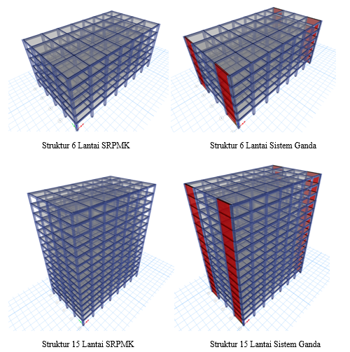

Figure 1 Pemodelan 3D Struktur 6 dan 15 Lantai
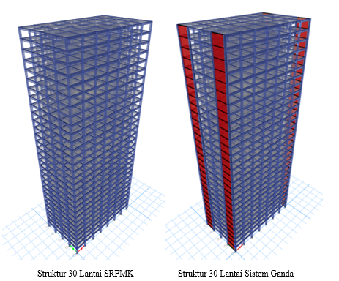
Figure 2 Pemodelan 3D Struktur 30 Lantai

RESULTS AND DISCUSSION
Figure 4 presents the capacity curves of the different building models, derived from the relationship between base shear and structural displacement. In the X direction, the dual system in the 15- and 30-story structures exhibits greater structural capacity compared to the SMRF system. In contrast, for the 6-story structure, the dual system demonstrates lower capacity than the SMRF system, indicating that the inclusion of shear walls in low-rise buildings primarily contributes to increased stiffness rather than enhanced strength.

Figure 3 Capacity Curve in the X Direction
Figure 5 illustrates the capacity curves in the Y direction, where shear walls are incorporated in the dual system. The results show that all structural models with the dual system achieve higher capacity than the SMRF system, with the 6-story dual system in particular exhibiting a significantly larger lateral load capacity.

Figure 4 Capacity Curve Y Direction

The graph in Figure 6 shows the relationship between spectral acceleration, spectral displacement, and structural demand. In the Acceleration Displacement Response Spectra (ADRS) format, the capacity curve is represented by spectral acceleration, which corresponds to base shear, and spectral displacement, which corresponds to roof displacement. The intersection point between the capacity curve and the demand curve is referred to as the performance point, which reflects the structural response to the design earthquake. In this study, the performance points of buildings with different heights were analyzed using values of S_{S} = 1.107 and S₁ = 0.507. The results indicate that the performance point shifts to the right with increasing seismic intensity, suggesting that the structures become more vulnerable to earthquake loads.
Tables 4 and 5 present the number and status of plastic hinges for different building heights and seismic-resisting systems. When the earthquake shaking intensity exceeds the design threshold, the condition of the plastic hinges tends to deteriorate. The results of this study indicate that the extent of plastic hinge failure increases with building height.

Table 4 Number And Status Of Plastic Hinges X-Dir In The Model
Type of Model | No. of Hinges | HINGE STATUS
Type of Model | No. of Hinges | IO |  | LS |  | CP
Type of Model | No. of Hinges | No. | % Total | No. | % Total |  | No. | % Total
6 SRPMK | 1764 | 1432 | 81.18 | 292 | 16.55 |  | 40 | 2.27
6 GANDA | 1716 | 1256 | 73.19 | 457 | 26.63 |  | 3 | 0.17
15 SRPMK | 4410 | 4050 | 91.84 | 319 | 7.23 |  | 41 | 0.93
15 GANDA | 4290 | 3587 | 83.61 | 652 | 15.20 |  | 51 | 1.19
30 SRPMK | 8820 | 7974 | 90.41 | 822 | 9.32 |  | 24 | 0.27
30 GANDA | 8580 | 8171 | 95.23 | 393 | 4.58 |  | 16 | 0.19

Table 5 Number And Status Of Plastic Hinges Y-Dir In The Model
Type of Model | No. of Hinges | HINGE STATUS
Type of Model | No. of Hinges | IO |  | LS |  | CP
Type of Model | No. of Hinges | No. | % Total | No. | % Total | No. | % Total
6 SRPMK | 1764 | 1550 | 87.87 | 214 | 12.13 | 0 | 0.00
6 GANDA | 1716 | 1256 | 73.19 | 457 | 26.63 | 3 | 0.17
15 SRPMK | 4410 | 3946 | 89.48 | 434 | 9.84 | 30 | 0.68
15 GANDA | 4290 | 3587 | 83.61 | 652 | 15.20 | 51 | 1.19
30 SRPMK | 8820 | 7868 | 89.21 | 952 | 10.79 | 0 | 0.00
30 GANDA | 8580 | 7242 | 84.41 | 1232 | 14.36 | 106 | 1.24

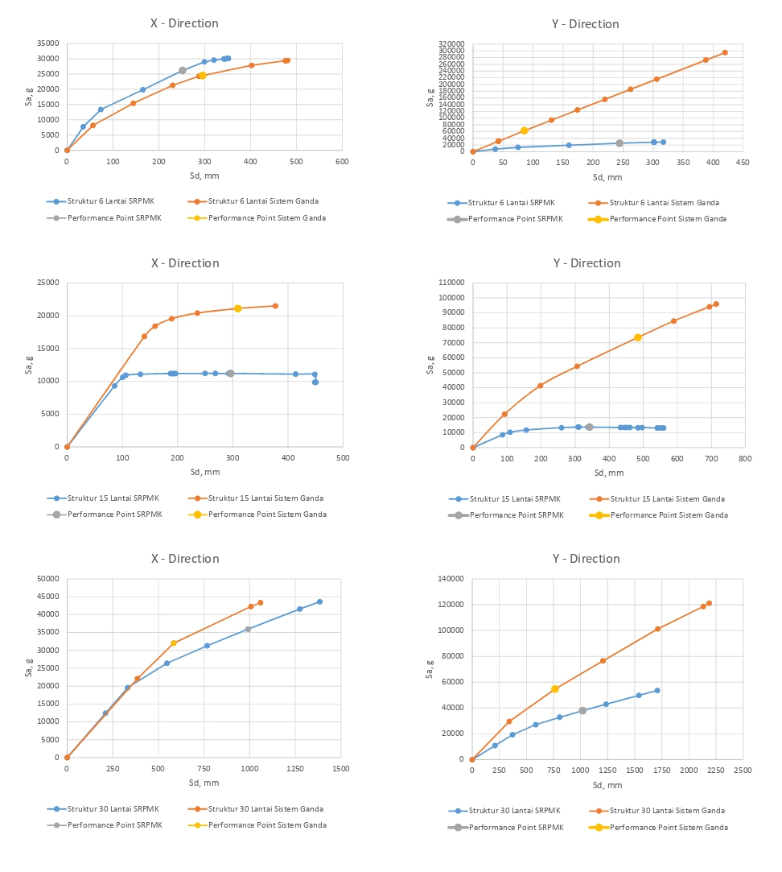
Figure 5 Performance Point Pada Struktur
Tables 6 and 7 present the base shear and roof displacement values at the performance point, which reflect the level of structural damage observed in this study. The results indicate that the structural condition lies between the elastic stage and the Life Safety (LS) performance level, still ensuring occupant safety.

Table 6 Base Shear (V) and Roof Displacement X-dir at Performance Point
Performance Points | SEISMIC ZONE V
Type of Model | 6 SRPMK | 6 GANDA | 15 SRPMK | 15 GANDA | 30 SRPMK | 30 GANDA
V (kN) | 27700.423 | 25158.366 | 11105.391 | 21483.624 | 40719.998 | 40612.974
D (m) | 0.278 | 0.317 | 0.406 | 0.373 | 1.232 | 0.939
Performance level | IO | IO | IO | IO | IO | IO

Table 7 Base Shear (V) and Roof Displacement Y-dir at Performance Point
Performance Points | SEISMIC ZONE V
Type of Model | 6 SRPMK | 6 GANDA | 15 SRPMK | 15 GANDA | 30 SRPMK | 30 GANDA
V (kN) | 26721.384 | 65554.959 | 13411.135 | 76002.413 | 42483.101 | 71861.185
D (m) | 0.275 | 0.090 | 0.470 | 0.508 | 1.218 | 1.113
Performance level | IO | IO | IO | IO | IO | IO

CONCLUSION
The analysis leads to several conclusions. First, based on the capacity curves, the addition of shear walls in low-rise structures results in lower capacity, as the presence of shear walls makes the structure excessively stiff. Second, from the performance points obtained, it can be observed that for all structures with dual systems, the performance point tends to shift to the right, indicating that even up to 30 stories, the use of SMRF systems provides better performance compared to dual systems. Third, the number and status of plastic hinges show that the SMRF models demonstrate superior seismic performance compared to the dual system, with the majority of plastic hinges remaining at the Immediate Occupancy level. Although the dual system models are still within the safe range, they exhibit a slightly higher tendency for damage. Finally, the dual system structures exhibit higher base shear capacity and smaller roof displacements, indicating greater stiffness and improved lateral resistance. All structural models satisfy the Immediate Occupancy criteria, confirming that from a seismic performance perspective, the designs already meet the required standards.

References
1. Surahman A. Modeling Effects on Forces in Shear Wall-Frame Structures. J Eng Technol Sci [Internet]. 2015 May 31;47(2):117–25. Available from: http://journals.itb.ac.id/index.php/jets/article/view/1436
2. Zad N. A Parametric Study on the Effects of Shear Wall Locations in a Typical Five-Story Reinforced Concrete Structure Subjected to a Severe Earthquake. Curr Trends Civ Struct Eng [Internet]. 2021 Sep 15;7(5). Available from: https://irispublishers.com/ctcse/fulltext/a-parametric-study-on-the-effects-of-shearwall-locations-in-a-typical-five-story-reinforced.ID.000675.php
3. Mansour MY, Dicleli M, Lee JY. Nonlinear Analysis of R/C Low-Rise Shear Walls. Adv Struct Eng [Internet]. 2004 Aug 1;7(4):345–61. Available from: https://journals.sagepub.com/doi/10.1260/1369433041653525
4. BAIG MA, Rashid R. EFFECT OF SHEAR WALL ON PERFORMANCE OF MULTISTOREY BUILDING. Int J Eng Sci Technol [Internet]. 2020 Sep 28;4(5):26–39. Available from: https://www.granthaalayahpublication.org/ojs-sys/index.php/ijoest/article/view/IJOEST_111_1
5. Suwondo R, Alama S. Seismic evaluation of reinforced concrete moment resisting frames using pushover analysis. IOP Conf Ser Earth Environ Sci. 2020;426(1).
6. Kalibhat M, Kumar M AY, Kamath K, Kalibhat MG, Kumar AY, Shet S, et al. Seismic Performance of R.C. Frames With Vertical Stiffness Irregularity From Pushover Analysis. IOSR J Mech Civ Eng [Internet]. 2019;(July):2320–34. Available from: www.iosrjournals.org

