Assessment and Improvement of Trans Jatim Bus Stops Performance Based on Minimum Service Standards: A Case Study in Gresik–Surabaya–Sidoarjo

Hilda Surya Agung Hanafi^{’1,a)}, Amalia Nur Adibah^{2,b)}, Khoirul Abadi ^{3,c)}
¹²³Department of Civil Engineering, Engineering Faculty, University of Muhammadiyah Malang, Malang, Indonesia
^{(c)}Corresponding author : khoirul@gmail.com
^{a)} hildasurya3@gmail.com
^{b)}amalianuradibah@umm.ac.id

Abstract. Rapid urbanization and increasing mobility in metropolitan areas necessitate the availability of a reliable, comfortable, and inclusive public transportation system. This study evaluates the feasibility of Trans East Java (Trans Jatim) bus stop facilities performance along Corridor 1 (Gresik–Surabaya–Sidoarjo) based on the Minimum Service Standards (SPM) stipulated in the Minister of Transportation Regulation No. 27 of 2015. A quantitative descriptive approach was employed through direct observation of 34 bus stops, assessing six main indicators: safety, security, comfort, affordability, equity, and operational accuracy.
The results indicate that most bus stops performance do not meet the required standard criteria. In terms of safety, good scores were recorded for lighting and vehicle identification, although the absence of security personnel remains a concern. Security indicators were adequate regarding traffic equipment, but no vehicle storage facilities were available. Comfort was relatively well addressed through cleanliness and boarding/alighting access, yet ventilation and temperature control facilities were lacking. Equity scored the lowest, with accessibility for persons with disabilities largely unmet. Operational accuracy was satisfactory in terms of payment systems, but bus arrival information was accessible only via the mobile application.
Overall, the bus stop facility performance feasibility score was 64 out of 100, indicating the need for comprehensive facility improvements. These findings provide essential insights for local governments and operators in developing safer, more inclusive, and user-friendly bus stops, thereby enhancing public interest and ridership in public transportation.

Keywords: Bus Stops, Performance, Minimum Service Standards, Public Transportation, metropolitan area

INTRODUCTION
The rapid urbanization and increasing mobility of the population in urban areas pose serious challenges in providing adequate transportation systems. The dominance of the use of private vehicles not only causes congestion and infrastructure damage, but also worsens air and environmental quality. This condition demands the development of a reliable, integrated, and environmentally friendly public transportation system as an urgent solution to support the creation of a sustainable city.
Public transportation plays an important role in supporting economic dynamics and the urbanization process. In the midst of rapid urban growth, the availability of an efficient and affordable public transportation system is an important factor in connecting economic and residential hubs. Public transportation enables labor mobility, expanding access to employment, education, and other public services.
Public transportation is one of the more efficient means of transportation than private transportation or private vehicles [1]. The purpose of holding transportation services is to make it easier for residents to drive as well as reduce urban congestion due to the high use of private vehicles compared to public transportation [2]. In supporting public transportation, it is necessary to improve the supporting facilities, namely bus stops as temporary stops for passengers. Bus stops or shelters are places to pick up and drop off bus passengers, usually placed on the bus transportation service network. [3]. Bus stops have an important role in supporting public transportation because as a place for passengers to drop off and board public transportation such as Trans Jatim, the comfort of the bus stop is one of the supporting factors to support the community in riding Trans Jatim.
Equitable distribution of bus stop comfort is an important factor in supporting passengers in boarding public transportation. Vulnerable groups are often not involved in urban development planning, as evidenced by the lack of facilities that can support their mobility. In fact, the rights of involvement and the provision of their needs are listed in the Constitution of the Republic of Indonesia [4]. The procurement of special facilities needed by persons with disabilities includes to provide certainty of fulfillment of accessibility for persons with disabilities in settlements [5]. The facilities in question are guides, barrier-free sidewalks, signs and handrails for people with blind/blind disabilities [6]. lighting, priority seating and interactive information boards for people with deaf/deaf disabilities [7]. , and there are ramp and handrail facilities for people with disabilities [8]
The purpose of this study is to find out about the feasibility of the bus stop from Transjatim Corridor I with the Gresik Surabaya Sidoarjo route, with the observation method and the use of minimum service standards (SPM) on the basis of Ministerial Regulation No. 27 of 2015, as a form of equitable distribution of the feasibility and comfort of passengers at the Trans Jatim Bus stop in corridor I.

METHODS
The method used in this study is a quantitative descriptive method, which aims to provide a comprehensive understanding of the identification of the design elements of the Trans East Java Bus stop. This approach allows researchers to systematically collect and analyze numerical data from users as well as direct observations in the field. The main focus of this study is to evaluate the design dimensions of bus stops, including accessibility, comfort, safety, aesthetics, and the availability of supporting facilities, in accordance with Ministerial Regulation No. 27 of 2015.
Trans Jatim is a bus rapid transit (BRT)-based mass transportation system created by the East Java Provincial Government, in collaboration with the East Java Transportation Office. Trans Jatim is designed to provide safe, comfortable, affordable, and integrated public transportation services. Bus Rapid Transit (BRT) is one of the commonly known modes of public transportation in big cities. Especially in Indonesia [9]. As one way to reduce congestion and air pollution, as well as reduce dependence on private vehicles.

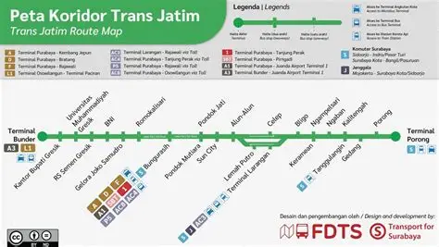
Figure 1. Research Location Route

This research was carried out by conducting a direct survey at all bus stops, using the guidelines of Ministerial Regulation No. 27 of 2015 which aims to find out the direct state of bus stops at the location . In this problem, what is of concern is several bus stops in the city that are passed through (Gresik – Surabaya – Sidoarjo) Because the feasibility and convenience of bus stops is one of the important factors in supporting the Trans East Java BRT and petrifying the community in accessing public transportation services. [10]. Figure 1. Thus the route map of the BRT Trans Jatim Corridor I bus where there are a total of 14 Bunder stops in the city of Gresik, 1 main stop at the Purabaya bus stop in Surabaya, and 19 stops in Sidoarjo City. In corridor I BRT Trans Jatim has a significant route with a distance of 72 – 72.5 kilometers passing through several toll road sections, namely the Surabaya Gresik Toll Road and the Sidoarjo Waru Toll Road, in taking this route it takes approximately 2 hours to go from Bunder Terminal (Gresik) to Porong Terminal (Sidoarjo). At the Trans East Java bus stop, it is also necessary to evaluate the slope of the ramp for people with disabilities because the government is obliged to facilitate users with disabilities to use public transportation services with a slope height of 8% (1:12). To achieve this value, the ramp should be within the facility path zone as much as possible. [6]

RESULTS AND DISCUSSION
This study analyzes the minimum service standards (SPM) regarding facilities and forms of satisfaction from Trans East Java services, especially in corridor 1 by determining security, safety, comfort, affordability, and equality for Trans East Java passengers in corridor 1. Some of the data above is used as supporting data for the research, but in this study the data used uses the Minimum Service Standard (SPM) using Ministerial Regulation no. 27 of 2015.

Observation Data
Based on the data from direct surveys at 34 bus stops, data results were obtained that can be used for facility evaluation materials in accordance with the Minimum Service Standards (SPM) where the data obtained is the amount of feasibility of facilities from 34 Trans East Java stops in corridor 1, from the survey results data were obtained on comfort, security, safety, affordability, and facility equity from 34 stops from Trans Jatim corridor 1.

Table 1. Recapitulation of PM Performance Assessment no. 27 of 2015
No | Type of Service |  | Survey Results | Value
Security
1 | Bus Stop | Lighting Description | 34/35 | 97
2 | Bus Stop | Security Officer | 3/35 | 9
3 | Bus Stop | Security breach information | 25/35 | 74
4 | Bus Stop | Vehicle Identity | 31/31 | 100
5 | Bus Stop | Driver's ID | 31/31 | 100
Safety
1 | Supporting Facilities | Traffic gear | 35/35 | 100
2 | Supporting Facilities | Vehicle storage facilities | 0/31 | 0
Comfort
1 | Bus Stop | Air ventilation facilities | 18/35 | 51
2 | Bus Stop | Cleaning facilities | 35/35 | 100
3 | Bus Stop | Easy boarding and disembarkation facilities | 35/35 | 100
4 | Bus Stop | Transport capacity | 35/35 | 100
5 | Bus Stop | Room temperature control facilities | 3/35 | 9
Equality
1 | Wheelchair-only spaces at the bus stop |  | None | 0
2 | Floor slope and special texture (at the Bus stop) |  | 14/35 | 40
Stop Time at the Bus Stop
1 | Bus Arrival Time Information |  | 3/35 | 9
2 | Information on the bus stops |  | 35/35 | 100
3 | Payment System |  | Available | 100
Final Score |  |  |  | 64

From the survey results from Table 1, it was obtained from direct observation, with 6 variables, namely safety, safety, comfort, affordability, equality, and punctuality of bus operations. In the safety variable there are several aspects that need to be considered, such as the number of officers at the bus stop with a value of 3 out of 34 stops, in the safety variable there is one aspect that needs to be considered, such as vehicle storage facilities because vehicles are stored in the terminal yard. In terms of convenience variables, almost all bus stops do not have room temperature control facilities and air ventilation for each stop. The affordability variable needs to be improved because the availability of integration between routes is used for passengers to find out when vehicles are coming. In the equality variable, each bus stop does not have a special wheelchair space and some access for wheelchairs is considered inadequate because it is too steep. In the operational accuracy variable, bus arrival time information can only be accessed through smartphones.
For service improvement at bus stops, it can be done in detail by calculating the percentage value of each variable, this is used to make it easier to improve services at bus stops, so that in each variable results can be found for service improvement to make it easier to evaluate bus stops.

Passenger Safety Indicators
In the passenger safety indicators, the Trans Jatim corridor 1 route from the table above has a fairly high value because some of the values of several variables are quite adequate including lighting, vehicle identity, driver identification, and information on security disturbances is quite multiply, but in the variable of security officers only at large terminal stops and there are several stops that have CCTV, so there needs to be an increase in the value of passenger safety indicators. The value of the passenger indicator is 76% Suitable and 34% Not Suitable, as shown in the diagram below.
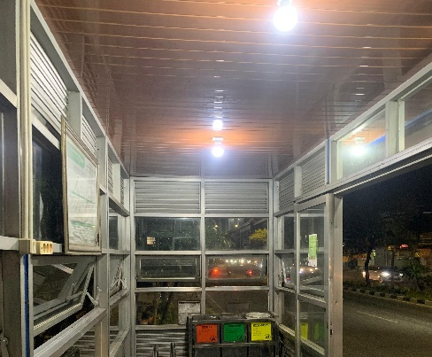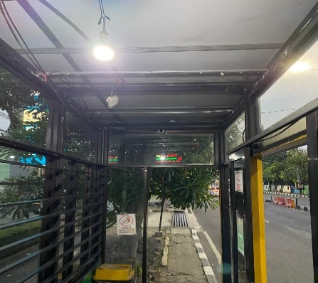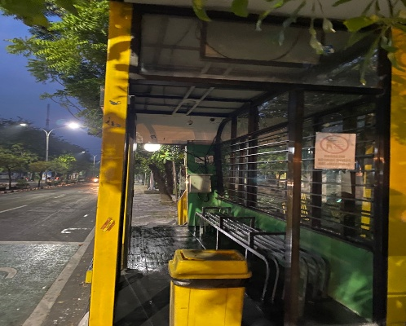
Figure 3. One of the Conditions of Safety Indicators for Trans Jatim

Gambar 4 . Safety Indicator Conformity

Vehicle Safety Indicators

In the safety indicators of the Trans Jatim corridor 1 route, the equipment at the bus stop, both signs and at each stop there are markings for bus stops and there are special signs for the Trans Jatim bus road itself, but for the bus stop there is no place so that the Trans East Java bus vehicle is parked in the main terminal yard, namely the Bunder (Gresik) terminal, Purabaya Terminal (Surabaya), Porong Terminal (Sidoarjo). The value of the food indicator has a value of 50% Suitable and 50% Not Suitable, explained in the salt below
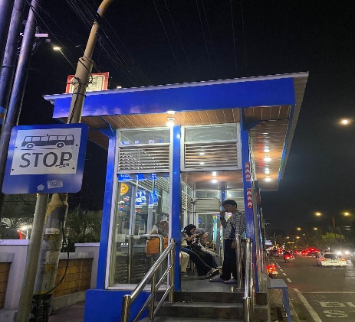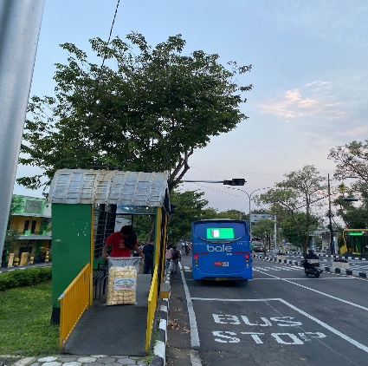
Figure 5. One of the Conditions of Safety Indicators for Trans Jatim

Gambar 6 . Suitability of Safety Indicators

Passenger Comfort Indicator
In the passenger comfort indicator of the Trans Jatim corridor 1 route, several aspects such as cleaning facilities for garbage cans already exist, and are supported by good carrying capacity, but there are some accesses for passengers that are not suitable so that there needs to be a rearrangement for the placement of the bus stop so that it is easily accessible for passengers, with no air ventilation at the bus stop so that the lack of air circulation is inadequate for the value of the indicator Comfort is 72% Suitable and 38% Not Suitable. Explained in the salt below.
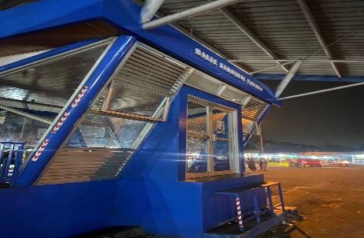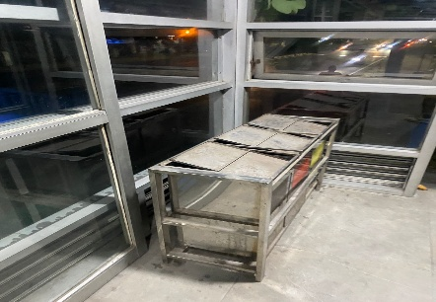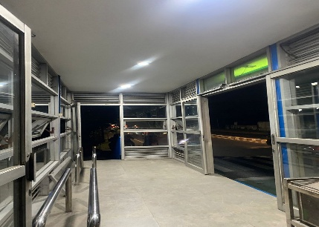
Figure 7 . One of the Conditions of Comfort Indicators for Trans Jatim

Figure 8 . Compatibility of Comfort Indicators

Passenger Equality Indicator
In the indicator of passenger equality on the Trans Jatim6 corridor 1 route at 34 stops does not have a special room for wheelchairs, making it an important problem for passengers with disabilities to enjoy or use public services and on the slope of the ramp has a very steep sharpness and makes the service less than optimal so that there needs to be an evaluation of the improvement regarding the problem for the value of the equality indicator: 21% Suitable and 79% Not Suitable, described in the diagram below.
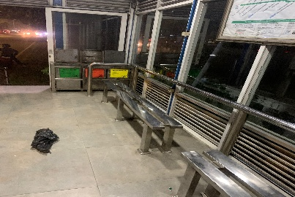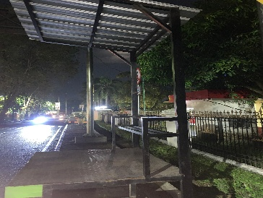
Gambar 8 . One of the Conditions of Equality Indicators for Trans Jatim

Figure 10 . Equivalency Indicator Conformity

Operational Accuracy Indicators
In the Operational Accuracy Indicator, the Trans Jatim corridor 1 route has a fairly complete payment system, which includes direct payments, through the Trans Jatim application, and through digital payment methods, but in the aspect of bus arrival information can only be seen through the application so that not all passengers can access the information board, there are only 3 points so the information is very minimal, The value of the operational accuracy indicator has a value of 70% Suitable and 30% Not Suitable, described in the diagram below.

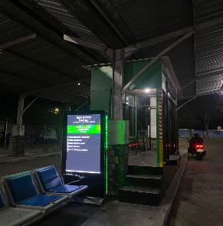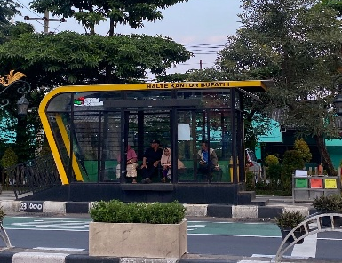
Gambar 8 . One of the Conditions of Operational Accuracy Indicators for Trans Jatim

Figure 12 . Operational Accuracy Indicator Conformity

Indicators of Final Value and Design of Bus Stop Plans
The final score for all bus stop facilities on the Trans Jatim corridor 1 route is presented by covering all assessment variables from security, safety, comfort, equality, and operational accuracy, so that a value of "64" is obtained from the value of all the feasibility of bus stop facilities in corridor 1 Trans Jatim. This needs to be improved for facilities in the Trans Jatim bus service corridor 1 because this is one of the efforts to support the community in choosing public transportation instead of private transportation.

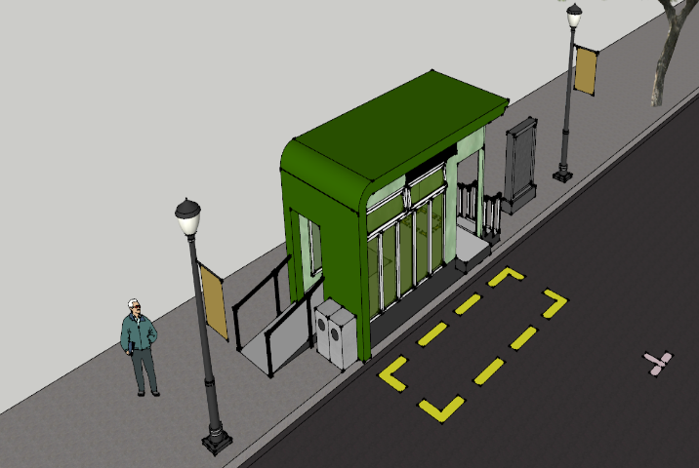
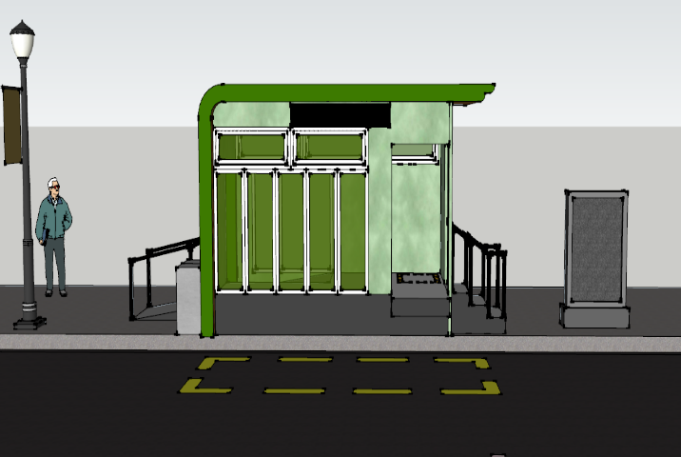
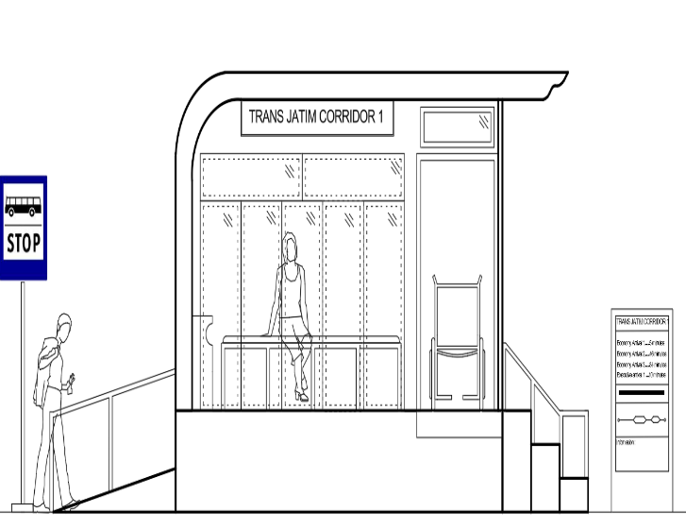
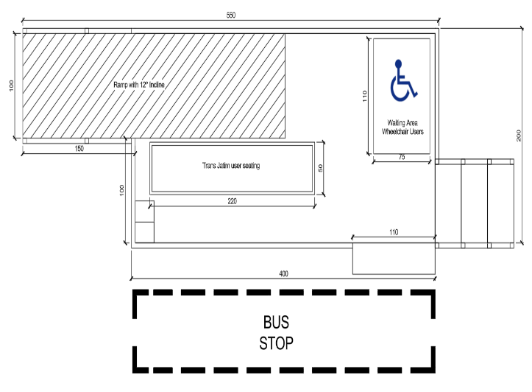
Final design of the plan for the Trans East Java bus stop Corridor route 1

Figure 14 . Final design in bus stop planning

CONCLUSIONS
Based on the results of a study of 34 bus stops in Corridor 1 of Trans Jatim (Gresik-Surabaya-Sidoarjo), it can be concluded that most bus stops have not fully met the Minimum Service Standards (SPM) according to Permenhub No. 27 of 2015. The assessment is conducted based on six key indicators: security, safety, comfort, affordability, equity, and operational accuracy. Security: Quite good in terms of lighting and vehicle identification, but minimal presence of security officers and CCTV facilities. Safety: Adequate traffic equipment is available, but there are no vehicle storage facilities at bus stops. Comfort: Hygiene facilities and access to buses are adequate, but the lack of ventilation and temperature control makes comfort suboptimal. Equality: Almost all bus stops are not disability-friendly, there are no wheelchair-only spaces and decent road access. Operational Accuracy: The payment system is good and digital, but bus arrival information is not yet available at all stops directly, only through the app. The final score of the total feasibility of the bus stop facility obtained a score of 64 out of 100, indicating the need for significant improvements. Overall, the condition of the Trans East Java bus stop in Corridor 1 has not fully met the minimum service standards and requires comprehensive improvements, especially for inclusivity and accessibility aspects. This result is expected to be an important input for the government and operators in improving the quality of safe, comfortable, and inclusive public transportation services for all levels of society, After the final evaluation is carried out and several designs are added in accordance with the provisions of following the Minimum Service Standards of Ministerial Regulation No. 27 of 2015, the result of the final value for the bus stop can be 70-80%. This will encourage the general public to use public transportation services instead of private vehicles.

References
[1] A. Kristianto, “Analisa Performa K-Means dan DBSCAN dalam Clustering Minat Penggunaan Transportasi Umum,” Elkom J. Elektron. dan Komput., vol. 14, no. 2, pp. 368–372, 2021, doi: 10.51903/elkom.v14i2.551.
[2] R. A. Firmansyah and K. H. Putra, “Analisis Tingkat Kepuasan Pengguna Transportasi Umum ‘Suroboyo Bus’ Rute Halte Rajawali-Terminal Purabaya Dengan Metode Importance Performance Analysis (Ipa),” Semin. Teknol. Perencanaan, Perancangan, Lingkungan, dan Infrastruktur FTSP ITATS -, pp. 1–6, 2019, [Online]. Available: https://ejurnal.itats.ac.id/stepplan/article/view/711/612
[3] I. W. Arnaya and I. Ramadhan, “Keefektifan Halte terhadap Kemacetan,” J. Teknol. Transp. dan Logistik, vol. 1, no. 1, pp. 39–44, 2020, [Online]. Available: https://garuda.kemdikbud.go.id/documents/detail/1898974
[4] ITDP, “Rekomendasi Menuju Halte Inklusif Transjakarta,” Inst. Transp. Dev. Policy, pp. 1–44, 2022.
[5] F. M. Karl et al., “PP Nomor 42 Tahun 2006,” Inj. Prev., vol. 13, no. 1, pp. 1–17, 2006, [Online]. Available: http://trid.trb.org/view.aspx?id=676436%0Ahttp://www-nrd.nhtsa.dot.gov/pdf/Esv/esv16/98S10P30.PDF-%0Ahttps://doi.org/10.1016/j.aap.2018.12.017%0Ahttp://kth.diva-portal.org/smash/record.jsf?searchId=2&pid=diva2:499650%0A%5C%5CSg-nwfs1%5CVOL1%5CDep030%5CAbt
[6] K. PUPR, “Pedoman Bidang Lingkungan dan Keselamatan Jalan No. 07/ P/ BM/ 2023 tentang Perencanaan Teknis Fasilitas Pejalan Kaki,” Kementeri. Pekerj. Umum Dan Perumah. Rakyat Direktorat Jenderal Bina Marga, no. 07, pp. 1–84, 2023.
[7] G. Ariya and L. S. Putranto, “Kebutuhan Penyandang Disabilitas Tunarungu Di Jabodetabek Terhadap Layanan Sarana Dan Prasarana Transportasi Kota,” JMTS J. Mitra Tek. Sipil, vol. 3, no. 1, p. 19, 2020, doi: 10.24912/jmts.v3i1.6977.
[8] A. Khairiah, “Perancangan pusat kegiatan mahasiswa universitas lampung dengan pendekatan desain inklusi,” Semin. Nas. Ins. Prof., vol. 1, no. 1, 2022, doi: 10.23960/snip.v1i1.153.
[9] F. Romadlon and Y. Saintika, “Preferensi Pengguna terhadap Layanan Bus Rapid Transit (BRT) Purwokerto-Purbalingga,” J. Manaj. Transp. Logistik, vol. 7, no. 2, p. 154, 2020, doi: 10.54324/j.mtl.v7i2.359.
[10] N. Ikromah, “Informasi Rute Pemberhentian, Tarif dan Halte Bus Transjatim Koridor I Terbaru Agustus 2024 Sumber Artikel berjudul " Informasi Rute Pemberhentian, Tarif dan Halte Bus Transjatim Koridor I Terbaru Agustus 2024 ", selengkapnya dengan link: https://jatim.pi,” Tim Pikiran Rakyat Jatim, 2024.

