Economic Viability and Cost-Effectiveness Analysis of 3D Concrete Printing Technologies in Construction Projects: Assessing the Financial Implications of Implementing Advanced Construction Methods
Dr. Dante L. Silva^{1, a)} Christ John L. Marcos^{1, b)}, Jimmy G. Catanes^{2, c)}, Joanne Alliyah B. Lagao^{1, d)}, Janelle L. Malibiran^{1, e)}, and Jasmine Justine G. Teodoro^{1, f)}
¹ School of Civil, Environmental, and Geological Engineering, Mapúa University, Manila, Philippines
² Commission on Higher Education, Philippines
^{a)} corresponding author: dlsilva@mapua.edu.ph
^{b)} engr.cjlmarcos@gmail.com
^{c)} jcatanes@ched.gov.ph
^{d)} jablagao@mymail.mapua.edu.ph
^{e)} jlmalibiran@mymail.mapua.edu.ph
^{f)} jjgteodoro@mymail.mapua.edu.ph
Abstract. 3D concrete printing (3DCP) is an emerging construction technology with the potential to reduce costs, labor, and project timelines while supporting sustainable building practices. However, its economic feasibility in developing countries, such as the Philippines, remains underexplored. This study assesses the cost-effectiveness of 3DCP in comparison to traditional construction methods by integrating secondary data from industry reports and case studies with survey responses from 100 construction professionals in Metro Manila. A seven-phase methodological framework was applied, incorporating cost analysis, project benchmarking, and statistical tests including Pearson correlation and one-sample t-tests. Results indicate that 3DCP reduces material waste by up to 90%, shortens construction durations, and minimizes labor requirements. Despite high upfront equipment and training costs, respondents perceive strong long-term financial returns, with cost efficiency closely linked to expected ROI. The study identifies adoption barriers, including financial investment, regulatory uncertainty, and skill gaps, and recommends targeted interventions such as policy support, workforce training, and pilot projects to address these challenges. These findings highlight 3DCP as a financially viable and transformative technology capable of enhancing affordability, sustainability, and productivity in the Philippine construction sector.

INTRODUCTION
3D concrete printing (3DCP) is an emerging construction technology that utilizes additive manufacturing to create structures by layering concrete based on digital models, offering precision, design flexibility, and reduced material waste compared to conventional methods^{[1]}. Unlike traditional techniques that rely heavily on manual labor and formwork, 3DCP integrates automation and digital fabrication, enabling streamlined processes and reducing project timelines^{[2]}. Its potential lies not only in cost optimization but also in addressing broader challenges within the construction industry, such as sustainability, housing demand, and workforce shortages.
Globally, the construction industry faces pressure to adopt sustainable practices due to rising carbon emissions and environmental degradation. Conventional building methods generate significant material waste, particularly from formwork and cement overuse. By contrast, 3DCP minimizes formwork and enables precise material deposition, which studies have shown can significantly reduce waste and improve material efficiency^{[3, 4]}. Incorporating supplementary cementitious materials and locally sourced aggregates further lowers costs and environmental impacts^{[5]}. These sustainability benefits, coupled with its design flexibility, position 3DCP as a potential solution for affordable housing, disaster-resilient structures, and rapid urban development.
Economic benefits have also been widely documented. Research indicates that 3DCP can lower project costs per square meter, shorten construction timelines, and enhance profitability^{[6, 7]}. Advances in material mixes, including fiber-reinforced and geopolymer concretes, have further improved durability and structural performance^{[8]}. However, adoption challenges remain. Initial investment in specialized printers, dependence on proprietary additives, and the absence of standardized codes increase financial risk^{[9]}. Moreover, some research cautions that sustainability gains may be overstated, with certain projects even reporting higher material expenditures^{[10]}. In addition, logistical issues and the need for specialized workforce training create transitional barriers^{[11]}. At the same time, digital innovations such as Building Information Modeling and lean construction frameworks, along with adaptable project management strategies emerging from the post-pandemic context, highlight how 3DCP can integrate with broader construction efficiency practices^{[12, 13]}.
Despite these advances and debates, little research has been devoted to Southeast Asia. In the Philippines, construction is still heavily labor-intensive, with low-wage labor forming a key component of project economics. This context raises questions about whether the labor-saving advantage of 3DCP provides the same financial benefits locally as it does in high-labor-cost countries. Recent Philippine studies emphasize the potential of predictive modeling and sustainable practices, such as the use of recycled concrete aggregates and artificial neural networks for forecasting project costs^{[14, 15]}. Furthermore, Metro Manila’s rapid urbanization, chronic housing shortages, and exposure to natural disasters underscore the urgency of adopting efficient, affordable, and resilient construction technologies.
Addressing this gap, the present study evaluates the financial implications and cost-effectiveness of 3DCP in Metro Manila. Specifically, it examines cost efficiency, material savings, labor requirements, project timelines, and long-term financial viability while also identifying potential adoption challenges. The study aims to provide evidence-based insights into whether 3DCP can serve as a feasible and competitive alternative to conventional building methods in the Philippine setting.

RESEARCH FINDINGS AND DISCUSSION

Methodology

Hyphothesis
The study tested two competing hypotheses to evaluate the economic viability of 3D concrete printing (3DCP). The null hypothesis (H₀) posits that the adoption of 3DCP technologies has no significant impact on project profitability and competitiveness within the construction industry. In contrast, the alternative hypothesis (H₁) asserts that the adoption of 3DCP technologies has a significant positive impact on project profitability and competitiveness. By examining cost efficiency, labor savings, project timelines, and long-term financial outcomes, the research aimed to determine whether sufficient evidence exists to reject the null hypothesis in favor of the alternative.

Research Framework
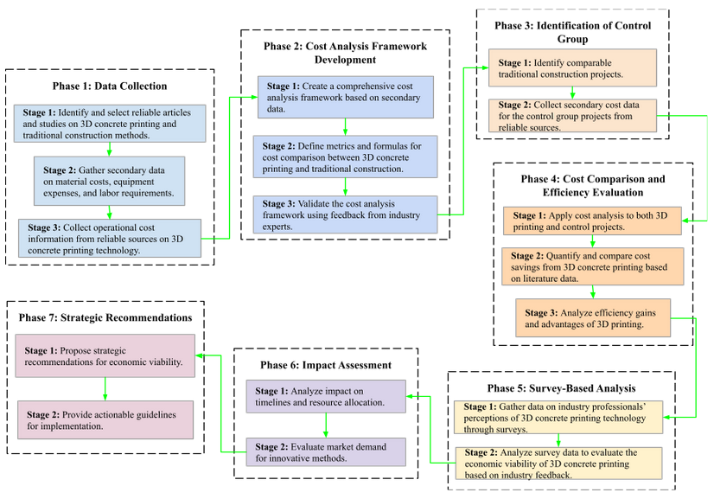
FIGURE 1. Methodological Framework

The methodological framework guided the research process from data collection to analysis and validation. As illustrated in Fig. 1, the framework followed a systematic seven-phase process that structured the study's approach to evaluating the economic and financial implications of 3D printing concrete (3DCP).

Research Design
A quantitative research design was employed, combining secondary data analysis with primary data collection through a survey of 100 construction professionals in Metro Manila. Secondary data included case studies, industry reports, and firm-level information, while the survey captured professionals' perceptions using a 5-point Likert scale. Descriptive and inferential statistics, including Pearson correlation and one-sample t-tests, were applied to test the hypotheses.

Data Collection
Secondary data covered material costs, equipment expenses, labor requirements, and operational details, with examples drawn from case studies in Alaska and New York, as well as technical specifications from leading 3DCP firms such as Apis-Cor and COBOD. The structured survey assessed perceptions of economic viability, efficiency, and challenges to adoption. Respondents were purposively selected to ensure representation from active industry professionals.

Cost Comparison Framework
A cost comparison framework was developed to evaluate both methods, using metrics such as cost per square meter, labor hours, and project timelines. This framework standardized comparisons and was validated by industry experts. TABLE 1 provides a detailed comparison of the leading 3DCP firms, highlighting disparities in setup costs, time, and printing capabilities. Despite variation in cost, most 3DCP systems demonstrate high efficiency and rapid setup, enabling them to cater to large-scale housing needs.

TABLE 1. Comparison of Leading 3D Concrete Printing (3DCP) Firms.
3DCP Firm | Cost | Setup Time | Maximum Build Size
Apis-Cor | $300,000+ (PHP 17.6M+) | Less than 1 hour | 8.5m x 1.6m x 1.5m
Batiprint3D | $300,000 (PHP 17.6M) | Less than 1 hour (2 people) | Unlimited W/L, 4.7m height
COBOD | $600,000+ (PHP 35.2M+) | 1 day | 9m height x 12m width, unlimited length
Constructions-3D | $550,000+ (PHP 32.3M+) | Several hours (2-3 people) | 9.5m x 9.5m x 3.3m
CyBe Construction | $185,000 - $400,000  (PHP 10.9M - 23.5M) | 2 hands-on operators | 2.5m x 5.0m x 4.0m
MudBots | $175,000 - $2.4M  (PHP 10.3M - 141.1M) | 2 hours (2 people) | 1.83m x 1.83m x 1.22m

RESEARCH FINDINGS

Cost Efficiency and Material Savings
The results demonstrate that 3DCP achieves substantial cost savings despite high equipment investments. For instance, in Fairbanks, Alaska, a 1,200-square-foot home exterior built with 3DCP costs USD 12.97 (PHP 762.60) per square foot compared to USD 51.38 (PHP 3,020.99) using traditional methods. Similarly, in New York, 3DCP homes were about 30% less expensive than conventionally built counterparts. Material efficiency also contributed to savings, with reductions of up to 90% through optimized cement-aggregate mixtures and elimination of formwork and scaffolding. Survey data reinforced these findings. As shown in Fig. 2, 35% of respondents perceived 3DCP to offer moderate cost-saving potential, while statistical analysis reported a mean cost-saving rating of 4.21 (SD = 0.58), significantly higher than neutral (t(99) = 8.74, p < 0.001).

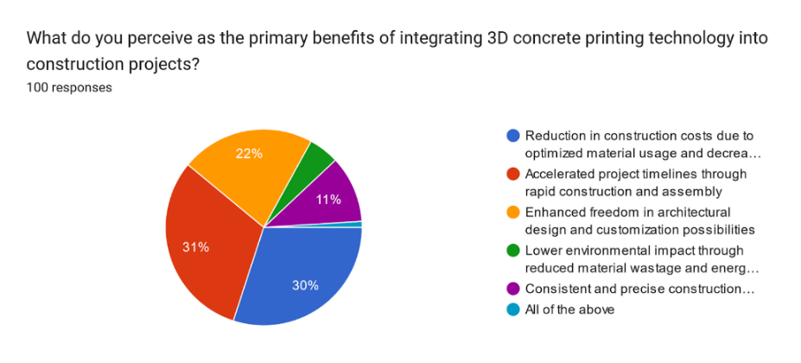
FIGURE 2. Perceived cost-saving potential of 3DCP

Labor Efficiency
3DCP projects typically require only three operators—machine oversight, material handling, and quality control—compared with large, multi-skilled teams in conventional builds. In the Philippines, where daily wages average ₱500–₱800, such reductions translate to significant cost savings. As shown in Fig. 3, 49% of respondents recognized 3DCP as a labor-saving innovation. The overall mean rating was 4.35 (SD = 0.62), significantly above neutral (t(99) = 9.21, p < 0.001). Furthermore, a positive correlation was observed between perceived labor efficiency and economic viability (r = 0.619, p < 0.001).
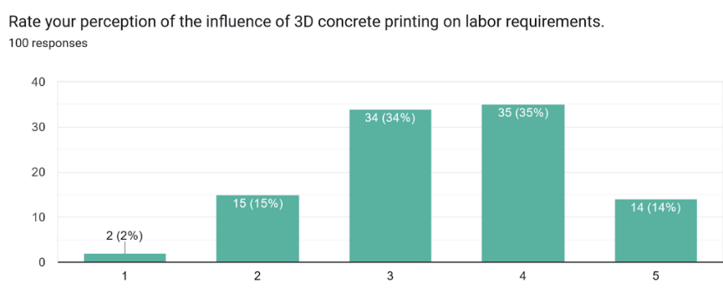
FIGURE 3. Perceived labor-saving impacts of 3DCP

Project Timelines
Construction speed emerged as another significant advantage. Small homes (600–800 sq. ft.) have been completed in under 24 hours, while larger projects (up to 4,100 sq. ft.) were built in 5–36 days, compared to 6–12 months for traditional projects. Fig. 4 shows that 56% of respondents believe 3DCP significantly reduces project durations, with statistical analysis yielding a mean rating of 4.28 (SD = 0.55), significantly higher than neutral (t(99) = 8.93, p < 0.001). These results reinforce evidence that 3DCP can reduce project durations by up to 70%.
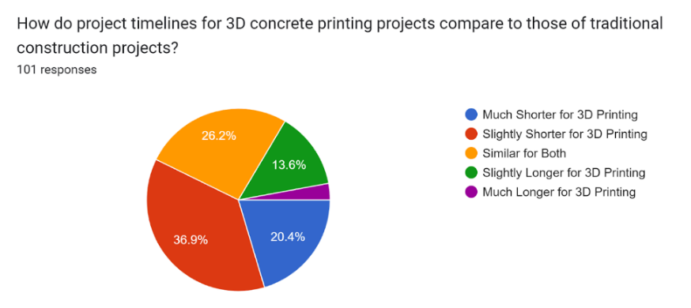
FIGURE 4. Perceived impact of 3DCP on project timelines

Long-Term Financial Assessment
Although upfront investments in equipment (USD 100,000–600,000+) and workforce training remain high, respondents perceived the long-term financial outcomes as favorable. The ROI received a mean rating of 4.10 (SD = 0.61), which is significantly above neutral (t(99) = 7.85, p < 0.001). Maintenance costs were also viewed as moderate, with a mean rating of 3.37. Correlation analysis revealed that perceptions of cost efficiency were positively associated with ROI expectations, highlighting interlinked financial benefits.

Adoption Trends and Challenges
Despite clear economic and operational advantages, adoption of 3DCP remains limited. Survey data showed that 78% of respondents had not observed widespread implementation, while 22% noted emerging applications in affordable housing, temporary shelters, and complex architectural designs. The main barriers included high upfront costs (36%), lack of technical expertise (28%), and regulatory uncertainty (20%). As illustrated in Fig. 5, these concerns highlight the need for training programs, capital investment strategies, and supportive policies to enable broader adoption.
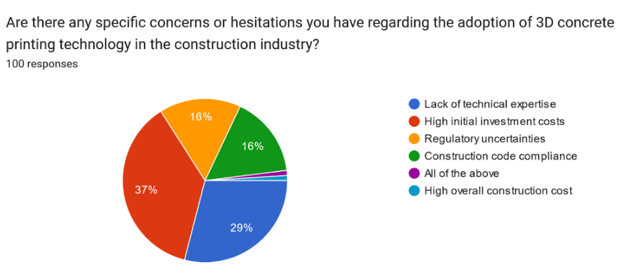
FIGURE 5. Concerns about 3DCP adoption in the construction industry

Future Challenges and Recommendations
Despite its demonstrated advantages, the widespread application of 3DCP in the Philippines is constrained by persistent challenges. The high cost of specialized equipment, lack of trained personnel, and limited regulatory frameworks restrict industry adoption. To mitigate these barriers, targeted interventions such as government subsidies, tax incentives, and the inclusion of 3DCP standards in local building codes are recommended. Collaborative pilot projects focused on affordable housing and disaster-resilient structures can also showcase practical benefits and foster wider acceptance. Furthermore, the development of workforce training programs will be essential to equip laborers with the skills required for operating advanced construction technologies.

CONCLUSION
This study provides empirical evidence that 3DCP outperforms traditional construction in terms of material efficiency, labor reduction, and project timelines, offering strong indications of its long-term economic viability despite the high initial costs. Statistical analyses confirmed positive perceptions among industry professionals, particularly in relation to cost savings and return on investment. Nonetheless, adoption remains limited due to structural barriers that must be addressed at the policy, industry, and institutional levels. Overall, the findings highlight 3DCP as a transformative technology for the Philippine construction sector, with the potential to enhance affordability, sustainability, and productivity if supported by enabling frameworks and strategic implementation.

Acknowledgments
We gratefully acknowledge Mapúa University for funding this research, the professionals who participated in our survey, our advisers and mentors for their guidance, and all others whose contributions made this research possible.

References
- Batikha, M., Jotangia, R., Baaj, M. Y., & Mousleh, I. (2022). 3D concrete printing for sustainable and economical construction: A comparative study. Automation in Construction, 134, 104087. https://doi.org/10.1016/j.autcon.2021.104087
- Inozemtcev, A., & Duong, T. Q. (2019). Technical and economic efficiency of materials using 3D-printing in construction on the example of high-strength lightweight fiber-reinforced concrete. E3S Web of Conferences, 97, 02010. https://doi.org/10.1051/e3sconf/20199702010
- Chen, Y., He, S., Gan, Y., Çopuroğlu, O., Veer, F., & Schlangen, E. (2022). A review of printing strategies, sustainable cementitious materials and characterization methods in the context of extrusion-based 3D concrete printing. Journal of Building Engineering, 45, 103599. https://doi.org/10.1016/j.jobe.2021.103599
- Bakar, M. S. A., Sa’ude, N., Ibrahim, M., & Ismail, N. a. N. (2023). Additive manufacturing (3D printing): A review of current 3D concrete printing on materials, methods, applications, properties and challenges. In Nucleation and Atmospheric Aerosols. American Institute of Physics. https://doi.org/10.1063/5.0120868
- Al-Tamimi, A. K., Alqamish, H. H., Khaldoune, A., Alhaidary, H., & Shirvanimoghaddam, K. (2023). Framework of 3D Concrete Printing Potential and Challenges. Buildings, 13(3), 827. https://doi.org/10.3390/buildings13030827
- Waqar, A., Othman, I., & Pomares, J. C. (2023). Impact of 3D Printing on the Overall Project Success of Residential Construction Projects Using Structural Equation Modelling. International Journal of Environmental Research and Public Health, 20(5), 3800. https://doi.org/10.3390/ijerph20053800
- Vijayalaxmi, J., & Singh, P. (2023). Comparative analysis of concrete 3D printing and conventional construction technique for housing. In Elsevier eBooks (pp. 177–190). https://doi.org/10.1016/b978-0-323-86011-6.00011-8
- Ahmed, G. H. (2023). A review of “3D concrete printing”: Materials and process characterization, economic considerations and environmental sustainability. Journal of Building Engineering, 66, 105863. https://doi.org/10.1016/j.jobe.2023.105863
- Reichenbach, M. (2023, October 25). The Ultimate Guide to Concrete 3D printing in 2023 - 3DSourced. 3DSourced. https://www.3dsourced.com/guides/concrete-3d-printing/
- Hanaphy, P. (2022). Contentious new study challenges the cost and sustainability benefits of concrete 3D printing. 3D Printing Industry. https://3dprintingindustry.com/news/contentious-new-study-challenges-the-cost-and-sustainability-benefits-of-concrete-3d-printing-210694/
- Besklubova, S., Tan, B. Q., Zhong, R. Y., & Spicek, N. (2023). Logistic cost analysis for 3D printing construction projects using a multi-stage network-based approach. Automation in Construction, 151, 104863. https://doi.org/10.1016/j.autcon.2023.104863
- Silva, D., De Jesus, K. L., Villaverde, B., Enciso, A. I., Mecija, A. N., & Mendoza, J. O. (2021, October 29). Interdisciplinary framework: A building information modeling using structural equation analysis in lean construction project management. Scopus. https://www.scopus.com/pages/publications/85120447449
- Silva, D., de Jesus, K. L., Villaverde, B., Torre, R. G. D., Espero, N., Fermin, K. J., & Ramirez, R. R. (2022). Post-pandemic Project Change Management Model: An Adaptable Framework Utilizing Levenberg–Marquardt Algorithm and Dynamic Causal Loop Diagram for Construction Innovation. Scopus. https://www.scopus.com/pages/publications/85125224766
- Malasan, C. M., Villaverde, B. S., Silva, D. L., & De Jesus, K. L. M. (2021, December 4). Artificial Neural Network with Sensitivity Analysis: Predicting the Flexural Strength of Concrete Pavement using Locally Sourced Dilapidated Concrete as Partial Replacement. Scopus. https://www.scopus.com/pages/publications/85126397128#
- Gante, D. V., Silva, D. L., & Leopoldo, M. P. (2022, August 10). Forecasting Construction Cost Using Artificial Neural Network for Road Projects in the Department of Public Works and Highways Region XI. Scopus. https://www.scopus.com/pages/publications/85138315443

