The Evaluating Jakarta's River Pollution through Streamlined Hotspot Analysis

Vieri Leonardy^{1,a)}, Nicholas Jonathan Abdiel^{1,b)}, Andre Meliano^{1,c)}, Fabian Surya Pramudya^{2,3,d)}, and Alfi Yusrotis Zakiyyah^{2,e)}
¹ Computer Science Department, School of Computer Science, Bina Nusantara University, Jakarta, Indonesia
² Mathematics Department, School of Computer Science, Bina Nusantara University, Jakarta, Indonesia
³ Geospatial Artificial Intelligence (Geo-AI) Research and Innovation Lab, School of Computer Science, Bina Nusantara University, Jakarta, Indonesia
^{e)} Corresponding author: alfi.zakiyyah@binus.ac.id
^{a)} vieri.leonardy@binus.ac.id
^{b)} andre.meliano@binus.ac.id
^{c)} nicholas.abdiel@binus.ac.id
^{d)} fabian.pramudya@binus.edu

Abstract. Jakarta, as Indonesia's economic, cultural, and political hub, has long grappled with significant river pollution that has deteriorated its riverbanks. This study offers a comprehensive examination of river pollution by evaluating parameters such as water quality, waste loading, and human activities along the riverbanks. Using publicly available data from the Indonesian government, we employed geospatial analysis on a GIS platform, leveraging a simplified hotspot analysis approach. Our classification results were validated against the amounts of garbage recorded at Jakarta's waste filtering facilities. Qualitative analysis revealed that the heavily polluted downstream areas in western, northern, central, and eastern Jakarta are primarily influenced by human activities and a shortage of filtering facilities, whereas the upstream areas in the south exhibit relatively lower pollution levels. These findings highlight the critical role of government policies on river waste management and public behavior, and they also pinpoint potential sites for future garbage filtering facilities to alleviate the pollution burden on downstream areas.
Keywords: Hotspot; GIS; polluted; qualitative analysis.

Introduction
In the previous 25 years, the Jakarta Metropolitan area have seen tremendous growth and development, particularly in the industrial and other economic sectors. A consequence of this multisectoral development is related to urbanization dan the density population. Milledge et al. [1] found that population density controls microbiological contamination across the river in their research. Study about river in Jakarta, this province is located on lowlands with an average height of 8 meters above sea level at the river estuary and crossed by 13 rivers, all of which empty into Jakarta Bay. Many previous researchers are showing the severity and distribution of Jakarta’s polluted river. The study of Krukut River, one of the rivers used as the source of drinking water, in [2] concludes that the water quality standard is heavily contaminated in all observation points by the domestic waste, with potential domestic contamination load in the the river was found high reaching up to 203562.89 kg/day, 275814.4 kg/day and 190562.7 kg/day for BOD, COD and TSS values respectively on its worst section. A study in [3] showed a comprehensive assessment of a single unit Water Quality Index derived from physical, chemical, and biological parameters of the river. The calculation result of the Water Quality Index value shows that 83 % of rivers and 79 % of ponds in Jakarta are at a very concerning level
Three main rivers are flowing into Jakarta Bay such that the Cisadane River in the west, the Bekasi River in the east, and the Ciliwung River which flows through the center of Jakarta. Ciliwung River, which divides the province into the north-east and south-west sides, is widely known as one of the most important rivers in the province. [4]. In addition to these three main rivers, several small rivers and streams flow from the southern to the northern part of the province, helping to flow and drain returns. Approaching Jakarta, the potential for pollutants to contaminate the river increases because the rivers flow through residential areas, business areas, and industrial areas, where the drainage and sanitary infrastructures are becoming worse. Organic matters are the main sources of domestic pollution in the Ciliwung River, besides pesticides and heavy metals from industries [5]. Because of how the Jakarta residents thread their garbage is always the main problem in Jakarta, always on handling the amount of garbage in the riverbank and the ground area is not enough, it is just too much waste produced by the household and any kind of activity area. Most of the garbage and waste is usually in a form of solid is plastic and that is very common to see in the river. Other than plastic, the most containment of the river is chemical detergent and scrap of food or organic materials. From all these problems, we want to research more into how to handle them in certain places and find what is the place that causes these problems the most.
This research aims to expand the previous research and approaches by incorporating geographical information systems and analysis to visualize and assess the river water quality of Jakarta. Instead of focusing on a particular river, we utilized many layers of government-published datasets and spatially analyzed the entire Rivers in the Jakarta Province are

AREA AND DATA

In this research, we use data from the Open Jakarta data and Jakarta Satu. All the data is free to use and all the data is taken in the year 2020, the reason we choose the year 2020 is that we want it to take place closer to the year 2021 and see the situation now. The Data is mostly have been reported or analyzed by media and agencies that involve with the environment, the dataset is mostly in a form of an Excel sheet that constructs columns and rows, and data spatial location. The data that we use is mostly from websites (Open Jakarta) and (JakartaSatu).
TABLE 1 Below shows the dataset used in this research
TABLE 1. Dataset description
Data Name | Data Form | Description
Data_Kualitas_Air_Sungai_Tahun_2020 | Excel | This data is used to understand the quality of the Jakarta rivers water that has been analyzed, consisting of the polluted categories, all the elements quality standards, and the location.
Lokasi_Saringan_Sampah_DKI_Jakarta_2020 | Excel | This data map all the location of filter dam all across DKI Jakarta river
Sungai_Garis | Layer | The location of specific rivers in DKI Jakarta
Sungai_Garis_Kategori | Layer | The location of specific rivers in DKI Jakarta that has been set into different category line of the river quality
Location_of_Traditional_Market | Layer | The location of all registered traditional market in DKI Jakarta
Batas_Kec_DKI_Jakarta_Update | Layer | The boarder of DKI Jakarta districts that consist of West, North, East, South, Central and Regency

All the data sheets are included with a coordinate system of longitude - latitude we using (WGS 1984). We using this type of coordinate because is easy to understand and easier to find all across the internet. The form of the sheets data that we found are raw data and mostly consist of attributes that we don’t want to use, so we do normalize.

METHODOLOGY
This research uses quantitative methods with knowledge of Geographic Information System. There are several geoprocessing tools such as ArcGIS web, ArcGIS dashboard, and ArcGIS Pro to apply statistics to data. Most of the work is bases on this figure below FIGURE 1.
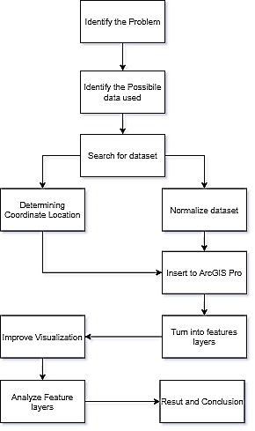

FIGURE 1. Research Flowchart

The first stage in our research is to identify the problem base on the information of real-world problems, research reference, and reported by media or agencies. The second stage is to identify the data used for a certain problem that has been found. Most of the data is found on the public use dataset website it's free and can be used for study or research purposes only. the dataset is mostly in a form of the final analysis or report. The third stage is to search the dataset that we want to found, some of the websites that we have found are from different types of Indonesia environment agency.
The hotspot calculation is conducted using spatial statistical model, based on equal distance weighting of all the objects inside the Jakarta Province boundary for each feature (water quality, market, etc.). Assume that Xj is the attribute value for feature j, wi,j is the spatial weight between feature I and j, n is equal to the total number of features, according to [1], the local hotspot statistics for each parameter is obtained via the equation

$$G_{i}=\frac{\sum_{j=1}^{n}{w_{i,j}x_{j}}-\overline{X }\sum_{j=1}^{n}{w_{i,j}}}{S\sqrt{\frac{n\sum_{j=1}^{n}{{w^{2}}_{i,j}}-{(\sum_{j=1}^{n}{w_{i,j}})}^{2}}{n-1}}}$$
(1)
Where

$$\overline{X }=\frac{\sum_{n=1}^{∞}{\left(a_{n}\right)}}{n}$$
$$S = \sqrt{\frac{\sum_{j=1}^{n}{{x^{2}}_{j}}}{n}-{(\overline{X})}^{2}}$$
(2)

The result of G_{i} is the estimated value in z-axis for each pixel or points, thus required no further calculation. The Gi value from each of the parameter layer then combined based on the equally weighted linear Multi Criteria Analysis [3], [6], [7], [8]. Assuming that all the parameters have equal contribution to the river water pollution, each of the parameter will be equally weighted. Finally, the aggregate index of overall linear combination is calculated using equation

$$LC = \frac{1}{n}\sum_{j=1}^{n}{w_{i}G_{i}}$$
(3)

Where LC is linear combination result, as the new z-axis value for the final layer, n is number of parameters, Wi =1 is analytical weight value.

The fourth stage is to normalize the dataset into a table that we want with all the attributes we have chosen and the second thing that needs to be done is to determine location point base on the coordinate we use the coordinate is longitude and latitude. After that, we are ready to load it into ArcGIS Pro and convert certain attributes into feature layers and spatial data. Before we start the feature analysis layer, we enhance the visualization of certain features with color contrast and position to observe and identify them more clearly. And then start the analysis.
Most of the analysis that we have done is mostly using overlay methods or multiple layers, before analyzing the data layers, we will be set into another form of data or add any type of attributes Ex(turn one of the data into hotspot analysis, or add a new field to the attributes table, or using a certain selection in one layer), after that we determine what we found and is it what we think or want to happen.
Finally, after we found the result and what we got, we give a conclusion on what's happening and what's the solution for a certain problem. All the problem that we want to solve is the state of water quality in a certain river area, how many garbage and waste in a certain part of area with what kind of waste and what place is produce the most garbage and waste in area of Jakarta

Result and Discussion

In this part, we analyze the quality of the water and amount of garbage near a certain area of Jakarta. The analysis is done using ArcGIS Pro software for geoprocessing with a simple type of overlay analysis to determine a certain part of the area and what sort of pattern we can find with all the data we use.

WATER QUALITY
To find out the water quality in every river in Jakarta we use a dataset (Sungai_Garis) The river line layer, (Data_Kualitas_Air_Sungai_Tahun_2020) that has been analyzed by (DKI Jakarta Provincial Environment Agency) in the month of April - May year 2020. The data mostly shown a certain type of elements with a range of quality standard, in each river has 4 to 6 different sample of water taken by the agency and analyzed by using their lab equipment, the final result of each element is the amount of how much element in that one place or sample.
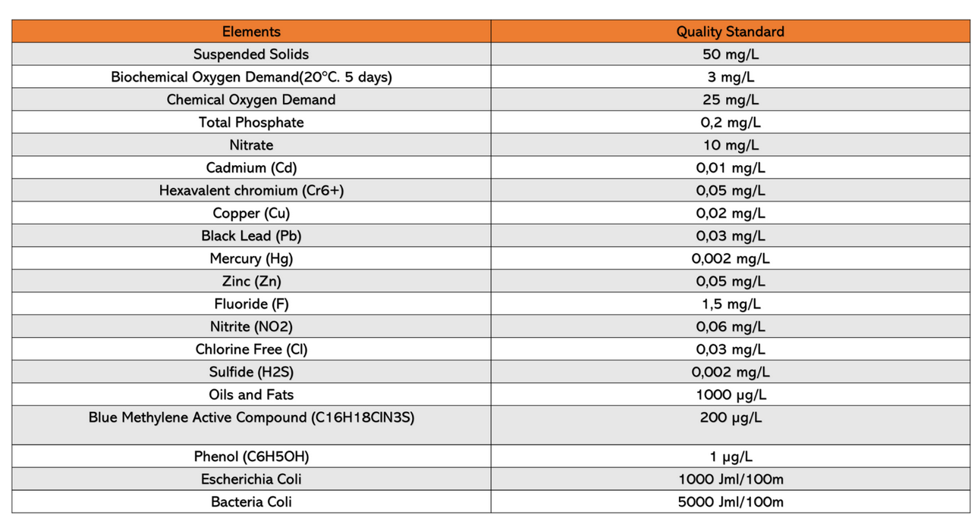
This figure below FIGURE 2 is all the elements that they want to find with a certain rage of quality standard.
For all the river will be categorized into 3 different category that is (Cemar Berat: Heavily Polluted), (Cemar Sedang: Mid Polluted), and (Cemar Ringan: Low Polluted). In each river will get a certain category, depending on how many elements are beyond or less than the quality standard. And that is all the dataset that we have use to determine the water quality and where is all the place is the most polluted quality of the river water in Jakarta.
FIGURE 2. Elements with certain tange of quality standard
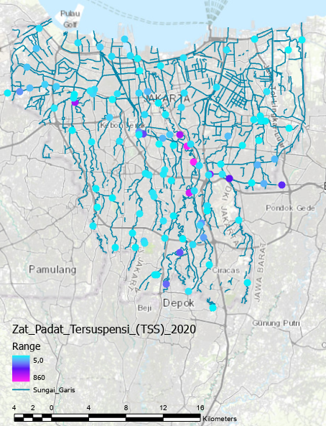
FIGURE 3. Satellite photos using ArcGIS Pro (Application written in Indonesian)

In ArcGIS Pro, the process is we separate all the different type of elements and visualize using (unclass color) and (hotspot) to find a certain pattern and most of the feature will be point feature to represent it. One of the elements shown in FIGURE 3 is suspended solids, the color is between the blue and purple ranges, the more values past the quality standard distance the more purple the color get, the figure using a scale of 1:220.000.
By doing this visual, we can determint what type of elements got the most beyond quality standart that has been determint by the agency. Other visual for hotspot can be use for seeing all the hot zone of the elements the more densy it’s the more that particular element in that area.
Finally, with the data (Data_Kualitas_Air_Sungai_Tahun_2020) we also can see what area is beyond the quality standards are, that has been set and detriment by the agency and we visualize the location of the most polluted areas in the city of Jakarta can be seen in FIGURE 3 the point color red is most polluted, yellow mid polluted, and green is less polluted, and in FIGURE 4 is a converted point feature turn into the river line some of the river line are not connected properly so we change it manually and some are unidentified.
It can be seen in FIGURE 5 that the most polluted areas of Jakarta's water quality are the north and center of Jakarta and another pattern can be seen along the river to the less polluted south side of Jakarta. The main reason is that the river water flows from the highest point of ground and flows along the way through the lowest side of the ground and eventually into the sea and the polluted water on the southern side is taken along with the river flow. and second reason central Jakarta is heavily polluted is that the densest and crowded part of all city of Jakarta is the central part. The number showed the most polluted is about 83% and mid polluted is 16% and the less polluted is only 1% that location is in the (Kalibaru Barat River).

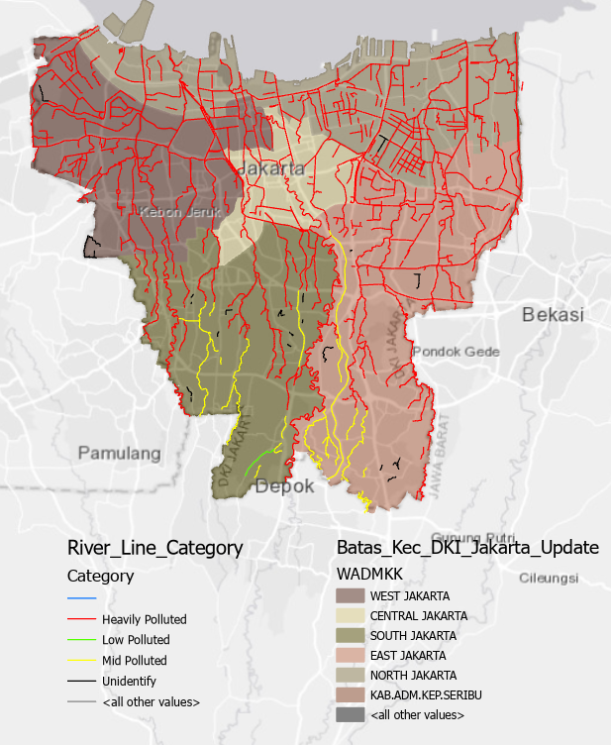
FIGURE 4. Converted point feature (Application written in Indonesian)

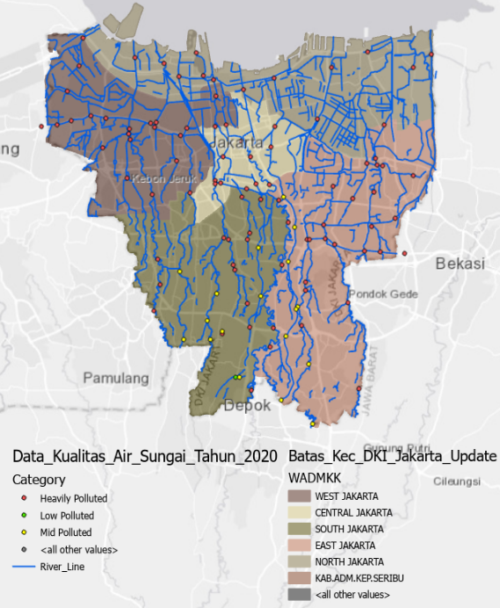
FIGURE 5. River water quality data (Application written in Indonesian)

We have determinant the elements that have beyond the quality standard, and usually end it up in the reivers, they are Suspended Solids, Biochemical oxygen demand, Chemical Oxygen Demand, Escherichia Coli, Bacteria Coli.
The main reason why suspended solid is one of the most polluted is because it's mainly in a form of plastic, dirt, sand, and random solid stuff sometimes it can be absolutely random garbage or use things example mattress, cloth fabric, wood, scrab of tin, and metal.
For Biochemical oxygen demand and Chemical Oxygen Demand is the need for oxygen in the water and those elements are considered the need is lower because of the mix-up chemical and detergent that lower the oxygen. The process is when a certain type of bacteria or small organisms in a river trying to use oxygen to reduce the amount of unwanted chemicals, the more waste or chemicals in the river the more bacterial need oxygen to reduce the chemical. And for Escherichia Coli and Bacteria Coli is the waste produce by humans and animals but it mostly human waste from the sewer that connect it to the rivers stream.
All the element locations can be seen in this Fig.5 (Suspended Solids), Fig.6 (Biochemical Oxygen Demand), Fig.7 (Chemical Oxygen Demand), Fig.8 (Escherichia Coli and Bacteria Coli). The way we visualize the pictures is using a heatmap or hotspot, because it’s the easiest way to see a certain area more clearly with a radius of 20, weight field of the number of elements in that single point feature, Color Scheme Heat Map 1 Semitransparent, Method dynamic and all the description feature in this FIGURE 9, the pictures in a scale of 1:220.000.
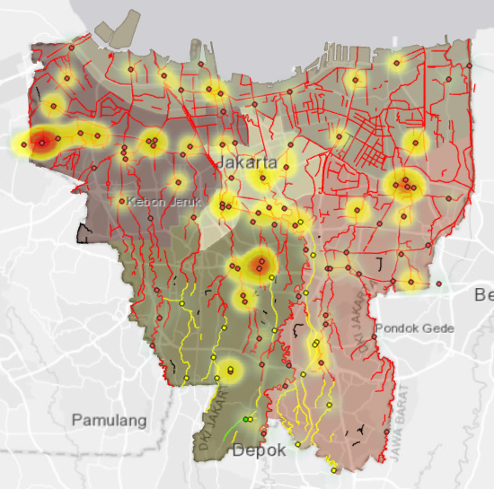
The element Suspended Solids from Fig.5 Average 100 (mg/L), we can see that the densest area is in central DKI Jakarta between district east of Jakarta and the upper site of south Jakarta mainly the river of (Ciliwung) and (Kalibaru Timur) both of the rivers are a natural river where it's the oldest river in Jakarta and it was reported that it is one of the most polluted rivers in Jakarta.
FIGURE 6. The element Biochemical Oxygen Demand

The element Biochemical Oxygen Demand from FIGURE 6 Average 16 (mg/L), by the look of the figure we can see that most area of this element is reduced almost nothing and there are only a few areas left that has a good amount of Oxygen mostly in East Jakarta, left side of West Jakarta, and some in central Jakarta. It's no good for this element to reduce too much, the need for oxygen for living microorganisms and any living things in the river is very important, microorganisms can help reduce chemicals waste or any type of chemical in the river, because there is too much waste to handle the oxygen is depleted and for many living things like different type fish are going to die and their food chain will be ruin.
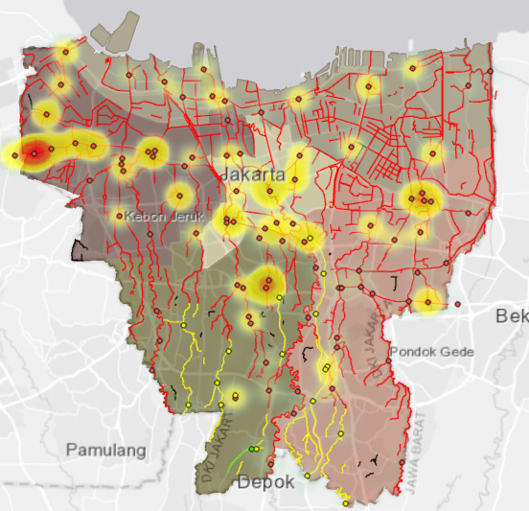
FIGURE 7. The element Chemical Oxygen Demand

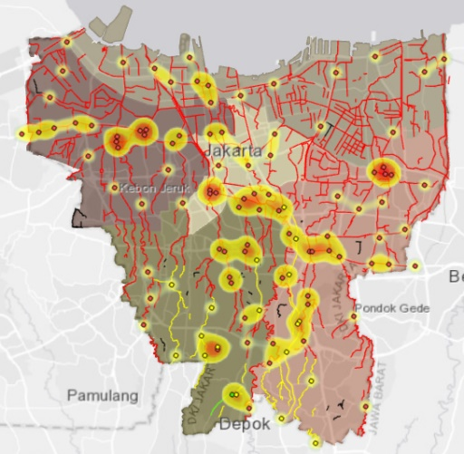
The element Chemical Oxygen Demand from FIGURE 7, Average 47 (mg/L), it’s an element that is almost the same has (Biochemical Oxygen Demand) but the main purpose of this element is to oxidation of organic matter in water, the area location is almost the same is in East Jakarta, left side of West Jakarta, and some in central Jakarta.
FIGURE 8. The element Escherichia Coli

The element Escherichia Coli from FIGURE 8, Average 177.585.076,9 (Total/100 mL) and Bacteria Coli from Average 128.671.813,2 (Total/100 mL) the same Fig.8, both of these elements is basically the same because it is a type of organic waste bacterial produced mostly by humans, so human waste, by the look of the figure both share similar area and it mostly covers all river area in DKI Jakarta the densest area is in central Jakarta, it’s because the sewer of DKI Jakarta is connected to the river stream and it will flow to direction of the ocean. And it’s pretty common for human waste washup into the river around the world, but by the look of it, it’s a lot of human waste washup into the river DKI Jakarta and that indicates the city of Jakarta population is really dense.
THE MOST PRODUCE WASTE
In the next part after finding the most polluted quality of river water, now we move on to the next part of the analysis is to find a certain location of the river that produces the most waste. In this analysis, we have found 3 type of places that is great to identify the activity of producing waste, that is House hold, Traditional Market, and Filter Dam. The reason we picked these particular places is that in Indonesia they are the most polluted place and we want to know which one is the most produce or got the most garbage and waste, with that information and data that we have, we can observe their condition of that particular location.
TRADITIONAL MARKET
The activity of the Traditional Markets in Indonesia is always so crowded with different kinds of vendors roaming around the market and sometimes the vendor put their stand in the ground and most of the vendors are selling foods or organic items like fruits, vegetables, meats, and spices according to all the reports of the statistic sectoral of DKI Jakarta. Most DKI Jakarta Traditional Market garbage and waste, is handle properly by the Business Manager in every Traditional Market, It was recorded that every month in every market produce about 430 tons of garbage and waste, and almost 20% of garbage and waste is not recorded to the final disposal dump. But most of the garbage was thrown into the street or near the river, and that is about 80 ton of all different kind of garbage and waste. To identify the problem, we will use a data set of all the locations of Traditional Market in all Jakarta with an attribute of the location coordinate, name of the market, and district of the market. With that we try to find which market is the most near each other to the river, and maybe it can be used for handling a certain market waste more properly.
HOUSE HOLD
House Hold consider to be the most produce garbage and waste in the river and the drainage, The activity of the average household is producing the most of detergent, scraps of food, wet garbage, and plastic. It was recorded by (Central Bureau of Statistics). There is no knowing which populated area throws the most garbage and waste because all the near river from household is almost in category (most polluted). We consider that every household in all of Jakarta is producing it.
FILTER DAM
We choose filter dam because this particular location can identify a certain area or place that near the river and by using Filter Dam to identify which dam filter got the most garbage and waste in their filter and with filter dam we can see a pattern by visuals using ArcGIS Pro where it all goes and end up. The method is by using unclassed color symbology and using the (average waste/month m3) in each filter dam as the weight field. Shown in Fig.10 are all registered locations of DKI Jakarta traditional market, and with this location, we want to find which market is close to each other and close to the river the most. We use kernel density analysis to find the densest area. After we find what the densest area, we then combine the category line to see if the densest area is polluted to the rivers, And the final result is in Fig.12 with the pictures in a scale of 1:220.000.
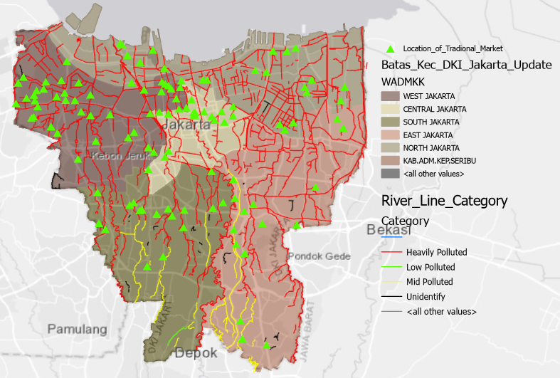
FIGURE 9. Scheme Heat Map 1 Semitransparent (Application written in Indonesian)
From the observation on Fig.11 we can see that the densest area of the traditional market is located in the middle north side of Jakarta, some in the upper site of south Jakarta, and farther away in the west of Jakarta. These are the places that we consider the most produce polluted waste to the rivers, the densest is located in Northside of Jakarta and the specific places of the traditional market in the central Jakarta are (Pasar Mangga Besar), (Pasar Timbul Kartini), (Pasar Asem Reges) they are the places that need observation and management more carefully by the government or the manager who handle the waste.
The final spot of this analysis is the filter dam location, using data around DKI Jakarta, can be seen in Fig.12 using the data (Lokasi_Saringan_Sampah_DKI_Jakarta_2020) with visualization of unclassed color with the field of the (average waste volume/month m³) year 2020. And finally in Fig.13 we used every element hotspot that has been set, we going to layer it all together with a filter dam location to see is there a location that needs a new filter dam location, what area of the river is the most contaminate by chemical waste, and is the elements in the certain area affecting the filter dam.
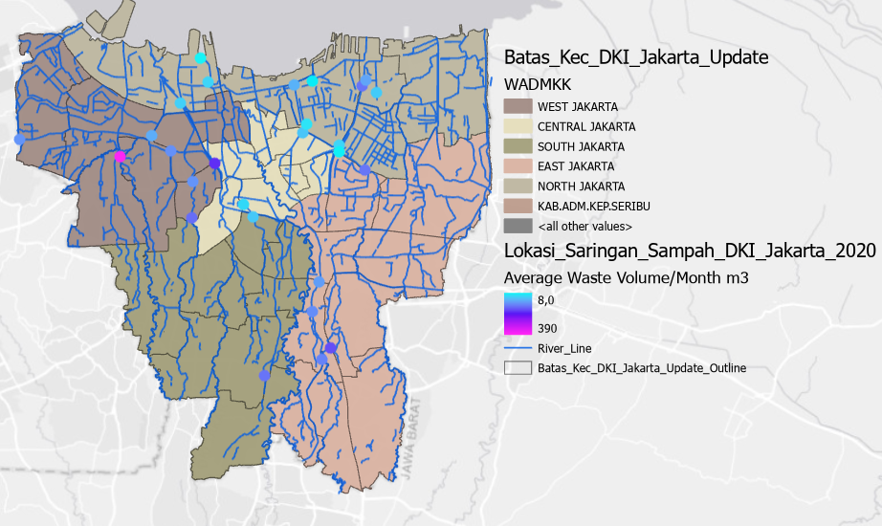
FIGURE 10. All registered locations of DKI Jakarta traditional market (Application written in Indonesian)
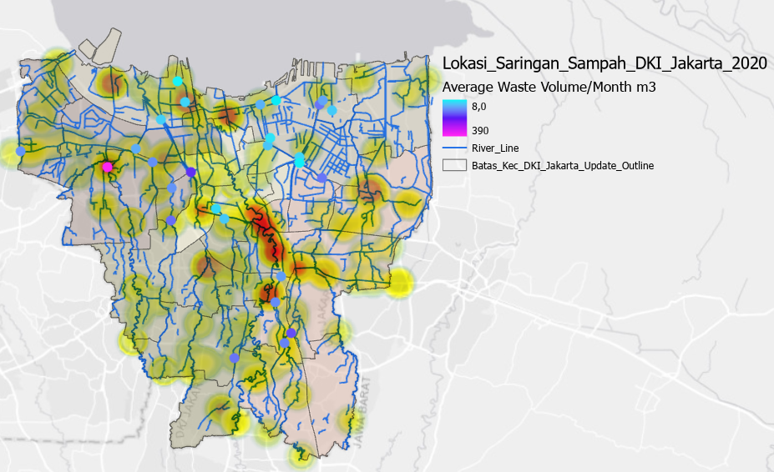
FIGURE 11. the densest area of the traditional market is located in the middle north side of Jakarta (Application written in Indonesian)

By the observation of FIGURE 11, we can see that the most polluted river that is layered by combines of different elements is mostly in (Ciliwung River) is located in central of Jakarta. Other things that can be seen is, there are almost no filter dams in the district of East part of Jakarta and West part of Jakarta, by the look of the observation mainly in FIGURE 12.a) (Pesanggrahan River), FIGURE 12.b) (Krukut River), and FIGURE 12.c) (Buaran River). Because what we observe, the river that we mention is a natural river and the filter dam mostly build in a Riverbank or Embankment type of river, it almost the same problem in an area like (Ciliwung river) it built naturally and there no special facility like filter dam that handles the garbage in that part the river. For the river flow, it can be seen by the pattern of how much garbage is caught by the filter dam from the south side of Jakarta the garbage flow along to the north side of Jakarta and finally to the ocean. Another thing that we can see is that the filter dam (Cengkareng) the pinkest color of the point feature, handle more garbage because it handles many branches of rivers and part of South Jakarta rivers.

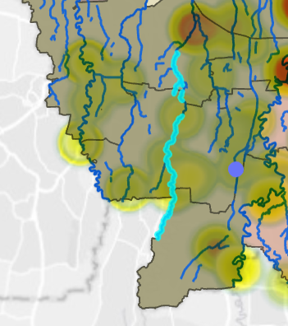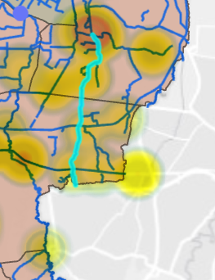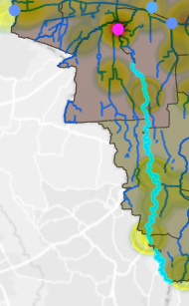
(a) (b) (c)
FIGURE 12. The observation of a) Pesanggrahan River, b) Krukut River, c) Buaran River (Application written in Indonesian)

CONCLUSION
Pollutants abound in the rivers of Jakarta. By Using Hotspot Anlysis methods, this research find most polluted areas of Jakarta's water quality are the north and center of Jakarta. Also, we find that the organic easily find in the river mainly Escherichia Coli from Average 177.585.076,9 (Total/100 mL) and Bacteria Coli from Average 128.671.813,2 (Total/100 mL) .
We consider that the Jakarta River has never been cleaned up properly or sufficiently since, as DKI Jakarta's population continues to rise month by month. Many people continue to throw their waste into a nearby river. We recommend that the government educate all Indonesian, from elementary school through maturity, about the dangers of polluted rivers. Also we support to government to formulate a law enforcement model for waste management including who throw garbage into the river. And finally, we suggest to all the people do mutual cooperation pick up garbage on their area or near the river in certain days.

Acknowledgments
The Author wishes to thank the Research and Technology Transfer Office, Bina Nusantara University for financial support. This work as part of the Penelitian Internasional Binus: Optimasi Graf Neural Networks pada Data Sains project, with contract number No. 017/VR.RTT/III/2021 and contract date 22 Maret 2021. We are also gratefully to ESRI – Indonesia and Geo-AI Research and Innovation Laboratory, School of Computer Science, Bina Nusantara University for the support in this research internship program.

References
- D. G. Milledge, S. K. Gurjar, J. T. Bunce, V. Tare, R. Sinha, and P. E. Carbonneau, "Population density controls on microbial pollution across the Ganga catchment," Water Research, vol. 128, pp. 82-91, 2018.
- I. P. Rachmawati, E. Riani, and A. Riadi, "Status mutu air dan beban pencemaran Sungai Krukut, DKI Jakarta," Journal of Natural Resources and Environmental Management, vol. 10, no. 2, pp. 220-233, 2020.
- V. Belton and T. Stewart, Multiple criteria decision analysis: an integrated approach. Springer Science & Business Media, 2012.
- R. M. Delinom, "Groundwater management issues in the Greater Jakarta area, Indonesia," 筑波大学陸域環境研究センター報告, vol. 8, no. 別冊 2, pp. 40-54, 2008.
- P. Sidauruk, "Study of Interaction of Shallow Groundwater and River along the Cisadane and Ciliwung River of Jakarta Basin and Its Management using Environmental Isotopes," Jurnal Ilmiah Aplikasi Isotop dan Radiasi, vol. 8, no. 1, 2013.
- D. Hendrawan, "Water quality of rivers and ponds on DKI Jakarta," Makara Journal of Technology, vol. 9, no. 1, p. 3, 2005.
- A. Getis and J. K. Ord, "The analysis of spatial association by use of distance statistics," Geographical analysis, vol. 24, no. 3, pp. 189-206, 1992.
- J. Klapka and P. Piňos, "Decision support system for multicriterial R&D and information systems projects selection," European Journal of Operational Research, vol. 140, no. 2, pp. 434-446, 2002.

