Harnessing Artificial Intelligence for Disease Prediction and Brain-Computer Interface: A Systematic Literature Review
Wildan Rizkia Noor Akhsal Hermawan^{a)}, Richard Wijaya Harianto^{b)}, Kanz Abdillah Hamada^{c)}, and M. Aldiki Febriantono^{d)}
Computer Science Department, School of Computer Science, Bina Nusantara University, Jakarta, Indonesia

^{a)} Corresponding author: wildan.hermawan@binus.ac.id
^{b)} richard.harianto@binus.ac.id
^{c)} kanz.hamada@binus.ac.id
^{d)} m.aldiki@binus.ac.id

Abstract. Artificial Intelligence has revolutionized various sectors, including healthcare and neurotechnology. The utilization of artificial intelligence in sickness guaging and Brain-Computer Interface structures is analyzed exhaustively in this paper. The accentuation is on how electronic reasoning jump advances like as machine learning and deep learning further foster disease assumption accuracy, limit, and clinical affiliation. Using clinical and normal data, artificial intelligence technologies, for instance, Support Vector Machine, K-Nearest Neighbor, Artificial Neural Network, and deep learning models beat in seeing disease events and deciding sickness improvement. Besides, BCI innovation, which permits direct correspondence between the mind and outer gadgets, has gained huge headway, especially in supporting people with formative handicaps. The essential spotlight is on how AI approaches, for example, machine learning and deep learning upgrade sickness expectation precision, effectiveness, and clinical administration. AI strategies, for example, Support Vector Machine, K-Nearest Neighbor, Artificial Neural Network, and deep learning models beat in perceiving sickness examples and guaging illness movement using clinical and natural information. Besides, BCI innovation, which considers direct correspondence between the brain and outer hardware, has gained extraordinary headway, prominently in helping people with portability troubles. Besides, BCI innovation, which permits direct correspondence between the psyche and outside gadgets, has gained huge headway, especially in supporting people with formative handicaps. The essential spotlight is on how AI approaches, for example, machine learning and deep learning upgrade sickness expectation precision, productivity, and clinical administration. AI strategies, for example, Support Vector Machine, K-Closest Neighbor, Artificial Neural Network, and deep learning models outflank in perceiving sickness examples and estimating illness movement using clinical and natural information. Besides, BCI innovation, which considers direct correspondence between the brain and outer hardware, has gained extraordinary headway, remarkably in helping people with versatility challenges.
Keywords: Artificial Intelligence, Disease Prediction, Brain Computer Interface, Computational Biology.

INTRODUCTION
Artificial Intelligence (AI) comprises various models developed by humans to analyze data and make decisions. AI models are invaluable for explaining probabilities, such as a machine's ability to interpret and predict specific symptoms in patients that may indicate particular conditions. This demonstrates that current AI systems, compared to humans, can learn logical relationships and make decisions based on the provided information. The use of AI has been widely implemented in various industrial sectors, including the field of health. Some researchers use AI to assist them in detecting or predicting research subjects that are being developed.
In healthcare, experts use AI to predict diseases using clinical and biomedical data. Through AI techniques such as machine learning (ML) and deep learning (DL), it can help in handling large data sets. This makes it easier for all health experts, especially doctors, to detect the initial symptoms of the patient's disease, assess the risk of the patient's disease, identify the disease, and even predict the development of the patient's disease [1] [2]. The use of AI methods such as machine learning is considered capable of being integrated and has proven to be very effective for the decision-making process. With the existence of machine learning such as Support Vector Machines (SVM), K-Nearest Neighbors (K-NN), Decision Trees, Logistic Regression (LR), AdaBoost (AB), Naïve Bayes (NB), and Fuzzy Logic (FL), these methods help overcome various problems and challenges in the world of healthcare, proving support for implementing AI in this field [2].
Brain-Computer Interface (BCI) technology has progressed rapidly. This technology creates a new avenue of communication for individuals who have disabilities or motor disorders, so that with the help of BCI, individuals can regain their motor skills through exercises guided by brain signals [3]. Not only in the world of health, but the use of BCI can also be implemented in the gaming platform. Providing insight into developing a game for educational purposes or to solve problems, several technologies have implemented BCI in the games they have made, such as virtual reality, mixed reality, and augmented reality [4].
This research examines how to implement AI methods in disease prediction and the relevance of Brain-Computer Interface (BCI) technology through a systematic literature review (SLR). Several research questions (RQ) have been proposed to support the implementation of the development of artificial intelligence in the world of healthcare and computational biology, see TABLE 1. We hope that the review that has been made can be used as a basic resource to study topics related to the subject of research, provide breakthroughs to accelerate digitization, utilize artificial intelligence in disease prediction and BCI, and provide insights for potential future research projects.
TABLE 1. List of Research Questions
Research Questions
RQ1 | How are AI methods implemented in disease prediction systems?
RQ2 | What is the evolution in the use of AI and BCI technologies for clinical and non-clinical applications?
RQ3 | How does AI perform in predicting lung cancer risk compared to Brock's model based on lung nodule size and morphology?

METHODS
We used the Systematic Literature Review (SLR) method because it provides a transparent and systematic method for collecting research data [5]. This strategy empowers analysts to assess the nature of accessible proof and depict the discoveries utilizing satisfactory logical systems [6]. The essential objective of SLR is to take care of the issue recognized during the examination, uncover various perspectives regarding the matter being scrutinized, and distinguish suitable hypotheses [5] [6]. Favored Revealing Things for Orderly Audits and Meta-Examination (PRISMA) is applied in four stages: distinguishing proof, screening, qualification check, and characterization [6]. Its purpose is to accomplish the goals of the research.
Our focus was on identifying revelant literature in the early stages of our research. We accessed multiple databases, including Scopus, Science Direct, and IEEE using a variety of keywords outlined in TABLE 2. To ensure a comprehensive analysis, we restricted our search to articles published between 2018 and 2024. We specifically targeted freely accessible scientific journals and conference proceedings. By examining the titles and abstracts, we filtered the search results to include only the most pertinent papers for our systematic literature review.
TABLE 2. Search terms used for the literature review
Database | Keyword | Number of Paper
ScienceDirect | disease AND prediction AND artificial AND intelligence | 179
IEEE | brain AND computer AND interface | 24
Scopus | disease AND prediction AND artificial AND intelligence | 280

In the screening phase, we discard papers or journals that have been retrieved. We started to discard papers or journals that are not suitable, papers or journals that are indicated to be the same or multiple, and other reasons that make the papers or journals irrelevant to our research. Papers or journals meeting the title of our systematic literature review will be incorporated, whereas those not aligning with the title of our research will be excluded. The search for studies related to the topic relevant to our research, utilizing predetermined keywords in the identification phase, we successfully gathered a total of (n=144) papers.
At the next stage, we conduct a literature evaluation of the papers or journals that have been found. We analyzed the raw data gathered during our earlier literature review, then documented the main discoveries extracted from the literature. Subsequently, we proceeded to gather metadata from specific articles pertinent to our research topic. From (n = 90) the researcher took (n = 55) which suited the research needs. In the last phase, by classifying the literature that has been determined whether it belongs to a qualitative or quantitative synthesis (Meta-analysis). We found no significant quality issues with the papers or journals we reviewed, and we also verified that the papers or journals provided detailed descriptions of the methods employed, the datasets utilized, and comprehensive results. All the papers and journals we reviewed were sufficient to meet the criteria. After determining the papers that met the criteria, there were (n=25) papers that were of the highest quality and most relevant FIGURE 1.

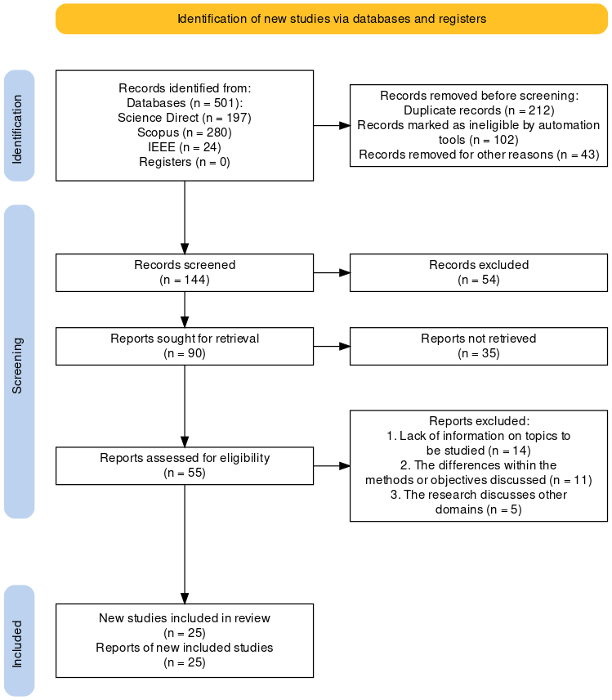
FIGURE 1. Research Process

RESULTS AND DISCUSSION
After reviewing 25 papers that we deemed relevant to our topic, we have finally identified all the answers to the research questions that have been set by further examining the role of AI in disease prediction system, the use of AI and BCI technologies, and AI perform in predicting lung cancer.

IMPLEMENTATION AI METHODS IN DISEASE PREDICTION SYSTEMS
The integration of artificial intelligence (AI) into disease prediction systems has revolutionized the field of healthcare. AI methods have shown tremendous potential in enhancing the accuracy, efficiency, and timeliness of disease diagnosis and prognosis. By leveraging vast amounts of data from electronic health records, medical images, and other sources, AI algorithms can identify patterns and make predictions that surpass traditional methods. This paper aims to explore how various AI techniques, including machine learning, neural networks, and natural language processing, are implemented in disease prediction systems. We will examine the methodologies, applications, and outcomes of these AI-driven systems in predicting a range of diseases, as presented in TABLE 3.
TABLE 3. The use of Artificial Intelligence in disease prediction systems
References | Name of Disease | AI Methods | Result
[7] | Stroke Risk Prediction | Logistic Regression, SVM (Support Vector Machine), Convolutional Neural Network (CNN), Random Forest, Recurrent Neural Networks (RNN) | Of the several types of AI and methods used, the most accurate method is Convolutional Neural Network (CNN) to predict diseases based on medical image analysis, with an accuracy of up to 95% in Alzheimer's disease detection.
[2] | Heart Disease Prediction | Logistic Regression, Naïve Bayes, K-Nearest Neighbor (KNN), Support Vector Machine (SVM), Decision Tree, Random Forest, Multilayer Perceptron (MLP) | Considering the Artificial Intelligence frameworks utilized, it has been mulled over that Random Forest is the best Artificial Intelligence technique for anticipating coronary sickness. This system accomplished the most fundamental accuracy (90.0%), precision (90.91%), review (100 percent), F1 score (90.91%), and ROC-AUC score (89.90%) with different parts. K-NN and Decision Tree likewise performed well, yet Random Forest's ability to administer complex collaborations in the data went with it an unmatched choice. Curiously, Guileless Bayes and Multilayer Perceptron were significant solid areas for less, with the picked features.
[8] | Prediction of Sepsis | Bidirectional Long Short-Term Memory (BiLSTM) | The use of these models was weighed against standard scoring systems such as SIRS, MEWS, Couch, and qSOFA. The findings indicated that PC-based artificial intelligence models would perform better in farsighted execution than normal score systems. The execution of AI calculations resulted in notable drops in key clinical evaluations, including a 39.50% decrease in in-clinical office mortality, a 32.27% reduction in length of stay, and a 22.74% decrease in 30-day readmission rates. Artificial Intelligence Information models other than expected sepsis in baby adolescents in the Neonatal Intensive Care Unit (NICU) a few hours earlier clinical confirmation, indicating the potential for early intervention.
[9] | Prediction of Foot Ulcers | Artificial Neural Network (ANN) and a Decision Tree (DT) algorithm | The outcomes showed that the ANN beat the DT, accomplishing a precision of 97% in foreseeing the event of foresee diabetic foot ulcers (DFUs) DFUs. The review reasons that artificial intelligence techniques, especially neural networks, can be exceptionally viable in foreseeing diabetic foot ulcers, possibly decreasing the grimness and mortality related with this condition by empowering early mediation and anticipation methodologies.
[10] | Prediction Models for Cardiovascular Disease | Logistic Regression, Naïve Bayes, K-Nearest Neighbors (K-NN), Support Vector Machine (SVM), Decision Tree, Random Forest, Multilayer Perceptron | In view of the presentation measurements, Random Forest is the suggested technique for heart disease expectation because of its high exactness, accuracy, and wonderful review, making it exceptionally dependable for down to earth clinical applications. Random Forest is the most reliable and dependable strategy for heart disease expectation with an exactness of 90%, accuracy of 90.91%, review of 100 percent, and a ROC-AUC score of 89.90%
[11] | Prediction of Colorectal Neoplasms | Kernel Density Estimator (KDE)-based transformation to improve data separability and applied Gaussian process classifiers to create the predictive models. | The data showed that the best models had Matthews Correlation Coefficients (MCC) of 0.37 and 0.39 for people, outperforming routine waste and unusual blood tests. These findings indicate that imitation data models based on blood biomarkers and other innocuous data could successfully differentiate CRC risk, reducing unneeded colonoscopies and altering enjoyment plan portion in clinical concept structures with restricted resources. The outline looks at the use of PC-based data to improve CRC screening feasibility and early recognized evidence, ultimately leading to better assumptions and the essential social event of colorectal neoplasms.
[12] | Lung Nodule Risk Prediction | Lung Cancer Prediction convolutional neural network (LCP-CNN), Brock Model | The LCP-CNN accomplished a region under the collector working trademark bend (AUC) of 0.936, higher than the Brock model's AUC of 0.873 with manual estimations. The outcomes recommend that computer-based intelligence models like LCP-CNN can give more exact cellular breakdown in the lungs risk expectations than conventional strategies, stressing the significance of knob size and morphology in these forecasts.
[13] | Heart Disease Prediction | Decision Trees, Random Forest, Support Vector Machine (SVM), K-Nearest Neighbor (KNN), Convolutional Neural Networks (CNN), XGBoost, Hybrid (Random Forest + SVM) | The examination shows the capability of different Artificial Intelligence and Machine Learning strategies in foreseeing heart disease with critical exactness. The Convolutional Neural Networks (CNNs) and half and half models (Random Forest + SVM) showed the best presentation measurements, making them the most reliable and solid techniques for heart disease expectation in this review. Given their high precision, responsiveness, and particularity, these techniques are prescribed for sending in clinical settings to aid the early identification and conclusion of coronary illness.
[14] | Disease Diagnosis and Prediction | Least-Squares SVM, Hybrid Fuzzy-Artificial Immune + KNN, SVM + Feature Selection, Optimized SVM, SVM, KNN, PNN Combination, Neural Fuzzy + KNN + Quadratic, Mammography-Based Classifier (MLC), Decision Tree (C4.5), Multiple Classifiers (SMO, J48, NB, IBK) | In view of the outcomes, it is apparent that both ML and DL methods offer significant upgrades in illness determination and forecast. Among the strategies assessed, Support Vector Machine (SVM) joined with highlight determination arose as the most reliable for breast cancer disease analysis, accomplishing up to 99.51% exactness. For general sickness determination, Convolutional Neural Network (CNN) are profoundly powerful because of their prevalent picture acknowledgment capacities. Thus, for the most noteworthy precision and effectiveness in clinical finding, a blend of SVM with highlight choice for organized information and CNN for picture-based conclusion is suggested. These strategies give high exactness as well as influence the qualities of both ML and DL ways to deal with convey vigorous analytic instruments.
[15] | Prediction in Lung SBRT | Logistic Regression (LR), multilayer perceptron classifier (MLP), Extreme Gradient Boosting (XGB), Support Vector Classifier (SVC), Random Forest Classifier (RF), and Gaussian Naive Bayes. | The information was adjusted using the Synthetic Minority Oversampling Technique (SMOTE), and models were built with 85% of the data and approved with the remaining 15%. The LR calculation was the best-performing model, with 80% accuracy, 66% responsiveness, and 90% specificity. Tumor diameter, neutrophil/lymphocyte ratio (NLR), biopsy status at diagnosis, tumor location and type, diagnosis, and histology all had substantial predictive value. The work demonstrates that AI models, specifically LR, can effectively predict SBRT responses, potentially guiding therapy decisions and improving patient outcomes.

Execution of artificial intelligence techniques in sickness expectation frameworks has shown critical headways in the field of medical care. Artificial intelligence calculations, especially those utilizing AI and profound learning procedures, have the ability to break down complex datasets with high exactness, hence empowering early identification and worked on prognostic capacities. The joining of computer-based intelligence in illness forecast upgrades symptomatic accuracy as well as improves patient administration and results. Notwithstanding, the fruitful sending of this man-made intelligence situation requires thorough approval, straightforward procedures, and consistent joining into clinical work processes.

THE EVOLUTION IN THE USE OF AI AND BCI TECHNOLOGIES
Evolution of AI and BCI technologies, tracing their development from foundational theories to contemporary applications. The role of AI and machine learning (ML) algorithms in processing and analyzing brain signals for both conventional EEG-based brain-computer interfaces (BCIs) and alternative BCI systems using fNIRS, MEG, fMRI, ECoG, and iCor signals. It identifies five main application areas: rapid calibration systems to minimize calibration time, interference suppression for low-amplitude EEG signals, and practical classification issues in communication, mental condition estimation, and motor imagery (MI). Despite numerous AI and ML algorithms showing potential, comparing their effectiveness is challenging due to varied methodologies and datasets. Future research should focus on developing high-quality Big Data datasets with both physiological and pathological recordings and standardizing evaluation methods.
Artificial neural networks (ANNs), particularly convolutional neural networks (CNNs), are highlighted as versatile but computationally complex, requiring optimized settings and potential integration with nature-inspired optimization techniques. Linear discriminant analysis (LDA) and support vector machines (SVMs) are noted for their lower computational complexity. Combining these methods with advanced signal processing techniques like wavelet transform (WT), empirical mode decomposition (EMD), independent component analysis (ICA), or principal component analysis (PCA) enhances performance, as shown in FIGURE 2. However, accuracy decreases significantly when tested on disabled patients, necessitating further improvements. Testing in real-life scenarios, increasing classification accuracy through optimal channel selection, designing hybrid BCIs, and exploring parallel processing to reduce computational costs and enable real-time applications are essential for future advancements [4] [16].
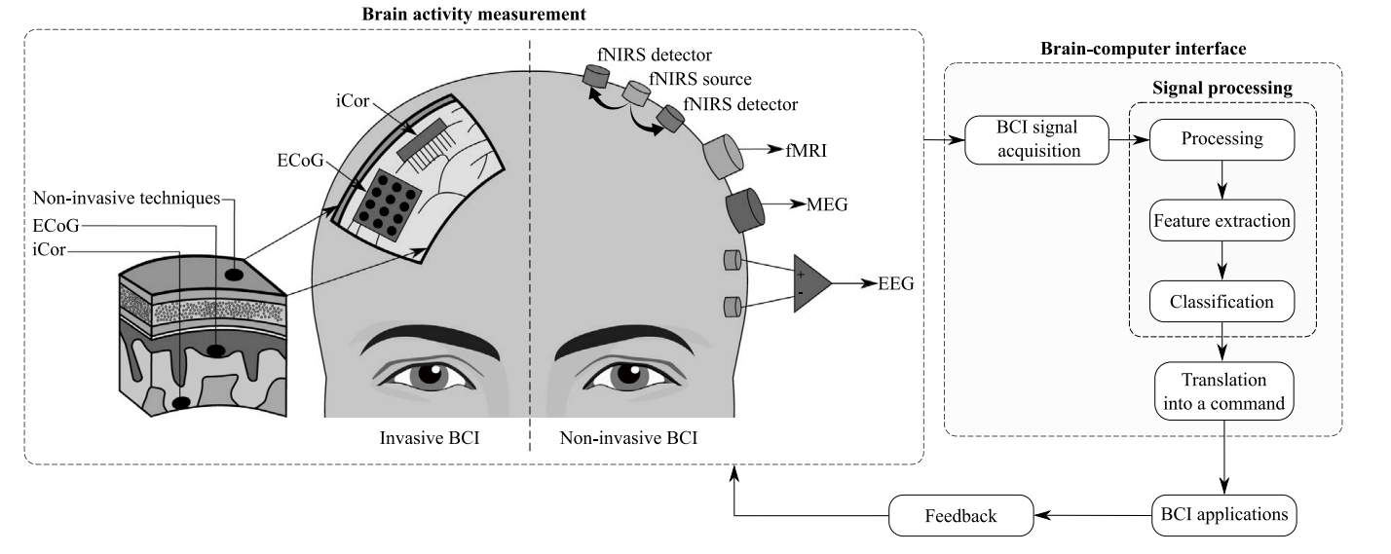
FIGURE 2. Block diagram of a generic brain activity monitoring (BCI) system which combines invasive and non-invasive methods [23].

Examples of some of the cases in the papers that have been traced, AI methods in classifying mild traumatic brain injury (mTBI) using EEG signals from mice, highlighting advancements in both rule-based and deep learning algorithms. Researchers employed Decision Trees (DT), Random Forest (RF), Neural Network (NN), Support Vector Machine (SVM), K-Nearest Neighbors (KNN), and Convolutional Neural Networks (CNNs) to process the data. CNNs demonstrated superior performance, achieving a classification accuracy of 92.03% for 1-minute non-overlapping epochs by effectively capturing the temporal dynamics of EEG signals. This underscores the efficacy of CNNs in handling large datasets for training. For wake stage analysis, KNN with a 'K' value of 7 outperformed CNN, indicating that while CNNs are powerful, their effectiveness can be limited by data availability. The findings suggest that CNNs and other AI methods hold significant promise for identifying brain-based biomarkers and advancing the diagnosis and treatment of TBI [17].

AI PERFORM IN PREDICTING LUNG CANCER RISK COMPARED TO BROCK’S MODEL BASED ON LUNG NODULE SIZE AND MORPHOLOGY
The artificial intelligence model (AI), explicitly the Cellular breakdown in the Lung Cancer Prediction Convolutional Neural Network (LCP-CNN), exhibits predominant execution in anticipating cellular breakdown in the lungs risk contrasted with the Brock model, which depends on knob size and morphology. The Brock model's precision improves while utilizing programmed estimations of knob size, with the region under the collector working trademark bend (AUC) expanding to 0.883 with programmed hub distance across and to 0.896 with programmed identical round width, contrasted with 0.873 with manual estimations [14]. The LCP-CNN artificial intelligence model basically beats the Brock model with an AUC of 0.936, exhibiting favored judicious precision over both manual and modified assessments used in the Brock model [14].
The importance of nodule size and morphology is also evident in the AI model's performance [14]. Ablating nodules and parenchymal texture in the AI model result in a slight decrease in predictive accuracy (AUC 0.915), while implanting spheres of the same size as the nodules shows an AUC of 0.889. Removing nodule information and leaving only the parenchyma causes a significant drop in AI performance (AUC 0.717) [14]. This features that knob size and morphology are basic variables for artificial intelligence expectation, like their significance in the Brock model. Albeit the Brock model advantages from programmed knob size estimations, artificial intelligence models like LCP-CNN offer prevalent precision in foreseeing cellular breakdown in the lungs risk by coordinating more perplexing imaging highlights without requiring manual estimations.

CONCLUSIONS
In this paper, we highlight how to utilize computational models and AI methods to assist the field of computational biology in predicting and diagnosing diseases. By using machine learning (ML) and deep learning (DL) algorithms, we aim to increase the accuracy and reliability of disease detection. We took one sample, colorectal cancer (CRC) prediction, performed Kernel Density Estimator (KDE) based transformation to separate the data, and applied a Gaussian process classifier to create a predictive model. Using Matthews Correlation Coefficients (MCC), we obtained results of 0,37 and 0,39. These results indicate that the model can identify colorectal cancer (CRC). All the examples we have provided are based on an in-depth review of related papers, demonstrating that various AI methods can be effectively used to predict disease diagnoses.
This paper discusses the evolution of artificial intelligence (AI) and brain-computer interface (BCI) technologies, highlighting the role of AI and machine learning (ML) algorithms in processing and analyzing brain signals from various BCI methods such as EEG, fNIRS, MEG, fMRI, ECoG, and iCor. Five main applications are identified: rapid calibration systems to minimize calibration time, interference suppression for low-amplitude EEG signals, and practical classification issues in communication, mental state estimation, and motor imagery (MI). However, despite many AI and ML algorithms showing potential, comparing their effectiveness is difficult due to varying methodologies and datasets. Therefore, we suggest developing high-quality Big Data datasets and providing standardized evaluation methods to advance the evolution of AI and BCI technologies. The use case of AI in classifying mild traumatic brain injury (mTBI) with EEG signals shows that CNN performs very well with 92.03% classification accuracy, demonstrating the great potential of AI in identifying brain biomarkers and advancing the diagnosis and treatment of TBI. In the case of lung cancer prediction, the Lung Cancer Prediction Convolutional Neural Network (LCP-CNN) is considered to surpass the traditional Brock model, achieving an Area Under the Receiver Operating Characteristic Curve (AUC) value of 0,936. It can be concluded that the predictive ability of AI models is superior to conventional methods, considering several aspects such as nodule size and morphology in assessing lung cancer risk.
To ensure data validation of AI's involvement in predicting and diagnosing diseases, research related to this field of study needs further review. It is necessary to explore the integration of AI models with the system so that the impact on patients and the world of health can be maximized. With the aim of improving sustainability by maintaining data quality, the robustness of the algorithms used, and the ability to interpret the adoption of the technology used. The implementation of this technology shows results that are in line with expectations, such as the prediction of CRC, lung cancer, and heart disease, so that it can pave the way for health experts in the world to consider diagnosis results more accurately.

Acknowledgments
We would like to express our sincere gratitude to all those who have contributed to the success of this literature review research. Wildan Rizkia Noor Akhsal Hermawan, who played a crucial role in data collection; Richard Wijaya Harianto, who was responsible for data analysis; Kanz Abdillah Hamada, who handled data processing; and M. Aldiki Febriantono, who also ensured the validation of data.

References
1. Hameed, H.A., Artificial Intelligence: What it Was, and What it Should Be? International Journal of Advanced Computer Science and Applications, 2020. 11(6).
2. Hossain, M.I., et al., Heart disease prediction using distinct artificial intelligence techniques: performance analysis and comparison. Iran Journal of Computer Science, 2023. 6(4): p. 397-417.
3. Lin, C., et al. Multi-channel Wireless Implantable Brain-Computer Interface System. in 2023 45th Annual International Conference of the IEEE Engineering in Medicine & Biology Society (EMBC). 2023. IEEE.
4. Gezgez, C. and E. Kaçar. Virtual character control by brain-computer interface and comparison of performance metrics. in International Conference on INnovations in Intelligent SysTems and Applications. 2021. IEEE.
5. Ali, A., et al., Financial fraud detection based on machine learning: a systematic literature review. Applied Sciences, 2022. 12(19): p. 9637.
6. Kitchenham, B. and S. Charters, Guidelines for performing systematic literature reviews in software engineering. 2007, UK.
7. Jiang, S., Y. Gu, and E. Kumar, Stroke risk prediction using artificial intelligence techniques through electronic health records. Artificial Intelligence Evolution, 2023: p. 88-98.
8. Haas, R. and S.C. McGill, Artificial Intelligence for the Prediction of Sepsis in Adults. Canadian Journal of Health Technologies, 2022. 2(3).
9. Mousa, K.M., et al., Prediction of foot ulcers using artificial intelligence for diabetic patients at Cairo university hospital, Egypt. SAGE Open Nursing, 2023. 9: p. 23779608231185873.
10. Van Smeden, M., et al., Critical appraisal of artificial intelligence-based prediction models for cardiovascular disease. European heart journal, 2022. 43(31): p. 2921-2930.
11. Tokutake, K., et al., Artificial intelligence for the prevention and prediction of colorectal neoplasms. Journal of Translational Medicine, 2023. 21(1): p. 431.
12. Chetan, M.R., et al., Developing an understanding of artificial intelligence lung nodule risk prediction using insights from the Brock model. European Radiology, 2022. 32(8): p. 5330-5338.
13. Chinmayi, N.R., Heart Disease Prediction using Artificial Intelligence and Machine Learning. International Journal of Preclinical & Clinical Research, 2023. 4(2): p. 32-37.
14. Ghaffar Nia, N., E. Kaplanoglu, and A. Nasab, Evaluation of artificial intelligence techniques in disease diagnosis and prediction. Discover Artificial Intelligence, 2023. 3(1): p. 5.
15. EtİZ, D., et al., Response Prediction in Lung SBRT with Artificial Intelligence. Turk Onkoloji Dergisi, 2023. 38(3).
16. Barnova, K., et al., Implementation of artificial intelligence and machine learning-based methods in brain–computer interaction. Computers in Biology and Medicine, 2023. 163: p. 107135.
17. Vishwanath, M., et al. Classification of electroencephalogram in a mouse model of traumatic brain injury using machine learning approaches. 2020. IEEE.

