Developing a Model Using Pretrained Deep Convolutional Neural Networks (DCNNs) for Detecting Cassava Leaf Diseases
Abram Setyo Prabowo^{1,a)}, Simeon Yuda Prasetyo^{1,b)}, Faisal^{2,c)}, and Elvina Benedicta Santoso^{1,d)}
¹Department of Computer Science, Bina Nusantara University, Jakarta, Indonesia
²Department of Mathematics, Bina Nusantara University, Jakarta, Indonesia

^{a)} Corresponding author: abram.setyo@binus.ac.id
^{b)} simeon.prasetyo@binus.ac.id
^{c)} faisal@binus.ac.id
^{d)} elvina.santoso@binus.ac.id
Abstract. Cassava leaf diseases significantly threaten agricultural productivity, so early detection is important for effective management. This research develops a model to detect cassava leaf diseases using pre-trained Deep Convolutional Neural Networks (DCNNs). Several DCNN architectures, including VGG16, VGG19, ResNet50, ResNet101, and XCeption, were evaluated through two stages of model development: transfer learning and fine-tuning. Experimental results show that the VGG16 model is most successful in both stages, achieving an accuracy of 0.7322 in the transfer learning stage and 0.7818 in the fine-tuning stage. Compared with other evaluated models, VGG16 achieved the highest accuracy, indicating that its large capacity and basic architecture produce a powerful feature representation for identifying visual patterns associated with cassava leaf diseases. Additionally, transfer learning of the VGG16 model, trained on the ImageNet dataset, offers important advantages in the identification of visual patterns in cassava disease datasets. The VGG19 model also performs well, usually providing the second-best results after the VGG16. However, further research is needed to fully understand the elements that contribute to VGG16's superiority, such as optimal hyperparameter values and characteristics of the datasets used. In summary, DCNN models such as VGG16 and VGG19 have great potential to be integrated into agricultural monitoring systems to improve disease management efforts and increase crop yields.
Keywords: Deep learning, Convolution Neural Network, Classification, Cassava Leaf Diseases

INTRODUCTION
In Indonesia, cassava (Manihot esculenta) is an important food crop and is the main substitute for rice in eating habits. According to FAO (Food and Agriculture Organization), Indonesia is now one of the largest cassava producers in the world, with production of 15 million tons of cassava in recent years. Cassava is famous for its high nutritional content, including carbohydrates, phosphate, calcium and vitamin C, in addition to its function in ensuring food security. However, various leaf diseases that can reduce the quality and quantity of harvest often pose a danger to cassava production. Caring for cassava plants is very important for farmers, because there is a risk of cassava leaf plants being attacked by diseases such as Brown Cassava. Striped Disease (CBSD) and Cassava Bacterial Blight (CBB). Proper identification and early detection are essential to prevent further spread of the disease and reduce loss of crop productivity.
Conventional approaches to cassava leaf disease detection often rely on professionals skilled in visually inspecting leaves, which is labor intensive, time consuming, and prone to human error. Therefore, currently approaches using deep learning and artificial intelligence have had many good impacts and have surpassed what conventional approaches cannot do. Deep Convolutional Neural Networks (DCNN) is a deep learning approach for identifying plant diseases from leaf photos because this approach is considered to produce extraordinary performance in image classification tasks [1]–[4]. A study categorizes and identifies various types of plant diseases on cassava leaves by applying the Enhanced Convolutional Neural Network (ECNN) model and the research also evaluates the Deep Convolutional Neural Network (DCNN) [5] , the results of which are able to provide a good level of accuracy and are able to identify diseases such as cassava Moses disease (CMD), cassava brown steak disease (CBSD), and cassava bacterial blight (CBB). Additionally, the use of pre-trained ResNet50 models can also be used. succeeded in classifying cassava diseases and achieved high accuracy [6].
This research focuses on developing a model using an artificial intelligence approach to identify cassava leaf diseases, in this case the deep learning model was chosen because it has excellent capabilities in managing large amounts of data and its ability to extract complex characteristics. Some cassava diseases can be detected visually. Leaves may show symptoms through changes in color and shape. One of the symptoms that can be seen on the stem is that the appearance of the stem is damaged and the texture is different. Root symptoms can be seen on roots that have been removed, where there are changes on the inside or outside of the tuber. The mitigation process can be easier if an easy diagnosis is followed by knowledge of the causes of the disease.A study [7] conducted experiments by applying machine learning to detect and classify diseases in cassava leaf plants such as Cassava Mosaic Disease (CMD) and Cassava Bacterial Blight Disease (CBBD). The study used multiple models trained on over 18,000 photos of cassava leaves gathered at different dates, covering leaves with differing degrees of symptom expression. The first model is used to diagnose healthy leaves, whereas the second is utilized to detect disease in unhealthy leaves. The two most accurate models are exported. The 5-fold cross validation test was used to test the Cubic Support Vector Machine (CSVM) model developed for health diagnosis, producing an accuracy of 83.9%, and the Coarse Gaussian Support Vector Machine (CGSVM) model developed for disease detection producing an accuracy of 61.9%. For image classification, the use of Convolutional Neural Network (CNN) along with various available CNN modifications is one of the most effective methods [8]. CNN has the ability to learn a hierarchy of data features that allows a model to discover patterns that are difficult to discover by conventional methods.
The use of deep learning models to detect cassava diseases has been studied in a number of studies. A study [9] built an intelligent system that detects cassava leaf diseases using the MobileNetV2 deep learning model, the results show that the overall test data accuracy rate is 65.6%. In addition, an approach using Deep Convolutional Neural Network (DCNN) [10] was carried out to detect diseases in plant leaves. The accessible data set was used to train the DCNN model, the data used were photos of leaves from 39 plant species and the results showed that the data classification accuracy was 83.12%. Other results with the same approach also show accuracy results that have reached 97.28% [11]. These studies show the potential of deep learning models, such as CNN models, to accurately detect various cassava diseases. The use of deep learning models offers cost-effective and scalable disease detection technology, which is critical to support improved control and prevent destabilization of food security in regions that depend on cassava as a staple crop.
Although previous research results show satisfactory value, this proposed research will concentrate on further development and improvisation to improve the precision and efficiency of DCNN. Tuning parameters in CNN layers, using data augmentation methods to increase the diversity of the dataset, and learning transfer learning technology to use information from previously trained models are all part of these experiments. Testing and evaluation using different fine tuning requires retraining several layers or the entire model using a more specific target dataset. This is done in order to find out any improvements from the proposed improvisation.

METHODS
This study adopts an experimental approach aimed at refining and optimizing the Deep Convolutional Neural Network (DCNN) model for disease diagnosis on cassava leaves. Figure 1. illustrates the experimentation method, which consists of a succession of experimental and assessment processes focused on data augmentation, transfer learning, and fine-tuning approaches. This experiment divides the dataset used into training, validation, and testing data. For consistency, images were cropped to distinguish leaves and resized to 224 x 224 pixels. Images were standardized to RGB color mode, forming a prepared training data set. Deep convolutional neural network (DCNN) models including VGG16, VGG19, ResNet50, ResNet101, and Xception were selected for training. Determining hyperparameters such as learning rate, batch size, epoch, transfer learning as well as data augmentation is used to improve model performance. Model effectiveness is measured using recall, accuracy, and precision on independent validation sets, leading to iterative hyperparameter tuning to reduce overfitting. Finally, a series of separate tests evaluated the refined models, and a comparative analysis determined each model's ability to detect cassava leaf diseases.

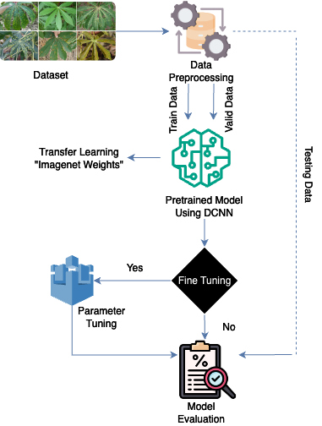
FIGURE 1. Experiment process

DATASET
The dataset in this experiment is data consisting of 21,391 photos of cassava leaves grouped into five condition categories: healthy, Cassava Mosaic Disease (CMD), Cassava Bacterial Blight (CBB), Cassava Green Mite (CGM), and Cassava Brown Line Disease. All photos come from updated public data and taken with a smartphone camera [12]. The data set was separated into three subsets to facilitate experiments: 80% for training, 10% for validation, and 10% for testing. Figure 2. illustrates examples of photos of cassava leaves from each class in the dataset.

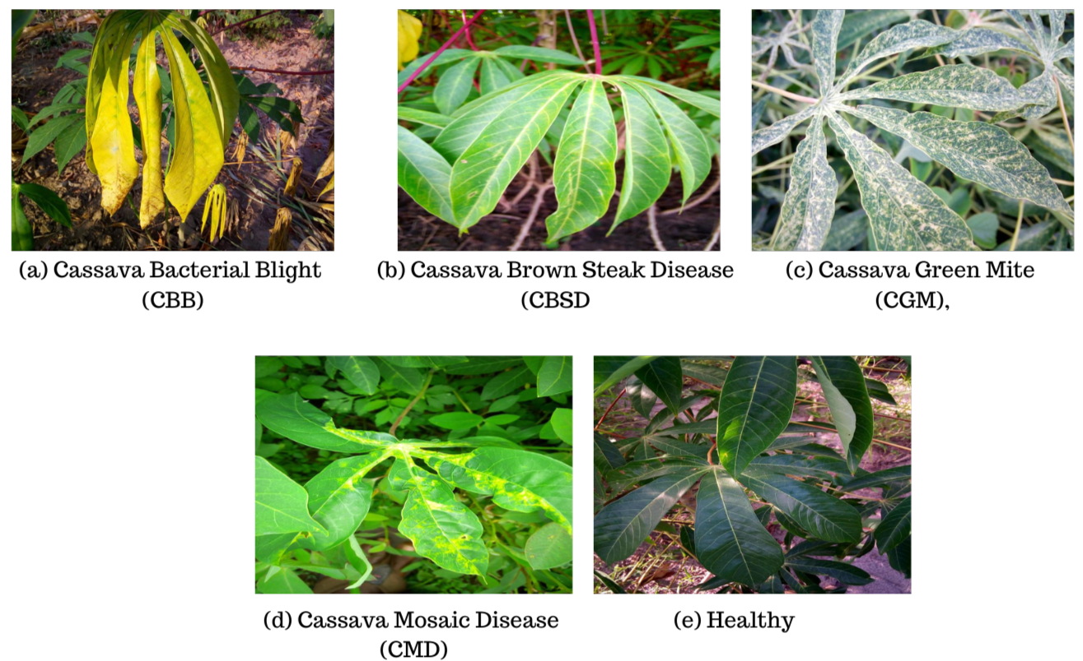
FIGURE 2. Dataset containing 5 conditions of cassava leaf disease

Pretrained Deep Convolutional Neural Network(DCNN)
Pretrained Deep Convolutional Neural Networks (DCNN) provide important advantages and are frequently used in various computer vision tasks, including diagnosing diseases in cassava leaves. These existing models have been taught to recognize common features in photos, efficiently assembling layered representations of the visual patterns needed to distinguish different classes of objects, such as cassava leaf diseases. In this study, the VGG16, VGG19, ResNet50, ResNet101, and Xception models are applied to the DCNN model. Using a pre-trained DCNN, the developed model can apply transfer learning to adapt knowledge gained from extensive training on datasets such as ImageNet to the unique task of diagnosing diseases on cassava leaves. Using a pre-trained DCNN can also help reduce the computational resources and time required for training and these methods are able to speed up training convergence often resulting in improved performance, especially when dealing with limited or insufficient labeled data. Furthermore, having been trained on a variety of datasets covering many image classes, these models have strong generalization capabilities. This promotes greater performance on unknown data and strengthens generalization capabilities [13].

VGG
VGG (Visual Geometry Group) is a Deep Convolutional Neural Network (DCNN) architecture notable for its vast depth and consistent structure. It is made up of many convolution layers, a small 3x3 filter, and a max-pooling layer. The VGG architecture has become one of the most prominent DCNN designs in computer vision research due to its simple structure and excellent performance in a variety of applications, including image classification [14]. VGG16 and VGG19 are frequently used VGG architectures that contain 16 and 19 convolution layers, respectively. VGG is easy to implement and has strong feature extraction capabilities, as well as the ability to transfer knowledge to related jobs effectively through a transfer learning approach.
The VGG16 and VGG19 architectures are depicted in Figure 3. All kernels in the VGG16 architecture are 3 x 3, and a maximum merging layer of 2 x 2 with step 2 is used to down sample the input images. The VGG16 architecture consists of thirteen fully connected classification layers as classification blocks, with the first two layers consisting of 4096 channels, and the last layer consisting of 1,000 channels with a softmax activation function. However, VGG16 and VGG19 differ in that they use 16 convolutional layers rather than 13 layers in a convolutional block. If a 224 x 224 x 3 RGB image is fed as a standard input to the VGG16 convolutional network, the size of the sampled image retrieved and filtered will be 7 x 7 x 512 before entering the classification block.

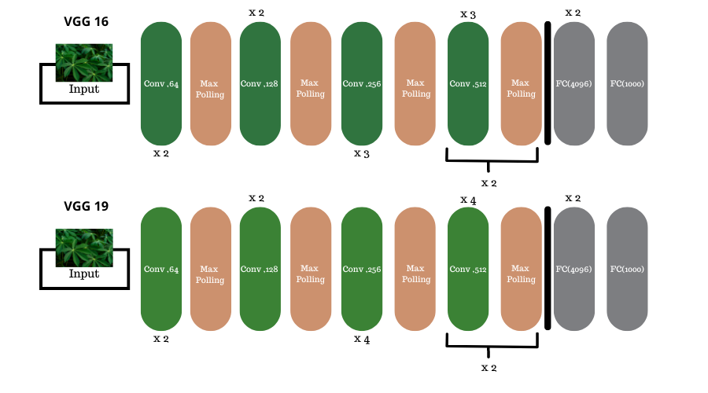
FIGURE 3. Basic layers of VGG architecture

RESNET (RESIDUAL NETWORK)
ResNet's innovation is the use of residual blocks which is able to solve the problem of missing gradients which often hinders the training of very deep networks. Short networks that traverse one or more layers are included in this residual block, which allows the network to learn a residual function—that is, the difference between the desired mapping and the input—rather than a direct mapping. This method makes training deep networks easier, even on networks with hundreds or thousands of layers. Efforts to identify plant diseases, for which data are often scarce, have demonstrated that ResNet is a valuable approach in recent years. The study [6] achieved important improvements in detection accuracy by demonstrating the efficacy of a trained ResNet50 model in correctly recognizing cassava leaf diseases. ResNet is the recommended model because ResNet's adherence to transfer learning is able to increase model robustness and scalability. This ability can be applied in diagnosing plant diseases. ResNet models can also be adapted to specific datasets with very few labeled samples.

XCEPTION
The convolutional neural network (CNN) architecture known as Xception (Extreme Inception) divides the convolution process into two stages: depthwise convolutions and pointwise convolutions [15]. This allows the model to develop the idea of Inception utilizing depthwise separable convolutions. The output of the depthwise convolutions is combined in the second stage using 1x1 convolution, while each input channel in the first step is subjected to a distinct convolution filter.The effectiveness of feature extraction from photos can be increased by this model while reducing the number of parameters and computational costs. Additionally, Xception similarly to ResNet uses connections to guarantee proper gradient flow during training which facilitates the formation of very deep networks.

RESULTS AND DISCUSSION

EXPERIMENT SETTINGS
This experiment will assess the ability of the DCNN model to detect cassava leaf diseases using photos from smartphones. This experiment will evaluate DCNN models using XCeption, ResNet50, VGG16, and VGG19. The data used is an RGB photo reduced to 224 x 224 pixels. During training, model checkpoints are used periodically to maintain model weights. If performance decreases, training is stopped immediately. During the pairing phase, the learning rate is changed from 0.0001 during the transfer phase to 0.00001 during the fitting phase. Batch size is set at 16.

EXPERIMENT RESULTS
The experimental results of detecting leaf cassava desease using a pre-trained DCNN model are displayed in Table 1. It is evident that when compared to other models like VGG19, ResNet50, ResNet101, and XCeption, the VGG16 model performs the best during both the transfer learning and fine tuning stages. With an accuracy of 0.7322 during the transfer learning phase, VGG16 was the most accurate at 0.7818 during the fine-tuning phase, it remained the best.
TABLE 1. Pretrained DCNN Model Comparison Results
Model | Phase | Accuracy | Precision | Recall | F1-Score
VGG16 | Transfer Learning | 0.732 | 0.7053 | 0.7322 | 0.7054
VGG16 | Fine-Tuning | 0.7818 | 0.7846 | 0.7818 | 0.7829
VGG19 | Transfer Learning | 0.6832 | 0.6417 | 0.6832 | 0.6552
VGG19 | Fine-Tuning | 0.7449 | 0.7391 | 0.7449 | 0.7324
ResNet50 | Transfer Learning | 0.6243 | 0.5374 | 0.6243 | 0.5189
ResNet50 | Fine-Tuning | 0.6388 | 0.5477 | 0.6388 | 0.5686
ResNet101 | Transfer Learning | 0.6322 | 0.5262 | 0.6322 | 0.5274
ResNet101 | Fine-Tuning | 0.6248 | 0.5132 | 0.6248 | 0.5402
Xception | Transfer Learning | 0.6944 | 0.6727 | 0.6944 | 0.6769
Xception | Fine-Tuning | 0.7388 | 0.7236 | 0.7388 | 0.7263

Based on the learning curve shown in Figure 4, it does show that in the last epoch there was overfitting

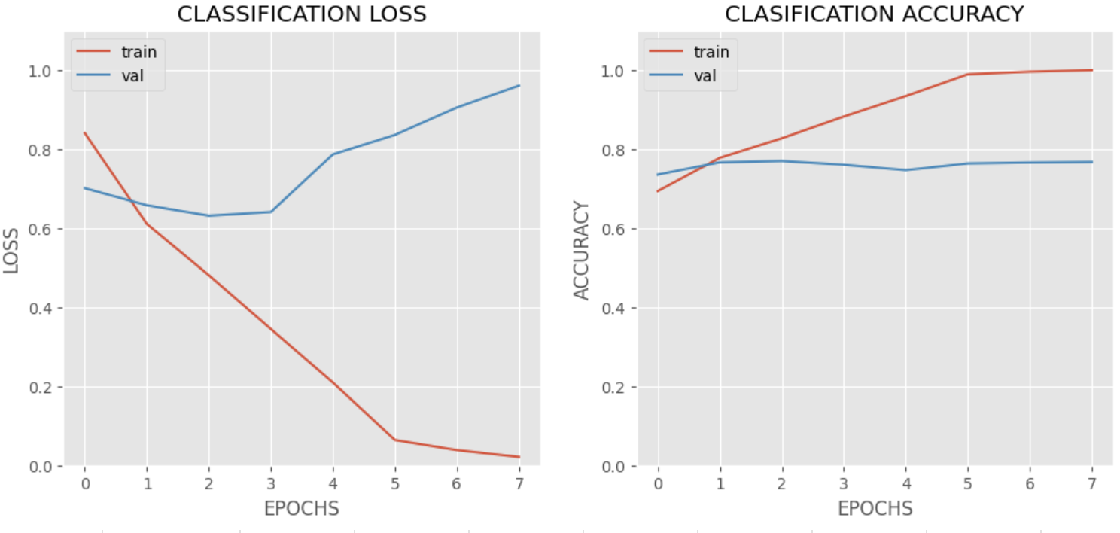
FIGURE 4. Loss and accuracy of VGG16 model

However, in the results of this experiment a callback was applied so that the best weight was selected from each iteration based on the lowest validation loss so that overfitting in the last epoch did not indicate overfitting in the overall model. By using these callbacks, we can ensure that the resulting model is the best based on performance on validation data, thereby reducing the impact of overfitting seen in the training curve. However, if a curve indicating overfitting remains visible after using callbacks, this indicates that the model is still learning irrelevant details from the training data. By using more data, applying better regularization, or performing data augmentation, this can be solved. Numerous findings from this study can help to explain why the VGG16 model performed better in this experiment. First it is easier to train and converge quickly with VGG16 due to its comparatively basic and shallow architecture. Second, the cassava disease dataset, along with other sizable datasets from ImageNet, has been used to train VGG16, which can offer notable gains in visual pattern identification. Furthermore, the VGG16 model's enormous capacity makes it capable of effectively capturing pertinent information inside the dataset. Further factors that could have led to VGG16's better performance were effective optimization methods and hyperparameter adjustments. But in order to provide a more thorough evaluation, additional research is required, such as feature visualization, experimenting with other hyperparameters, and a deeper comprehension of the dataset features. This study also shows better performance than previous study [9], where detecting cassava leaf disease resulted in an accuracy rate in testing of 65.6% using the MobileNetV2 model, while this research was able to produce an accuracy of 78.18% by applying model VGG16.

CONCLUSIONS
Experimental results show that the VGG16 model identifies cassava diseases better than other evaluated models, such as VGG19, ResNet50, ResNet101, and XCeption. The strong feature representation capability of VGG16 is demonstrated with the highest accuracy with 0.7322 during the transfer learning stage and 0.7818 during the adjustment stage. With a fine-tuning accuracy of 0.7449, VGG19 ranked second. Refining VGG16 and VGG19 on the cassava disease dataset provides significant benefits, including fitting the model to the specific characteristics of the dataset, which improves performance. This process improves accuracy by allowing the model to learn unique features not present in the original training dataset such as ImageNet, allowing the model to capture specific patterns and characteristics of cassava diseases.
The refinement also optimizes the use of general features learned from large datasets while incorporating specific information from cassava disease datasets, thereby reducing the risk of overfitting due to pre-trained weights. This provides the flexibility to adapt the model to various tasks without changing the overall architecture, so it can adapt to different conditions and data sets. As a result, applying adjustments to the pretrained VGG16 model improved the performance in cassava leaf disease detection. In conclusion, DCNN models such as VGG16 and VGG19 can be integrated into agricultural monitoring systems to improve disease management efforts and crop yields while effectively detecting cassava leaf diseases.

ACKNOWLEDGMENTS
We would like to express our gratitude to Bina Nusantara University for its support through the “BINUS Beginner Research” scheme with contract No: 069A/VRRTT/III/2024.

References
- G. Shrestha, M. Das, N. Dey, and others, “Plant Disease Detection Using CNN,” in 2020 IEEE applied signal processing conference (ASPCON), 2020, pp. 109–113.
- U. naz and M. M. Malik, “A Comprehensive Review of Plant Disease Detection Using Deep Learning,” Univ. Wah J. Comput. Sci., vol. 5, pp. 1–12, 2023.
- D. A. Pramudhita, F. Azzahra, I. K. Arfat, R. Magdalena, and S. Saidah, “Strawberry Plant Diseases Classification Using CNN Based on MobileNetV3-Large and EfficientNet-B0 Architecture,” J. Ilm. Tek. Elektro Komput. dan Inform., vol. 9, no. 3, pp. 522–534, 2023.
- P. D. Rinanda, D. N. Aini, T. A. Pertiwi, S. Suryani, and A. J. Prakash, “Implementation of Convolutional Neural Network (CNN) for Image Classification of Leaf Disease In Mango Plants Using Deep Learning Approach,” Public Res. J. Eng. Data Technol. Comput. Sci., vol. 1, no. 2, pp. 56–61, 2024.
- U. K. Lilhore et al., “Enhanced Convolutional Neural Network Model for Cassava Leaf Disease Identification and Classification,” Mathematics, vol. 10, no. 4, pp. 1-19, 2022.
- A. Ramcharan et al., “A Mobile-Based Deep Learning Model for Cassava Disease Diagnosis,” Front. Plant Sci., vol. 10, pp. 1-8, 2019.
- A. Segun et al., “Detection and Classification of Cassava Diseases Using Machine Learning,” Int. J. Comput. Sci. Softw. Eng., vol. 8, no. 7, pp. 166-176, 2019.
- E. Erdem and T. Aydin, “Detection of Pneumonia with a Novel CNN-based Approach,” Sak. Univ. J. Comput. Inf. Sci., vol. 4, no. 1, pp. 26–34, 2021.
- H. R. Ayu, A. Surtono, and D. K. Apriyanto, “Deep learning for detection cassava leaf disease,” J. Phys. Conf. Ser., vol. 1751, no. 1, pp. 1-6, 2021.
- S. K. Towfek and N. Khodadadi, “Deep Convolutional Neural Network and Metaheuristic Optimization for Disease Detection in Plant Leaves,” J. Intell. Syst. Internet Things, vol. 10, no. 1, pp. 66–75, 2023.
- A. Azeta, K. Jonathan, B. Guembe, and E. Nwadoziokwu, “A Deep Learning Approach for Cassava Leaf Disease Diagnosis,” SSRN Electron. J., vol. 1, pp. 1-12, 2023.
- E. Mwebaze, T. Gebru, A. Frome, S. Nsumba, and T. F. Jeremy, “iCassava 2019Fine-Grained Visual Categorization Challenge,” ArXiv, vol. abs/1908.0, pp. 4321-4326, 2019.
- R. Dzierżak and Z. Omiotek, “Application of Deep Convolutional Neural Networks in the Diagnosis of Osteoporosis,” Sensors, vol. 22, no. 21, pp. 1-18, 2022.
- S. C. B, A. L. A, B. Diwakar, K. R, and G. M, “Evaluating Performance of Deep Learning Architectures for Image Classification,” 2020 5th Int. Conf. Commun. Electron. Syst., pp. 917–922, 2020.
- F. Chollet, “Xception: Deep Learning with Depthwise Separable Convolutions,” in 2017 IEEE Conference on Computer Vision and Pattern Recognition (CVPR), 2017, pp. 1800–1807.

