Mapping of Flood and Rainfall to Identifying Areas that Susceptible to Flood in Jakarta
Mutyayasa Adji Nugroho^{a)}, Daniel Syafik Hidayat^{b)}, and Alif Tri Handoyo^{c)}
Department of Computer Science, Bina Nusantara University, Jakarta, Indonesia

^{a)} Corresponding author: mutyayasa.nugroho@binus.ac.id
^{b)} daniel.hidayat@binus.ac.id
^{c)} alif.handoyo@binus.ac.id
Abstract. Floods are Indonesia's second-biggest disaster after drought. 7,970 accidents were reported in the past 10 years. Jakarta, with a population of over 11 million people, is particularly at risk from heavy rains, rapid urbanization and harsh infrastructure. This study aims to improve flood management by developing a geospatial method to identify flood vulnerability and predict future risks in Jakarta. We focus on five administrative cities in Jakarta using real-time hourly precipitation data from the World Rainfall Satellite Map and world-class historical flood data from the JRC Surface Water Map. Advanced geospatial analysis techniques were used, including Google Earth Engine and Sentinel-1 SAR satellite imagery. Data preprocessing includes filtering, smoothing, and thresholding to improve flood detection accuracy. VH polarization mode and IW (Interference Width) mode captures detailed surface variations and apply intermediate filters to smooth them. Calculate the difference between pre-flood and post-flood data and set thresholds to detect significant changes. The study produced two major maps. One shows the water level during the flood divided into 0-30%, 30-70%, and 70-100%, and the water level in the most affected area is 0-30% (0.81 km2). The other shows the rainfall intensity related to the occurrence of floods. The map will provide valuable information to urban planners, policy makers, and stakeholders, facilitating targeted flood response and response strategies, and contributing to a more resilient infrastructure in Jakarta.
Keywords: Flood, Rainfall, Mapping of Flood, Geospatial, Data Science

INTRODUCTION
Floods are a frequent problem in Indonesian cities, including Jakarta [1]. According to the Indonesian National Disaster Management Agency (BNPB), as of the beginning of 2024, a total of 816 disasters have occurred in Indonesia, of which 248 are floods. Also, from 2015 to 2024, floods accounted for 8,068 disasters and floods accounted for 7,970 disasters, making them the second-largest disaster after drought (dibi.bnpb.go.id) [2]. For every disaster that occurs, the Indonesian government has established disaster response rules stipulated in Law No. 1, Law No. 24 of 2007 on Disaster Management. According to the 2020 data of the Bureau of Meteorology, Climatology and Geophysics (BMKG), flooding in the Jakarta region is caused by heavy rains during the rainy season, which increases water levels in Jakarta [3].
Flood control has long been achieved by constructing high embankments over rivers and oceans [4]. However, this does not reduce flooding. According to BNPB, Jakarta experiences an average of 10 floods per year (dibi.bnpb.go.id) [5]. As a result, advanced data science and geospatial analysis techniques have enabled flood prevention measures to be used in flood mapping [6]. Therefore, the DKI government in Jakarta plays an important role in taking decisions to deal with flood problems and formulating development plans and spatial plans for flood centers aimed at preventing future floods [7].
In geospatial technology, such as the use of Sentinel-1 Synthetic Aperture Radar (SAR) satellite imagery and platform such as Google Earth Engine (GEE), have revolutionized flood mapping and forecasting [8]. These technologies allow real-time monitoring and high-resolution spatial analysis to more accurately identify flood extent [9], but challenges remain in integrating multiple data sources to create comprehensive flood risk models [10].
The purpose of this study is to integrate approach to flood risk management, which combines real-time hourly precipitation data with historical flood data to provide a more comprehensive understanding of flood dynamic in Jakarta and surrounding areas which has a significant impact on urban flood occurrence. Unlike previous studies that focused on a single data source or specific aspects of flood management [11], this study uses a multi-source dataset to provide a more detailed spatial analysis of flood-prone areas. We provide, by relating rainfall data to past floods and using advanced mapping techniques to obtain accurate and complete flood maps, including the use of Google Earth Engine (GEE) and Sentinel-1 Synthetic Aperture Radar (SAR) satellite imagery.
The aim of this paper is to identify and map the flood-affected areas in Jakarta. It includes detailed spatial analysis to visually represent flood-prone areas, providing a clear understanding of the extent and distribution of flood impacts. Clarify the route and causes of Jakarta's flooding. By analyzing historical flood data and current rainfall patterns, to uncover potential factors contributing to flooding, such as lack of infrastructure, land use change, and climate change and to provide governments and communities with customized information on flood prevention and disaster response. This includes translating research findings into actionable information and recommendations that policy makers and local governments can use to implement effective flood management strategies and increase community resilience.

METHODS

DATA
This paper used precipitation data from the Global Precipitation Satellite Map and historical flood data from the JRC Global Surface Water Mapping Layer. The data covers five administrative cities in the DKI Jakarta region: West Jakarta, East Jakarta, South Jakarta, North Jakarta, and Central Jakarta.
Precipitation data from Global precipitation satellite map data is provided by JAXA Earth Observation Research Center [12]. This data provides a global hourly rain rate with a 0.1 x 0.1 degree resolution [13]. Values ​​were estimated using multiband passive microwave and infrared radiometers from the GPM core observation satellite and other satellite constellations [14]. There are 4 attributes are hourlyPrecipRate (mm/hr), hourlyPrecipRateGC (mm/hr), observationTimeFlag (h), and gaugeQualityInfo (count/d) [15]. (see TABLE 1)

TABLE 1. Attributes of rainfall data
Name | Description | Min  (est.values) | Max  (est.values) | Units
hourlyPrecipRate | Overview of hourly precipitation | 0 | 204.88 | mm/hr
hourlyPrecipRateGC | Summary of hourly precipitation adjusted by rain gauge | 0 | 200.36 | mm/hr
observationTimeFlag | Relative time between file start time and microwave radiometer (imager/sounder) observation time. If there are no observations within the time window, the time is a negative number of hours since the last observation. | -124.72 | 16.06 | h
gaugeQualityInfo | Whether or not the track gauge is adjusted in a "temporary" state. 1 means adjusted, 0 means unadjusted. If the condition is permanent, the pixel value is the average number of meters per day within the pixel used for adjustment.. | 0 | 121 | count/d

Flood history data from JRC Global Surface Water Mapping Layers is obtained from EC JRC/Google. This data includes maps of the location and temporal distribution of surface water from 1984 to 2021 and provides statistics on the extent and change of those water surfaces. This data was generated using 4,716,475 scenes from Landsat 5, 7, and 8 acquired between March 16, 1984, and December 31, 2021. Each pixel was individually classified into water/non-water using an expert system, and the results were collated into a monthly history for the entire period and two epochs (1984-1999, 2000-2021) for change detection. There are 5 attributes in this data: occurrence (%), change_abs, change_norm (%), seasonality, and recurrence (%). (see TABLE 2)
TABLE 2. Attributes of historical flood data (Source: EC JRC/Google)
Name | Description | Min  (est.values) | Max  (est.values) | Units
occurrence | How often water appears. | 0 | 100 | %
change_abs | Absolute changes that occurred between two periods: 1984-1999 and 2000-2021. | -100 | 100 | %
change_norm | Standardization changes that occur. (era 1-era 2)/(era 1+era 2) * 100. | -100 | 100 | %
seasonality | Number of months in existence. | 0 | 12
recurrence | Annual water return frequency. | 0 | 100 | %

METHODS
In this paper, to map the flood in Jakarta, several steps are taken, namely Pre-Processing and Processing using Google Earth Engine (GEE) after which a mapping visualization is produced that identifies flood areas. (see FIGURE 1)
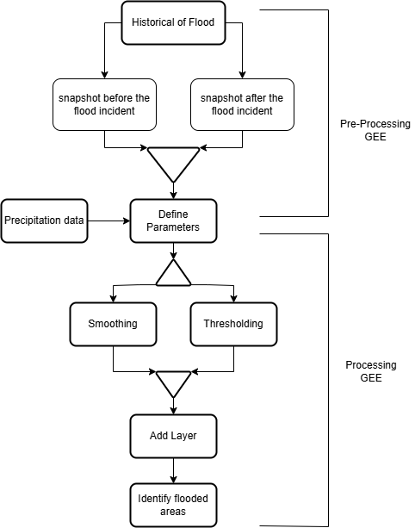
FIGURE 1. Framework of analysis

In performing pre-processing, we began by initializing data from flood history and collecting data from August 2016 to July 2020. We then filtered the data to obtain the relevant information, specifically data with Vertical Horizontal (VH) polarization. VH polarization involves radar waves being transmitted with a vertical orientation and received with a horizontal orientation [16], aiding in detecting changes in flooded or waterlogged areas [17]. Additionally, we used the Interferometric Wide (IW) instrument mode, an imaging mode on Sentinel-1 SAR designed to provide wide area coverage with high spatial resolution [18]. The IW mode uses multiple adjacent sub-swaths to capture data over a larger area with sufficient detail[19]. This model is highly effective for monitoring environmental changes and natural disasters such as floods because it can cover extensive areas and provide detailed data for surface change analysis [20]. After filtering the data, we divided it into snapshots before and after the flood. The pre-flood data was used as the minimum value for the predetermined dates, and the post-flood data was averaged over the specified date range. This pre-processing is crucial to obtain the initial data needed for subsequent analysis.
Based on the data obtained in preprocessing, these data were associated with precipitation data and the two datasets were integrated and processed. Next, we determined the smoothing and threshold parameters to use for our analysis. The combined pre-flood and post-flood data were smoothed with a median filter using the predetermined smoothing parameters [21]. This process produces smoother data, reduces noise, and improves accuracy [22]. In this smoothing process, the symbols x and y represent the center coordinates, i and j represent the offsets from the center coordinates, and the pre-flood and post-flood data are represented by B and A, respectively. (see Equations 1 and 2)
Smoothing Before the Floods:
$B^{'}\left(x,y\right)=Median (\frac{B(x+i,y+j)}{i^{2}+j^{2}≤{SMOOTHING_RADIUS}^{2}})$ (1)

Smoothing After the Floods:
$A^{'}\left(x,y\right)=Median (\frac{A(x+i,y+j)}{i^{2}+j^{2}≤{SMOOTHING_RADIUS}^{2}})$ (2)

After smoothing, we calculated the difference between pre-flood and post-flood data. The results are then thresholded to identify significant changes in the data below a predetermined threshold parameter value. This threshold is set to help identify areas with increasing rainfall in the Jakarta metropolitan area. In this thresholding, the symbols x and y represent the center coordinates, D represents the difference between pre-flood and post-flood data, and pre-flood and post-flood data are represented by B and A, respectively. (see Equations 3 and 4)

Difference Before and After Flood:
$D(x,y)=A'(x,y)-B'(x,y)$ (3)

Threshold:
$T\left(x,y\right)=(1 if D(x,y)<Diff_Upper_Threshold, 0 if D(x,y)>Diff_Upper_Threshold)$ (4)

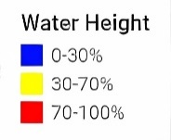
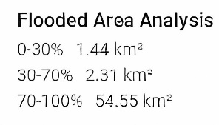
After that, the results of the smoothing and thresholding processes are combined into a single layer to identify areas that are potentially flood-prone. The thresholding value used will be lower. The results of this mapping can be seen in FIGURE 2 and FIGURE 3.
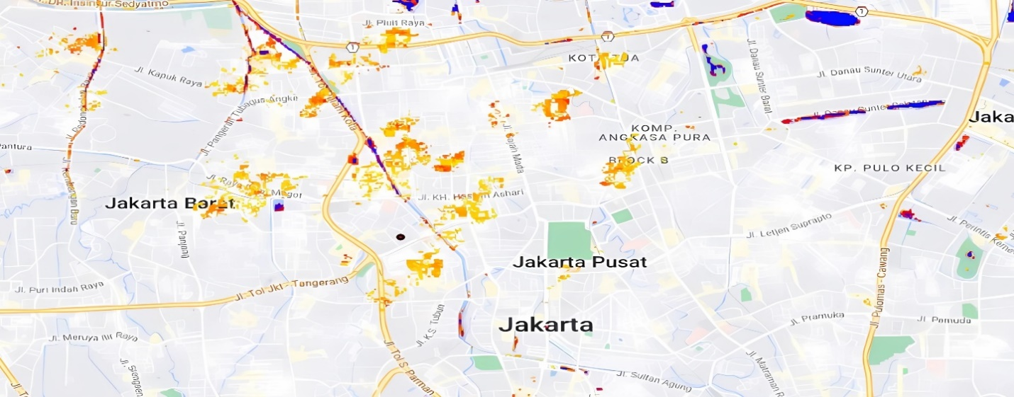
FIGURE 2. Displaying flood analysis results with different colors indicating water height levels in various areas. blue represents areas with 0-30% water height, yellow indicates 30-70% water height, and red signifies 70-100% water height.
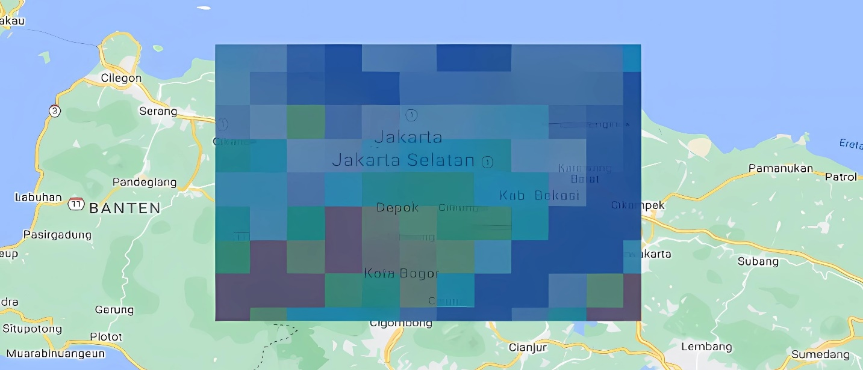
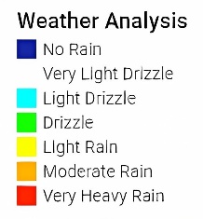
FIGURE 3. Weather analysis map of Jakarta and surrounding areas, using color coding to show different rainfall intensities: dark blue (no rain), light blue (very light drizzle), teal (light drizzle), green (drizzle), yellow (light rain), orange (moderate rain), and red (very heavy rain).

RESULTS AND DISCUSSION
Utilizing Sentinel-1 SAR data and Google Earth Engine, we obtained flood map analysis results in the DKI Jakarta area which are shown in FIGURE 2. The map shows the extent and distribution of potential floods in DKI Jakarta. Based on the map results, it was found that the flood area was divided into three water level ratios: 0-30%, 30-70%, and 70-100%.
Based on this analysis, the area of ​​the flood area with a water level between 0 and 30% was found to be 0.81 square kilometers. This could have occurred due to rainfall, which was not that large, as can be seen in Figure 3. This area is also shown in red on the map. In addition, When the water level is between 30 and 70%, it occupies an area of ​​0.42 square kilometers and is colored yellow. Of course, this can happen because of sufficient rainfall, which can be seen in FIGURE 3. Finally, the area that has the greatest potential for flooding, namely 70-100%, has an area of ​​0.36 square kilometers and is marked in blue. This happens when there is heavy rain as recorded in FIGURE 3.
These results show that areas that are least likely to be affected by flooding are areas with low or medium water levels (0-70%), while areas that have the potential to be most affected by flooding (70-100%) are few. The maps in FIGURE 2 and FIGURE 3 clearly show the distribution, intensity of flooding and rainfall. This analysis also shows the importance of improvements in infrastructure to reduce the impact of flooding in the DKI Jakarta area. By understanding the spread and distribution patterns of floods, it is possible for authorities to start taking more effective preventative and response actions, thereby reducing losses due to flooding.

CONCLUSIONS
Flood mapping in the DKI Jakarta area using SAR Sentinel-1 data and the Google Earth Engine platform provides information regarding the extent, distribution, intensity of floods and rainfall. Analysis shows that most of the areas affected by flooding have low to moderate water levels (0-70%), while some areas are shown to have high water levels (70-100%).
These findings help provide better understanding and information to the community, especially the DKI Jakarta community, about flood patterns in their area and provide information on the importance of flood prevention efforts and provide input for the National Disaster Management Agency (BNPB) and other related parties to take more effective action in reduce the risk of flooding to the community and the environment. Therefore, this map is very important for sustainable flood prevention efforts in DKI Jakarta in the future.

Acknowledgments
The data used in this publication, specifically the 'Global Rainfall Map in Near-Real-Time (GSMaP_NRT)', was produced and distributed by the Earth Observation Research Center, Japan Aerospace Exploration Agency (JAXA). We gratefully acknowledge JAXA's Global Rainfall Watch System for providing the data. Additionally, we extend our gratitude to the JRC Global Surface Water Mapping Layers, with the dataset provided by EC JRC / Google.

References
1. Hapsari, R.I. and M. Zenurianto, View of Flood Disaster Management in Indonesia and the Key Solutions. American Journal of Engineering Research, 2016. 5(3): p. 140-151.
2. Siddiq, A. and A.W. Sejati. Combining Landsat, VIIRS Night-time Light, and Sentinel-1 SAR for Spatial Flood Risk Assessment in Coastal Area: an Earth Engine Cloud Computing Process. in IOP Conference Series: Earth and Environmental Science. 2023. IOP Publishing.
3. Ardha, M., et al., Utilization of Sentinel-1 Satellite Imagery Data to Support Land Subsidence Analysis in DKI Jakarta, Indonesia. Journal of Degraded and Mining Lands Management, 2021. 8(2): p. 2587-2593.
4. Budiyono, Y., et al., Flood Risk Assessment for Delta Mega-Cities: a Case Study of Jakarta. Natural Hazards, 2015. 75(1): p. 389-413.
5. Wijayanti, E., et al. Extreme Coastal Flood Inundation Mapping Based on Sentinel 1 Using Google Earth Engine. in E3S Web of Conferences. 2023. EDP Sciences.
6. Surminski, S., et al., Reflections on the Current Debate on How to Link Flood Insurance and Disaster Risk Reduction in the European Union. Natural Hazards, 2015. 79(3): p. 1451-1479.
7. Wicaksono, A. and H. Herdiansyah. The Impact Analysis of Flood Disaster in DKI Jakarta: Prevention and Control Perspective. in Journal of Physics: Conference Series. 2019. IOP Publishing.
8. Zhang, H., et al., Mapping Photovoltaic Panels in Coastal China Using Sentinel-1 and Sentinel-2 Images and Google Earth Engine. Remote Sensing, 2023. 15(15): p. 1-20.
9. Rana, B., Real-Time Flood Inundation Monitoring in Capital of India Using Google Earth Engine and Sentinel Database. Knowledge-Based Engineering and Sciences, 2023. 4(3): p. 1-16.
10. Shastry, A., et al., Mapping Floods from Remote Sensing Data and Quantifying the Effects of Surface Obstruction by Clouds and Vegetation. Remote Sensing of Environment, 2023. 291: p. 1-12.
11. Tambunan, M.P. The Pattern of Spatial Flood Disaster Region in DKI Jakarta. in IOP Conference Series: Earth and Environmental Science. 2017. IOP Publishing.
12. Islam, M.T. and Q. Meng, An Exploratory Study of Sentinel-1 SAR for Rapid Urban Flood Mapping on Google Earth Engine. International Journal of Applied Earth Observation and Geoinformation, 2022. 113: p. 1-13.
13. Bauer-Marschallinger, B., et al., Satellite-Based Flood Mapping through Bayesian Inference from a Sentinel-1 SAR Datacube. Remote Sensing, 2022. 14(15): p. 1-28.
14. Moharrami, M., M. Javanbakht, and S. Attarchi, Automatic Flood Detection Using Sentinel-1 Images on the Google Earth Engine. Environmental monitoring and assessment, 2021. 193(5): p. 248.
15. Kubota, T., et al., Global Satellite Mapping of Precipitation (GSMaP) Products in the GPM Era. Satellite Precipitation Measurement: Volume 1, 2020. 67: p. 355-373.
16. Long, S., T.E. Fatoyinbo, and F. Policelli, Flood Extent Mapping for Namibia Using Change Detection and Thresholding with SAR. Environmental Research Letters, 2014. 9(3).
17. Mehmood, H., C. Conway, and D. Perera, Mapping of Flood Areas Using Landsat with Google Earth Engine Cloud Platform. Atmosphere, 2021. 12(7): p. 1-16.
18. Sun, Z., et al., Nation-scale Mapping of Coastal Aquaculture Ponds with Sentinel-1 SAR Data Using Google Earth Engine. Remote Sensing, 2020. 12(18): p. 1-18.
19. Few, R., Flood Hazards and Health: Responding to Present and Future Risks. Environmental Research Letters, 2014. 9: p. 3.
20. Pekel, J.-F., et al., High-Resolution Mapping of Global Surface Water and its Long-Term Changes. Nature, 2016. 540(7633): p. 418-422.
21. Jacinth Jennifer, J., S. Saravanan, and D. Abijith, Integration of SAR and Multi-Spectral Imagery in Flood Inundation Mapping–A Case Study on Kerala Floods 2018. ISH Journal of Hydraulic Engineering, 2022. 28(sup1): p. 480-490.
22. Tiwari, V., et al., Flood Inundation Mapping-Kerala 2018; Harnessing the Power of SAR, Automatic Threshold Detection Method and Google Earth Engine. PLoS One, 2020. 15(8): p. 1-17.

