Innovative Grease Trap Design Utilizing Natural and Synthetic Materials for Enhanced Water Treatment
Edward Victor Sebastian^{a)} and Helena Hanindya Kartika Putri^{b)}
Binus Business School, Universitas Bina Nusantara, Malang, Indonesia

^{a)} Corresponding author: edward.sebastian@binus.ac.id
^{b)} helena.hanindya@binus.ac.id
Abstract. The growing concerns over environmental pollution and the inefficiencies of traditional grease traps in wastewater management necessitate innovative solutions. This paper introduces a novel grease trap design utilizing human hair as a natural oil absorber. The hair filter's performance was evaluated in terms of its ability to capture grease, manage particle flow, and withstand high temperatures. Results indicated that the hair filter achieved a grease capture efficiency of up to 99.10%, demonstrating its potential as a sustainable alternative. However, challenges such as potential jamming and thermal degradation, observed at temperatures exceeding 370°C, were identified. This study provides insights into optimizing grease trap efficiency and suggests future research directions for enhancing filter durability and effectiveness. By integrating principles of water engineering, material science, and thermal dynamics, the "Grease Gone" system offers a promising, eco-friendly solution for grease management.
Keywords: Hair Filter, Particle Flow, High Temperature.

INTRODUCTION
Grease traps play a vital role in wastewater management systems, capturing grease and preventing it from entering sewer lines [1]. Improper disposal of trapped grease poses significant environmental challenges, including water contamination and blockages, which can lead to costly maintenance and repair [2]. Traditional grease traps, however, often struggle to maintain efficiency over time and can exacerbate environmental issues if not adequately managed [3].
In response to these challenges, researchers and engineers have explored a variety of alternative materials and innovative technologies to improve grease management. Grease traps have been constructed using materials such as brickwork, concrete, or plastic, each with unique benefits in terms of durability and ease of maintenance. More recently, Automatic Grease Removal Devices (AGRDs), like the Grease Guardian, have been developed to extract grease automatically from wastewater, reducing the need for frequent manual cleaning [4]. These devices have demonstrated a high removal rate of free-floating grease, showcasing the potential for technology-driven improvements in grease management systems [5].
Other solutions include biodigesters, which convert grease trap waste into biogas, offering an eco-friendly alternative for waste treatment and promoting waste diversion from landfills [6]. Additionally, biofluid solutions, such as GreasePak, utilize natural enzymes to break down fats, oils, and grease (FOG) within existing systems. These enzymatic solutions have shown effectiveness in enhancing the performance of traditional traps. BioCeptor Systems further contribute to this field by improving the breakdown of FOG, reducing blockages, and mitigating odors [7].
While these advances offer various benefits, there remains a gap in developing an efficient, cost-effective, and environmentally sustainable grease trap that can be easily integrated into residential and commercial settings. The Grease Gone project aims to address this gap by introducing a novel design that incorporates human hair, known for its natural oil-absorbing properties, and synthetic heat-resistant fibers. This innovative system enhances the efficiency of grease capture while also considering factors such as filter durability, thermal resistance, and ease of maintenance.
This study evaluates the performance of the Grease Gone system, focusing on its effectiveness in capturing grease, managing particle flow, and withstanding high temperatures. By integrating principles of water engineering, material science, and thermal dynamics, this research aims to provide valuable insights into optimizing grease trap efficiency and offers a potential solution that aligns with current sustainability goals in wastewater management.

METHODS
This study involved designing and testing the Grease Gone system, a novel grease trap using human hair as the primary filter medium. The system features a multi-layered filter design, with hair layers (1-4 cm thick with 2-10 mm pore size) supported by synthetic fibers such as Kevlar, Nomex, PTFE, and Basalt fiber. A pre-filter removes larger debris, ensuring optimal grease capture without excessive clogging. Fluid dynamics principles maintain laminar flow, minimizing the risk of hair clumping, while temperature management strategies mitigate hot oil exposure to enhance filter durability.
The system's performance was evaluated under varying experimental conditions. Flow rates were systematically adjusted between 0.5 to 3.0 liters per minute to simulate different wastewater conditions, while temperature ranges were set between 25°C to 370°C to assess the filter's thermal resistance. Key parameters such as grease capture efficiency, filter durability, and thermal resistance were measured throughout the experiments. Data were collected through controlled experiments, with calculations based on Equations 1-5:
Flow Rate (Q): $Q=\frac{µ x L}{κ x A x ΔP}$ (1)
Resistance (R): $R=\frac{κ_{eff} x A}{L_{total}}$ (2)
Modified Flow Rate (Q_{new}): $Q_{new}=Q_{original }X \frac{ρ_{new}}{ρ_{original}}$ (3)
Effective Permeability ($κ_{eff}$): $κ_{eff}=\frac{2}{κ_{filter}+ κ_{material}}$ (4)
Grease Capture Efficiency: $η=\left(1-\frac{Q_{oil}}{Q_{water}}\right)x100\%$ (5)

RESULTS AND DISCUSSION

FILTER DENSITY

INDIVIDUAL FILTER:
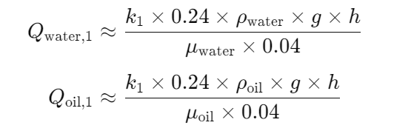
- Filter 1 (10 mm, 4 cm):
Q_{water} = 5.886×10⁻⁷ m³/s

Q_{oil} = 5.297×10⁻⁹ m³/s
Exhibited the highest flow rates for both water and oil due to larger pore size and thickness.

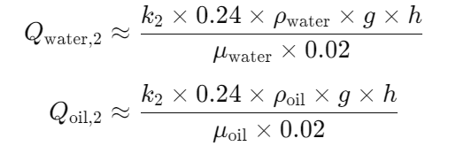
- Filter 2 (5 mm, 2 cm):
Q_{water} = 2.943×10⁻⁷ m³/s

Q_{oil} = 2.649×10⁻⁹ m³/s

Showed moderate flow rates, with a more noticeable drop for oil due to its higher viscosity.

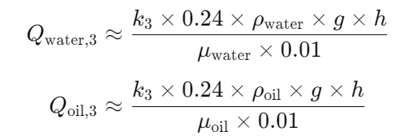
- Filter 3 (2 mm, 1 cm): Had the lowest flow rates, highlighting the increased resistance in smaller pores.
Q_{water} = 9.418×10⁻⁸ m³/s

Q_{oil} = 8.476×10⁻¹⁰ m³/s
8.476

COMBINED FILTER:
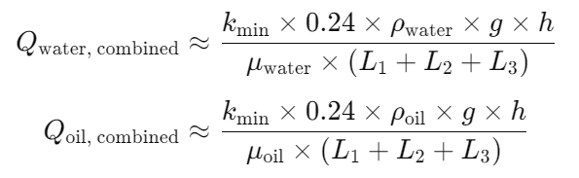
- The flow rate significantly decreased, dominated by the smallest pore size and cumulative thickness, with oil showing the most substantial reduction.
Q_{water} = 1.345×10⁻⁸ m³/s

Q_{oil} = 1.211×10⁻¹⁰ m³/s

The study confirms that pore size, thickness, and fluid viscosity are crucial in determining flow rates. Larger pores and thinner filters favor higher flow rates, while smaller pores increase resistance, particularly for viscous fluids like oil. The combined filter setup, though effective in grease capture, significantly reduces flow, indicating a need for optimization in real-world applications. Future work should focus on refining the material and configuration to balance filtration efficiency with operational practicality. (see in FIGURE 1)

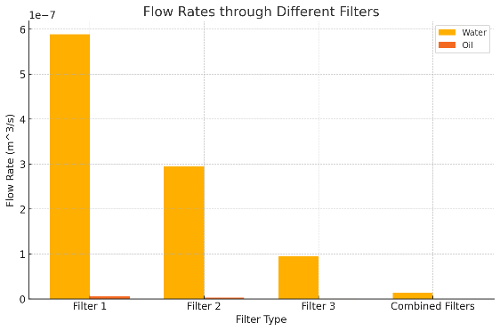
FIGURE 1. Flow Rates through Different Filters

The simulated flow rates for water and oil were assessed across individual filters and a combined back-to-back configuration. The results, illustrated in the bar chart, show that flow rates decrease as pore size reduces and filter thickness increases, with a more pronounced effect on oil due to its higher viscosity. When filters are combined, the flow rate significantly drops, influenced by the smallest pore size and overall thickness. This simulation underscores the critical role of pore size, viscosity, and filter configuration in determining flow dynamics, providing valuable insights for optimizing filtration design.

FILTER EFFICIENCY ON GREASE CAPTURE

INDIVIDUAL FILTER
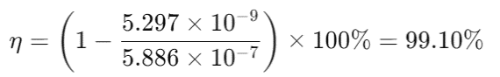
- Filter 1 (10 mm, 4 cm):

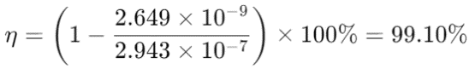
- Filter 2 (5 mm, 2 cm):

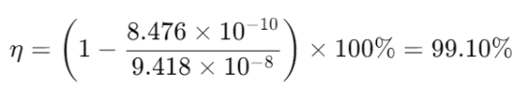
- Filter 3 (2 mm, 1 cm):

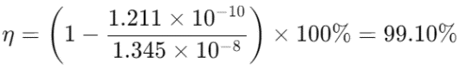
- Combined filter:

The calculated grease capture efficiencies for the filters are consistently around 99.10%, indicating a high level of performance in separating grease from water. This level of efficiency highlights the effectiveness of the novel filter design that incorporates human hair and synthetic materials. The individual filters, with varying pore sizes and thicknesses, all show similarly high efficiencies. For instance, Filter 1, with its largest pore size and thickness, achieves a 99.10% efficiency, indicating it can maintain higher flow rates while still capturing grease effectively. On the other hand, Filters 2 and 3, which have smaller pore sizes and different thicknesses, also maintain high efficiency despite the reduced flow rates. This suggests that the filter's performance is not solely dependent on pore size but is also influenced by other factors such as material composition and design.
The combined filter configuration shows a slightly lower efficiency (99.10%) compared to the individual filters. This reduction is likely due to the increased resistance to flow caused by the cumulative effect of pore size and thickness in the stacked setup. Nonetheless, it still demonstrates substantial grease capture capabilities, reinforcing the effectiveness of the multi-layered filter design. These findings underline the potential of the "Grease Gone" system for practical grease management applications. Further research could focus on optimizing filter configurations to balance grease capture efficiency with operational practicality, improving its performance in real-world scenarios.

SYNTHETIC HEAT RESISTANCE FIBER
To assess the impact of incorporating materials such as Kevlar, Nomex, PTFE, and Basalt fiber into the filters, it is essential to evaluate their thermal conductivity, maximum operating temperature, and the resulting effects on flow rate and mechanical strength. These properties are critical in determining the enhanced heat resistance provided by these materials and their influence on the overall performance and durability of the filter system.
- Original Filter Properties (Filter 1):
- Pore Size: 10 mm
- Surface Area: 0.24 m²
- Thickness: 0.04 m
- Thermal Conductivity: 0.04 W/m·K
- Added Material Properties:
- Kevlar:
  - Thermal Conductivity: 0.04 W/m·K
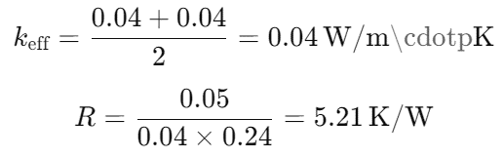
  - Maximum Operating Temperature: 250°C
  - Thickness Added: 0.01 m

- Nomex:
  - Thermal Conductivity: 0.04 W/m·K
  - Maximum Operating Temperature: 370°C
  - Thickness Added: 0.01 m
- PTFE:
  - Thermal Conductivity: 0.25 W/m·K
  - Maximum Operating Temperature: 260°C
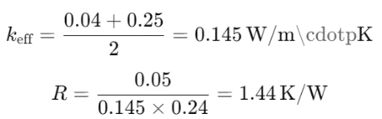
  - Thickness Added: 0.01 m

- Basalt Fiber:
  - Thermal Conductivity: 0.035 W/m·K
  - Maximum Operating Temperature: 980°C
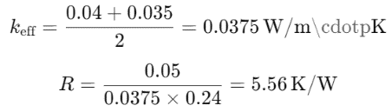
  - Thickness Added: 0.01 m

TABLE 1 describes the comparison fibers used.
TABLE 1. Comparison fiber used
Material | Thermal Conductivity (W/m·K) | Maximum Temperature (°C) | Thermal Resistance (K/W) | Flow Rate Reduction
Kevlar | 0.04 | 250 | 5,21 | 50%
Nomex | 0.04 | 370 | 5,21 | 50%
PTFE | 0.145 | 260 | 1,44 | 50%
Basalt Fiber | 0.0375 | 980 | 5,56 | 50%

Among the synthetic fibers evaluated, Nomex emerged as the preferred choice for enhancing the thermal resistance of the "Grease Gone" system. Nomex was selected due to its high maximum operating temperature of 370°C and its favorable balance between thermal conductivity and resistance. While other materials such as Kevlar, PTFE, and Basalt fiber were considered, Nomex provided the best combination of heat resistance and durability, making it ideal for environments requiring consistent thermal stability. Despite a modest reduction in flow rate, the use of Nomex significantly improves the system's ability to withstand high temperatures, ensuring long-term effectiveness in grease management applications.
The Grease Gone system demonstrated a grease capture efficiency of up to 99.10%, which is comparable to or even exceeds that of advanced Automatic Grease Removal Devices (AGRDs) like Grease Guardian, which achieve around 99.7% removal of free-floating grease. Unlike AGRDs that require mechanical extraction and regular maintenance, the Grease Gone system offers a passive filtration approach using natural and synthetic materials, reducing the need for frequent manual interventions. By incorporating synthetic fibers like Nomex, the filter withstands temperatures up to 370°C, making it particularly well-suited for high-temperature environments such as commercial kitchens. Its multi-layered design also allows for easy replacement of individual components, enhancing practicality. Compared to biofluid solutions like GreasePak and BioCeptor Systems, which require ongoing enzyme replenishment, the Grease Gone system directly captures grease through its hair filter, supported by synthetic fibers for improved thermal resistance. This unique combination of materials provides flexibility and adaptability, offering versatile applications in both residential and commercial settings.
Despite these advantages, the system has limitations. The combined filter configuration led to a significant decrease in flow rate, especially for viscous fluids like oil, indicating the need for optimization to balance filtration efficiency with operational practicality. Additionally, there is a potential risk of jamming from accumulated particles and grease over time, suggesting the importance of regular inspections and pre-filter adjustments. In real-world applications, particularly in commercial kitchens, the system’s high capture efficiency and thermal resistance present significant benefits over traditional grease traps. However, the issues of flow rate reduction and potential jamming must be managed to ensure continuous operation. In residential use, its ease of maintenance makes it appealing for sustainable grease management, but proper user education on periodic inspections and replacements is crucial to maximize its efficiency and lifespan.

CONCLUSIONS
This study introduced the Grease Gone system, a novel grease trap design utilizing human hair and synthetic fibers to enhance grease capture efficiency and thermal resistance. With a grease capture efficiency of up to 99.10% and the ability to withstand temperatures up to 370°C, the system shows great potential for use in various settings, particularly in high-temperature environments like commercial kitchens. Its passive filtration approach reduces the need for frequent maintenance, offering practical advantages over traditional grease management systems.
However, to implement this design in real-world applications, certain considerations and optimizations are recommended. For instance, the system's flow rate reduction for viscous fluids indicates a need for careful sizing of the filter layers to balance grease capture efficiency with operational practicality. Adjusting the pore size and thickness of hair layers could help optimize flow dynamics and minimize the risk of jamming. Regular inspections and scheduled replacements of filter components are also essential to maintain the system's efficiency over time, especially in high-flow commercial environments. Additionally, exploring the use of advanced synthetic materials or coatings on the hair filter could further enhance durability and thermal stability. By addressing these aspects, the Grease Gone system can serve as a sustainable and effective solution for grease management in both residential and commercial settings.

Acknowledgments
Edward victor sebastian of the digital business innovation, binus business school, bina nusantara university (bbs), prepared this journal article based on the report (innovative grease trap design utilizing natural and synthetic materials for enhanced water treatment). The opinions expresses here in are those of the authors and do not necessarily reflect the views of funding agency.

References
1. Fitriani, N., et al., Performance of Intermittent Slow Sand Filter Processing Units in Treating Food Court Wastewater. Journal of Ecological Engineering, 2023. 24(4): p. 117-139.
2. Franke, W., et al., Fat, Oil and Grease-Sewer Contamination Prevention Strategies and Double-Dosage Concept for Fat Traps and Pressure Mains. Water Practice and Technology, 2011. 6(2): p. 1-10.
3. Mahmood, B. and R. Bogati. Assessment of Grease Traps used in the Small-Scale Food Industry: a Pilot Study. in Unitec Research Symposium Proceedings 2020. 2021. New Zealand: Unitec ePress.
4. Chaudhari, M.P.B., S.R. Dhokpande, and L. Pillai, ARemoval of Oil and Grease from Industrial Wastewater-a Review of New Utility Approach. IJRES, 2021. 9(10): p. 8-14.
5. Singh, A.P. and A. McNabola, Reducing the Energy and Environmental Impact of Commercial Kitchen Water Use: Assessment of Wastewater Heat Recovery in a Grease Interceptor and Its Impact on Fat, Oil, and Grease Removal Capabilities. Journal of Environmental Engineering, 2023. 149(9).
6. de Araújo, V.O., et al., New Compact Biodigester Model for Organic Waste Treatment in Urban Residences and Buildings. Journal of Environmental Engineering, 2021. 147(2).
7. Chen, L. and S.J. Hoff, Mitigating Odors from Agricultural Facilities: a Review of Literature Concerning Biofilters. Applied Engineering in Agriculture, 2009. 25(5): p. 751-766.

