Artificial intelligence for early detection of financial crises: A proposed measurement
Fitri Rusdianasari^{a)}, Muhammad Sri Wahyudi Suliswanto^{b)}, Mochamad Rofik^{c)}, and Aris Soelistyo^{d)}
Faculty of Economics and Business, Universitas Muhammadiyah Malang, Malang, Indonesia

^{b)} Corresponding author: ms.wahyudi@umm.ac.id
^{a)} fitrirusdianasari@umm.ac.id
^{c)} rovikumm@gmail.com
^{d)} aris_s@umm.ac.id
Abstract. Early detection of financial crises is an important challenge for global economic stability. This research aims to develop an artificial intelligence (AI) based scoring model to detect early signs of a financial crisis which can become an early warning system for policy makers. The method used in preparing this article is a qualitative research method with a literature study approach. By combining a machine learning approach and macroeconomic, financial and market indicators that have been proven relevant in previous literature, this model is designed to provide a risk score that can assist decision makers in monitoring and assessing potential crises. Neural networks are used to process information from several macroeconomic indicators which will then be processed and produce output that can be used to make decisions. The results of this study offer a model prepared based on information input consisting of macroeconomic indicators such as GDP, inflation, unemployment, excessive credit growth, high market volatility, and bond yield spreads as important parameters in the scoring model. Apart from that, this study also offers a flowchart that shows how neural networks work which can help regulators detect the risk of a financial crisis in the future.
Keywords: Financial crisis, artificial intelligence, early warning system, scoring model

INTRODUCTION
A financial crisis is an event that can result in major losses not only for financial institutions but also for the global economy. History has recorded several major financial crises, such as the Asian Financial Crisis in 1997 and the Global Financial Crisis in 2008, which caused very significant economic losses and had long-term impacts [1]–[3]. To avoid or mitigate the impact of a financial crisis, early detection of signs of crisis is especially important.
Artificial intelligence (AI) technology has developed rapidly in recent decades and offers great potential for early detection of financial crises. AI has the ability to analyse large amounts of data and identify patterns that traditional methods cannot detect [4]–[6]. Using techniques such as machine learning and deep learning, AI can process financial, social and economic data in real-time, providing early warning of potential crises before the symptoms become apparent [7]–[9]. The role of AI in this sector is becoming increasingly important given the ever-increasing complexity of global financial markets.
Early detection of financial crises through AI can help financial institutions and governments take appropriate preventive actions, thereby minimizing the impact caused by the crisis [10], [11]. Additionally, by integrating AI in early warning systems, we can create a financial system that is more resilient and responsive to unexpected changes in market conditions [12]–[14]. Therefore, this study aims to map the variables that have an impact on the national economy, both from the macro, monetary and real sectors, where the performance of these variables can be a signal of an economic crisis, so it is hoped that there will be signals In this way, regulators can take preventive steps that can mitigate the crisis or reduce the impact of the crisis in the future.

METHODS
The method used in preparing this article is a qualitative research method with a literature study approach. A literature study was conducted to understand the concepts and theories relevant to early detection of financial crises and the application of AI in the financial sector. The literature reviewed includes journal articles, books, and research reports from various credible sources. The focus of this literature study is to identify the main indicators that will be used as variables that influence the financial crisis that have been used in previous studies. These variables can later be used as the proposed scoring model to detect warnings of a financial crisis. To model it, an Artificial Neural Network (ANN) or artificial neural network is used which is adopted from the workings of the human brain so that the output results will provide a signal in the form of early detection of a financial crisis.
The ANN framework is an information processing system that has the same performance characteristics as human biological neural networks and is part of soft computing that emphasizes the thinking process ([15]–[17]. The computational process in a neural network is designed to resemble the overly complex working system of neurons in the human brain. Neural networks consist of elements for processing information called neurons, units, cells, or nodes. Each neuron is connected to other neurons by a connection link which is represented by weight [5], [14]. ANN can model linear or non-linear relationships, in this case ANN is also considered a non-linear or non-parametric statistical method as well as a model that can be an alternative in decision making because it does not require assumptions that are difficult for researchers [18]. The way ANN works is that it is able to conclude parts of the population that are unknown only with information from samples obtained as a form of information input in accordance with the principle of forecasting future conditions from the results of past sample information in the form of real time series data [19], [20]. This forecasting model is usually expressed in a functional relationship between input and output so that in the ANN framework it has a flow consisting of 3 stages including input layer, hidden layer and output, as presented in FIUGRE 1 [21]. In practice, input is in the form of data information received by the neural network in the input layer. The number of nodes or neurons in the input layer depends on the number of inputs in the model and each input defines one neuron. Next, there is a hidden layer located between the input and output layers. After the data is processed in the computing process, an output layer will appear which becomes the prediction result which can then be used as material for decision making [22]. Software that can be used to process the ANN method includes Matlab, R studio, Python, and others.

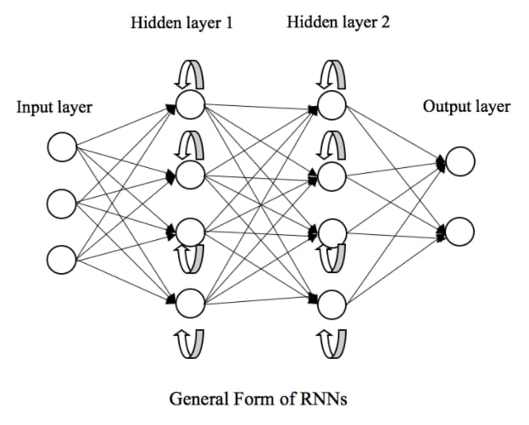
FIGURE 1. Artificial Neural Network Framework

RESULTS AND DISCUSSION
AI is emerging as a technology with great potential to provide early warnings and enable financial authorities to take preventive measures before a crisis reaches its peak. AI's ability to process and analyse large amounts of data and detect hidden patterns provides its own advantages in detecting financial anomalies. AI can be used to model complex market dynamics, identify systemic risks, and predict potential crises with a higher degree of accuracy compared to traditional approaches. Thus, the integration of AI in financial analysis can have a significant impact in maintaining financial market stability and reducing the negative impact of previously undetected crises.
Scoring models can be used to detect financial crises by identifying potential risks or early signs that indicate the possibility of a crisis occurring. A scoring model is a scoring system that combines various economic, financial and market indicators to produce a risk score that indicates the likelihood of a financial crisis occurring. This score can be used by policy makers, central banks, or financial institutions to assess economic stability and take preventive action if necessary.
Based on the results of a review of previous literature studies, the complexity of macroeconomic variables as indicators that will become the input layer to be further formulated in the scoring model proposed in this study including TABLE 1:
TABLE 1. Macroeconomic indicators
No. | Variables | Indicators | Description
1. | Macroeconomic (X1) | Economic growth [13], [14], [23], [24] (X1,1) | A significant decline in GDP growth can be an early sign of an economic crisis
1. | Macroeconomic (X1) | Inflation [25]–[29] (X1,2) | High inflation rates or unexpected inflation fluctuations can signal economic instability
1. | Macroeconomic (X1) | Unemployment [30]–[35] (X1,3) | A sudden increase in unemployment can be an indicator of stress in the economy
1. | Macroeconomic (X1) | Oil Price Shock [36]–[40] (X1,3) | World oil prices are an indicator of increasing global inflation.
2. | Finance (X2) | Debt to GDP Ratio [41]–[45] (X2,1) | High debt levels in both the public and private sectors can increase the risk of a debt crisis
2. | Finance (X2) | Credit growth [10], [46]–[49] (X2,2) | Excessive credit growth, especially credit to the private sector, is often associated with crises
2. | Finance (X2) | Leverage in banking sector [50]–[53] (X2,3) | High levels of leverage in the banking system can increase the risk of systemic failure.
2. | Finance (X2) | Spread Yield of Bond [54]–[57] (X2,4) | The spread between high-risk bonds and low-risk bonds is often used as an indicator of stress in financial markets
3. | Market (X3) | Asset price [49], [58]–[60] (X3,1) | An increase in asset prices, such as shares or property, which is not supported by fundamentals can indicate the formation of an asset bubble
3. | Market (X3) | Market volatility [61]–[65] (X3,2) | Increased stock or foreign exchange market volatility can signal increased uncertainty
3. | Market (X3) | Market sentiment [66]–[70] (X3,3) | Sentiment analysis of financial news and social media can provide insight into risk perceptions among investors
4. | Trade and balance payment (X4) | Deficit of balance payment [71]–[73] (X4,1) | Imbalances in international trade or capital flows can be a sign that a country's economy is vulnerable to crisis
4. | Trade and balance payment (X4) | Foreign reserve [74]–[77] (X4,2) | A significant decline in foreign exchange reserves could indicate pressure on the currency and a potential foreign exchange crisis
Source: various previous literature studies

The indicators above will then function as an input layer which contains information in the form of both numeric and non-numerical data. First, the variable derivative is modelled as follows:
(1)
Each variable has several measurement indicators which are formulated as follows:
(2)
Each input will be processed by perceptron and then appropriate weighting will be conducted based on the calculation process and the amount of weighting is based on how important the input feature is. Determining the weighting data is also strengthened through interviews and validation from experts so that it will be known that the most priority indicators will get the highest weight value and vice versa. Some statistical analyses that can be conducted include: First, Logistic Regression and Probit. These models are used to estimate the probability of a crisis occurring based on the indicators that will be used. By inputting historical data, this model can identify the relationship between certain variables (for example, credit growth, inflation, asset prices) and the occurrence of a crisis. Second, Vector Autoregression (VAR). VAR can be used to analyse the dynamic relationships between several economic and financial variables, helping to predict how shocks in one variable may affect the financial system.
Furthermore, after being weighted there is a bias which acts as an additional value added to the input calculation results which have been multiplied by the weight. Bias helps the perceptron in adjusting the results and makes the model more flexible. Bias acts as a regulator so that the model can make better forecasts. In the following formulation, the weighting results are added to the bias value to produce a calculation called net input or linear function (z).
(3)
(4)
(5)
Noted:
z= net input layer
x = input
w = weight
b = bias
m = total input
The results of the weighting can be used to determine a composite risk score that reflects the level of likelihood of a crisis occurring. For example:
- Score 0-4: Low risk
- Score 5-7: Medium risk
- Score 8-10: High risk
After getting the net input 𝑧, this value is processed through an activation function which will determine whether the net input is converted into a perceptron output which is called the hidden layer. The layer in this function is tasked with perfecting the processed model so that more complex results can be obtained. The processed results from the hidden layer will then produce an output layer where this layer is the final result of the perceptron which is obtained through an activation function in the form of a prediction count or forecast from the perceptron’s in the input layer, which in turn these results can help provide early detection of financial crises.
From the mathematical formulation above, the ANN framework for early detection of financial crises can be described by including economic variable indicators as input as following FIGURE 2:
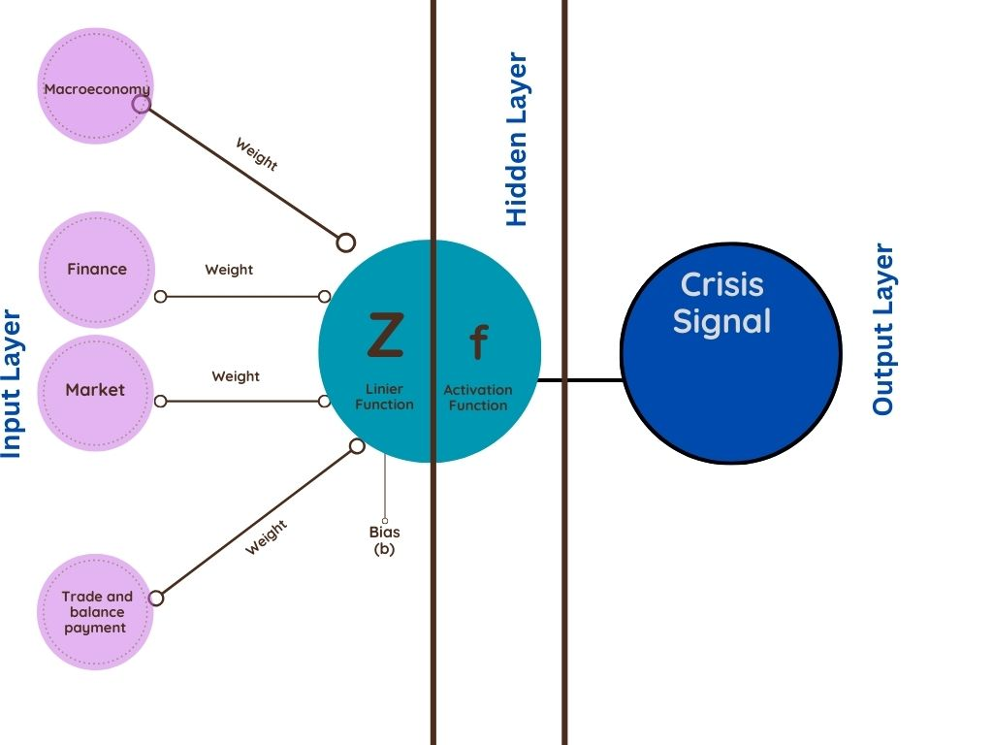
FIGURE 2. ANN Framework in the Financial Crisis Early Warning System

CONCLUSIONS

Design an early crisis detection model by adopting the ANN method development model with input in the form of macroeconomic, financial, market and balance of payments variables obtained from previous literature studies. Furthermore, these indicators will be weighted and then reSduced to measurement indicators which are weighted based on the priorities of the calculation process and processed into output which is expected to contribute as a reference in policy making to mitigate and reduce the major impacts of future crises. However, this study is also limited to modelling without further testing with existing empirical data. The hope is that further research can be assessed empirically to conduct more in-depth and comprehensive testing.

References
- M. Mellor, “The financial crisis,” Capital. Nature, Social., vol. 20, no. 1, pp. 34–36, 2009, doi: 10.1080/10455750902727170.
- C. Tang and et al Dungey, “Are Financial Crises Alike?,” IMF Work. Pap., vol. 10, no. 14, p. 1, 2010, doi: 10.5089/9781451962086.001.
- F. Allen, A. Demirguc-Kunt, L. Klapper, and M. Soledad Martinez Peria, The foundations of financial inclusion: Understanding ownership and use of formal accounts are in the development, no. December. 2012.
- F. Mulyarti, . S., S. Subanti, E. Zukhronah, and W. Sulandari, “Implementation of Neural Network in Early Detection of Financial Crisis in Singapore,” KnE Life Sci., 2024, doi: 10.18502/kls.v8i1.15587.
- S. Chen, Y. Huang, and L. Ge, “an Early Warning System for Financial Crises: a Temporal Convolutional Network Approach,” Technol. Econ. Dev. Econ., vol. 30, no. 3, pp. 688–711, 2024, doi: 10.3846/tede.2024.20555.
- M. Kas and Y. IRPICI, “Predictability of Financial Crises in Turkey: ANN-Based Early Warning System,” Ekon. Yaklasim, vol. 35, no. 130, p. 99, 2024, doi: 10.5455/ey.30004.
- R. Soviani, “Early Warning Indicators for a Financial Crises . The Case of Romania,” vol. 27, no. 3, pp. 45–63, 2014.
- M. Costa Navajas and A. Thegeya, “Financial Soundness Indicators and Banking Crises,” IMF Work. Pap., vol. 13, no. 263, p. 1, 2013, doi: 10.5089/9781484327616.001.
- N. Martinez, “Predicting Financial Crises,” Whart. Res. Sch., pp. 1–45, 2016.
- T. Turap, T. B. Merupakan, T. B. Lebih, and T. D. Turap, “Development of an Early Warning System based on Artificial Intelligence,” Korean Inst. Ind. Eng., vol. 25, no. 3, pp. 1–17, 2012, doi: DOI: 10.1109/SSAIC61213.2024.00135.
- F. Allen and D. M. Gale, “An Introduction to Financial Crises,” SSRN Electron. J., 2011, doi: 10.2139/ssrn.1008311.
- S. Li, “Advancing financial crisis prediction: Big data, AI, and economic theories,” Appl. Comput. Eng., vol. 74, no. 1, pp. 104–109, 2024, doi: 10.54254/2755-2721/74/20240448.
- S. Coulibaly and A. Marouane, “Macroeconomic Currency Crisis Early Warning Indicators in Emerging Countries,” J. Bus. Econ. Dev., vol. 9, no. 2, pp. 21–35, 2024, doi: 10.11648/j.jbed.20240902.11.
- P. Funica, “Indicators of Financial Crisis: How do They Perform?,” SSRN Electron. J., 2011, doi: 10.2139/ssrn.1477026.
- S. Zheng and X. Hu, “Early Warning Method for Public Health Emergency Under Artificial Neural Network in the Context of Deep Learning,” Front. Psychol., vol. 12, no. February, pp. 1–11, 2021, doi: 10.3389/fpsyg.2021.594031.
- A. Wang, “Intelligent Early Warning Support System of Financial Crisis Based on Recurrent Neural Network,” Proc. - 2022 Int. Conf. Artif. Intell. Auton. Robot Syst. AIARS 2022, pp. 246–250, 2022, doi: 10.1109/AIARS57204.2022.00062.
- C. Sevim, A. Oztekin, O. Bali, S. Gumus, and E. Guresen, “Developing an early warning system to predict currency crises,” Eur. J. Oper. Res., vol. 237, no. 3, pp. 1095–1104, 2014, doi: 10.1016/j.ejor.2014.02.047.
- M. Kathikeyan, A. Roy, S. S. Hameed, P. R. Gedamkar, G. Manikandan, and V. Kale, “Optimization System for Financial Early Warning Model Based on the Computational Intelligence and Neural Network Method,” Proc. 5th Int. Conf. Contemp. Comput. Informatics, IC3I 2022, pp. 2059–2064, 2022, doi: 10.1109/IC3I56241.2022.10072848.
- Y. Zhang, “Financial system crisis early warning model analysis based on neural network with entropy method,” Proc. - 2018 Int. Conf. Robot. Intell. Syst. ICRIS 2018, pp. 560–563, 2018, doi: 10.1109/ICRIS.2018.00144.
- B.-C. Kwon and N.-W. Cho, “Development of an Early Warning System based on Artificial Intelligence,” IE interfaces, vol. 25, no. 3, pp. 319–326, 2012, doi: 10.7232/ieif.2012.25.3.319.
- T. Wang, S. Zhao, G. Zhu, and H. Zheng, “A machine learning-based early warning system for systemic banking crises,” Appl. Econ., vol. 53, no. 26, pp. 2974–2992, 2021, doi: 10.1080/00036846.2020.1870657.
- S. Zheng and X. Hu, “Early Warning Method for Public Health Emergency Under Artificial Neural Network in the Context of Deep Learning,” Front. Psychol., vol. 12, 2021, doi: 10.3389/fpsyg.2021.594031.
- A. Abbate and M. Marcellino, “Macroeconomic activity and risk indicators :,” 2017.
- O. Tkachenko, M. Halaburda, and I. Kulaga, “Economic Growth Under Crisis Conditions With the Influences of Cultural and Social Factors,” Ukr. J. Appl. Econ. Technol., vol. 8, no. 1, pp. 90–98, 2023, doi: 10.36887/2415-8453-2023-1-13.
- S. Budsayaplakorn, S. Dibooglu, and I. Mathur, “Can macroeconomic indicators predict a currency crisis? Evidence from selected Southeast Asian countries,” Emerg. Mark. Financ. Trade, vol. 46, no. 6, pp. 5–21, 2010, doi: 10.2753/REE1540-496X460601.
- M. Gallegati and D. Delli Gatti, “Macrofinancial imbalances in historical perspective: A global crisis index,” J. Econ. Dyn. Control, vol. 91, pp. 190–205, 2018, doi: 10.1016/j.jedc.2018.01.026.
- K. S. Chernousova and R. M. Shilman, “Inflation Processes in the Conditions of the Global Crisis,” Lect. Notes Civ. Eng., vol. 378 LNCE, pp. 80–85, 2023, doi: 10.1007/978-3-031-38122-5_12.
- J. Kaehler and C. S. Weber, “Inflation in the aftermath of financial crises,” Econ. Model., vol. 128, 2023, doi: 10.1016/j.econmod.2023.106512.
- G. Jałtuszyk, “Inflation, the global financial crisis, and COVID-19 pandemic,” J. Manag. Financ. Sci., no. 46, pp. 9–19, 2023, doi: 10.33119/jmfs.2022.46.1.
- E. R. Njike-Tchaptchet and C. Tadmon, “Mathematical modeling of the unemployment problem in a context of financial crisis,” Math. Comput. Simul., vol. 211, pp. 241–262, 2023, doi: 10.1016/j.matcom.2023.04.014.
- S. Huikari and M. Korhonen, “Unemployment, global economic crises and suicides: evidence from 21 OECD countries,” Appl. Econ., vol. 53, no. 13, pp. 1540–1550, 2021, doi: 10.1080/00036846.2020.1838430.
- Z. Hasan and I. Sabilirrasyad, “Youth Unemployment and Financial Crises: A Systemic Literature Review,” Proceeding Int. Conf. Econ. Bus. Inf. Technol., vol. 4, pp. 916–921, 2023, doi: 10.31967/prmandala.v4i0.867.
- F. Bonna, “Creating connections for expansive learning in crisis-laden times of long-term unemployment,” Eur. J. Res. Educ. Learn. Adults, vol. 12, no. 3, pp. 251–266, 2021, doi: 10.3384/RELA.2000-7426.3882.
- W. Lei, Z. Li, and D. Mei, “Financial crisis, labor market frictions, and economic volatility,” PLoS One, vol. 18, no. 9 September, 2023, doi: 10.1371/journal.pone.0291106.
- O. Voytyk and N. Mazii, “Labor market amid the crisis and ways to improve its governmental regulation,” Democr. Gov., vol. 30, no. 2, pp. 144–157, 2022, doi: 10.23939/dg2022.02.144.
- M. Ullah et al., “Impact of Oil Price Shocks on Crypto and Conventional Financial Assets during Financial Crises: Evidence from the Russian Financial Market,” Int. J. Energy Econ. Policy, vol. 14, no. 4, pp. 472–483, 2024, doi: 10.32479/ijeep.16374.
- Y. Yu, S. L. Guo, and X. C. Chang, “Oil prices volatility and economic performance during COVID-19 and financial crises of 2007–2008,” Resour. Policy, vol. 75, 2022, doi: 10.1016/j.resourpol.2021.102531.
- Z. Umar, M. Gubareva, M. Naeem, and A. Akhter, “Return and volatility transmission between oil price shocks and agricultural commodities,” PLoS One, vol. 16, no. 2 February 2021, 2021, doi: 10.1371/journal.pone.0246886.
- A. A. Putra, D. P. Emrinaldi Nur, and F. Putra, “Oil price crisis and bankruptcy risk,” Int. J. Energy Econ. Policy, vol. 11, no. 4, pp. 7–13, 2021, doi: 10.32479/ijeep.11111.
- M. Rivki, A. M. Bachtiar, T. Informatika, F. Teknik, and U. K. Indonesia, “Relationship Between Financial Crisis And Oil Shock And Its Effect On East- West Asia Trade Flows,” Iran. Econ. Rev., vol. 16, no. 30, pp. 119–138, 2011, doi: 10.22059/ier.2011.32733.
- J. Kronick and S. Ambler, “Predicting financial crises: debt versus debt service ratios,” Appl. Econ., vol. 55, no. 47, pp. 5553–5571, 2023, doi: 10.1080/00036846.2022.2140112.
- C. D. Romer and D. H. Romer, “Fiscal space and the aftermath of financial crises: How it matters and why,” Brookings Pap. Econ. Act., vol. 2019, no. Spring, pp. 239–331, 2019, doi: 10.1353/eca.2019.0003.
- Z. Jin, “Optimal Debt Ratio and Consumption Strategies in Financial Crisis,” J. Optim. Theory Appl., vol. 166, no. 3, pp. 1029–1050, 2015, doi: 10.1007/s10957-014-0629-0.
- J. L. Stein, “A Tale of Two Debt Crises: A Stochastic Optimal Control Analysis,” SSRN Electron. J., 2012, doi: 10.2139/ssrn.1726747.
- A. Zdzienicka and D. Furceri, “How Costly are Debt Crises?,” SSRN Electron. J., 2012, doi: 10.2139/ssrn.1653855.
- K. Müller and E. Verner, “Credit Allocation and Macroeconomic Fluctuations,” Rev. Econ. Stud., 2023, doi: 10.1093/restud/rdad112.
- X. Li, J. Zhang, and D. An, “Banking crises and corporate trade credit: The role of creditor protection,” Financ. Res. Lett., vol. 65, 2024, doi: 10.1016/j.frl.2024.105508.
- T. H. Baker, K. Judge, and A. Klein, “Credit, Crises, and Infrastructure: the Differing Fates of Large and Small Businesses,” Bost. Univ. Law Rev., vol. 102, no. 4, pp. 1353–1396, 2022, doi: 10.2139/ssrn.4049321.
- M. Chibane, A. Gabriel, and G. A. Giménez Roche, “Credit booms and crisis-emergent asset comovement: The problem of latent correlation,” Q. Rev. Econ. Financ., vol. 85, pp. 270–279, 2022, doi: 10.1016/j.qref.2022.03.009.
- I. Qizam, N. Khairina, and N. Betriasinta, “Dynamic leverage policy in Islamic and conventional banks during crises in the OIC countries: a procyclicality and prospect-theory analysis,” J. Islam. Account. Bus. Res., 2024, doi: 10.1108/JIABR-10-2023-0331.
- J. Geanakoplos, “Leverage Cycle Theory of Economic Crises and Booms,” Oxford Res. Encycl. Econ. Financ., 2024, doi: 10.1093/acrefore/9780190625979.013.484.
- C. Giraldo, I. Giraldo, J. E. Gomez-Gonzalez, and J. M. Uribe, “Banks’ leverage in foreign exchange derivatives in times of crisis: A tale of two countries,” Emerg. Mark. Rev., vol. 55, 2023, doi: 10.1016/j.ememar.2023.101028.
- Ö. Öztekin, “Systemic Banking Crises, Institutional Environment, and Corporate Leverage,” J. Financ. Quant. Anal., vol. 57, no. 3, pp. 1115–1141, 2022, doi: 10.1017/S0022109020000861.
- D. Khametshin, “High-Yield Bond Markets During the COVID-19 Crisis: The Role of Monetary Policy,” SSRN Electron. J., 2021, doi: 10.2139/ssrn.3821621.
- M. Gubareva, “The impact of Covid-19 on liquidity of emerging market bonds,” Financ. Res. Lett., vol. 41, pp. 1–13, 2021, doi: 10.1016/j.frl.2020.101826.
- D. Chionis, I. Pragidis, and P. Schizas, “The determinants of Greek bond yields: an empirical study before and during the crisis,” J. Econ. Stud., vol. 43, no. 3, pp. 504–519, 2016, doi: 10.1108/JES-12-2014-0197.
- G. Menounos, C. Alexiou, and S. Vogiazas, “Investigating the relationship between high-yield bonds and equities and its implications for strategic asset allocation during the Great Recession,” Int. J. Financ. Econ., vol. 24, no. 3, pp. 1193–1209, 2019, doi: 10.1002/ijfe.1711.
- L. A. Kuehn, D. Schreindorfer, and F. Schulz, “Persistent Crises and Levered Asset Prices,” Rev. Financ. Stud., vol. 36, no. 6, pp. 2571–2616, 2023, doi: 10.1093/rfs/hhac081.
- T. Hennig, “Predicting Financial Crises: The Role of Asset Prices,” IMF Work. Pap., vol. 2023, no. 157, p. 1, 2023, doi: 10.5089/9798400248498.001.
- Y. Shen, “Research on the Relationship Between Financial Crisis and Global Asset Prices,” BCP Bus. Manag., vol. 20, pp. 1076–1081, 2022, doi: 10.54691/bcpbm.v20i.1105.
- R. G. Hapau, “Capital Market Volatility During Crises: Oil Price Insights, VIX Index, and Gold Price Analysis,” Manag. Mark., vol. 18, no. 3, pp. 290–314, 2023, doi: 10.2478/mmcks-2023-0016.
- A. A. Davidescu, R. G. Hapau, and E. M. Manta, “Impact of Crises on Capital Market Volatility: A Bibliometric Analysis,” pp. 21–53, 2022, doi: 10.1108/s1569-37592022000109b003.
- M. N. Khan, “Market volatility and crisis dynamics: a comprehensive analysis of U.S., China, India, and Pakistan stock markets with oil and gold interconnections during COVID-19 and Russia–Ukraine war periods,” Futur. Bus. J., vol. 10, no. 1, 2024, doi: 10.1186/s43093-024-00314-8.
- P. Goyal and P. Soni, “Stock markets volatility during crises periods: a bibliometric analysis,” Qual. Res. Financ. Mark., 2024, doi: 10.1108/QRFM-06-2023-0143.
- H. Hammami and Y. Boujelbene, “The effects of stock market crises shocks on market liquidity, market volatility and exchange rate volatility: Case of the Tunisian stock market,” Int. J. Financ., vol. 7, no. 1, pp. 40–58, 2022, doi: 10.47941/ijf.828.
- C. Tzomakas, D. Anastasiou, A. Katsafados, and S. I. Krokida, “Crisis sentiment and banks’ stock price crash risk: A missing piece of the puzzle?,” J. Int. Financ. Mark. Institutions Money, vol. 87, 2023, doi: 10.1016/j.intfin.2023.101806.
- B. Gaies, M. S. Nakhli, R. Ayadi, and J. M. Sahut, “Exploring the causal links between investor sentiment and financial instability: A dynamic macro-financial analysis,” J. Econ. Behav. Organ., vol. 204, pp. 290–303, 2022, doi: 10.1016/j.jebo.2022.10.013.
- C. Bai, Y. Duan, X. Fan, and S. Tang, “Financial market sentiment and stock return during the COVID-19 pandemic,” Financ. Res. Lett., vol. 54, 2023, doi: 10.1016/j.frl.2023.103709.
- C. Li, S. R. Tan, N. Ho, and W. M. Chia, “Behavioral heterogeneity and financial crisis: The role of sentiment,” Phys. A Stat. Mech. its Appl., vol. 603, 2022, doi: 10.1016/j.physa.2022.127767.
- Y. Ma, P. Wu, C. Ling, and S. Ding, “Research on public opinion effecting on stock price during crises based on model checking,” Expert Syst. Appl., vol. 249, 2024, doi: 10.1016/j.eswa.2024.123442.
- D. Pierri, G. Montes‐Rojas, and P. Mira-Llambi, “Persistent Current Account Deficits and Balance of Payments Crises,” SSRN Electron. J., 2022, doi: 10.2139/ssrn.4062621.
- D. Pierri, G. Montes-Rojas, and P. Mira-Llambi, “Persistent external deficits and balance of payments crises,” Eur. Econ. Rev., vol. 159, 2023, doi: 10.1016/j.euroecorev.2023.104568.
- J. Weeks, “Euro Crises and Euro Scams: Trade not Debt and Deficits Tell the Tale,” Rev. Polit. Econ., vol. 26, no. 2, pp. 171–189, 2014, doi: 10.1080/09538259.2014.881009.
- J. P. Allegret and A. Allegret, “The role of international reserves holding in buffering external shocks,” Appl. Econ., vol. 50, no. 29, pp. 3128–3147, 2018, doi: 10.1080/00036846.2017.1418075.
- G. Benigno, L. Fornaro, and M. Wolf, “Reserve accumulation, growth and financial crises,” J. Int. Econ., vol. 139, 2022, doi: 10.1016/j.jinteco.2022.103660.
- A. F. de A. da Silva Junior, “International reserves: self-insurance and monetary policy in crisis,” Int. J. Emerg. Mark., 2020, doi: 10.1108/IJOEM-09-2019-0677.
- F. Arce, J. Bengui, and J. Bianchi, “A Macroprudential Theory of Foreign Reserve Accumulation,” SSRN Electron. J., 2022, doi: 10.2139/ssrn.4106791.

